Aleutian Islands Golden King Crab Model Scenarios for May 2021 Assessment

January 2021 DRAFT REPORT

M.S.M. Siddeek^{1,} J. Zheng¹, C. Siddon¹, B. Daly², M.J. Westphal³, and L. Hulbert¹
¹Alaska Department of Fish and Game, Division of Commercial Fisheries, P.O. Box 115526, Juneau, Alaska 99811
²Alaska Department of Fish and Game, Division of Commercial Fisheries, 351 Research Ct., Kodiak, Alaska 99615
³Alaska Department of Fish and Game, Division of Commercial Fisheries, PO Box 920587, Dutch Harbor, Alaska 99692.

Preamble

In this report, we provide a set of model scenarios that could be selected for May 2021 assessment, and OFL and ABC determination for the Aleutian Islands golden king crab. The scenarios are based on May 2020 CPT and June 2020 SSC recommendations. This document does not follow the standard SAFE document format. A standard SAFE document will be presented at the May 2021 CPT meeting.

Highlights:
- Observer catch-per-unit-effort (CPUE) data were standardized with an Year:Area interaction, measuring area from observer samples’ fishing footprints (Appendix A).

Inclusion of Year:Area interaction addressed the area shrinkage issue as a result of reduction in number of vessels during post-rationalization period and provided improved CPUE estimates. Estimate of variances for biomass indices was improved following May 2020 CPT suggestion.

- The 2015–2019 cooperative survey CPUE data were standardized by a mixed random effects model. A random slope procedure was applied to account for Vessel, area (Block), and Strings’ random effects (see Appendix A).

The best random structure for CPUE standardization included Block/String random effects. Discrepancy in abundance estimates because of including cooperative survey CPUE indices was addressed.
However, the data series is not long enough to use it exclusively in the model fit for OFL and ABC calculation.

- The period for mean number of recruit estimation for initialization of equilibrium abundance and for estimation of management reference points (e.g., F₃₅ and MMB₃₅) was re-evaluated by the R_{sigma} procedure.

Sensitivity analysis on the 70% R_{sigma} cutoff point to determine the range of years for reference point estimation was performed. Different percentages of R_{sigma} were considered in the analysis. This analysis led to choosing an extended time, 1987–2017, common to both regions (EAG and WAG) rather than the previously used period of 1987–2012.

- The probable cause(s) for retrospective patterns of MMB in EAG was re-investigated.

A new model scenario, 19.1b, with an additional third total selectivity for the 2016–2019 period was considered. The retrospective pattern of 19.1b reduced the mean Mohn rho estimate from that of 19.1a (see Figure 21).

- EAG model 19.1a was implemented in Gmacs and some results were compared with that of status quo models.

Gmacs model fitted the CPUE indices better than the rest. However, the results are preliminary and further refinement is needed. Excel copies of “dat,” “ctl,” and “prj” files are attached for any suggestions from the CPT for improvement.

- A total of seven model scenarios were formulated considering different CPUE standardization procedures, likelihood functions, and analytical framework (i.e., Gmacs analytical framework for model 19.1a for EAG). The May 2019 accepted model scenario 19.1 was considered as the base scenario (see Table A).

We propose either 19.1a, 19.1b for EAG and 19.1a for WAG, or 20.1 as an appropriate model for final OFL and ABC calculation in May 2021.

For detailed accounts of the Aleutian Islands golden king crab model formulation, fisheries, and biology, we direct you to the stock assessment report presented at the May 2020 CPT and June 2020 SSC meetings (Siddeek et al., 2020).

Input Data

- No changes to the input data were presented at the May 2020 CPT meeting. Thus, the time series of data used in the model are retained catch (1981/82–2019/20), total catch (1990/91–2019/20), and groundfish bycatch (1989/90–2019/20), biomass, and size compositions.
- Observer pot sample legal size crab CPUE data were standardized by the GLM with the negative binomial link function with variable selection by first CAIC (modified AIC) and followed by R square criterion, separately for 1995/96–2004/05 (pre-rationalization) and 2005/06–2019/20 (post-rationalization) periods. Fish ticket retained CPUE were standardized by the generalized linear model (GLM) with the negative binomial link functions for the 1985/86–1998/98 period (see Appendix A).
- A Year and Area interaction was considered in model scenario 20.1 to estimate a set of observer CPUE indices. Area was defined based on observer sample locations within 1nmi x 1nmi grids to reflect fishing footprints.
- A mixed random effects model was used to standardize CPUE from the cooperative survey data for 2015/16–2019/20.

Brief descriptions of various model scenarios discussed in this report are listed in Table A.

Table A. Features of all model scenarios: Initial condition was estimated in year 1960 by the equilibrium condition; two catchability and two sets of logistic total selectivity curves were used for the pre- and post-rationalization periods for all models except 19.1b; and a common M of 0.21 yr⁻¹ based on the estimate from the combined EAG and WAG data was used. The effective sample sizes for size compositions were estimated in two stages: Stage-1 using the number of vessel days/trips; and Stage-2 using the Francis re-iteration method. A fixed male maturity minimum size of 111 mm carapace length (CL) was used for MMB calculation.

Model | CPUE data type | Period for mean number of recruit calculation for (a) initial equilibrium abundance composition, and (b) reference points estimations
19.1 (accepted model in May 2019 (formerly 20.1bVer2), implemented with up to 2019/20 data) | Observer data from 1995/96–2019/20; fish ticket data from 1985/86–1998/99; two catchability and total selectivity for the 1960–2004 and 2005–2019 periods, one retention and groundfish bycatch selectivity; and observer and Fish Ticket CPUE standardization by negative binomial models. | 1987–2012
19.1a | 19.1+ change the period for mean number of recruit calculation. | 1987–2017
19.1b | 19.1a+ consider three total selectivity periods (1960–2004, 2005–2015, 2016–2019). | 1987–2017
19.1c | 19.1a+ implement Gmacs (EAG). | 1987–2017
19.1d | 19.1a+ consider EAG cooperative survey CPUE indices for 2015–2019. Use observer CPUE indices for 1995/96–2019/20 and Fish Ticket CPUE indices for 1985/86–1998/99. | 1987–2017
19.1e | 19.1a+ consider EAG cooperative survey CPUE indices for 2015–2019. Use Fish Ticket CPUE indices for 1985/86–2019/20 without observer CPUE indices. | 1987–2017
20.1 | 19.1a+ consider observer CPUE standardized with Year:Area interaction. | 1987–2017

Response to May 2020 CPT comments

Comment 1:
The CPT noted that while the method used to select the degrees of freedom for the splines was acceptable statistically, there was often a wide range of degrees of freedom with similar AIC values (given the lack of independence among data points) and hence that the lowest value of degrees of freedom at which AIC is approximately constant could have been selected.

Response:
Done (see Appendix A).

Comment 2:
The CPT requested that the next assessment explore the sensitivity of the results to alternative percentages of R_{sigma} (e.g., 50%, 60%, 70%, 80%) and describe the trade-offs among alternatives (e.g., inclusion of imprecise estimates, a non-contiguous set of years, etc.)

Response:
The following figures (Figs. R1 and R2) show that considering different percentages of R_{sigma} does not appreciably affect the MMB or recruit trends, especially toward the terminal year. Therefore, we considered 60% -70% of R_{sigma} as a suitable range common to both regions to determine number of years for mean number of recruit estimation. Thus, based on this criteria, we arbitrarily selected the 1987-2017 range for mean recruit calculation.

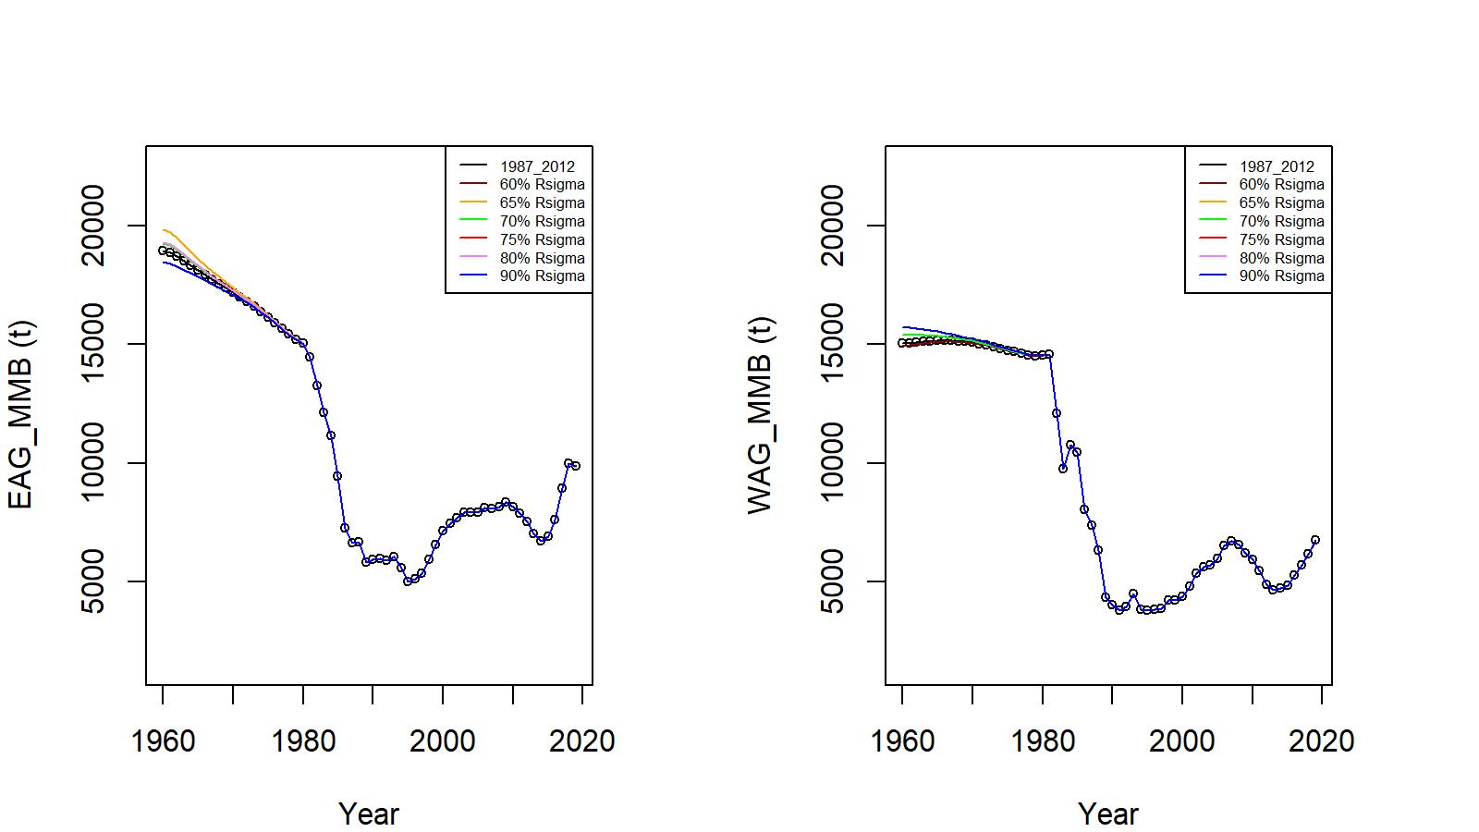

Figure R1. MMB trends for different percentages of R_{sigma} cut off mark to determine the time period for reference mean R calculation (EAG: 60%: 1987-2017, 65%: 1987-2017, 70%: 1985-2017, 75%: 1984-2017, 80%: 1984-2017, 90%: 1975-2018; WAG: 60%: 1989-2017, 65%: 1987-2018, 70%: 1987-2018, 75%: 1986-2018, 80%: 1986-2018; 90%: 1986-2018).

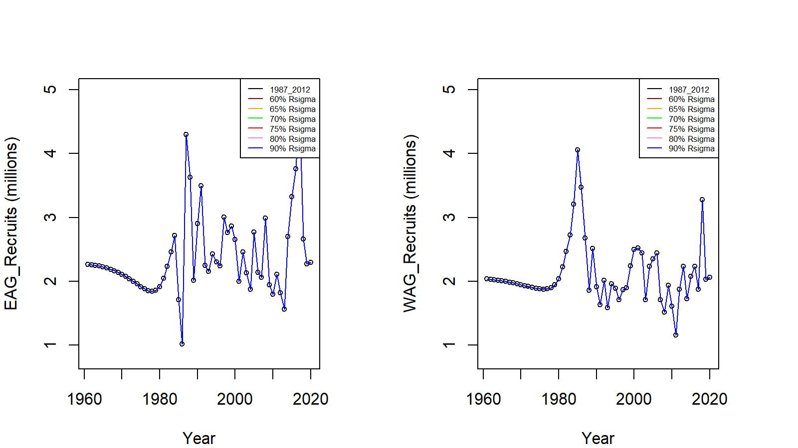
Figure R2. Recruit trends for different percentages of R_{sigma} cut off mark to determine the time period for reference mean R calculation.

Comment 3:
The method used to construct the CPUE indices accounts for years*blocks for which there are no data (and in principle for years*blocks with very few data points) by filling them in using a log-linear model, i.e.,:
$$\hat{B_{i, j}}= e^{A_{i} + C_{j} }$$
where A_{i} is the factor estimate for year i, and C_{j} is the factor estimate for block j, where the A and C parameters are estimated from a log-linear regression of the biomass estimates on year and block (treated as factors). The variance for the final indices (Equation B.16) accounts for the variance of the standardized CPUE values for years*blocks with data but ignores the biomass estimates based on the above formula. This variance should be based on two contributions: a) from block*years with data, and b) from those based on the above formula for year*blocks with no or few data.
Response:
Done (see Appendix A).

Comment 4:
The fits to the observer CPUE series should be shown separately for the index based on area*year interactions and that based on the default approach.
Response:
Done (see Appendix A, Figures A.2 and A.3).

Comment 5:
Time-series of MMB should be shown for all years and for the most recent 15 years—this will help the CPT assess trends.

Response:
Done (see Figure 12).

Comment 6:

The fits to the cooperative survey index should be shown.

Response:
Done (see Appendix A, Figure A.8).

Comment 7:

The CPT looks forward to seeing a version of the assessment in GMACS.

Response:
As an initial attempt, EAG19.1a model was implemented in GMACS. The results are preliminary and further improvement is needed.

Response to June 2020 SSC comments:

Comment 1

The annual fishery CPUE index is estimated by combining estimates from one model (model with year:area interaction) that was fit to all year-area combinations that had any fishing effort, and another model (without a year:area interaction) to estimate mean CPUE in those year-area combinations that did not have any fishing effort. The SSC requests more detailed documentation on how Year:Area interaction method is implemented in CPUE standardization.

Response:
To make it clear: Year:Area interaction parameters were estimated for blocks reporting fishing effort by the GLM model, which included soak time as a predictor variable. This final model was then used to predict the biomass indices for those year-area combinations that did not have any fishing effort (Appendix A). Thus, predictions implicitly considered soak time.

Comment 2

The SSC recommends consideration of alternative random effects structures that may reflect the sampling design and variability in CPUE as well or better. For example, a model with a fixed ‘Area’ (= ‘block’) effect and a 3-level random effect that nests pot within strings within vessels and other structures could be considered [e.g. Catch = Year + Area + s(soak) + s(depth) + (1 | vessel/string/pot)]. The SSC recommends that the authors reexamine and justify the random effects structure in the model for the cooperative survey data if it is included in models next year.

Response:
We believe that our random effects structure was best configured following the cooperative sampling design after several trial-and-error formulations in previous iterations. If there are any better structural suggestions on the random effects model, We will consider them in the near future.

Comment 3

The SSC recommends that the authors consider the advantages and disadvantages of combining the two areas because we are setting a single OFL/ABC.
Response:
We modelled EAG and WAG stocks separately for a number of reasons:
- Alaska Board of Fisheries decided to manage the two areas with separate total allowable catches.
- The productivity and extent of stock distribution in the two areas are different, e.g.,
- WAG has lower CPUE and wider area of stock distribution than EAG.
- There is a fishing area gap between EAG and WAG.
- Tagging studies have shown little mixing between the two areas.

Anyway, the suggestion is well taken and it has the advantage of reducing the stock assessment workload from two to one. We will investigate this in the near future.

Comment 4

The SSC recommends that, if this approach was used, the CV would be a better choice. This is because the standard deviations of high recruitments with the same CV might be higher than a cutoff and would result in reference points that are biased lower. The SSC also recommends exploring choosing a reasonable lag from the current year that would include most crabs that have recruited into the fishery. For example, if most crabs are observed by age 6, the 2020 assessment would use recruitments from 1987-2014, and the 2021 assessment would use 1987 – 2015, and so on.

Response: Please see our response to CPT comment 2.

Comment 5

In the two WAG jitter runs for models 20.1 and 20.1b, there are runs that have lower objective function values (e.g., runs 15 and 78 in 20.1b). Typically, these runs would become the new global minimum and be the starting points for new jitter runs for a final model. The OFL for the WAG would be about 1,900 t instead of 1,800 t under these scenarios. Considering that the final gradients for these runs are also very small, the SSC requests an explanation as to why these model runs were not used.

Response:
Current jitter analysis indicated that EAG initial optimization appear to have achieved the global minimum, but WAG jitter runs showed that some runs have (e.g., run#8) lower negative log likelihood values than the initial optimized value (Appendix B). However, we need to consider other factors, for example, low log likelihood values resulted in an unexpected spike in predicted groundfish bycatch in a year (we have noticed this). But groundfish bycatch removal in the golden king crab fishery is very minor. Therefore, for this exercise we used jitter run#8 input parameter values to estimate reference points by the model 19.1a for WAG.

Introduction

Genetic studies have not shown any evidence for separate golden king stocks in the Aleutian Islands.
CPUE trends suggest different factors may influence stock productivity in EAG and WAG, which are separated by the 174° W longitude meridian. Since 1996, the Alaska Department of Fish and Game (ADF&G) has divided management of the Aleutian Islands golden king fishery into EAG and WAG (ADF&G 2002). The stocks in the two areas are managed with annual total allowable (retained) catches. Additional management measures include a male-only fishery and a minimum legal-size limit (152.4 mm CW, or approximately 136 mm CL), which is at least one annual molt increment larger than the 50% maturity length of 120.8 mm CL for males (Otto and Cummiskey, 1985).

There is a paucity of information on golden king crab life history characteristics, due in part to the deep depth (~300–1000 m) and extremely rough bottom distribution on the slopes and trenches and the asynchronous nature of life history events, growth, and reproduction (Otto and Cummiskey, 1985; Somerton and Otto, 1986; Watson et al., 2002).

Figures 1 and 2 provide the historical time series of catch and CPUE for EAG and WAG, respectively. Increases in CPUE were observed during the late 1990s through the early 2000s, and with the implementation of crab rationalization in 2005. In 2012, the Alaska Board of Fisheries (BOF) increased the TAC levels to 3.310 million pounds for EAG and 2.980 million pounds for WAG beginning with the 2012/13 fishing year. The below par fishery performance in WAG in middle 2010s lead to reduction in TAC to 2.235 million pounds, which reflected a 25% reduction in the TAC for WAG, while the TAC for EAG was kept at the same level 3.31 million pounds for the 2015/16 through 2017/18 fishing seasons. With the improved fishery performance and stock status since 2017/18, the TACs were increased to 2.5 million pounds for WAG and 3.856 million pounds for EAG in 2018/19 and 2.87 million pounds for WAG and 4.31 million pounds for EAG in 2019/20 fishing years.

A new harvest strategy based on model estimated mature male abundance was accepted by the BOF in March 2019, specifying a 15% maximum harvest rate for EAG and 20% maximum harvest rate for WAG, and was first implemented for the 2019/20 fishery (Daly, et al., 2019). Based on the new harvest strategy, the TACs were set to 2.96 million pounds for WAG and 3.65 million pounds for EAG for the 2020/21 fishery.

Analytic Approach

The underlying population dynamics model is male-only and length-based (Siddeek et al., 2020). This model combines commercial retained catch, total catch, groundfish (trawl and pot) fishery discarded catch, standardized observer legal size catch-per-unit-effort (CPUE) and commercial fishery CPUE indices, fishery retained catch size composition, total catch size composition, and tag recaptures by release-recapture length to estimate stock assessment parameters. The tagging data were used to calculate the size transition matrix.

We fitted the observer and commercial fishery CPUE indices with GLM estimated standard errors and an additional constant variance. The additional constant variance was estimated by the model fit. There were significant changes in fishing practice due to changes in management regulations (e.g., constant TAC since 1996/97 and crab rationalization since 2005/06), pot configuration (escape web on the pot door increased to 9-inch since 1999), and improved observer coverage in Aleutian Islands golden king crab fisheries since 1998. These changes prompted us to consider two sets of catchability and total selectivity parameters with only one set of retention parameters for the periods 1985/86–2004/05 and 2005/06–2019/20. We also considered three total selectivity parameters in model scenario 19.1b to address the retrospective issue in the EAG assessment.

We projected the equilibrium abundance in 1960 with natural mortality and annual recruitment to create the initial abundance by size at the start of the (available) fishery data in 1981. The R₀ for equilibrium abundance was determined using the average model estimated number of recruits for a selected period. We used standardized CPUE indices (Appendix A) and catch and size composition information to determine the stock abundance trends in both regions. We assumed that the observer and fish ticket CPUE indices are linearly related to exploitable abundance. We kept M constant at 0.21 yr⁻¹. We assumed the directed pot fishery discard mortality proportion at 0.20 yr⁻¹, overall groundfish fishery mortality proportion at 0.65 yr⁻¹ [mean of groundfish pot fishery mortality (0.5 yr⁻¹) and groundfish trawl fishery mortality (0.8 yr⁻¹)], groundfish fishery selectivity at full selection for all length classes (i.e., selectivity = 1.0). We did not model any discard of legal-size males in the directed pot fishery.

We considered number of vessel-days as the initial input effective sample sizes (i.e., stage-1) for retained and total size compositions, and number of trips for groundfish discard catch size composition without enforcing any upper limit. We did not fit the groundfish size composition following an earlier CPT suggestion in all model scenarios. We estimated the stage-2 effective sample sizes iteratively from stage-1 input effective sample sizes by the Francis (2011) method for all model scenarios.

We used weighting factors for catch biomass, recruitment deviation, pot fishery F, and groundfish fishery F. We set the retained catch biomass weight to an arbitrarily large value (500.0) because retained catches are more reliable than any other data sets. We scaled the total catch biomass weight in accordance with the observer annual sample sizes (number of pots) with a maximum of 250.0. The total catches were derived from observer nominal total CPUE and effort. In some years, observer sample sizes were low (Tables 3). We chose a small groundfish bycatch weight (0.2) based on the September 2015 CPT suggestion to lower its weight. We used the best fit criteria to choose the lower weight for the groundfish bycatch. Groundfish bycatch of Aleutian Islands golden king crab is very low (Table 2). We set the CPUE weights to 1.0 for all scenarios. We included a constant (model estimated) variance in addition to input CPUE variance for the CPUE fit. We used the Burnham et al. (1987) suggested formula for ln(CPUE) [and ln(MMB)] variance estimation (formula in Siddeek et al., 2020)). However, the estimated additional variance values were small for both observer and fish ticket CPUE indices for the two regions. Nevertheless, the CPUE index variances estimated from the negative binomial and lognormal GLMs were adequate to fit the model, as confirmed by the fit diagnostics (Fox and Weisberg, 2011).

We used the AD Model Builder (Fournier et al., 2012) for model fitting.

Results

Model equations and weights for different data sets were provided in Siddeek et al. (2020). These weights (with the corresponding coefficient of variations) adequately fitted various data under integrated model setting. All scenarios considered molt probability parameters in addition to the linear growth increment and normal growth variability parameters to determine the size transition matrix.

In the May 2019 assessment and before, the length-weight relationship of $W=aL^{b}$ , based on 1991 weight vs. CL data, where a= 3.725*10⁻⁴, b = 3.0896, was used for biomass calculation from number of crabs by length. We updated the length-weight relationship parameters using cooperative survey collected data during 2018/19 with a = 1.095*10⁻⁴, b = 3.35923. Furthermore, we calculated the crab weight in a size bin using Beyer’s (1987) formula, which considers integration through the lower (CL_{l}) - to upper (CL_{u})- limits of a size bin:

$W_{l}=(\frac{1}{{CL}_{u}- {CL}_{l}})(\frac{a}{1+b})({CL}_{u}^{b+1}-{CL}_{l}^{b+1}$) (1)

The CPT plan is to bring all crab assessment models into the generalized Gmacs framework. We tested the Gmacs application with model 19.1a for EAG. The results are mixed when compared with status quo model outputs (see the tables and figures).

Tables of input values and parameter estimates

- Historical GHL, TAC, catch, effort, CPUE, and mean crab weight are summarized in Table 1 for EAG and WAG.
- Time series of retained and total catch and groundfish fishery discard mortality are summarized in Table 2 for EAG and WAG.
- Time series of pot fishery and observer nominal retained and total CPUE, annual pot fishing effort, observer sample size, and estimated observer CPUE indices are listed in Table 3 for EAG and WAG.
- The estimated commercial fishery CPUE indices are provided in Table 4 for EAG and WAG. The CPUE index estimation methods, and fits are described in Appendix A.
- The parameter estimates with coefficient of variation for four model scenarios 19.1 (base), 19.1a, 19.1d, and 20.1 are summarized respectively in Tables 5 for EAG and 11 (except 19.1d) for WAG. We have also provided the boundaries for parameter searches in those tables, and the estimates were within the bounds.
- The mature male and legal male abundance time series for model scenarios 19.1 (base), 19.1a, 19.1d, and 20.1 are summarized in Tables 6 to 9 for EAG and Tables 12 to 14 (except 19.1d) for WAG.
- The recruitment estimates for those model scenarios are summarized in Tables 6 to 9 for EAG and Tables 12 to 14 for WAG.
- The likelihood component values and the total likelihood values for four model scenarios 19.1, 19.1a, 19.1d, and 20.1 are summarized in Table 10 for EAG and Table 15 (except 19.1d) for WAG.
- The Tier level, MMB_{35%}, current MMB, current MMB/MMB_{35%}, F_{OFL}, F_{35%}, OFL, and ABC (under 25% buffer) for EAG, WAG, and the entire Aleutian Islands (AI) are listed in Table 16 for all model scenarios.

Graphs of estimates

- We provide the retained length composition fits in Figure 3 for EAG and Figure 13 for WAG, total length composition fits in Figure 4 for EAG and Figure 14 for WAG, and groundfish discarded catch length composition fits in Figure 5 for EAG and Figure 15 for WAG for 19.1, 19.1a, 19.1b, 19.1d (only for EAG), and 20.1 model scenarios. The retained and total catch size composition fits appear satisfactory. But the fits to groundfish bycatch size compositions are bad.
- We provide the pre- and post-rationalization periods’ total and retained selectivity curves in Figures 6 for EAG and Figures 16 for WAG for 19.1, 19.1a, 19.1b, and 20.1 model scenarios. Total selectivity for the pre-rationalization period was used in the tagging model. The groundfish bycatch selectivity appeared flat in the preliminary analysis, indicating that all size groups were vulnerable to the gear. This is also shown in the size compositions of groundfish bycatch (Figures 5 and 15).
- We provide the CPUE fits by 19.1, 19.1a, 19.1b, 19.1c (EAG Gmacs fit), 19.1d, and 20.1 model scenarios in Figure 7 for EAG and CPUE fits by 19.1, 19.1a, 19.1b, and 20.1 model scenarios in Figure 17 for WAG. All scenarios appear to fit the CPUE indices satisfactorily for both management areas. However, the Gmacs fits closer to input indices but the trend is bit wobbly compared to status quo model trends.
- We show the recruitment trends for 19.1, 19.1a, 19.1b, 19.1c (EAG Gmacs fit), 19.1d, and 20.1 model scenarios in Figure 8 for EAG and for 19.1, 19.1a, 19.1b, and 20.1 model scenarios in Figure 18 for WAG. The recruitment pulse peaked in recent years for all model fits in EAG. However, the recruit trend fluctuated widely for the Gmacs fit.
- We provide the fits to retained catch, total catch, and groundfish discarded catch by 19.1, 19.1a, 19.1b, 19.1d, and 20.1 model scenarios in Figure 9 for EAG and by 19.1, 19.1a, 19.1b, and 20.1 model scenarios in Figure 19 for WAG. The retained and ground fish bycatch fits are adequate, but the total catch fits showed some discrepancy. We did not provide the Gmacs fit trends because they showed similar trends but were underestimates.
- We provide the fits to pre–1985 retained catches (in number of crabs) by 19.1, 19.1a, 19.1b, 19.1d, and 20.1 model scenarios in Figure 10 for EAG and by19.1, 19.1a, 19.1b, and 20.1 model scenarios in Figure 20 for WAG. All scenarios adequately fitted the 1981/82–1984/85 retained catches in both areas.
- We provide the pot fishery total fishing mortality (F) plots for 19.1, 19.1a, 19.1b, 19.1c (EAG Gmacs fit), 19.1d, and 20.1 model scenarios for EAG (left) and for 19.1, 19.1a, 19.1b, and 20.1 model scenarios for WAG (right) in Figure 11. The F peaked in late 1980s and early to mid-1990s and systematically declined in the EAG. Slight increases in F were observed from 2014 to 2016, followed by a decline in the EAG. On the other hand, the F in the WAG peaked in late 1980s, 1990s and early 2000s, declined in late 2000s, and slightly increased in 2013–2014 before declining and slightly increasing. The Gmacs F trend was like status quo trends in early years, but it dipped low since 2010 and steadily increased thereafter.

- We provide MMB trends for 19.1, 19.1a, 19.1b, 19.1c (EAG Gmacs fit), 19.1d, 19.1e, and 20.1 model scenarios for EAG (left) and for 19.1, 19.1a, 19.1b, and 20.1 model scenarios for WAG (right) in Figure 12. We provide the MMB trends for the long time series (1960/61–2019/20) at the top panel and for the short time series (2005/06–2019/20) at the bottom panel of Figure 12. Mature male biomass tracked the CPUE trends well for all scenarios for EAG and WAG. However, Gmacs MMB trends tracked well with the status quo trends but with different fluctuations. We determined the mature male biomass values on February 15 each year after the fishery.

- We compare 10-year retrospective patterns for model 19.1a with model 19.1b for EAG and also provide the retrospective pattern for model 19.1a for WAG as a control in Figure 21. The mean (modified) Mohn rho value was lower for 19.1b than for 19.1a for EAG.

Specification of the Tier level

The OFL and ABC for Aleutian Islands golden king crab stocks are determined under Tier 3 level. The calculation procedures are described below:

The critical assumptions for MMB_{MSY} reference point estimation of Aleutian Islands golden king crab are:
- Natural mortality is constant.
- Growth transition matrix is fixed and estimated using tagging data with the molt probability sub-model.
- Total fishery selectivity and retention curves are length dependent and the 2005/06–2019/20 (or 2016/17–2019/20 for model 19.1b) period of selectivity estimates are used.
- Groundfish bycatch fishery selectivity is kept constant at 1.0 for all length groups.
- Model estimated recruits (in millions of crab) are averaged for the time periods 1987– 2012 (for model 19.1) or 1987– 2017 (for all other models).
- Model estimated groundfish bycatch mortality values are averaged for the period 2010/11 – 2019/20 (10 years).
- Knife-edge minimum maturity size of 111 mm CL is used for MMB estimation for all model scenarios.

Method:
We simulated the population abundance starting from the model estimated terminal year stock size by length, model estimated parameter values, a fishing mortality value (F), and adding a constant number of annual recruits. Once the stock dynamics were stabilized (we used the 99th year estimates) for an F, we calculated the MMB/R for that F. We computed the relative MMB/R in percentage, ${\left(\frac{MMB}{R}\right)}_{x\%}$ (where x% = $\frac{\frac{{MMB}_{F}}{R}}{\frac{{MMB}_{0}}{R}} ×100$ and ${MMB}_{0}/R$ is the virgin MMB/R) for different F values.
F_{35%} is the F value that produces the MMB/R value equal to 35% of ${MMB}_{0}/R$.
MMB_{35%} is estimated using the following formula:
${MMB}_{35\%}={\left(\frac{MMB}{R}\right)}_{35}×\overline{R}$ , where $\overline{R}$ is the mean number of model estimated recruits for a selected period.

Specification of the OFL:
We determined $F_{OFL}$ using the following equation with an iterative procedure accounting for intervening total removals. The formulas for removal of catches and groundfish discards are given in Siddeek et al. (2020).

If,
${MMB}_{current}> {MMB}_{35\%}, F_{OFL}= F_{35\%}$

If,
${MMB}_{current}≤ {MMB}_{35\% } and {MMB}_{current} >0.25{MMB}_{35\%}$ ,

$F_{OFL}= F_{35\%} \frac{\left(\frac{{MMB}_{current}}{{MMB}_{35\%}} - α\right)}{\left(1-α\right)}$ (2)

If,
${MMB}_{current} ≤0.25{MMB}_{35\%}$ ,

$F_{OFL}=0.$

where α is a parameter, ${MMB}_{current }$is the mature male biomass in the current year, and MMB_{35%} is the proxy MMB_{MSY} for Tier 3 stocks. We set α at 0.1.

Calculation of the ABC:
We estimated the cumulative probability distribution of OFL assuming a log normal distribution of OFL. We calculated the OFL at the 0.5 probability and the ABC using a 25% buffer on OFL.

The OFL and ABC estimates for various model scenarios under Tier 3 are summarized separately for EAG, WAG, and the entire Aleutian Islands (AI) in Table 16.

Acknowledgments
We thank CPT and SSC members, and industry personnel for many suggestions on improving the assessment. We appreciate Bill Bechtol’s suggestions for improving clarity of the first draft.

Literature Cited
ADF&G (Alaska Department of Fish and Game). 2002. Annual management report for the shellfish fisheries of the Westward Region, 2001. Alaska Department of Fish and Game, Division of Commercial Fisheries, Regional Information Report 4K02–54, Kodiak, Alaska.
Beyer, J.E., 1987. On length–weight relationships. Part 1. Computing the mean weight of the fish in a given length class. ICLARM Fishbyte 5 (1), 11–13.
Bozdogan, H. 1987. Model selection and Akaike's Information Criterion (AIC): The general theory and its analytical extensions. Psychometrika, 52, 345-370.
Burnham, K.P. and D.R. Anderson. 2002. Model Selection and Multimodal Inference, A practical Information- Theoretic Approach. 2nd edition. Springer-Verlag, NY, 488p.
Campbell, R.A. 2004. CPUE standardization and the construction of indices of stock abundance in a spatially varying fishery using general linear models. Fish. Res., 70:209-227.
Daly, B., M.S.M. Siddeek, M. Stichert, S. Martell, and J. Zheng. 2019. Recommended harvest strategy for Aleutian Islands golden king crab. Alaska Department of Fish and Game, Fishery Manuscript Series No. 19-03, Anchorage.
Feenstra, J., A. Linnane, M. Haddon, and A. Punt. 2019. Impacts on CPUE from vessel fleet composition changes in an Australian lobster (Jasus edwardsii) fishery. New Zealand Journal of Marine and Freshwater Research 53:292-302.
Fournier, D.A., H.J. Skaug, J. Ancheta, J. Ianelli, A. Magnusson, M.N. Maunder, A. Nielsen, and J. Sibert. 2012. AD Model Builder: using automatic differentiation for statistical inference of highly parameterized complex nonlinear models. Optim. Methods Softw. 27:233-249.
Fox, J., and S. Weisberg. 2011. An R Companion to Applied Regression. Second edition. Sage Publications, Inc. 449 p.
Francis, R.I.C.C. 2011. Data weighting in statistical fisheries stock assessment models. Can. J. Fish. Aquat. Sci. 68: 1124–1138.
Maunder, M.N., and A.E. Punt. 2004. Standardizing catch and effort data: a review of recent approaches. Fisheries Research, 70: 141-159.
Otto, R.S., and P.A. Cummiskey. 1985. Observations on the reproductive biology of golden king crab (Lithodes aequispina) in the Bering Sea and Aleutian Islands. Pages 123-135 In: Proceedings of the International King Crab Symposium. Alaska Sea Grant College Program, AK-SG-85-12, Fairbanks, Alaska.
R Core Team. 2018. R: A language and environment for statistical computing. R Foundation for Statistical Computing, Vienna, Austria. URL http://www.R-project.org/.
Siddeek, M.S.M., J. Zheng, C. Siddon, B. Daly, M.J. Westphal, and L. Hulbert. 2020. Aleutian Islands Golden king crab model-based stock assessment in Spring 2020. CRAB2020SAFE chapter. North Pacific Fishery Management Council, Anchorage, Alaska.
Somerton, D.A., and R.S. Otto. 1986. Distribution and reproductive biology of the golden king crab, Lithodes aequispina, in the Eastern Bering Sea. Fishery Bulletin 81(3): 571-584.
Starr, P.J. 2012. Standardized CPUE analysis exploration: using the rock lobster voluntary logbook and observer catch sampling programmes. New Zealand Fisheries Assessment Report 2012/34, 75 p.
Watson, L.J., D. Pengilly, and S.F. Blau. 2002. Growth and molting of golden king crabs (Lithodes aequispinus) in the eastern Aleutian Islands, Alaska. Pages 169-187 in Crabs in cold water regions: biology, management, and economics, Alaska Sea Grant College Program, AK-SG-02-01, Fairbanks, Alaska.

Table 1. | Commercial fishery history for the Aleutian Islands golden king crab fishery 1981/82–2019/20: number of vessels, guideline harvest level (GHL; established in lb, converted to t) for 1996/97 – 2004/05, total allowable catch (TAC; established in lb, converted to t ) for 2005/06– 2019/20, weight of retained catch (harvest; t),number of retained crab, pot lifts, fishery catch-per-unit- effort (CPUE; retained crab per pot lift), and average weight (kg) of landed crab. The values are separated by EAG and WAG beginning in 1996/97.
Crab Fishing Season | Vessels |  | GHL/TAC |  | Harvestª |  | Crab^{b} |  | Pot Lifts |  | CPUE^{b} |  | Average Weight^{c}
1981/82 | 14–20 |  | – |  | 599 |  | 240,458 |  | 27,533 |  | 9 |  | 2.5^{d}
1982/83 | 99–148 |  | – |  | 4,169 |  | 1,737,109 |  | 179,472 |  | 10 |  | 2.4^{d}
1983/84 | 157–204 |  | – |  | 4,508 |  | 1,773,262 |  | 256,393 |  | 7 |  | 2.5^{d}
1984/85 | 38–51 |  | – |  | 2,132 |  | 971,274 |  | 88,821 |  | 11 |  | 2.2e
1985/86 | 53 |  | – |  | 5,776 |  | 2,816,313 |  | 236,601 |  | 12 |  | 2.1^{f}
1986/87 | 64 |  | – |  | 6,685 |  | 3,345,680 |  | 433,870 |  | 8 |  | 2.0^{f}
1987/88 | 66 |  | – |  | 4,199 |  | 2,177,229 |  | 307,130 |  | 7 |  | 1.9^{f}
1988/89 | 76 |  | – |  | 4,820 |  | 2,488,433 |  | 321,927 |  | 8 |  | 1.9^{f}
1989/90 | 68 |  | – |  | 5,453 |  | 2,902,913 |  | 357,803 |  | 8 |  | 1.9^{f}
1990/91 | 24 |  | – |  | 3,153 |  | 1,707,618 |  | 215,840 |  | 8 |  | 1.9^{f}
1991/92 | 20 |  | – |  | 3,494 |  | 1,847,398 |  | 234,857 |  | 8 |  | 1.9^{f}
1992/93 | 22 |  | – |  | 2,854 |  | 1,528,328 |  | 203,221 |  | 8 |  | 1.9^{f}
1993/94 | 21 |  | – |  | 2,518 |  | 1,397,530 |  | 234,654 |  | 6 |  | 1.8^{f}
1994/95 | 35 |  | – |  | 3,687 |  | 1,924,271 |  | 386,593 |  | 5 |  | 1.9^{f}
Crab Fishing Season | Vessels |  | GHL/TAC |  | Harvestª |  | Crab^{b} |  | Pot Lifts |  | CPUE^{b} |  | Average Weight^{c}
1995/96 | 28 |  | – |  | 3,157 |  | 1,582,333 |  | 293,021 |  | 5 |  | 2.0^{f}
 | EAG | WAG | EAG | WAG | EAG | WAG | EAG | WAG | EAG | WAG | EAG | WAG | EAG | WAG
1996/97 | 14 | 13 | 1,452 | 1,225 | 1,493 | 1,145 | 731,909 | 602,968 | 113,460 | 99,267 | 7 | 6 | 2.04^{f} | 1.91^{f}
1997/98 | 13 | 9 | 1,452 | 1,225 | 1,588 | 1,109 | 780,610 | 569,550 | 106,403 | 86,811 | 7 | 7 | 2.04^{f} | 1.95^{f}
1998/99 | 14 | 3 | 1,361 | 1,225 | 1,473 | 768 | 740,011 | 410,018 | 83,378 | 35,975 | 9 | 11 | 2.00^{f} | 1.86^{f}
1999/00 | 15 | 15 | 1,361 | 1,225 | 1,392 | 1,256 | 709,332 | 676,558 | 79,129 | 107,040 | 9 | 6 | 1.95^{f} | 1.86^{f}
2000/01 | 15 | 12 | 1,361 | 1,225 | 1,422 | 1,308 | 704,702 | 705,613 | 71,551 | 101,239 | 10 | 7 | 2.00^{f} | 1.86^{f}
2001/02 | 19 | 9 | 1,361 | 1,225 | 1,442 | 1,243 | 730,030 | 686,738 | 62,639 | 105,512 | 12 | 7 | 2.00^{f} | 1.81^{f}
2002/03 | 19 | 6 | 1,361 | 1,225 | 1,280 | 1,198 | 643,886 | 664,823 | 52,042 | 78,979 | 12 | 8 | 2.00^{f} | 1.81^{f}
2003/04 | 18 | 6 | 1,361 | 1,225 | 1,350 | 1,220 | 643,074 | 676,633 | 58,883 | 66,236 | 11 | 10 | 2.09^{f} | 1.81^{f}
2004/05 | 19 | 6 | 1,361 | 1,225 | 1,309 | 1,219 | 637,536 | 685,465 | 34,848 | 56,846 | 18 | 12 | 2.04^{f} | 1.77^{f}
2005/06 | 7 | 3 | 1,361 | 1,225 | 1,300 | 1,204 | 623,971 | 639,368 | 24,569 | 30,116 | 25 | 21 | 2.09^{f} | 1.91^{f}
2006/07 | 6 | 4 | 1,361 | 1,225 | 1,357 | 1,030 | 650,587 | 527,734 | 26,195 | 26,870 | 25 | 20 | 2.09^{f} | 1.95^{f}
2007/08 | 4 | 3 | 1,361 | 1,225 | 1,356 | 1,142 | 633,253 | 600,595 | 22,653 | 29,950 | 28 | 20 | 2.13^{f} | 1.91^{f}
2008/09 | 3 | 3 | 1,361 | 1,286 | 1,426 | 1,150 | 666,946 | 587,661 | 24,466 | 26,200 | 27 | 22 | 2.13^{f} | 1.95^{f}
2009/10 | 3 | 3 | 1,429 | 1,286 | 1,429 | 1,253 | 679,886 | 628,332 | 29,298 | 26,489 | 26 | 24 | 2.09^{f} | 2.00^{f}
2010/11 | 3 | 3 | 1,429 | 1,286 | 1,428 | 1,279 | 670,983 | 626,246 | 25,851 | 29,994 | 26 | 21 | 2.13^{f} | 2.04^{f}
Crab Fishing Season | Vessels |  | GHL/TAC |  | Harvestª |  | Crab^{b} |  | Pot Lifts |  | CPUE^{b} |  | Average Weight^{c}
 | EAG | WAG | EAG | WAG | EAG | WAG | EAG | WAG | EAG | WAG | EAG | WAG | EAG | WAG
2011/12 | 3 | 3 | 1,429 | 1,286 | 1,429 | 1,276 | 668,828 | 616,118 | 17,915 | 26,326 | 37 | 23 | 2.13^{f} | 2.09^{f}
2012/13 | 3 | 3 | 1,501 | 1,352 | 1,504 | 1,339 | 687,666 | 672,916 | 20,827 | 32,716 | 33 | 21 | 2.18^{f} | 2.00^{f}
2013/14 | 3 | 3 | 1,501 | 1,352 | 1,546 | 1,347 | 720,220 | 686,883 | 21,388 | 41,835 | 34 | 16 | 2.13^{f} | 1.95^{f}
2014/15 | 3 | 2 | 1,501 | 1,352 | 1,554 | 1,217 | 719,064 | 635,312 | 17,002 | 41,548 | 42 | 15 | 2.18^{f} | 1.91^{f}
2015/16 | 3 | 2 | 1,501 | 1,352 | 1,590 | 1,139 | 763,604 | 615,355 | 19,376 | 41,108 | 39 | 15 | 2.09^{f} | 1.85^{f}
2016/17 | 3 | 3 | 1,501 | 1,014 | 1,578 | 1,015 | 793,983 | 543,796 | 24,470 | 38,118 | 32 | 14 | 1.99^{f} | 1.87^{f}
2017/18 | 3 | 3 | 1,501 | 1,014 | 1,571 | 1,014 | 802,610 | 519,051 | 25,516 | 30,885 | 31 | 17 | 1.96^{f} | 1.95^{f}
2018/19 | 3 | 3 | 1,749 | 1,134 | 1,830 | 1,135 | 940,336 | 578,221 | 25,553 | 29,156 | 37 | 20 | 1.95^{f} | 1.96^{f}
2019/20 | 3 | 3 | 1,955 | 1,302 | 2,031 | 1,288 | 1,057,464 | 649,832 | 30,998 | 42,924 | 34 | 15 | 1.92^{f} | 1.98^{f}

Note:
- Includes deadloss.
- Number of crab per pot lift.
- Average weight of landed crab, including dead loss.
- Managed with 6.5" carapace width (CW) minimum size limit.
- Managed with 6.5" CW minimum size limit west of 171° W longitude and 6.0" minimum size limit east of 171° W longitude.
- Managed with 6.0" minimum size limit.
Catch and effort data include cost recovery fishery.

Table 2. Annual weight of total fishery mortality to Aleutian Islands golden king crab, 1981/82 – 2019/20, partitioned by source of mortality: retained catch, bycatch mortality during crab fisheries, and bycatch mortality during groundfish fisheries. For bycatch in the federal groundfish fisheries, historical data (1991–2008) are not available for areas east and west of 174W, and are listed for federal groundfish reporting areas 541, 542, and 543 combined. The 2009– present data are available by separate EAG and WAG fisheries and are listed as such. A mortality rate of 20% was applied for crab fisheries bycatch, and a mortality rate of 50% for groundfish pot fisheries and 80% for the trawl fisheries were applied.
 |  |  | Bycatch Mortality by Fishery Type (t)
 | Retained Catch (t) |  | Crab |  | Groundfish |  | Total Fishery Mortality (t)
Season | EAG | WAG | EAG | WAG | EAG | WAG | EAG | WAG | Entire AI
1981/82 | 490 | 95 |  |  |  |  |  |  | 585
1982/83 | 1,260 | 2,655 |  |  |  |  |  |  | 3,914
1983/84 | 1,554 | 2,991 |  |  |  |  |  |  | 4,545
1984/85 | 1,839 | 424 |  |  |  |  |  |  | 2,263
1985/86 | 2,677 | 1,996 |  |  |  |  |  |  | 4,673
1986/87 | 2,798 | 4,200 |  |  |  |  |  |  | 6,998
1987/88 | 1,882 | 2,496 |  |  |  |  |  |  | 4,379
1988/89 | 2,382 | 2,441 |  |  |  |  |  |  | 4,823
1989/90 | 2,738 | 3,028 |  |  |  |  |  |  | 5,766
1990/91 | 1,623 | 1,621 |  |  |  |  |  |  | 3,244
1991/92 | 2,035 | 1,397 | 515 | 344 | 0 |  |  |  | 4,291
1992/93 | 2,112 | 1,025 | 1,206 | 373 | 0 |  |  |  | 4,716
1993/94 | 1,439 | 686 | 383 | 258 | 4 |  |  |  | 2,770
1994/95 | 2,044 | 1,540 | 687 | 823 | 1 |  |  |  | 5,095
1995/96 | 2,259 | 1,203 | 725 | 530 | 2 |  |  |  | 4,719
1996/97 | 1,738 | 1,259 | 485 | 439 | 5 |  |  |  | 3,926
1997/98 | 1,588 | 1,083 | 441 | 343 | 1 |  |  |  | 3,455
1998/99 | 1,473 | 955 | 434 | 285 | 1 |  |  |  | 3,149
1999/00 | 1,392 | 1,222 | 313 | 385 | 3 |  |  |  | 3,316
2000/01 | 1,422 | 1,342 | 82 | 437 | 2 |  |  |  | 3,285
2001/02 | 1,442 | 1,243 | 74 | 387 | 0 |  |  |  | 3,146
2002/03 | 1,280 | 1,198 | 52 | 303 | 18 |  |  |  | 2,850
2003/04 | 1,350 | 1,220 | 53 | 148 | 20 |  |  |  | 2,792
2004/05 | 1,309 | 1,219 | 41 | 143 | 1 |  |  |  | 2,715
2005/06 | 1,300 | 1,204 | 22 | 73 | 2 |  |  |  | 2,601
2006/07 | 1,357 | 1,022 | 28 | 81 | 18 |  |  |  | 2,506
2007/08 | 1,356 | 1,142 | 24 | 114 | 59 |  |  |  | 2,695
2008/09 | 1,426 | 1,150 | 61 | 102 | 33 |  |  |  | 2,772
2009/10 | 1,429 | 1,253 | 111 | 108 | 18 | 5 | 1,558 | 1,366 | 2,923
2010/11 | 1,428 | 1,279 | 123 | 124 | 49 | 3 | 1,600 | 1,407 | 3,006
2011/12 | 1,429 | 1,276 | 106 | 117 | 25 | 4 | 1,560 | 1,398 | 2,957
2012/13 | 1,504 | 1,339 | 118 | 145 | 9 | 6 | 1,631 | 1,491 | 3,122
2013/14 | 1,546 | 1,347 | 113 | 174 | 5 | 7 | 1,665 | 1,528 | 3,192
2014/15 | 1,554 | 1,217 | 127 | 175 | 9 | 5 | 1,691 | 1,397 | 3,088
2015/16 | 1,590 | 1,139 | 165 | 157 | 23 | 2 | 1,778 | 1,298 | 3,076
2016/17 | 1,578 | 1,015 | 203 | 145 | 101 | 4 | 1,882 | 1,164 | 3,046
2017/18 | 1,571 | 1,014 | 219 | 126 | 47 | 2 | 1,837 | 1,142 | 2,979
2018/19 | 1,830 | 1,135 | 240 | 140 | 24 | 3 | 2,094 | 1,278 | 3,372
2019/20 | 2,031 | 1,288 | 275 | 112 | 18 | 6 | 2,327 | 1,406 | 3,733

Table 3. Time series of nominal annual pot fishery retained, observer retained, and observer total catch-per-unit-effort (CPUE, number of crabs per pot lift), total pot fishing effort (number of pot lifts), observer sample size (number of sampled pots), and GLM estimated observer CPUE Index (for model 19.1) for the EAG and WAG golden king crab stocks, 1985/86–2019/20. Observer retained CPUE includes retained and non-retained legal-size crabs.

Year | Pot Fishery Nominal Retained CPUE |  | Obs. Nominal Retained CPUE |  | Obs. Nominal Total CPUE |  | Pot Fishery Effort (no.pot lifts) |  |  | Obs. Sample Size (no.pot lifts) |  | Obs. CPUE Index
Year | EAG | WAG | EAG | WAG | EAG | WAG | EAG | WAG |  | EAG | WAG | EAG | WAG
1985/86 | 11.90 | 11.90 |  |  |  |  | 117,718 |  | 118,563
1986/87 | 8.42 | 7.32 |  |  |  |  | 155,240 |  | 277,780
1987/88 | 7.03 | 7.15 |  |  |  |  | 146,501 |  | 160,229
1988/89 | 7.52 | 7.93 |  |  |  |  | 155,518 |  | 166,409
1989/90 | 8.49 | 7.83 |  |  |  |  | 155,262 |  | 202,541
1990/91 | 8.90 | 7.00 | 6.84 | 8.34 | 13.00 | 26.67 | 106,281 |  | 108,533 | 138 | 340
1991/92 | 8.20 | 7.40 | 9.84 | 6.14 | 36.91 | 19.17 | 133,428 |  | 101,429 | 377 | 857
1992/93 | 8.40 | 5.90 | 10.44 | 4.26 | 38.52 | 16.83 | 133,778 |  | 69,443 | 199 | 690
1993/94 | 7.80 | 4.40 | 5.91 | 12.75 | 20.81 | 17.23 | 106,890 |  | 127,764 | 31 | 174
1994/95 | 5.90 | 4.10 | 4.66 | 6.62 | 12.91 | 19.23 | 191,455 |  | 195,138 | 127 | 1,270
1995/96 | 5.90 | 4.70 | 6.03 | 6.03 | 16.98 | 14.28 | 177,773 |  | 115,248 | 6,388 | 5,598 | 1.00 | 1.17
1996/97 | 6.50 | 6.10 | 6.02 | 5.90 | 13.81 | 13.54 | 113,460 |  | 99,267 | 8,360 | 7,194 | 0.94 | 0.98
1997/98 | 7.30 | 6.60 | 7.99 | 6.72 | 18.25 | 15.03 | 106,403 |  | 86,811 | 4,670 | 3,985 | 0.87 | 0.98
1998/99 | 8.90 | 11.40 | 9.82 | 9.43 | 25.77 | 23.09 | 83,378 |  | 35,975 | 3,616 | 1,876 | 1.00 | 1.09
1999/00 | 9.00 | 6.30 | 10.28 | 6.09 | 20.77 | 14.49 | 79,129 |  | 107,040 | 3,851 | 4,523 | 0.92 | 0.91
2000/01 | 9.90 | 7.00 | 10.40 | 6.46 | 25.39 | 16.64 | 71,551 |  | 101,239 | 5,043 | 4,740 | 0.82 | 0.84
2001/02 | 11.70 | 6.50 | 11.73 | 6.04 | 22.48 | 14.66 | 62,639 |  | 105,512 | 4,626 | 4,454 | 1.04 | 0.82
2002/03 | 12.40 | 8.40 | 12.70 | 7.47 | 22.59 | 17.37 | 52,042 |  | 78,979 | 3,980 | 2,509 | 1.10 | 0.91
2003/04 | 10.90 | 10.20 | 11.34 | 9.33 | 19.43 | 18.17 | 58,883 |  | 66,236 | 3,960 | 3,334 | 0.97 | 1.16
2004/05 | 18.30 | 12.10 | 18.34 | 11.14 | 28.48 | 22.45 | 34,848 |  | 56,846 | 2,206 | 2,619 | 1.44 | 1.24
2005/06 | 25.40 | 21.20 | 29.52 | 23.89 | 38.55 | 36.23 | 24,569 |  | 30,116 | 1,193 | 1,365 | 0.98 | 1.16
2006/07 | 24.80 | 19.60 | 25.13 | 23.93 | 33.39 | 33.47 | 26,195 |  | 26,870 | 1,098 | 1,183 | 0.80 | 1.10
2007/08 | 28.00 | 20.00 | 31.10 | 21.01 | 40.38 | 32.46 | 22,653 |  | 29,950 | 998 | 1,082 | 0.89 | 1.00
2008/09 | 27.30 | 22.40 | 29.97 | 24.50 | 38.23 | 38.16 | 24,466 |  | 26,200 | 613 | 979 | 0.88 | 1.15
2009/10 | 25.90 | 23.70 | 26.60 | 26.54 | 35.88 | 34.08 | 26,298 |  | 26,489 | 408 | 892 | 0.73 | 1.23
2010/11 | 26.00 | 20.90 | 26.40 | 22.43 | 37.10 | 29.05 | 25,851 |  | 29,994 | 436 | 867 | 0.76 | 1.10
2011/12 | 37.30 | 23.40 | 39.48 | 23.63 | 52.04 | 31.13 | 17,915 |  | 26,326 | 361 | 837 | 1.08 | 1.10
2012/13 | 33.02 | 20.57 | 37.82 | 22.88 | 47.57 | 30.76 | 20,827 |  | 32,716 | 438 | 1,109 | 1.04 | 1.07
2013/14 | 33.67 | 16.42 | 35.94 | 16.89 | 46.16 | 25.01 | 21,388 |  | 41,835 | 499 | 1,223 | 1.02 | 0.81
2014/15 | 42.29 | 15.29 | 47.01 | 15.25 | 60.00 | 22.67 | 17,002 |  | 41,548 | 376 | 1,137 | 1.34 | 0.73
2015/16 | 39.41 | 14.97 | 43.27 | 15.81 | 58.68 | 22.14 | 19,376 |  | 41,108 | 478 | 1,296 | 1.26 | 0.74
2016/17 | 32.45 | 14.29 | 36.89 | 16.65 | 52.82 | 24.41 | 24,470 |  | 38,118 | 617 | 1,060 | 1.05 | 0.86
2017/18 | 31.46 | 16.81 | 35.18 | 19.30 | 54.62 | 25.54 | 25,516 |  | 30,885 | 585 | 760 | 1.00 | 0.98
2018/19 | 36.80 | 19.83 | 41.57 | 22.90 | 62.97 | 30.61 | 25,553 |  | 29,156 | 475 | 688 | 1.25 | 1.18
2019/20 | 34.11 | 16.18 | 40.88 | 19.25 | 57.46 | 27.15 | 30,998 |  | 42,924 | 540 | 793 | 1.16 | 0.96

Table 4. Time series of GLM estimated CPUE indices and standard errors [standard error of ln(CPUE index)] for fish ticket based retained catch-per-pot lift (CPUE) for the EAG and WAG golden king crab stock. The GLM was fitted to the 1985/86 to 1998/99 time series of data.

Year | EAG Negative Binomial  CPUE Index | Standard Error of  ln (CPUE) | WAG Negative Binomial  CPUE Index | Standard Error of ln (CPUE)
1985/86 | 1.63 | 0.05 | 2.07 | 0.05
1986/87 | 1.23 | 0.05 | 1.59 | 0.04
1987/88 | 0.96 | 0.05 | 1.22 | 0.04
1988/89 | 1.04 | 0.04 | 1.41 | 0.03
1989/90 | 1.08 | 0.03 | 1.15 | 0.03
1990/91 | 0.99 | 0.05 | 0.87 | 0.03
1991/92 | 0.90 | 0.04 | 0.76 | 0.04
1992/93 | 0.92 | 0.04 | 0.61 | 0.04
1993/94 | 0.91 | 0.05 | 0.76 | 0.05
1994/95 | 0.81 | 0.04 | 0.83 | 0.04
1995/96 | 0.78 | 0.04 | 0.90 | 0.04
1996/97 | 0.78 | 0.04 | 0.84 | 0.03
1997/98 | 1.05 | 0.05 | 0.76 | 0.03
1998/99 | 1.21 | 0.05 | 1.06 | 0.03

Table 5. Parameter estimates and coefficient of variations (CV) with the 2019 MMB (MMB estimated on 15 Feb 2020) for models 19.1, 19.1a, 19.1d, and 20.1 for the golden king crab data from the EAG, 1985/86–2019/20. Recruitment and fishing mortality deviations and initial size frequency determination parameters were omitted from this list.
 | Model 19.1 |  | Model 19.1a |  | Model 19.1d |  | Model 20.1
Parameter | Estimate | CV | Estimate | CV | Estimate | CV | Estimate | CV | Limits
log_ω₁ ( growth incr. intercept) | 2.54 | 0.01 | 2.54 | 0.01 | 2.54 | 0.01 | 2.54 | 0.01 | 1.0, 4.5
ω₂ ( growth incr. slope) | -8.29 | 0.21 | -8.29 | 0.21 | -8.29 | 0.21 | -8.28 | 0.21 | -12.0-5.0
log_a (molt prob. slope) | -2.51 | 0.02 | -2.51 | 0.02 | -2.51 | 0.02 | -2.50 | 0.02 | -4.61-1.39
log_b (molt prob. L50) | 4.95 | 0.001 | 4.95 | 0.001 | 4.95 | 0.001 | 4.95 | 0.001 | 3.869,5.05
σ (growth variability std) | 3.68 | 0.03 | 3.68 | 0.03 | 3.68 | 0.03 | 3.68 | 0.03 | 0.1,12.0
log_total sel deltaθ, 1985–04 | 3.38 | 0.02 | 3.38 | 0.02 | 3.38 | 0.02 | 3.39 | 0.02 | 0.,4.4
log_ total sel deltaθ, 2005–19 | 2.96 | 0.02 | 2.96 | 0.02 | 2.96 | 0.02 | 2.94 | 0.02 | 0.,4.4
log_ ret. sel deltaθ, 1985–19 | 1.87 | 0.02 | 1.87 | 0.02 | 1.87 | 0.02 | 1.87 | 0.02 | 0.,4.4
log_tot sel θ₅₀, 1985–04 | 4.83 | 0.002 | 4.83 | 0.002 | 4.83 | 0.002 | 4.84 | 0.002 | 4.0,5.0
log_tot sel θ₅₀, 2005–19 | 4.92 | 0.002 | 4.92 | 0.002 | 4.92 | 0.002 | 4.92 | 0.002 | 4.0,5.0
log_ret. sel θ₅₀, 1985–19 | 4.92 | 0.0003 | 4.92 | 0.0003 | 4.92 | 0.0003 | 4.92 | 0.0003 | 4.0,5.0
log_β_{r} (rec.distribution par.) | -1.08 | 0.17 | -1.08 | 0.17 | -1.08 | 0.17 | -1.08 | 0.17 | -12.0, 12.0
logq2 (catchability 1995–04) | -0.54 | 0.13 | -0.54 | 0.13 | -0.54 | 0.13 | -0.54 | 0.13 | -9.0, 2.25
logq3 (catchability 2005–19) | -0.73 | 0.16 | -0.73 | 0.16 | -0.68 | 0.18 | -0.78 | 0.15 | -9.0, 2.25
log_mean_rec (mean rec.) | 0.83 | 0.05 | 0.83 | 0.05 | 0.82 | 0.05 | 0.84 | 0.05 | 0.01, 5.0
log_mean_Fpot (Pot fishery F) | -0.95 | 0.07 | -0.95 | 0.07 | -0.94 | 0.07 | -0.97 | 0.07 | -15.0, -0.01
log_mean_Fground (GF byc. F) | -9.14 | 0.09 | -9.14 | 0.09 | -9.13 | 0.09 | -9.16 | 0.09 | -15.0, -1.6
$σ_{e}^{2}$ (observer CPUE additional var) | 0.05 | 0.36 | 0.05 | 0.36 | 0.05 | 0.37 | 0.05 | 0.37 | 0.0, 0.15
$σ_{e}^{2}$ (fishery CPUE additional var) | 0.03 | 0.44 | 0.03 | 0.44 | 0.03 | 0.44 | 0.03 | 0.44 | 0.0,1.0
$σ_{e}^{2}$ (survey CPUE additional var) |  |  |  |  | 0.08 | 0.71 |  |  | 0.0,1.0
2019 MMB | 9,872 | 0.22 | 9,858 | 0.22 | 8,954 | 0.21 | 10,406 | 0.21

Table 6. Annual abundance estimates of model recruits (millions of crabs), legal male biomass (t) with coefficient of variations (CV), and mature male biomass (t) with CV for model 19.1 for golden king crab in the EAG. Legal male biomass was estimated on July 1 (start of fishing year) of fishing year y. Mature male biomass for fishing year y was estimated on February 15 of year y+1, after the year y fishery total catch removal. Recruit estimates for 1961 to 2019 were restricted to 1985–2019. Equilibrium MMB_{eq} and MMB_{35%} are also listed.
Year | Recruits to the Model ( ≥ 101 mm CL) | Mature Male Biomass  ( ≥ 111 mm CL) | CV | Legal Size Male Biomass ( ≥ 136 mm CL) | CV
MMB_{eq} =22,685
MMB_{35%}=6,608
1985 | 1.71 | 9,460 | 0.04 | 9,675 | 0.06
1986 | 1.02 | 7,254 | 0.04 | 8,194 | 0.04
1987 | 4.29 | 6,660 | 0.05 | 6,416 | 0.04
1988 | 3.63 | 6,677 | 0.05 | 5,367 | 0.05
1989 | 2.02 | 5,834 | 0.06 | 4,825 | 0.07
1990 | 2.90 | 5,930 | 0.05 | 4,362 | 0.07
1991 | 3.49 | 5,990 | 0.04 | 4,648 | 0.06
1992 | 2.25 | 5,908 | 0.04 | 4,462 | 0.05
1993 | 2.16 | 6,062 | 0.03 | 4,474 | 0.05
1994 | 2.43 | 5,597 | 0.04 | 4,893 | 0.04
1995 | 2.31 | 5,011 | 0.04 | 4,452 | 0.04
1996 | 2.24 | 5,122 | 0.04 | 3,847 | 0.04
1997 | 3.01 | 5,374 | 0.05 | 3,980 | 0.04
1998 | 2.76 | 5,929 | 0.05 | 4,086 | 0.05
1999 | 2.87 | 6,584 | 0.05 | 4,513 | 0.05
2000 | 2.65 | 7,160 | 0.06 | 5,160 | 0.06
2001 | 2.00 | 7,476 | 0.06 | 5,761 | 0.06
2002 | 2.46 | 7,714 | 0.07 | 6,260 | 0.06
2003 | 2.13 | 7,913 | 0.07 | 6,562 | 0.07
2004 | 1.87 | 7,924 | 0.07 | 6,745 | 0.07
2005 | 2.77 | 7,939 | 0.07 | 6,862 | 0.07
2006 | 2.14 | 8,110 | 0.07 | 6,744 | 0.08
2007 | 2.07 | 8,092 | 0.07 | 6,835 | 0.08
2008 | 2.99 | 8,171 | 0.07 | 6,943 | 0.08
2009 | 1.94 | 8,361 | 0.06 | 6,873 | 0.08
2010 | 1.80 | 8,161 | 0.06 | 7,067 | 0.07
2011 | 2.11 | 7,875 | 0.06 | 7,109 | 0.07
2012 | 1.82 | 7,559 | 0.06 | 6,846 | 0.06
2013 | 1.57 | 7,045 | 0.06 | 6,525 | 0.06
2014 | 2.70 | 6,711 | 0.07 | 6,119 | 0.06
2015 | 3.33 | 6,925 | 0.08 | 5,617 | 0.07
2016 | 3.76 | 7,627 | 0.11 | 5,431 | 0.08
2017 | 4.80 | 8,942 | 0.14 | 5,827 | 0.11
2018 | 2.66 | 10,005 | 0.18 | 6,778 | 0.14
2019 | 2.27
Table 7. Annual abundance estimates of model recruits (millions of crabs), legal male biomass (t) with coefficient of variations (CV), and mature male biomass (t) with CV for model 19.1a for golden king crab in the EAG. Legal male biomass was estimated on July 1 (start of fishing year) of fishing year y. Mature male biomass for fishing year y was estimated on February 15 of year y+1, after the year y fishery total catch removal. Recruit estimates for 1961 to 2019 were restricted to 1985–2019. Equilibrium MMB_{eq} and MMB_{35%} are also listed.
Year | Recruits to the Model ( ≥ 101 mm CL) | Mature Male Biomass  ( ≥ 111 mm CL) | CV | Legal Size Male Biomass ( ≥ 136 mm CL) | CV
MMB_{eq} =23,743
MMB_{35%}=6,917
1985 | 1.71 | 9,462 | 0.04 | 9,677 | 0.06
1986 | 1.02 | 7,255 | 0.04 | 8,196 | 0.04
1987 | 4.29 | 6,661 | 0.05 | 6,417 | 0.04
1988 | 3.63 | 6,677 | 0.05 | 5,368 | 0.05
1989 | 2.02 | 5,834 | 0.06 | 4,825 | 0.07
1990 | 2.90 | 5,930 | 0.05 | 4,363 | 0.07
1991 | 3.49 | 5,990 | 0.04 | 4,649 | 0.06
1992 | 2.25 | 5,908 | 0.04 | 4,463 | 0.05
1993 | 2.16 | 6,062 | 0.03 | 4,475 | 0.05
1994 | 2.43 | 5,597 | 0.04 | 4,894 | 0.04
1995 | 2.31 | 5,012 | 0.04 | 4,452 | 0.04
1996 | 2.24 | 5,122 | 0.04 | 3,848 | 0.04
1997 | 3.01 | 5,374 | 0.05 | 3,980 | 0.04
1998 | 2.76 | 5,930 | 0.05 | 4,087 | 0.05
1999 | 2.87 | 6,585 | 0.05 | 4,513 | 0.05
2000 | 2.65 | 7,161 | 0.06 | 5,160 | 0.06
2001 | 2.00 | 7,478 | 0.06 | 5,762 | 0.06
2002 | 2.46 | 7,715 | 0.07 | 6,261 | 0.06
2003 | 2.13 | 7,914 | 0.07 | 6,563 | 0.07
2004 | 1.87 | 7,925 | 0.07 | 6,746 | 0.07
2005 | 2.77 | 7,940 | 0.07 | 6,863 | 0.07
2006 | 2.14 | 8,111 | 0.07 | 6,744 | 0.08
2007 | 2.07 | 8,093 | 0.07 | 6,836 | 0.08
2008 | 2.99 | 8,171 | 0.07 | 6,944 | 0.08
2009 | 1.94 | 8,361 | 0.06 | 6,874 | 0.08
2010 | 1.80 | 8,160 | 0.06 | 7,067 | 0.07
2011 | 2.11 | 7,875 | 0.06 | 7,109 | 0.07
2012 | 1.82 | 7,558 | 0.06 | 6,846 | 0.06
2013 | 1.57 | 7,044 | 0.06 | 6,525 | 0.06
2014 | 2.70 | 6,709 | 0.07 | 6,118 | 0.06
2015 | 3.32 | 6,922 | 0.08 | 5,616 | 0.07
2016 | 3.76 | 7,622 | 0.11 | 5,429 | 0.08
2017 | 4.79 | 8,934 | 0.14 | 5,824 | 0.11
2018 | 2.66 | 9,993 | 0.18 | 6,773 | 0.14
2019 | 2.27
Table 8. Annual abundance estimates of model recruits (millions of crabs), legal male biomass (t) with coefficient of variations (CV), and mature male biomass (t) with CV for model 19.1d for golden king crab in the EAG. Legal male biomass was estimated on July 1 (start of fishing year) of fishing year y. Mature male biomass for fishing year y was estimated on February 15 of year y+1, after the year y fishery total catch removal. Recruit estimates for 1961 to 2019 were restricted to 1985–2019. Equilibrium MMB_{eq} and MMB_{35%} are also listed. Bent-Point fit: logistic maturity curve fitted to Bent-Point lines determined maturity proportion.
Year | Recruits to the Model ( ≥ 101 mm CL) | Mature Male Biomass  (Bent-Point fit) | CV | Legal Size Male Biomass ( ≥ 136 mm CL) | CV
MMB_{eq} =23,417
MMB_{35%}=6,823
1985 | 1.71 | 9,457 | 0.04 | 9,668 | 0.06
1986 | 1.02 | 7,250 | 0.04 | 8,190 | 0.04
1987 | 4.30 | 6,657 | 0.05 | 6,412 | 0.04
1988 | 3.63 | 6,675 | 0.05 | 5,363 | 0.05
1989 | 2.01 | 5,833 | 0.06 | 4,821 | 0.07
1990 | 2.91 | 5,929 | 0.05 | 4,360 | 0.07
1991 | 3.49 | 5,990 | 0.04 | 4,646 | 0.06
1992 | 2.25 | 5,908 | 0.04 | 4,461 | 0.05
1993 | 2.16 | 6,061 | 0.03 | 4,473 | 0.05
1994 | 2.43 | 5,596 | 0.04 | 4,892 | 0.04
1995 | 2.31 | 5,010 | 0.04 | 4,450 | 0.04
1996 | 2.24 | 5,119 | 0.04 | 3,845 | 0.04
1997 | 3.01 | 5,370 | 0.05 | 3,977 | 0.04
1998 | 2.76 | 5,923 | 0.05 | 4,082 | 0.05
1999 | 2.86 | 6,576 | 0.05 | 4,507 | 0.05
2000 | 2.65 | 7,148 | 0.06 | 5,152 | 0.06
2001 | 1.99 | 7,460 | 0.06 | 5,751 | 0.06
2002 | 2.45 | 7,692 | 0.07 | 6,245 | 0.06
2003 | 2.12 | 7,884 | 0.07 | 6,543 | 0.07
2004 | 1.86 | 7,888 | 0.07 | 6,721 | 0.07
2005 | 2.76 | 7,895 | 0.07 | 6,831 | 0.08
2006 | 2.13 | 8,059 | 0.07 | 6,706 | 0.08
2007 | 2.06 | 8,037 | 0.07 | 6,789 | 0.08
2008 | 2.98 | 8,114 | 0.07 | 6,892 | 0.08
2009 | 1.94 | 8,303 | 0.06 | 6,819 | 0.08
2010 | 1.80 | 8,104 | 0.06 | 7,011 | 0.07
2011 | 2.10 | 7,822 | 0.06 | 7,055 | 0.07
2012 | 1.83 | 7,511 | 0.06 | 6,794 | 0.06
2013 | 1.57 | 7,005 | 0.06 | 6,476 | 0.06
2014 | 2.64 | 6,660 | 0.07 | 6,078 | 0.06
2015 | 3.20 | 6,817 | 0.08 | 5,580 | 0.07
2016 | 3.48 | 7,386 | 0.10 | 5,366 | 0.08
2017 | 4.24 | 8,423 | 0.13 | 5,682 | 0.10
2018 | 2.54 | 9,185 | 0.17 | 6,456 | 0.13
2019 | 2.23
Table 9. Annual abundance estimates of model recruits (millions of crabs), legal male biomass (t) with coefficient of variations (CV), and mature male biomass (t) with CV for model 20.1 for golden king crab in the EAG. Legal male biomass was estimated on July 1 (start of fishing year) of fishing year y. Mature male biomass for fishing year y was estimated on February 15 of year y+1, after the year y fishery total catch removal. Recruit estimates for 1961 to 2019 were restricted to 1985–2019. Equilibrium MMB_{eq} and MMB_{35%} are also listed. Cut-Line fit: logistic maturity curve fitted to Cut- Line determined maturity proportion.
Year | Recruits to the Model ( ≥ 101 mm CL) | Mature Male Biomass  (Cut-Line fit) | CV | Legal Size Male Biomass ( ≥ 136 mm CL) | CV
MMB_{eq} =24,041
MMB_{35%}=7,011
1985 | 1.71 | 9,482 | 0.04 | 9,714 | 0.06
1986 | 1.02 | 7,269 | 0.04 | 8,215 | 0.04
1987 | 4.30 | 6,676 | 0.05 | 6,427 | 0.04
1988 | 3.61 | 6,690 | 0.05 | 5,376 | 0.05
1989 | 2.02 | 5,845 | 0.06 | 4,835 | 0.07
1990 | 2.90 | 5,941 | 0.05 | 4,370 | 0.07
1991 | 3.49 | 5,996 | 0.04 | 4,656 | 0.06
1992 | 2.22 | 5,904 | 0.04 | 4,467 | 0.05
1993 | 2.15 | 6,043 | 0.03 | 4,474 | 0.05
1994 | 2.44 | 5,572 | 0.04 | 4,880 | 0.04
1995 | 2.32 | 4,996 | 0.04 | 4,426 | 0.04
1996 | 2.26 | 5,123 | 0.04 | 3,825 | 0.04
1997 | 3.06 | 5,404 | 0.05 | 3,969 | 0.05
1998 | 2.83 | 6,003 | 0.05 | 4,096 | 0.05
1999 | 2.94 | 6,713 | 0.05 | 4,555 | 0.05
2000 | 2.73 | 7,347 | 0.06 | 5,249 | 0.06
2001 | 2.07 | 7,717 | 0.06 | 5,905 | 0.06
2002 | 2.53 | 8,000 | 0.06 | 6,458 | 0.06
2003 | 2.14 | 8,223 | 0.07 | 6,806 | 0.07
2004 | 1.87 | 8,223 | 0.07 | 7,027 | 0.07
2005 | 2.76 | 8,207 | 0.07 | 7,149 | 0.07
2006 | 2.17 | 8,346 | 0.07 | 7,007 | 0.08
2007 | 2.09 | 8,313 | 0.07 | 7,061 | 0.08
2008 | 3.00 | 8,381 | 0.07 | 7,144 | 0.07
2009 | 1.96 | 8,559 | 0.06 | 7,063 | 0.07
2010 | 1.82 | 8,351 | 0.06 | 7,247 | 0.07
2011 | 2.15 | 8,063 | 0.06 | 7,281 | 0.07
2012 | 1.85 | 7,750 | 0.06 | 7,012 | 0.06
2013 | 1.59 | 7,234 | 0.07 | 6,694 | 0.06
2014 | 2.75 | 6,901 | 0.07 | 6,289 | 0.07
2015 | 3.43 | 7,142 | 0.09 | 5,785 | 0.08
2016 | 3.92 | 7,913 | 0.11 | 5,607 | 0.09
2017 | 5.00 | 9,341 | 0.15 | 6,045 | 0.11
2018 | 2.74 | 10,506 | 0.18 | 7,082 | 0.14
2019 | 2.31
Table 10. Negative log-likelihood values of the fits for models 19.1 (base), 19.1a, 19.1d, and 20.1 for golden king crab in the EAG. Likelihood components with zero entry in the entire rows are omitted. RetdcatchB= retained catch biomass.

Likelihood Component | 19.1 | 19.1a | 19.1d | 20.1
Number of free parameters | 149 | 149 | 150 | 149
Retlencomp | -1288.48 | -1288.41 | -1287.37 | -1288.39
Totallencomp | -1424.53 | -1424.57 | -1423.34 | -1428.63
Observer cpue | -1.02 | -1.01 | -0.67 | -1.69
RetdcatchB | 7.66 | 7.66 | 7.69 | 7.90
TotalcatchB | 23.36 | 23.36 | 23.30 | 23.46
GdiscdcatchB | 0.0003 | 0.00 | 0.00 | 0.00
Rec_dev | 7.25 | 7.25 | 6.71 | 7.45
Pot F_dev | 0.01 | 0.01 | 0.01 | 0.01
Gbyc_F_dev | 0.03 | 0.03 | 0.03 | 0.03
Tag | 2692.52 | 2692.51 | 2692.54 | 2692.30
Fishery cpue | -3.5164 | -3.5179 | -3.5094 | -3.5062
RetcatchN | 0.0056 | 0.0057 | 0.0053 | 0.0058
Total | 13.28 | 13.32 | 16.10 | 8.94

Table 11. Parameter estimates and coefficient of variations (CV) with the 2019 MMB (MMB estimated on 15 Feb 2020) for models 19.1, 19.1a, and 20.1 for the golden king crab data from the WAG, 1985/86–2019/20. Recruitment and fishing mortality deviations and initial size frequency determination parameters were omitted from this list.
 | Model 19.1 |  | Model 19.1a |  | Model 20.1
Parameter | Estimate | CV | Estimate | CV | Estimate | CV | Limits
log_ω₁ ( growth incr. intercept) | 2.54 | 0.01 | 2.54 | 0.01 | 2.54 | 0.01 | 1.0, 4.5
ω₂ ( growth incr. slope) | -7.73 | 0.22 | -7.45 | 0.23 | -7.74 | 0.22 | -12.0-5.0
log_a (molt prob. slope) | -2.62 | 0.03 | -2.64 | 0.03 | -2.62 | 0.03 | -4.61-1.39
log_b (molt prob. L50) | 4.95 | 0.001 | 4.95 | 0.001 | 4.95 | 0.001 | 3.869,5.05
σ (growth variability std) | 3.69 | 0.03 | 3.69 | 0.03 | 3.69 | 0.03 | 0.1,12.0
log_total sel deltaθ, 1985–04 | 3.41 | 0.01 | 3.42 | 0.01 | 3.42 | 0.01 | 0.,4.4
log_ total sel deltaθ, 2005–19 | 2.84 | 0.02 | 2.84 | 0.02 | 2.83 | 0.02 | 0.,4.4
log_ ret. sel deltaθ, 1985–19 | 1.79 | 0.02 | 1.80 | 0.02 | 1.79 | 0.02 | 0.,4.4
log_tot sel θ₅₀, 1985–04 | 4.87 | 0.002 | 4.88 | 0.002 | 4.87 | 0.002 | 4.0,5.0
log_tot sel θ₅₀, 2005–19 | 4.90 | 0.001 | 4.90 | 0.001 | 4.90 | 0.001 | 4.0,5.0
log_ret. sel θ₅₀, 1985–19 | 4.92 | 0.0002 | 4.92 | 0.0002 | 4.92 | 0.0002 | 4.0,5.0
log_β_{r} (rec.distribution par.) | -1.04 | 0.16 | -1.04 | 0.15 | -1.03 | 0.15 | -12.0, 12.0
logq2 (catchability 1995–04) | -0.04 | 1.83 | -0.04 | 1.77 | -0.06 | 1.13 | -9.0, 2.25
logq3 (catchability 2005–19) | -0.39 | 0.22 | -0.40 | 0.20 | -0.40 | 0.25 | -9.0, 2.25
log_mean_rec (mean rec.) | 0.73 | 0.05 | 0.79 | 0.05 | 0.73 | 0.06 | 0.01, 5.0
log_mean_Fpot (Pot fishery F) | -0.70 | 0.09 | -0.72 | 0.09 | -0.71 | 0.09 | -15.0, -0.01
log_mean_Fground (GF byc. F) | -8.29 | 0.10 | -8.07 | 0.10 | -8.30 | 0.10 | -15.0, -1.6
$σ_{e}^{2}$ (observer CPUE additional var) | 0.02 | 0.35 | 0.01 | 0.37 | 0.05 | 0.33 | 0.0, 0.15
$σ_{e}^{2}$ (fishery CPUE additional var) | 0.02 | 0.60 | 0.03 | 0.57 | 0.02 | 0.54 | 0.0,1.0
2019 MMB | 6,743 | 0.16 | 7,077 | 0.15 | 6,990 | 0.21

Table 12. Annual abundance estimates of model recruits (millions of crabs), legal male biomass (t) with coefficient of variations (CV), and mature male biomass (t) with CV for model 19.1 for golden king crab in the WAG. Legal male biomass was estimated on July 1 (start of fishing year) of fishing year y. Mature male biomass for fishing year y was estimated on February 15 of year y+1, after the year y fishery total catch removal. Recruit estimates for 1961 to 2019 were restricted to 1985–2019. Equilibrium MMB_{eq} and MMB_{35%} are also listed.
Year | Recruits to the Model ( ≥ 101 mm CL) | Mature Male Biomass  ( ≥ 111 mm CL) | CV | Legal Size Male Biomass ( ≥ 136 mm CL) | CV
MMB_{eq} =18,029
MMB_{35%}=5,227
1985 | 4.05 | 10,477 | 0.05 | 9,016 | 0.10
1986 | 3.47 | 8,046 | 0.05 | 8,431 | 0.08
1987 | 2.68 | 7,392 | 0.04 | 5,963 | 0.06
1988 | 1.86 | 6,330 | 0.04 | 5,584 | 0.05
1989 | 2.52 | 4,342 | 0.04 | 4,938 | 0.04
1990 | 1.92 | 4,040 | 0.05 | 3,106 | 0.06
1991 | 1.64 | 3,810 | 0.05 | 2,837 | 0.05
1992 | 2.02 | 3,951 | 0.04 | 2,776 | 0.05
1993 | 1.59 | 4,520 | 0.03 | 2,929 | 0.05
1994 | 1.96 | 3,823 | 0.03 | 3,508 | 0.03
1995 | 1.89 | 3,817 | 0.04 | 2,828 | 0.03
1996 | 1.71 | 3,827 | 0.04 | 2,769 | 0.04
1997 | 1.86 | 3,893 | 0.04 | 2,813 | 0.04
1998 | 1.90 | 4,214 | 0.04 | 2,890 | 0.04
1999 | 2.24 | 4,243 | 0.04 | 3,173 | 0.04
2000 | 2.50 | 4,392 | 0.04 | 3,113 | 0.04
2001 | 2.53 | 4,816 | 0.05 | 3,118 | 0.04
2002 | 2.45 | 5,344 | 0.05 | 3,443 | 0.05
2003 | 1.71 | 5,641 | 0.05 | 3,952 | 0.05
2004 | 2.23 | 5,718 | 0.06 | 4,419 | 0.05
2005 | 2.35 | 5,993 | 0.06 | 4,578 | 0.06
2006 | 2.45 | 6,531 | 0.05 | 4,721 | 0.06
2007 | 1.72 | 6,725 | 0.05 | 5,167 | 0.06
2008 | 1.52 | 6,560 | 0.05 | 5,478 | 0.06
2009 | 1.94 | 6,207 | 0.05 | 5,545 | 0.05
2010 | 1.61 | 5,944 | 0.05 | 5,204 | 0.05
2011 | 1.16 | 5,462 | 0.05 | 4,922 | 0.05
2012 | 1.87 | 4,878 | 0.05 | 4,595 | 0.05
2013 | 2.23 | 4,645 | 0.05 | 3,993 | 0.05
2014 | 1.73 | 4,736 | 0.06 | 3,528 | 0.06
2015 | 2.08 | 4,861 | 0.07 | 3,588 | 0.06
2016 | 2.24 | 5,282 | 0.08 | 3,737 | 0.07
2017 | 1.88 | 5,703 | 0.09 | 4,066 | 0.08
2018 | 3.28 | 6,170 | 0.12 | 4,505 | 0.09
2019 | 2.03
Table 13. Annual abundance estimates of model recruits (millions of crabs), legal male biomass (t) with coefficient of variations (CV), and mature male biomass (t) with CV for model 19.1a for golden king crab in the WAG. Legal male biomass was estimated on July 1 (start of fishing year) of fishing year y. Mature male biomass for fishing year y was estimated on February 15 of year y+1, after the year y fishery total catch removal. Recruit estimates for 1961 to 2019 were restricted to 1985–2019. Equilibrium MMB_{eq} and MMB_{35%} are also listed.
Year | Recruits to the Model ( ≥ 101 mm CL) | Mature Male Biomass  ( ≥ 111 mm CL) | CV | Legal Size Male Biomass ( ≥ 136 mm CL) | CV
MMB_{eq} =19,954
MMB_{35%}=5,810
1985 | 3.65 | 10,773 | 0.05 | 9,445 | 0.09
1986 | 3.57 | 8,171 | 0.05 | 8,787 | 0.07
1987 | 2.61 | 7,496 | 0.04 | 6,114 | 0.06
1988 | 1.86 | 6,392 | 0.04 | 5,642 | 0.05
1989 | 2.61 | 4,413 | 0.05 | 4,962 | 0.04
1990 | 2.03 | 4,173 | 0.05 | 3,121 | 0.06
1991 | 1.77 | 4,028 | 0.05 | 2,885 | 0.06
1992 | 2.37 | 4,319 | 0.05 | 2,892 | 0.06
1993 | 2.30 | 5,217 | 0.05 | 3,142 | 0.06
1994 | 3.36 | 5,181 | 0.07 | 3,911 | 0.05
1995 | 3.65 | 6,259 | 0.10 | 3,631 | 0.07
1996 | 3.18 | 3,779 | 0.04 | 4,355 | 0.09
1997 | 1.89 | 3,862 | 0.04 | 2,729 | 0.04
1998 | 1.89 | 4,197 | 0.03 | 2,821 | 0.04
1999 | 2.26 | 4,233 | 0.04 | 3,119 | 0.03
2000 | 2.53 | 4,395 | 0.04 | 3,066 | 0.04
2001 | 2.57 | 4,839 | 0.05 | 3,076 | 0.04
2002 | 2.50 | 5,397 | 0.05 | 3,409 | 0.05
2003 | 1.76 | 5,726 | 0.05 | 3,939 | 0.05
2004 | 2.24 | 5,827 | 0.06 | 4,435 | 0.05
2005 | 2.30 | 6,090 | 0.06 | 4,631 | 0.06
2006 | 2.49 | 6,603 | 0.06 | 4,787 | 0.06
2007 | 1.72 | 6,796 | 0.05 | 5,206 | 0.06
2008 | 1.54 | 6,628 | 0.05 | 5,502 | 0.06
2009 | 1.98 | 6,283 | 0.05 | 5,568 | 0.05
2010 | 1.61 | 6,031 | 0.05 | 5,234 | 0.05
2011 | 1.17 | 5,546 | 0.05 | 4,964 | 0.05
2012 | 1.91 | 4,967 | 0.05 | 4,644 | 0.05
2013 | 2.27 | 4,747 | 0.05 | 4,044 | 0.05
2014 | 1.78 | 4,857 | 0.06 | 3,584 | 0.06
2015 | 2.14 | 5,011 | 0.06 | 3,652 | 0.06
2016 | 2.30 | 5,464 | 0.07 | 3,822 | 0.07
2017 | 1.92 | 5,910 | 0.08 | 4,179 | 0.07
2018 | 3.44 | 6,422 | 0.11 | 4,646 | 0.08
2019 | 2.16

Table 14. Annual abundance estimates of model recruits (millions of crabs), legal male biomass (t) with coefficient of variations (CV), and mature male biomass (t) with CV for model 20.1 for golden king crab in the WAG. Legal male biomass was estimated on July 1 (start of fishing year) of fishing year y. Mature male biomass for fishing year y was estimated on February 15 of year y+1, after the year y fishery total catch removal. Recruit estimates for 1961 to 2019 were restricted to 1985–2019. Equilibrium MMB_{eq} and MMB_{35%} are also listed. Bent-Point fit: logistic maturity curve fitted to Bent-Point lines determined maturity proportion.
Year | Recruits to the Model ( ≥ 101 mm CL) | Mature Male Biomass (Bent-Point fit) | CV | Legal Size Male Biomass ( ≥ 136 mm CL) | CV
MMB_{eq} =18,159
MMB_{35%}=5,266
1985 | 3.98 | 10,554 | 0.05 | 9,127 | 0.10
1986 | 3.51 | 8,092 | 0.05 | 8,522 | 0.08
1987 | 2.67 | 7,440 | 0.04 | 6,012 | 0.06
1988 | 1.85 | 6,365 | 0.04 | 5,621 | 0.05
1989 | 2.51 | 4,366 | 0.04 | 4,970 | 0.04
1990 | 1.91 | 4,057 | 0.05 | 3,130 | 0.05
1991 | 1.64 | 3,822 | 0.05 | 2,854 | 0.05
1992 | 1.97 | 3,949 | 0.04 | 2,786 | 0.05
1993 | 1.56 | 4,489 | 0.03 | 2,933 | 0.05
1994 | 1.98 | 3,780 | 0.03 | 3,491 | 0.03
1995 | 1.89 | 3,783 | 0.04 | 2,786 | 0.03
1996 | 1.71 | 3,799 | 0.04 | 2,729 | 0.04
1997 | 1.89 | 3,877 | 0.04 | 2,780 | 0.04
1998 | 1.92 | 4,220 | 0.04 | 2,864 | 0.04
1999 | 2.27 | 4,273 | 0.04 | 3,162 | 0.04
2000 | 2.53 | 4,446 | 0.04 | 3,125 | 0.04
2001 | 2.54 | 4,888 | 0.05 | 3,151 | 0.04
2002 | 2.45 | 5,424 | 0.05 | 3,496 | 0.05
2003 | 1.70 | 5,715 | 0.06 | 4,017 | 0.05
2004 | 2.23 | 5,780 | 0.06 | 4,487 | 0.06
2005 | 2.40 | 6,060 | 0.06 | 4,637 | 0.06
2006 | 2.48 | 6,620 | 0.06 | 4,772 | 0.07
2007 | 1.74 | 6,833 | 0.05 | 5,229 | 0.06
2008 | 1.47 | 6,664 | 0.05 | 5,560 | 0.06
2009 | 1.90 | 6,274 | 0.05 | 5,641 | 0.05
2010 | 1.61 | 5,981 | 0.05 | 5,283 | 0.05
2011 | 1.21 | 5,496 | 0.05 | 4,965 | 0.05
2012 | 1.85 | 4,918 | 0.05 | 4,616 | 0.05
2013 | 2.24 | 4,677 | 0.06 | 4,021 | 0.05
2014 | 1.67 | 4,753 | 0.07 | 3,556 | 0.06
2015 | 2.09 | 4,852 | 0.08 | 3,610 | 0.07
2016 | 2.36 | 5,302 | 0.10 | 3,734 | 0.08
2017 | 2.02 | 5,812 | 0.13 | 4,053 | 0.10
2018 | 3.35 | 6,369 | 0.16 | 4,542 | 0.12
2019 | 2.06
Table 15. Negative log-likelihood values of the fits for models 19.1 (base), 19.1a, and 20.1 for golden king crab in the WAG. Likelihood components with zero entry in the entire rows are omitted. RetdcatchB= retained catch biomass.

Likelihood Component | 19.1 | 19.1a | 20.1
Number of free parameters | 149 | 149 | 149
Retlencomp | -1243.20 | -1245.46 | -1239.82
Totallencomp | -1562.06 | -1573.77 | -1570.87
Observer cpue | -13.02 | -18.06 | -0.08
RetdcatchB | 5.25 | 6.03 | 5.72
TotalcatchB | 45.78 | 42.87 | 46.06
GdiscdcatchB | 0.00 | 13.78 | 0.00
Rec_dev | 4.84 | 5.42 | 4.85
Pot F_dev | 0.03 | 0.03 | 0.03
Gbyc_F_dev | 0.04 | 0.11 | 0.04
Tag | 2694.15 | 2694.25 | 2694.04
Fishery cpue | -5.7167 | -3.5009 | -5.7715
RetcatchN | 0.0019 | 0.0035 | 0.0018
Total | -73.91 | -78.31 | -65.80

Table 16. Stock status, reference biomass and fishing mortality, OFL (total catch), and ABC for various models for EAG, WAG, and AI golden king crab stock.

EAG:
Biomass, OFL, and ABC are in t. Current MMB = MMB on 15 Feb. 2021.

Model | Tier | MMB_{35%} | Current MMB | MMB/  MMB_{35%} | F_{OFL} | F_{35%} | OFL | ABC  (0.75*OFL)
19.1 | 3a | 6,608 | 8,537 | 1.29 | 0.61 | 0.61 | 3,030 | 2,272
19.1a | 3a | 6,917 | 8,527 | 1.23 | 0.61 | 0.61 | 3,277 | 2,269
19.1b | 3a | 6,811 | 8,020 | 1.18 | 0.57 | 0.57 | 2,752 | 2,064
19.1c | 3a | 7,986 | 8,350 | 1.05 | 0.99 | 0.99 | 1,778 | 1,333
19.1d | 3a | 6,823 | 7,908 | 1.16 | 0.61 | 0.61 | 2,723 | 2,042
19.1e | 3a | 6,899 | 7,718 | 1.12 | 0.59 | 0.59 | 2,677 | 2,008
20.1 | 3a | 7,011 | 8,896 | 1.27 | 0.60 | 0.60 | 3,207 | 2,406

WAG:
Biomass, OFL, and ABC are in t. Current MMB = MMB on 15 Feb. 2021.

Model | Tier | MMB_{35%} | Current MMB | MMB/  MMB_{35%} | F_{OFL} | F_{35%} | OFL | ABC  (0.75*OFL)
19.1 | 3a | 5,227 | 6,419 | 1.23 | 0.56 | 0.56 | 1,856 | 1,392
19.1a | 3a | 5,810 | 6,757 | 1.16 | 0.56 | 0.56 | 1,933 | 1,450
19.1b | 3a | 5,204 | 6,591 | 1.27 | 0.55 | 0.55 | 1,762 | 1,322
20.1 | 3a | 5,266 | 6,608 | 1.25 | 0.56 | 0.56 | 1,930 | 1,447

AI:
OFL and ABC are in t.
Model | OFL | ABC  (0.75*OFL)
19.1 | 4,886 | 3,664
19.1a | 5,210 | 3,719
19.1b | 4,514 | 3,386
20.1 | 5,137 | 3,853

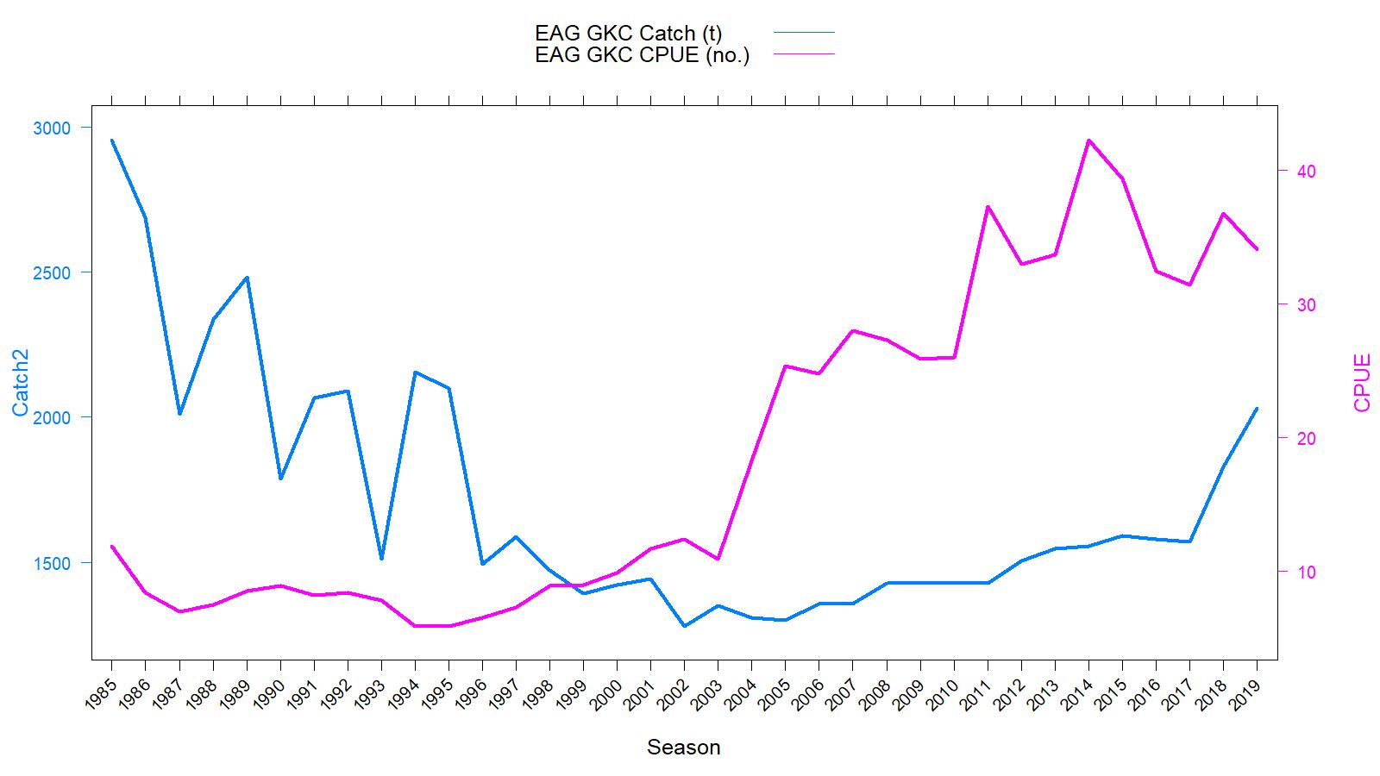
Figure 1. Historical commercial harvest (from fish tickets; metric tons) and catch-per-unit effort (CPUE, number of crabs per pot lift) of golden king crab in the EAG, 1985/86–2019/20 fisheries (note: 1985 refers to the 1985/86 fishing year).

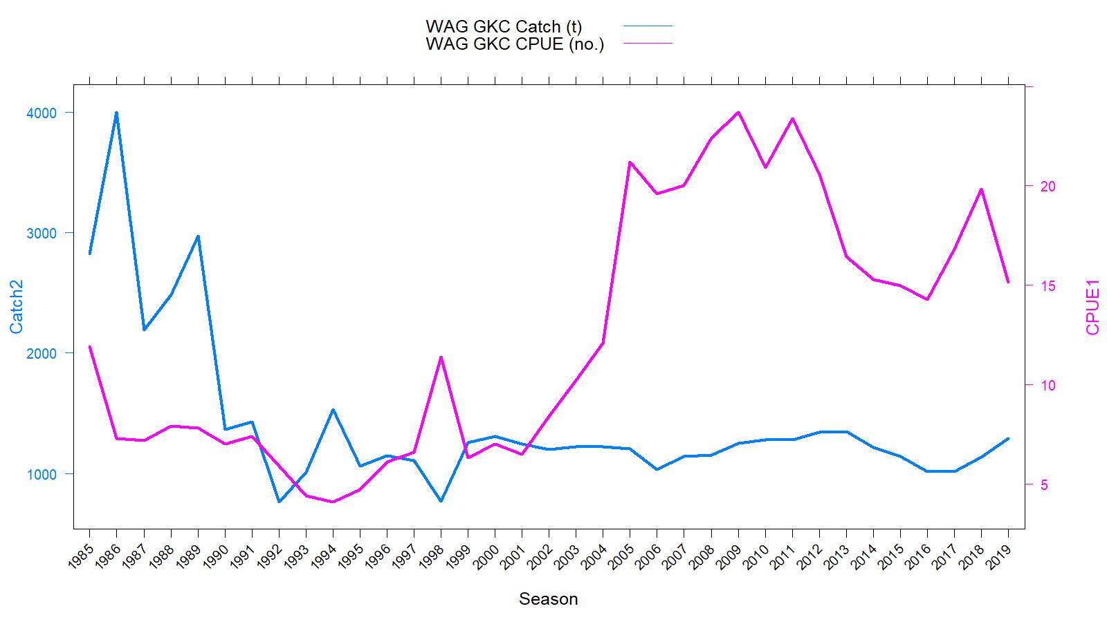
Figure 2. Historical commercial harvest (from fish tickets; metric tons) and catch-per-unit effort (CPUE, number of crabs per pot lift) of golden king crab in the WAG, 1985/86–2019/20 fisheries (note: 1985 refers to the 1985/86 fishing year).

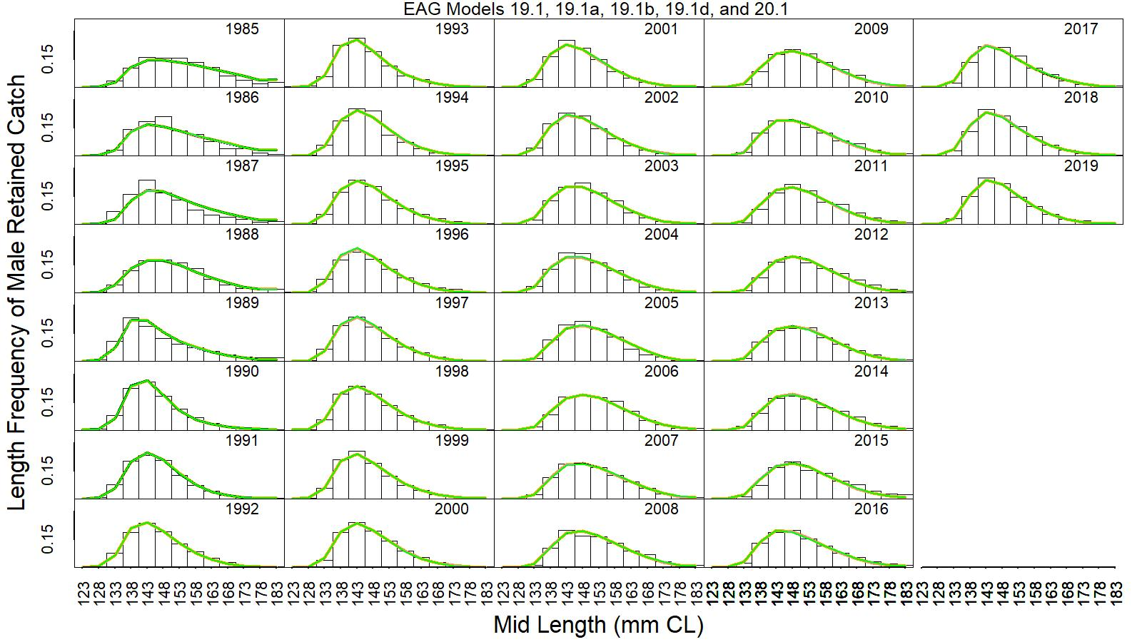
Figure 3. Predicted (line) vs. observed (bar) retained catch relative length frequency distributions for models 19.1 (orange line), 19.1a (black line), 19.1b (dark green line), 19.1d (violet line), and 20.1 (green line), for golden king crab in the EAG, 1985/86 to 2019/20. This color scheme is used in all other figures.

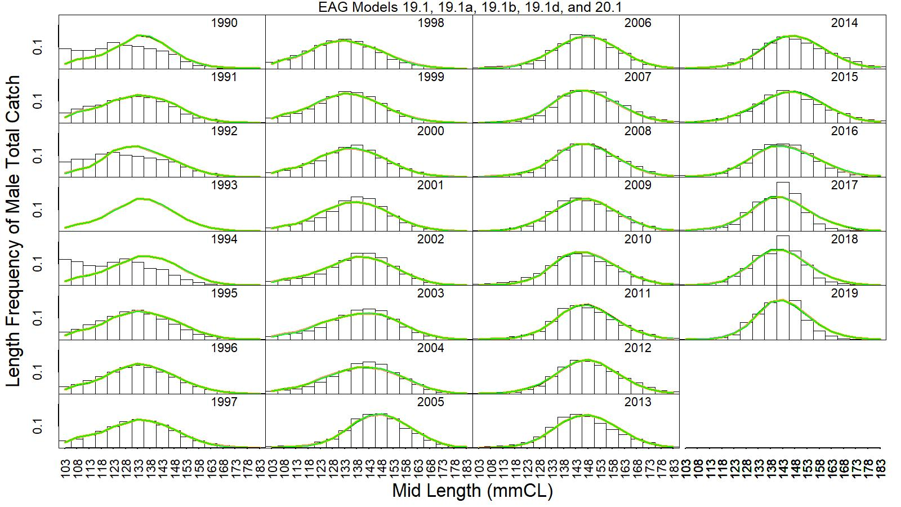
Figure 4. Predicted (line) vs. observed (bar) total catch relative length frequency distributions for models 19.1, 19.1a, 19.1b, 19.1d, and 20.1 for golden king crab in the EAG, 1990/91 to 2019/20.

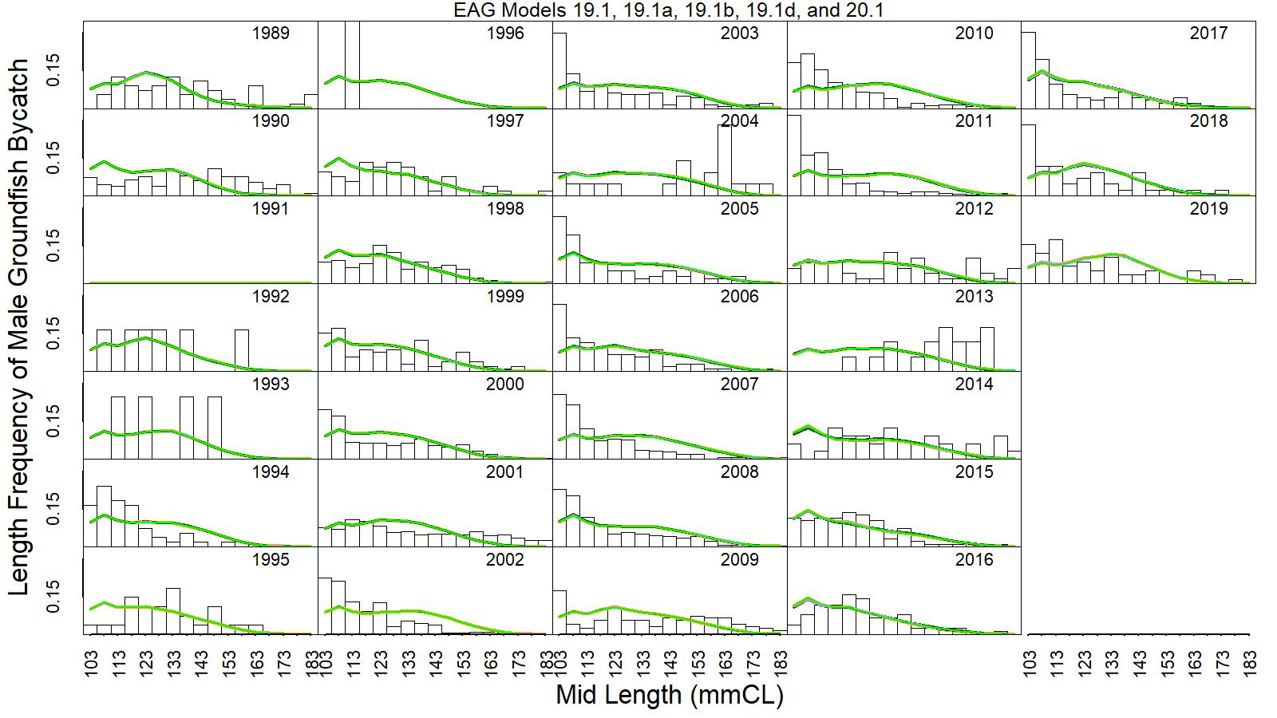

Figure 5. Predicted (line) vs. observed (bar) groundfish discard catch relative length frequency distributions for models 19.1, 19.1a, 19.1b, 19.1d, and 20.1 for golden king crab in the EAG, 1989/90 to 2019/20.

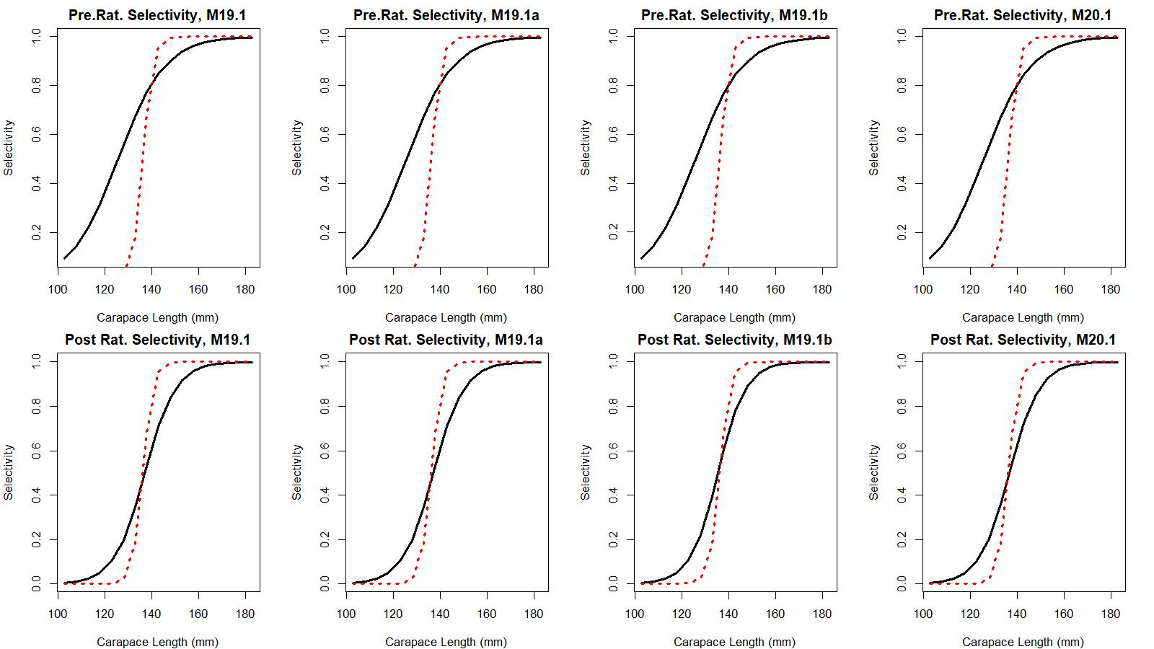
Figure 6. Estimated total (black solid line) and retained selectivity (red dotted line) for pre- and post- rationalization periods for models 19.1, 19.1a, 19.1b, and 20.1 fits to golden king crab data in the EAG.

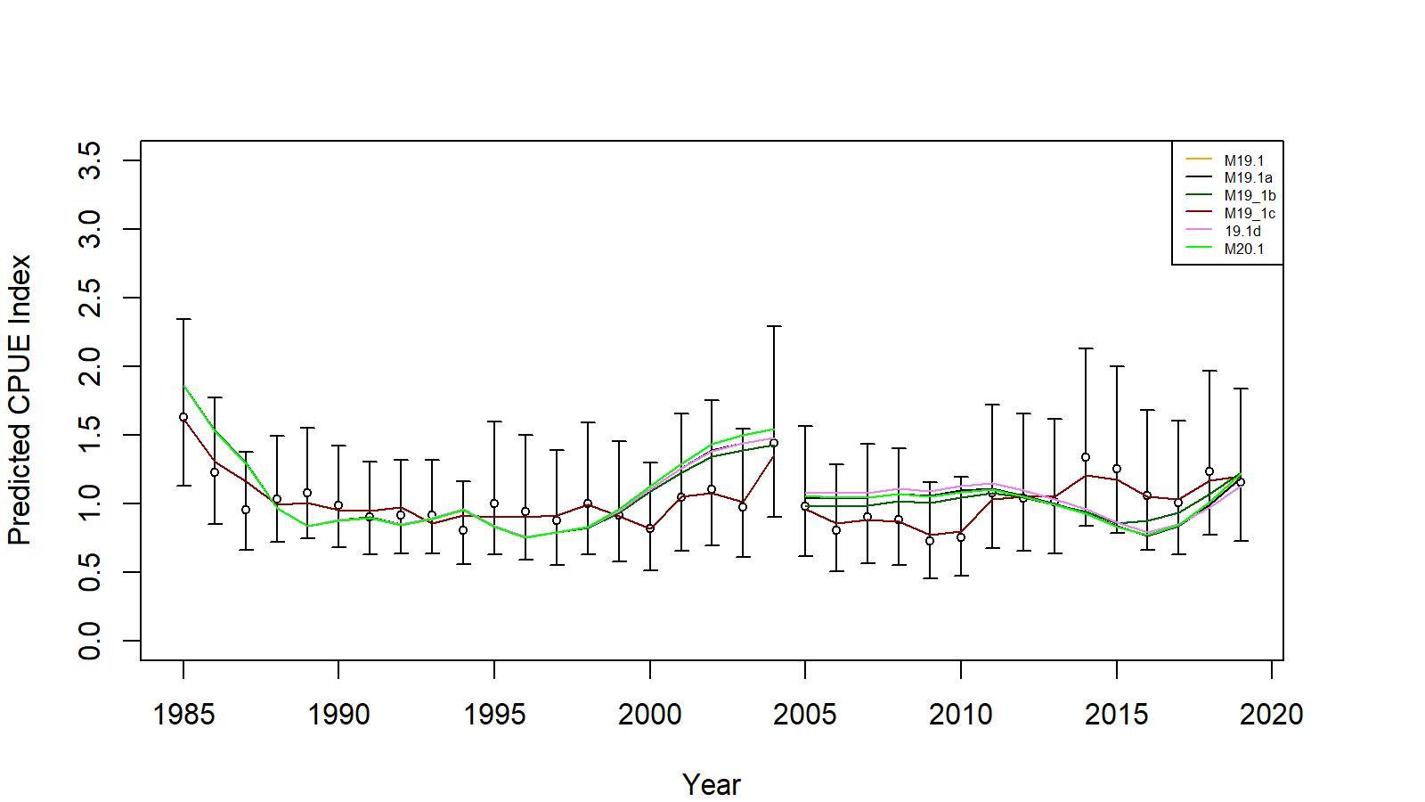
Figure 7. Comparison of input CPUE indices [with +/- 2 SE for model 19.1 (black open circles)] with predicted CPUE indices (colored solid lines) by 19.1, 19.1a, 19.1b, 19.1c (EAG Gmacs fit), 19.1d, and 20.1 model fits for EAG golden king crab data, 1985/86–2019/20. Model estimated additional standard error was added to each input standard error.

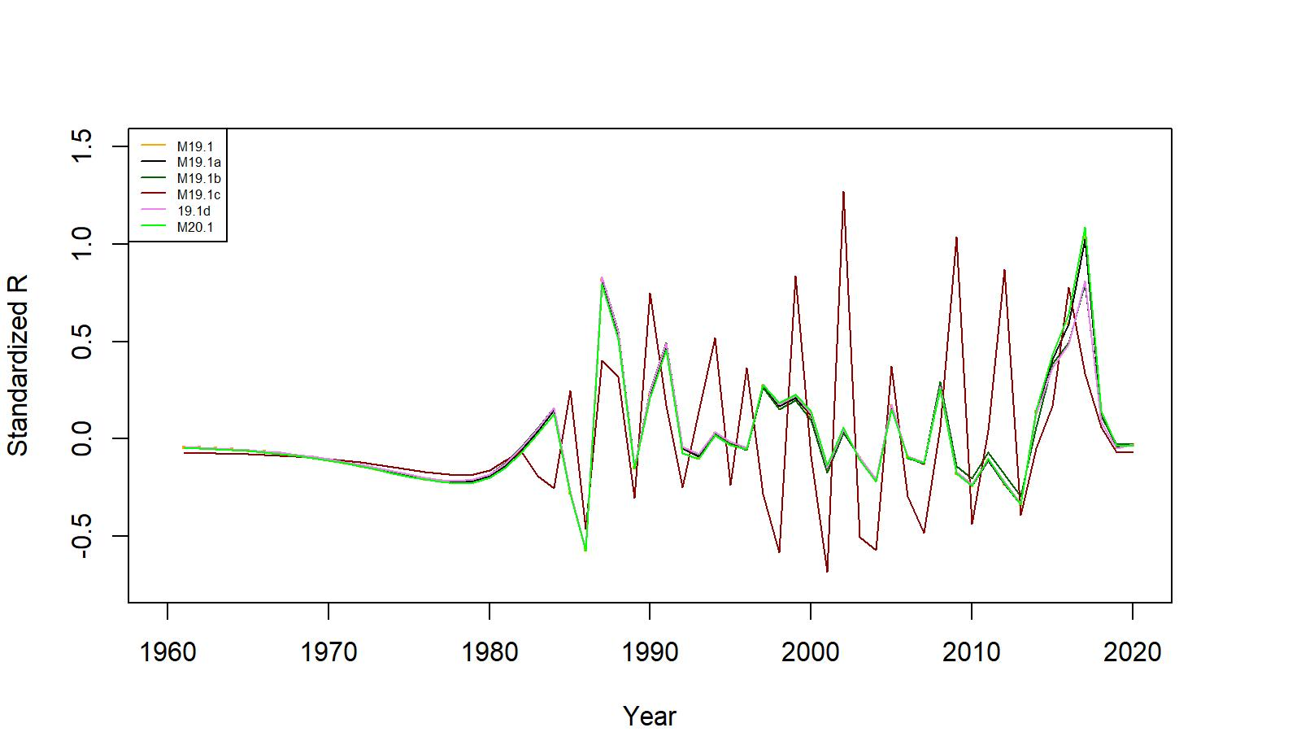
Figure 8. Estimated number of male recruits (crab size ≥ 101 mm CL) for 19.1, 19.1a, 19.1b, 19.1c (EAG Gmacs fit), 19.1d, and 20.1 model fits for EAG golden king crab data, 1961–2020. The number of recruits is standardized using (R-mean R)/mean R for comparing different models’ results.

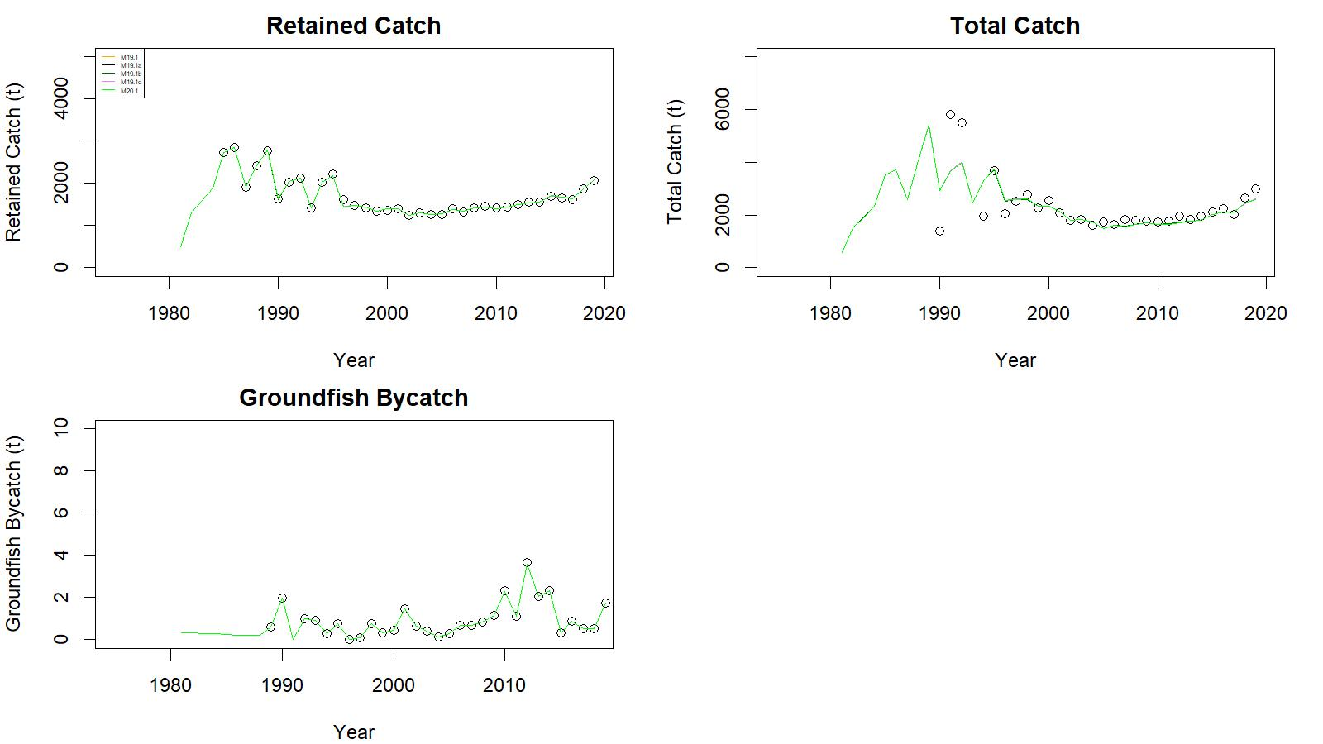
Figure 9. Observed (open circle) vs. predicted (solid line) retained catch (top left), total catch (top right), and groundfish bycatch (bottom left) of golden king crab for 19.1, 19.1a, 19.1b, 19.1d, and 20.1 model fits in EAG, 1981/82–2019/20.

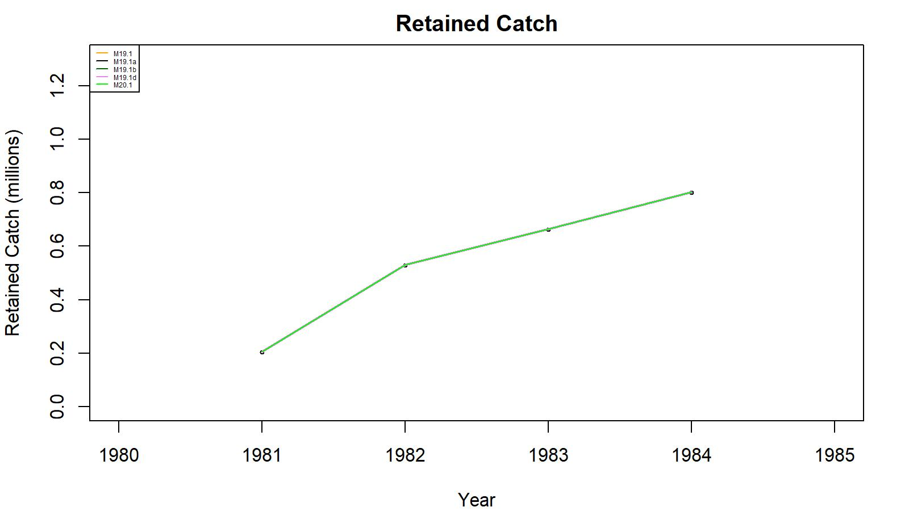
Figure 10. Observed (open circle) vs. predicted (solid line) retained catch of golden king crab for 19.1, 19.1a, 19.1b, 19.1d, and 20.1 model fits in EAG, 1981/82–1984/85. Note: Input retained catches to the model during pre-1985 fishery period was in number of crabs.

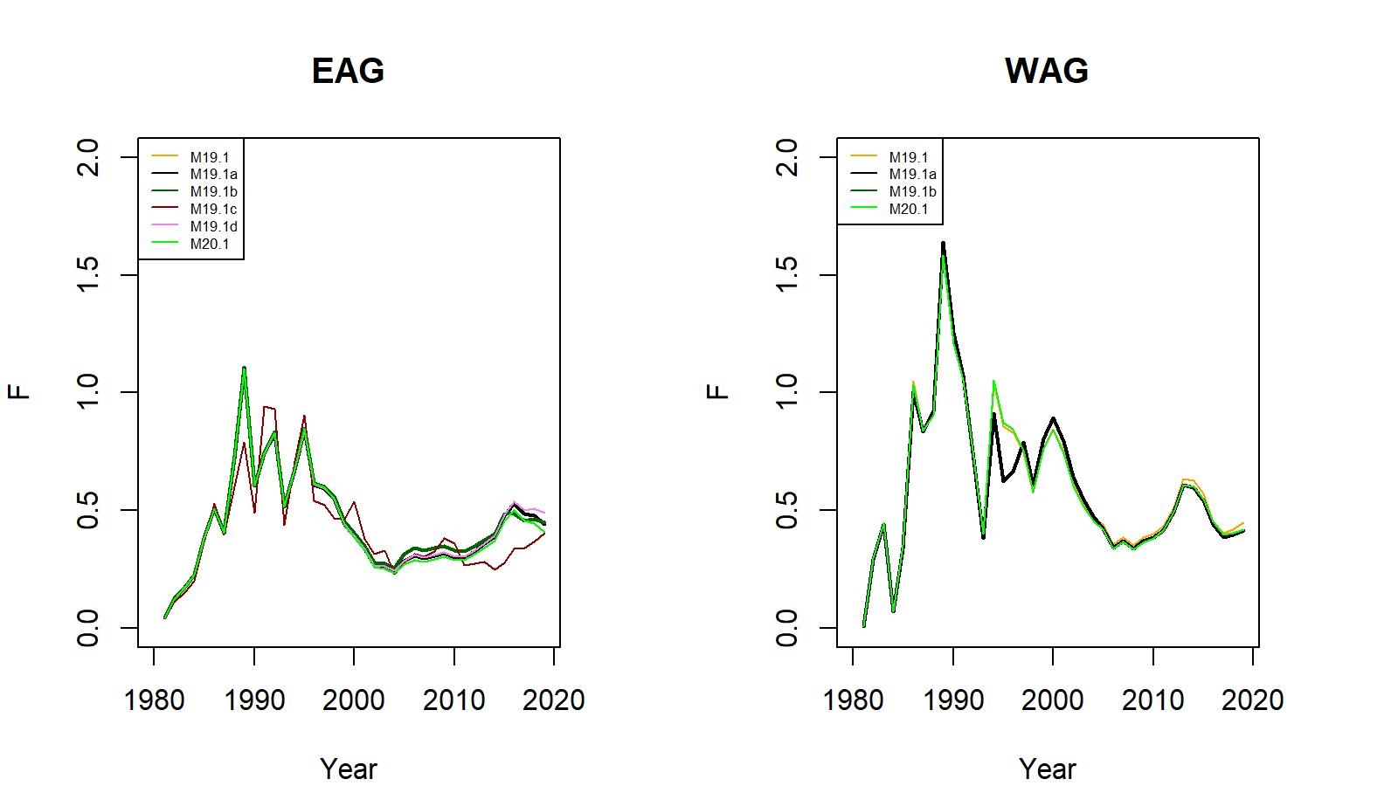
Figure 11. Trends in pot fishery full selection total fishing mortality of golden king crab for 19.1, 19.1a, 19.1b, 19.1c (EAG Gmacs fit), 19.1d, and 20.1 model fits to EAG (left) and for 19.1, 19.1a, 19.1b, and 20.1 model fits to WAG (right) data, 1981/82–2019/20.

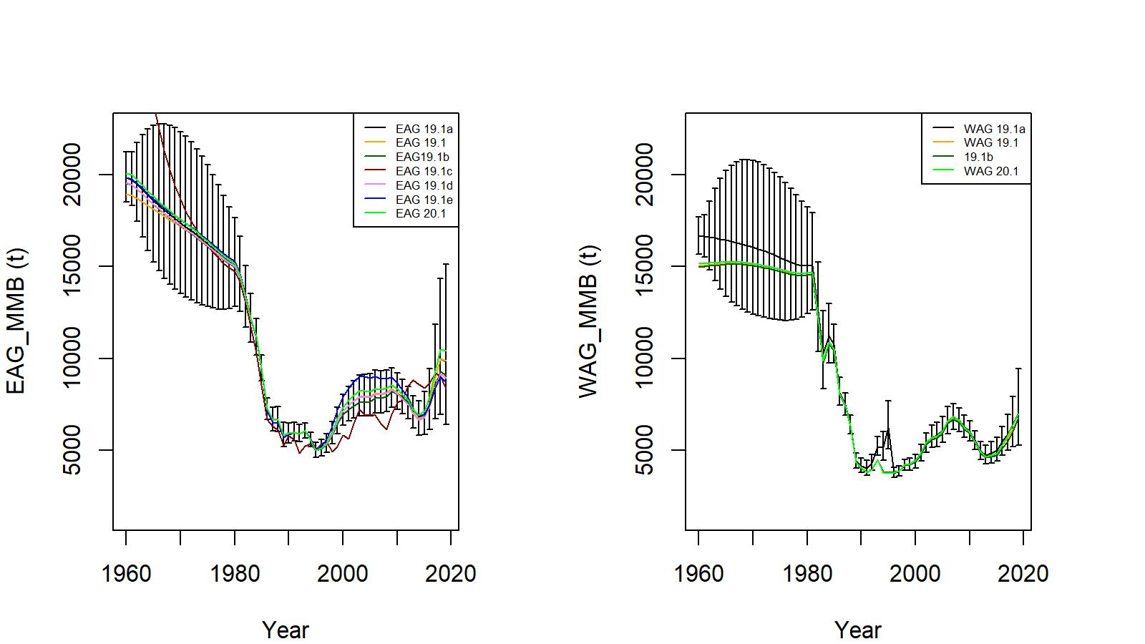
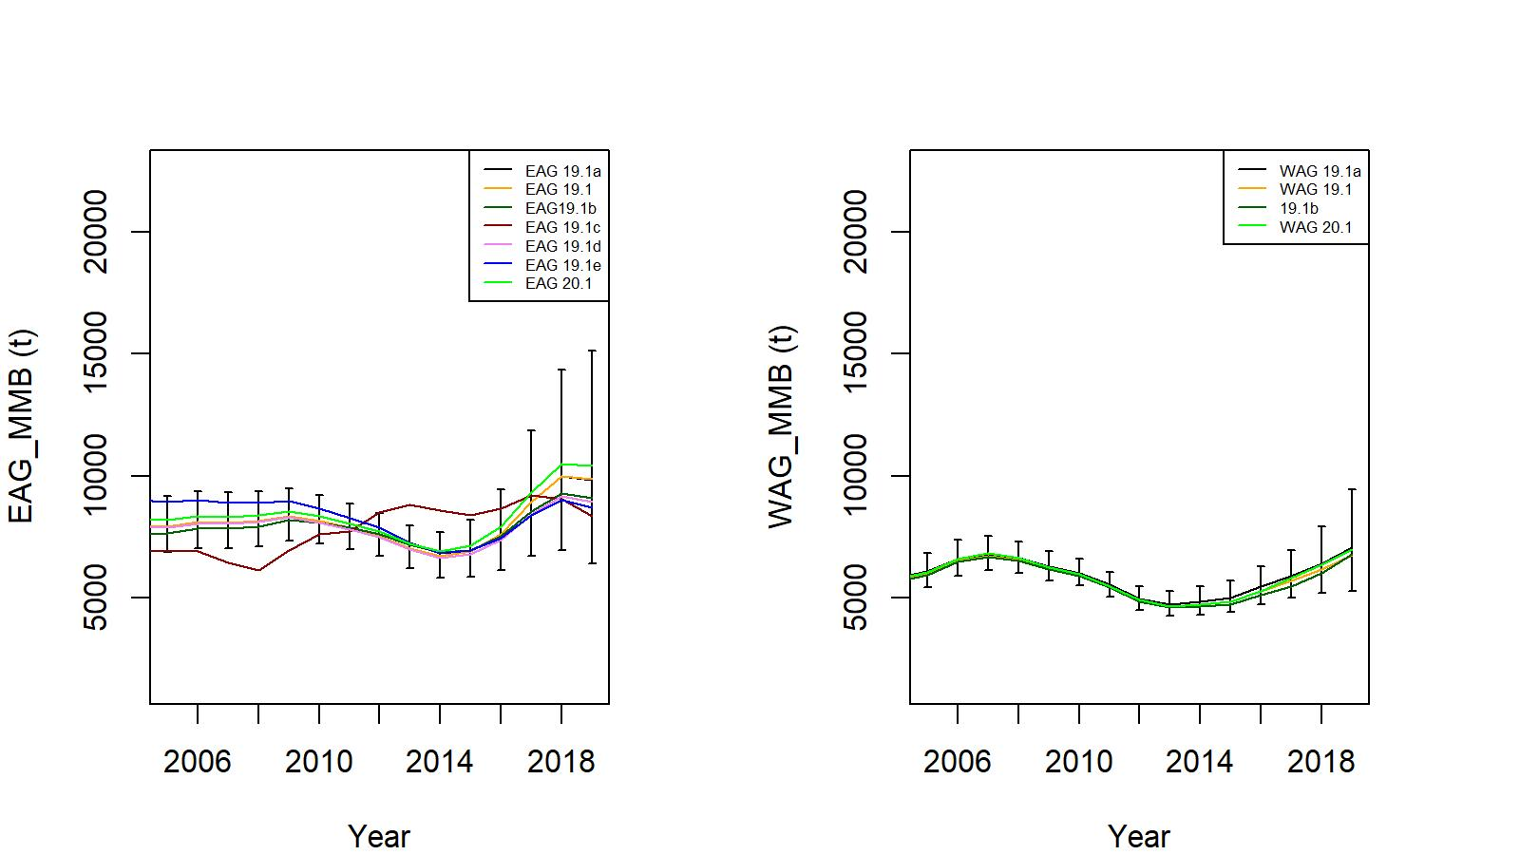
Figure 12. Trends in golden king crab mature male biomass for 19.1, 19.1a, 19.1b, 19.1c (EAG Gmacs fit), 19.1d, 19.1e, and 20.1 model fits to EAG (left) and WAG (right) data. Top panel: 1960/61–2019/20, bottom panel: 2005/06–2019/20. Model19.1a estimate has two standard error confidence limits.

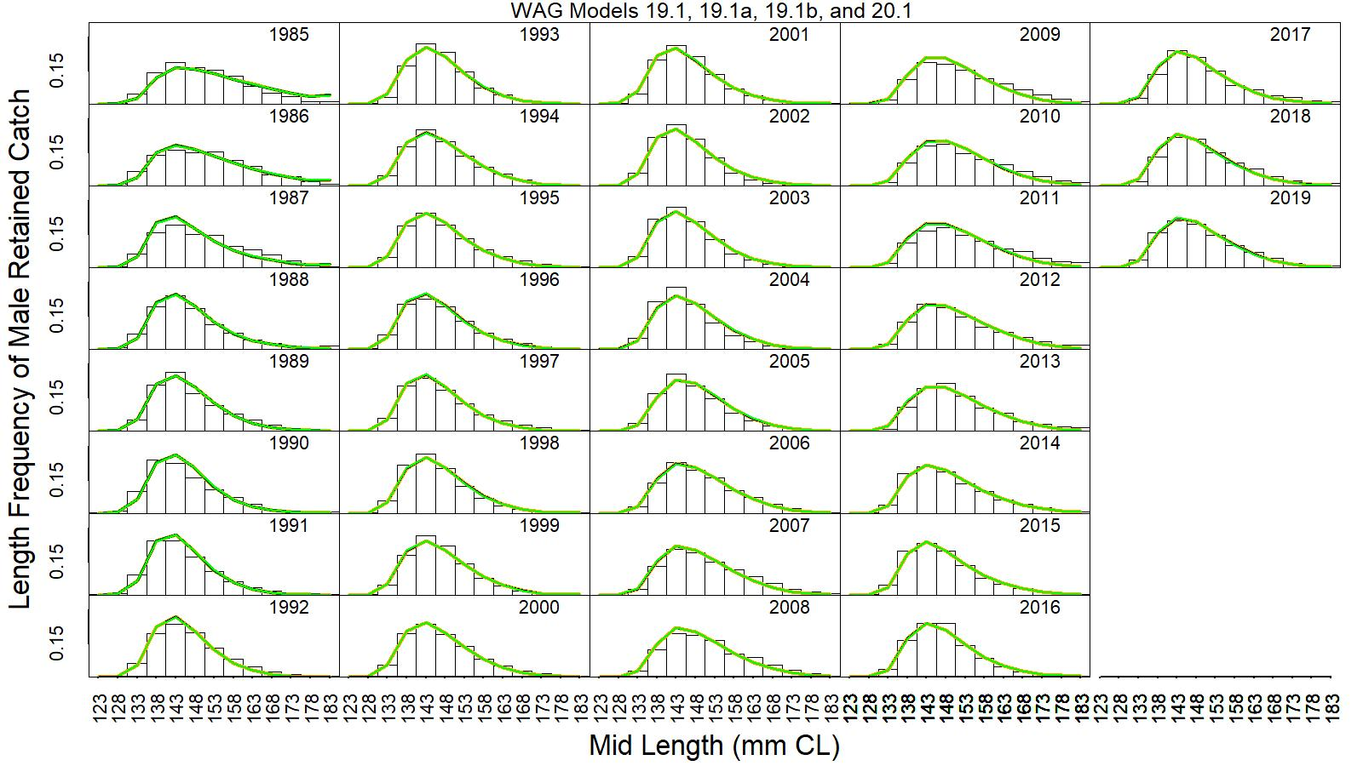

Figure 13. Predicted (line) vs. observed (bar) retained catch relative length frequency distributions for models 19.1 (orange line), 19.1a (black line), 19.1b (dark green line), and 20.1 (green line), for golden king crab in the WAG, 1985/86 to 2019/20. This color scheme is used in all other figures.

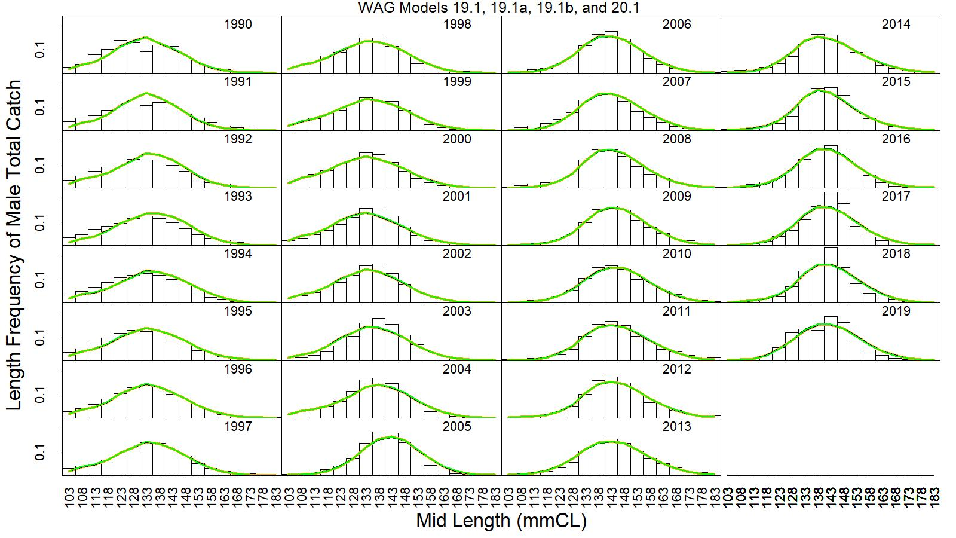
Figure 14. Predicted (line) vs. observed (bar) total catch relative length frequency distributions for models 19.1, 19.1a, 19.1b, and 20.1 for golden king crab in the WAG, 1990/91 to 2019/20.

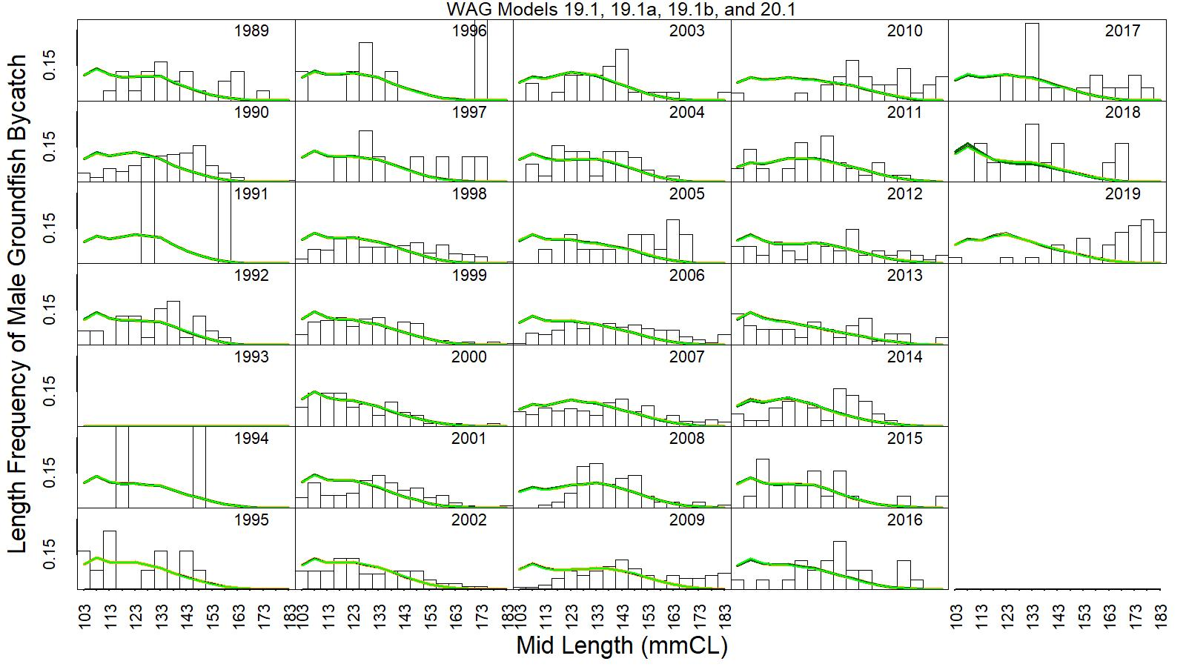
Figure 15. Predicted (line) vs. observed (bar) groundfish discard catch relative length frequency distributions for models 19.1, 19.1a, 19.1b, and 20.1 for golden king crab in the WAG, 1989/90 to 2019/20.

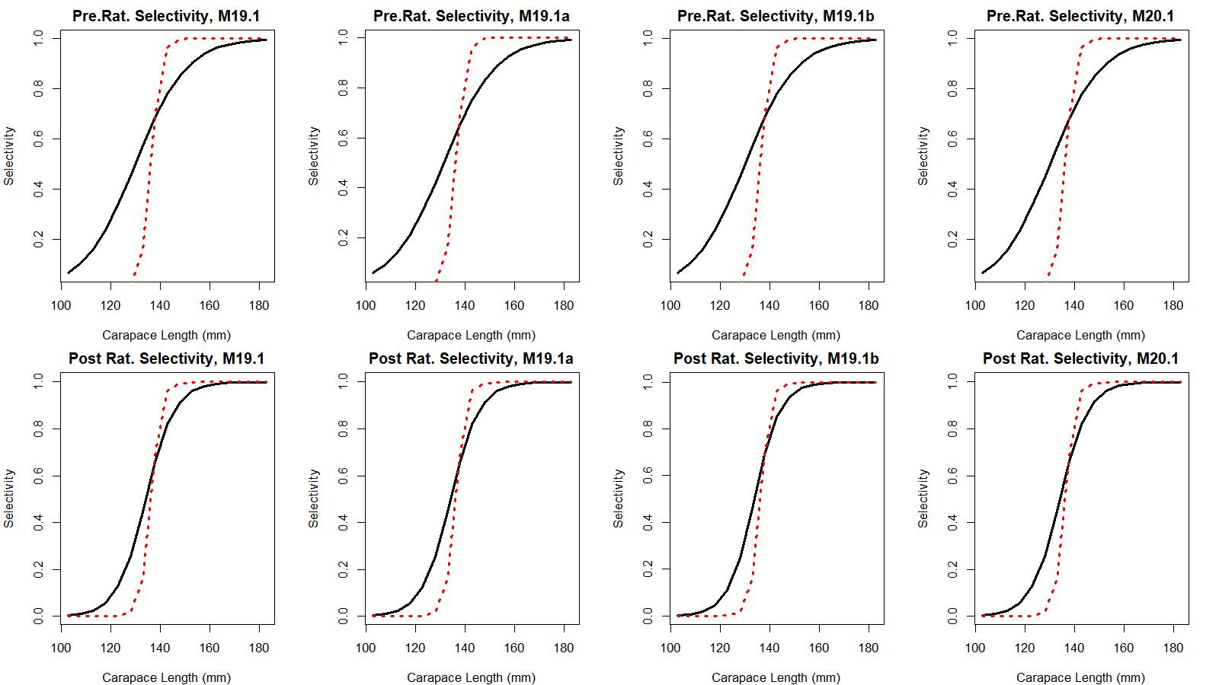

Figure 16. Estimated total (black solid line) and retained selectivity (red dotted line) for pre- and post- rationalization periods for models 19.1, 19.1a, 19.1b, and 20.1 fits to golden king crab data in the WAG.

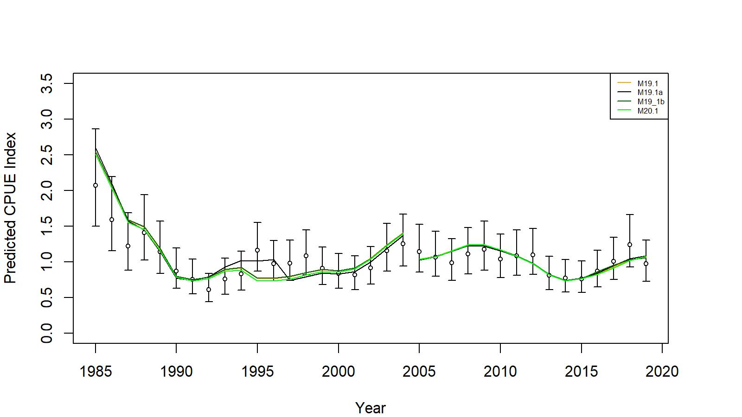
Figure 17. Comparison of input CPUE indices [with +/- 2 SE for model 19.1 (black circles)] with predicted CPUE indices (colored solid lines) by 19.1, 19.1a, 19.1b, and 20.1 model fits for WAG golden king crab data, 1985/86–2019/20. Model estimated additional standard error was added to each input standard error.

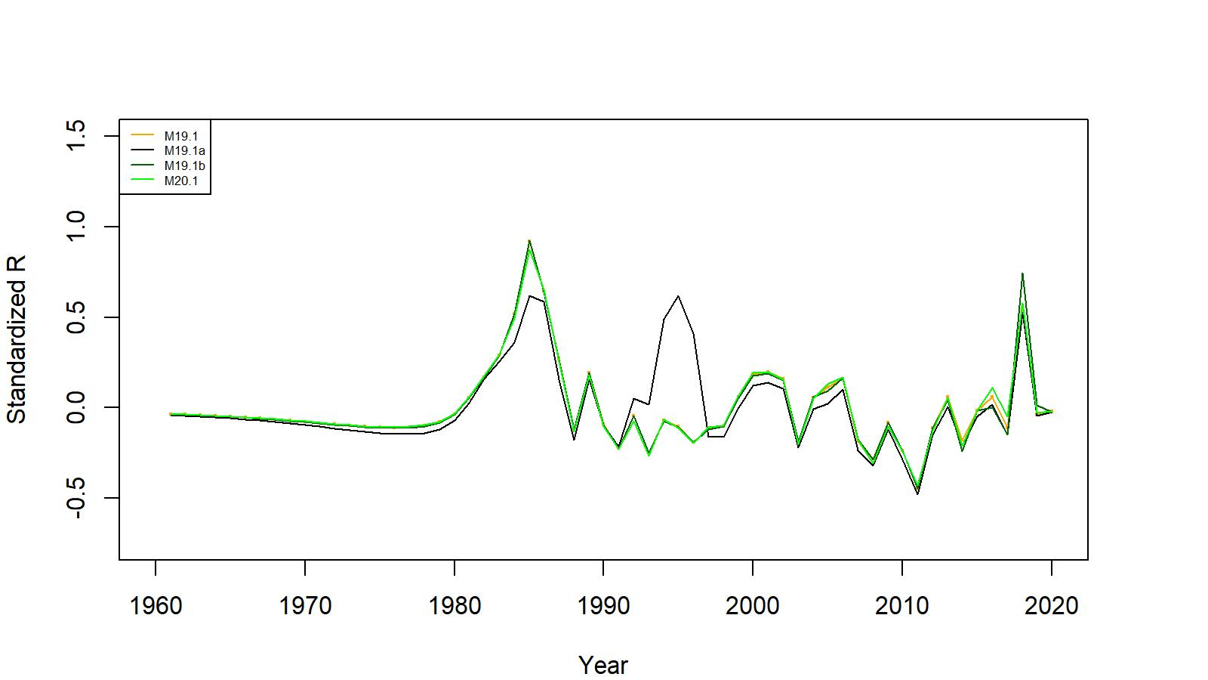
Figure 18. Estimated number of male recruits (crab size ≥ 101 mm CL) for 19.1, 19.1a, 19.1b, and 20.1 model fits for WAG golden king crab data, 1961–2020. The number of recruits is standardized using (R-mean R)/mean R for comparing different models’ results.

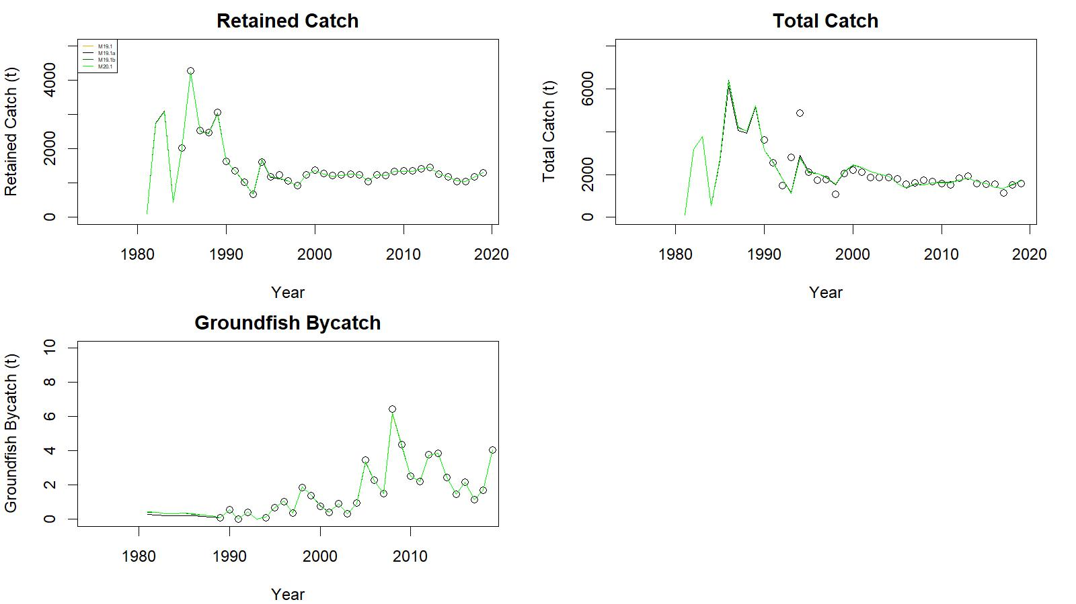
Figure 19. Observed (open circle) vs. predicted (solid line) retained catch (top left), total catch (top right), and groundfish bycatch (bottom left) of golden king crab for 19.1, 19.1a, 19.1b, and 20.1 model fits in WAG, 1981/82–2019/20.

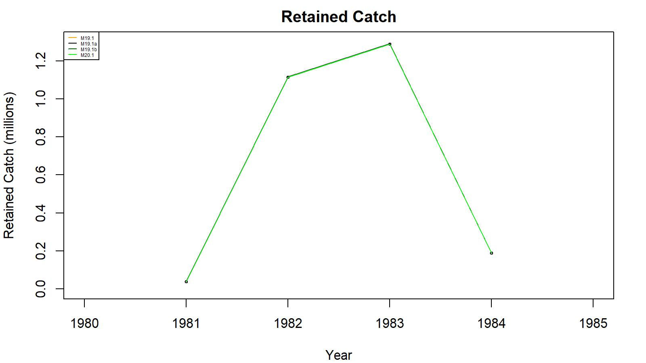
Figure 20. Observed (open circle) vs. predicted (solid line) retained catch of golden king crab for 19.1, 19.1a, 19.1b, and 20.1 model fits in WAG, 1981/82–1984/85. Note: Input retained catches to the model during pre-1985 fishery period was in number of crabs.

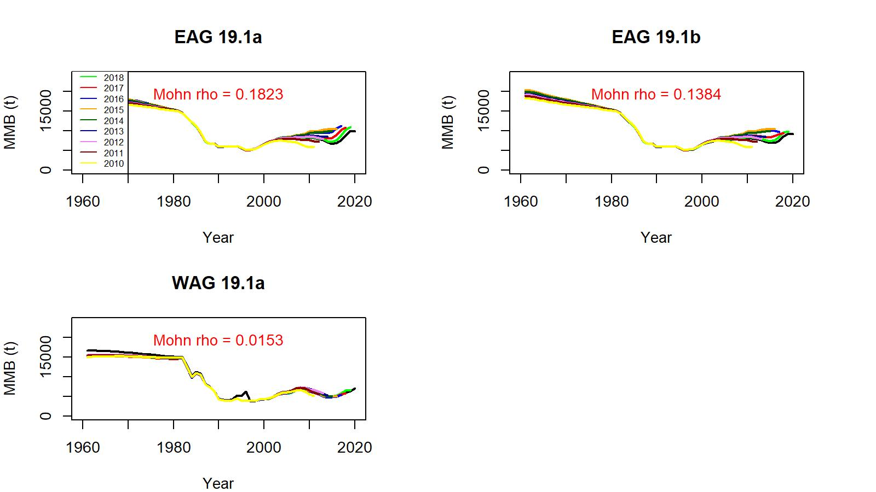
Figure 21. Comparison of 19.1a and 19.1b models’ retrospective fits for EAG and WAG.

Appendix A: CPUE standardization

This section is restricted to new analyses for standardization of observer, fisheries, and cooperative survey CPUE data. Siddeek et al. (2020) provides details of data preparation for catch, size composition, and CPUE computations.

All models used CPUE indices estimated by the hybrid method (i.e., initial selection of predictor variables by AIC followed by R² criterion (at least 0.01 increase in R² for inclusion of a new variable to already selected set of predictor variables) to select the final model. This section is subdivided into three parts:
- CPUE standardization of observer and commercial fisheries CPUE by GLM with non-interaction predictor variables.
- CPUE standardization of observer CPUE by GLM including Year:Area interaction term in the predictor variables.
- CPUE standardization of cooperative survey CPUE by a mixed random effects model.

We estimated two sets of CPUE indices for pre- and post- rationalization periods for models input.

Observer CPUE index by GLM:

  - Non-interaction GLM model:

The CPUE standardization followed the GLM fitting procedure (Maunder and Punt, 2004; Starr, 2012). We considered the negative binomial GLM on positive and zero catches to select the explanatory variables. The response variable CPUE is the observer sample catch record for a pot haul. The negative binomial model uses the log link function for the GLM fit.

For the non-interaction model, we assumed the null model to be

$\ln\left({CPUE}_{i}\right)={Year}_{y_{i}}$ (A.1)
where Year is a factorial variable.
The maximum set of model terms offered to the stepwise selection procedure was:

${ln⁡(CPUE}_{I}) ={Year}_{y_{i}}+ns\left({Soak}_{si},df\right)+{Month}_{m_{i}}+{Vessel}_{vi}+{Captain}_{ci}+{Area}_{ai}+{Gear}_{gi}+ns\left({Depth}_{di},df\right)$, (A.2)

where Soak is in unit of days and is numeric; Month, Area (Block) code, Vessel code, Captain code, and Gear code are factorial variables; Depth in fathom is a numeric variable; ns=cubic spline, and df = degree of freedom.

We used a log link function and a dispersion parameter (θ) in the GLM fitting process. We used the R² criterion for predictor variable selection.

We estimated the degrees of freedom and dispersion parameters by calculating AICs for a range of values and locating the best value at the minimum AIC (results are not shown but available with the first author).

Instead of using the traditional AIC (-2log_likelihood+2p), we used the Consistent Akaike
Information Criteria (CAIC) (Bozdogan 1987) {-2log_likelihood+[ln(n)+1]*p} for variable selection by StepAIC, where n=number of observations and p= number of parameters to be estimated. The number of selected variables were further reduced for parsimony, if feasible, by the R² criterion using the StepCPUE function, i.e., a hybrid selection procedure (Feenstra et al. 2019).

Example of R codes used for fixed effect GLM fitting are as follows:

For EAG 1995_04 CPUE indices:
library(MASS)
library(splines)
Step 1:
glm.object<- glm(Legals~Year,family = negative.binomial(1.38),data=datacore)
epotsampleoutAIC<-stepAIC(glm.object,scope=list(upper= ~(Year+ns(SoakDays,df=4)+Month+Vessel+Captain+Area+Gear+ns(Depth,df=9)),lower=~Year),family=negative.binomial(1.38),direction="forward",trace=9,k=log(nrow(datacore))+1.0)

Step 2:

glm.object<- glm(Legals~Year,family = negative.binomial(1.38),data=datacore)
epotsampleout<-stepCPUE(glm.object,scope=list(upper=~(Year+Gear+Captain+ns(SoakDays,df=4)+
Month+Area),lower=~Year),family=negative.binomial(1.38),direction="forward",trace=9,r2.change=0.01)

The final main effect models for EAG were:

Model 19.1:
Initial selection by stepAIC:
$\ln\left(CPUE\right)= Year+Gear+Captain+ns\left(Soak, 4\right)+Month+Block$
AIC=203808

Final selection by stepCPUE:
$\ln\left(CPUE\right)= Year+Gear+Captain+ns\left(Soak, 4\right)+Month$ (A.3)
for the 1995/96–2004/05 period [θ=1.38, $R^{2}=0.2204$]

Initial selection by stepAIC:
$\ln\left(CPUE\right)= Year+ Captain+Gear+ ns\left(Soak, 3\right)$
AIC=72633

Final selection by stepCPUE:
$\ln\left(CPUE\right)= Year+ Captain+ Gear+ns\left(Soak, 3\right)$ (A.4)
for the 2005/06–2019/20 period [$=2.32, R^{2}=0.1102$].

The final models for WAG were:

Model 19.1:
Initial selection by stepAIC:
$\ln\left(CPUE\right)= Year+Captain+ns\left(Soak, 7\right)+Gear+Area+Month+Vessel$
AIC=190945

Final selection by stepCPUE:
$\ln\left(CPUE\right)= Year+Captain+ns\left(Soak, 7\right)+Gear$ (A.5)
for the 1995/96–2004/05 period [θ=0.97, $R^{2}=0.1681$]

Initial selection by stepAIC:
$\ln\left(CPUE\right)= Year+Gear+Captain+ Month+ ns\left(Soak, 19\right)$
AIC=110148

Final selection by stepCPUE:
$\ln\left(CPUE\right)= Year+ Captain+Gear+ns\left(Soak, 19\right)$ (A.6)
for the 2005/06–2019/20 period [$=1.13, R^{2}=0.0706, Soak forced in$].

  - Year:Area interaction GLM:

For year and area interaction analysis, we designed the areas in to 1 nmi x 1 nmi grids enmeshed in 10 larger blocks (Figure A.1). The number of blocks was restricted to a small number of 10 to prevent GLM fitting problems.

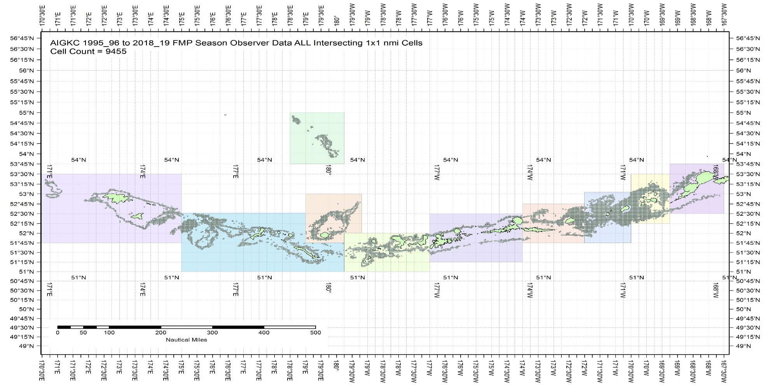

Figure A.1. The 1995/96 to 2019/20 observer pot samples enmeshed in 10 blocks for the Aleutian Islands golden king crab.
The blocks were determined from visually exploring each year’s pot distribution locations (available with the first author). The blocks contain observed patches of crab distribution during this time period.

Table A.1. Number of 1 nmi x 1 nmi grids containing observer sample locations within each block by fishing year for the Aleutian Islands golden king crab, 1995/96–2019/20 data. Blocks 1–4 belong to EAG and 5 – 10 to WAG. Sum of ever fished number of grids for each block is listed at the bottom row.
Year | Block_1 | Block_2 | Block_3 |  | Block_4 |  | Block_5 |  |  | Block_6 |  | Block_7 |  | Block_8 |  | Block_9 |  | Block_10
1995 | 125 | 529 | 748 |  | 379 |  | 218 |  |  | 373 |  | 112 |  | 722 |  | 166 |  | 122
1996 | 149 | 814 | 761 |  | 372 |  | 89 |  |  | 473 |  | 359 |  | 799 |  | 200 |  | 35
1997 | 116 | 530 | 755 |  | 257 |  | 202 |  |  | 443 |  | 104 |  | 568 |  | 274 |  | 0
1998 | 78 | 581 | 453 |  | 236 |  | 18 |  |  | 318 |  | 157 |  | 251 |  | 132 |  | 0
1999 | 123 | 593 | 454 |  | 231 |  | 163 |  |  | 476 |  | 182 |  | 627 |  | 193 |  | 145
2000 | 72 | 540 | 754 |  | 301 |  | 187 |  |  | 440 |  | 195 |  | 555 |  | 547 |  | 47
2001 | 123 | 507 | 507 |  | 329 |  | 45 |  |  | 369 |  | 288 |  | 634 |  | 256 |  | 9
2002 | 97 | 387 | 584 |  | 271 |  | 71 |  |  | 341 |  | 205 |  | 335 |  | 242 |  | 37
2003 | 43 | 492 | 530 |  | 299 |  | 111 |  |  | 347 |  | 212 |  | 465 |  | 150 |  | 61
2004 | 81 | 289 | 377 |  | 216 |  | 77 |  |  | 319 |  | 150 |  | 359 |  | 172 |  | 116
2005 | 0 | 205 | 221 |  | 118 |  | 8 |  |  | 220 |  | 83 |  | 261 |  | 54 |  | 0
2006 | 0 | 154 | 248 |  | 122 |  | 15 |  |  | 191 |  | 58 |  | 220 |  | 39 |  | 0
2007 | 0 | 111 | 177 |  | 110 |  | 24 |  |  | 228 |  | 78 |  | 173 |  | 20 |  | 0
2008 | 0 | 111 | 203 |  | 93 |  | 12 |  |  | 181 |  | 67 |  | 196 |  | 0 |  | 0
2009 | 0 | 59 | 146 |  | 60 |  | 6 |  |  | 137 |  | 95 |  | 220 |  | 25 |  | 0
2010 | 0 | 81 | 141 |  | 85 |  | 1 |  |  | 115 |  | 73 |  | 260 |  | 39 |  | 0
2011 | 0 | 126 | 117 |  | 33 |  | 3 |  |  | 83 |  | 73 |  | 266 |  | 9 |  | 0
2012 | 0 | 146 | 110 |  | 56 |  | 7 |  |  | 91 |  | 85 |  | 312 |  | 53 |  | 0
2013 | 2 | 149 | 129 |  | 51 |  | 12 |  |  | 144 |  | 105 |  | 293 |  | 86 |  | 0
2014 | 1 | 138 | 96 |  | 41 |  | 39 |  |  | 120 |  | 114 |  | 319 |  | 37 |  | 0
2015 | 0 | 135 | 147 |  | 61 |  | 46 |  |  | 163 |  | 106 |  | 280 |  | 16 |  | 48
2016 | 0 | 145 | 231 |  | 63 |  | 26 |  |  | 134 |  | 89 |  | 210 |  | 106 |  | 0
2017 | 0 | 97 | 170 |  | 110 |  | 11 |  |  | 87 |  | 79 |  | 198 |  | 118 |  | 0
2018 | 0 | 91 | 158 |  | 95 |  | 7 |  |  | 69 |  | 82 |  | 204 |  | 121 |  | 0
2019 | 1 | 112 | 171 |  | 101 |  | 0 |  |  | 0 |  | 89 |  | 316 |  | 138 |  | 0
 |  |  |  | Block_1 |  | Block_2 |  | Block_3 | Block_4 |  | Block_5 |  | Block_6 |  | Block_7 |  | Block_8 |  | Block_9 |  | Block_10
1995-2019 – Total number of 1x1 cells ever fished |  |  |  | 375 |  | 1363 |  | 1754 | 907 |  | 452 |  | 1026 |  | 777 |  | 1940 |  | 998 |  | 325

We assumed the null model to be

$\ln\left({CPUE}_{i}\right)={Year}_{y_{i}}$:Area_{ai} (A.7)

The maximum set of model terms offered to the stepwise selection procedure was:

${ln⁡(CPUE}_{I}) ={Year}_{y_{i}}:{Area}_{ai}+ns\left({Soak}_{si},df\right)+{Month}_{m_{i}}+{Vessel}_{vi}+{Captain}_{ci}+{Area}_{ai}+{Gear}_{gi}+ns\left({Depth}_{di},df\right)$. (A.8)

Example of R codes used for interaction effect GLM fitting are as follows:

For WAG 1995_04 CPUE indices:
library(MASS)
library(splines)
Step 1:
glm.object<- glm(Legals~Year:Area,family = negative.binomial(0.97),data=datacore)
wpotsampleoutAIC<-stepAIC(glm.object,scope=list(upper= ~(Year:Area+ns(SoakDays,df=7)+Month+Vessel+Captain+Gear+ns(Depth,df=10)), lower=~Year:Area),family= negative.binomial(0.97),direction="forward",trace=9,k=log(nrow(datacore))+1.0)

Step 2:

glm.object<- glm(Legals~Year:Area,family = negative.binomial(0.97),data=datacore)
wpotsampleout<-stepCPUE(glm.object,scope=list(upper= ~(Vessel+ns(SoakDays,df=7)+Gear+Month+Year:Area),lower=~Year:Area),family= negative.binomial(0.97),direction="forward",trace=9,r2.change=0.01)

The final interaction effect models for EAG were:

Model 20.1:
Initial selection by stepAIC:
$\ln\left(CPUE\right)= Gear+Captain+ns\left(Soak, 4\right)+Month+Year:Area$
AIC=203156

Final selection by stepCPUE:
$\ln\left(CPUE\right)= Gear+Captain+ns\left(Soak, 4\right)+Year:Area$ (A.9)
for the 1995/96–2004/05 period [θ=1.38, $R^{2}=0.2235$]

Initial selection by stepAIC:
$\ln\left(CPUE\right)= Vessel+Gear+ ns\left(Soak, 3\right)+Month+Year:Area$
AIC=72771

Final selection by stepCPUE:
$\ln\left(CPUE\right)= Vessel+Gear+ns\left(Soak, 3\right)+Year:Area$ (A.10)
for the 2005/06–2019/20 period [$=2.32, R^{2}=0.1212$].

The final interaction effect models for WAG were:

Model 20.1:
Initial selection by stepAIC:
$\ln\left(CPUE\right)= Vessel+ns\left(Soak, 7\right)+Gear+Month+Year:Area$
AIC=191060

Final selection by stepCPUE:
$\ln\left(CPUE\right)= Vessel+ns\left(Soak, 7\right)+Gear+Year:Area$ (A.11)
for the 1995/96–2004/05 period [θ=0.97, $R^{2}=0.1719$]

Initial selection by stepAIC:
$\ln\left(CPUE\right)= Gear+Vessel+Month+ Year:Area+ns(Soak, 19)$
AIC=110438

Final selection by stepCPUE:
$\ln\left(CPUE\right)=Gear+Month+Year:Area+ ns(Soak,19)$ (A.12)
for the 2005/06–2019/20 period [$=1.13, R^{2}=0.0866, Soak forced in$].

Steps:
- Block-scale analysis:

The estimate of the CPUE index in each Year-Area (Area=Block) was first obtained:
${CPUE}_{ij}= e^{{YB}_{ij}+ σ_{ij}^{2}/2}$ (A.13)

Where ${CPUE}_{ij}$ is the CPUE index in the ith year and jth block, ${YB}_{ij}$ is the coefficient of the ith year and jth block interaction, and $σ_{ij}$ is the biased correction standard error for expected CPUE value.

The number of 1 nmi x 1 nmi grids in each block can change from year to year; so, we considered using the total number of grids ever fished in a block, $N_{everj}$ [this is equivalent to assuming that the grids fished in any year randomly sample the stock in that block (see Campbell, 2004)].

The abundance index for jth block in ith year is

$B_{ij}= N_{{ever}_{j} }{CPUE}_{ij}$ (A.14)

As you noticed in Table A.1, no-observer samplings took place in certain years for some blocks. We filled the $B_{ij}$ index gaps as follows:

- Fit the following log-linear model,

$\hat{B_{i, j}}= e^{A_{i}+ C_{j}}$ (A.15)

where A_{i} is the factor estimate for year i, and Cj is the factor estimate for block j, where the A and C parameters are estimated from a log-linear regression of the biomass estimates on year and block (treated as factors).

- Used the fitted model to predict the biomass index for blocks x years with no (or very limited) data. Note that the input B_{ij} estimates were based on the existence of fishing effort, which implicitly considered a soak factor for CPUE standardization.

Annual biomass index,$B_{i}$ , was estimated as,
$B_{i}= \sum_{j}{B_{ij}}$ (A.16)

The variance of the total biomass index was computed as:

$Var \left(B_{i}\right)= \sum_{j}{{N_{ever, j}}^{2} var({CPUE}_{i, j})}$ (A.17)

where $N_{ever, j}$is the total number of 1 nmi x 1 mni cells ever fished in block j, and ${CPUE}_{i, j}$ is the CPUE index for year i and block j.

The variance for the final indices (Equation A.16) comes from two contributions: (a) the variance of the standardized CPUE values for years*blocks with data, and (b) those based on the above prediction formula (Equation A.15) for year*blocks with no or few data. Some B_{ij} predictions were negative and hence treated as zeros when estimating the overall B_{i} and its variance.

To compare with other model scenario predicted CPUE indices (Figures 7 for EAG and 17 for WAG), as well as to input into the assessment model 20.1 for EAG and WAG, we rescaled the $B_{i}$ indices by the geometric mean of estimated $B_{i}$ values separately for the pre- and post-rationalization periods. The corresponding standard error (~CV) of CPUE_{i} was estimated by

$\sqrt{\frac{Var(B_{i})}{{\left(B_{i}\right)}^{2}}}$ (A.18)
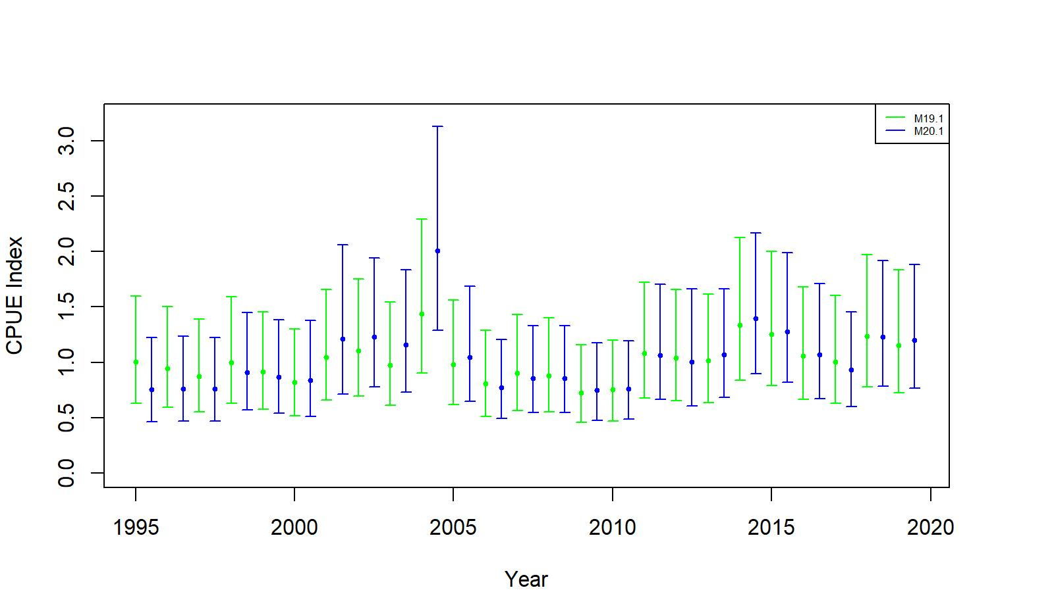
Figure A.2. Comparison of standardized (negative binomial GLM) CPUE indices with +/- 2 SE between no interaction (green, 19.1) and Year:Area interaction (blue, 20.1) models for golden king crab observer data from EAG. Model estimated additional standard error was added to SE.
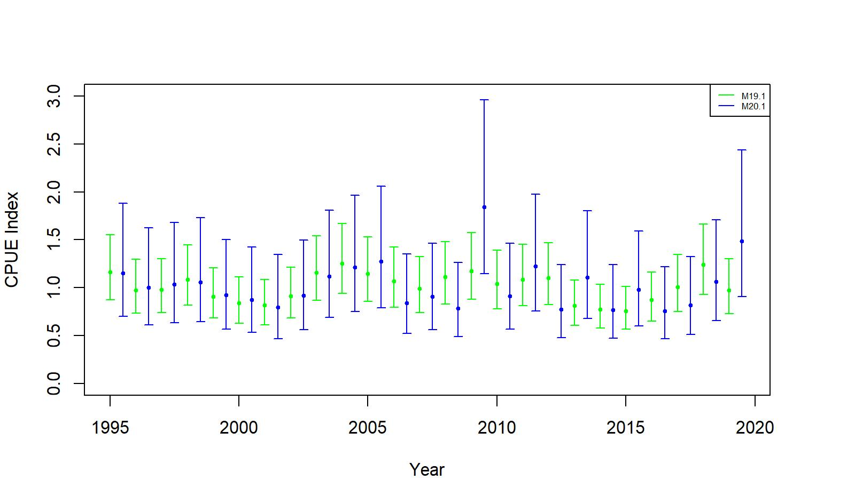
Figure A.3. Comparison of standardized (negative binomial GLM) CPUE indices with +/- 2 SE between no interaction (green, 19.1) and Year:Area interaction (blue, 20.1) models for golden king crab observer data from WAG. Model estimated additional standard error was added to SE.

- Commercial fishery CPUE index by non-interaction model:

We fitted negative binomial GLM models for fish ticket retained CPUE time series 1985/86 – 1998/99 offering Year, Month, Vessel, Captain, and Area as explanatory variables and applying the hybrid selection method. Reduced area resolution (grouped ADF&G code- AreaGP) was used for model fitting.

The final model under negative binomial error structure for EAG was:

Initial selection by stepAIC:
$\ln\left(CPUE\right)= Year+Vessel+Month$
AIC=16,997

Final selection by stepCPUE:
$\ln\left(CPUE\right)= Year+Vessel+Month$ (A.19)
for the 1985/86–1998/99 period [θ=10.45, $R^{2}=0.3328$]

and that for WAG was:

Initial selection by stepAIC:
$\ln\left(CPUE\right)= Year+Vessel+Area$
AIC=31,701

Final selection by stepCPUE:
$\ln\left(CPUE\right)= Year+Vessel+Area$ (A.20)
for the 1985/86–1998/99 period [θ=6.67, $R^{2}=0.3569$]

d. Cooperative Survey

1. Brief summary of the survey method

The ADF&G and industry collaborative pot survey was initiated in 2015 in the EAG and has continued since then. The survey was extended to WAG in 2018. A stratified two-stage sampling design has been implemented in a 2 nmi X 2 nmi grids within 1000 m depth covering the entire golden king crab fishing area. The 2 nmi x 2 nmi choice was the best compromise between scale of fishing gear, accuracy of defining habitat, and number of possible stations (Figure A.4).

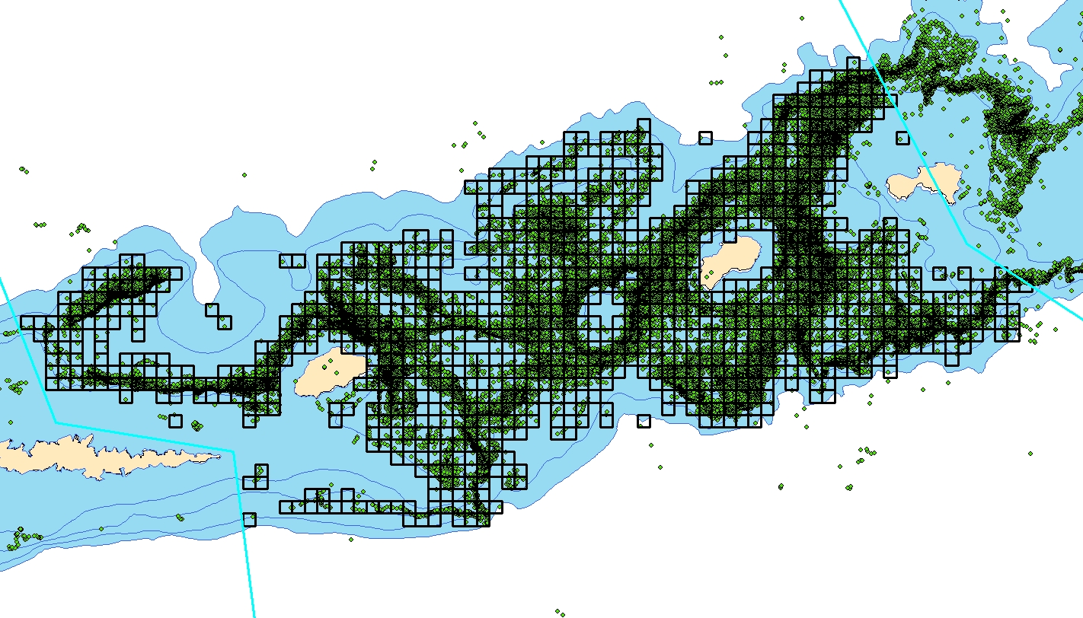

Figure A.4. Survey design: 2 nmi x 2 nmi grids overlaid on observer pot sample locations (green squares) in EAG.

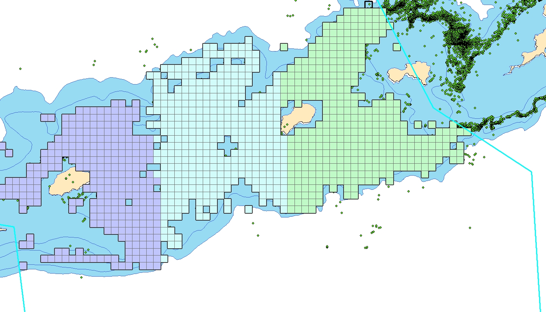
Figure A.5. Survey design: 2 nmi x 2 nmi grids stratified by three equal sizes for selecting random pot sampling locations in EAG.
There are nearly 1,100 grids in the EAG divided into three equal size strata for selecting random pot sampling locations (Figures A.5 and A.6).

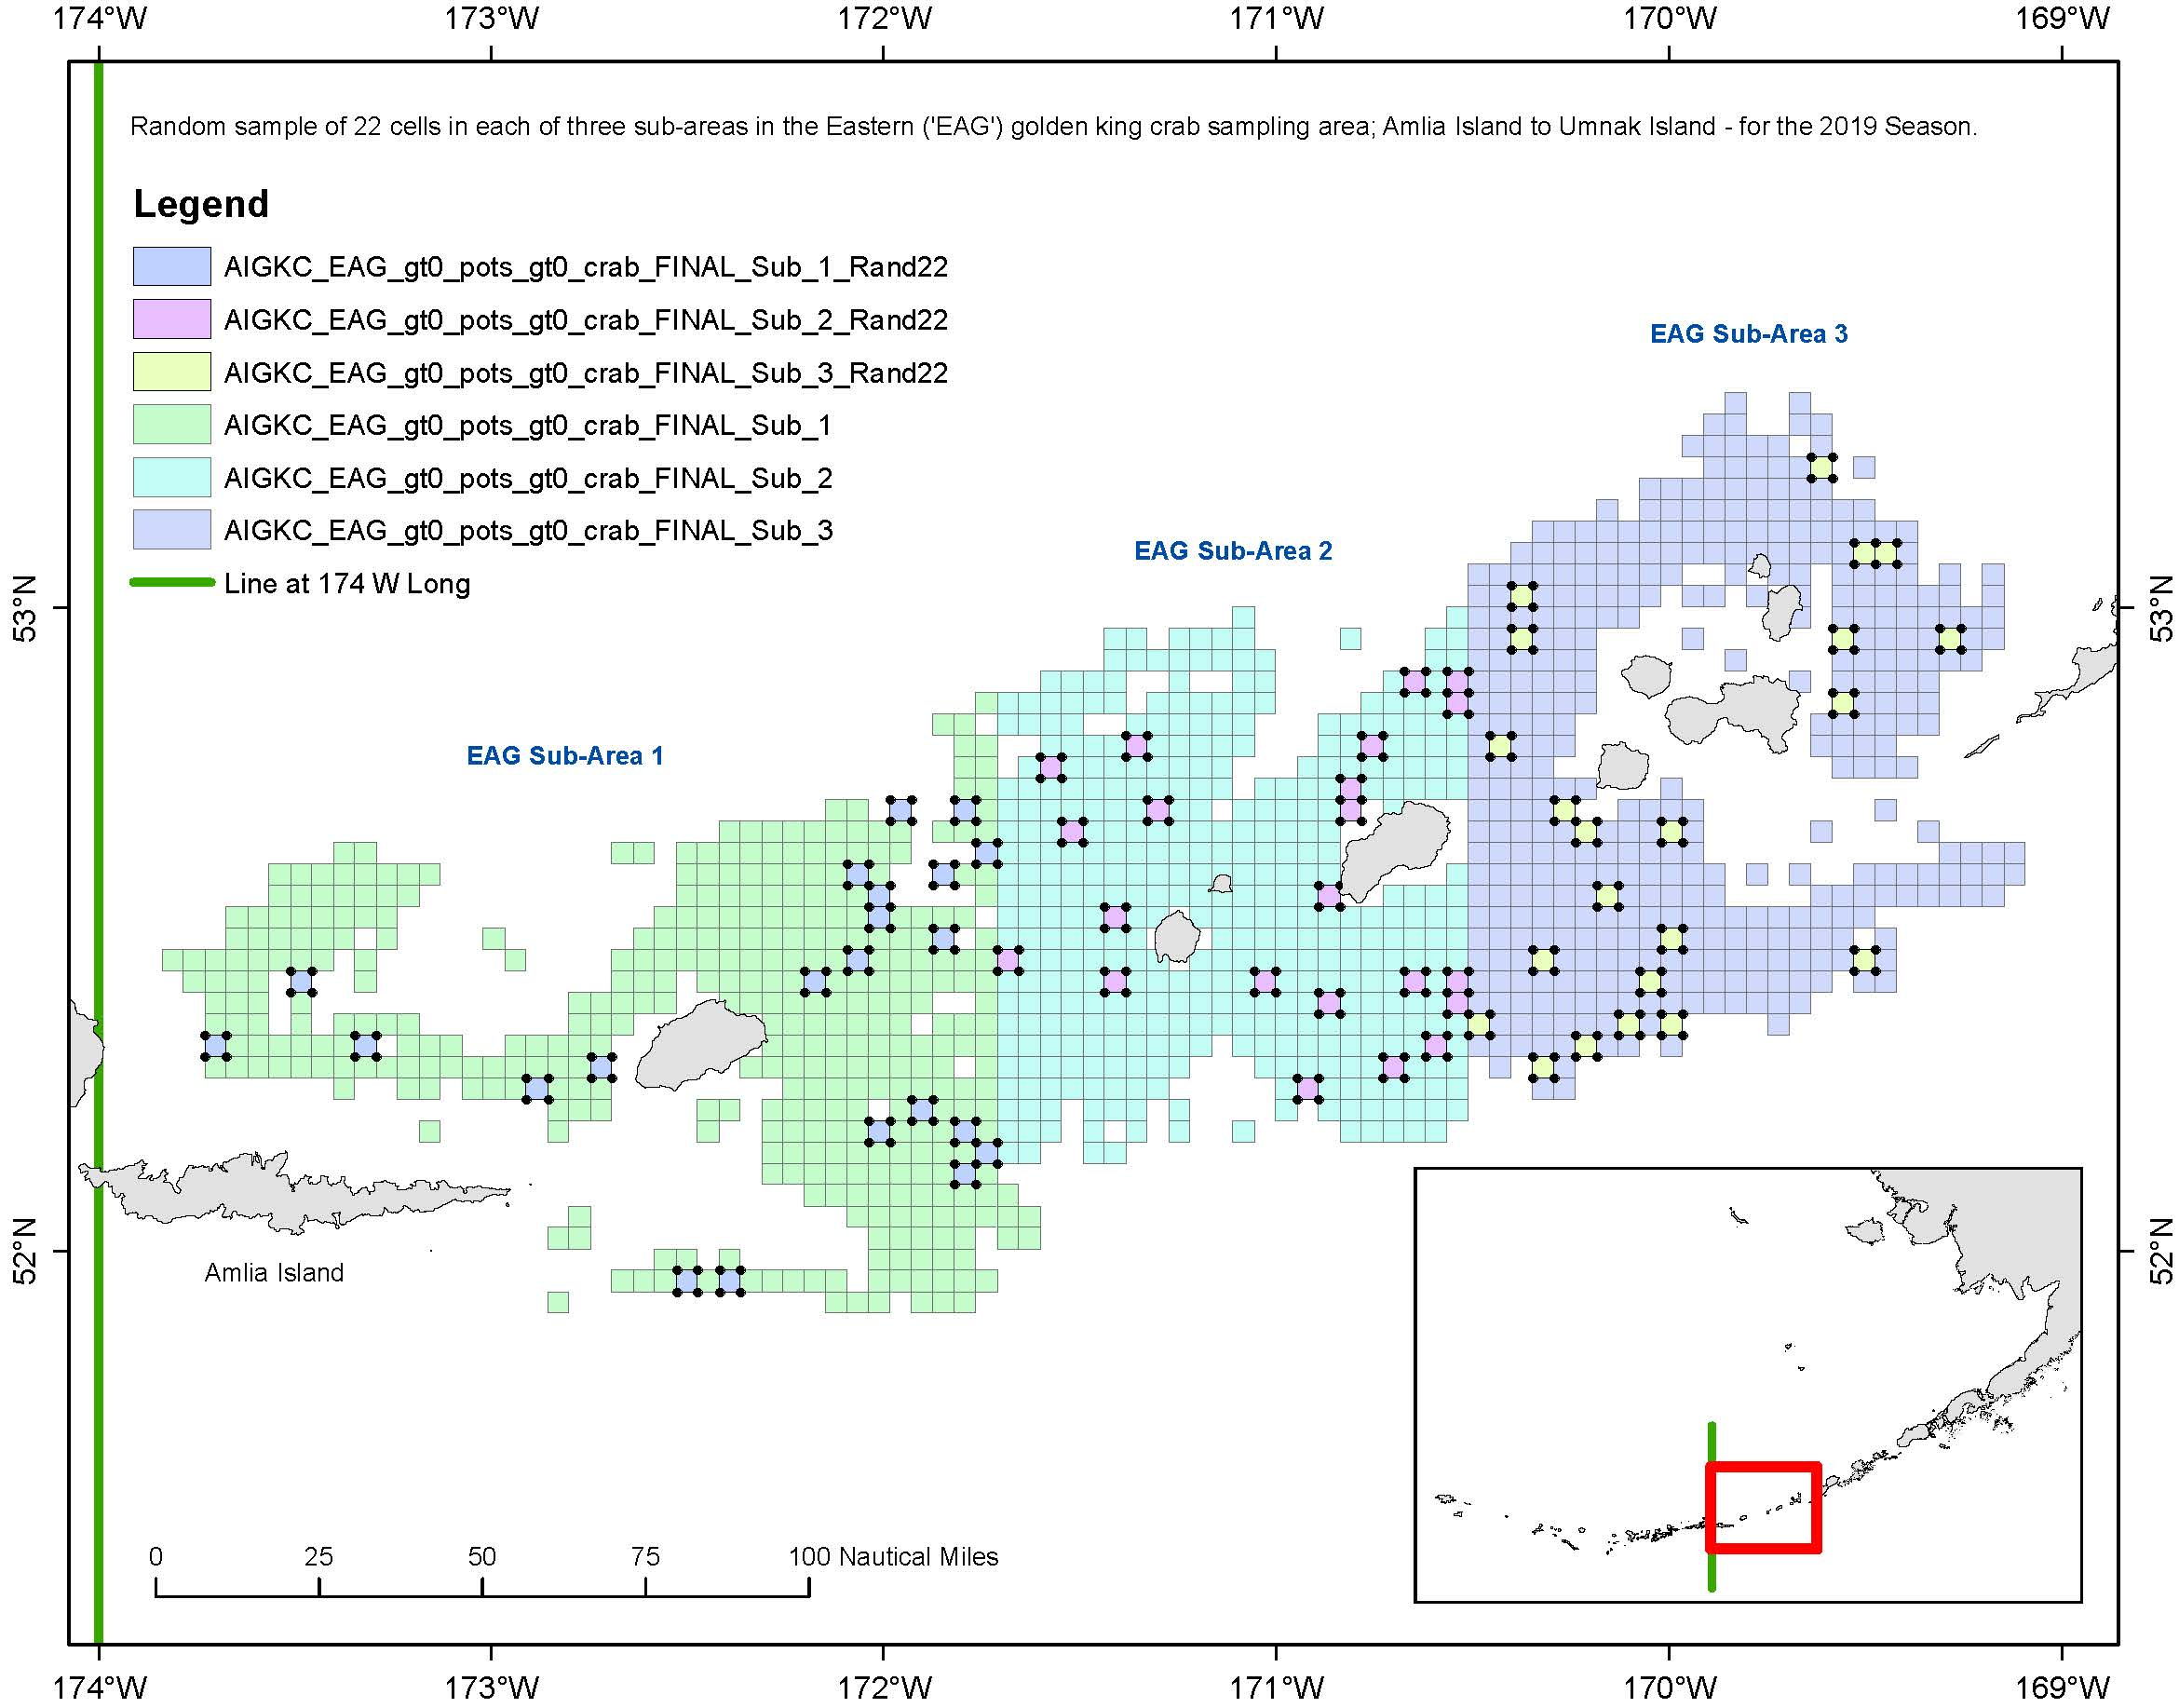

Figure A.6. Random sample of 22 cells selected in each of three sub strata in EAG during the 2019 fishery.

Survey occurs during the first month of each fishing season with one to two ADF&G biologists onboard the fishing vessel to collect fishery and biological data. Fishing operations take place in a randomly selected set of grids in each strata using longlined pots. The number of pots per string ranges from 30 to 40, 200 m apart, and a vessel carry on average 35 strings. Pot sizes range from 5.5 ft x 5.5 ft to 7 ft x 7 ft with large mesh sizes for retention of legal king crab. A few small-mesh research pots are also deployed for special studies. The fishing operation is not standardized for depth or soak time to allow normal fishing practices.

There are multiple pots (typically about 5 pots) sampled for each longline string with approximately 35 crab sampled per pot. For example, if 100 crab are caught in a sampled pot, the biologist samples every third crab. An example of the data collected is shown below. Work on size composition plots and CPUE by size, year, and area is still ongoing at this time.

fishery | year | vessel | skipper | String# | pot_size | mesh_size | bait | subsample_rate | species_code | sex | size | legal
EAG | 2015 | 20556 | Chad_Hoefer | 1 | 5x5 | king(large) | halibut | 2 | 923 | 1 | 187 | 1

Pot# | date_in | time_in | depth_start | start_lat | start_lon | depth_out | end_lat | end_lon | date_out | time_out | comments | soak_time
1 | 8/4/2015 | 17:00 | 132 | 52.74133 | -170.692 | 133 | 52.7515 | -170.675 | 8/17/2015 | 3:00 |  | 12.41667

Standardization of cooperative survey CPUE by mixed random effects model:

A unique property of the cooperative survey is that multiple pots from multiple strings are sampled. All sample measurements are from the EAG, except for 2018 and 2019 when measurements were also taken from WAG. The CPT and SSC suggested to use the random effects model to standardize the survey CPUE data.

Data:
There are 27,255 records from five years (2015–2019) of cooperative surveys.

Data preparation for CPUE standardization:
- Created two new columns by concatenating Vessel Code with String# as well as with String and Pot# because String# and Pot# are not unique numbers to each vessel. The new column names were identified as VesString and VesStingPot.
For example, a Vessel Code 20556 with a String# 3 was concatenated to be 205563 in a new column VesString, and a Vessel Code 20556 with a String#17 and a Pot# 5 was concatenated to be 20556175 in a new column VesStringPot.
- Raised the Catch in each record by the Sample Rate.
- Subset the data by large mesh king crab pot [Mesh ID not equal to 2 (i.e., small mesh pot)], legal size (> 135 mm CL), and EAG (EAGWAG=1). The female (Sex=2) catch without any male (Sex=1) in a crab pot was set to 0 to account for the possibility of zero catch for expected CPUE determination.
- Further subset the data by 5% to 95%, trimmed Soak time, and 1% to 99% trimmed Depth. This is to exclude catches from any unusual pot operations.
- Summed up the catch across sizes for each Pot# and labelled it as SumCatch. Thus, each Pot# has a single catch number.

The mixed random effects model considered a random intercept procedure with the following initial model formulation:

Sum Catch = Y+ns(Soak,df=3)+ns(Depth, df=10)+(1|Vessel/VesStringPot)+(1|Block/String)

We used the “lme4” library in R (version 3.5.1, R Core Team, 2018) with the “glmer()” function to fit the mixed random effects model. The glmer() function allows us to use any type of error model (we used the negative binomial model with the dispersion parameter value of 2.32) to fit the data. The initial model resulted in a singular fit (i.e., Vessel and VesStringPot:Vessel group variances were (very close to) zero):

Groups Name Variance Std.Dev.
VesStringPot:Vessel (Intercept) 4.537e-16 2.130e-08
VesString:Block (Intercept) 3.568e-01 5.974e-01
Block (Intercept) 5.949e-04 2.439e-02
Vessel (Intercept) 0.000e+00 0.000e+00

Therefore we used the following model formulation:

Sum Catch = Y+ns(Soak,df=3)+ns(Depth, df=10)+(1|Block/String)

library(MASS)
library(splines)
library(Matrix)
library(lme4)
best.lmefit<- glmer(SumCatch~ Year+ns(SoakDays, df=3)+ns(Depth, df=10)+(1|Block/VesString), family = negative.binomial(2.32),
control=glmerControl(optimizer="bobyqa", optCtrl=list(maxfun=100000)), data=eSurvey15_19Subtrim)

where Sum Catch= observed CPUE, best.lmefit = expected CPUE. Year, SoakDays and Depth are fixed effect variables. The fixed effect variables were selected from fit of a fixed effect model on the survey data. The dispersion parameter value for the negative binomial error model and the degrees of freedom for cubic splines were borrowed from the observer final GLM model estimate for EAG for the post rationalization period.

The QQ plot for the fit assured model assumptions were correct (Figure A.7).

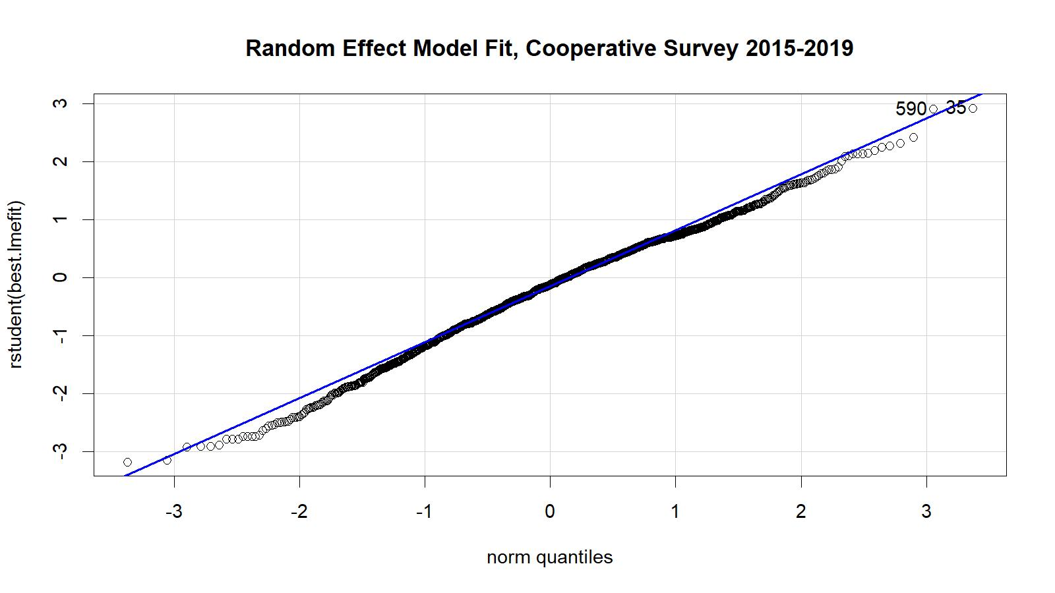

Figure A.7. Studentized residual plot for the mixed random effects model fit using the 2015–2019 EAG data.

Comparison of standardized CPUE from cooperative survey data (2015–19) for EAG and the corresponding years’ observer CPUE indices indicated similar pattern except for 2019 (Figure A.8).

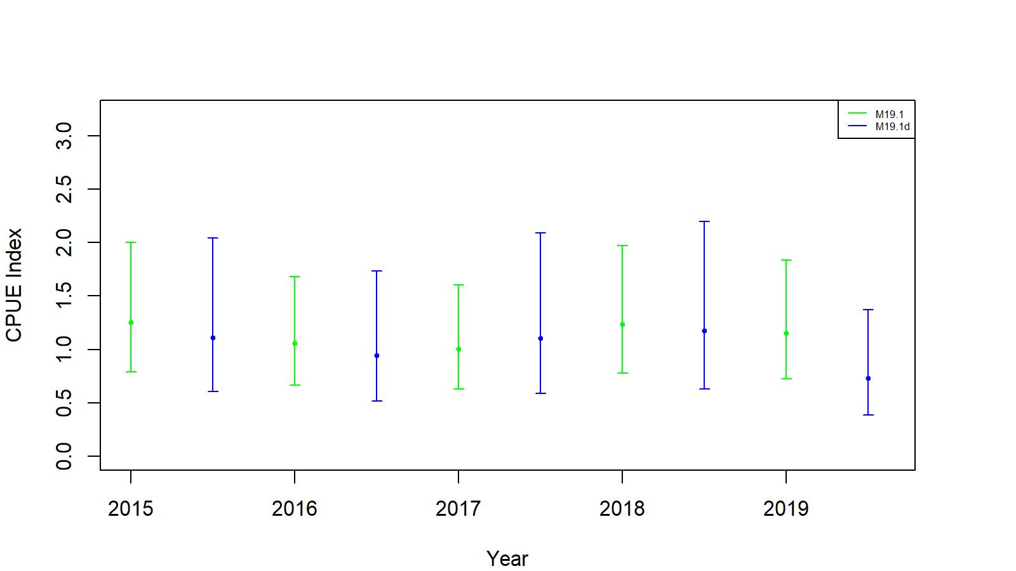
Figure A.8. Comparison of cooperative survey model CPUE indices (blue, 19.1d) and observer non interaction factor model CPUE indices (green, 19.1). The confidence limits are determined with ±2SE. Model estimated additional standard error was added to SE.

We standardized the yearly mean of predicted survey CPUEs for 2015–2019 by the geometric mean to obtain the CPUE indices for input to the assessment models (19.1d and 19.1e) (Table A.2).

Table A.2. The cooperative survey predicted legal male standardized (by geometric mean) CPUE indices by the mixed random effects model, standard errors (SE), and lower- and upper- 95% confidence limits with added model estimated additional standard error for EAG, 2015–2019 data.

Year | Predicted CPUE index | SE | Lower Limit | Upper Limit | Sample size
2015 | 1.11164 | 0.02666 | 0.60593 | 2.03943 | 335
2016 | 0.94664 | 0.02656 | 0.51610 | 1.73636 | 304
2017 | 1.10698 | 0.04148 | 0.58576 | 2.09199 | 206
2018 | 1.17588 | 0.03565 | 0.62952 | 2.19642 | 199
2019 | 0.73004 | 0.03749 | 0.38940 | 1.36867 | 289

Appendix B: Jittering

Jittering of model 19.1b parameter estimates:

We followed the Stock Synthesis approach to do 100 jitter runs of model 19.1b parameter estimates to use as initial parameter values (as .PIN file in ADMB) to assess model stability and to determine whether a global as opposed to local minima has been reached by the search algorithm:

The Jitter factor of 0.3 was multiplied by a random normal deviation rdev=N(0,1), to give a transformed parameter value based upon the predefined parameter:
, (B.1)
with the final jittered initial parameter value back transformed as:
(B.2)
where P_{max} and P_{min} are upper and lower bounds of parameter search space and P_{val} is the estimated parameter value before the jittering.
The jitter results are summarized for model scenario 19.1b in Table B.1 for EAG and Table B.2 for WAG. Original fit produced the highest log likelihood value for EAG but run #8 produced the highest value for WAG. Therefore, for WAG, we used the parameter estimates from run #8 for reference points estimation.

Table B.1. Results from 100 jitter runs for scenario 19.1b for EAG. Jitter run 0 corresponds to the original optimized estimates.

Jitter Run | Objective Function | Maximum Gradient | B_{35%} (t) | OFL (t) | Current MMB (t)
0 | 13.31635 | 0.000519 | 6,917 | 3,025 | 8,527
1 | 13.31635 | 0.000058 | 6,917 | 3,025 | 8,527
2 | 13.31635 | 0.000124 | 6,917 | 3,025 | 8,527
3 | 13.31635 | 0.000219 | 6,917 | 3,025 | 8,527
4 | 13.31635 | 0.000368 | 6,917 | 3,025 | 8,527
5 | 13.31635 | 0.000200 | 6,917 | 3,025 | 8,527
6 | 13.31635 | 0.000118 | 6,917 | 3,025 | 8,527
7 | 13.31635 | 0.000235 | 6,917 | 3,025 | 8,527
8 | 13.31635 | 0.000246 | 6,917 | 3,025 | 8,527
9 | 13.31635 | 0.000411 | 6,917 | 3,025 | 8,527
10 | 13.31635 | 0.000256 | 6,917 | 3,025 | 8,527
11 | 13.31635 | 0.000059 | 6,917 | 3,025 | 8,527
12 | 13.31635 | 0.000061 | 6,917 | 3,025 | 8,527
13 | 13.31635 | 0.000035 | 6,917 | 3,025 | 8,527
14 | 13.31635 | 0.000059 | 6,917 | 3,025 | 8,527
15 | 13.31635 | 0.000269 | 6,917 | 3,025 | 8,527
16 | 13.31635 | 0.000199 | 6,917 | 3,025 | 8,527
17 | 13.31635 | 0.000240 | 6,917 | 3,025 | 8,527
18 | 13.31635 | 0.000067 | 6,917 | 3,025 | 8,527
19 | 13.31635 | 0.000062 | 6,917 | 3,025 | 8,527
20 | 13.31635 | 0.000008 | 6,917 | 3,025 | 8,527
21 | 13.31635 | 0.000138 | 6,917 | 3,025 | 8,527
22 | 13.31635 | 0.000283 | 6,917 | 3,025 | 8,527
23 | 13.31635 | 0.000054 | 6,917 | 3,025 | 8,527
24 | 13.31635 | 0.000048 | 6,917 | 3,025 | 8,527
25 | 13.31635 | 0.000056 | 6,917 | 3,025 | 8,527
26 | 13.31635 | 0.000041 | 6,917 | 3,025 | 8,527
27 | 13.31635 | 0.000003 | 6,917 | 3,025 | 8,527
28 | 13.31635 | 0.000078 | 6,917 | 3,025 | 8,527
29 | 13.31635 | 0.000113 | 6,917 | 3,025 | 8,527
30 | 13.31635 | 0.000004 | 6,917 | 3,025 | 8,527
31 | 13.31635 | 0.000115 | 6,917 | 3,025 | 8,527
32 | 13.31635 | 0.000238 | 6,917 | 3,025 | 8,527
33 | 13.31635 | 0.000074 | 6,917 | 3,025 | 8,527
34 | 13.31635 | 0.000060 | 6,917 | 3,025 | 8,527
35 | 13.31635 | 0.000696 | 6,917 | 3,025 | 8,527
36 | 13.31635 | 0.000077 | 6,917 | 3,025 | 8,527
37 | 13.31635 | 0.000025 | 6,917 | 3,025 | 8,527
38 | 13.31635 | 0.000109 | 6,917 | 3,025 | 8,527
39 | 13.31635 | 0.000075 | 6,917 | 3,025 | 8,527
40 | 13.31635 | 0.000112 | 6,917 | 3,025 | 8,527
41 | 13.31635 | 0.000161 | 6,917 | 3,025 | 8,527
42 | 13.31635 | 0.000006 | 6,917 | 3,025 | 8,527
43 | 13.31635 | 0.000083 | 6,917 | 3,025 | 8,527
44 | 21.30480 | 0.000351 | 7,342 | 3,259 | 9,036
45 | 13.31635 | 0.000546 | 6,917 | 3,025 | 8,527
46 | 13.31635 | 0.000044 | 6,917 | 3,025 | 8,527
47 | 13.31635 | 0.000095 | 6,917 | 3,025 | 8,527
48 | 13.31635 | 0.000108 | 6,917 | 3,025 | 8,527
49 | 13.31635 | 0.000024 | 6,917 | 3,025 | 8,527
50 | 13.31635 | 0.000063 | 6,917 | 3,025 | 8,527
51 | 13.31635 | 0.000080 | 6,917 | 3,025 | 8,527
52 | 13.31635 | 0.000081 | 6,917 | 3,025 | 8,527
53 | 13.31635 | 0.000215 | 6,917 | 3,025 | 8,527
54 | 13.31635 | 0.000047 | 6,917 | 3,025 | 8,527
55 | 13.31635 | 0.000262 | 6,917 | 3,025 | 8,527
56 | 21.30480 | 0.000564 | 7,342 | 3,259 | 9,036
57 | 13.31635 | 0.000045 | 6,917 | 3,025 | 8,527
58 | 13.31635 | 0.000013 | 6,917 | 3,025 | 8,527
59 | 13.31635 | 0.000397 | 6,917 | 3,025 | 8,527
60 | 13.31635 | 0.000043 | 6,917 | 3,025 | 8,527
61 | 13.31635 | 0.000052 | 6,917 | 3,025 | 8,527
62 | 13.31635 | 0.000155 | 6,917 | 3,025 | 8,527
63 | 13.31635 | 0.000180 | 6,917 | 3,025 | 8,527
64 | 13.31635 | 0.000126 | 6,917 | 3,025 | 8,527
65 | 13.31635 | 0.000038 | 6,917 | 3,025 | 8,527
66 | 13.31635 | 0.000018 | 6,917 | 3,025 | 8,527
67 | 13.31635 | 0.000526 | 6,917 | 3,025 | 8,527
68 | 13.31635 | 0.000021 | 6,917 | 3,025 | 8,527
69 | 13.31635 | 0.000092 | 6,917 | 3,025 | 8,527
70 | 13.31635 | 0.000185 | 6,917 | 3,025 | 8,527
71 | 13.31635 | 0.000546 | 6,917 | 3,025 | 8,527
72 | 13.31635 | 0.000053 | 6,917 | 3,025 | 8,527
73 | 13.31635 | 0.000023 | 6,917 | 3,025 | 8,527
74 | 13.31635 | 0.000015 | 6,917 | 3,025 | 8,527
75 | 13.31635 | 0.000183 | 6,917 | 3,025 | 8,527
76 | 13.31635 | 0.000501 | 6,917 | 3,025 | 8,527
77 | 13.31635 | 0.000118 | 6,917 | 3,025 | 8,527
78 | 13.31635 | 0.000213 | 6,917 | 3,025 | 8,527
79 | 13.31635 | 0.000032 | 6,917 | 3,025 | 8,527
80 | 13.31635 | 0.000060 | 6,917 | 3,025 | 8,527
81 | 13.31635 | 0.000064 | 6,917 | 3,025 | 8,527
82 | 13.31635 | 0.000051 | 6,917 | 3,025 | 8,527
83 | 13.31635 | 0.000024 | 6,917 | 3,025 | 8,527
84 | 13.31635 | 0.000104 | 6,917 | 3,025 | 8,527
85 | 13.31635 | 0.000191 | 6,917 | 3,025 | 8,527
86 | 13.31635 | 0.000692 | 6,917 | 3,025 | 8,527
87 | 13.31635 | 0.000224 | 6,917 | 3,025 | 8,527
88 | 13.31635 | 0.000371 | 6,917 | 3,025 | 8,527
89 | 13.31635 | 0.000079 | 6,917 | 3,025 | 8,527
90 | 13.31635 | 0.000102 | 6,917 | 3,025 | 8,527
91 | 13.31635 | 0.000318 | 6,917 | 3,025 | 8,527
92 | 13.31635 | 0.000136 | 6,917 | 3,025 | 8,527
93 | 13.31635 | 0.000099 | 6,917 | 3,025 | 8,527
94 | 13.31635 | 0.000045 | 6,917 | 3,025 | 8,527
95 | 13.31635 | 0.000132 | 6,917 | 3,025 | 8,527
96 | 13.31635 | 0.000129 | 6,917 | 3,025 | 8,527
97 | 13.31635 | 0.000016 | 6,917 | 3,025 | 8,527
98 | 13.31635 | 0.000357 | 6,917 | 3,025 | 8,527
99 | 13.31635 | 0.000140 | 6,917 | 3,025 | 8,527
100 | 13.31635 | 0.000202 | 6,917 | 3,025 | 8,527
Table B.2 Results from 100 jitter runs for scenario 19.1b for WAG. Jitter run 0 corresponds to the original optimized estimates. Run #8 produced the highest log likelihood value.

Jitter Run | Objective Function | Maximum Gradient | B_{35%} (t) | OFL (t) | Current MMB (t)
0 | -73.90125 | 0.001176 | 5,243 | 1,856 | 6,417
8 | -78.30854 | 0.000505 | 5,810 | 1,933 | 6,757
1 | -73.90125 | 0.000180 | 5,243 | 1,856 | 6,417
2 | -73.90125 | 0.000124 | 5,243 | 1,856 | 6,417
3 | -73.90125 | 0.000172 | 5,243 | 1,856 | 6,417
4 | -73.90125 | 0.000225 | 5,243 | 1,856 | 6,417
5 | -73.90125 | 0.000319 | 5,243 | 1,856 | 6,417
6 | -73.90125 | 0.000029 | 5,243 | 1,856 | 6,417
7 | -73.90125 | 0.000031 | 5,243 | 1,856 | 6,417
8 | -78.30854 | 0.000505 | 5,810 | 1,933 | 6,757
9 | -73.90125 | 0.000340 | 5,243 | 1,856 | 6,417
10 | -72.35523 | 0.000025 | 5,657 | 1,950 | 6,704
11 | -73.90125 | 0.000122 | 5,243 | 1,856 | 6,417
12 | -73.90125 | 0.000159 | 5,243 | 1,856 | 6,417
13 | -73.90125 | 0.000407 | 5,243 | 1,856 | 6,417
14 | -73.90125 | 0.000006 | 5,243 | 1,856 | 6,417
15 | -73.90125 | 0.000302 | 5,243 | 1,856 | 6,417
16 | -73.90125 | 0.000083 | 5,243 | 1,856 | 6,417
17 | -73.90125 | 0.000002 | 5,243 | 1,856 | 6,417
18 | -73.90125 | 0.000412 | 5,243 | 1,856 | 6,417
19 | -73.90125 | 0.000076 | 5,243 | 1,856 | 6,417
20 | -73.90125 | 0.000288 | 5,243 | 1,856 | 6,417
21 | -73.90125 | 0.000126 | 5,243 | 1,856 | 6,417
22 | -73.90125 | 0.000060 | 5,243 | 1,856 | 6,417
23 | -73.90125 | 0.000223 | 5,243 | 1,856 | 6,417
24 | -73.90125 | 0.000159 | 5,243 | 1,856 | 6,417
25 | -73.90125 | 0.000473 | 5,243 | 1,856 | 6,417
26 | -73.90125 | 0.000075 | 5,243 | 1,856 | 6,417
27 | -73.90125 | 0.000290 | 5,243 | 1,856 | 6,417
28 | -73.90125 | 0.000146 | 5,243 | 1,856 | 6,417
29 | -73.90125 | 0.000045 | 5,243 | 1,856 | 6,417
30 | -73.90125 | 0.000428 | 5,243 | 1,856 | 6,417
31 | -73.90125 | 0.000132 | 5,243 | 1,856 | 6,417
32 | -73.90125 | 0.000162 | 5,243 | 1,856 | 6,417
NA | NA | NA | NA | NA | NA
34 | -73.90125 | 0.000328 | 5,243 | 1,856 | 6,417
35 | -73.90125 | 0.000077 | 5,243 | 1,856 | 6,417
36 | -72.44073 | 0.000165 | 5,731 | 1,939 | 6,756
37 | -72.35523 | 0.000056 | 5,657 | 1,950 | 6,704
38 | -73.90125 | 0.000609 | 5,243 | 1,856 | 6,417
39 | -73.90125 | 0.000217 | 5,243 | 1,856 | 6,417
40 | -73.90125 | 0.000073 | 5,243 | 1,856 | 6,417
41 | -73.90125 | 0.000048 | 5,243 | 1,856 | 6,417
42 | -77.56897 | 0.000356 | 5,739 | 1,971 | 6,790
43 | -73.90125 | 0.000293 | 5,243 | 1,856 | 6,417
44 | -73.90125 | 0.000017 | 5,243 | 1,856 | 6,417
45 | -73.90125 | 0.000086 | 5,243 | 1,856 | 6,417
46 | -73.90125 | 0.000165 | 5,243 | 1,856 | 6,417
47 | -73.90125 | 0.000035 | 5,243 | 1,856 | 6,417
48 | -73.90125 | 0.000230 | 5,243 | 1,856 | 6,417
49 | -73.90125 | 0.000044 | 5,243 | 1,856 | 6,417
50 | -73.90125 | 0.000202 | 5,243 | 1,856 | 6,417
51 | -73.90125 | 0.000166 | 5,243 | 1,856 | 6,417
52 | -73.90125 | 0.000261 | 5,243 | 1,856 | 6,417
53 | -73.90125 | 0.000102 | 5,243 | 1,856 | 6,417
54 | -73.90125 | 0.000048 | 5,243 | 1,856 | 6,417
55 | -73.90125 | 0.000034 | 5,243 | 1,856 | 6,417
56 | -73.90125 | 0.000028 | 5,243 | 1,856 | 6,417
57 | -73.90125 | 0.000094 | 5,243 | 1,856 | 6,417
58 | -73.90125 | 0.000195 | 5,243 | 1,856 | 6,417
59 | -73.90125 | 0.000054 | 5,243 | 1,856 | 6,417
60 | -73.90125 | 0.000027 | 5,243 | 1,856 | 6,417
61 | -73.90125 | 0.000260 | 5,243 | 1,856 | 6,417
62 | -73.90125 | 0.000031 | 5,243 | 1,856 | 6,417
63 | -73.90125 | 0.000142 | 5,243 | 1,856 | 6,417
64 | -73.90125 | 0.000116 | 5,243 | 1,856 | 6,417
65 | -73.90125 | 0.000104 | 5,243 | 1,856 | 6,417
66 | -73.90125 | 0.000311 | 5,243 | 1,856 | 6,417
67 | -73.90125 | 0.000115 | 5,243 | 1,856 | 6,417
68 | -73.90125 | 0.000060 | 5,243 | 1,856 | 6,417
69 | -77.56897 | 0.000323 | 5,739 | 1,971 | 6,790
70 | -73.90125 | 0.000386 | 5,243 | 1,856 | 6,417
71 | -73.90125 | 0.000176 | 5,243 | 1,856 | 6,417
72 | -77.56897 | 0.000054 | 5,739 | 1,971 | 6,790
73 | -73.90125 | 0.000092 | 5,243 | 1,856 | 6,417
74 | -73.90125 | 0.000151 | 5,243 | 1,856 | 6,417
75 | -73.90125 | 0.000068 | 5,243 | 1,856 | 6,417
76 | -73.90125 | 0.000189 | 5,243 | 1,856 | 6,417
77 | -73.90125 | 0.000143 | 5,243 | 1,856 | 6,417
78 | -73.90125 | 0.000302 | 5,243 | 1,856 | 6,417
79 | -73.90125 | 0.000128 | 5,243 | 1,856 | 6,417
80 | -73.90125 | 0.000409 | 5,243 | 1,856 | 6,417
81 | -73.90125 | 0.000135 | 5,243 | 1,856 | 6,417
82 | -73.90125 | 0.000072 | 5,243 | 1,856 | 6,417
83 | -73.90125 | 0.000084 | 5,243 | 1,856 | 6,417
84 | -73.90125 | 0.000212 | 5,243 | 1,856 | 6,417
85 | -73.90125 | 0.000109 | 5,243 | 1,856 | 6,417
86 | -73.90125 | 0.000563 | 5,243 | 1,856 | 6,417
87 | -73.90125 | 0.000508 | 5,243 | 1,856 | 6,417
88 | -73.90125 | 0.000128 | 5,243 | 1,856 | 6,417
89 | -73.90125 | 0.000069 | 5,243 | 1,856 | 6,417
90 | -72.44073 | 0.000443 | 5,731 | 1,939 | 6,756
91 | -73.90125 | 0.001260 | 5,243 | 1,856 | 6,417
92 | -73.90125 | 0.000086 | 5,243 | 1,856 | 6,417
93 | -73.90125 | 0.000184 | 5,243 | 1,856 | 6,417
94 | -73.90125 | 0.000101 | 5,243 | 1,856 | 6,417
95 | -73.90125 | 0.000033 | 5,243 | 1,856 | 6,417
96 | -73.90125 | 0.000066 | 5,243 | 1,856 | 6,417
97 | -73.90125 | 0.000236 | 5,243 | 1,856 | 6,417
98 | -77.56897 | 0.000228 | 5,739 | 1,971 | 6,790
99 | -73.90125 | 0.000029 | 5,243 | 1,856 | 6,417
100 | -73.90125 | 0.000200 | 5,243 | 1,856 | 6,417

