Aleutian Islands Golden King Crab Stock Assessment

May 2021 Crab SAFE DRAFT REPORT

M.S.M. Siddeek^{1,} J. Zheng¹, C. Siddon¹, B. Daly², M.J. Westphal³, and L. Hulbert¹
¹Alaska Department of Fish and Game, Division of Commercial Fisheries, P.O. Box 115526, Juneau, Alaska 99811
²Alaska Department of Fish and Game, Division of Commercial Fisheries, 351 Research Ct., Kodiak, Alaska 99615
³Alaska Department of Fish and Game, Division of Commercial Fisheries, PO Box 920587, Dutch Harbor, Alaska 99692.

Executive Summary

Stock
Golden king crab, Lithodes aequispinus, Aleutian Islands, east of 174° W longitude (EAG) and west of 174° W longitude (WAG).

Catches
The Aleutian Islands golden king crab (AIGKC) commercial fishery has been prosecuted every year since 1981/82. Retained catch peaked in 1986/87 at 2,686 t (5,922,425 lb) and 3,999 t (8,816,319 lb), respectively, for EAG and WAG, but the retained catch dropped sharply from 1989/90 to 1990/91. The fishery has been managed separately east (EAG) and west (WAG) of 174° W longitude since 1996/97, and Guideline Harvest Levels (GHLs) of 1,452 t (3,200,000 lb) for EAG and 1,225 t (2,700,000 lb) for WAG were introduced into management. The GHL was subsequently reduced to 1,361 t (3,000,000 lb) beginning in 1998/99 for EAG. The reduced harvest levels remained at 1,361 t (3,000,000 lb) for EAG and 1,225t (2,700,000 lb) for WAG through 2007/08, but were increased to 1,429 t (3,150,000 lb) for EAG and 1,294 t (2,835,000 lb) for WAG beginning with the 2008/09 fishing season following an Alaska Board of Fisheries (BOF) decision. The management specification changed from GHL to TAC (Total Allowable Catch) with adoption of the Crab Rationalization Program in 2005/06 (NPFMC 2007b). The TACs were increased by another BOF decision to 1,501 t (3,310,000 lb) for EAG and 1,352 t (2,980,000 lb) for WAG beginning with the 2012/13 fishing season. The below par fishery performance in WAG in 2014/15 and 2015/16 lead to reduction in TAC to 1,014 t (2,235,000 lb), which reflected a 25% reduction in the TAC for WAG, while the TAC for EAG was kept at the same level, 1,501 t (3,310,000 lb) for the 2016/17 through 2017/18 fishing seasons. With the improved fishery performance and stock status in 2017/18, the TACs were further increased to 1,134 t (2,500,000 lb) for WAG and 1,749 t (3,856,000 lb) for EAG beginning with the 2018/19 fishing season. With the implementation of a revised state harvest strategy in 2019, the TACs were further increased to 1,302 t (2,870,000 lb) for WAG and 1,955 t (4,310,000 lb) for EAG. Based on the model estimated abundances, the 2020/21 fishing season TACs were adjusted to 1,343 t (2,960,000 lb) for WAG and 1,656 t (3,650,000 lb) for EAG.

Catches have been regularly under the GHL/TAC and the fishery has harvested close to allowable levels since 1996/97. These TAC levels were set below the ABCs determined under Tier 5 criteria (considering 1991–1995 mean catch for the whole Aleutian Islands region, 3,145 t (6,933,822 lb), as the catch limit) under the most recent crab management plan. A new harvest strategy based on model estimated mature male abundance was accepted by the BOF in March 2019, specifying a 15% maximum harvest rate for EAG and 20% maximum harvest rate for WAG, and implemented during the 2019/20 fishery. In addition to the retained catch allotted as TAC, there was retained catch in a cost-recovery fishery towards a $300,000 goal in 2013/14 and 2014/15 to fund an onboard observer program, and towards a $500,000 goal in 2015/16 to 2020/21 to fund an onboard observer program and stock survey.

Total mortality of Aleutian Islands golden king crab includes retained catch in the directed and the cost recovery fisheries, mortality of discarded catch, and bycatch in fixed-gear and trawl groundfish fisheries, though bycatch in other fisheries is low compared to mortality in the directed fishery. Total retained catch in the post-rationalized fishery (2005/06–2020/21) has ranged from 2,387 t (5,262,000 lb) to 3,319 t (7,316,853 lb). Total mortality ranged from 2,506 t (5,525,000 lb) to 3,733 t (8,230,000 lb) for the same period. Total retained catch in 2020/21 was 2,770 t (6,106,746 lb): 1,733 t (3,821,118 lb) from the EAG fishery (which included cost-recovery catch), and 1,037 t (2,285,628 lb) from the WAG fishery. Discarded (non-retained) catch occurs mainly during the directed fishery. Although low levels of discarded catch can occur during other crab fisheries, there have been no such fisheries prosecuted since 2004/05, except as surveys for red king crab conducted under an Alaska Department of Fish and Game (ADF&G) Commissioner’s Permit (and no golden king crab were caught during the cooperative red king crab survey performed by industry and ADF&G in the Adak area in September 2015; Hilsinger et al. 2016). Estimates of the bycatch mortality during crab fisheries decreased during 1995/96–2005/06, both in absolute value and relative to the retained catch weight and stabilized during 2005/06–2014/15. Total estimated bycatch mortality during crab fisheries in 2020/21 was 241 t (531,000 lb) for EAG and 81 t (179,000 lb) for WAG (WAG fishery on-going). Discarded catch also occurs during fixed-gear and trawl groundfish fisheries but is small relative to the directed fishery. Groundfish fisheries are a minor contributor to total fishery discard mortality, 40 t (88,000 lb) for EAG and 17 t (37,000 lb) for WAG in 2020/21.

Catch per unit effort (CPUE, i.e., catch per pot lift) of retained legal males decreased from the 1980s into the mid-1990s, but increased after 1994/95, particularly with the initiation of the Crab Rationalization Program in 2005/06. Although CPUE for the two areas showed similar trends through 2010/11, during 2011/12–2014/15 CPUE trends have diverged (increasing for EAG and decreasing for WAG).

A cooperative golden king crab survey was performed by the Aleutian Islands King Crab Foundation (an industry group) and ADF&G in the EAG and WAG (beginning in August 2018) fisheries, by vessels that were commercial fishing (i.e., each vessel fishing an allotted share of total allowable catch). The cooperative survey was not conducted in 2020/21 due to COVID-19. For catch accounting, it was assumed that bycatch mortality that occurred during any survey was accounted for by reported discards for the season’s fishery.

Stock biomass
Estimated mature male biomass (MMB) for EAG under all scenarios decreased from the 1980s to the 1990s, then increased during the 2000s and systematically increased since 2014. Estimated MMB for WAG decreased during the late 1980s and 1990s, increased during the 2000s, decreased for several years since 2009 and has increased since 2014. The low levels of MMB for EAG were observed in 1995–1997 and in 1990s for WAG. Stock trends reflected the fishery standardized CPUE trends in both regions.

Recruitment
The numbers of recruits to the model size groups under all scenarios have fluctuated in both EAG and WAG. For EAG, model recruitment was high during 2017–2019, highest in 2018; and lowest in 1986. The model recruitment for WAG was high during 1984 to 1986, highest in 1985, and lowest in 2011. A slightly increasing trend in recruitment was observed since 2011 in WAG.

Management performance
The size-based assessment model was accepted at the September 2016 CPT and October 2016 SSC meetings for OFL determination for the 2017/18 fishery cycle. In addition, the CPT in January 2017 and SSC in February 2017 recommended using the Tier 3 method to compute OFL and ABC. The assessment model was first used for setting OFL and ABC for the 2017/18 fishing season. The CPT in May 2017 and SSC in June 2017 accepted the authors’ recommendation of using scenario 9 (i.e., model using the knife-edge maturity to determine MMB) for OFL and ABC calculation. During the May 2017 meeting, the CPT noted that a single OFL and ABC are defined for Aleutian Islands golden king crab (AIGKC), however; separate models are available by area. Hence, following previous assessments, OFLs and ABCs by area were summed to calculate OFL and ABC for the entire stock.

All models for EAG and WAG used the previous season’s fishery information (i.e., 2020/21 fishery, concluded in EAG and 77% of TAC achieved in WAG). We recommend any one from three models for EAG and WAG: model 21.1a (selection of a fixed period, 1987–2017, for mean number of recruit calculation for reference points estimation; and standardization of observer and fishery CPUE by the negative binomial generalized linear model); model 21.1b (same as 21.1a but consideration of three total selectivity periods to reduce retrospective pattern in EAG); and 21.1c (same as 21.1a but consideration of year and area interaction factor for observer CPUE standardization).

We also proposed variants of the above three models: 21.1a1, 21.1b1, and 21.1c1 [knife-edge maturity size increased by one size bin to 116 mm carapace length for mature male biomass (MMB) estimation]; and 21.1a2, 21.1b2, and 21.1c2 (logistic maturity curve for MMB estimation) for evaluation.

Model 19.1 is the base model (accepted model 19.1 in 2019) with the knife-edge male maturity at 111 mm CL, an M of 0.21yr⁻¹, selection of a fixed period, 1987–2012, for mean number of recruit calculation for reference points estimation; and addition of up to 2020/21 data. Models 21.1a, 21.1b, and 21.1c are modifications from the base model. Although we list the references points of model 19.1, we do not recommend selecting this model because that this model considered different fixed period for mean number of recruit calculation.

The data for the EAG are complete through the 2020/21 season. The fishery in the WAG was still operating when the assessment was conducted, with 77% of the TAC taken (as of 26 March 2021 reported summary). In a hypothetical scenario when the WAG fishery were to achieve the whole TAC by end of the 2020/21 fishing season, based on current retained to total fishing mortality ratio in WAG, it would result in a total catch of 3,482 t, which would be less than 2020/21 ABC.

Status and catch specifications (1000 t) of Aleutian Islands golden king crab
Year | MSST | Biomass (MMB) | TAC | Retained Catch | Total Catchª | OFL | ABC^{b}
2017/18 | 6.044 | 14.205 | 2.515 | 2.585 | 2.942 | 6.048 | 4.536
2018/19 | 5.880 | 17.848 | 2.883 | 2.965 | 3.355 | 5.514 | 4.136
2019/20 | 5.915 | 16.386 | 3.257 | 3.319 | 3.735 | 5.249 | 3.937
2020/21d | 5.998^{d,c} | 16.215^{d,c} | 2.999 | 2.770^{c} | 3.148^{c} | 4.798 | 3.599
2020/21e | 6.026 | 16.207
2020/21f | 5.964 | 14.871
2020/21g | 5.991 | 15.124
2021/22^{d} |  | 14.821 |  |  |  | 4.796 | 3.615
2021/22e |  | 14.816 |  |  |  | 4.817 | 3.613
2021/22^{f} |  | 13.832 |  |  |  | 4.407 | 3.305
2021/22^{g} |  | 14.048 |  |  |  | 4.471 | 3.353

Status and catch specifications (million lb) of Aleutian Islands golden king crab
Year | MSST | Biomass (MMB) | TAC | Retained Catch | Total Catchª | OFL | ABC^{b}
2017/18 | 13.325 | 31.315 | 5.545 | 5.699 | 6.487 | 13.333 | 10.000
2018/19 | 12.964 | 39.348 | 6.356 | 6.536 | 7.396 | 12.157 | 9.118
2019/20 | 13.041 | 36.124 | 7.180 | 7.317 | 8.234 | 11.572 | 8.679
2020/21d | 13.223^{d,c} | 35.748^{d,c} | 6.610 | 6.107^{c} | 6.940^{c} | 10.579 | 7.934
2020/21e | 13.284 | 35.730
2020/21f | 13.148 | 32.784
2020/21g | 13.207 | 33.341
2021/22^{d} |  | 32.675 |  |  |  | 10.573 | 7.969
2021/22e |  | 32.662 |  |  |  | 10.620 | 7.965
2021/22^{f} |  | 30.494 |  |  |  | 9.715 | 7.287
2021/22^{g} |  | 30.971 |  |  |  | 9.857 | 7.393

- Total retained catch plus estimated bycatch mortality of discarded bycatch during crab fisheries and groundfish fisheries.
- 25% buffer was applied to total catch OFL to determine ABC.
- WAG fishery was still being prosecuted when the assessment was conducted.
- Model 19.1(base model)
- Model 21.1a.
- Model 21.1b.
- Model 21.1c.

Basis for the OFL
The length-based model developed for the Tier 3 analysis estimated mature male biomass (MMB) on February 15 each year for the period 1961 through 2021. The terminal year mature male biomass was projected by an additional year to determine OFL and ABC for the 2021/22 season. The Tier 3 approach uses a constant annual natural mortality (M), knife-edge maturity size/maturity curve, and the mean number of recruits for different time periods for OFL and ABC calculation. Previously derived M of 0.21 yr⁻¹ from the combined data from the EAG and WAG data was used (Siddeek et al. 2018).

We provided OFL and ABC estimates for EAG and WAG separately and combined (i.e., for the entire Aleutian Islands; AI) from ten models, 19.1, 21.1a, 21.1b, and 21.1c (CPT/SSC suggested models); and 21.1a1, 21.1b1, 21.1c1, 21.1a2, 21.1b2, and 21.1c2 for EAG, WAG, and AI in the following six tables. The stock statuses of all models were above MMB_{35%} (i.e., they were in Tier 3a) except two WAG models, 21.1c1 and 21.1c2. The mean recruitment estimation period for those WAG models was reduced to 1993–1997 to bring up the current stock statuses above MMB_{35%} for combining the two regions’ OFL and ABC (following Siddeek, et al. 2017). The modified forms of WAG models were labeled as 21.1c1Ver2 and 21.1c2Ver2 and reference points only for those models are listed in the tables.
EAG (Tier 3):
Biomass, total OFL, and ABC for the next fishing season in millions of pounds. Current MMB = MMB on 15 Feb. 2021.
Model | Tier | MMB_{35%} | Current MMB | MMB/  MMB_{35%} | F_{OFL} | Recruitment Years to define MMB_{35%} | F_{35%} | OFL | ABC  (P*=0.49) | ABC  (0.75*OFL)
EAG19.1 | 3a | 14.762 | 19.229 | 1.30 | 0.61 | 1987–2012 | 0.61 | 6.470 | 6.432 | 4.853
EAG21.1a | 3a | 14.907 | 19.219 | 1.29 | 0.61 | 1987–2017 | 0.61 | 6.466 | 6.429 | 4.850
EAG21.1b | 3a | 14.658 | 16.960 | 1.16 | 0.56 | 1987–2017 | 0.56 | 5.545 | 5.516 | 4.159
EAG21.1c | 3a | 14.893 | 19.111 | 1.28 | 0.61 | 1987–2017 | 0.61 | 6.433 | 6.401 | 4.825
EAG21.1a1 | 3a | 14.353 | 18.510 | 1.29 | 0.55 | 1987–2017 | 0.55 | 5.956 | 5.921 | 4.467
EAG21.1a2 | 3a | 13.068 | 16.047 | 1.23 | 0.48 | 1987–2017 | 0.48 | 5.330 | 5.299 | 3.998
EAG21.1b1 | 3a | 14.202 | 16.245 | 1.14 | 0.50 | 1987–2017 | 0.50 | 5.063 | 5.037 | 3.798
EAG21.1b2 | 3a | 12.928 | 14.124 | 1.09 | 0.44 | 1987–2017 | 0.44 | 4.559 | 4.535 | 3.419
EAG21.1c1 | 3a | 14.468 | 18.480 | 1.28 | 0.54 | 1987–2017 | 0.54 | 5.838 | 5.809 | 4.379
EAG21.1c2 | 3a | 13.055 | 15.955 | 1.22 | 0.48 | 1987–2017 | 0.48 | 5.303 | 5.276 | 3.977

Biomass, total OFL, and ABC for the next fishing season in 1000 t.
Model | Tier | MMB_{35%} | Current MMB | MMB/  MMB_{35%} | F_{OFL} | Recruitment Years to Define MMB_{35%} | F_{35%} | OFL | ABC  (P*=0.49) | ABC  (0.75*OFL)
EAG19.1 | 3a | 6695.85 | 8722.17 | 1.30 | 0.61 | 1987–2012 | 0.61 | 2.935086 | 2.918135 | 2.201314
EAG21.1a | 3a | 6761.71 | 8717.56 | 1.29 | 0.61 | 1987–2017 | 0.61 | 2.932993 | 2.916042 | 2.199745
EAG21.1b | 3a | 6648.77 | 7692.93 | 1.16 | 0.56 | 1987–2017 | 0.56 | 2.515111 | 2.502109 | 1.886333
EAG21.1c | 3a | 6755.4 | 8668.57 | 1.28 | 0.61 | 1987–2017 | 0.61 | 2.918103 | 2.903490 | 2.188577
EAG21.1a1 | 3a | 6510.66 | 8396.05 | 1.29 | 0.55 | 1987–2017 | 0.55 | 2.701414 | 2.685591 | 2.026060
EAG21.1a2 | 3a | 5927.44 | 7279.04 | 1.23 | 0.48 | 1987–2017 | 0.48 | 2.417822 | 2.403729 | 1.813367
EAG21.1b1 | 3a | 6441.79 | 7368.6 | 1.14 | 0.50 | 1987–2017 | 0.50 | 2.296729 | 2.284992 | 1.722546
EAG21.1b2 | 3a | 5864.18 | 6406.58 | 1.09 | 0.44 | 1987–2017 | 0.44 | 2.067846 | 2.057141 | 1.550884
EAG21.1c1 | 3a | 6562.79 | 8382.48 | 1.28 | 0.54 | 1987–2017 | 0.54 | 2.648313 | 2.635166 | 1.986235
EAG21.1c2 | 3a | 5921.53 | 7237.36 | 1.22 | 0.48 | 1987–2017 | 0.48 | 2.405558 | 2.393397 | 1.804168
WAG (Tier 3):
Biomass, total OFL, and ABC for the next fishing season in millions of pounds. Current MMB = MMB on 15 Feb. 2021.
Model | Tier | MMB_{35%} | Current MMB | MMB/  MMB_{35%} | F_{OFL} | Recruitment Years to Define MMB_{35%} | F_{35%} | OFL | ABC  (P*=0.49) | ABC  (0.75*OFL)
WAG19.1 | 3a | 11.684 | 13.446 | 1.15 | 0.57 | 1987–2012 | 0.57 | 4.155 | 4.140 | 3.116
WAG21.1a | 3a | 11.662 | 13.444 | 1.15 | 0.57 | 1987–2017 | 0.57 | 4.154 | 4.138 | 3.115
WAG21.1b | 3a | 11.638 | 13.534 | 1.16 | 0.57 | 1987–2017 | 0.57 | 4.171 | 4.155 | 3.128
WAG21.1c | 3a | 11.521 | 11.860 | 1.03 | 0.57 | 1987–2017 | 0.57 | 3.424 | 3.410 | 2.568
WAG21.1a1 | 3a | 11.346 | 12.750 | 1.12 | 0.50 | 1987–2017 | 0.50 | 3.741 | 3.728 | 2.806
WAG21.1a2 | 3a | 10.297 | 11.108 | 1.08 | 0.44 | 1987–2017 | 0.44 | 3.308 | 3.291 | 2.481
WAG21.1b1 | 3a | 11.319 | 12.837 | 1.13 | 0.50 | 1987–2017 | 0.50 | 3.757 | 3.742 | 2.818
WAG21.1b2 | 3a | 10.270 | 11.165 | 1.09 | 0.44 | 1987–2017 | 0.44 | 3.384 | 3.371 | 2.538
WAG21.1c1Ver2 | 3a | 10.097 | 11.082 | 1.10 | 0.51 | 1993–1997 | 0.51 | 3.135 | 3.122 | 2.351
WAG21.1c2Ver2 | 3a | 9.145 | 9.655 | 1.06 | 0.45 | 1993–1997 | 0.45 | 2.830 | 2.818 | 2.122

Biomass, total OFL and ABC for the next fishing season in 1000 t.
Model | Tier | MMB_{35%} | Current MMB | MMB / MMB_{35%} | F_{OFL} | Recruitment Years to Define MMB_{35%} | F_{35%} | OFL | ABC  (P*=0.49) | ABC  (0.75*OFL)
WAG19.1 | 3a | 5299.98 | 6099.02 | 1.15 | 0.57 | 1987–2012 | 0.57 | 1.884520 | 1.877668 | 1.413390
WAG21.1a | 3a | 5289.69 | 6097.98 | 1.15 | 0.57 | 1987–2017 | 0.57 | 1.884023 | 1.877172 | 1.413017
WAG21.1b | 3a | 5279.01 | 6138.91 | 1.16 | 0.57 | 1987–2017 | 0.57 | 1.891769 | 1.884480 | 1.418827
WAG21.1c | 3a | 5225.69 | 5379.73 | 1.03 | 0.57 | 1987–2017 | 0.57 | 1.553061 | 1.546571 | 1.164796
WAG21.1a1 | 3a | 5146.52 | 5783.36 | 1.12 | 0.50 | 1987–2017 | 0.50 | 1.697025 | 1.690875 | 1.272768
WAG21.1a2 | 3a | 4670.5 | 5038.45 | 1.08 | 0.44 | 1987–2017 | 0.44 | 1.528387 | 1.522805 | 1.146290
WAG21.1b1 | 3a | 5134.43 | 5822.80 | 1.13 | 0.50 | 1987–2017 | 0.50 | 1.704275 | 1.697558 | 1.278206
WAG21.1b2 | 3a | 4658.28 | 5064.58 | 1.09 | 0.44 | 1987–2017 | 0.44 | 1.534941 | 1.529012 | 1.151206
WAG21.1c1Ver2 | 3a | 4579.97 | 5026.75 | 1.10 | 0.51 | 1993–1997 | 0.51 | 1.422027 | 1.416168 | 1.066520
WAG21.1c2Ver2 | 3a | 4148.13 | 4379.26 | 1.06 | 0.45 | 1993–1997 | 0.45 | 1.283679 | 1.278425 | 0.962759

Aleutian Islands (AI)
Total OFL and ABC for the next fishing season in millions of pounds.
Model | OFL | ABC | ABC
Model | OFL | (P*=0.49) | (0.75*OFL)
19.1 | 10.625 | 10.573 | 7.969
21.1a | 10.620 | 10.567 | 7.965
21.1b | 9.715 | 9.671 | 7.287
21.1c | 9.857 | 9.811 | 7.393
21.1a1 | 9.697 | 9.648 | 7.273
21.1a2 | 8.700 | 8.656 | 6.525
21.1b1 | 8.821 | 8.780 | 6.615
21.1b2 | 7.943 | 7.906 | 5.957
21.1c1 (with Ver 2 model for WAG) | 8.973 | 8.932 | 6.730
21.1c2(with Ver 2 model for WAG) | 8.133 | 8.095 | 6.100
Aleutian Islands (AI)
Total OFL and ABC for the next fishing season in 1000 t.
Model | OFL | ABC | ABC
Model | OFL | (P*=0.49) | (0.75*OFL)
19.1 | 4.81961 | 4.79580 | 3.61470
21.1a | 4.81702 | 4.79321 | 3.61276
21.1b | 4.40688 | 4.38659 | 3.30516
21.1c | 4.47116 | 4.45006 | 3.35337
21.1a1 | 4.39844 | 4.37647 | 3.29883
21.1a2 | 3.94621 | 3.92653 | 2.95966
21.1b1 | 4.00100 | 3.98255 | 3.00075
21.1b2 | 3.60279 | 3.58615 | 2.70209
21.1c1 (with Ver 2 model for WAG) | 4.07034 | 4.05133 | 3.05276
21.1c2(with Ver 2 model for WAG) | 3.68924 | 3.67182 | 2.76693

F

7. Probability density functions of the OFL

Assuming a lognormal distribution of total OFL, we determined the cumulative distributions of OFL and selected the median as the OFL.

8. Basis for the ABC recommendation
A x proportion buffer on the OFL; i.e., ABC = (1.0 - x) *OFL. The CPT recommended x = 0.25.

See also the section G on ABC.

9. A summary of the results of any rebuilding analysis:
Not applicable.

Summary of Major Changes

Changes (if any) to management of the fishery
- None.

Changes to input data
- Commercial fisheries data were updated with values from the most recent observer and fish ticket data for 2020/21: retained catch for the directed fishery and discarded catch estimates for the directed fishery, non-directed crab fisheries, and groundfish fisheries. Thus, the time series of data used in the model are retained catch (1981/82–2020/21), total catch (1990/91–2020/21), and groundfish bycatch (1989/90–2020/21) biomass and size compositions.
- We detected some errors in preparing observer and fish ticket size composition data for 2016–2019 and rectified them in the current assessment.
- Fish ticket retained CPUE were standardized by the generalized linear model (GLM) with the negative binomial link function for the 1985/86–1998/98 period.
- Observer pot sample legal size crab CPUE data were standardized by the GLM with the negative binomial link function with variable selection by CAIC (modified AIC) followed by R square criterion, separately for 1995/96–2004/05 and 2005/06–2020/21 periods. A Year and Area interaction factor was considered in one model (21.1c) to estimate a set of CPUE indices. The habitat areas were determined from observer historical pot locations as fishing footprints (see Appendix B).

Changes to assessment methodology
None.

Changes to assessment results
As expected, the addition of the 2020/21 data changed the OFL and ABC estimates, but changes in parameter or abundance estimates were not dramatic.

Response to January 2021 CPT comments
Comment#1: The current GMACS model has some unexpected behavior (e.g., an inability to fit the catch data and unrealistically good fits to the CPUE data) so is not viable for adoption. However, progress on a GMACS-based assessment should be included as an appendix to the assessment report.
Response: We continue to work with the GMACS group to tailor the base model to implement EAG 19.1 model. We try to mimic the status quo model (relabeled as 19.1A) results with GMACS output. Once this is satisfactorily matched, we will be ready to apply GMACS on EAG and WAG assessment.
Comparison of CPUE trends by EAG19.1A with GMACS run#10AUpdate (most parameters were fixed to modified EAG19.1A estimated parameter values and GMACS employing the same formula as that of the status quo model for CPUE calculation) is depicted in the following figure (Figure CPT1).
The GMACS ctl, dat, and prj files for EAG 19.1 are included in Appendix F.

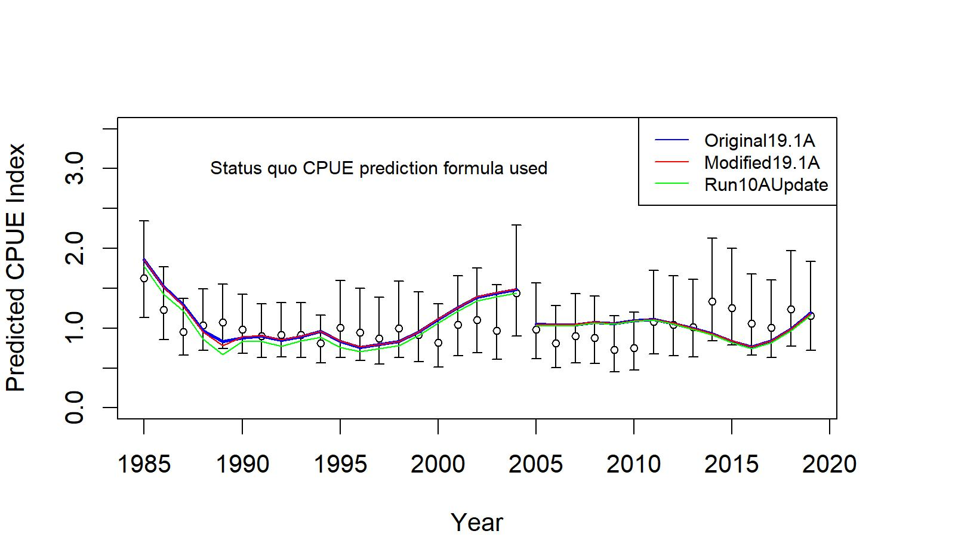
Figure CPT1. Comparison of input CPUE indices (open circles with +/- 2 SE for model 19.1A) with predicted CPUE indices (colored solid lines) under original model 19.1A, modified 19.1A to satisfy GMACS coding procedure, and GMACS Run#10AUpdate (most parameters were fixed to modified 19.1A model output) for EAG golden king crab data, 1985/86–2020/21. Model estimated additional standard error was added to each input standard error.

Comment# 2: During the January 2021 CPT meeting, authors presented the following model scenarios that include cooperative survey data: 19.1d: model 21.1a, but with the EAG cooperative survey CPUE indices for 2015–2019; 19.1e, as for 19.1d, but using the fish ticket CPUE data for the entire period. Model 19.1d had cooperative survey and CPUE data for same years (which could lead to double use of some data) and model 19.1e made no use of the observer CPUE data, even though these data are preferable to the fish ticket CPUE data. The CPT recommends that the results of an exploratory model in which model 21.1a is modified to use the EAG cooperative survey data, and the observer CPUE data from 2015 are ignored, be provided in an appendix to the assessment report. This model could be considered for use in the 2022 assessment.
Response: We provided results of an exploratory model (21.1d) in Appendix C in which model 21.1a is modified to use the EAG cooperative survey data for 2015–19, and the observer CPUE data from 2015–2019 are ignored.

Comment#3: The CPT was unclear why a predicted CPUE from the CPUE standardization with Year:Area interaction could be negative. Also, the formulae used to compute the variances for years*areas with no data should be provided and a bias correction factor should be applied to Equation A.15.

$\hat{B_{i, j}}= e^{A_{i}+ C_{j}}$ A.15
Response: We provided the clarification and formula to compute the standard deviations (hence variances) for years*areas with no data in Appendix B.
Comment#4: The analysts should consider a range of alternative standardization models for the EAG cooperative survey data (including that suggested by the SSC) and provide a rationale (including model fit, whether the analysis converged, etc.) for the selected model.
Response: We provided a few alternative standardization models for EAG cooperative survey data and provide the rationale for the selected model in Appendix C. The limitations on time series of data and factor levels (for example, only a maximum of three vessels) prevent us exploring variants of the simple random slope model.
Comment# 5: The assessment should more clearly provide the rationale for separate EAG and WAG assessments, including consideration of differences in trends in CPUE and age-compositions between the EAG and the WAG.

Response: We provided a few reasons in the January 2021CPT document. We added more reasons to justify separate stock assessments in the two regions in our response to February 2021 SSC comment#4.

Comment# 6: Model results should be presented only for the best fit (lowest objective function). If a best fit model exhibits unusual features (e.g., outlying F estimates or parameters on bounds), this can often be rectified by implementing bounds or smoothing penalties on some of the parameters.

Response: We detected some errors in input observer and fish ticket size measurement data for 2016–2019 and rectified them. This surprisingly eliminated multiple minima issue found earlier when jittering WAG parameter estimates.

Comment# 7: The runs used to create the retrospective plots should be checked as one run (1993 for WAG) appears to be a case where the minimizer has failed to converge.

Response: The minimizer did not fail in the retrospective run. The 1993 MMB jump was the result of an increase in total catch removal in the model (see Figure CPT2):

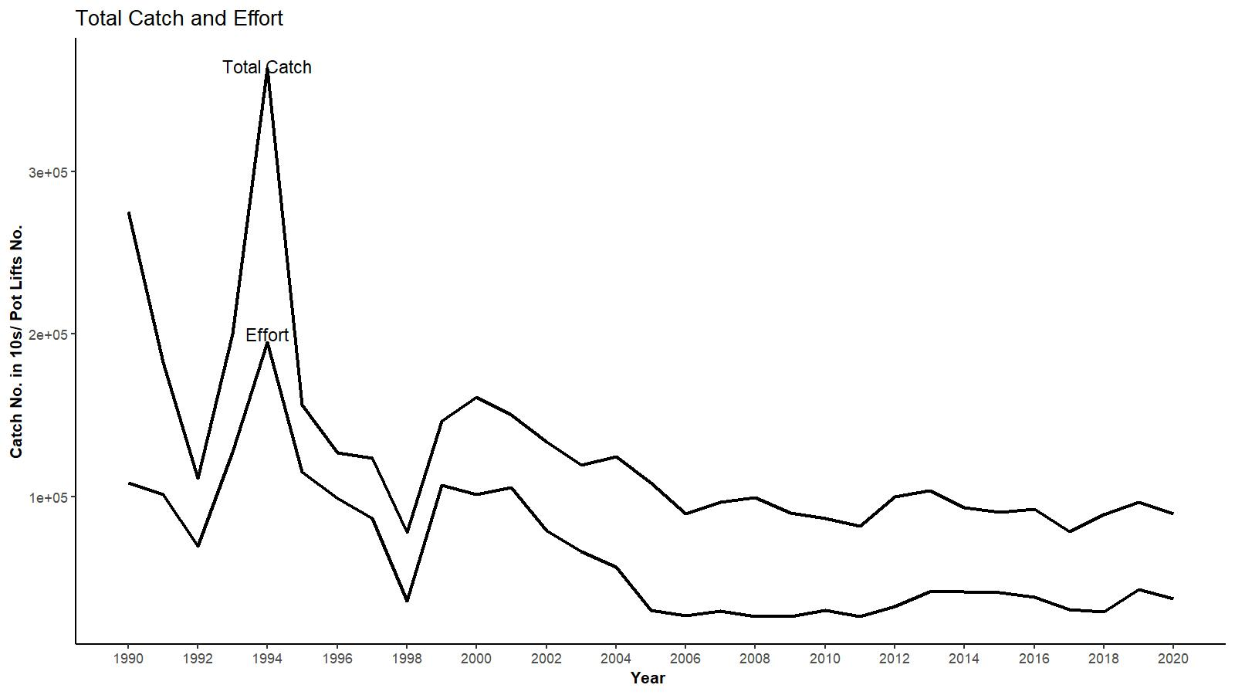

Figure CPT2. Estimated total catch (in 10s of crab) to the model size range (101 to 185+ mm CL) and effort (pot lifts) by year in WAG.

Comment # 8: Additional suggestions related to presentation:

- Add the historical TACs to the plot of catches and CPUEs.

Response: done (see Figure 6 in the main text).

- When plotting MMB, the x-axis value should be the second of the two years (e.g., the MMB for 2019/20 should be plotted against 2020, not 2019).

Response: done. See an example plot in Figure CPT3. We used the same procedure in constructing other plots.
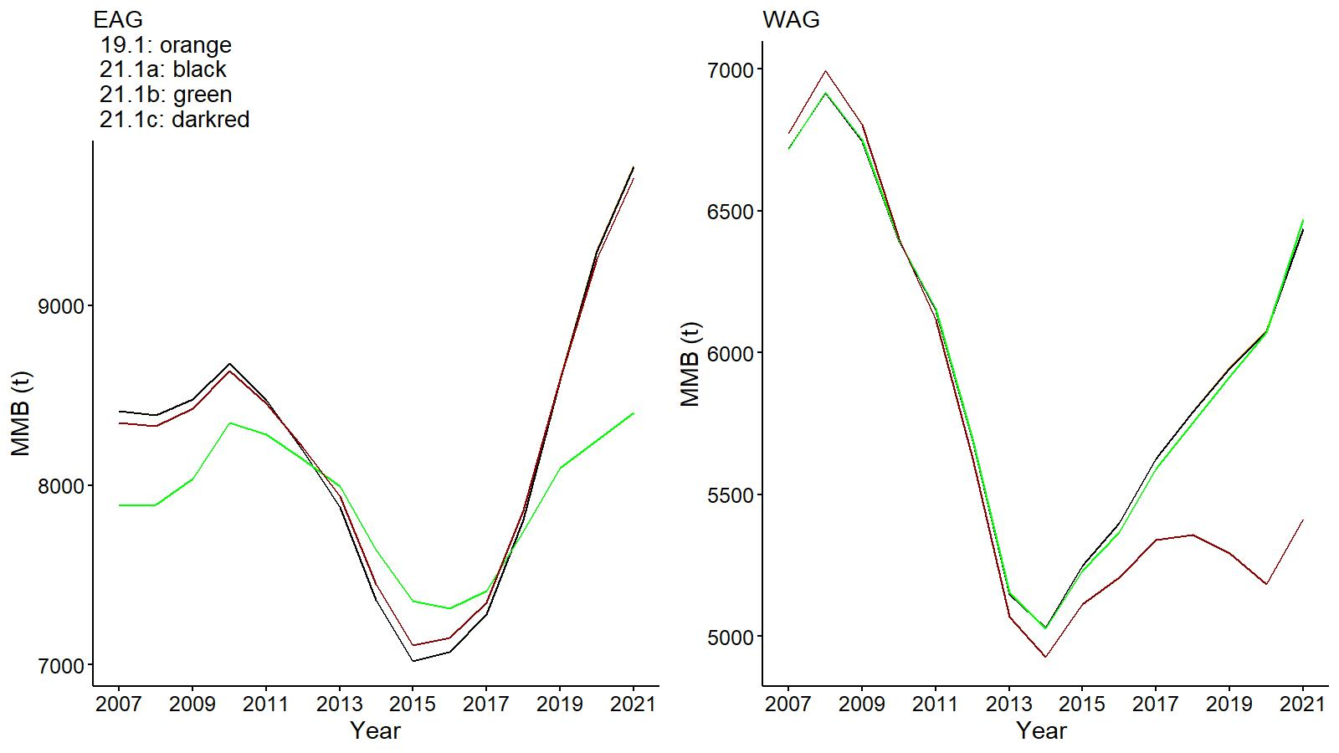
Figure CPT3. Trends in golden king crab mature male biomass for models 19.1, 21.1a, 21.1b, and 21.1c fits to EAG (left) and WAG (right) data, 2007–2021. Year 2021 refers to 2020/21 fishing season.

- Provide a figure that shows the size composition data for the fleet with time-varying selectivity in a vertical manner (e.g., Figure 12 in the snow crab assessment) to see changes in the data over time. This can be done using the R package ggridges.

Response: done (see Figures 9 to 11 for EAG and 27 to 29 for WAG in the main text).

- Additionally, a plot that shows the fits to the aggregate size-composition data would be useful.

Response: done (see Figure CPT4). Cumulative size compositions of retained catch fitted well for all models but total catch fits slightly differ.
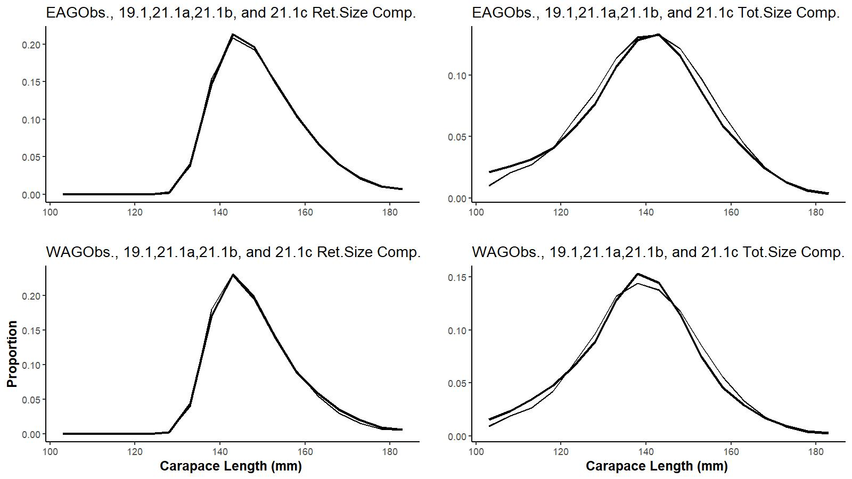
Figure CPT4. Cumulative size compositions vs carapace length for retained catch (left panels) and total catch (right panels) for EAG (top) and WAG (bottom). Different curves correspond to observed proportions and different models’ (19.1, 21.1a, 21.1b, and 21.1c) output.

- Include plots of the estimates of the smoothing functions (soak for the observer CPUE; depth and soak for the cooperative survey data) when conducting the CPUE and survey standardizations to check that these behave sensibly.

Response: We have addressed the soak time and depth effects on CPUE in the next section (f). We have not addressed the smoothing functions output because of time limitation. We will address this in the next run.

- Also plot the data on CPUE vs. depth and CPUE vs. soak time to allow the underlying patterns to be identified.

Response: done. We plotted annual observer nominal legal male CPUE against annual mean soak time and annual mean depth (Figure CPT5). Soak time appears to positively influence CPUE (adjusted R square for EAG and WAG: 0.81); but not depth (adjusted R square for EAG: -0.02, WAG: 0.25). Please note that their effects were already modelled in CPUE standardization.

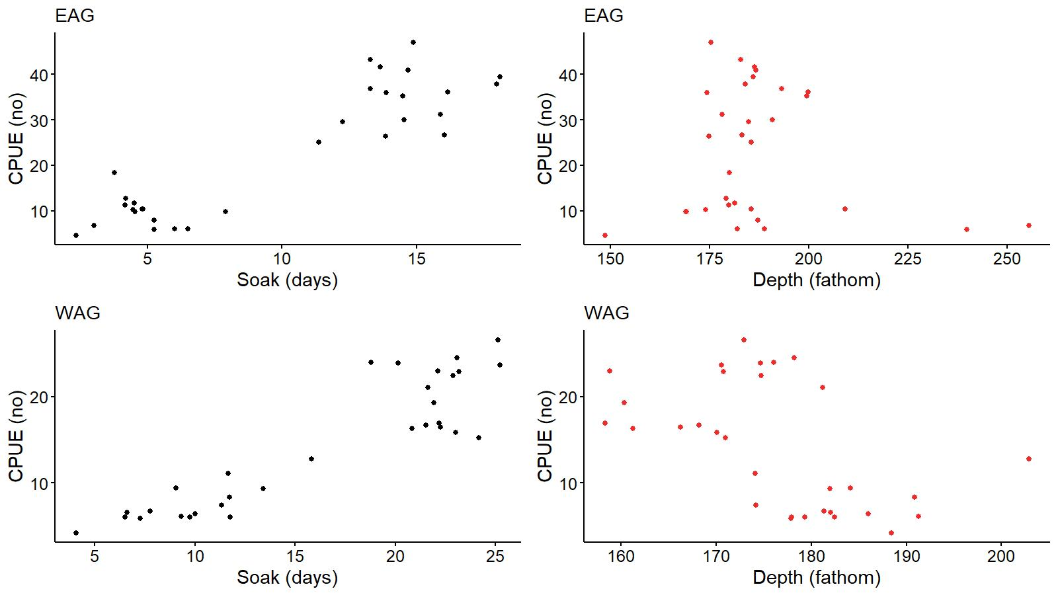
Figure CPT5. Annual observer nominal legal male CPUE vs annual mean soak time and annual mean depth in EAG (top) and WAG (bottom).

Response to one of June 2020 SSC comments:

Comment 4: The SSC recommends that, if this approach [i.e., 0.7 Sigma approach] were used, the CV would be a better choice. This is because the standard deviations of high recruitments with the same CV might be higher than a cutoff and would result in reference points that are biased lower. The SSC also recommends exploring choosing a reasonable lag from the current year that would include most crabs that have recruited into the fishery. For example, if most crabs are observed by age 6, the 2020 assessment would use recruitments from 1987–2014, and the 2021 assessment would use 1987– 2015, and so on.

Response: We did not adequately address the above comment earlier. We try to address the points below.

First point: Considering CV instead of standard deviation of rec_dev provided mixed results for choosing an appropriate year range for different levels of CV (e.g., CV 100%: 1985–2011; CV 125%: 1984–2013; and CV 150%: 1984–2016). Furthermore, years in the selected ranges were non-contiguous. We provide the case for 150% CV cutoff level below (Figure SSC1). Although CV standardizes different magnitudes of variability for a comparison, they appeared to be not useful here.

Second point: The fixed period 1987–2012 for mean number of recruit calculation used in the base model 19.1 considers 8-year time lag from the terminal year, which appears to be the recruitment age for golden king crab. However, it is necessary to locate cut off points on both ends of the time range to choose an appropriate fixed period for mean recruit calculation. The method used in our selection process takes care of this.

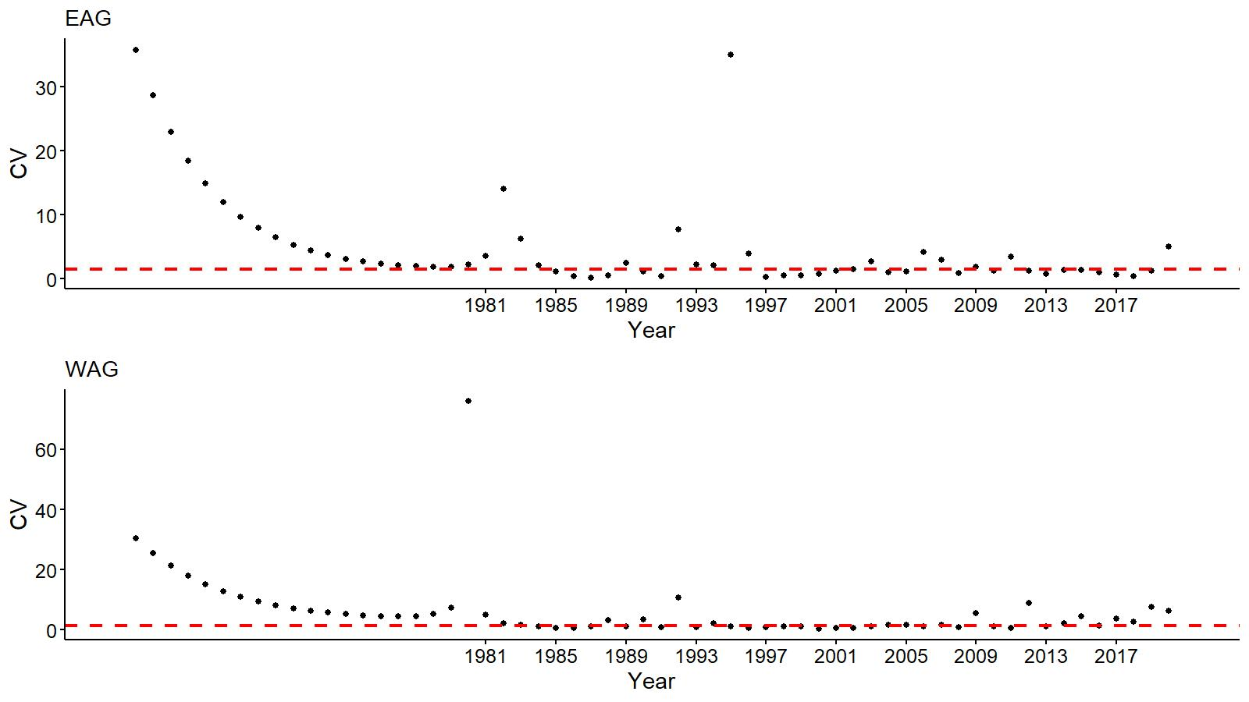
Figure SSC1. Coefficient of variation (CV) of recruit_dev vs. year for EAG (top) and WAG (bottom) for model 21.1a. The 1981–2020 marked years have input information for model fitting.

Response to February 2021 SSC comments

Comment#1: With respect to Model 21.1b (Same structure and data inputs as M21.1a, but with three-time blocks for selectivity (1960–2004, 2005–2015, and 2016+), the SSC agrees that justification will need to be provided as to why allowing time-varying selectivity based on these time blocks is appropriate, relative to other time-varying parameterizations.

Response: The first block, 1960–2004, pertains to the pre-rationalization period, which was the feature of all models. In the new model scenario (21.1b), the post-rationalization period was divided into two, 2005–2015 and 2016+, to create two selectivity blocks based on observed different fishing patterns (total size distribution shifted to small size groups, see reduced proportions in large size groups in Figure SSC2) between the two post-rationalization periods in EAG. The visualization of shift is clear in Figures 10a, b, and c in the main text. This pattern was not seen in WAG though. A three-selectivity-block design was created specifically to reduce the retrospective pattern in MMB in EAG (see the reduction in Mohn rho value for model 21.1b in EAG in Figure 23). Although several other factors separately or in combination may contribute to retrospective patterns (e.g., change in growth, change in catchability, etc.), change in selectivity was the easily demonstrable cause effect we have chosen.

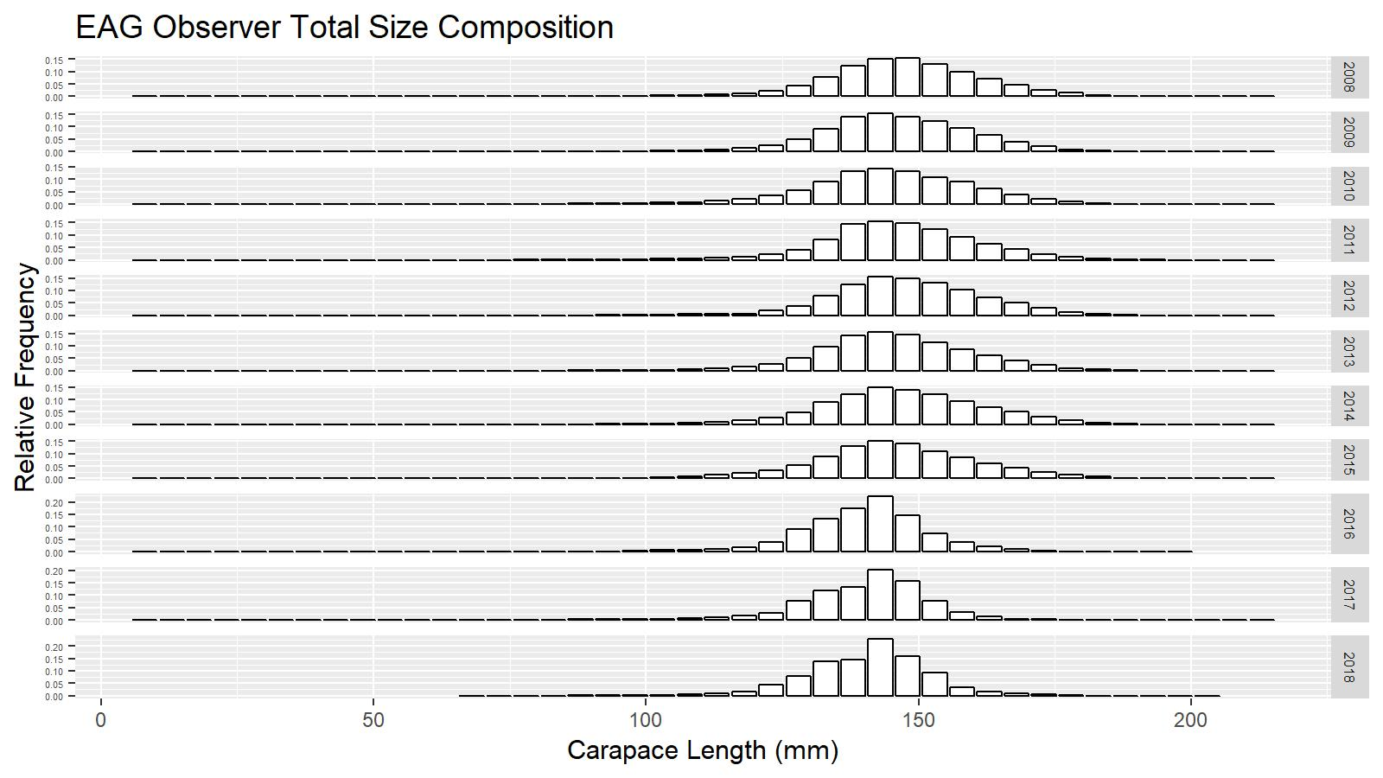
Figure SSC2. Observer total size composition for 2008–2018 in the EAG.

Comment#2: The SSC supports continued efforts to recreate existing operational model structures and explore novel structures, within the standardized GMACS platform.

Response: We continue effort to implement golden king crab stock assessment models in GMACS. Appendix F provides preliminary comparison of our model results with GMACS results for EAG19.1. Please see our response to CPT comment#1 as well.

Comment#3: An exploratory model in which M21.1a ignores 2015– observer CPUE data but incorporates estimates from the cooperative survey for EAG. The SSC encourages exploration of whether overlapping these indices may help in estimating catchability.

Response: We explored this issue but did not observe much difference in the post-rationalization catchability estimates.

Comment#4: The SSC would also like to reiterate its support for several previous suggestions:

- Exploration of a single-area model, or possibly a two-area model with larval connectivity, for the AIGKC crab stock.

Response: We expanded the list of justifications that were presented at the January 2021 CPT and February 2021 SSC meetings, for assessing EAG and WAG separately below:

We modelled EAG and WAG stocks separately for several reasons:
(a) The productivity in the two areas is different, e.g.,
-In recent years, EAG CPUE is one and half time of that in WAG; and CPUE trajectories are different in the two regions.
(b) WAG has wider area of stock distribution compared to limited area distribution in EAG.
(c) There is a fishing area gap between EAG and WAG (please see Figure 8 in the main text).
(d) Tagging studies have shown little mixing between the two areas (Watson and Gish 1992).
(e) Larval mixing between the two regions may be a possibility, but we do not have any data to prove that yet. However, unlike other king crabs, golden king crab females carry large, yolk-rich, eggs, which hatch into lecithotrophic larvae that do not require a pelagic phase for development into juveniles and hence unlikely to distribute widely.
(f) Integrating contradictory data in one single model may provide parameter estimates in between the two extremes which would not be applicable to either (see Richards 1991, Schnute and Hilborn 1993).
(g) Area specific assessment is superior to a wholistic approach for this stock because of patchy nature of golden king crab distribution.
h) Alaska Board of Fisheries decided to manage the two areas with separate total allowable catches.

- Evaluation of whether catches of AIGKC caught in the NMFS Aleutian Island trawl survey could be utilized as an additional index of abundance.

Response: We have not looked at the NMFS trawl data for AIGKC catches. We will explore any feasibility of including AIGKC caught in the NMFS Aleutian Island trawl survey as an additional index of abundance in the future.

- Continued exploration of the Year:Area effect in the CPUE standardization, specifically by fitting two area models and combining the results and comparing to the Year:Area model. Diagnostic plots of the data and model predictions of time trends by area (holding all other predictors at their median or mean value) might shed light on the nature of the interaction and aid interpretation.

Response: We addressed the Year:Area effect in the CPUE standardization including some of SSC’s suggestions in Appendix B. We have not made SSC suggested diagnostic plots in this report because of time limitation. We will address this in the next run.

- Introduction
- Scientific name:
Golden king crab, Lithodes aequispinus J.E. Benedict, 1895.

- Distribution:
General distribution of golden king crab is summarized by NMFS (2004). Golden king crab, also called brown king crab, occur from the Sea of Japan to the northern Bering Sea (ca. 61° N latitude), around the Aleutian Islands, generally in high-relief habitat such as inter-island passes, on various sea mounts, and as far south as northern British Columbia (Alice Arm) (Jewett et al. 1985). They are typically found on the continental slope at depths of 300–1,000 m on extremely rough bottom. They are frequently found on coral bottom.

The Aleutian Islands king crab stock boundary is defined by the boundaries of the Aleutian Islands king crab Registration Area O (Figure 1). In this chapter, “Aleutian Islands Area” means the area described by the current definition of Aleutian Islands king crab Registration Area O. Nichols et al. (2021) define the boundaries of Aleutian Islands king crab Registration Area O:

The Aleutian Islands king crab Registration Area O eastern boundary is the longitude of Scotch Cap Light (164°44.72′W long); the northern boundary is a line from Cape Sarichef (54°36′N lat) to 171°W long, north to 55°30′N lat; and the western boundary the United States–Russia Maritime Boundary Line of 1990.

During 1984/85–1995/96, the Aleutian Islands king crab populations had been managed using the Adak and Dutch Harbor Registration Areas, which were divided at 171° W longitude (Figure 2), but from the 1996/97 season to present the fishery has been managed using a division at 174° W longitude (Figure 1). In March 1996, the Alaska Board of Fisheries (BOF) replaced the Adak and Dutch Harbor areas with the newly created Aleutian Islands Registration Area O and directed ADF&G to manage the golden king crab fishery in the areas east and west of 174°W longitude as two distinct stocks. That re-designation of management areas was intended to reflect golden king crab stock distribution, congruent with the longitudinal pattern in fishery production prior to 1996/97 (Figure 3). The longitudinal pattern in fishery production relative to 174° W longitude since 1996/97 is like that observed prior to the change in management area definition, although there have been some changes in the longitudinal pattern in fishery production within the areas east and west of 174° W longitude (Figure 4).

Commercial fishing for golden king crab in the Aleutian Islands Area typically occurs at depths of 100–275 fathoms (183–503 m). Pots sampled by at-sea fishery observers in 2013/14 were fished at an average depth of 176 fathoms (322 m; N=499) in the area east of 174° W longitude and 158 fathoms (289 m; N=1,223) for the area west of 174° W longitude (Gaeuman 2014).

- Evidence of stock structure:
Given the expansiveness of the Aleutian Islands Area and the existence of deep (>1,000 m) canyons between some islands, at least some weak structuring of the stock within the area would be expected. Data for making inferences on stock structure of golden king crab within the Aleutian Islands are largely limited to the geographic distribution of commercial fishery catch and effort. Catch data by statistical area from fish tickets and catch data by location from pots sampled by observers suggest that habitat for legal-sized males may be continuous throughout the waters adjacent to the islands in the Aleutian chain. However, regions of low fishery catch suggest that availability of suitable habitat, in which golden king crab are present at only low densities, may vary longitudinally. Catch has been low in the fishery in the area between 174° W longitude and 176° W longitude (the Adak Island area, Figures 3 and 4) in comparison to adjacent areas, a pattern that is consistent with low CPUE for golden king crab between 174° W longitude and 176° W longitude (Figure 5) during the 2002, 2004, 2006, 2010, and 2012 NMFS Aleutian Islands bottom trawl surveys (von Szalay et al. 2011). In addition to longitudinal variation in density, there is also a gap in fishery catch and effort between the Petrel Bank-Petrel Spur area and the Bowers Bank area; both of those areas, which are separated by Bowers Canyon, have reported effort and catch. Recoveries during commercial fisheries of golden king crab tagged during ADF&G surveys (Blau and Pengilly 1994; Blau et al. 1998; Watson and Gish 2002; Watson 2004, 2007) provided no evidence of substantial movements by crab in the size classes that were tagged (males and females ≥90-mm carapace length [CL]). Maximum straight-line distance between release and recovery location of 90 golden king crab released prior to the 1991/92 fishery and recovered through the 1992/93 fishery was 61.2 km (Blau and Pengilly 1994). Of the 4,567 recoveries reported through April 12, 2016 for the male and female golden king crab tagged and released between 170.5° W longitude and 171.5° W longitude during the 1991, 1997, 2000, 2003, and 2006 ADF&G Aleutian Island golden king pot surveys, none of the 3,807 with recovery locations specified by latitude and longitude were recovered west of 173° W longitude and only fifteen were recovered west of 172° W longitude (V. Vanek, ADF&G, Kodiak, pers. comm.). Similarly, of 139 recoveries in which only the statistical area of recovery was reported, none were recovered in statistical areas west of 173° W longitude and only one was in a statistical area west of 172° W longitude.

- Life history characteristics relevant to management:
There is a paucity of information on golden king crab life history characteristics due in part to the deep depth distribution (~200–1000 m) and the asynchronous nature of life history events (Otto and Cummiskey 1985; Somerton and Otto 1986). The reproductive cycle is thought to last approximately 24 months and at any time of year ovigerous females can be found carrying egg clutches in highly disparate developmental states (Otto and Cummiskey 1985). Females carry large, yolk-rich, eggs, which hatch into lecithotrophic (i.e., the larvae can develop successfully to juvenile crab without eating; Shirley and Zhou 1997) larvae that are negatively phototactic (Adams and Paul 1999). Molting and mating are also asynchronous and protracted (Otto and Cummiskey 1985; Shirley and Zhou 1997) with some indications of seasonality (Hiramoto 1985). Molt increment for large males (adults) in Southeast Alaska is 16.3 mm CL per molt (Koeneman and Buchanan 1985) and was estimated at 14.4 mm CL for legal males in the EAG (Watson et al. 2002). Annual molting probability of males decreases with increasing size, which results in a protracted inter-molt period and creates difficulty in determining annual molt probability (Watson et al. 2002). Male size-at-maturity varies among stocks (Webb 2014) and declines with increasing latitude from about 130 mm CL in the Aleutian Islands to 90 mm CL in Saint Matthew Island section (Somerton and Otto 1986). Along with a lack of annual survey data, limited stock-specific life history stock information prevents development of the standard length-based assessment model.

- Summary of management history:
A complete summary of the management history through 2015/16 is provided in Leon et al. (2017). The first commercial landing of golden king crab in the Aleutian Islands was in 1975/76 but directed fishing did not occur until 1981/82.

The Aleutian Islands golden king crab fishery was restructured beginning in 1996/97 to replace the Adak and Dutch Harbor areas with the newly created Aleutian Islands Registration Area O and golden king crab in the areas east and west of 174° W longitude were managed separately as two stocks (ADF&G 2002). Hereafter, the east of 174° W longitude stock segment is referred to as EAG and the west of 174° W longitude stock segment is referred to as WAG. Table 1 provides the historical summary of number of vessels, GHL/TAC, harvest, effort, CPUE and average weight in the Aleutian Islands golden king crab fishery.

The fisheries in 1996/97–1997/98 were managed with GHLs of 1,452 t (3,200,000 lb) in EAG and 1,225 t (2,700,000 lb) in WAG (Table 1). During 1998/99–2004/05 the fisheries were managed with GHLs of 1,361 t (3,000,000 lb) for EAG and 1,225 t (2,700,000 lb) for WAG. During 2005/06–2007/08 the fisheries were managed with a total allowable catch (TAC) of 1,361 t (3,000,000 lb) for EAG and a TAC of 1,225 t (2,700,000 lb) for WAG. By state regulation (5 AAC 34.612), TAC for the Aleutian Islands golden king crab fishery during 2008/09–2011/12 was 1,429 t (3,150,000 lb) for EAG and 1,286 t (2,835,000 lb) for WAG. In March 2012, the BOF changed 5 AAC 34.612 so that the TAC beginning in 2012/13 would be 1,501 t (3,310,000 lb) for the EAG and 1,352 t (2,980,000 lb) for WAG. Additionally, the BOF added a provision to 5 AAC 34.612 that allows ADF&G to lower the TAC below the specified level if conservation concerns arise. The TAC for 2016/17 (and 2017/18) was reduced by 25% for WAG to 1,014 t (2,235,000 lb) while keeping the TAC for EAG at the same level as the previous season.

During 1996/97–2020/21 the annual retained catch during commercial fishing (including cost-recovery fishing that occurred during 2013/14–2020/21) has averaged 2% below the annual GHL/TACs. During 1996/97–2020/21, the retained catch has been as much as 13% below (1998/99) and as much as 6% above (2000/01) the GHL/TAC.

A summary of other relevant State of Alaska fishery regulations and management actions pertaining to the Aleutian Islands golden king crab fishery is provided below:

Beginning in 2005/06 the Aleutian Islands golden king crab fishery has been prosecuted under the Crab Rationalization Program. Accompanying the adoption of crab rationalization program was implementation of a community development quota (CDQ) fishery for golden king crab in the eastern Aleutians (i.e., EAG) and the Adak Community Allocation (ACA) fishery for golden king crab in the western Aleutians (i.e., WAG; Hartill 2012; Nichols et al. 2021). The CDQ fishery in the eastern Aleutians is allocated 10% of the golden king crab TAC for the area east of 174° W longitude and the ACA fishery in the western Aleutians is allocated 10% of the golden king crab TAC for the area west of 174° W longitude. The CDQ fishery and the ACA fishery are managed by ADF&G and prosecuted concurrently with the individual fishing quota (IFQ) fishery.

Golden king crab may be commercially fished only with king crab pots (defined in state regulation 5 AAC 34.050). Pots used to fish for golden king crab in the Aleutian Islands Area must be longlined and, since 1996, each pot must have at least four escape rings of five and one-half inches minimum inside diameter installed on the vertical plane or at least one-third of one vertical surface of the pot composed of not less than nine-inch stretched mesh webbing to permit escapement of undersized golden king crab (5 AAC 34.625 (b)). Prior to the regulation requiring an escape mechanism on pots, some participants in the Aleutian Islands golden king crab fishery voluntarily sewed escape rings (typically 139 mm [5.5 inches]) into their gear or, more rarely, included panels with escape mesh (Beers 1992). Regarding the gear used since the establishment of 5 AAC 34.625 (b) in 1996, Linda Kozak, a representative of the industry, reported in a 19 September 2008 email to the Crab Plan Team, “… the golden king crab fleet has modified their gear to allow for small crab sorting,” and provided a written statement from Lance Nylander, of Dungeness Gear Works in Seattle, who “believes he makes all the gear for the golden king crab harvesting fleet,” saying that “Since 1999, DGW has installed 9[-inch] escape web on the door of over 95% of Golden Crab pot orders we manufactured.” A study to estimate the contact-selection curve for male golden king crab was conducted aboard one vessel commercial fishing for golden king crab during the 2012/13 season and found gear and fishing practices used by that vessel were highly effective in reducing bycatch of sublegal-sized males and females (Vanek et al. 2013). In March 2011 (effective for 2011/12), the BOF amended 5 AAC 34.625 (b) to relax the “biotwine” specification for pots used in the Aleutian Islands golden king crab fishery relative to the requirement in 5 AAC 39.145 that “(1) a sidewall ...of all shellfish and bottom fish pots must contain an opening equal to or exceeding 18 inches in length... The opening must be laced, sewn, or secured together by a single length of untreated, 100 percent cotton twine, no larger than 30 thread.” Regulation 5 AAC 34.625 (b)(1) allows the opening described in 5 AAC 39.145 (1) to be “laced, sewn, or secured together by a single length of untreated, 100 percent cotton twine, no larger than 60 [rather than 30] thread.”

Regulation (5 AAC 34.610 (b)) sets the commercial fishing season for golden king crab in the Aleutian Islands Area as 1 August through 30 April. That regulatory fishing season became effective in 2015/16 (the commercial fishing season was set in regulation as 15 August through 15 May during 2005/06–2014/15).

Current regulations (5 AAC 39.645 (d)(4)(A)) stipulate that onboard observers are required on catcher vessels during the time that at least 50% of the retained catch is captured in each of the three trimesters of the 9-month fishing season. Onboard observers are required for 100% of fishing activity on catcher-processor vessels during the crab fishing season.

In addition, the commercial golden king crab fishery in the Aleutian Islands Area may only retain males at least 6.0-inches (152.4 mm) carapace width (CW), including spines (5 AAC 34.620 (b)), which is at least one annual molt increment larger than the 50% maturity length of 120.8 mm CL for males estimated by Otto and Cummiskey (1985). A carapace length (CL) ≥136 mm is used to identify legal-size males when CW measurements are not available (Table 3-5 in NPFMC 2007b). Note that the size limit for golden king crab has been 6-inches (152.4 mm) CW for the entire Aleutian Islands Area since the 1985/86 season. Prior to the 1985/86 season, the legal-size limit was 6.5-inches (165.1 mm) CW for at least one of the now-defunct Adak or Dutch Harbor Registration Areas.

We re-evaluated the male maturity size using 1991 pot survey measurements of carapace length and chela height in EAG and 1984 NMFS measurements in WAG (Siddeek et al. 2018). Bootstrap analysis of chela height and carapace length data provided the median 50% male maturity length estimates of 107.02 mm CL in EAG and 107.85 mm CL in WAG. We used a knife-edge 50% maturity length of 111.0 mm CL, which is the lower limit of the next upper size bin, for mature male biomass (MMB) estimation. We analyzed the recently collected (2018 to 2020) chela height and carapace length data and proposed a higher 50% maturity length of 116.0 mm CL and a maturity curve for MMB estimation (Appendix D).

Daily catch and catch-per-unit effort (CPUE) are determined in-season to monitor fishery performance and progress towards the respective TACs. Figures 6 to 8 provide the 1985/86–2020/21 time series of catches, CPUE, and the geographic distribution of catch during the 2020/21 fishing season. Increases in CPUE were observed during the late 1990s through the early 2000s, and with the implementation of crab rationalization in 2005. This is likely due to changes in gear configurations in the late 1990s (crab harvesters, personal communication, 1 July 2008) and, after rationalization, to increased soak time (Siddeek et al. 2015), and decreased competition owing to the reduced number of vessels fishing. Decreased competition could allow crab vessels to target only the most productive fishing areas. Trends in fishery nominal CPUE within the areas EAG and WAG generally paralleled each other during 1985/86–2010/11 but diverged thereafter (EAG CPUE exceeded one and half times of that in WAG). A moderate decreasing trend in CPUE was observed since 2014 in EAG. A sharp drop in CPUE was detected in 2020/21 for WAG (Figures 6 and 7)

- Brief description of the annual ADF&G harvest strategy:
In March 2019, the BOF adopted a revised harvest strategy (Daly et al. 2019). The annual TAC is set by state regulation, 5 AAC 34.612 (Harvest Levels for Golden King Crab in Registration Area O), per:

- In that portion of the Registration Area O east of 174° W. long., the total allowable catch level shall be established as follows:
- if MMA_{E} is less than 25 percent of MMA_{E,(1985-2017)}, the fishery will not open;
- if MMA_{E} is at least 25 percent but not greater than 100 percent of MMA_{E,(1985-2017)}, the number of legal male golden king crab available for harvest will be computed as (0.15)x(MMA_{E}/MMA_{E,(1985-2017)})x(MMA_{E}) or 25 percent of LMA_{E}, whichever is less; and
- if MMA_{E} is greater than 100 percent of MMA_{E,(1985-2017)}, the number of legal male golden king crab available for harvest will be computed as (0.15)x(MMA_{E}) or 25 percent of LMA_{E}, whichever is less.
- In that portion of the Registration Area O west of 174° W. long., the total allowable catch level shall be established as follows:
- if MMA_{W} is less than 25 percent of MMA_{W,(1985-2017)}, the fishery will not open
- if MMA_{W} is at least 25 percent but not greater than 100 percent of MMA_{W,(1985-2017)}, the number of legal male golden king crab available for harvest will be computed as (0.20)x(MMA_{W}/MMA_{W,(1985-2017)})x(MMA_{W}) or 25 percent of LMA_{W}, whichever is less; and
- if MMA_{W} is greater than 100 percent of MMA_{W,(1985-2017)}, the number of legal male golden king crab available for harvest will be computed as (0.20)x(MMA_{W}) or 25 percent of LMA_{W}, whichever is less.
- In implementing this harvest strategy, the department shall consider the reliability of estimates of golden king crab, the manageability of the fishery, and other factors the department determines necessary to be consistent with sustained yield principles and to use the best scientific information available and consider all sources of uncertainty as necessary to avoid overfishing.
- In this section,
- MMA_{E} means the abundance of male golden king crab in the portion of the Aleutian Islands Management Area O east of 174° W. long that are greater than or equal to 111 millimeters in carapace length estimated by the stock assessment model for the time prior to the start of the fishery;
- MMA_{E,(1985-2017)} means the mean value of the abundance of male golden king crab in the portion of the Aleutian Islands Management Area O east of 174° W. long that are greater than or equal to 111 millimeters in carapace length estimated by the stock assessment model for the time prior to the start of the fishery for the period 1985 – 2017;
- LMA_{E} means the abundance of male golden king crab in the portion of the Aleutian Islands Management Area O east of 174° W. long that are greater than or equal to 136 millimeters in carapace length estimated by the stock assessment model for the time prior to the start of the fishery;
- MMA_{W} means the abundance of male golden king crab in the portion of the Aleutian Islands Management Area O west of 174° W. long that are greater than or equal to 111 millimeters in carapace length estimated by the stock assessment model for the time prior to the start of the fishery;
- MMA_{W,(1985-2017)} means the mean value of the abundance of male golden king crab in the portion of the Aleutian Islands Management Area O west of 174° W. long that are greater than or equal to 111 millimeters in carapace length estimated by the stock assessment model for the time prior to the start of the fishery for the period 1985 – 2017; and
- LMA_{W} means the abundance of male golden king crab in the portion of the Aleutian Islands Management Area O west of 174° W. long that are greater than or equal to 136 millimeters in carapace length estimated by the stock assessment model for the time prior to the start of the fishery.

In addition to the retained catch that is limited by the TAC established by ADF&G under 5 AAC 34.612, ADF&G has authority to annually receive receipts up to $500,000 through cost-recovery fishing on Aleutian Islands golden king crab. The retained catch from that cost-recovery fishing is not counted against attainment of the annually established TAC.

- Summary of the history of the basis and estimates of MMB_{MSY} or proxy MMB_{MSY}:
We estimated the proxy MMB_{MSY} as MMB_{35%} using the Tier 3 estimation procedure, which is explained in a subsequent section.

- Data
- Summary of new information:
- Commercial fishery retained catch by size, estimated total catch by size, groundfish male discard catch by size, observer CPUE index, and commercial fishery CPUE index were updated to include 2020/21 information. Available data by year are shown below.

Year | 81 | 82 | 83 | 84 | 85 | 86 | 87 | 88 | 89 | 90 | 91 | 92 | 93 | 94 | 95 | 96 | 97 | 98 | 99 | 00 | 01 | 02 | 03 | 04 | 05 | 06 | 07 | 08 | 09 | 10 | .  . | .. | .. | 17 | 18 | 1  9 | 20
Ret.C. & Size Comp.
Total C. & Size Comp.
Ground fish ByC. & Size Comp.
Observ. CPUE
Fishery CPUE
Tag release
Tag Recovery

2. Data presented as time series:
a. Total Catch:
Fish ticket data on retained catch weight, catch numbers, effort (pot lifts), CPUE, and average weight of retained catch for 1981/82–2020/21 (Table 1). Estimated total catch weight for 1990/91–2020/21 (Table 2a).

b. Bycatch and discards:
Retained catch, bycatch mortality (male and female of all sizes) separated by the crab fishery and groundfish fishery, and total fishery mortality for 1981/82–2020/21 (Table 2). Crab fishery discards are available after observer sampling was established in 1988/89. Observer data for the 1988/89–1989/90 seasons are not considered reliable. Table 2 provides crab fishery discards and groundfish fishery bycatch for 1991/92–2020/21 seasons.

- Catch-per-unit-effort:
- Pot fishery and observer nominal retained and total CPUE, pot fishery effort, observer sample size, and estimated observer CPUE index delineated by EAG and WAG for 1985/86–2020/21 (Table 3).

- Estimated commercial fishery CPUE index with coefficient of variation (Table 4 for EAG and Table 14 for WAG). The estimation methods, and CPUE fits are described in Appendix B.

- Catch-at-length:
Information on length compositions is provided (Figures 9a, b, c to 11a, b, c for EAG; and 27a, b, c to 29a, b, c for WAG for models 21.1a, 21.1b, and 21.1c, respectively.

- Survey biomass estimates:
Estimates are not available for the area because no systematic surveys, covering the entire fishing area, have occurred.

- Survey catch–at–length:
Not available.

- Other time series data: None.

- Data which may be aggregated over time:
- Molt and size transition matrix: Tag release – recapture –time at liberty records from 1991, 1997, 2000, 2003, and 2006 male tag crab releases were aggregated by year at liberty to determine the molt increment and size transition matrix by the integrated model.
- Weight-at-length: Male length-weight relationship: $W=aL^{b}$ where a = 1.445*10⁻⁴, b = 3.28113 [σ = 0.00737 (bias correction for a was not required because of the very small value of σ); updated estimates from WAG data].
- Natural mortality: A previous model estimated fixed natural mortality value of 0.21 yr⁻¹, was used in the assessment.

- Information on any data sources that were available, but were excluded from the assessment:
Data from triennial ADF&G pot surveys for Aleutian Islands golden king crab in a limited area in EAG (between 170° 21’ and 171° 33’ W longitude) that were performed during 1997 (Blau et al. 1998), 2000 (Watson and Gish 2002), 2003 (Watson 2004), and 2006 (Watson 2007) are available, but were not used in this assessment. However, the tag release and recapture data from these surveys were used.

Data from the cooperative pot surveys conducted during 2015 to 2019 are available but is limited in time span for full usage. The EAG survey covers the full time series but WAG survey started only in 2018. We incorporated the EAG data in a model scenario (21.1d) as a test run in this assessment (see Appendix C).

- Analytic Approach
- History of modeling approaches for this stock:
A size structured assessment model based on only fisheries data was under development for several years for the EAG and WAG golden king crab stocks and accepted in 2016 for OFL and ABC setting for the 2017/18 season. The CPT in January 2017 and SSC in February 2017 recommended using the Tier 3 procedure to set the OFL and ABC. They also suggested using the maturity data to estimate the male mature biomass (MMB). We followed these suggestions in this report to estimate the model based OFL and ABC.

- Model Description:
- Description of overall modeling approach:
The underlying population dynamics model is male-only and length-based (Appendix A). This model combines commercial retained catch, total catch, groundfish fishery discarded catch, standardized observer legal size catch-per-unit-effort (CPUE) indices, fishery retained catch size composition, total catch size composition, and tag recaptures by release-recapture length to estimate stock assessment parameters. The tagging data were used to calculate the size transition matrix. To estimate the MMB, we used the knife-edge 50% maturity based on the chela height and carapace length data analysis. To include a long time series of CPUE indices for stock abundance contrast, we also considered the 1985/86–1998/99 legal size standardized fishery CPUE indices as a separate likelihood component in all scenarios (see Table T1).

There were significant changes in fishing practice associated with changes in management regulations (e.g., constant TAC since 1996/97 and crab rationalization since 2005/06), pot configuration (escape web on the pot door increased to 9-inch since 1999), and improved observer recording in Aleutian Islands golden king crab fisheries since 1998. These changes prompted us to consider two sets of catchability and total selectivity parameters with only one set of retention parameters for the periods 1985/86–2004/05 and 2005/06–2020/21. We also considered a model (21.1b) with three total selectivity curves to reduce the retrospective pattern of EAG MMB.

We fitted the observer and commercial fishery CPUE indices with standard errors (estimated by GLM) and an additional assessment model estimated constant variance. The assessment model predicted total and retained CPUEs. However, we compared only the predicted retained CPUE with the observer legal size crab CPUE indices in the likelihood function because observer recordings of legal-size crabs are reliable.

The data series ranges used for the WAG are the same as those for EAG.

- Software:
AD Model Builder (Fournier et al. 2012).

c.–f. Details are given in Appendix A.

- Critical assumptions and consequences of assumption failures:
Because of the lack of an annual stock survey, we relied heavily on standardized CPUE indices (Appendix B) and catch and size composition information to determine the stock abundance trends in both regions. We assumed that the observer and fish ticket CPUE indices are linearly related to exploitable abundance. We kept M constant at 0.21 yr⁻¹ and knife-edge maturity size at 111 mm CL (Siddeek et al. 2018). We also considered a higher knife-edge maturity size of 116 mm CL and maturity curves for MMB estimation in different model scenarios. We assumed directed pot fishery discard mortality at 0.20 yr⁻¹, overall groundfish fishery mortality at 0.65 yr⁻¹ (mean of groundfish pot fishery mortality [0.5 yr⁻¹] and groundfish trawl fishery mortality [0.8 yr⁻¹]), groundfish fishery selectivity at full selection for all length classes (selectivity = 1.0). Any discard of legal-size males in the directed pot fishery was not considered in this analysis. These fixed values invariably reduced the number of model parameters to be estimated and helped in convergence. We assumed different q’s (scaling parameter for standardized CPUE in the model, Equation A.13) and logistic selectivity patterns (Equation A.9) for different periods for the pot fishery.

- Changes to any of the above since the previous assessment:
None.

- Model code has been checked and validated.
The codes have been checked at various times by independent reviewers and the current codes are available from the first author.

- Model Selection and Evaluation

- Description of alternative model configurations:
We considered ten models for EAG and WAG (Table T1). We presented OFL and ABC results for all models separately for EAG, WAG, and the entire AI in the executive summary tables. We considered model 19.1 as the base model. It considers:

- Initial abundance by the equilibrium condition considering the mean number of recruits for 1987–2012: The equilibrium abundance was determined for 1960 (see Equations A.4 and A.5), projected forward with only M and annual recruits until 1980, then retained catches removed during 1981–1984 and projected to obtain the initial abundance in 1985.
- Observer CPUE indices for 1995/96–2020/21.
- Fishery CPUE indices for 1985/86–1998/99.
- Initial (Stage-1) weighting of effective sample sizes: number of vessel-days for retained and total catch size compositions, and number of fishing trips for groundfish discard size composition (the groundfish size composition was not used in model fitting); and (Stage-2) iterative re-weighting of effective sample sizes by the Francis method.
- Two catchabilities and two sets of logistic total selectivities for the periods 1985/86–2004/05 and 2005/06–2020/21, and a single set of logistic retention curve parameters.
- Full selectivity (selectivity =1.0) for groundfish fishery bycatch.
- Knife-edge 50% maturity size of 111 mm CL.
- Stock dynamics M = 0.21 yr⁻¹, pot fishery handling mortality = 0.2 yr⁻¹, and mean groundfish bycatch handling mortality = 0.65 yr⁻¹.
- Size transition matrix using tagging data estimated by the normal probability function with the logistic molt probability sub-model. The tag-recaptures were treated as Bernoulli trials (i.e., Stage-1 weighting).
- The period, 1987–2012, was used to determine the mean number of recruits for MMB_{35%} (a proxy for MMB_{MSY}) estimation under Tier 3.

The salient features and variations from the base scenario of all other scenarios are listed in Table T1. The list of fixed and estimable parameters is provided in Table A1 and detail weights with coefficient of variations (CVs) assigned to each type of data are listed in Table A2.

Best estimates of parameter values for the base model 19.1 were jittered to confirm model global convergence. The results indicated that global convergence was achieved for most runs (Appendix E).
Table T1. Features of all model scenarios: Initial condition was estimated in year 1960 by the equilibrium condition; two catchability and two sets of logistic total selectivity curves were used for the pre- and post-rationalization periods; a single retention curve was used for the whole period; and a common M of 0.21 yr⁻¹ was used. The effective sample sizes for size compositions were estimated in two stages: Stage-1: as the number of vessel days/trips and Stage-2: as the Francis re-iteration method. Changes in base model specifications are highlighted by the shaded text.

Model | CPUE Data Type and Maturity Option | Period for Mean Number of Recruit Calculation for (a) Initial Equilibrium Abundance and (b) Reference Points Estimations and Remarks
19.1 (accepted model in May 2019, implemented with up to 2020/21 data) | Observer data from 1995/96–2020/21 Fish ticket data from 1985/86–1998/99; Observer and fish ticket CPUE standardization by negative binomial model; a knife-edge minimum maturity size of 111 mm CL. | 1987–2012; CPT/SSC suggested base model.
21.1a | 19.1+ | 1987–2017; CPT/SSC suggested model.
21.1b | 21.1a+ three total selectivity periods (1960–2004; 2005–2015; 2016+). | CPT/SSC suggested model.
21.1c | 21.1a+ the observer CPUE data standardized including Year:Area interactions. | CPT/SSC suggested model.
21.1a1 | 21.1a+ a knife-edge minimum maturity size of 116 mm CL. | Authors proposed additional model.
21.1a2 | 21.1a+ maturity curve. | Authors proposed additional model.
21.1b1 | 21.1b+ a knife-edge minimum maturity size of 116 mm CL. | Authors proposed additional model.
21.1b2 | 21.1b+ maturity curve. | Authors proposed additional model.
21.1c1 | 21.1c+ a knife-edge minimum maturity size of 116 mm CL. | Authors proposed additional model.
21.1c2 | 21.1c+ maturity curve. | Authors proposed additional model.

- Progression of results:
The OFL and ABC estimates are like those estimates made in 2019.

- Label the approved model from the previous year as model:
We used the notation 19.1 for the base model which came from the last year accepted assessment model, 19.1.

- Evidence of search for balance between realistic and simpler models:
Unlike annually surveyed stocks, Aleutian Islands golden king crab stock biomass is difficult to track, and several biological parameters are assumed based on knowledge from red king crab (e.g., handling mortality rate of 0.2 yr-1) due to a lack of species/stock specific information. We fixed several model parameters after initially running the model with free parameters to reduce the number of parameters to be estimated (e.g., groundfish bycatch selectivity parameters were fixed). In CPUE standardization, instead of using the traditional AIC we used the Consistent Akaike Information Criteria (Bozdogan 1987) that considers number of parameters and data points used for fitting models when selecting the final model. The models also considered different configuration of parameters to select parsimonious models. The detailed results of all models are provided in tables and figures.

- Convergence status and criteria:
ADMB default convergence criteria were used.

- Table of the sample sizes assumed for the size compositional data:
We estimated the initial input effective sample sizes (i.e., Stage-1) either as number of vessel-days for retained and total catch compositions or number of fishing trips for groundfish size composition (note: we did not use the groundfish size composition in model fitting) for all model scenarios. Then we estimated the Stage-2 effective sample sizes iteratively from Stage-1 input effective sample sizes using the Francis’ (2011, 2017) mean length-based method.

We provide the initial input sample sizes (Stage-1) and Stage-2 effective sample sizes for models 21.1a, 21.1b, and 21.1c in Tables 5 to 7 for EAG and Tables 15 to 17 for WAG.

- Provide the basis for data weighting, including whether the input effective sample sizes are tuned, and the survey CV adjusted:
Described previously (f).

- Do parameter estimates make sense and are they credible?
The estimated parameter values are within the bounds and various plots suggest that the parameter values are reasonable for a fixed M value for the golden king crab stocks.

- Model selection criteria:
We used several diagnostic criteria to select appropriate models for our recommendation: CPUE fits, observed vs. predicted tag recapture numbers by time at large and release size, retained and total catch, and groundfish bycatch fits. Figures are provided for all model scenarios in the Results section.

- Residual analysis:
We illustrated residual fits by bubble plots for retained and total catch size composition predictions in various figures in the Results section.

- Model evaluation:
Only one base model with several model variations is presented and the evaluations are presented in the Results section below.

- Results

- List of effective sample sizes and weighting factors:
The Stage-1 and Stage-2 effective sample sizes are listed for various models in Tables 5 to 7 for EAG and Tables 15 to 17 for WAG. The weights, with the corresponding coefficient of variations specifications, for different data sets are provided in Table A2 for various models for both EAG and WAG. These weights (with the corresponding coefficient of variations) adequately fitted the length compositions, and no further changes were examined.

We used weighting factors for catch biomass, recruitment deviation, pot fishery F, and groundfish fishery F. We set the retained catch biomass weight to an arbitrarily large value (500.0) because retained catches are more reliable than any other data sets. We scaled the total catch biomass weight in accordance with the observer annual sample sizes (number of pots) with a maximum of 250.0. The total catches were derived from observer nominal total CPUE and effort. In some years, observer sample sizes were low (Tables 3). We chose a small groundfish bycatch weight (0.2) based on the September 2015 CPT suggestion for a lower its weight. We used the best fit criteria to choose the lower weight for the groundfish bycatch. Groundfish bycatch of Aleutian Islands golden king crab is very low (Table 2). We set the CPUE weights to 1.0 for all models. We included a constant (model estimated) variance in addition to input CPUE variance for the CPUE fit. We used the Burnham et al. (1987) suggested formula for ln(CPUE) (and ln(MMB)) variance estimation (Equation A.14). However, the estimated additional variance values were small for both observer and fish ticket CPUE indices for the two regions. Nevertheless, the CPUE index variances estimated from the negative binomial GLM were adequate to fit the model, as confirmed by the fit diagnostics (Fox and Weisberg 2011). Parameter estimates are provided in Tables 8 for EAG and 18 for WAG for models 19.1, 21.1a, 21.1b, and 21.1c. The numbers of estimable parameters are listed in Table A1.

- Include tables showing differences in likelihood:
Tables 13 and 23 list the total and component negative log likelihood values for EAG and WAG, respectively.

- Tables of estimates:
- The parameter estimates with coefficient of variation for models 19.1, 21.1a, 21.1b, and 21.1c are summarized in Tables 8 and 18 for EAG and WAG, respectively. We have also provided the boundaries for parameter searches in those tables. All parameter estimates were within the bounds.

- All models considered molt probability parameters in addition to the linear growth increment and normally distributed growth variability parameters to determine the size transition matrix.

- The mature male and legal male abundance time series for selected models (19.1, 21.1a, 21.1b, and 21.1c) are summarized in Tables 9 to 12 for EAG and Tables 19 to 22 for WAG.

- The recruitment estimates for those models are summarized in Tables 9 to 12 for EAG and Tables 19 to 22 for WAG.

- The negative log-likelihood component values and total negative log-likelihood values for models 19.1, 21.1a, 21.1b, and 21.1c are summarized in Table 13 for EAG and Table 23 for WAG. Although loglikelihood values of different models are not comparable because of data weighting (i.e., different magnitude of effective sample sizes), nevertheless, model 21.1c has the minimum total negative log likelihood for EAG and WAG. However, the total negative log likelihood values for the four models were not widely different. We may conclude that the input observer CPUE indices with Year and Area interaction appears to have positively influenced the overall fit.

- Graphs of estimates:
- Selectivity:
Total selectivity and retention curves of the pre- and post-rationalization periods for selected models are illustrated in Figures 12a and 12b for EAG and Figures 30a and 30b for WAG. Figures 12b and 30b correspond to second part (2016–2020) of the post-rationalization period in the three total selectivity model. Total selectivity for the pre-rationalization period was used in the tagging model. The groundfish bycatch selectivity appeared flat in the preliminary analysis, indicating that all size groups were vulnerable to the gear. This is also shown in the size compositions of groundfish bycatch (Figures 11 and 29 for model 21.1a for EAG and WAG, respectively). Thus, we set the groundfish bycatch selectivity to 1.0 for all length-classes in the subsequent analysis.

- Mature male biomass:
The mature male biomass time series for models 19.1, 21.1a, 21.1b, and 21.1c are depicted in Figure 26 for EAG and WAG. Mature male biomass tracked the CPUE trends well for selected models for EAG and WAG. The biomass variance was estimated using the Burnham et al. (1987) suggested formula (Equation A.14). We determined the mature male biomass values on 15 February each year and considered a fixed period time series of recruits (see Table T1) for estimating mean number of recruits for the MMB_{35%} calculation under a Tier 3 approach.

- Fishing mortality:
The full selection pot fishery F values over time for models 19.1, 21.1a, 21.1b, and 21.1c are shown in Figure 25 for EAG and WAG. The F peaked in late 1980s and early to mid-1990s and systematically declined in the EAG. Slight increases in F were observed from 2014 to 2016, followed by a decline in the EAG. On the other hand, the F in the WAG peaked in late 1980s, 1990s and early 2000s, declined in late 2000s, and slightly increased in 2013–2014 before declining.

- F vs. MMB:
We provide these plots for models 21.1a, 21.1b, and 21.1c for EAG and WAG in Figure 42. The 2020/21 F was below the overfishing levels in both regions.

- Stock-Recruitment relationship: None.

- Recruitment:
Temporal changes in total number of recruits to the modeled (19.1, 21.1a, 21.1b, and 21.1c) population are illustrated in Figure 14 for EAG and in Figure 32 for WAG. The recruitment distribution to the model size group (101–185 mm CL) is shown in Figures 15 and 33 for EAG and WAG, respectively for the respective models.

- Evaluation of the fit to the data:
- Fits to catches:
The fishery retained and total catch, and groundfish bycatch (observed vs. estimated) plots are illustrated in Figure 17 for EAG and in Figure 35 for WAG for models 19.1, 21.1a, 21.1b, and 21.1c. The 1981/82–1984//85 retained catch plots for respective models are depicted in Figures 18 and 36 for EAG and WAG, respectively. All predicted fits were very close to observed values, especially for retained catch and groundfish bycatch mortality. However, pre-1995 total catch data did not fit well.

- Survey data plot:
We provide some cooperative pot survey data plots in Appendix C.

- CPUE index data:
The comparison of predicted CPUE with input indices (open circles with 95% confidence intervals) for models 19.1, 21.1a, 21.1b, and 21.1c are shown in Figure 24 for EAG and Figure 41 for WAG. The CPUE variance was estimated using the Burnham et al. (1987) suggested formula (Equation A.14). These figures illustrate varying matches of CPUE predictions with input values by different models.

- Tagging data:
The predicted vs. observed tag recaptures by length-class for years 1 to 6 post tagging are depicted in Figure 13 for EAG and Figure 31 for WAG. The predictions appear reasonable. Note that we used the EAG tagging information for a fixed size transition matrix estimation for both stocks (EAG and WAG). The size transition matrices estimated using EAG tagging data in the EAG and WAG models were similar.

- Molt probability:
The predicted molt probabilities vs. CL are depicted for models 19.1, 21.1a, 21.1b, and 21.1c in Figures 16 for EAG and in Figure 34 for WAG. The fitted curves appear to be satisfactory.

- Fit to catch size compositions:
Retained and total length compositions are shown in Figures 9a, b, c and 10a, b, c for EAG and 27a, b, c and 28a, b, c for WAG for models 21.1a, 21.1b, and 21.1c, respectively. The groundfish discard length compositions for model 21.1a are shown in Figures 11 for EAG and 29 for WAG. The retained and total catch size composition fits appear satisfactory. But the fits to groundfish bycatch size compositions are bad. Note that we did not use the groundfish size compositions in any of the model fits.

We illustrate the standardized residual plots as bubble plots of size composition over time for retained catch (Figures 19 and 20 for EAG, and 37 and 38 for WAG) and for total catch (Figures 21 and 22 for EAG, and 39 and 40 for WAG) for two models (21.1a and 21.1c). The retained catch bubble plots do not appear to exhibit major pronounced patterns among residuals for the selected models.

- Marginal distributions for the fits to the composition data:
We did not provide this plot in this report.

- Plots of implied versus input effective sample sizes and time series of implied effective sample sizes:
We did not provide the plots or table values of implied vs. input effective sample sizes in this report. However, we provide the Stage-1 and the optimized re-weighted Stage-2 effective sample sizes in Tables 5 to 7 for EAG and in Tables 15 to 17 for WAG, respectively for models 21.1a, 21.1b, and 21.1c.

- Tables of RMSEs for the indices:
We did not provide this table in this report.

- Quantile-quantile (Q–Q) plots:
We did not provide these plots for model fits in this report. However, we provide a Q-Q plot for cooperative survey CPUE fit in Appendix C.

- Retrospective and historical analysis:
The retrospective fits for scenarios 21.1a, 21.1b, and 21.1c are shown in Figure 23 for EAG and WAG. The retrospective fits for the whole time series, 1961 to 2020, did not show severe departure when nine terminal years’ data were sequentially removed, especially for WAG, and hence the current formulation of the model appears stable. The modified Mohn rho (1999) values are also given in the figure.

Mohn rho (ρ) formula, modified by Deroba (2014), is:

$$Mohn ρ= \frac{\sum_{n=1}^{x}{\frac{\left[{\hat{MMB}}_{y=T-n,T-n}- {\hat{MMB}}_{y=T-n,T}\right]}{{\hat{MMB}}_{y=T-n,T}}}}{x}$$
where, ${\hat{MMB}}_{y=T-n,T-n}$ is the MMB estimated for terminal year T-n (left subscript) using data up to T-n years (right subscript), T is the terminal year of the entire data, x is the total number of peels, most recent year’s data is “peeled off” recursively n times, where n =1, 2, 3. …x. We used nine peels (x=9) and our T =2020.

The low values (rule of thumb: closer to zero / between -0.2 to 0.2) of Mohn rho indicate no severe model misspecification. The Mohn rho values show no severe model misspecification for WAG. The model 21.1b for EAG shows some reduction in the Mohn rho value compared to that of either model 21.1a or model 21.1c.

A severe drop in modeled biomass from initial MMB occurred when the fishery time series started in 1981 in both regions.

- Uncertainty and sensitivity analysis:
The main task was to determine a plausible size transition matrix to project the population over time. In a previous study, we investigated the sensitivity of the model to determining the size transition matrix by using or not using a molt probability function (Siddeek et al. 2016a). The model fit improved when molt probability model was included. Therefore, we included a molt probability sub-model for size transition matrix calculation in all model scenarios.

- Conduct ‘jitter analysis’:
We conducted jitter analysis on the base model 19.1 (Appendix E). The results indicated that global convergence was achieved for most runs.

- Calculation of the OFL

- Specification of the Tier level:
In the following section, we provide the Tier 3 method to determine OFL and ABC.

- List of parameter and stock size estimates (or best available proxies thereof) required by limit and target control rules specified in the fishery management plan:

The critical assumptions for MMB_{MSY} reference point estimation of Aleutian Islands golden king crab are:
- Natural mortality is constant.
- A fixed growth transition matrix is adequately estimated from tagging data and a molt probability sub-model.
- Total fishery selectivity and retention curves are length-dependent and the 2005/06–2020/21 period selectivity estimates are applicable.
- Groundfish bycatch fishery selectivity is kept constant at 1.0 for all length groups.
- Model estimated recruits (in millions of crab) are valid for different periods considered in selected models.
- Model estimated groundfish bycatch mortality values are appropriately averaged for the period 2011/12–2020/21 (10 years).
- The knife-edge 50% maturity size used for MMB estimation is correct.

Method:
We simulated the population abundance starting from the model estimated terminal year stock size by length, model estimated parameter values, a fishing mortality value (F), and a constant number of annual recruits. Once stock dynamics was stabilized (we used the 99th year estimates) for an F, we calculated the MMB/R for that F. We computed the relative MMB/R in percentage, ${\left(\frac{MMB}{R}\right)}_{x\%}$ (where x% = $\frac{\frac{{MMB}_{F}}{R}}{\frac{{MMB}_{0}}{R}} ×100$ and ${MMB}_{0}/R$ is the virgin MMB/R) for different F values.
F_{35%} is the F value producing an MMB/R value equal to 35% of ${MMB}_{0}/R$.
MMB_{35%} is estimated using the following formula:
${MMB}_{35\%}={\left(\frac{MMB}{R}\right)}_{35\%}×\overline{R}$ , where $\overline{R}$ is the mean number of model estimated recruits for a selected period.

3. Specification of the OFL:
  - Provide the equations (from Amendment 24) on which the OFL is to be based:

$F_{OFL}$ uses Equation A.28. The OFL is estimated by an iterative procedure accounting for intervening total removals (see Appendix A).

  - Basis for projecting MMB to the time of mating:
We followed the NPFMC 2007a guideline.

  - Specification of F_{OFL}, OFL, and other applicable measures (if any) relevant to determining whether the stock is overfished or if overfishing is occurring:

The 2020/21 fishery data indicated that overfishing did not occur (Total Catch < OFL) and the stock did not reach the overfished status (MMB > MSST). See Management Performance table below. The OFL and ABC values for 2021/22 in the table below are the recommended values.

Status and catch specifications (1000 t) of Aleutian Islands golden king crab
Year | MSST | Biomass (MMB) | TAC | Retained Catch | Total Catchª | OFL | ABC^{b}
2017/18 | 6.044 | 14.205 | 2.515 | 2.585 | 2.942 | 6.048 | 4.536
2018/19 | 5.880 | 17.848 | 2.883 | 2.965 | 3.355 | 5.514 | 4.136
2019/20 | 5.915 | 16.386 | 3.257 | 3.319 | 3.735 | 5.249 | 3.937
2020/21d | 5.998^{d,c} | 16.215^{d,c} | 2.999 | 2.770^{c} | 3.148^{c} | 4.798 | 3.599
2020/21e | 6.026 | 16.207
2020/21f | 5.964 | 14.871
2020/21g | 5.991 | 15.124
2021/22^{d} |  | 14.821 |  |  |  | 4.796 | 3.615
2021/22e |  | 14.816 |  |  |  | 4.817 | 3.613
2021/22^{f} |  | 13.832 |  |  |  | 4.407 | 3.305
2021/22^{g} |  | 14.048 |  |  |  | 4.471 | 3.353

Status and catch specifications (million lb) of Aleutian Islands golden king crab
Year | MSST | Biomass (MMB) | TAC | Retained Catch | Total Catchª | OFL | ABC^{b}
2017/18 | 13.325 | 31.315 | 5.545 | 5.699 | 6.487 | 13.333 | 10.000
2018/19 | 12.964 | 39.348 | 6.356 | 6.536 | 7.396 | 12.157 | 9.118
2019/20 | 13.041 | 36.124 | 7.180 | 7.317 | 8.234 | 11.572 | 8.679
2020/21d | 13.223^{d,c} | 35.748^{d,c} | 6.610 | 6.107^{c} | 6.940^{c} | 10.579 | 7.934
2020/21e | 13.284 | 35.730
2020/21f | 13.148 | 32.784
2020/21g | 13.207 | 33.341
2021/22^{d} |  | 32.675 |  |  |  | 10.573 | 7.969
2021/22e |  | 32.662 |  |  |  | 10.620 | 7.965
2021/22^{f} |  | 30.494 |  |  |  | 9.715 | 7.287
2021/22^{g} |  | 30.971 |  |  |  | 9.857 | 7.393

- Total retained catch plus estimated bycatch mortality of discarded bycatch during crab fisheries and groundfish fisheries.
- 25% buffer was applied to total catch OFL to determine ABC.
- WAG fishery was still operating when the assessment was conducted.
- Model 19.1(base model)
- Model 21.1a.
- Model 21.1b.
- Model 21.1c.

4. Specification of the retained portion of the total catch OFL:
The retained catch portions of the total-catch OFL for EAG, WAG, and the entire Aleutian Islands (AI = EAG + WAG) stock were calculated for the three models (21.1a, 21.1b, and 21.1c):

Model 21.1a:
EAG: 2,801 t (6.176 million lb)
WAG: 1,782 t (3.928 million lb)
AI: 4,583 t (10.104 million lb).

Model 21.1b:
EAG: 2,386 t (5.260 million lb)
WAG: 1,790 t (3.947 million lb)
AI: 4,176 t (9.207 million lb).

Model 21.1c:
EAG: 2,787 t (6.143 million lb)
WAG: 1,461 t (3.222 million lb)
AI: 4,248 t (9.365 million lb).

- Calculation of ABC
We estimated the cumulative probability distribution of OFL assuming a log normal distribution of OFL. We calculated the OFL at the 0.5 probability and the maximum ABC at the 0.49 probability and considered an additional buffer by setting ABC =0.75*OFL

We provide the ABC estimates with the 25% buffer for EAG, WAG, and AI considering models 21.1a, 21.1b, and 21.1c:

Model 21.1a:
EAG: ABC = 2,200 t (4.850 million lb)
WAG: ABC = 1,413 t (3.115 million lb)
AI: ABC = 3,613 t (7.965 million lb).

Model 21.1b:
EAG: ABC = 1,886 t (4.159 million lb)
WAG: ABC = 1,419 t (3.128 million lb)
AI: ABC = 3,305 t (7.287 million lb).

Model 21.1c:
EAG: ABC = 2,188 t (4.825 million lb)
WAG: ABC = 1,165 t (2.568 million lb)
AI: ABC = 3.353 t (7.393 million lb).

- List of variables related to scientific uncertainty:
- Models rely largely on fisheries data.
- Observer and fisheries CPUE indices played a major role in the assessment model.
- Natural mortality, 0.21 yr⁻¹, was estimated in the previous model and not independently estimated here.
- The period to compute the average number of recruits relative to the assumption that this represents “a period determined to be representative of the production potential of the stock.”
- Fixed bycatch mortality rates were used in each fishery (crab fishery and the groundfish fishery) that discarded golden king crab.
- Discarded catch and bycatch mortality for each fishery that bycatch occurred during 1981/82–1989/90 were not available.

- List of additional uncertainties for alternative sigma-b.
We recommend a buffer of 25% to account for additional uncertainties.

- Author recommended ABC:
Authors recommend three ABC options based on 25% buffer on the OFL under models 21.1a, 21.1b and 21.1c.

- Rebuilding Analysis
Not applicable. This stock has not been declared overfished.

- Data Gaps and Research Priorities
- Recruit abundances were tied to commercial catch sampling data. The implicit assumption in the analysis was that the estimated recruits come solely from the same exploited stock through growth and mortality. The current analysis did not consider that additional recruitment may occur through immigration from neighboring areas and possibly separate sub-stocks. The analysis also did not consider emigration from the study area, which would result in an assumption of increased M or a reduced estimate of recruits. Extensive tagging experiments or resource surveys are needed to investigate stock distributions.
- We estimated M in the model. However, an independent estimate of M is needed for comparison, which could be achieved with tagging experiments.
- An extensive tagging study may provide independent estimates of molting probability and growth. We used historical tagging data to determine the size transition matrix.
- An arbitrary 20% handling mortality rate on discarded males was used, which was obtained from the red king crab literature (Kruse et al. 2000; Siddeek 2002). An experimental-based independent estimate of handling mortality is needed for Aleutian Islands golden king crab.
- The Aleutian King Crab Research Foundation recently initiated crab survey programs in the Aleutian Islands. This program needs to be strengthened and continued for golden king crab research to address some of the data gaps and establish a fishery independent data source.
- It is unclear how the recent changes in environmental conditions in the Bering Sea will affect golden king crab growth and survival. Limited length-weight data from the cooperative survey and independent biological sampling in 2018 and 2020 from WAG were used in the current assessment; however, more measurements are needed from both regions to increase the sample size to refine the length-weight model.
- We use male maturity information to determine MMB. The ADF&G observer sampling, dock side sampling, and cooperative survey programs collected male maturity data during 2018/19 through 2020/21. Preliminary analysis on these data is presented in this assessment. The CPT previously recommended to collect additional data on small size crab (sublegal) to improve maturity fit. The maturity data collection needs to be continued to accumulate more measurements on small crab.
- Morphometric measurements provide size at maturity. Ideally, an experimental study under natural environment condition is needed to collect male size at functional maturity data to determine functional maturity size.

- Acknowledgments
We thank ADF&G personnel in Kodiak, Dutch Harbor, and Juneau for preparing/providing various fisheries and biological data and plots for this assessment; We appreciate technical and editorial input from CPT and SSC members, and industry personnel.

- Literature Cited
Adams, C.F., and A.J. Paul. 1999. Phototaxis and geotaxis of light-adapted zoeae of the golden king crab Lithodes aequispinus (Anomura: Lithodidae) in the laboratory. Journal of Crustacean Biology. 19(1): 106-110.
ADF&G (Alaska Department of Fish and Game). 2002. Annual management report for the shellfish fisheries of the Westward Region, 2001. Alaska Department of Fish and Game, Division of Commercial Fisheries, Regional Information Report 4K02–54, Kodiak, Alaska.
Barnard, D.R., and R. Burt. 2004. Summary of the 2002 mandatory shellfish observer program database for the general and CDQ fisheries. Alaska Department of Fish and Game, Division of Commercial Fisheries, Regional Information Report 4K04–27, Kodiak, Alaska.
Barnard, D.R., R. Burt, and H. Moore. 2001. Summary of the 2000 mandatory shellfish observer program database for the open access fisheries. Alaska Department of Fish and Game, Division of Commercial Fisheries, Regional Information Report 4K01–39, Kodiak, Alaska.
Beers, D.E. 1992. Annual biological summary of the Westward Region shellfish observer database, 1991. Alaska Department of Fish and game, Division of Commercial Fisheries, Regional Information Report 4K92-33, Kodiak.
Blau, S.F., and D. Pengilly. 1994. Findings from the 1991 Aleutian Islands golden king crab survey in the Dutch Harbor and Adak management areas including analysis of recovered tagged crabs. Alaska Department of Fish and Game, Commercial Fisheries Management and Development Division, Regional Information Report 4K94-35, Kodiak.
Blau, S.F., L.J. Watson, and I. Vining. 1998. The 1997 Aleutian Islands golden king crab survey. Alaska Department of Fish and Game, Commercial Fisheries Management and Development Division, Regional Information Report 4K98-30, Kodiak.
Bowers, F.R., M. Schwenzfeier, S. Coleman, B.J. Failor-Rounds, K. Milani, K. Herring, M. Salmon, and M. Albert. 2008. Annual management report for the commercial and subsistence shellfish fisheries of the Aleutian Islands, Bering Sea, and the Westward Region’s shellfish observer program, 2006/07. Alaska Department of Fish and Game, Divisions of Sport Fish and Commercial Fisheries, Fishery Management Report No. 08-02, Anchorage, Alaska.
Bowers, F.R., M. Schwenzfeier, K. Herring, M. Salmon, J. Shaishnikoff, H. Fitch, J. Alas, and B. Baechler. 2011. Annual management report for the commercial and subsistence shellfish fisheries of the Aleutian Islands, Bering Sea, and the Westward Region’s shellfish observer program, 2009/10. Alaska Department of Fish and Game, Divisions of Sport Fish and Commercial Fisheries, Fishery Management Report No. 11-05, Anchorage, Alaska.
Bozdogan, H. 1987. Model selection and Akaike's Information Criterion (AIC): The general theory and its analytical extensions. Psychometrika, 52, 345-370.
Burnham, K.P., D.R. Anderson, G.C. White, C. Brownie, and K.H. Pollock. 1987. Design and analysis methods for fish survival experiments based on release-recapture. American Fisheries Society, Monograph 5, 437p.
Burnham, K.P. and D.R. Anderson. 2002. Model Selection and Multimodal Inference, A practical Information- Theoretic Approach. 2nd edition. Springer-Verlag, NY, 488p.
Daly, B., M.S.M. Siddeek, M. Stichert, S. Martell, and J. Zheng. 2019. Recommended harvest strategy for Aleutian Islands golden king crab. Alaska Department of Fish and Game, Fishery Manuscript Series No. 19-03, Anchorage.
Deroba, J.J. 2014. Evaluating the consequences of adjusting fish stock assessment estimates of biomass for retrospective patterns using Mohn’s rho. North American Journal of Fisheries Management 34:380-390.
Feenstra, J., R. McGarvey, A. Linnane, M. Haddon, J. Matthews, and A.E. Punt. 2019. Impacts on CPUE from vessel fleet composition changes in an Australian lobster (Jasus edwardsii) fishery, New Zealand Journal of Marine and Freshwater Research, 53: 292–302.
Fournier, D.A., H.J. Skaug, J. Ancheta, J. Ianelli, A. Magnusson, M.N. Maunder, A. Nielsen, and J. Sibert. 2012. AD Model Builder: using automatic differentiation for statistical inference of highly parameterized complex nonlinear models. Optim. Methods Softw. 27:233-249.
Fox, J., and S. Weisberg. 2011. An R Companion to Applied Regression. Second edition. Sage Publications, Inc. 449 p.
Francis, R.I.C.C. 2011. Data weighting in statistical fisheries stock assessment models. Canadian Journal of. Fisheries and Aquatic Sciences 68: 1124–1138.
Francis, R.I.C.C. 2017. Revisiting data weighting in fisheries stock assessment models. Fisheries Research 192: 5-15.
Gaeuman, W.B. 2011. Summary of the 2009/10 mandatory crab observer program database for the BSAI commercial crab fisheries. Fishery Data Series No. 11-04. Alaska Department of Fish and Game, Kodiak.
Gaeuman, W.B. 2014. Summary of the 2013/2014 Mandatory Crab Observer Program Database for the Bering Sea/Aleutian Islands commercial crab fisheries. Alaska Department of Fish and Game, Fishery Data Series No. 14-49, Anchorage.
Hartill, T. 2012. Annual management report for the community development quota and Adak Community Allocation crab fisheries in the Bering Sea and Aleutian Islands, 2010/11. Pages 177–194 in Fitch, H., M. Schwenzfeier, B. Baechler, T. Hartill, M. Salmon, M. Deiman, E. Evans, E. Henry, L. Wald, J. Shaishnikoff, and K. Herring. Annual management report for the commercial and subsistence shellfish fisheries of the Aleutian Islands, Bering Sea and the Westward Region’s Shellfish Observer Program, 2010/11. Alaska Department of Fish and Game, Fishery Management Report No. 12-22, Anchorage.
Hilsinger, J., C. Siddon, and L. Hulbert. 2016. Cooperative red king crab survey in the Adak area, 2015. Anchorage., Alaska Department of Fish and Game, Fishery Data Series No. 16-18.
Hiramoto, K. 1985. Overview of the golden king crab, Lithodes aequispina, fishery and its fishery biology in the Pacific waters of Central Japan. Pages 297-315, In: Proceedings of the International King Crab Symposium. Alaska Sea Grant College Program, AK-SG-85-12, Fairbanks, Alaska.
Jewett, S.C., N.A. Sloan, and D.A. Somerton. 1985. Size at sexual maturity and fecundity of the fjord-dwelling golden king crab Lithodes aequispina Benedict from northern British Columbia. Journal of Crustacean Biology 5: 377–385.
Koeneman, T.M., and D.V. Buchanan. 1985. Growth of the golden king crab, Lithodes aequispina, in Southeast Alaskan waters. Pages 281-297, In: Proceedings of the International King Crab Symposium. Alaska Sea Grant College Program, AK-SG-85-12, Fairbanks, Alaska.
Kruse, G.H., L.C. Byrne, F.C. Funk, S.C. Matulich, and J. Zheng. 2000. Analysis of minimum size limit for the red king crab fishery in Bristol Bay, Alaska. N. Am. J. Fish. Manage. 20:307-319.
Leon, J. M., J. Shaishnikoff, E. Nichols, and M. Westphal. 2017. Annual management report for shellfish fisheries of the Bering Sea–Aleutian Islands management area, 2015/16. Alaska Department of Fish and Game, Fishery Management Report No. 17-10, Anchorage.
Maunder, M.N., and A.E. Punt. 2004. Standardizing catch and effort data: a review of recent approaches. Fisheries Research 70: 141-159.
Mohn, R. 1999. The retrospective problem in sequential population analysis: An investigation using cod fishery and simulated data. ICES Journal of Marine Science 56:473-488.
Moore, H., L.C. Byrne, and M.C. Schwenzfeier. 2000. Summary of the 1999 mandatory shellfish observer program database for the open access fisheries. Alaska Department of Fish and Game, Division of Commercial Fisheries, Regional Information Report 4K00–50, Kodiak, Alaska.
Morrison, R., R.K. Gish, and M. Ruccio. 1998. Annual management report for the shellfish fisheries of the Aleutian Islands. Pages 82–139 in ADF&G. Annual management report for the shellfish fisheries of the Westward Region. Alaska Department of Fish and Game, Division of Commercial Fisheries, Regional Information Report 4K98-39, Kodiak.
National Marine Fisheries Service (NMFS). 2004. Bering Sea Aleutian Islands Crab Fisheries Final Environmental Impact Statement. National Marine Fisheries Service, Alaska Region, Juneau, August 2004.
Nichols, E., J. Shaishnikoff, and M. Westphal. 2021. Annual management report for shellfish fisheries of the Bering Sea/Aleutian Islands Management Area, 2019/20. Alaska Department of Fish and Game, Fishery Management Report No. 21-06, Anchorage.
North Pacific Fishery Management Council (NPFMC). 2007a. Initial Review Draft: Environmental Assessment for proposed Amendment 24 to the Fishery Management Plan for Bering Sea and Aleutian Islands King and Tanner Crabs to Revise Overfishing Definitions. 17 January 2007. North Pacific Fishery Management Council, Anchorage.
North Pacific Fishery Management Council (NPFMC). 2007b. Public Review Draft: Environmental Assessment for proposed Amendment 24 to the Fishery Management Plan for Bering Sea and Aleutian Islands King and Tanner Crabs to Revise Overfishing Definitions. 14 November 2007. North Pacific Fishery Management Council, Anchorage.
Otto, R.S., and P.A. Cummiskey. 1985. Observations on the reproductive biology of golden king crab (Lithodes aequispina) in the Bering Sea and Aleutian Islands. Pages 123-135 In: Proceedings of the International King Crab Symposium. Alaska Sea Grant College Program, AK-SG-85-12, Fairbanks, Alaska.
R Core Team. 2020. R: A language and environment for statistical computing. R Foundation for Statistical Computing, Vienna, Austria. URL http://www.R-project.org/.
Richards, L.J. 1991. Use of contradictory data sources in stock assessments. Fisheries Research 11(3-4): 225-238.
Schnute, J.T. and R. Hilborn. 1993. Analysis of contradictory data sources in fish stock assessment. Canadian Journal of Fisheries and Aquatic Sciences 50(9):1916-1923.
Shirley, T.C., and S. Zhou. 1997. Lecithotrophic development of the golden king crab Lithodes aequispinus (Anomura: Lithodidae). J. Crust. Biol. 17(2):207-216.
Siddeek, M.S.M. 2002. Review of biological reference points used in Bering Sea and Aleutian Islands (king and Tanner) crab management. Alaska Department of Fish and Game, Division of Commercial Fisheries, Regional Information Report 5J02-06, Juneau, Alaska.
Siddeek, M.S.M., D.R. Barnard, L.J. Watson, and R.K. Gish. 2005. A modified catch-length analysis model for golden king crab (Lithodes aequispinus) stock assessment in the eastern Aleutian Islands. Pages 783-805 in Fisheries assessment and management in data limited situations, Alaska Sea Grant College Program, AK-SG-05-02, Fairbanks, Alaska.
Siddeek, M.S.M., J. Zheng, and D. Pengilly. 2015. Aleutian Islands Golden King Crab (Lithodes aequispinus) Model-Based Stock Assessment in Fall 2015. Draft report submitted for the September 2015 Crab Plan Team Meeting. North Pacific Fishery Management Council, Anchorage, Alaska.
Siddeek, M.S.M., J. Zheng, A.E. Punt, and V. Vanek. 2016a. Estimation of size-transition matrices with and without moult probability for Alaska golden king crab using tag–recapture data. Fisheries Research 180:161-168.
Siddeek, M.S.M., J. Zheng, and D. Pengilly 2016b. Standardizing CPUE from the Aleutian Islands golden king crab observer data. In: T.J. Quinn II, J.L. Armstrong, M.R. Baker, J. Heifetz, and D. Witherell (eds.), Assessing and Managing Data-Limited Fish Stocks. Alaska Sea Grant, University of Alaska Fairbanks, Alaska, USA, pp. 97-116.
Siddeek, M.S.M., J. Zheng, C. Siddon, B. Daly, and D. Pengilly. 2017. Aleutian Islands golden king crab model-based stock assessment in Spring 2017. CRAB2017SAFE chapter. North Pacific Fishery Management Council, Anchorage, Alaska.
Siddeek, M.S.M., J. Zheng, C. Siddon, B. Daly, J. Runnebaum, and M.J. Westphal. 2018. Aleutian Islands Golden king crab model-based stock assessment in Spring 2018. CRAB2018SAFE chapter. North Pacific Fishery Management Council, Anchorage, Alaska.
Somerton, D.A., and R.S. Otto. 1986. Distribution and reproductive biology of the golden king crab, Lithodes aequispina, in the Eastern Bering Sea. Fishery Bulletin 81(3): 571-584.
Starr, P.J. 2012. Standardized CPUE analysis exploration: using the rock lobster voluntary logbook and observer catch sampling programmes. New Zealand Fisheries Assessment Report 2012/34, 75 p.
Vanek, V., D. Pengilly, and M.S.M. Siddeek. 2013. A study of commercial fishing gear selectivity during the 2012/13 Aleutian Islands golden king crab fishery east of 174° W longitude. Alaska Department of Fish and Game, Division of Sport Fish and Commercial Fisheries, Fishery Data Series No. 13-41.
Von Szalay, P.G., C.N. Roper, N.W. Raring, and M.H. Martin. 2011. Data report: 2010 Aleutian Islands bottom trawl survey. U.S. Dep. Commerce., NOAA Technical Memorandum NMFS-AFSC-215.
Watson, L.J. 2004. The 2003 triennial Aleutian Islands golden king crab survey and comparisons to the 1997 and 2000 surveys (revised October 17, 2005). Alaska Department of Fish and Game, Division of Commercial Fisheries, Regional Information Report 4K04-42, Kodiak. [Revised 10/17/2005].
Watson, L.J. 2007. The 2006 triennial Aleutian Islands golden king crab survey. Alaska Department of Fish and Game, Fishery Management Report No. 07-07, Anchorage.
Watson, L.J., and R.K. Gish. 2002. The 2000 Aleutian Islands golden king crab survey and recoveries of tagged crabs in the 1997–1999 and 2000–2002 fishing seasons. Alaska Department of Fish and Game, Division of Commercial Fisheries, Regional Information Report 4K02-6, Kodiak.
Watson, L.J., D. Pengilly, and S.F. Blau. 2002. Growth and molting of golden king crabs (Lithodes aequispinus) in the eastern Aleutian Islands, Alaska. Pages 169-187 in Crabs in cold water regions: biology, management, and economics, Alaska Sea Grant College Program, AK-SG-02-01, Fairbanks, Alaska.
Webb. J. 2014. Reproductive ecology of commercially important Lithodid crabs. Pages 285-314 in B.G. Stevens (ed.). King Crabs of the World: Biology and Fisheries Management. CRC Press, Taylor & Francis Group, New York.
Table 1. | Commercial fishery history for the Aleutian Islands golden king crab fishery 1981/82–2020/21: number of vessels, guideline harvest level (GHL; established in lb, converted to t) for 1996/97 – 2004/05, total allowable catch (TAC; established in lb, converted to t ) for 2005/06– 2020/21, weight of retained catch (harvest; t), number of retained crab, pot lifts, fishery catch-per-unit- effort (CPUE; retained crab per pot lift), and average weight (kg) of landed crab. The values are separated by EAG and WAG beginning in 1996/97.
Crab Fishing Season | Vessels |  | GHL/TAC |  | Harvestª |  | Crab |  | Pot Lifts |  | CPUE^{b} |  | Average Weight^{c}
1981/82 | 14–20 |  | – |  | 599 |  | 240,458 |  | 27,533 |  | 9 |  | 2.5^{d}
1982/83 | 99–148 |  | – |  | 4,169 |  | 1,737,109 |  | 179,472 |  | 10 |  | 2.4^{d}
1983/84 | 157–204 |  | – |  | 4,508 |  | 1,773,262 |  | 256,393 |  | 7 |  | 2.5^{d}
1984/85 | 38–51 |  | – |  | 2,132 |  | 971,274 |  | 88,821 |  | 11 |  | 2.2e
1985/86 | 53 |  | – |  | 5,776 |  | 2,816,313 |  | 236,601 |  | 12 |  | 2.1^{f}
1986/87 | 64 |  | – |  | 6,685 |  | 3,345,680 |  | 433,870 |  | 8 |  | 2.0^{f}
1987/88 | 66 |  | – |  | 4,199 |  | 2,177,229 |  | 307,130 |  | 7 |  | 1.9^{f}
1988/89 | 76 |  | – |  | 4,820 |  | 2,488,433 |  | 321,927 |  | 8 |  | 1.9^{f}
1989/90 | 68 |  | – |  | 5,453 |  | 2,902,913 |  | 357,803 |  | 8 |  | 1.9^{f}
1990/91 | 24 |  | – |  | 3,153 |  | 1,707,618 |  | 215,840 |  | 8 |  | 1.9^{f}
1991/92 | 20 |  | – |  | 3,494 |  | 1,847,398 |  | 234,857 |  | 8 |  | 1.9^{f}
1992/93 | 22 |  | – |  | 2,854 |  | 1,528,328 |  | 203,221 |  | 8 |  | 1.9^{f}
1993/94 | 21 |  | – |  | 2,518 |  | 1,397,530 |  | 234,654 |  | 6 |  | 1.8^{f}
1994/95 | 35 |  | – |  | 3,687 |  | 1,924,271 |  | 386,593 |  | 5 |  | 1.9^{f}
Crab Fishing Season | Vessels |  | GHL/TAC |  | Harvestª |  | Crab |  | Pot Lifts |  | CPUE^{b} |  | Average Weight^{c}
1995/96 | 28 |  | – |  | 3,157 |  | 1,582,333 |  | 293,021 |  | 5 |  | 2.0^{f}
 | EAG | WAG | EAG | WAG | EAG | WAG | EAG | WAG | EAG | WAG | EAG | WAG | EAG | WAG
1996/97 | 14 | 13 | 1,452 | 1,225 | 1,493 | 1,145 | 731,909 | 602,968 | 113,460 | 99,267 | 7 | 6 | 2.04^{f} | 1.91^{f}
1997/98 | 13 | 9 | 1,452 | 1,225 | 1,588 | 1,109 | 780,610 | 569,550 | 106,403 | 86,811 | 7 | 7 | 2.04^{f} | 1.95^{f}
1998/99 | 14 | 3 | 1,361 | 1,225 | 1,473 | 768 | 740,011 | 410,018 | 83,378 | 35,975 | 9 | 11 | 2.00^{f} | 1.86^{f}
1999/00 | 15 | 15 | 1,361 | 1,225 | 1,392 | 1,256 | 709,332 | 676,558 | 79,129 | 107,040 | 9 | 6 | 1.95^{f} | 1.86^{f}
2000/01 | 15 | 12 | 1,361 | 1,225 | 1,422 | 1,308 | 704,702 | 705,613 | 71,551 | 101,239 | 10 | 7 | 2.00^{f} | 1.86^{f}
2001/02 | 19 | 9 | 1,361 | 1,225 | 1,442 | 1,243 | 730,030 | 686,738 | 62,639 | 105,512 | 12 | 7 | 2.00^{f} | 1.81^{f}
2002/03 | 19 | 6 | 1,361 | 1,225 | 1,280 | 1,198 | 643,886 | 664,823 | 52,042 | 78,979 | 12 | 8 | 2.00^{f} | 1.81^{f}
2003/04 | 18 | 6 | 1,361 | 1,225 | 1,350 | 1,220 | 643,074 | 676,633 | 58,883 | 66,236 | 11 | 10 | 2.09^{f} | 1.81^{f}
2004/05 | 19 | 6 | 1,361 | 1,225 | 1,309 | 1,219 | 637,536 | 685,465 | 34,848 | 56,846 | 18 | 12 | 2.04^{f} | 1.77^{f}
2005/06 | 7 | 3 | 1,361 | 1,225 | 1,300 | 1,204 | 623,971 | 639,368 | 24,569 | 30,116 | 25 | 21 | 2.09^{f} | 1.91^{f}
2006/07 | 6 | 4 | 1,361 | 1,225 | 1,357 | 1,030 | 650,587 | 527,734 | 26,195 | 26,870 | 25 | 20 | 2.09^{f} | 1.95^{f}
2007/08 | 4 | 3 | 1,361 | 1,225 | 1,356 | 1,142 | 633,253 | 600,595 | 22,653 | 29,950 | 28 | 20 | 2.13^{f} | 1.91^{f}
2008/09 | 3 | 3 | 1,361 | 1,286 | 1,426 | 1,150 | 666,946 | 587,661 | 24,466 | 26,200 | 27 | 22 | 2.13^{f} | 1.95^{f}
2009/10 | 3 | 3 | 1,429 | 1,286 | 1,429 | 1,253 | 679,886 | 628,332 | 29,298 | 26,489 | 26 | 24 | 2.09^{f} | 2.00^{f}
2010/11 | 3 | 3 | 1,429 | 1,286 | 1,428 | 1,279 | 670,983 | 626,246 | 25,851 | 29,994 | 26 | 21 | 2.13^{f} | 2.04^{f}
Crab Fishing Season | Vessels |  | GHL/TAC |  | Harvestª |  | Crab |  | Pot Lifts |  | CPUE^{b} |  | Average Weight^{c}
 | EAG | WAG | EAG | WAG | EAG | WAG | EAG | WAG | EAG | WAG | EAG | WAG | EAG | WAG
2011/12 | 3 | 3 | 1,429 | 1,286 | 1,429 | 1,276 | 668,828 | 616,118 | 17,915 | 26,326 | 37 | 23 | 2.13^{f} | 2.09^{f}
2012/13 | 3 | 3 | 1,501 | 1,352 | 1,504 | 1,339 | 687,666 | 672,916 | 20,827 | 32,716 | 33 | 21 | 2.18^{f} | 2.00^{f}
2013/14 | 3 | 3 | 1,501 | 1,352 | 1,546 | 1,347 | 720,220 | 686,883 | 21,388 | 41,835 | 34 | 16 | 2.13^{f} | 1.95^{f}
2014/15 | 3 | 2 | 1,501 | 1,352 | 1,554 | 1,217 | 719,064 | 635,312 | 17,002 | 41,548 | 42 | 15 | 2.18^{f} | 1.91^{f}
2015/16 | 3 | 2 | 1,501 | 1,352 | 1,590 | 1,139 | 763,604 | 615,355 | 19,376 | 41,108 | 39 | 15 | 2.09^{f} | 1.85^{f}
2016/17 | 3 | 3 | 1,501 | 1,014 | 1,578 | 1,015 | 793,983 | 543,796 | 24,470 | 38,118 | 32 | 14 | 1.99^{f} | 1.87^{f}
2017/18 | 3 | 3 | 1,501 | 1,014 | 1,571 | 1,014 | 802,610 | 519,051 | 25,516 | 30,885 | 31 | 17 | 1.96^{f} | 1.95^{f}
2018/19 | 3 | 3 | 1,749 | 1,134 | 1,830 | 1,135 | 940,336 | 578,221 | 25,553 | 29,156 | 37 | 20 | 1.95^{f} | 1.96^{f}
2019/20 | 3 | 3 | 1,955 | 1,302 | 2,031 | 1,288 | 1,057,464 | 649,832 | 30,998 | 42,924 | 34 | 15 | 1.92^{f} | 1.98^{f}
2020/21 | 3 | 3 | 1,656 | 1,343 | 1,733 | 1,037* | 902,122 | 560,519* | 30,072 | 37,478* | 30 | 15* | 1.92^{f} | 1.85^{f*}

Note:
- Includes deadloss.
- Number of crab per pot lift.
- Average weight of landed crab, including dead loss.
- Managed with 6.5" carapace width (CW) minimum size limit.
- Managed with 6.5" CW minimum size limit west of 171° W longitude and 6.0" minimum size limit east of 171° W longitude.
- Managed with 6.0" minimum size limit.
*As of March 26, 2021, WAG fishery is ongoing.
Catch and effort data include cost recovery fishery.

Table 2. Annual weight of total fishery mortality to Aleutian Islands golden king crab, 1981/82 – 2020/21, partitioned by source of mortality: retained catch, bycatch mortality during crab fisheries, and bycatch mortality during groundfish fisheries. For bycatch in the federal groundfish fisheries, historical data (1991–2008) are not available for areas east and west of 174W, and are listed for federal groundfish reporting areas 541, 542, and 543 combined. The 2009– present data are available by separate EAG and WAG fisheries and are listed as such. A mortality rate of 20% was applied for crab fisheries bycatch, and a mortality rate of 50% for groundfish pot fisheries and 80% for the trawl fisheries were applied.
 |  |  | Bycatch Mortality by Fishery Type (t)
 | Retained Catch (t) |  | Crab |  | Groundfish |  | Total Fishery Mortality (t)
Season | EAG | WAG | EAG | WAG | EAG | WAG | EAG | WAG | Entire AI
1981/82 | 490 | 95 |  |  |  |  |  |  | 585
1982/83 | 1,260 | 2,655 |  |  |  |  |  |  | 3,914
1983/84 | 1,554 | 2,991 |  |  |  |  |  |  | 4,545
1984/85 | 1,839 | 424 |  |  |  |  |  |  | 2,263
1985/86 | 2,677 | 1,996 |  |  |  |  |  |  | 4,673
1986/87 | 2,798 | 4,200 |  |  |  |  |  |  | 6,998
1987/88 | 1,882 | 2,496 |  |  |  |  |  |  | 4,379
1988/89 | 2,382 | 2,441 |  |  |  |  |  |  | 4,823
1989/90 | 2,738 | 3,028 |  |  |  |  |  |  | 5,766
1990/91 | 1,623 | 1,621 |  |  |  |  |  |  | 3,244
1991/92 | 2,035 | 1,397 | 515 | 344 | 0 |  |  |  | 4,291
1992/93 | 2,112 | 1,025 | 1,206 | 373 | 0 |  |  |  | 4,716
1993/94 | 1,439 | 686 | 383 | 258 | 4 |  |  |  | 2,770
1994/95 | 2,044 | 1,540 | 687 | 823 | 1 |  |  |  | 5,095
1995/96 | 2,259 | 1,203 | 725 | 530 | 2 |  |  |  | 4,719
1996/97 | 1,738 | 1,259 | 485 | 439 | 5 |  |  |  | 3,926
1997/98 | 1,588 | 1,083 | 441 | 343 | 1 |  |  |  | 3,455
1998/99 | 1,473 | 955 | 434 | 285 | 1 |  |  |  | 3,149
1999/00 | 1,392 | 1,222 | 313 | 385 | 3 |  |  |  | 3,316
2000/01 | 1,422 | 1,342 | 82 | 437 | 2 |  |  |  | 3,285
2001/02 | 1,442 | 1,243 | 74 | 387 | 0 |  |  |  | 3,146
2002/03 | 1,280 | 1,198 | 52 | 303 | 18 |  |  |  | 2,850
2003/04 | 1,350 | 1,220 | 53 | 148 | 20 |  |  |  | 2,792
2004/05 | 1,309 | 1,219 | 41 | 143 | 1 |  |  |  | 2,715
2005/06 | 1,300 | 1,204 | 22 | 73 | 2 |  |  |  | 2,601
2006/07 | 1,357 | 1,022 | 28 | 81 | 18 |  |  |  | 2,506
2007/08 | 1,356 | 1,142 | 24 | 114 | 59 |  |  |  | 2,695
2008/09 | 1,426 | 1,150 | 61 | 102 | 33 |  |  |  | 2,772
2009/10 | 1,429 | 1,253 | 111 | 108 | 18 | 5 | 1,558 | 1,366 | 2,923
2010/11 | 1,428 | 1,279 | 123 | 124 | 49 | 3 | 1,600 | 1,407 | 3,006
2011/12 | 1,429 | 1,276 | 106 | 117 | 25 | 4 | 1,560 | 1,398 | 2,957
2012/13 | 1,504 | 1,339 | 118 | 145 | 9 | 6 | 1,631 | 1,491 | 3,122
2013/14 | 1,546 | 1,347 | 113 | 174 | 5 | 7 | 1,665 | 1,528 | 3,192
2014/15 | 1,554 | 1,217 | 127 | 175 | 9 | 5 | 1,691 | 1,397 | 3,088
2015/16 | 1,590 | 1,139 | 165 | 157 | 23 | 2 | 1,778 | 1,298 | 3,076
2016/17 | 1,578 | 1,015 | 203 | 145 | 101 | 4 | 1,882 | 1,164 | 3,046
2017/18 | 1,571 | 1,014 | 219 | 126 | 47 | 2 | 1,837 | 1,142 | 2,979
2018/19 | 1,830 | 1,135 | 240 | 140 | 24 | 3 | 2,094 | 1,278 | 3,372
2019/20 | 2,031 | 1,288 | 275 | 112 | 18 | 6 | 2,327 | 1,406 | 3,733
2020/21 | 1,733 | 1,037* | 241 | 81 | 40 | 17 | 2,014 | 1,134 | 3,148

*As of March 26, 2021, WAG fishery is ongoing.

Table 2a. Time series of estimated total male catch (weight of crabs on the deck without applying any handling mortality) for the EAG and WAG golden king crab stocks (1990/91–2020/21). The crab weights are for the size range ≥ 101mm CL and a length-weight formula was used to predict weight at the mid-point of each size bin. NA: no observer sampling to compute catch.
Year | Total Catch Biomass (t)  EAG | Total Catch Biomass (t)  WAG
1990/91 | 1,405 | 3,657
1991/92 | 5,861 | 2,555
1992/93 | 5,532 | 1,508
1993/94 | NA | 2,804
1994/95 | 1,971 | 4,911
1995/96 | 3,711 | 2,115
1996/97 | 2,052 | 1,754
1997/98 | 2,540 | 1,789
1998/99 | 2,783 | 1,079
1999/00 | 2,275 | 2,079
2000/01 | 2,554 | 2,215
2001/02 | 2,099 | 2,123
2002/03 | 1,806 | 1,880
2003/04 | 1,825 | 1,856
2004/05 | 1,629 | 1,871
2005/06 | 1,737 | 1,793
2006/07 | 1,636 | 1,553
2007/08 | 1,818 | 1,610
2008/09 | 1,815 | 1,733
2009/10 | 1,771 | 1,687
2010/11 | 1,755 | 1,597
2011/12 | 1,770 | 1,523
2012/13 | 1,948 | 1,831
2013/14 | 1,839 | 1,916
2014/15 | 1,966 | 1,593
2015/16 | 2,125 | 1,558
2016/17 | 2,234 | 1,568
2017/18 | 2,376 | 1,435
2018/19 | 2,724 | 1,632
2019/20 | 3,026 | 1,709
2020/21 | 2,584 | 1,561*
*As of March 26, 2021, WAG fishery is ongoing.

Table 3. Time series of nominal annual pot fishery retained, observer retained, and observer total catch-per-unit-effort (CPUE, number of crabs per pot lift), total pot fishing effort (number of pot lifts), observer sample size (number of sampled pots), and GLM estimated observer CPUE Index (for non-interaction model) for the EAG and WAG golden king crab stocks, 1985/86–2020/21. Observer retained CPUE includes retained and non-retained legal-size crabs.

Year | Pot Fishery Nominal Retained CPUE |  | Obs. Nominal Retained CPUE |  | Obs. Nominal Total CPUE |  | Pot Fishery Effort (no.pot lifts) |  |  | Obs. Sample Size (no.pot lifts) |  | Obs. CPUE Index
Year | EAG | WAG | EAG | WAG | EAG | WAG | EAG | WAG |  | EAG | WAG | EAG | WAG
1985/86 | 11.90 | 11.90 |  |  |  |  | 117,718 |  | 118,563
1986/87 | 8.42 | 7.32 |  |  |  |  | 155,240 |  | 277,780
1987/88 | 7.03 | 7.15 |  |  |  |  | 146,501 |  | 160,229
1988/89 | 7.52 | 7.93 |  |  |  |  | 155,518 |  | 166,409
1989/90 | 8.49 | 7.83 |  |  |  |  | 155,262 |  | 202,541
1990/91 | 8.90 | 7.00 | 6.84 | 8.34 | 13.00 | 26.67 | 106,281 |  | 108,533 | 138 | 340
1991/92 | 8.20 | 7.40 | 9.84 | 6.14 | 36.91 | 19.17 | 133,428 |  | 101,429 | 377 | 857
1992/93 | 8.40 | 5.90 | 10.44 | 4.26 | 38.52 | 16.83 | 133,778 |  | 69,443 | 199 | 690
1993/94 | 7.80 | 4.40 | 5.91 | 12.75 | 20.81 | 17.23 | 106,890 |  | 127,764 | 31 | 174
1994/95 | 5.90 | 4.10 | 4.66 | 6.62 | 12.91 | 19.23 | 191,455 |  | 195,138 | 127 | 1,270
1995/96 | 5.90 | 4.70 | 6.03 | 6.03 | 16.98 | 14.28 | 177,773 |  | 115,248 | 6,388 | 5,598 | 1.00 | 1.16
1996/97 | 6.50 | 6.10 | 6.02 | 5.90 | 13.81 | 13.54 | 113,460 |  | 99,267 | 8,360 | 7,194 | 0.94 | 0.98
1997/98 | 7.30 | 6.60 | 7.99 | 6.72 | 18.25 | 15.03 | 106,403 |  | 86,811 | 4,670 | 3,985 | 0.87 | 0.98
1998/99 | 8.90 | 11.40 | 9.82 | 9.43 | 25.77 | 23.09 | 83,378 |  | 35,975 | 3,616 | 1,876 | 1.00 | 1.09
1999/00 | 9.00 | 6.30 | 10.28 | 6.09 | 20.77 | 14.49 | 79,129 |  | 107,040 | 3,851 | 4,523 | 0.92 | 0.91
2000/01 | 9.90 | 7.00 | 10.40 | 6.46 | 25.39 | 16.64 | 71,551 |  | 101,239 | 5,043 | 4,740 | 0.82 | 0.84
2001/02 | 11.70 | 6.50 | 11.73 | 6.04 | 22.48 | 14.66 | 62,639 |  | 105,512 | 4,626 | 4,454 | 1.04 | 0.82
2002/03 | 12.40 | 8.40 | 12.70 | 7.47 | 22.59 | 17.37 | 52,042 |  | 78,979 | 3,980 | 2,509 | 1.10 | 0.91
2003/04 | 10.90 | 10.20 | 11.34 | 9.33 | 19.43 | 18.17 | 58,883 |  | 66,236 | 3,960 | 3,334 | 0.97 | 1.16
2004/05 | 18.30 | 12.10 | 18.34 | 11.14 | 28.48 | 22.45 | 34,848 |  | 56,846 | 2,206 | 2,619 | 1.44 | 1.25
2005/06 | 25.40 | 21.20 | 29.52 | 23.89 | 38.55 | 36.23 | 24,569 |  | 30,116 | 1,193 | 1,365 | 0.98 | 1.14
2006/07 | 24.80 | 19.60 | 25.13 | 23.93 | 33.39 | 33.47 | 26,195 |  | 26,870 | 1,098 | 1,183 | 0.80 | 1.07
2007/08 | 28.00 | 20.00 | 31.10 | 21.01 | 40.38 | 32.46 | 22,653 |  | 29,950 | 998 | 1,082 | 0.89 | 0.99
2008/09 | 27.30 | 22.40 | 29.97 | 24.50 | 38.23 | 38.16 | 24,466 |  | 26,200 | 613 | 979 | 0.88 | 1.11
2009/10 | 25.90 | 23.70 | 26.60 | 26.54 | 35.88 | 34.08 | 26,298 |  | 26,489 | 408 | 892 | 0.72 | 1.18
2010/11 | 26.00 | 20.90 | 26.40 | 22.43 | 37.10 | 29.05 | 25,851 |  | 29,994 | 436 | 867 | 0.75 | 1.04
2011/12 | 37.30 | 23.40 | 39.48 | 23.63 | 52.04 | 31.13 | 17,915 |  | 26,326 | 361 | 837 | 1.08 | 1.08
2012/13 | 33.02 | 20.57 | 37.82 | 22.88 | 47.57 | 30.76 | 20,827 |  | 32,716 | 438 | 1,109 | 1.03 | 1.10
2013/14 | 33.67 | 16.42 | 35.94 | 16.89 | 46.16 | 25.01 | 21,388 |  | 41,835 | 499 | 1,223 | 1.01 | 0.81
2014/15 | 42.29 | 15.29 | 47.01 | 15.25 | 60.00 | 22.67 | 17,002 |  | 41,548 | 376 | 1,137 | 1.33 | 0.77
2015/16 | 39.41 | 14.97 | 43.27 | 15.81 | 58.68 | 22.14 | 19,376 |  | 41,108 | 478 | 1,296 | 1.26 | 0.77
2016/17 | 32.45 | 14.29 | 36.89 | 16.65 | 52.82 | 24.41 | 24,470 |  | 38,118 | 617 | 1,060 | 1.06 | 0.88
2017/18 | 31.46 | 16.81 | 35.18 | 19.30 | 54.62 | 25.54 | 25,516 |  | 30,885 | 585 | 760 | 1.01 | 1.01
2018/19 | 36.80 | 19.83 | 41.57 | 22.90 | 62.97 | 30.69 | 25,553 |  | 29,156 | 475 | 688 | 1.24 | 1.23
2019/20 | 34.11 | 15.10 | 40.88 | 16.30 | 57.46 | 22.73 | 30,998 |  | 42,963 | 540 | 967 | 1.15 | 0.97
2020/21 | 30.00 | 14.96* | 36.15 | 16.44* | 57.21 | 24.12* | 30,072 |  | 37,478* | 552 | 672* | 1.04 | 1.02*
*As of March 26, 2021, WAG fishery is ongoing.

Table 4. Time series of negative binomial GLM estimated CPUE indices and coefficient of variation (CV) for the fish ticket based retained catch-per-pot lift for the EAG golden king crab stock. The GLM was fitted to the 1985/86 to 1998/99 time series of data.

Year | CPUE Index | CV
1985/86 | 1.63 | 0.03
1986/87 | 1.23 | 0.04
1987/88 | 0.96 | 0.05
1988/89 | 1.04 | 0.04
1989/90 | 1.08 | 0.03
1990/91 | 0.99 | 0.05
1991/92 | 0.90 | 0.05
1992/93 | 0.92 | 0.05
1993/94 | 0.91 | 0.05
1994/95 | 0.81 | 0.05
1995/96 | 0.78 | 0.06
1996/97 | 0.78 | 0.06
1997/98 | 1.05 | 0.04
1998/99 | 1.21 | 0.04

Table 5. The initial input number of vessel-days/trips and Stage-2 effective sample sizes iteratively estimated by the Francis method for retained, total, and groundfish discard catch size compositions of golden king crab for model 21.1a fit to EAG data. NA: not available.

Year | Initial Input Retained Vessel-Days Sample Size (no) | Stage-2 Retained Effective Sample Size (no) | Initial Input Total Vessel-Days Sample Size (no) | Stage-2 Total Effective Sample Size (no) | Initial Input Groundfish Trip Sample Size (no) | Stage-2 Groundfish Effective Sample Size (no)
1985/86 | 57 | 49
1986/87 | 11 | 9
1987/88 | 61 | 53
1988/89 | 352 | 304
1989/90 | 792 | 683 |  |  | 9 | 4
1990/91 | 163 | 141 | 22 | 13 | 13 | 6
1991/92 | 140 | 121 | 48 | 29 | NA | NA
1992/93 | 49 | 42 | 41 | 24 | 2 | 1
1993/94 | 340 | 293 | NA | NA | 2 | 1
1994/95 | 319 | 275 | 34 | 20 | 4 | 2
1995/96 | 879 | 758 | 1,117 | 665 | 5 | 2
1996/97 | 547 | 472 | 509 | 303 | 4 | 2
1997/98 | 538 | 464 | 711 | 423 | 8 | 4
1998/99 | 541 | 467 | 574 | 342 | 15 | 7
1999/00 | 463 | 399 | 607 | 361 | 14 | 7
2000/01 | 436 | 376 | 495 | 295 | 16 | 8
2001/02 | 488 | 421 | 510 | 303 | 13 | 6
2002/03 | 406 | 350 | 438 | 261 | 15 | 7
2003/04 | 405 | 349 | 416 | 248 | 17 | 8
2004/05 | 280 | 242 | 299 | 178 | 10 | 5
2005/06 | 266 | 230 | 232 | 138 | 12 | 6
2006/07 | 234 | 202 | 143 | 85 | 14 | 7
2007/08 | 199 | 172 | 134 | 80 | 17 | 8
2008/09 | 197 | 170 | 113 | 67 | 15 | 7
2009/10 | 170 | 147 | 95 | 57 | 16 | 8
2010/11 | 183 | 158 | 108 | 64 | 26 | 13
2011/12 | 160 | 138 | 107 | 64 | 13 | 6
2012/13 | 187 | 161 | 99 | 59 | 18 | 9
2013/14 | 193 | 167 | 122 | 73 | 17 | 8
2014/15 | 168 | 145 | 99 | 59 | 16 | 8
2015/16 | 190 | 164 | 125 | 74 | 10 | 5
2016/17 | 223 | 192 | 155 | 92 | 12 | 6
2017/18 | 213 | 184 | 133 | 79 | 12 | 6
2018/19 | 218 | 188 | 234 | 139 | 9 | 4
2019/20 | 214 | 185 | 148 | 88 | 8 | 4
2020/21 | 227 | 196 | 155 | 92 | 6 | 3
Table 6. The initial input number of vessel-days/trips and Stage-2 effective sample sizes iteratively estimated by the Francis method for retained, total, and groundfish discard catch size compositions of golden king crab for model 21.1b fit to EAG data. NA: not available.

Year | Initial Input Retained Vessel-Days Sample Size (no) | Stage-2 Retained Effective Sample Size (no) | Initial Input Total Vessel-Days Sample Size (no) | Stage-2 Total Effective Sample Size (no) | Initial Input Groundfish Trip Sample Size (no) | Stage-2 Groundfish Effective Sample Size (no)
1985/86 | 57 | 47
1986/87 | 11 | 9
1987/88 | 61 | 50
1988/89 | 352 | 291
1989/90 | 792 | 654 |  |  | 9 | 4
1990/91 | 163 | 135 | 22 | 13 | 13 | 6
1991/92 | 140 | 116 | 48 | 28 | NA | NA
1992/93 | 49 | 40 | 41 | 24 | 2 | 1
1993/94 | 340 | 281 | NA | NA | 2 | 1
1994/95 | 319 | 264 | 34 | 20 | 4 | 2
1995/96 | 879 | 726 | 1,117 | 653 | 5 | 2
1996/97 | 547 | 452 | 509 | 298 | 4 | 2
1997/98 | 538 | 445 | 711 | 416 | 8 | 4
1998/99 | 541 | 447 | 574 | 336 | 15 | 7
1999/00 | 463 | 383 | 607 | 355 | 14 | 7
2000/01 | 436 | 360 | 495 | 290 | 16 | 8
2001/02 | 488 | 403 | 510 | 298 | 13 | 6
2002/03 | 406 | 335 | 438 | 256 | 15 | 7
2003/04 | 405 | 335 | 416 | 243 | 17 | 8
2004/05 | 280 | 231 | 299 | 175 | 10 | 5
2005/06 | 266 | 220 | 232 | 136 | 12 | 6
2006/07 | 234 | 193 | 143 | 84 | 14 | 7
2007/08 | 199 | 164 | 134 | 78 | 17 | 8
2008/09 | 197 | 163 | 113 | 66 | 15 | 7
2009/10 | 170 | 140 | 95 | 56 | 16 | 8
2010/11 | 183 | 151 | 108 | 63 | 26 | 12
2011/12 | 160 | 132 | 107 | 63 | 13 | 6
2012/13 | 187 | 155 | 99 | 58 | 18 | 9
2013/14 | 193 | 159 | 122 | 71 | 17 | 8
2014/15 | 168 | 139 | 99 | 58 | 16 | 8
2015/16 | 190 | 157 | 125 | 73 | 10 | 5
2016/17 | 223 | 184 | 155 | 91 | 12 | 6
2017/18 | 213 | 176 | 133 | 78 | 12 | 6
2018/19 | 218 | 180 | 234 | 137 | 9 | 4
2019/20 | 214 | 177 | 148 | 87 | 8 | 4
2020/21 | 227 | 188 | 155 | 91 | 6 | 3
Table 7. The initial input number of vessel-days/trips and Stage-2 effective sample sizes iteratively estimated by the Francis method for retained, total, and groundfish discard catch size compositions of golden king crab for model 21.1c fit to EAG data. NA: not available.

Year | Initial Input Retained Vessel-Days Sample Size (no) | Stage-2 Retained Effective Sample Size (no) | Initial Input Total Vessel-Days Sample Size (no) | Stage-2 Total Effective Sample Size (no) | Initial Input Groundfish Trip Sample Size (no) | Stage-2 Groundfish Effective Sample Size (no)
1985/86 | 57 | 48
1986/87 | 11 | 9
1987/88 | 61 | 52
1988/89 | 352 | 298
1989/90 | 792 | 670 |  |  | 9 | 4
1990/91 | 163 | 138 | 22 | 13 | 13 | 6
1991/92 | 140 | 119 | 48 | 29 | NA | NA
1992/93 | 49 | 41 | 41 | 24 | 2 | 1
1993/94 | 340 | 288 | NA | NA | 2 | 1
1994/95 | 319 | 270 | 34 | 20 | 4 | 2
1995/96 | 879 | 744 | 1,117 | 665 | 5 | 2
1996/97 | 547 | 463 | 509 | 303 | 4 | 2
1997/98 | 538 | 455 | 711 | 423 | 8 | 4
1998/99 | 541 | 458 | 574 | 342 | 15 | 7
1999/00 | 463 | 392 | 607 | 361 | 14 | 7
2000/01 | 436 | 369 | 495 | 295 | 16 | 8
2001/02 | 488 | 413 | 510 | 304 | 13 | 6
2002/03 | 406 | 344 | 438 | 261 | 15 | 7
2003/04 | 405 | 343 | 416 | 248 | 17 | 8
2004/05 | 280 | 237 | 299 | 178 | 10 | 5
2005/06 | 266 | 225 | 232 | 138 | 12 | 6
2006/07 | 234 | 198 | 143 | 85 | 14 | 7
2007/08 | 199 | 168 | 134 | 80 | 17 | 8
2008/09 | 197 | 167 | 113 | 67 | 15 | 7
2009/10 | 170 | 144 | 95 | 57 | 16 | 8
2010/11 | 183 | 155 | 108 | 64 | 26 | 13
2011/12 | 160 | 135 | 107 | 64 | 13 | 6
2012/13 | 187 | 158 | 99 | 59 | 18 | 9
2013/14 | 193 | 163 | 122 | 73 | 17 | 8
2014/15 | 168 | 142 | 99 | 59 | 16 | 8
2015/16 | 190 | 161 | 125 | 74 | 10 | 5
2016/17 | 223 | 189 | 155 | 92 | 12 | 6
2017/18 | 213 | 180 | 133 | 79 | 12 | 6
2018/19 | 218 | 185 | 234 | 139 | 9 | 4
2019/20 | 214 | 181 | 148 | 88 | 8 | 4
2020/21 | 227 | 192 | 155 | 92 | 6 | 3

Table 8. Parameter estimates and coefficient of variations (CV) with the 2020 MMB (MMB estimated on 15 Feb 2021) for models 19.1, 21.1a, 21.1b, and 21.1c for the golden king crab data from the EAG, 1985/86–2020/21. Recruitment and fishing mortality deviations and initial size frequency determination parameters were omitted from this list.
 | Model 19.1 |  | Model 21.1a |  | Model 21.1b |  | Model 21.1c
Parameter | Estimate | CV | Estimate | CV | Estimate | CV | Estimate | CV | Limits
log_ω₁ ( growth incr. intercept) | 2.538 | 0.01 | 2.538 | 0.01 | 2.539 | 0.01 | 2.538 | 0.01 | 1.0, 4.5
ω₂ ( growth incr. slope) | -8.175 | 0.21 | -8.175 | 0.21 | -8.079 | 0.21 | -8.166 | 0.21 | -12.0-5.0
log_a (molt prob. slope) | -2.508 | 0.02 | -2.508 | 0.02 | -2.520 | 0.02 | -2.509 | 0.02 | -4.61-1.39
log_b (molt prob. L50) | 4.949 | 0.001 | 4.949 | 0.001 | 4.949 | 0.001 | 4.949 | 0.001 | 3.869,5.05
σ (growth variability std) | 3.676 | 0.03 | 3.676 | 0.03 | 3.679 | 0.03 | 3.676 | 0.03 | 0.1,12.0
log_total sel deltaθ, 1985–04 | 3.384 | 0.02 | 3.384 | 0.02 | 3.397 | 0.02 | 3.390 | 0.02 | 0.,4.4
log_ total sel deltaθ, 2005–20 | 2.989 | 0.02 | 2.989 | 0.02 | 3.070 | 0.03 | 2.989 | 0.02 | 0.,4.4
log_ total sel deltaθ, 2016–20 |  |  |  |  | 2.909 | 0.04 |  |  | 0.,4.4
log_ ret. sel deltaθ, 1985–20 | 1.859 | 0.02 | 1.859 | 0.02 | 1.857 | 0.02 | 1.860 | 0.02 | 0.,4.4
log_tot sel θ₅₀, 1985–04 | 4.835 | 0.002 | 4.835 | 0.002 | 4.838 | 0.003 | 4.836 | 0.002 | 4.0,5.0
log_tot sel θ₅₀, 2005–20 | 4.919 | 0.002 | 4.919 | 0.002 | 4.934 | 0.002 | 4.918 | 0.002 | 4.0,5.0
log_tot sel θ₅₀, 2016–20 |  |  |  |  | 4.899 | 0.002 |  |  | 4.0,5.0
log_ret. sel θ₅₀, 1985–20 | 4.915 | 0.0003 | 4.915 | 0.0003 | 4.915 | 0.0003 | 4.915 | 0.0003 | 4.0,5.0
log_β_{r} (rec.distribution par.) | -1.080 | 0.17 | -1.080 | 0.17 | -1.076 | 0.17 | -1.079 | 0.17 | -12.0, 12.0
logq2 (catchability 1995–04) | -0.547 | 0.13 | -0.547 | 0.13 | -0.530 | 0.13 | -0.557 | 0.12 | -9.0, 2.25
logq3 (catchability 2005–20) | -0.743 | 0.16 | -0.743 | 0.16 | -0.691 | 0.17 | -0.713 | 0.15 | -9.0, 2.25
log_mean_rec (mean rec.) | 0.840 | 0.05 | 0.840 | 0.05 | 0.825 | 0.05 | 0.840 | 0.05 | 0.01, 5.0
log_mean_Fpot (Pot fishery F) | -0.959 | 0.07 | -0.959 | 0.07 | -0.921 | 0.08 | -0.958 | 0.07 | -15.0, -0.01
log_mean_Fground (GF byc. F) | -9.155 | 0.08 | -9.155 | 0.08 | -9.128 | 0.08 | -9.155 | 0.08 | -15.0, -1.6
$σ_{e}^{2}$ (observer CPUE additional var) | 0.058 | 0.36 | 0.058 | 0.36 | 0.035 | 0.38 | 0.018 | 0.64 | 0.0, 0.15
$σ_{e}^{2}$ (fishery CPUE additional var) | 0.033 | 0.44 | 0.033 | 0.44 | 0.034 | 0.44 | 0.034 | 0.44 | 0.0,1.0
2020 MMB | 9,778 | 0.22 | 9,771 | 0.22 | 8,402 | 0.20 | 9,711 | 0.19

Table 9. Annual abundance estimates of model recruits (millions of crab), legal male biomass (t) with coefficient of variations (CV), and mature male biomass (t) with CV for model 19.1 for golden king crab in the EAG. Legal male biomass was estimated on July 1 (start of fishing year) of fishing year y. Mature male biomass for fishing year y was estimated on February 15 of year y+1, after the year y fishery total catch removal. Recruits estimates for 1961 to 2021 are restricted to 1985–2021. Equilibrium MMB_{eq} and MMB_{35%} are also listed.
Year | Recruits to the Model ( ≥ 101 mm CL) | Mature Male Biomass  ( ≥ 111 mm CL) | CV | Legal Size Male Biomass ( ≥ 136 mm CL) | CV
MMB_{eq} =22,976
MMB_{35%}=6,696
1985 | 1.71 | 9,543 | 0.04 | 9,694 | 0.05
1986 | 1.01 | 7,321 | 0.04 | 8,224 | 0.04
1987 | 4.31 | 6,730 | 0.05 | 6,447 | 0.04
1988 | 3.60 | 6,762 | 0.05 | 5,392 | 0.05
1989 | 2.02 | 5,910 | 0.06 | 4,854 | 0.07
1990 | 2.90 | 6,003 | 0.05 | 4,389 | 0.06
1991 | 3.50 | 6,067 | 0.04 | 4,673 | 0.06
1992 | 2.25 | 5,985 | 0.04 | 4,485 | 0.05
1993 | 2.15 | 6,130 | 0.03 | 4,499 | 0.05
1994 | 2.44 | 5,658 | 0.04 | 4,917 | 0.03
1995 | 2.322 | 5,076 | 0.04 | 4,470 | 0.04
1996 | 2.25 | 5,196 | 0.04 | 3,865 | 0.04
1997 | 3.04 | 5,465 | 0.05 | 4,006 | 0.04
1998 | 2.80 | 6,047 | 0.05 | 4,122 | 0.05
1999 | 2.91 | 6,731 | 0.06 | 4,565 | 0.05
2000 | 2.71 | 7,341 | 0.06 | 5,235 | 0.06
2001 | 2.04 | 7,689 | 0.06 | 5,864 | 0.06
2002 | 2.53 | 7,956 | 0.07 | 6,396 | 0.07
2003 | 2.18 | 8,191 | 0.07 | 6,727 | 0.07
2004 | 1.89 | 8,215 | 0.07 | 6,944 | 0.07
2005 | 2.81 | 8,233 | 0.07 | 7,087 | 0.08
2006 | 2.17 | 8,411 | 0.07 | 6,974 | 0.08
2007 | 2.10 | 8,389 | 0.07 | 7,068 | 0.08
2008 | 3.04 | 8,476 | 0.07 | 7,174 | 0.08
2009 | 1.98 | 8,676 | 0.06 | 7,104 | 0.08
2010 | 1.84 | 8,472 | 0.06 | 7,305 | 0.07
2011 | 2.15 | 8,188 | 0.06 | 7,353 | 0.06
2012 | 1.86 | 7,876 | 0.06 | 7,092 | 0.06
2013 | 1.60 | 7,360 | 0.06 | 6,775 | 0.06
2014 | 2.71 | 7,019 | 0.06 | 6,374 | 0.06
2015 | 2.73 | 7,074 | 0.07 | 5,870 | 0.06
2016 | 2.92 | 7,280 | 0.08 | 5,654 | 0.07
2017 | 3.46 | 7809 | 0.10 | 5,755 | 0.08
2018 | 4.27 | 8,588 | 0.14 | 6,114 | 0.10
2019 | 3.19 | 9,307 | 0.19 | 6,571 | 0.13
2020 | 2.56 | 9,778 | 0.22 | 7,291 | 0.19
2021 | 2.32
Table 10. Annual abundance estimates of model recruits (millions of crab), legal male biomass (t) with coefficient of variations (CV), and mature male biomass (t) with CV for model 21.1a for golden king crab in the EAG. Legal male biomass was estimated on July 1 (start of fishing year) of fishing year y. Mature male biomass for fishing year y was estimated on February 15 of year y+1, after the year y fishery total catch removal. Recruits estimates for 1961 to 2021 are restricted to 1985–2021. Equilibrium MMB_{eq} and MMB_{35%} are also listed.
Year | Recruits to the Model ( ≥ 101 mm CL) | Mature Male Biomass  ( ≥ 111 mm CL) | CV | Legal Size Male Biomass ( ≥ 136 mm CL) | CV
MMB_{eq} =23,202
MMB_{35%}=6,762
1985 | 1.71 | 9,543 | 0.04 | 9,695 | 0.05
1986 | 1.01 | 7,321 | 0.04 | 8,224 | 0.04
1987 | 4.31 | 6,730 | 0.05 | 6,447 | 0.04
1988 | 3.60 | 6,762 | 0.05 | 5,392 | 0.05
1989 | 2.02 | 5,911 | 0.06 | 4,854 | 0.07
1990 | 2.90 | 6,003 | 0.05 | 4,389 | 0.06
1991 | 3.50 | 6,067 | 0.04 | 4,673 | 0.06
1992 | 2.25 | 5,985 | 0.04 | 4,486 | 0.05
1993 | 2.15 | 6,130 | 0.03 | 4,499 | 0.05
1994 | 2.44 | 5,658 | 0.04 | 4,917 | 0.03
1995 | 2.32 | 5,076 | 0.04 | 4,470 | 0.04
1996 | 2.25 | 5,196 | 0.04 | 3,865 | 0.04
1997 | 3.04 | 5,465 | 0.05 | 4,006 | 0.04
1998 | 2.80 | 6,048 | 0.05 | 4,122 | 0.05
1999 | 2.91 | 6,731 | 0.06 | 4,565 | 0.05
2000 | 2.71 | 7,341 | 0.06 | 5,235 | 0.06
2001 | 2.04 | 7,689 | 0.06 | 5,864 | 0.06
2002 | 2.53 | 7,956 | 0.07 | 6,396 | 0.07
2003 | 2.18 | 8,191 | 0.07 | 6,727 | 0.07
2004 | 1.89 | 8,215 | 0.07 | 6,944 | 0.07
2005 | 2.81 | 8,233 | 0.07 | 7,088 | 0.08
2006 | 2.17 | 8,411 | 0.07 | 6,974 | 0.08
2007 | 2.10 | 8,389 | 0.07 | 7,068 | 0.08
2008 | 3.04 | 8,476 | 0.07 | 7,174 | 0.08
2009 | 1.98 | 8,676 | 0.06 | 7,104 | 0.08
2010 | 1.84 | 8,472 | 0.06 | 7,305 | 0.07
2011 | 2.15 | 8,188 | 0.06 | 7,353 | 0.06
2012 | 1.86 | 7,876 | 0.06 | 7,091 | 0.06
2013 | 1.59 | 7,360 | 0.06 | 6,775 | 0.06
2014 | 2.71 | 7,018 | 0.06 | 6,374 | 0.06
2015 | 2.73 | 7,073 | 0.07 | 5,870 | 0.06
2016 | 2.92 | 7,279 | 0.08 | 5,653 | 0.07
2017 | 3.46 | 7,807 | 0.10 | 5,754 | 0.08
2018 | 4.27 | 8,584 | 0.14 | 6,113 | 0.10
2019 | 3.19 | 9,301 | 0.19 | 6,568 | 0.13
2020 | 2.56 | 9,771 | 0.22 | 7,287 | 0.19
2021 | 2.32

Table 11. Annual abundance estimates of model recruits (millions of crab), legal male biomass (t) with coefficient of variations (CV), and mature male biomass (t) with CV for model 21.1b for golden king crab in the EAG. Legal male biomass was estimated on July 1 (start of fishing year) of fishing year y. Mature male biomass for fishing year y was estimated on February 15 of year y+1, after the year y fishery total catch removal. Recruits estimates for 1961 to 2021 are restricted to 1985–2021. Equilibrium MMBeq and MMB_{35%} are also listed.
Year | Recruits to the Model ( ≥ 101 mm CL) | Mature Male Biomass  ( ≥ 111 mm CL) | CV | Legal Size Male Biomass ( ≥ 136 mm CL) | CV
MMB_{eq} =22,941
MMB_{35%}=6,649
1985 | 1.70 | 9,509 | 0.04 | 9,650 | 0.06
1986 | 1.01 | 7,290 | 0.04 | 8,186 | 0.04
1987 | 4.30 | 6,703 | 0.05 | 6,412 | 0.04
1988 | 3.62 | 6,737 | 0.05 | 5,363 | 0.05
1989 | 2.01 | 5,890 | 0.06 | 4,818 | 0.07
1990 | 2.92 | 5,985 | 0.05 | 4,355 | 0.07
1991 | 3.49 | 6,053 | 0.04 | 4,641 | 0.06
1992 | 2.25 | 5,971 | 0.04 | 4,460 | 0.05
1993 | 2.15 | 6,119 | 0.03 | 4,474 | 0.05
1994 | 2.43 | 5,645 | 0.03 | 4,895 | 0.03
1995 | 2.29 | 5,051 | 0.04 | 4,450 | 0.04
1996 | 2.21 | 5,145 | 0.04 | 3,841 | 0.04
1997 | 2.96 | 5,372 | 0.05 | 3,963 | 0.04
1998 | 2.69 | 5,887 | 0.05 | 4,050 | 0.05
1999 | 2.79 | 6,489 | 0.05 | 4,441 | 0.05
2000 | 2.56 | 7,005 | 0.06 | 5,039 | 0.06
2001 | 1.93 | 7,260 | 0.06 | 5,586 | 0.06
2002 | 2.41 | 7,452 | 0.07 | 6,026 | 0.06
2003 | 2.12 | 7,636 | 0.07 | 6,280 | 0.07
2004 | 1.85 | 7,654 | 0.07 | 6,433 | 0.07
2005 | 2.77 | 7,686 | 0.07 | 6,551 | 0.08
2006 | 2.12 | 7,885 | 0.07 | 6,448 | 0.08
2007 | 2.07 | 7,889 | 0.07 | 6,565 | 0.08
2008 | 3.11 | 8,033 | 0.07 | 6,696 | 0.08
2009 | 2.09 | 8,349 | 0.07 | 6,658 | 0.08
2010 | 1.93 | 8,283 | 0.06 | 6,936 | 0.07
2011 | 2.30 | 8,140 | 0.06 | 7,108 | 0.07
2012 | 2.04 | 7,991 | 0.06 | 6,981 | 0.06
2013 | 1.77 | 7,641 | 0.06 | 6,808 | 0.06
2014 | 2.51 | 7,355 | 0.06 | 6,563 | 0.06
2015 | 2.67 | 7,313 | 0.07 | 6,197 | 0.07
2016 | 2.79 | 7,414 | 0.07 | 5,947 | 0.07
2017 | 3.11 | 7,743 | 0.09 | 5,937 | 0.08
2018 | 3.43 | 8,097 | 0.12 | 6,153 | 0.09
2019 | 2.70 | 8,248 | 0.17 | 6,349 | 0.11
2020 | 2.51 | 8,402 | 0.20 | 6,561 | 0.16
2021 | 2.28

Table 12. Annual abundance estimates of model recruits (millions of crab), legal male biomass (t) with coefficient of variations (CV), and mature male biomass (t) with CV for model 21.1c for golden king crab in the EAG. Legal male biomass was estimated on July 1 (start of fishing year) of fishing year y. Mature male biomass for fishing year y was estimated on February 15 of year y+1, after the year y fishery total catch removal. Recruits estimates for 1961 to 2021 are restricted to 1985–2021. Equilibrium MMBeq and MMB_{35%} are also listed.
Year | Recruits to the Model ( ≥ 101 mm CL) | Mature Male Biomass  ( ≥ 111 mm CL) | CV | Legal Size Male Biomass ( ≥ 136 mm CL) | CV
MMB_{eq} =23,196
MMB_{35%}=6,755
1985 | 1.71 | 9,557 | 0.04 | 9,718 | 0.06
1986 | 1.02 | 7,332 | 0.04 | 8,241 | 0.04
1987 | 4.32 | 6,744 | 0.05 | 6,456 | 0.04
1988 | 3.58 | 6,776 | 0.05 | 5,401 | 0.05
1989 | 2.03 | 5,918 | 0.06 | 4,865 | 0.07
1990 | 2.89 | 6,008 | 0.05 | 4,396 | 0.06
1991 | 3.49 | 6,064 | 0.04 | 4,678 | 0.06
1992 | 2.22 | 5,973 | 0.04 | 4,485 | 0.05
1993 | 2.14 | 6,105 | 0.03 | 4,491 | 0.05
1994 | 2.44 | 5,628 | 0.03 | 4,898 | 0.03
1995 | 2.32 | 5,050 | 0.04 | 4,440 | 0.04
1996 | 2.25 | 5,173 | 0.04 | 3,837 | 0.04
1997 | 3.03 | 5,443 | 0.05 | 3,980 | 0.04
1998 | 2.80 | 6,024 | 0.05 | 4,100 | 0.05
1999 | 2.92 | 6,713 | 0.05 | 4,541 | 0.05
2000 | 2.70 | 7,327 | 0.06 | 5,212 | 0.06
2001 | 2.05 | 7,675 | 0.06 | 5,848 | 0.06
2002 | 2.55 | 7,950 | 0.06 | 6,380 | 0.06
2003 | 2.14 | 8,186 | 0.07 | 6,714 | 0.06
2004 | 1.86 | 8,193 | 0.07 | 6,940 | 0.07
2005 | 2.78 | 8,188 | 0.07 | 7,076 | 0.07
2006 | 2.17 | 8,348 | 0.07 | 6,944 | 0.07
2007 | 2.11 | 8,330 | 0.07 | 7,013 | 0.07
2008 | 3.03 | 8,424 | 0.07 | 7,111 | 0.07
2009 | 2.00 | 8,634 | 0.06 | 7,048 | 0.07
2010 | 1.87 | 8,454 | 0.06 | 7,257 | 0.07
2011 | 2.21 | 8,205 | 0.06 | 7,320 | 0.06
2012 | 1.90 | 7,937 | 0.05 | 7,085 | 0.06
2013 | 1.60 | 7,447 | 0.06 | 6,810 | 0.06
2014 | 2.70 | 7,107 | 0.06 | 6,445 | 0.06
2015 | 2.73 | 7,149 | 0.07 | 5,957 | 0.06
2016 | 2.94 | 7,347 | 0.07 | 5,732 | 0.07
2017 | 3.41 | 7,859 | 0.09 | 5,817 | 0.08
2018 | 4.20 | 8,587 | 0.12 | 6,170 | 0.09
2019 | 3.17 | 9,258 | 0.16 | 6,595 | 0.11
2020 | 2.56 | 9,711 | 0.19 | 7,263 | 0.16
2021 | 2.32

Table 13. Negative log-likelihood values of the fits for models 19.1 (last year’s accepted model with additional 2020/21 data), 20.1a, 21.1b, and 21.1c for golden king crab in the EAG. Likelihood components with zero entry in the entire rows are omitted. RetdcatchB = retained catch biomass.

Likelihood Component | Model 19.1 | Model 21.1a | Model 21.1b | Model 21.1c | 21.1a-19.1 | 21.1b-19.1 | 21.1c-19.1
Number of free parameters | 152 | 152 | 154 | 152
Retlencomp | -1334.9600 | -1334.9600 | -1325.3100 | -1331.1500 | 0 | 9.65 | 3.81
Totallencomp | -1486.6000 | -1486.6000 | -1481.4000 | -1487.0300 | 0 | 5.2 | -0.43
Observer cpue | 0.1376 | 0.1441 | -6.5913 | -6.3306 | 0.0065 | -6.7289 | -6.4682
RetdcatchB | 7.6797 | 7.6795 | 7.5856 | 7.8838 | -0.0002 | -0.0941 | 0.2041
TotalcatchB | 23.7070 | 23.7071 | 23.5424 | 23.7389 | 0.00010 | -0.1646 | 0.0319
GdiscdcatchB | 0.0003 | 0.0003 | 0.0003 | 0.0003 | 0 | 0 | 0
Rec_dev | 6.8557 | 6.8548 | 5.7315 | 6.6954 | -0.0009 | -1.1242 | -0.1603
Pot F_dev | 0.0128 | 0.0128 | 0.0120 | 0.0128 | 0 | -0.0008 | 0
Gbyc_F_dev | 0.0267 | 0.0267 | 0.0261 | 0.0265 | 0 | -0.0006 | -0.0002
Tag | 2692.6000 | 2692.6000 | 2692.9000 | 2692.5700 | 0 | 0.3 | -0.03
Fishery cpue | -3.5625 | -3.5628 | -3.3106 | -3.2839 | -0.0003 | 0.2519 | 0.2786
RetcatchN | 0.0062 | 0.0062 | 0.0058 | 0.0061 | 0 | -0.0004 | -0.00010
Total | -94.0875 | -94.0851 | -86.8140 | -96.8547 | 0.0024 | 7.2735 | -2.7672

Table 14. Time series of negative binomial GLM estimated CPUE indices and coefficient of variations (CV) for the fish ticket based retained catch-per-pot lift for the WAG golden king crab stock. The GLM was fitted to the 1985/86 to 1998/99 time series of data. GLM predictor variables were selected by R square criteria.

Year | CPUE Index | CV
1985/86 | 2.07 | 0.02
1986/87 | 1.59 | 0.03
1987/88 | 1.22 | 0.04
1988/89 | 1.41 | 0.02
1989/90 | 1.15 | 0.02
1990/91 | 0.87 | 0.04
1991/92 | 0.76 | 0.05
1992/93 | 0.61 | 0.07
1993/94 | 0.76 | 0.07
1994/95 | 0.83 | 0.04
1995/96 | 0.90 | 0.04
1996/97 | 0.84 | 0.04
1997/98 | 0.76 | 0.04
1998/99 | 1.06 | 0.03

Table 15. The initial input number of vessel-days/trips and Stage-2 effective sample sizes iteratively estimated by the Francis method for retained, total, and groundfish discard catch size compositions of golden king crab for model 21.1a model fit to WAG data. NA: not available.

Year | Initial Input Retained Vessel-Days Sample Size (no) | Stage-2 Retained Effective Sample Size (no) | Initial Input Total Vessel-Days Sample Size (no) | Stage-2 Total Effective Sample Size (no) | Initial Input Groundfish Trip Sample Size (no) | Stage-2 Groundfish Effective Sample Size (no)
1985/86 | 45 | 24
1986/87 | 23 | 12
1987/88 | 8 | 4
1988/89 | 286 | 152
1989/90 | 513 | 274 |  |  | 7 | 5
1990/91 | 205 | 109 | 190 | 93 | 6 | 4
1991/92 | 102 | 54 | 104 | 51 | 1 | 1
1992/93 | 76 | 41 | 94 | 46 | 3 | 2
1993/94 | 378 | 202 | 62 | 30 | NA | NA
1994/95 | 367 | 196 | 119 | 58 | 2 | 1
1995/96 | 705 | 376 | 907 | 445 | 5 | 3
1996/97 | 817 | 436 | 1,061 | 520 | 8 | 5
1997/98 | 984 | 525 | 1,116 | 547 | 6 | 4
1998/99 | 613 | 327 | 638 | 313 | 14 | 9
1999/00 | 915 | 488 | 1,155 | 567 | 18 | 12
2000/01 | 1,029 | 549 | 1,205 | 591 | 11 | 7
2001/02 | 898 | 479 | 975 | 478 | 11 | 7
2002/03 | 628 | 335 | 675 | 331 | 16 | 10
2003/04 | 688 | 367 | 700 | 343 | 8 | 5
2004/05 | 449 | 239 | 488 | 239 | 9 | 6
2005/06 | 337 | 180 | 220 | 108 | 6 | 4
2006/07 | 337 | 180 | 321 | 157 | 14 | 9
2007/08 | 276 | 147 | 257 | 126 | 17 | 11
2008/09 | 318 | 170 | 258 | 127 | 19 | 12
2009/10 | 362 | 193 | 292 | 143 | 24 | 15
2010/11 | 328 | 175 | 222 | 109 | 13 | 8
2011/12 | 295 | 157 | 252 | 124 | 14 | 9
2012/13 | 288 | 154 | 241 | 118 | 18 | 12
2013/14 | 327 | 174 | 236 | 116 | 17 | 11
2014/15 | 305 | 163 | 219 | 107 | 18 | 12
2015/16 | 287 | 153 | 243 | 119 | 10 | 6
2016/17 | 392 | 209 | 253 | 124 | 12 | 8
2017/18 | 299 | 159 | 222 | 109 | 10 | 6
2018/19 | 328 | 175 | 318 | 156 | 5 | 3
2019/20 | 338 | 180 | 224 | 110 | 6 | 4
2020/21 | 372 | 198 | 176 | 86 | 7 | 5
Table 16. The initial input number of vessel-days/trips and Stage-2 effective sample sizes iteratively estimated by the Francis method for retained, total, and groundfish discard catch size compositions of golden king crab for model 21.1b model fit to WAG data. NA: not available.
Year | Initial Input Retained Vessel-Days Sample Size (no) | Stage-2 Retained Effective Sample Size (no) | Initial Input Total Vessel-Days Sample Size (no) | Stage-2 Total Effective Sample Size (no) | Initial Input Groundfish Trip Sample Size (no) | Stage-2 Groundfish Effective Sample Size (no)
1985/86 | 45 | 24
1986/87 | 23 | 12
1987/88 | 8 | 4
1988/89 | 286 | 153
1989/90 | 513 | 275 |  |  | 7 | 5
1990/91 | 205 | 110 | 190 | 94 | 6 | 4
1991/92 | 102 | 55 | 104 | 51 | 1 | 1
1992/93 | 76 | 41 | 94 | 46 | 3 | 2
1993/94 | 378 | 202 | 62 | 31 | NA | NA
1994/95 | 367 | 197 | 119 | 59 | 2 | 1
1995/96 | 705 | 377 | 907 | 448 | 5 | 3
1996/97 | 817 | 437 | 1,061 | 524 | 8 | 5
1997/98 | 984 | 527 | 1,116 | 551 | 6 | 4
1998/99 | 613 | 328 | 638 | 315 | 14 | 9
1999/00 | 915 | 490 | 1,155 | 570 | 18 | 12
2000/01 | 1,029 | 551 | 1,205 | 595 | 11 | 7
2001/02 | 898 | 481 | 975 | 481 | 11 | 7
2002/03 | 628 | 336 | 675 | 333 | 16 | 10
2003/04 | 688 | 368 | 700 | 346 | 8 | 5
2004/05 | 449 | 240 | 488 | 241 | 9 | 6
2005/06 | 337 | 180 | 220 | 109 | 6 | 4
2006/07 | 337 | 180 | 321 | 158 | 14 | 9
2007/08 | 276 | 148 | 257 | 127 | 17 | 11
2008/09 | 318 | 170 | 258 | 127 | 19 | 12
2009/10 | 362 | 194 | 292 | 144 | 24 | 15
2010/11 | 328 | 176 | 222 | 110 | 13 | 8
2011/12 | 295 | 158 | 252 | 124 | 14 | 9
2012/13 | 288 | 154 | 241 | 119 | 18 | 12
2013/14 | 327 | 175 | 236 | 116 | 17 | 11
2014/15 | 305 | 163 | 219 | 108 | 18 | 12
2015/16 | 287 | 154 | 243 | 120 | 10 | 6
2016/17 | 392 | 210 | 253 | 125 | 12 | 8
2017/18 | 299 | 160 | 222 | 110 | 10 | 6
2018/19 | 328 | 176 | 318 | 157 | 5 | 3
2019/20 | 338 | 181 | 224 | 111 | 6 | 4
2020/21 | 372 | 199 | 176 | 87 | 7 | 5

Table 17. The initial input number of vessel-days/trips and Stage-2 effective sample sizes iteratively estimated by the Francis method for retained, total, and groundfish discard catch size compositions of golden king crab for model 21.1c model fit to WAG data. NA: not available.

Year | Initial Input Retained Vessel-Days Sample Size (no) | Stage-2 Retained Effective Sample Size (no) | Initial Input Total Vessel-Days Sample Size (no) | Stage-2 Total Effective Sample Size (no) | Initial Input Groundfish Trip Sample Size (no) | Stage-2 Groundfish Effective Sample Size (no)
1985/86 | 45 | 24
1986/87 | 23 | 12
1987/88 | 8 | 4
1988/89 | 286 | 154
1989/90 | 513 | 275 |  |  | 7 | 5
1990/91 | 205 | 110 | 190 | 96 | 6 | 4
1991/92 | 102 | 55 | 104 | 53 | 1 | 1
1992/93 | 76 | 41 | 94 | 47 | 3 | 2
1993/94 | 378 | 203 | 62 | 31 | NA | NA
1994/95 | 367 | 197 | 119 | 60 | 2 | 1
1995/96 | 705 | 378 | 907 | 458 | 5 | 3
1996/97 | 817 | 439 | 1,061 | 536 | 8 | 5
1997/98 | 984 | 528 | 1,116 | 564 | 6 | 4
1998/99 | 613 | 329 | 638 | 322 | 14 | 9
1999/00 | 915 | 491 | 1,155 | 583 | 18 | 12
2000/01 | 1,029 | 552 | 1,205 | 609 | 11 | 7
2001/02 | 898 | 482 | 975 | 492 | 11 | 7
2002/03 | 628 | 337 | 675 | 341 | 16 | 10
2003/04 | 688 | 369 | 700 | 354 | 8 | 5
2004/05 | 449 | 241 | 488 | 246 | 9 | 6
2005/06 | 337 | 181 | 220 | 111 | 6 | 4
2006/07 | 337 | 181 | 321 | 162 | 14 | 9
2007/08 | 276 | 148 | 257 | 130 | 17 | 11
2008/09 | 318 | 171 | 258 | 130 | 19 | 12
2009/10 | 362 | 194 | 292 | 147 | 24 | 16
2010/11 | 328 | 176 | 222 | 112 | 13 | 8
2011/12 | 295 | 158 | 252 | 127 | 14 | 9
2012/13 | 288 | 155 | 241 | 122 | 18 | 12
2013/14 | 327 | 176 | 236 | 119 | 17 | 11
2014/15 | 305 | 164 | 219 | 111 | 18 | 12
2015/16 | 287 | 154 | 243 | 123 | 10 | 7
2016/17 | 392 | 210 | 253 | 128 | 12 | 8
2017/18 | 299 | 161 | 222 | 112 | 10 | 7
2018/19 | 328 | 176 | 318 | 161 | 5 | 3
2019/20 | 338 | 181 | 224 | 113 | 6 | 4
2020/21 | 372 | 200 | 176 | 89 | 7 | 5

Table 18. Parameter estimates and coefficient of variations (CV) with the 2020 MMB (MMB estimated on 15 Feb 2021) for models 19.1, 21.1a, 21.1b, and 21.1c for the golden king crab data from the WAG, 1985/86–2020/21. Recruitment and fishing mortality deviations and initial size frequency determination parameters were omitted from this list.
 | Model 19.1 |  | Model 21.1a |  | Model 21.1b |  | Model 21.1c
Parameter | Estimate | CV | Estimate | CV | Estimate | CV | Estimate | CV | Limits
log_ω₁ ( growth incr. intercept) | 2.538 | 0.01 | 2.538 | 0.01 | 2.538 | 0.01 | 2.539 | 0.01 | 1.0, 4.5
ω₂ ( growth incr. slope) | -7.479 | 0.23 | -7.479 | 0.23 | -7.469 | 0.23 | -7.441 | -0.23 | -12.0-5.0
log_a (molt prob. slope) | -2.644 | 0.03 | -2.644 | 0.03 | -2.645 | 0.03 | -2.647 | -0.03 | -4.61-1.39
log_b (molt prob. L50) | 4.948 | 0.001 | 4.948 | 0.001 | 4.948 | 0.001 | 4.948 | 0.001 | 3.869,5.05
σ (growth variability std) | 3.691 | 0.03 | 3.691 | 0.03 | 3.691 | 0.03 | 3.692 | 0.03 | 0.1,12.0
log_total sel deltaθ, 1985–04 | 3.405 | 0.01 | 3.405 | 0.01 | 3.406 | 0.01 | 3.408 | 0.01 | 0.,4.4
log_ total sel deltaθ, 2005–20 | 2.878 | 0.02 | 2.878 | 0.02 | 2.898 | 0.03 | 2.882 | 0.02 | 0.,4.4
log_ total sel deltaθ, 2016–20 |  |  |  |  | 2.841 | 0.03 |  |  | 0.,4.4
log_ ret. sel deltaθ, 1985–20 | 1.783 | 0.02 | 1.783 | 0.02 | 1.783 | 0.02 | 1.784 | 0.02 | 0.,4.4
log_tot sel θ₅₀, 1985–04 | 4.869 | 0.002 | 4.869 | 0.002 | 4.870 | 0.002 | 4.870 | 0.002 | 4.0,5.0
log_tot sel θ₅₀, 2005–20 | 4.901 | 0.001 | 4.901 | 0.001 | 4.901 | 0.002 | 4.901 | 0.001 | 4.0,5.0
log_tot sel θ₅₀, 2016–20 |  |  |  |  | 4.901 | 0.002 |  |  | 4.0,5.0
log_ret. sel θ₅₀, 1985–20 | 4.915 | 0.0002 | 4.915 | 0.0002 | 4.915 | 0.0002 | 4.915 | 0.0002 | 4.0,5.0
log_β_{r} (rec.distribution par.) | -1.029 | 0.16 | -1.029 | 0.16 | -1.030 | 0.16 | -1.028 | -0.16 | -12.0, 12.0
logq2 (catchability 1995–04) | -0.032 | 2.12 | -0.032 | 2.12 | -0.031 | 2.23 | -0.038 | -1.80 | -9.0, 2.25
logq3 (catchability 2005–20) | -0.430 | 0.20 | -0.430 | 0.20 | -0.426 | 0.20 | -0.392 | -0.22 | -9.0, 2.25
log_mean_rec (mean rec.) | 0.722 | 0.05 | 0.722 | 0.05 | 0.722 | 0.06 | 0.706 | 0.06 | 0.01, 5.0
log_mean_Fpot (Pot fishery F) | -0.726 | 0.08 | -0.726 | 0.08 | -0.724 | 0.08 | -0.709 | -0.09 | -15.0, -0.01
log_mean_Fground (GF byc. F) | -8.383 | 0.09 | -8.383 | 0.09 | -8.382 | 0.09 | -8.362 | -0.09 | -15.0, -1.6
$σ_{e}^{2}$ (observer CPUE additional var) | 0.018 | 0.34 | 0.018 | 0.34 | 0.018 | 0.34 | 0.022 | 0.36 | 0.0, 0.15
$σ_{e}^{2}$ (fishery CPUE additional var) | 0.025 | 0.60 | 0.025 | 0.60 | 0.025 | 0.60 | 0.025 | 0.57 | 0.0,1.0
2020 MMB | 6,438 | 0.15 | 6,436 | 0.15 | 6,469 | 0.17 | 5,413 | 0.16

Table 19. Annual abundance estimates of model recruits (millions of crab), legal male biomass (t) with coefficient of variations (CV), and mature male biomass (t) with CV for model 19.1 for golden king crab in the WAG. Legal male biomass was estimated on July 1 (start of fishing year) of fishing year y. Mature male biomass for fishing year y was estimated on February 15 of year y+1, after the year y fishery total catch removal. Recruits estimates for 1961 to 2021 are restricted to 1985–2021. Equilibrium MMB_{eq} and MMB_{35%} are also listed.
Year | Recruits to the Model ( ≥ 101 mm CL) | Mature Male Biomass  ( ≥ 111 mm CL) | CV | Legal Size Male Biomass ( ≥ 136 mm CL) | CV
MMB_{eq} =18,279
MMB_{35%}=6,696
1985 | 4.00 | 10,590 | 0.05 | 9,037 | 0.10
1986 | 3.46 | 8,141 | 0.05 | 8,478 | 0.08
1987 | 2.65 | 7,472 | 0.04 | 5,995 | 0.06
1988 | 1.87 | 6,390 | 0.04 | 5,602 | 0.05
1989 | 2.53 | 4,397 | 0.04 | 4,943 | 0.04
1990 | 1.93 | 4,102 | 0.05 | 3,109 | 0.06
1991 | 1.62 | 3,871 | 0.05 | 2,846 | 0.05
1992 | 2.02 | 4,008 | 0.04 | 2,793 | 0.05
1993 | 1.59 | 4,578 | 0.03 | 2,947 | 0.05
1994 | 1.95 | 3,876 | 0.03 | 3,525 | 0.03
1995 | 1.89 | 3,863 | 0.04 | 2,843 | 0.03
1996 | 1.73 | 3,871 | 0.04 | 2,778 | 0.04
1997 | 1.85 | 3,940 | 0.04 | 2,815 | 0.04
1998 | 1.89 | 4,256 | 0.04 | 2,896 | 0.04
1999 | 2.24 | 4,282 | 0.04 | 3,177 | 0.03
2000 | 2.51 | 4,433 | 0.04 | 3,111 | 0.04
2001 | 2.56 | 4,871 | 0.05 | 3,112 | 0.04
2002 | 2.51 | 5,432 | 0.05 | 3,438 | 0.05
2003 | 1.76 | 5,769 | 0.05 | 3,962 | 0.05
2004 | 2.28 | 5,886 | 0.06 | 4,464 | 0.05
2005 | 2.34 | 6,183 | 0.06 | 4,666 | 0.06
2006 | 2.47 | 6,720 | 0.05 | 4,847 | 0.06
2007 | 1.74 | 6,916 | 0.05 | 5,299 | 0.06
2008 | 1.52 | 6,746 | 0.05 | 5,608 | 0.06
2009 | 1.97 | 6,393 | 0.05 | 5,677 | 0.05
2010 | 1.67 | 6,150 | 0.05 | 5,336 | 0.05
2011 | 1.20 | 5,691 | 0.05 | 5,061 | 0.05
2012 | 2.01 | 5,150 | 0.05 | 4,757 | 0.05
2013 | 2.46 | 5,029 | 0.06 | 4,182 | 0.05
2014 | 1.86 | 5,249 | 0.06 | 3,778 | 0.06
2015 | 1.96 | 5,400 | 0.06 | 3,954 | 0.06
2016 | 1.73 | 5,627 | 0.07 | 4,203 | 0.07
2017 | 1.93 | 5,791 | 0.07 | 4,499 | 0.07
2018 | 2.27 | 5,947 | 0.09 | 4,682 | 0.07
2019 | 2.16 | 6,077 | 0.12 | 4,722 | 0.09
2020 | 2.23 | 6,438 | 0.15 | 4,767 | 0.11
2021 | 2.06

Table 20. Annual abundance estimates of model recruits (millions of crab), legal male biomass (t) with coefficient of variations (CV), and mature male biomass (t) with CV for model 21.1a for golden king crab in the WAG. Legal male biomass was estimated on July 1 (start of fishing year) of fishing year y. Mature male biomass for fishing year y was estimated on February 15 of year y+1, after the year y fishery total catch removal. Recruits estimates for 1961 to 2021 are restricted to 1985–2021. Equilibrium MMB_{eq} and MMB_{35%} are also listed.
Year | Recruits to the Model ( ≥ 101 mm CL) | Mature Male Biomass  ( ≥ 111 mm CL) | CV | Legal Size Male Biomass ( ≥ 136 mm CL) | CV
MMB_{eq} =18,243
MMB_{35%}=5,290
1985 | 4.00 | 10,589 | 0.05 | 9,037 | 0.10
1986 | 3.46 | 8,140 | 0.05 | 8,478 | 0.08
1987 | 2.65 | 7,472 | 0.04 | 5,995 | 0.06
1988 | 1.87 | 6,390 | 0.04 | 5,602 | 0.05
1989 | 2.53 | 4,397 | 0.04 | 4,943 | 0.04
1990 | 1.93 | 4,102 | 0.05 | 3,109 | 0.06
1991 | 1.62 | 3,871 | 0.05 | 2,846 | 0.05
1992 | 2.02 | 4,008 | 0.04 | 2,793 | 0.05
1993 | 1.59 | 4,578 | 0.03 | 2,947 | 0.05
1994 | 1.95 | 3,876 | 0.03 | 3,525 | 0.03
1995 | 1.89 | 3,863 | 0.04 | 2,843 | 0.03
1996 | 1.73 | 3,871 | 0.04 | 2,778 | 0.04
1997 | 1.85 | 3,940 | 0.04 | 2,815 | 0.04
1998 | 1.89 | 4,256 | 0.04 | 2,896 | 0.04
1999 | 2.24 | 4,282 | 0.04 | 3,177 | 0.03
2000 | 2.51 | 4,433 | 0.04 | 3,111 | 0.04
2001 | 2.56 | 4,871 | 0.05 | 3,112 | 0.04
2002 | 2.51 | 5,432 | 0.05 | 3,438 | 0.05
2003 | 1.76 | 5,769 | 0.05 | 3,962 | 0.05
2004 | 2.28 | 5,886 | 0.06 | 4,464 | 0.05
2005 | 2.34 | 6,183 | 0.06 | 4,666 | 0.06
2006 | 2.47 | 6,720 | 0.05 | 4,846 | 0.06
2007 | 1.74 | 6,916 | 0.05 | 5,299 | 0.06
2008 | 1.52 | 6,746 | 0.05 | 5,608 | 0.06
2009 | 1.97 | 6,393 | 0.05 | 5,676 | 0.05
2010 | 1.67 | 6,150 | 0.05 | 5,336 | 0.05
2011 | 1.20 | 5,691 | 0.05 | 5,061 | 0.05
2012 | 2.01 | 5,150 | 0.05 | 4,757 | 0.05
2013 | 2.46 | 5,029 | 0.06 | 4,181 | 0.05
2014 | 1.86 | 5,249 | 0.06 | 3,778 | 0.06
2015 | 1.96 | 5,399 | 0.06 | 3,953 | 0.06
2016 | 1.73 | 5,626 | 0.07 | 4,203 | 0.07
2017 | 1.93 | 5,790 | 0.07 | 4,499 | 0.07
2018 | 2.27 | 5,945 | 0.09 | 4,682 | 0.07
2019 | 2.16 | 6,076 | 0.12 | 4,721 | 0.09
2020 | 2.23 | 6,436 | 0.15 | 4,765 | 0.11
2021 | 2.06

Table 21. Annual abundance estimates of model recruits (millions of crab), legal male biomass (t) with coefficient of variations (CV), and mature male biomass (t) with CV for model 21.1b for golden king crab in the WAG. Legal male biomass was estimated on July 1 (start of fishing year) of fishing year y. Mature male biomass for fishing year y was estimated on February 15 of year y+1, after the year y fishery total catch removal. Recruits estimates for 1961 to 2021 are restricted to 1985–2021. Equilibrium MMB_{eq} and MMB_{35%} are also listed.
Year | Recruits to the Model ( ≥ 101 mm CL) | Mature Male Biomass  ( ≥ 111 mm CL) | CV | Legal Size Male Biomass ( ≥ 136 mm CL) | CV
MMB_{eq} =18,232
MMB_{35%}=5,279
1985 | 3.99 | 10,594 | 0.05 | 9,040 | 0.10
1986 | 3.46 | 8,143 | 0.05 | 8,482 | 0.08
1987 | 2.65 | 7,473 | 0.04 | 5,997 | 0.06
1988 | 1.86 | 6,390 | 0.04 | 5,602 | 0.05
1989 | 2.53 | 4,398 | 0.04 | 4,942 | 0.04
1990 | 1.93 | 4,103 | 0.05 | 3,108 | 0.06
1991 | 1.62 | 3,872 | 0.05 | 2,845 | 0.05
1992 | 2.02 | 4,009 | 0.04 | 2,793 | 0.05
1993 | 1.59 | 4,578 | 0.03 | 2,947 | 0.05
1994 | 1.95 | 3,875 | 0.03 | 3,524 | 0.03
1995 | 1.89 | 3,862 | 0.03 | 2,841 | 0.03
1996 | 1.73 | 3,870 | 0.04 | 2,776 | 0.04
1997 | 1.85 | 3,939 | 0.04 | 2,813 | 0.04
1998 | 1.89 | 4,255 | 0.03 | 2,894 | 0.04
1999 | 2.24 | 4,281 | 0.04 | 3,175 | 0.03
2000 | 2.51 | 4,433 | 0.04 | 3,109 | 0.04
2001 | 2.56 | 4,870 | 0.05 | 3,110 | 0.04
2002 | 2.51 | 5,431 | 0.05 | 3,436 | 0.05
2003 | 1.77 | 5,770 | 0.05 | 3,960 | 0.05
2004 | 2.29 | 5,890 | 0.06 | 4,462 | 0.05
2005 | 2.32 | 6,185 | 0.06 | 4,666 | 0.06
2006 | 2.47 | 6,719 | 0.05 | 4,849 | 0.06
2007 | 1.74 | 6,918 | 0.05 | 5,298 | 0.06
2008 | 1.52 | 6,750 | 0.05 | 5,607 | 0.06
2009 | 1.98 | 6,397 | 0.05 | 5,678 | 0.05
2010 | 1.67 | 6,153 | 0.05 | 5,339 | 0.05
2011 | 1.20 | 5,694 | 0.05 | 5,063 | 0.05
2012 | 2.01 | 5,154 | 0.05 | 4,760 | 0.05
2013 | 2.44 | 5,028 | 0.06 | 4,184 | 0.05
2014 | 1.82 | 5,230 | 0.06 | 3,780 | 0.06
2015 | 1.97 | 5,366 | 0.06 | 3,947 | 0.06
2016 | 1.71 | 5,591 | 0.07 | 4,177 | 0.07
2017 | 1.94 | 5,752 | 0.07 | 4,466 | 0.07
2018 | 2.27 | 5,915 | 0.09 | 4,644 | 0.07
2019 | 2.23 | 6,071 | 0.13 | 4,686 | 0.09
2020 | 2.24 | 6,469 | 0.17 | 4,740 | 0.12
2021 | 2.06
Table 22. Annual abundance estimates of model recruits (millions of crab), legal male biomass (t) with coefficient of variations (CV), and mature male biomass (t) with CV for model 21.1c for golden king crab in the WAG. Legal male biomass was estimated on July 1 (start of fishing year) of fishing year y. Mature male biomass for fishing year y was estimated on February 15 of year y+1, after the year y fishery total catch removal. Recruits estimates for 1961 to 2021 are restricted to 1985–2021. Equilibrium MMB_{eq} and MMB_{35%} are also listed.
Year | Recruits to the Model ( ≥ 101 mm CL) | Mature Male Biomass  ( ≥ 111 mm CL) | CV | Legal Size Male Biomass ( ≥ 136 mm CL) | CV
MMB_{eq} =18,014
MMB_{35%}=5,226
1985 | 3.99 | 10,599 | 0.05 | 9,028 | 0.10
1986 | 3.46 | 8,152 | 0.05 | 8,481 | 0.08
1987 | 2.65 | 7,486 | 0.04 | 6,001 | 0.06
1988 | 1.86 | 6,401 | 0.04 | 5,609 | 0.05
1989 | 2.53 | 4,404 | 0.04 | 4,951 | 0.04
1990 | 1.92 | 4,106 | 0.04 | 3,114 | 0.05
1991 | 1.62 | 3,872 | 0.05 | 2,848 | 0.05
1992 | 2.00 | 4,002 | 0.04 | 2,792 | 0.05
1993 | 1.57 | 4,559 | 0.03 | 2,943 | 0.05
1994 | 1.97 | 3,852 | 0.03 | 3,512 | 0.03
1995 | 1.89 | 3,847 | 0.03 | 2,819 | 0.03
1996 | 1.72 | 3,858 | 0.04 | 2,757 | 0.03
1997 | 1.87 | 3,932 | 0.04 | 2,799 | 0.04
1998 | 1.90 | 4,259 | 0.03 | 2,881 | 0.04
1999 | 2.25 | 4,294 | 0.04 | 3,171 | 0.03
2000 | 2.51 | 4,451 | 0.04 | 3,115 | 0.04
2001 | 2.54 | 4,887 | 0.05 | 3,122 | 0.04
2002 | 2.49 | 5,436 | 0.05 | 3,450 | 0.05
2003 | 1.75 | 5,759 | 0.05 | 3,968 | 0.05
2004 | 2.31 | 5,875 | 0.06 | 4,458 | 0.05
2005 | 2.39 | 6,198 | 0.06 | 4,650 | 0.06
2006 | 2.52 | 6,775 | 0.05 | 4,839 | 0.06
2007 | 1.72 | 6,994 | 0.05 | 5,321 | 0.06
2008 | 1.46 | 6,804 | 0.05 | 5,667 | 0.05
2009 | 1.92 | 6,402 | 0.05 | 5,745 | 0.05
2010 | 1.64 | 6,115 | 0.05 | 5,372 | 0.05
2011 | 1.19 | 5,627 | 0.05 | 5,049 | 0.05
2012 | 1.99 | 5,069 | 0.05 | 4,707 | 0.05
2013 | 2.41 | 4,927 | 0.06 | 4,110 | 0.05
2014 | 1.80 | 5,113 | 0.06 | 3,692 | 0.06
2015 | 1.84 | 5,207 | 0.06 | 3,843 | 0.06
2016 | 1.55 | 5,339 | 0.06 | 4,056 | 0.06
2017 | 1.66 | 5,357 | 0.07 | 4,287 | 0.07
2018 | 1.88 | 5,294 | 0.09 | 4,366 | 0.07
2019 | 1.90 | 5,184 | 0.13 | 4,244 | 0.09
2020 | 2.16 | 5,413 | 0.16 | 4,063 | 0.12
2021 | 2.03

Table 23. Negative log-likelihood values of the fits for models 19.1 (last year’s accepted model with additional 2020/21 data), 20.1a, 21.1b, and 21.1c for golden king crab in the WAG. Likelihood components with zero entry in the entire rows are omitted. RetdcatchB = retained catch biomass.
Likelihood Component | Model 19.1 | Model 21.1a | Model 21.1b | Model 21.1c | 21.1a-19.1 | 21.1b-19.1 | 21.1c-19.1
Number of free parameters | 152 | 152 | 154 | 152
Retlencomp | -1300.4500 | -1300.4200 | -1301.3600 | -1301.5800 | 0.03 | -0.91 | -1.13
Totallencomp | -1606.4100 | -1606.4300 | -1607.5300 | -1612.6400 | -0.02 | -1.12 | -6.23
Observer cpue | -14.6181 | -14.6180 | -14.6192 | -10.6439 | 0.00010 | -0.0011 | 3.9742
RetdcatchB | 5.0494 | 5.0493 | 5.0588 | 5.2239 | -0.0001 | 0.0094 | 0.1745
TotalcatchB | 45.3462 | 45.3465 | 45.4377 | 45.4480 | 0.0003 | 0.0915 | 0.1018
GdiscdcatchB | 0.0014 | 0.0014 | 0.0014 | 0.0013 | 0 | 0 | -0.0001
Rec_dev | 4.4273 | 4.4274 | 4.4465 | 4.8170 | 0.00010 | 0.0192 | 0.3897
Pot F_dev | 0.0266 | 0.0266 | 0.0266 | 0.0265 | 0 | 0 | -0.00010
Gbyc_F_dev | 0.0435 | 0.0435 | 0.0435 | 0.0436 | 0 | 0 | 0.0001
Tag | 2694.9900 | 2694.9900 | 2695.0400 | 2695.1300 | 0 | 0.05 | 0.14
Fishery cpue | -5.4124 | -5.4131 | -5.3625 | -5.5391 | -0.0007 | 0.0499 | -0.1267
RetcatchN | 0.0024 | 0.0024 | 0.0024 | 0.0019 | 0 | 0 | -0.0005
Total | -177.0030 | -177.0010 | -178.8120 | -179.7090 | 0.002 | -1.809 | -2.706

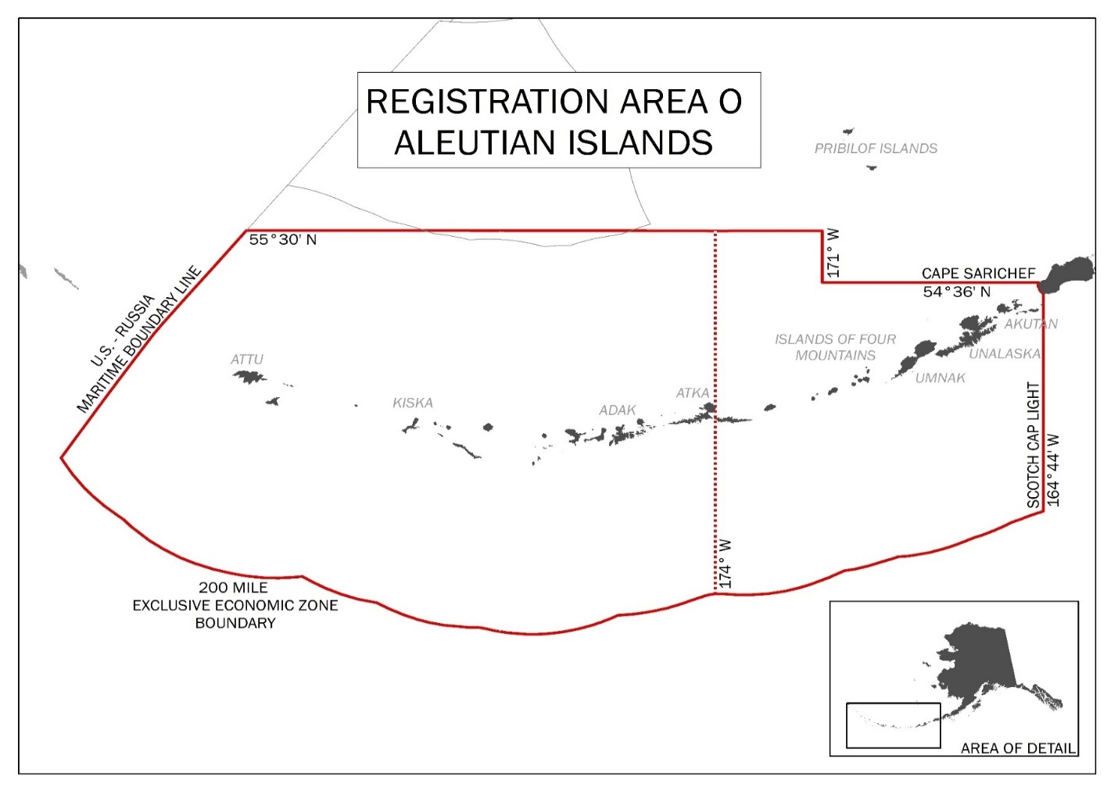
Figure 1. Aleutian Islands, Area O, red and golden king crab management area (from Nichols et al. 2021).

Figure 2. Adak (Area R) and Dutch Harbor (Area O) king crab registration area and districts, 1984/85–1995/96 seasons (Leon et al. 2017).

Figure 3. Percent of total 1981/82–1995/96 golden king crab retained catch weight (harvest) from one-degree longitude intervals in the Aleutian Islands, with dotted line denoting the border at 171° W longitude used during the 1984/85–1995/96 seasons to divide fishery management between the Dutch Harbor Area (east of 171° W longitude) and the Adak Area (west of 171° W longitude) and solid line denoting the border at 174° W longitude used since the 1996/97 season to manage crab east and west of 174° W longitude (adapted from Figure 4-2 in Morrison et al. 1998).

Figure 4. Retained catch (t) of golden king crab within one-degree longitude intervals in the Aleutian Islands during the 2000/01 through 2020/21 commercial fishery seasons; solid line denotes the border at 174° W longitude that has been used since the 1996/97 season to manage Aleutian Island golden king crab as separate stocks east and west of 174° W longitude and dashed line denotes the border at 171° W longitude used during the 1984/85–1995/96 seasons to divide fishery management between the Dutch Harbor Area (east of 171° W longitude) and the Adak Area (west of 171° W longitude).

Figure 5. Average golden king crab CPUE (kg/nm2) for tows, number of tows, and average depth of tows from one-degree longitude intervals during the 2002, 2004, 2006, 2010, and 2012 NMFS Aleutian Islands bottom trawl surveys; preliminary summary of data obtained on 1 April 2013 from http://www.afsc.noaa.gov/RACE/groundfish/survey_data/default.htm.

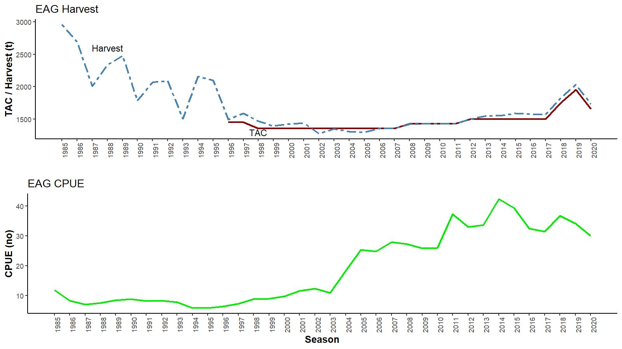

Figure 6. Historical commercial harvest (from fish tickets; metric tons), total allowable catch (TAC), and catch-per-unit effort (CPUE, number of crab per pot lift) of golden king crab in the EAG, 1985/86–2020/21 fisheries (note: 1985 refers to the 1985/86 fishing year).

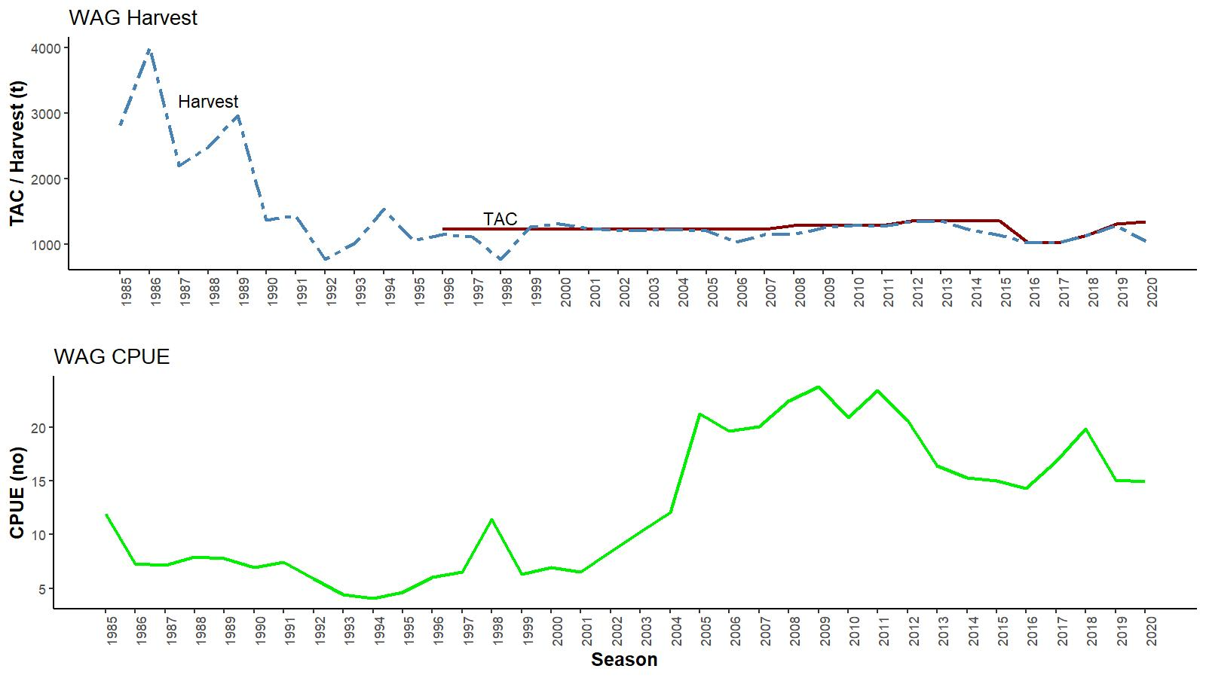
Figure 7. Historical commercial harvest (from fish tickets; metric tons) ), total allowable catch (TAC), and catch-per-unit effort (CPUE, number of crab per pot lift) of golden king crab in the WAG, 1985/86–2019/20 fisheries (note: 1985 refers to the 1985/86 fishing year).

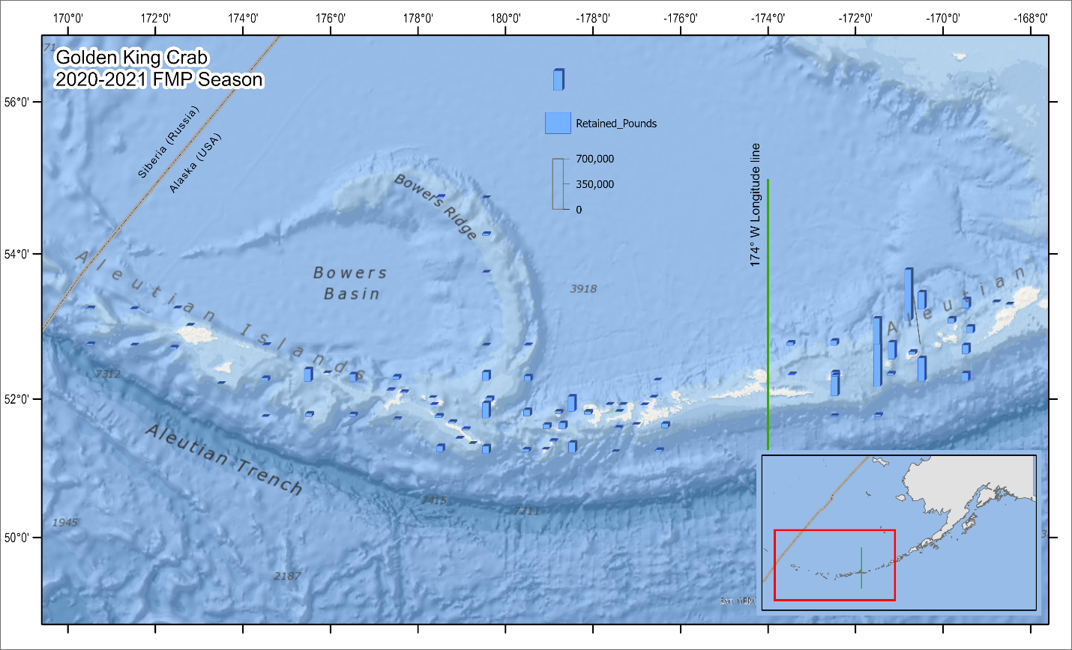

Figure 8. Catch distribution by statistical area.in 2020/21.

Figure 9a. Predicted vs. observed retained catch relative length frequency distributions under model 21.1a for golden king crab in the EAG, 1985/86 to 2020/21. Each year has a pair of plots with the front plot for observed and the back plot for predicted proportions.

Figure 9b. Predicted vs. observed retained catch relative length frequency distributions under model 21.1b for golden king crab in the EAG, 1985/86 to 2020/21. Each year has a pair of plots with the front plot for observed and the back plot for predicted proportions.

Figure 9c. Predicted vs. observed retained catch relative length frequency distributions under model 21.1c for golden king crab in the EAG, 1985/86 to 2020/21. Each year has a pair of plots with the front plot for observed and the back plot for predicted proportions.

Figure 10a. Predicted vs. observed total catch relative length frequency distributions under model 21.1a for golden king crab in the EAG, 1990/91 to 2020/21. Each year has a pair of plots with the front plot for observed and the back plot for predicted proportions.

Figure 10b. Predicted vs. observed total catch relative length frequency distributions under model 21.1b for golden king crab in the EAG, 1990/91 to 2020/21. Each year has a pair of plots with the front plot for observed and the back plot for predicted proportions.

Figure 10c. Predicted vs. observed total catch relative length frequency distributions under model 21.1c for golden king crab in the EAG, 1990/91 to 2020/21. Each year has a pair of plots with the front plot for observed and the back plot for predicted proportions.

Figure 11. Predicted vs. observed groundfish discarded bycatch relative length frequency distributions under model 21.1a for golden king crab in the EAG, 1989/90 to 2020/21. Each year has a pair of plots with the front plot for observed and the back plot for predicted proportions.

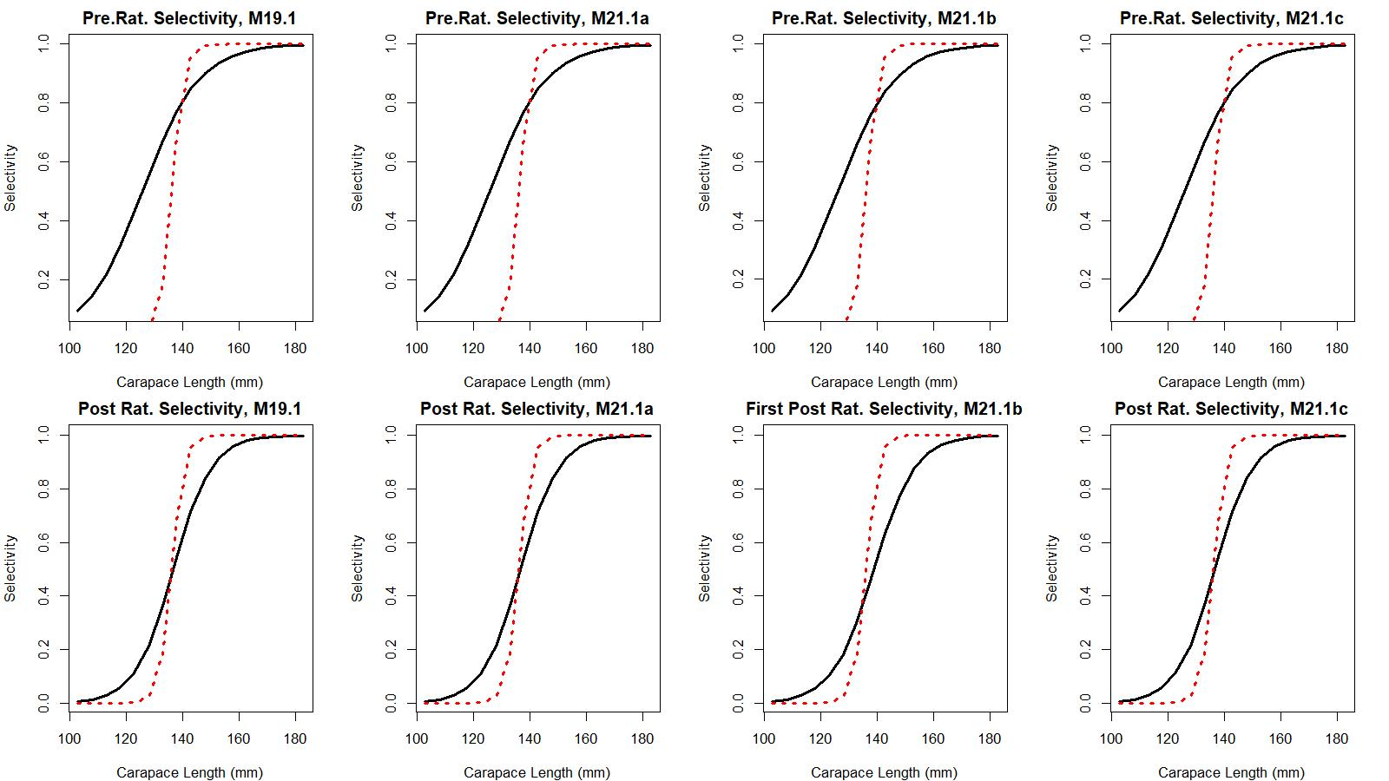
Figure 12a. Estimated total (black solid line) and retained selectivity (red dotted line) for pre- and post- rationalization periods under models 19.1, 21.1a, 21.1b, and 21.1c fits to golden king crab data in the EAG. The post-rationalization total selectivity for 21.1b corresponds to first part (2005–2015) of the post-rationalization period.

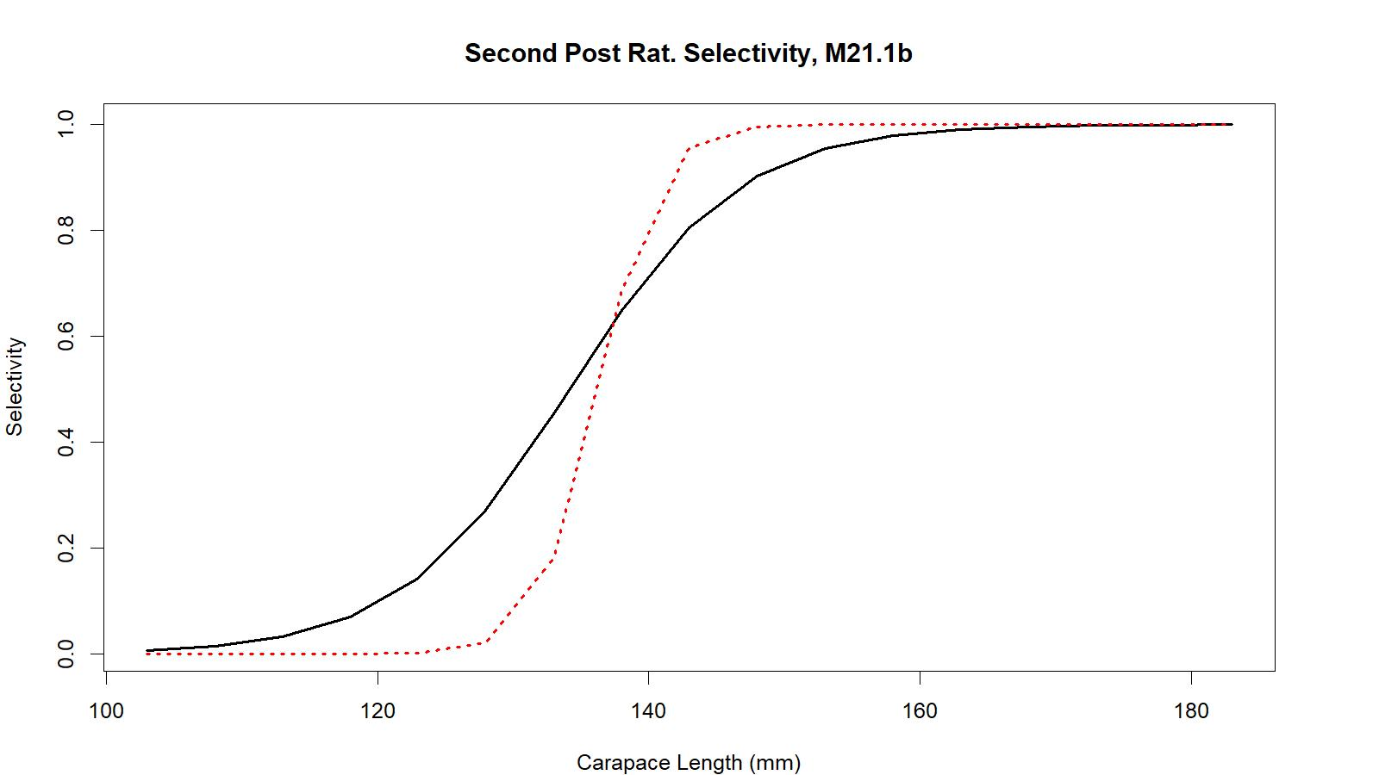
Figure 12b. Estimated total (black solid line) and retained selectivity (red dotted line) for second part (2016–2020) of the post- rationalization period under model 21.1b fit to golden king crab data in the EAG.

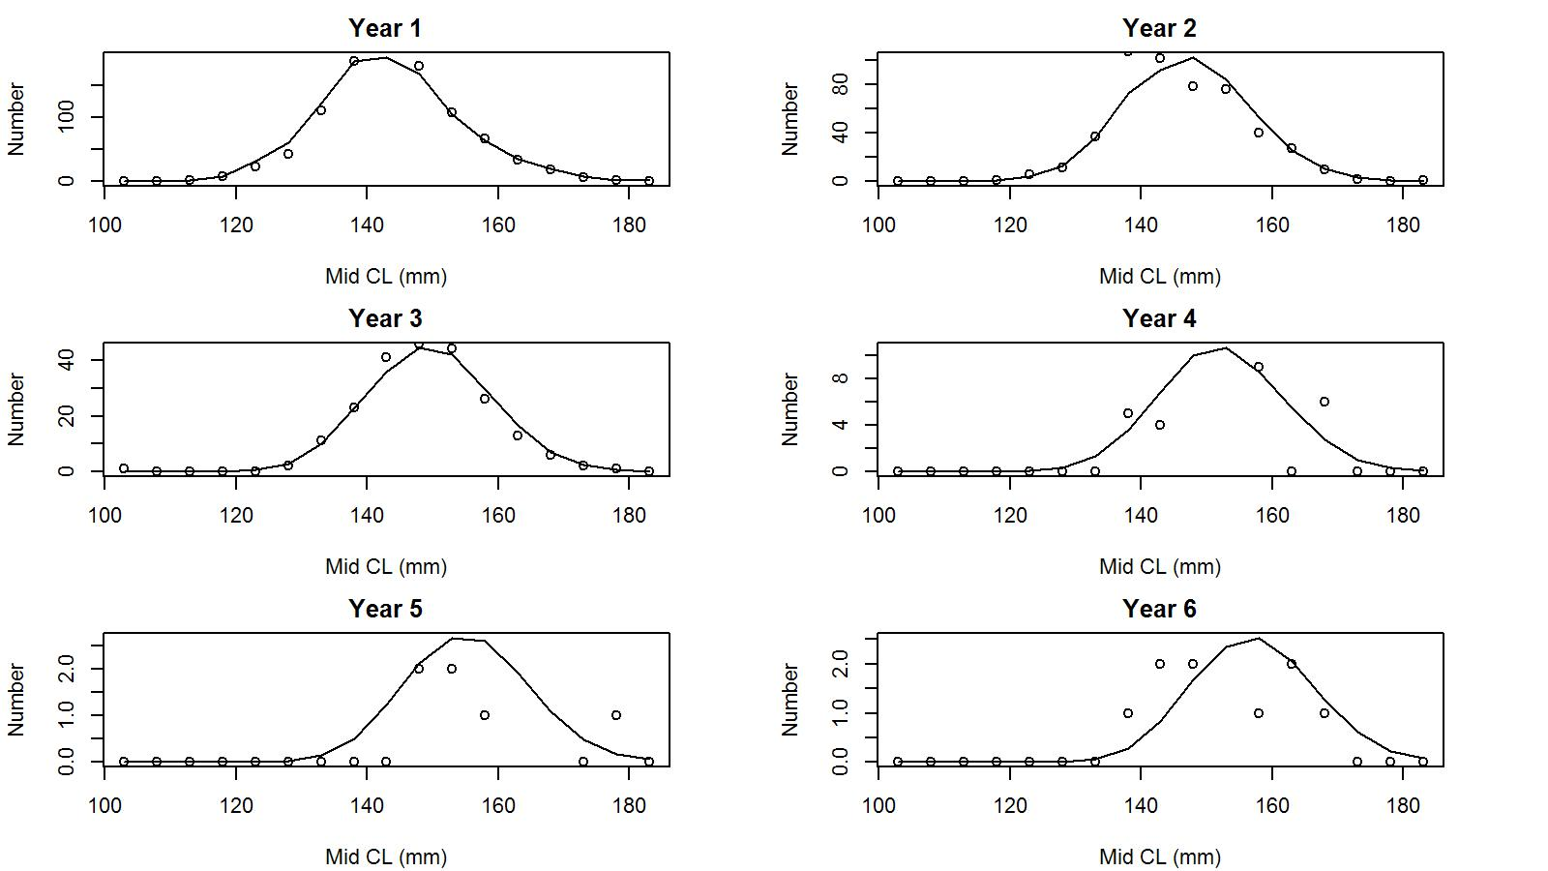
Figure 13. Observed (open circles) vs. predicted (solid line) tag recaptures by size bin for years 1 to 6 post tagging under model 21.1a for EAG golden king crab.

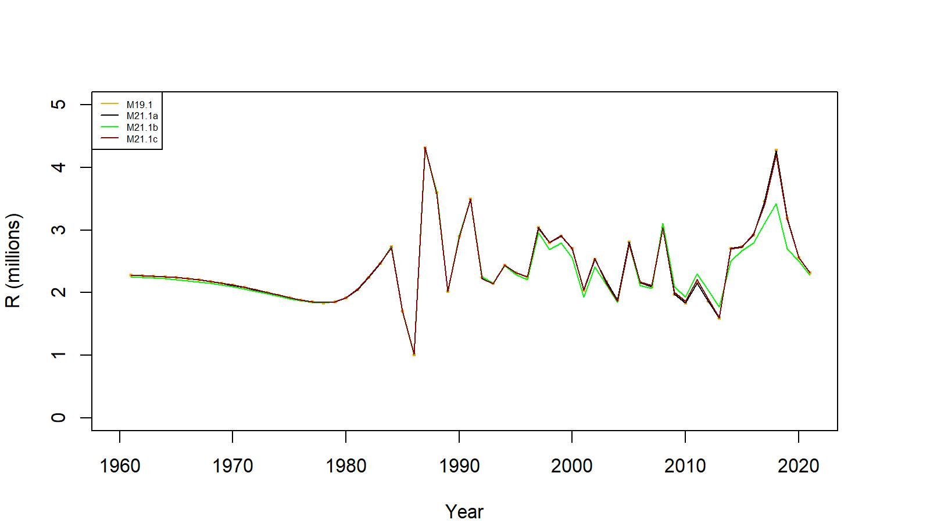

Figure 14. Estimated number of male recruits (crab size ≥ 101 mm CL) to the assessment model under models 19.1, 21.1a, 21.1b, and 21.1c fits to EAG golden king crab data, 1961–2021.

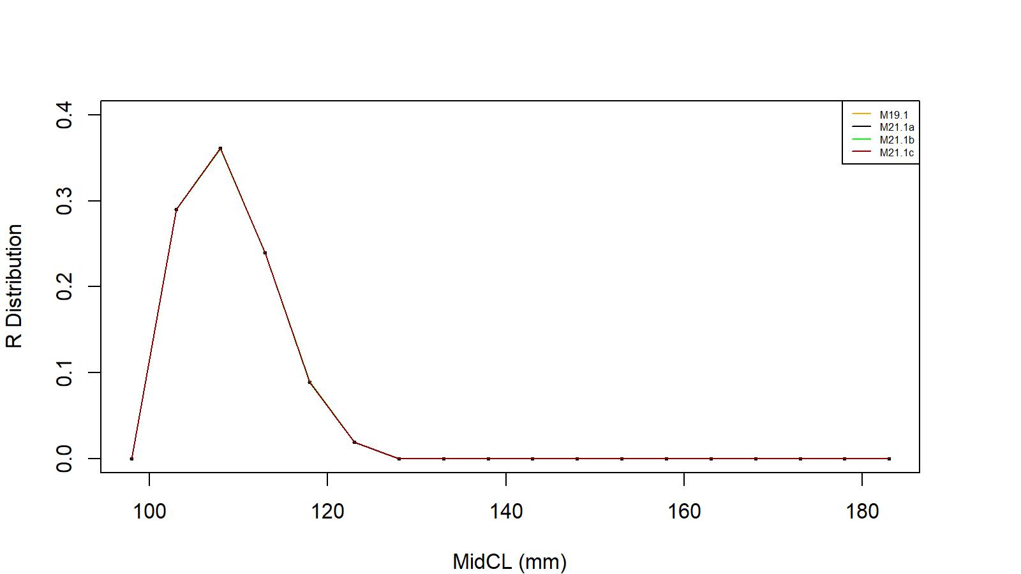
Figure 15. Recruit size distribution to the assessment model under models 19.1, 21.1a, 21.1b, and 21.1c fits to EAG golden king crab data.

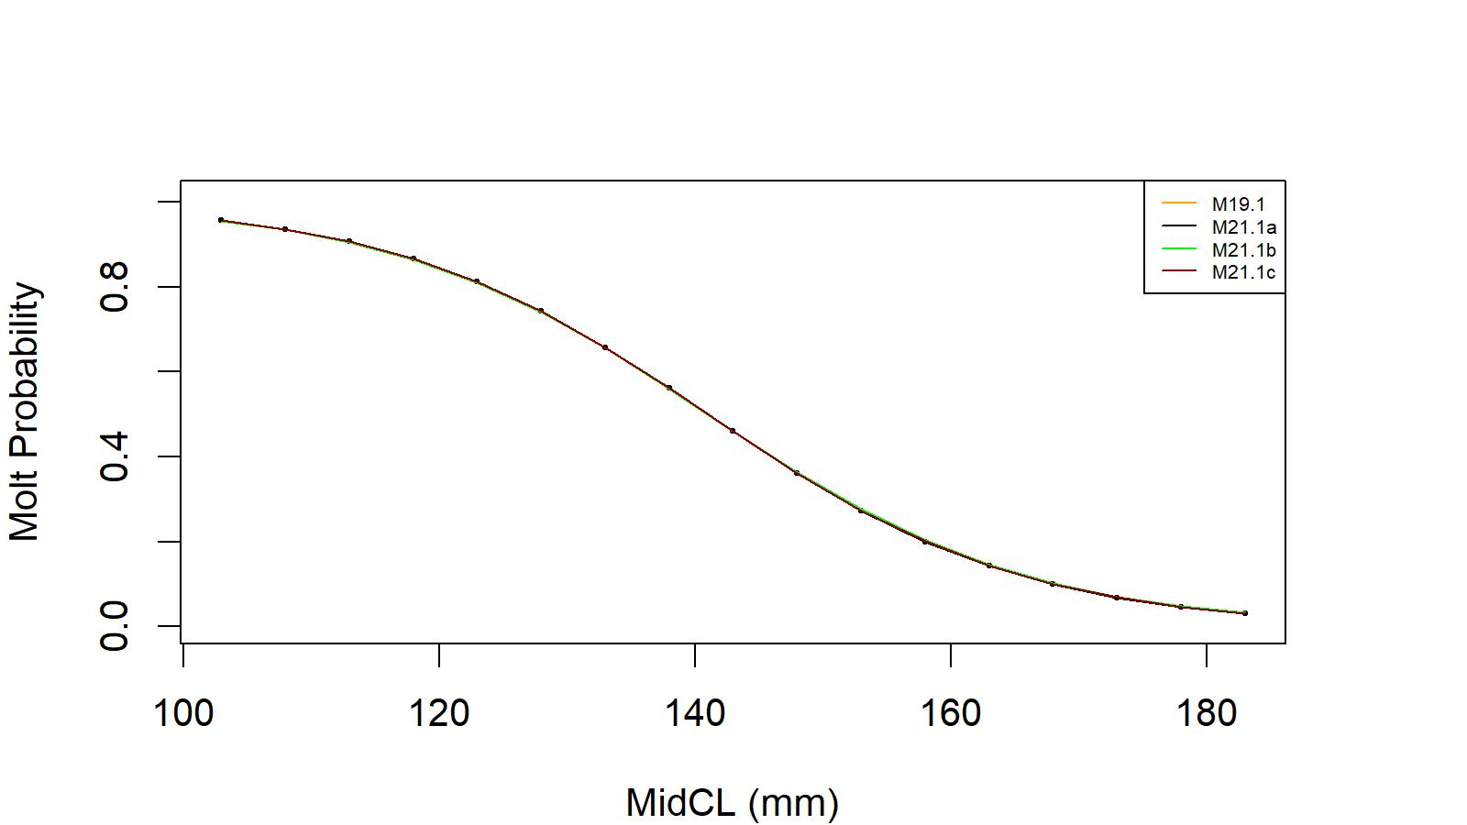
Figure 16. Estimated molt probability vs. carapace length of golden king crab under models 19.1, 21.1a, 21.1b, and 21.1c fits to EAG golden king crab data.

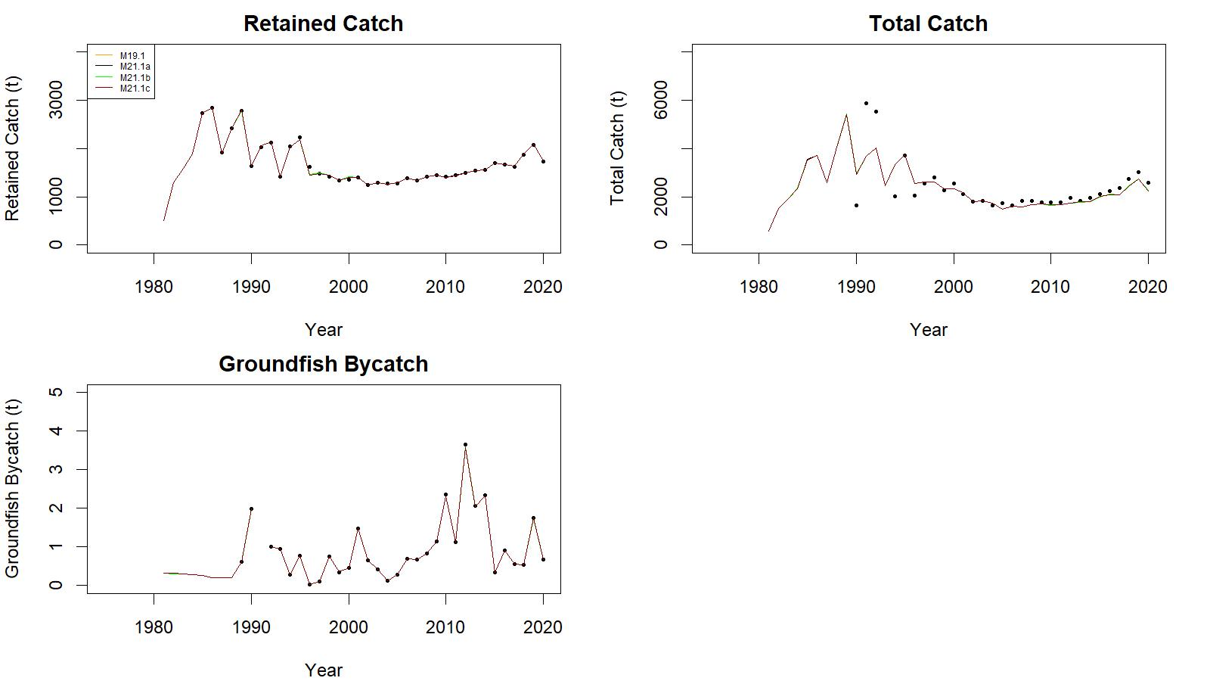

Figure 17. Observed (open circle) vs. predicted (solid line) retained catch (top left), total catch (top right in), and groundfish bycatch (bottom left) of golden king crab under models 19.1, 21.1a, 21.1b, and 21.1c fits in EAG, 1981/82–2020/21.

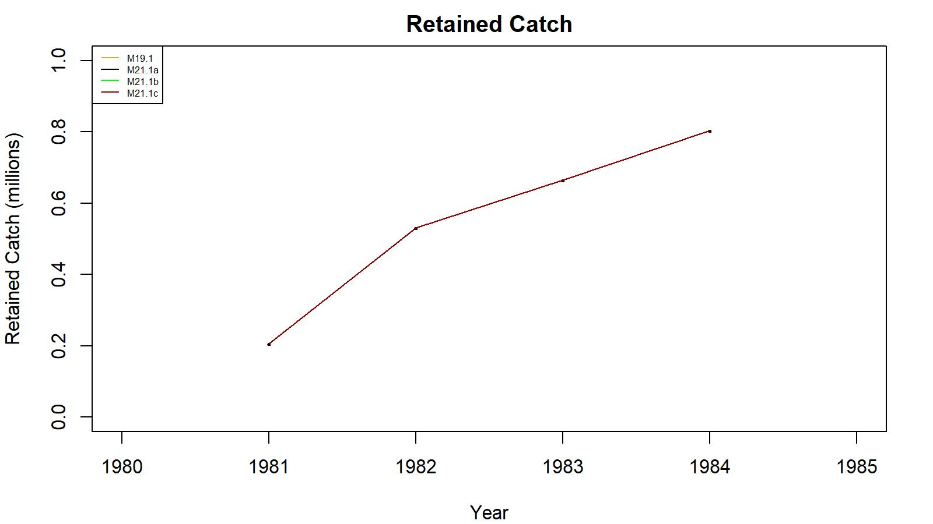
Figure 18. Observed (open circle) vs. predicted (solid line) retained catch of golden king crab for models 19.1, 21.1a, 21.1b, and 21.1c fits in the EAG, 1981/82–1984/85. Note: Input retained catches to the model during pre-1985 fishery period was in number of crabs.

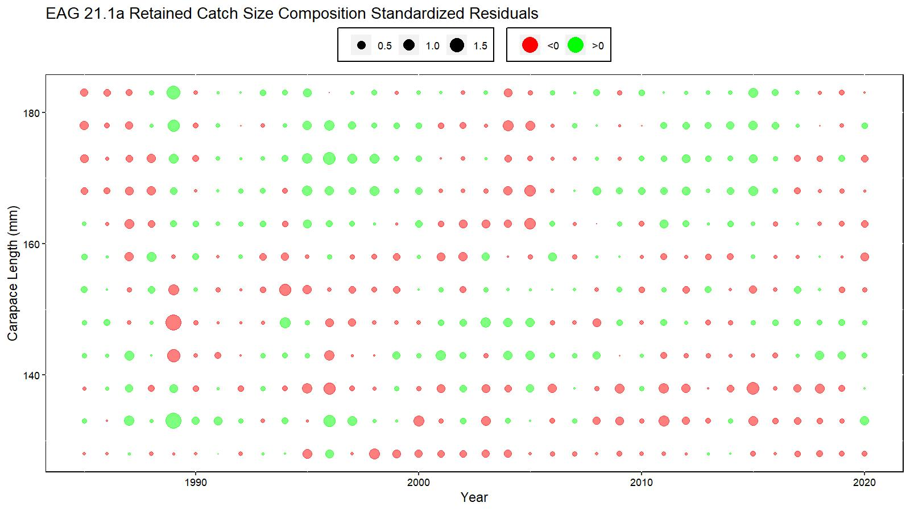
Figure 19. Bubble plot of standardized residuals of retained catch length composition for model 21.1a fit for EAG golden king crab, 1985/86–2020/21. Green circles are the positive and pink circles are the negative standardized residuals. The area of the circle is the relative magnitude of the residual.
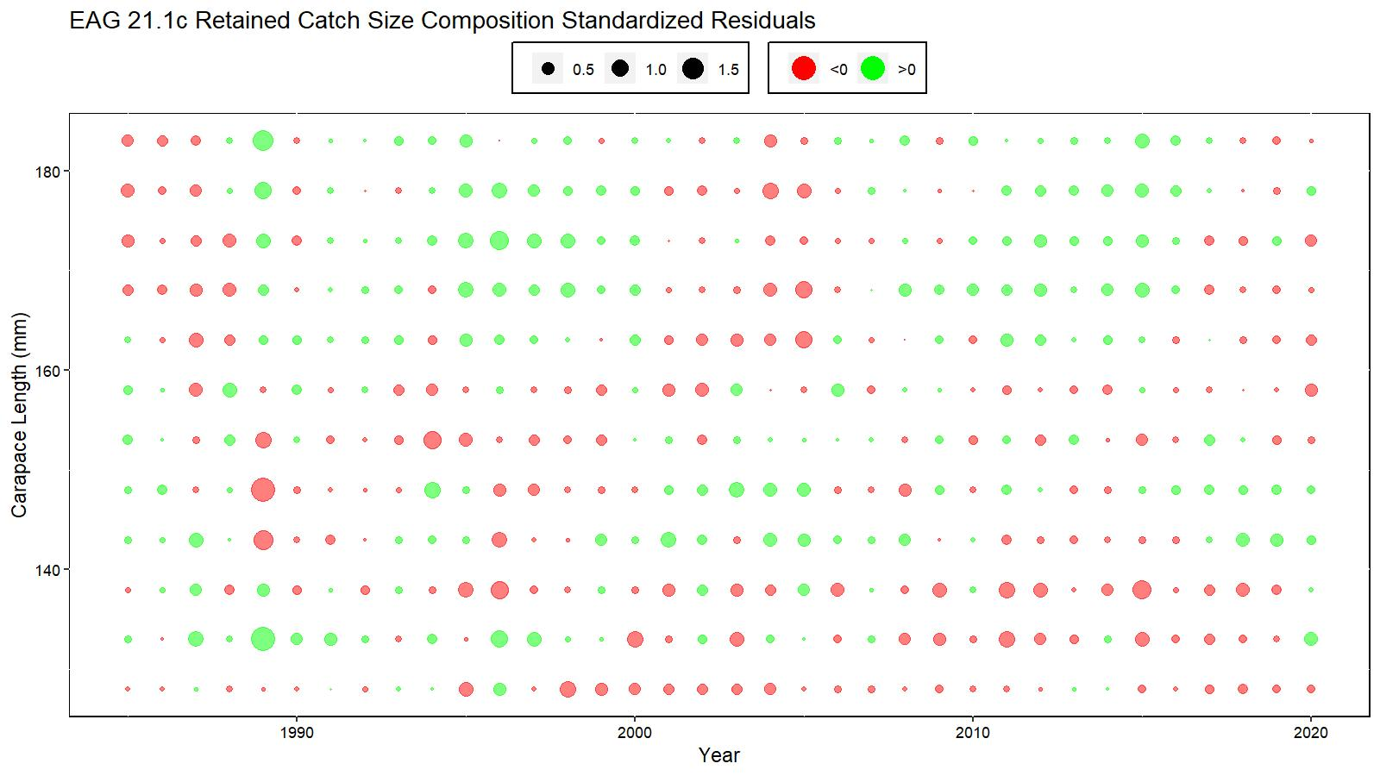
Figure 20. Bubble plot of standardized residuals of retained catch length composition for model 21.1c fit for EAG golden king crab, 1985/86–2020/21. Green circles are the positive and pink circles are the negative standardized residuals. The area of the circle is the relative magnitude of the residual.

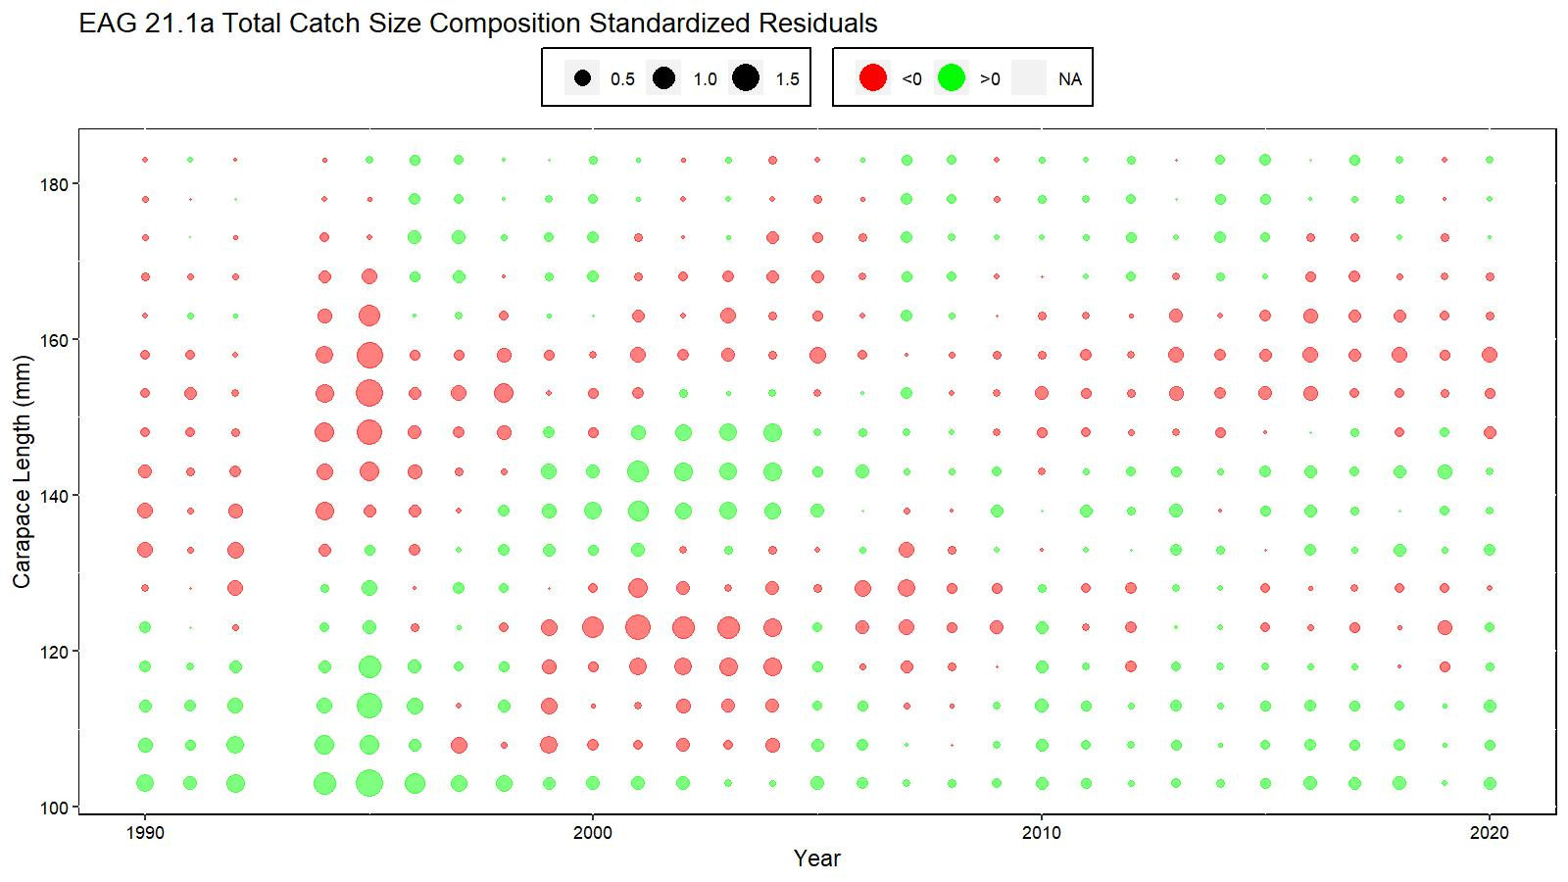
Figure 21. Bubble plot of standardized residuals of total catch length composition for model 21.1a fit for EAG golden king crab, 1990/91–2020/21. Green circles are the positive and pink circles are the negative standardized residuals. The area of the circle is the relative magnitude of the residual.
Figure 22. Bubble plot of standardized residuals of total catch length composition for model 21.1c fit for EAG golden king crab, 1990/91–2020/21. Green circles are the positive and pink circles are the negative standardized residuals. The area of the circle is the relative magnitude of the residual.

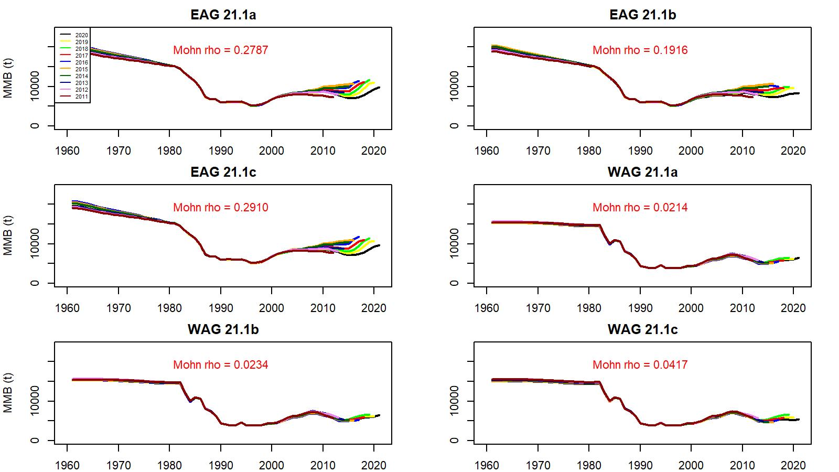

Figure 23. Retrospective fits of MMB by the model following removal of terminal year data under models 21.1a, 21.1b, and 21.1c for golden king crab in the EAG and WAG, 1960/61–2020/21.

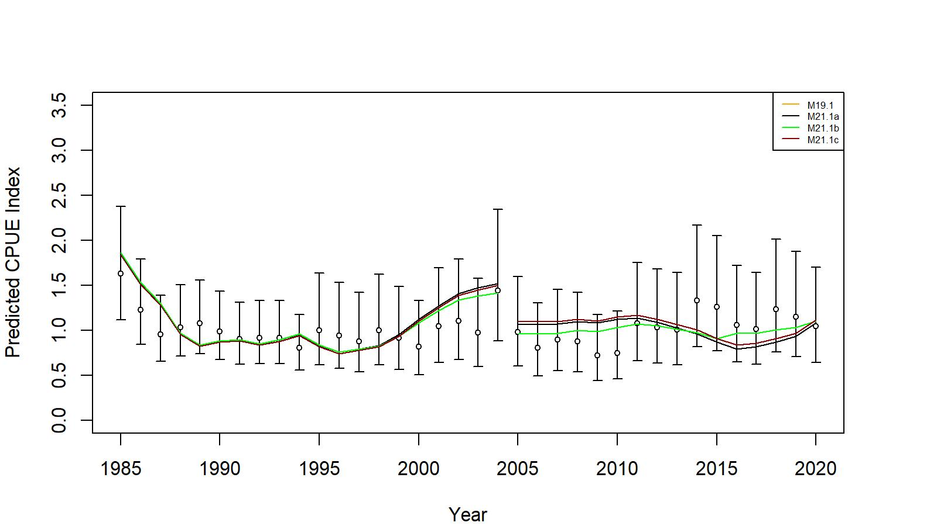
Figure 24. Comparison of input CPUE indices (open circles with +/- 2 SE for model 19.1) with predicted CPUE indices (colored solid lines) under 19.1, 21.1a, 21.1b, and 21.1c for EAG golden king crab data, 1985/86–2020/21. Model estimated additional standard error was added to each input standard error.

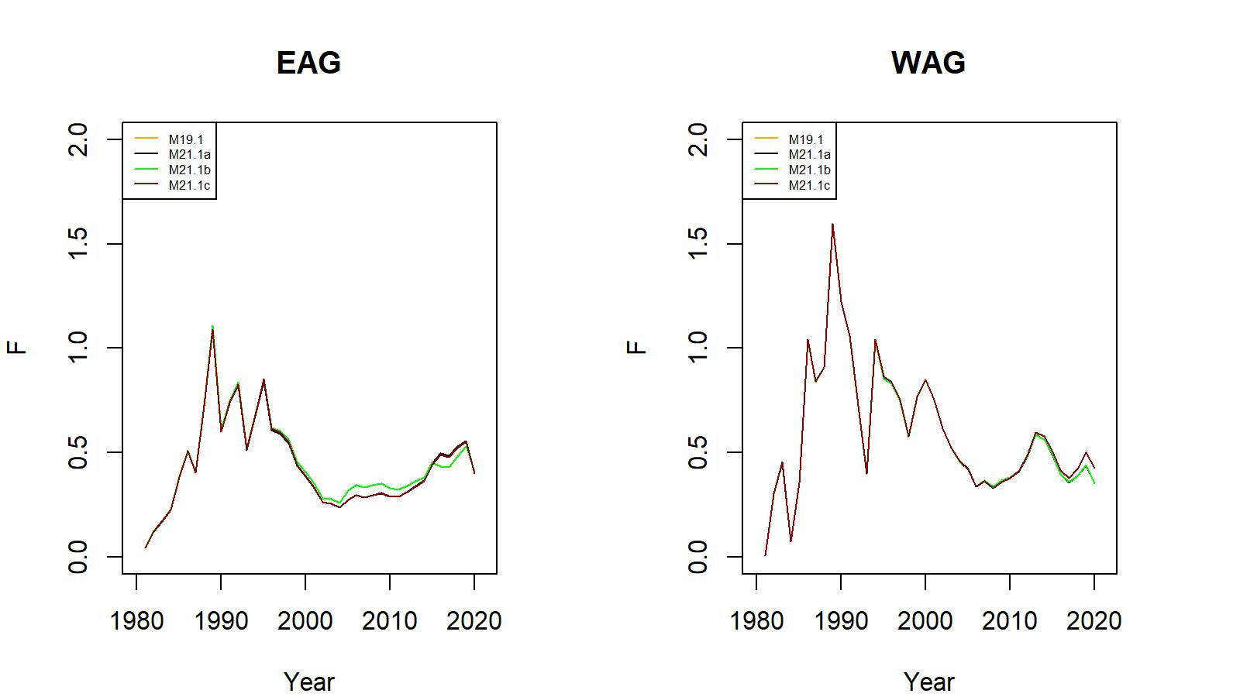
Figure 25. Trends in pot fishery full selection total fishing mortality of golden king crab for models 19.1, 21.1a, 21.1b, and 21.1c fits in the EAG (left) and WAG (right) data, 1981/82–2020/21.

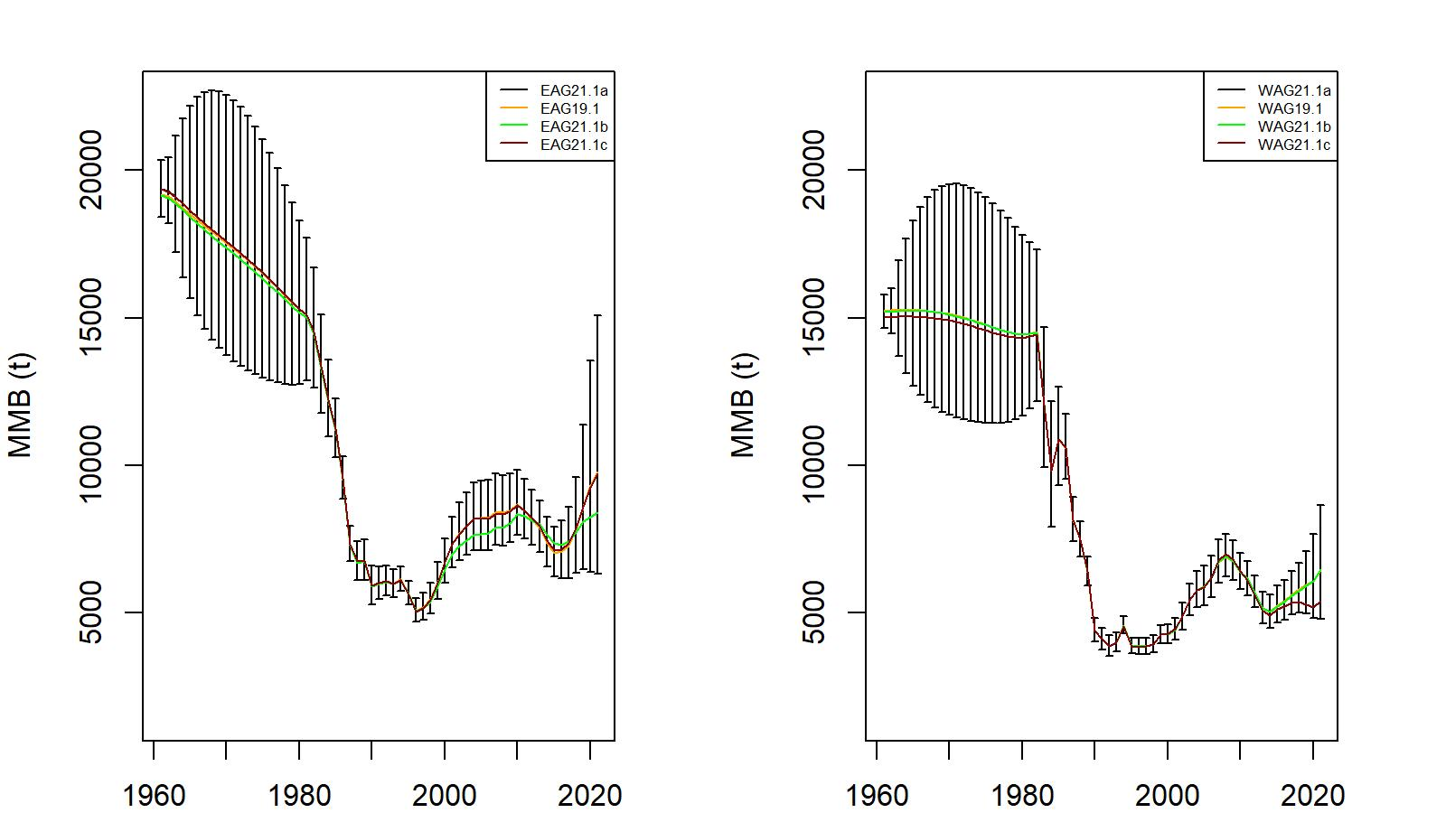
Figure 26. Trends in golden king crab mature male biomass for models 19.1, 21.1a, 21.1b, and 21.1c fits to EAG (left) and WAG (right) data, 1961–2021. Model 21.1a estimate has two standard error confidence limits. Year 2021 refers to 2020/21 fishing season.

Figure 27a. Predicted vs. observed retained catch relative length frequency distributions under model 21.1a for golden king crab in the WAG, 1985/86 to 2020/21. Each year has a pair of plots with the front plot for observed and the back plot for predicted proportions.

Figure 27b. Predicted vs. observed retained catch relative length frequency distributions under model 21.1b for golden king crab in the WAG, 1985/86 to 2020/21. Each year has a pair of plots with the front plot for observed and the back plot for predicted proportions.

Figure 27c. Predicted vs. observed retained catch relative length frequency distributions under model 21.1c for golden king crab in the WAG, 1985/86 to 2020/21. Each year has a pair of plots with the front plot for observed and the back plot for predicted proportions.

Figure 28a. Predicted vs. observed total catch relative length frequency distributions under model 21.1a for golden king crab in the WAG, 1990/91 to 2020/21. Each year has a pair of plots with the front plot for observed and the back plot for predicted proportions.
Figure 28b. Predicted vs. observed total catch relative length frequency distributions under model 21.1b for golden king crab in the WAG, 1990/91 to 2020/21. Each year has a pair of plots with the front plot for observed and the back plot for predicted proportions.
Figure 28c. Predicted vs. observed total catch relative length frequency distributions under model 21.1c for golden king crab in the WAG, 1990/91 to 2020/21. Each year has a pair of plots with the front plot for observed and the back plot for predicted proportions.

Figure 29. Predicted vs. observed groundfish discarded bycatch relative length frequency distributions under model 21.1a for golden king crab in the WAG, 1989/90 to 2020/21. Each year has a pair of plots with the front plot for observed and the back plot for predicted proportions.

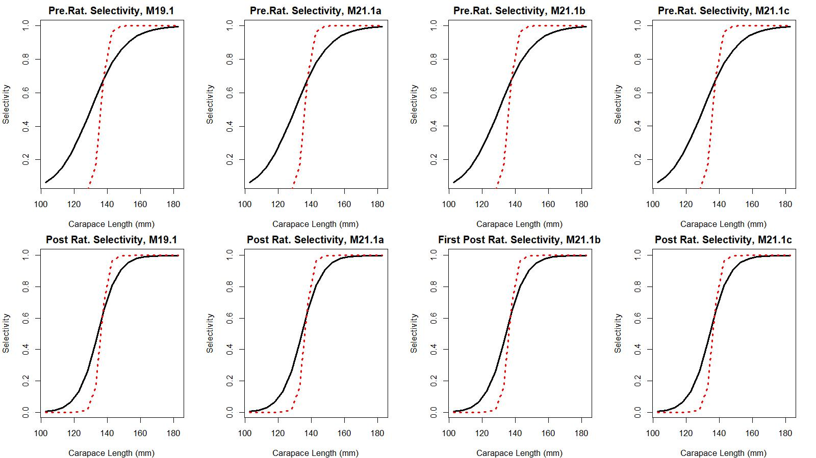

Figure 30a. Estimated total (black solid line) and retained selectivity (red dotted line) for pre- and post- rationalization periods under models 19.1, 21.1a, 21.1b, and 21.1c fits to golden king crab data in the WAG. The post-rationalization total selectivity for 21.1b corresponds to first part (2005–2015) of the post-rationalization period.

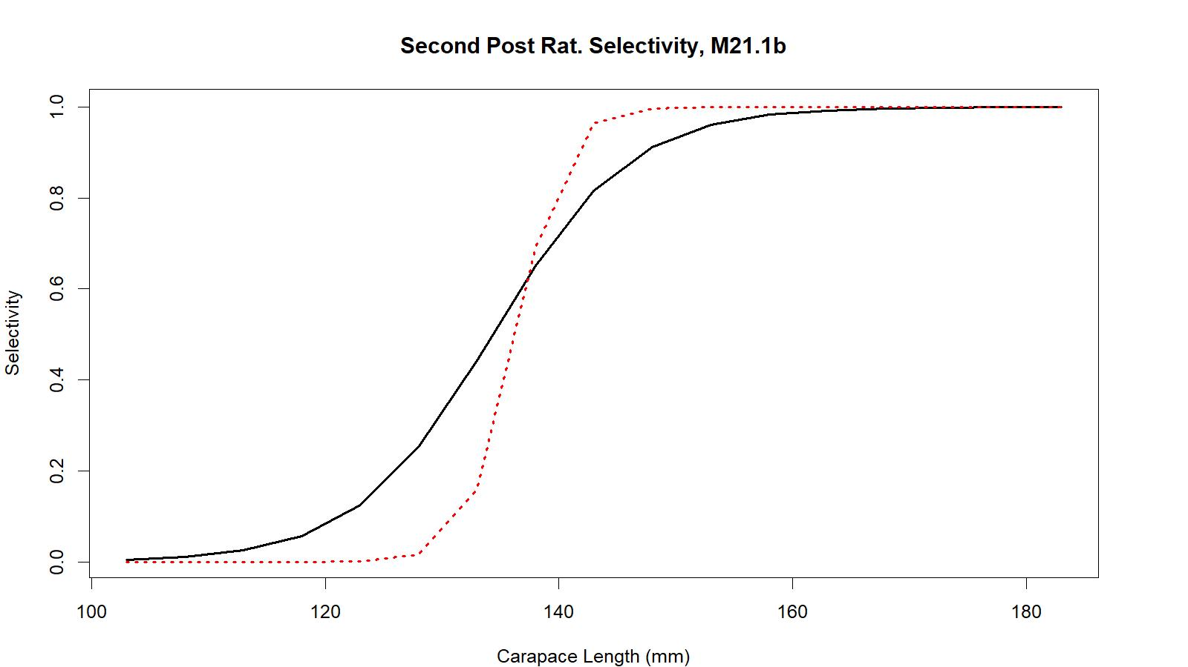
Figure 30b. Estimated total (black solid line) and retained selectivity (red dotted line) for second part (2016–2020) of the post- rationalization period under model 21.1b fit to golden king crab data in the WAG.

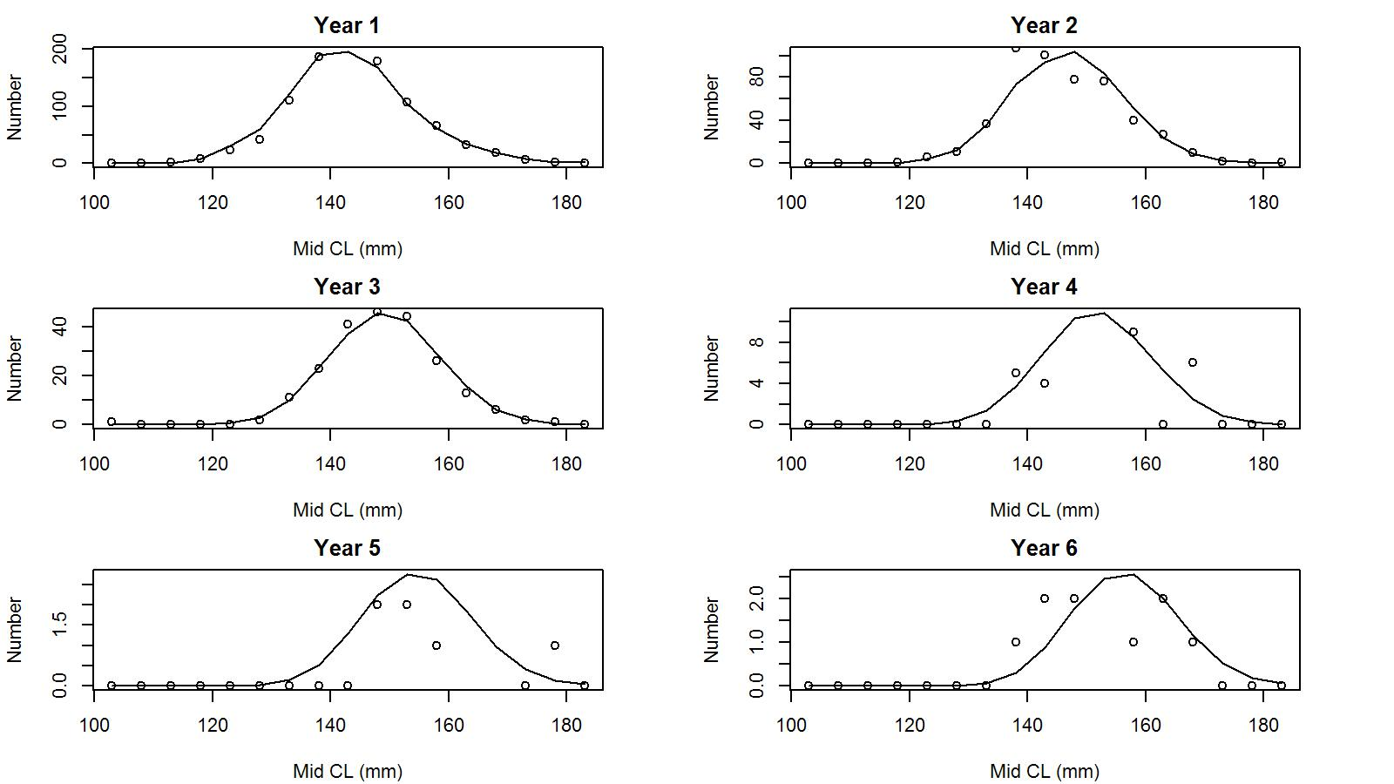

Figure 31. Observed (open circles) vs. predicted (solid line) tag recaptures by size bin for years 1 to 6 post tagging under model 21.1a fit to WAG golden king crab data.

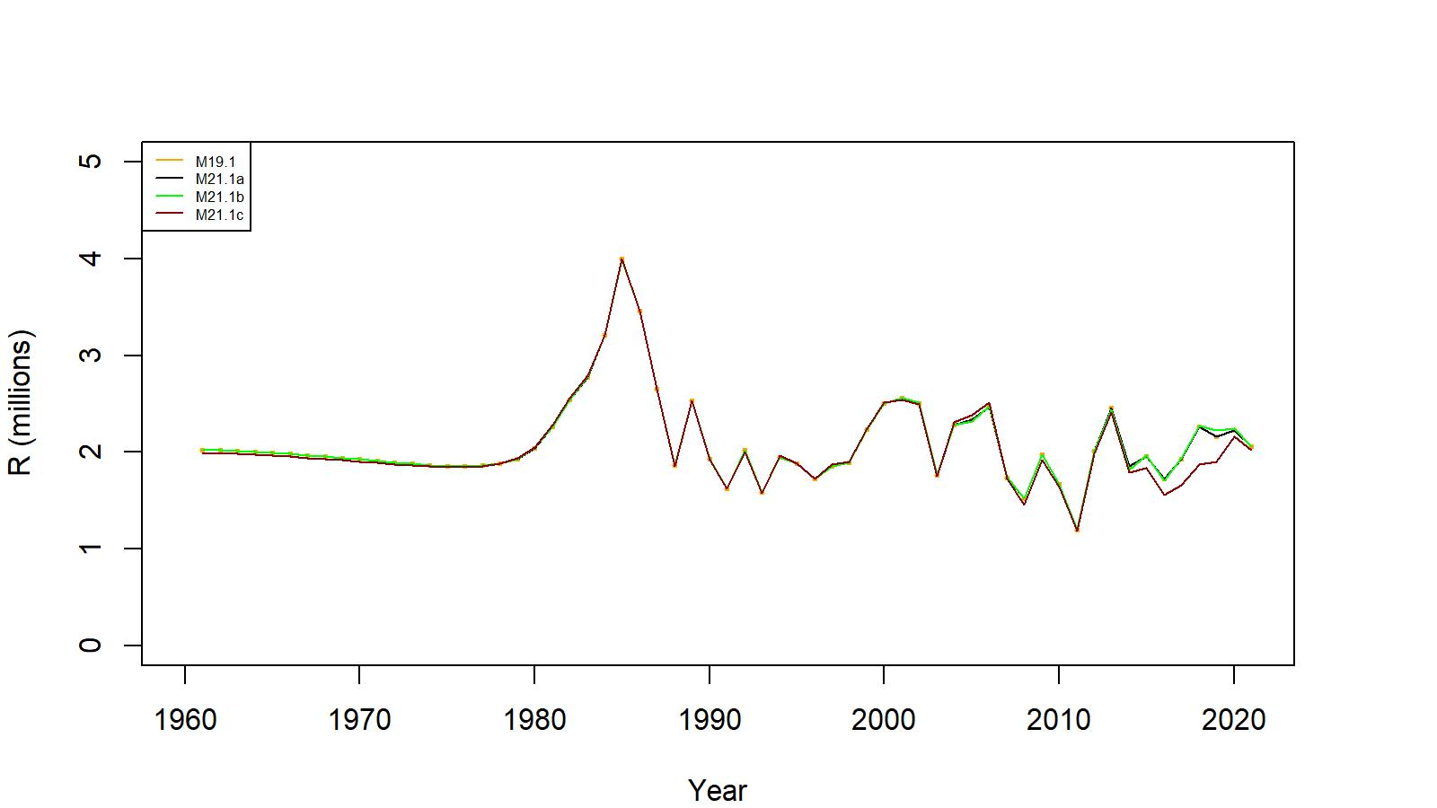
Figure 32. Estimated number of male recruits (crab size ≥ 101 mm CL) to the assessment model under models 19.1, 21.1a, 21.1b, and 21.1c fits to WAG golden king crab data, 1961–2021.

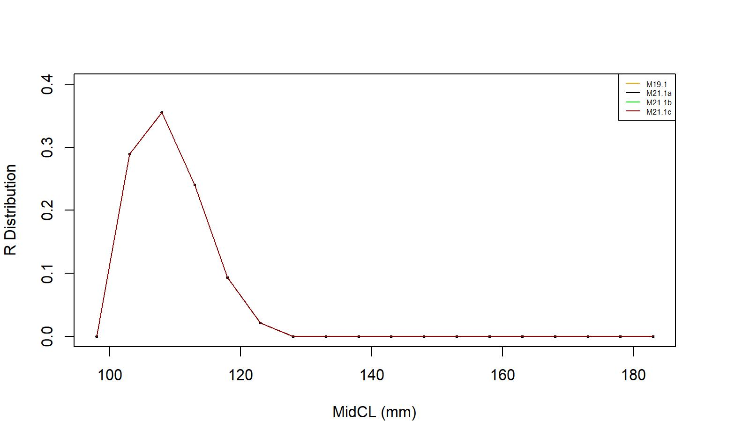

Figure 33. Recruit size distribution to the assessment model under models 19.1, 21.1a, 21.1b, and 21.1c fits to WAG golden king crab data.

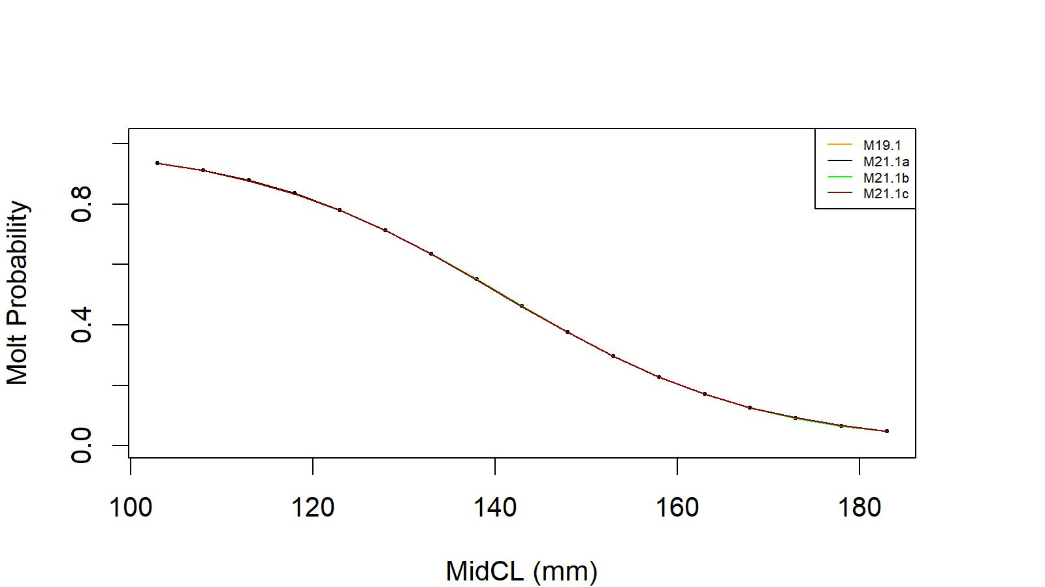

Figure 34. Estimated molt probability vs. carapace length of golden king crab for models 19.1, 21.1a, 21.1b, and 21.1c fits to WAG golden king crab data.

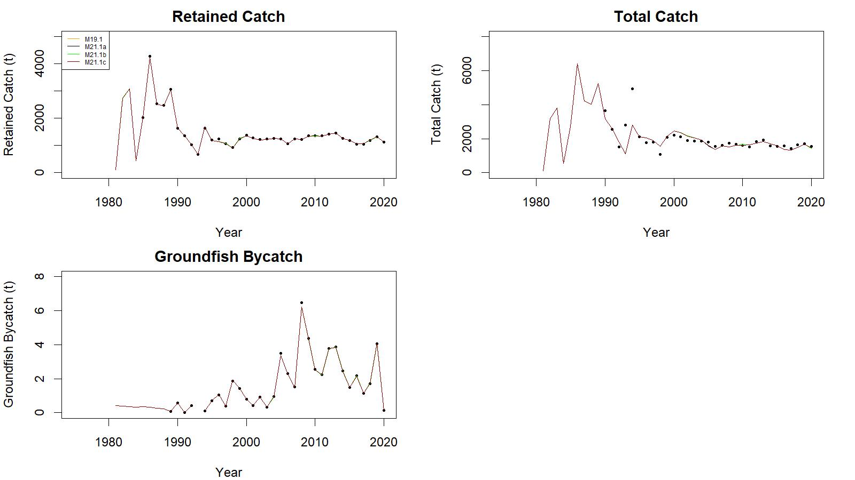

Figure 35. Observed (open circle) vs. predicted (solid line) retained catch (top left), total catch (top right), and groundfish bycatch (bottom left) of golden king crab for models 19.1, 21.1a, 21.1b, and 21.1c fits to WAG data, 1981/82–2020/21.

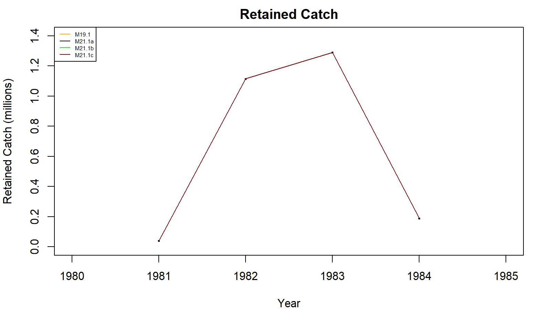
Figure 36. Observed (open circle) vs. predicted (solid line) retained catch of golden king crab for models 19.1, 21.1a, 21.1b, and 21.1c fits to WAG data, 1981/82–1984/85. Note: Input retained catches to the model during pre-1985 fishery period was in number of crabs.

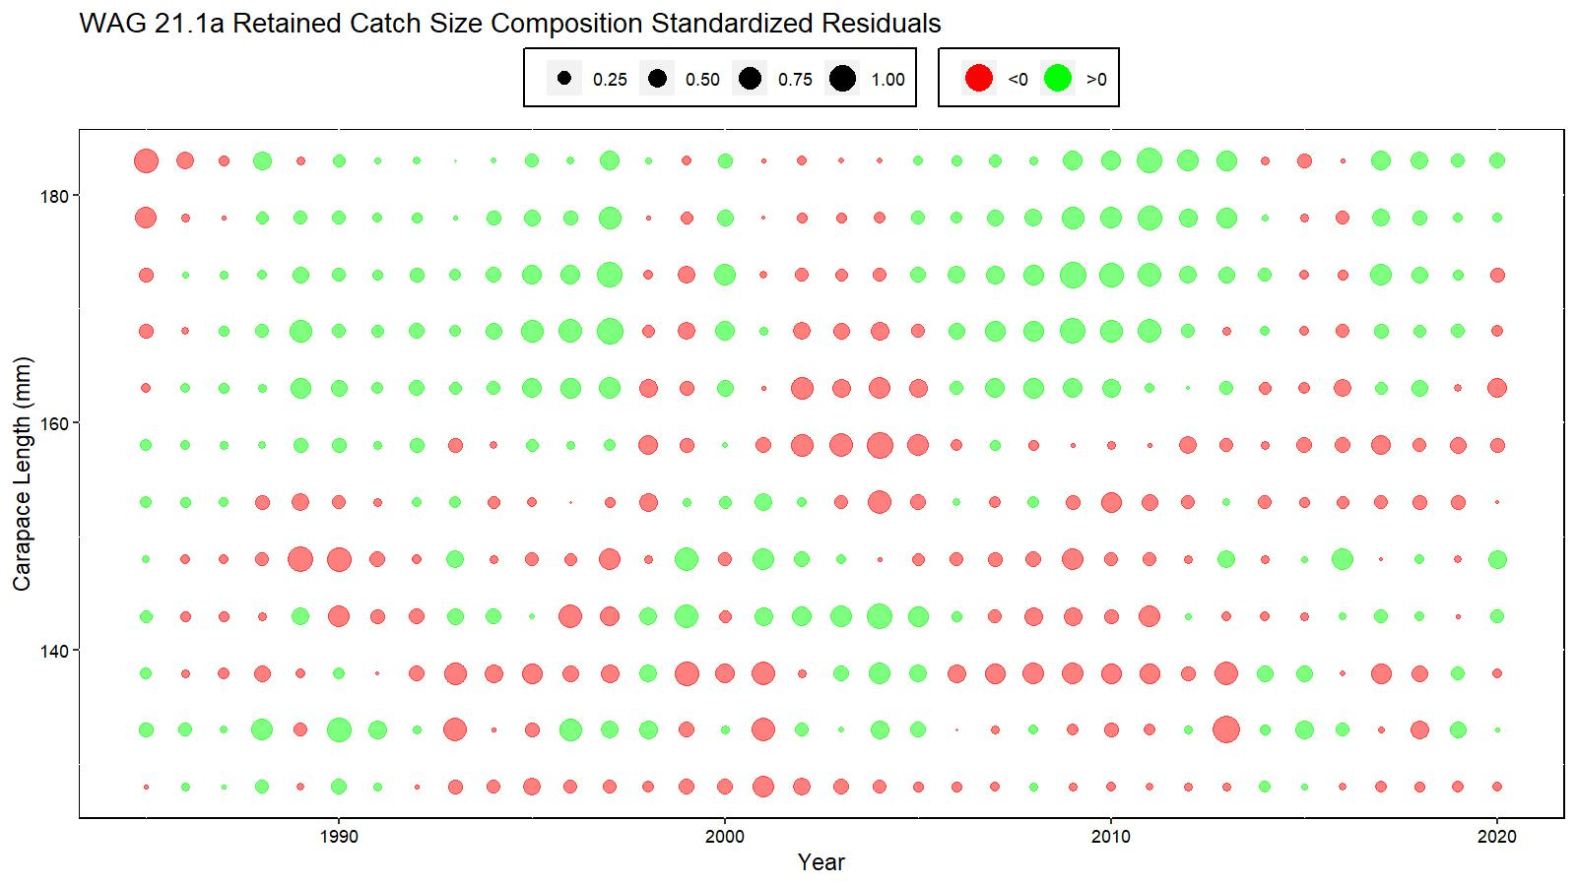
Figure 37. Bubble plot of standardized residuals of retained catch length composition for model 21.1a fit to WAG golden king crab data, 1985/86–2020/21. Green circles are the positive and pink circles are the negative standardized residuals. The area of the circle is the relative magnitude of the residual.

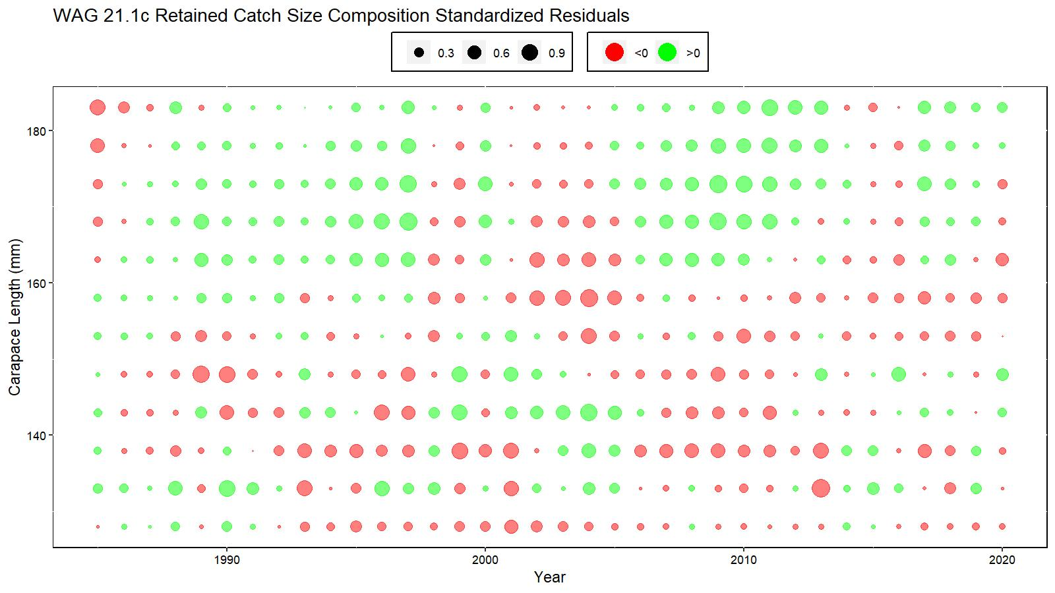
Figure 38. Bubble plot of standardized residuals of retained catch length composition for model 21.1c fit to WAG golden king crab data, 1985/86–2020/21. Green circles are the positive and pink circles are the negative standardized residuals. The area of the circle is the relative magnitude of the residual.

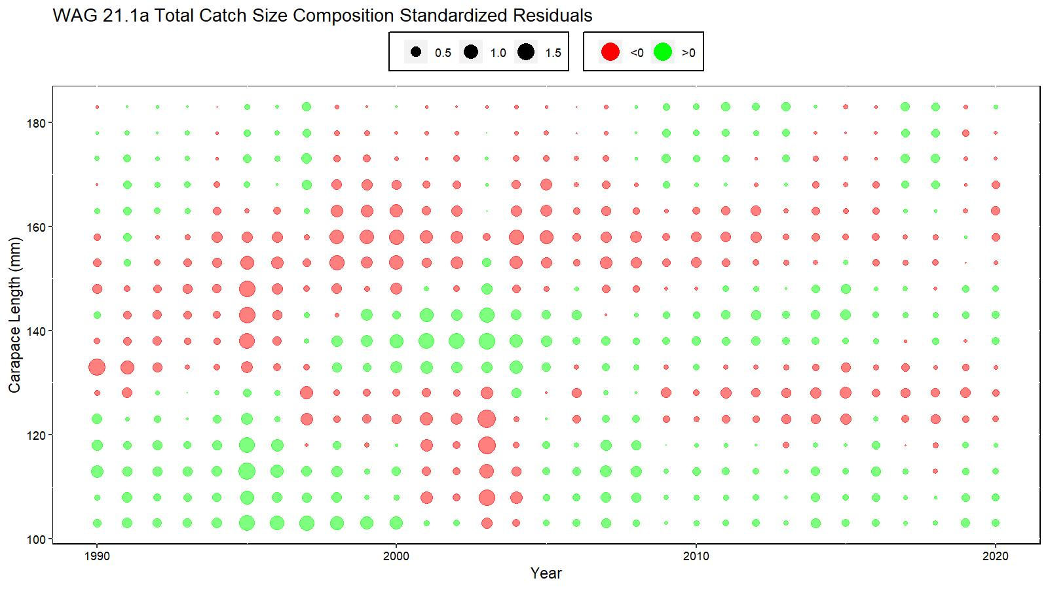
Figure 39. Bubble plot of standardized residuals of total catch length composition for model 21.1a fit to WAG golden king crab data, 1990/91–2020/21. Green circles are the positive and pink circles are the negative standardized residuals. The area of the circle is the relative magnitude of the residual.

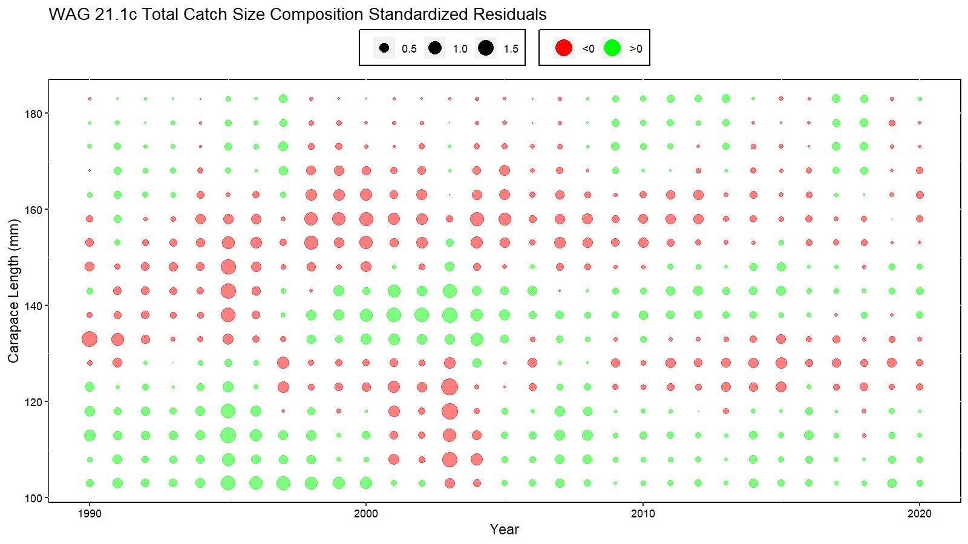
Figure 40. Bubble plot of standardized residuals of total catch length composition for model 21.1c fit to WAG golden king crab data, 1990/91–2020/21. Green circles are the positive and pink circles are the negative standardized residuals. The area of the circle is the relative magnitude of the residual.

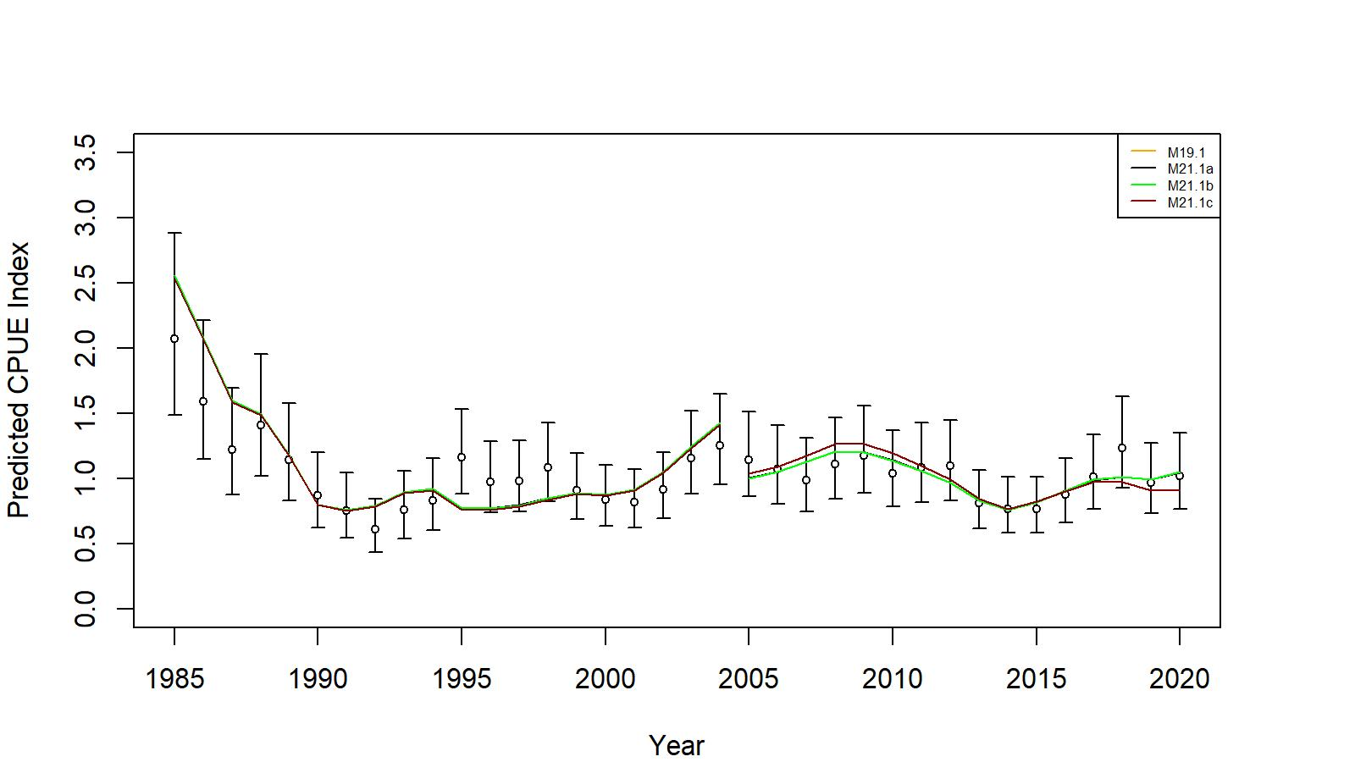
Figure 41. Comparison of input CPUE indices (open circles with +/- 2 SE for model 19.1) with model predicted CPUE indices (colored solid lines) under models 19.1, 21.1a, 21.1b, and 21.1c fits to WAG golden king crab data, 1985/86–2020/21. Model estimated additional standard error was added to each input standard error.

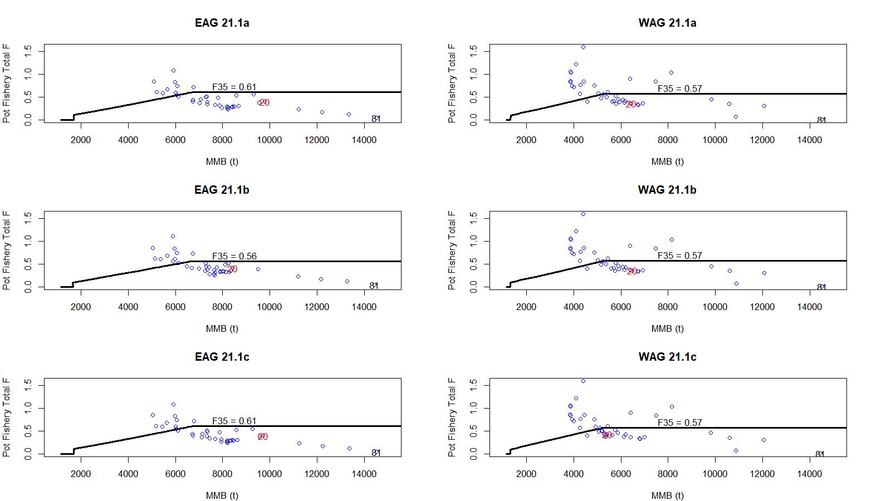
Figure 42. Relationships between full fishing mortalities for the directed pot fishery and mature male biomass during 1981/82–2020/21 under models, 21.1a, 21.1b, and 21.1c fits to EAG and WAG data. F in 2020/21 (red) and 1981/82 (black) are shown in the plots.

