
Bering Sea Fishery Ecosystem Plan:

Action Module to evaluate short- to long-term effects of climate change on fish, fisheries, and the Bering Sea Ecosystem, and develop management considerations
DRAFT Action Module Workplan
Contents
Goal 1
Introduction 2
Action Module goals and objectives 3
Objectives 4
Action Module Results/Products 6
Examples: 6
Short-term (1-3 years) 6
Medium-term (5-10 years): 7
Long-term: 7
How it will be implemented in the Council process 7
Planning and Logistics 8
How Action Module will interface with existing work 8
Action Module Taskforce 8
Deliverables and tracking progress 9
Milestones 9
References 9
Appendix 1. Action Module Scoping Summary from Core BS FEP 10

Goal
The goal of the climate change module is to support equitable climate change adaptation pathways and long-term resilience for the coupled social-ecological system of the Eastern Bering Sea. This module will support the capacity to i) evaluate management tools to develop incremental (normative) adaptation measures to preserve livelihoods, health and wellbeing across fisheries and dependent coastal communities, as well as, ii) enable transformative adaptation needed to ensure the productivity and sustainability of the coupled social-ecological Bering Sea system. To achieve this, the climate change module will be used to synthesize current knowledge regarding climate change effects on the EBS system, identify potential climate-resilient management measures that can improve adaptive capacity and avoid maladaptation (Figure 1), and evaluate the risks, timescale, and probability of success of various climate-resilient management policies under future scenarios of change.
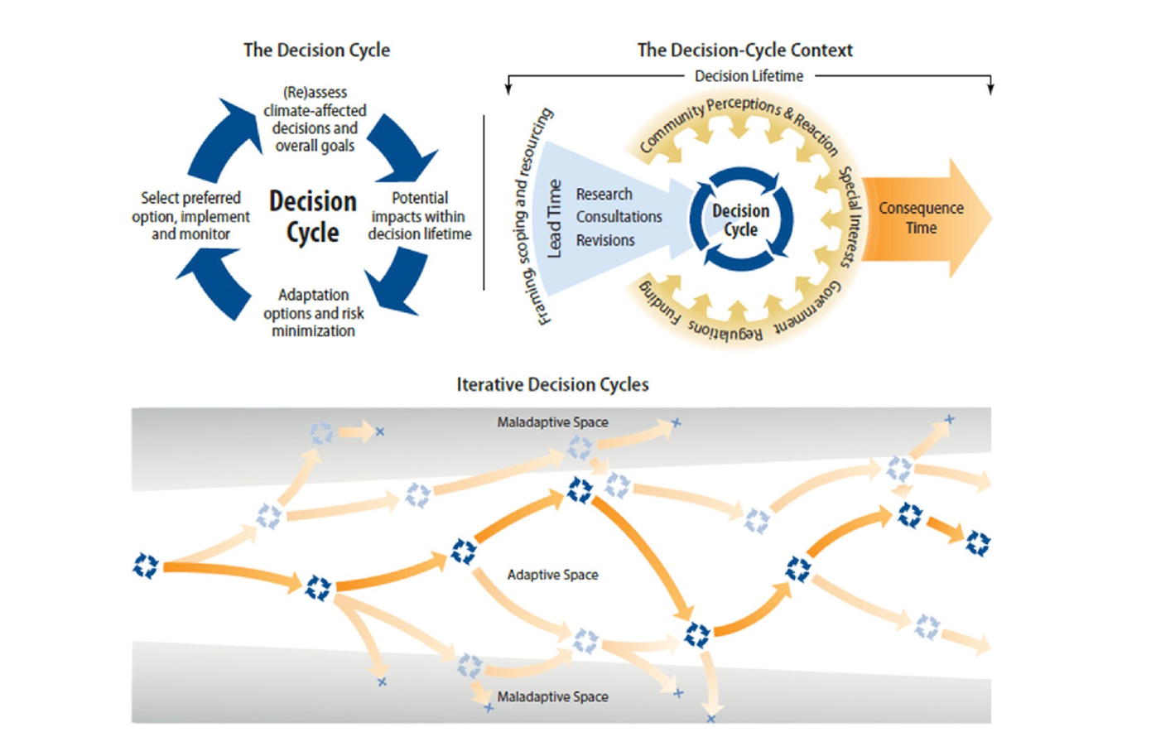
Figure 1 Climate adaptation pathways. From Wise et al. 2014.

Introduction
Coastal communities in the Bering Sea have coevolved with the marine ecosystem for thousands of years and subsistence fisheries and harvest have long been critical for the collective wellbeing and stability of Alaskan communities. Commercial fisheries in the Bering Sea also support economic vitality and food security both within and outside of Alaska. One out of every two fish captured annually in the US come from Alaska, and regional fisheries support a >$5 billion 2018 USD fishing industry, nearly half of which is Bering Sea groundfish harvest. Groundfish fisheries in the Bering Sea have a 30+ year history of large and sustainable harvests due in part to proactive science-based adaptive management that is able to adjust to highly productive yet variable ecosystem dynamics. Yet, Bering Sea fisheries are driven by ecological processes and climate conditions that are increasingly extreme and difficult to anticipate (e.g., 2016 and 2018 marine heatwaves and associated negative impacts to seabirds, marine mammals, and commercially important groundfish fisheries). The frequency and intensity of marine heatwaves and extreme events in the Bering Sea is projected to increase in coming decades, and conditions are expected to shift markedly over the next 20-50 years (Figure 2). Specifically, marine heatwaves may become more commonplace and severe, winter and summer water temperatures are anticipated to increase, and the duration and frequency of productive “cold” multi-year stanzas are projected to decline.
Future fisheries management in the Bering Sea will face major challenges with respect to climate change. Climate change may have rapid and widespread effects on fish and fisheries that may result in both “losers” and “winners" under future conditions. Climate change may continue to cause changes in distribution, survival, growth, timing, behavior, fisheries catchability, and strength of species interactions. Some of these changes may occur gradually, whereas other species may exhibit sudden threshold-like changes in abundance and distribution in response to changing climate conditions (i.e., as conditions cross ecological “tipping-points”). A recent example is climate-driven northward redistribution and change in abundance of multiple groundfish species in the Bering Sea.
At the same time, as a major contributor to national capture fisheries, Bering Sea fisheries will be an essential contributor to sustainable and affordable nutrition for the future global population of 9 billion people (2050 UN estimate). This will require continuation of efficient and sustainable approaches to fisheries and cutting edge, “climate-ready” fisheries management tools and policies. Some of these tools may already be in-hand in the context of ecosystem-based management tools (e.g., annual harvest rates, sloping control rules, ecosystem-based limits, bycatch reduction incentives) and should be preserved going forward. Others, especially long-term and fixed management policies (e.g., protected areas, annual biomass caps, minimal biomass thresholds), which by design are intended to provide stability and remain stationary even when conditions are variable, may be vulnerable to the one-way trajectory of changing conditions and might require modification or periodic revaluation. To improve climate resilience in fisheries management, a portfolio of climate resilient fisheries management approaches that integrate dynamic,adaptive, and fixed management tools across spatial and temporal scales should be developed.
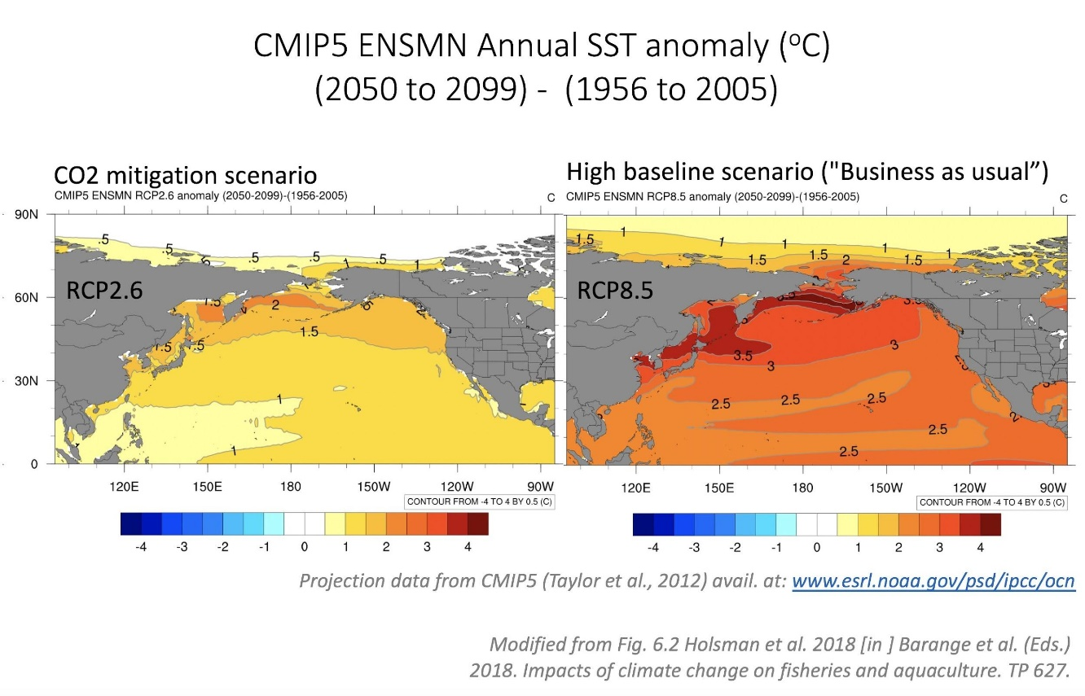
Figure 2 Projected end of century changes in sea surface temperature (SST) anomalies relative to historical SST under global carbon mitigation (left) and unmitigated (right) future scenarios. Based on Coupled Model Intercomparison Project (CMIP) 5 ensemble scenarios.

Action Module goals and objectives
Under this climate module, Bering Sea climate change taskforce (and any sub-module assessment teams) comprised of a diversity of knowledge holders from agency and university researchers, coastal communities, and non-governmental organizations, will coordinate to provide a synthesis of anticipated short to long-term climate change impacts on Bering Sea fish, fisheries, and coastal communities. The taskforce will assemble information from recent ongoing and completed efforts, present synthesized results to the Council and other stakeholders for feedback, and work with the Council and stakeholders to develop climate resilient management tools and policies.
The end product is a climate change and fisheries report (e.g., “Bering Sea Fisheries and Climate Change Assessment Report”), specifying short-, medium-, and long-term management actions to build climate resilience in regional fisheries and fishing communities, develop or expand fisheries for species favored under climate change, and identify technological needs and knowledge gaps that should be addressed in order to promote resiliency and adaptation to climate-induced declines (Figure 3). These strategic policies could be implemented as needed between module cycles (see sections 4 and 5 for more detail) and would aim to use long-term management scenario analyses to inform short-term climate-specific decisions during relevant management cycles (e.g., annual groundfish assessment cycle, updates to essential fish habitat designations, updates to marine mammal assessments and species biological opinions). Particular emphasis would be focused on developing tools that test the long-term performance of dynamic management tools (e.g., seasonal forecasts), adaptive management policies (e.g., annual assessments and annual to decadal projections, dynamic spatial management, or temperature-dependent fishery shifts), and fixed management measures (e.g., long-term ecosystem biomass caps, closure areas, and/or minimal biomass threshold reference points).
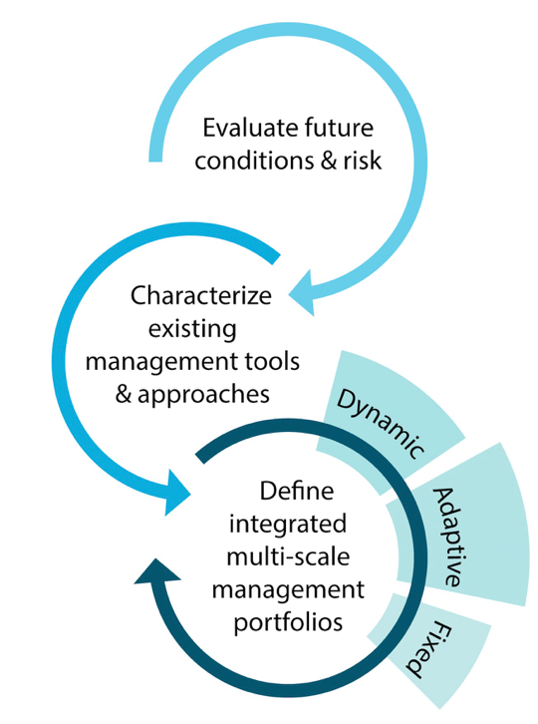
Figure 3 Iterative climate-resilient fisheries management approach. Modified from Holsman et al. 2019.

Objectives
The primary goal of this climate module is to leverage ongoing, proposed, and completed projects at AFSC to ensure climate resilience in the region’s fishery management. Specifically, the module will address the following objectives:
- Coordinate researchers and knowledge holders to synthesize results of various ongoing and completed climate change research projects including, but not limited to:
  - Synthesize current and projected climate change impacts on the coupled social-ecological Bering Sea system through synthesis of diverse sources of knowledge, context and impacts of change and evaluation of future impacts and risks.
  - Rapid Climate Vulnerability Assessments, which use expert knowledge to identify species and communities vulnerable to climate change and prioritize research needs.
  - Operationalized climate change management strategy evaluations (MSEs) of various alternative harvest strategies for key species under the most recent Intergovernmental Panel on Climate Change projections of carbon mitigation scenarios (sensu ACLIM: Alaska Climate Integrated Modeling Project). Include synthesis of current understanding from cross regional and global coordination of ensemble modeling projects aimed at evaluating climate-resilient management tools.
  - Project changes in species distributions and phenology which includes projected changes in habitat under future climate scenarios in order to estimate potential shifts in BSAI FMP species distributions and potential fishing grounds (sensu Predicting changes in habitat for groundfishes under future climate scenarios using spatial distribution modeling).
  - Performance, validation, and operationalized delivery of weekly forecasts (up to 9 months from present day) of Bering Sea conditions, fish productivity and distribution, ecosystem condition, and fisheries relevant metrics (e.g., recruitment, predation, growth, energetics) specifically aimed at informing the annual groundfish assessment cycle (sensu The Bering Seasons Project).
- Evaluate the scope of impact on focal species and communities identified in step (1) with participation from researchers, regional experts and diverse knowledge holders.
- Strategic revaluation of management strategies (every 3-5 years or more frequently). The climate change module taskforce will work with the FEP Team (and/or Council committees, Plan Teams and working groups) to iteratively identify and assess the performance of potential short-term, medium and long-term management actions for climate adaptation (i.e., derive alternative strategies for MSEs).
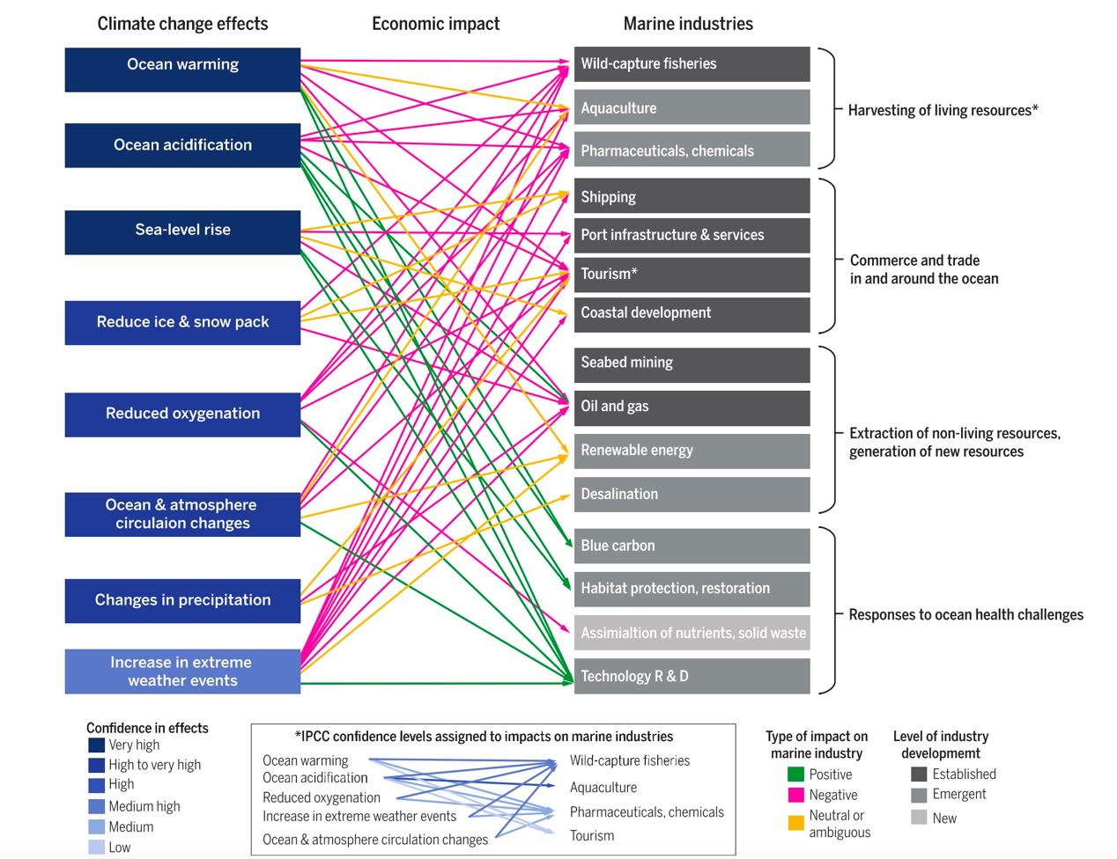
Figure 4 Climate change impacts on marine systems. From Alisson and Bassett 2015.

Action Module Results/Products
Results of this module will help the Council track climate impacts on the Bering Sea ecosystem and ensure that fisheries management in the region is flexible enough to adapt to rapid shifts in species distributions or abundances under future conditions. Initial studies suggest that the outcome of potential climate change impacts on fish and fisheries in the Bering Sea largely depends on harvest strategies in the region. Climate change represents an additional source of uncertainty in the system that needs to be accounted for in trade-off analyses and future policies. Fortunately, completed and ongoing studies continue to advance regional understanding of potential climate change impacts to fish and fisheries.
The challenge that remains is to identify management measures that provide scope for fisheries adaptation to future climate conditions and to ensure that diverse perspectives are considered when assessing risks, impacts and tradeoffs. The latter relies on both understanding of biological trajectories of change as well as understanding and considering social, cultural and economic implications and scope for adaptation in the intricately coupled social-ecological Bering Sea ecosystem. Co-production of knowledge is essential for identifying, understanding and promoting pathways of adaptation in both fisheries and fishing communities. Some social and ecological changes could help promote adaptation, but others might intensify negative impacts of climate-driven change. Thus climate evaluations need to include coupled climate-biological-social-economic evaluations in order to inform management actions that effectively address climate-driven species declines, utilize novel opportunities, and promote equitable adaptive pathways. Of particular interest to the Council might be the future performance of existing management approaches, and ecosystem-based management measures such as protected areas, alternative time-space closures, catch share programs, bycatch reduction incentives, sector/gear specific fishing areas, minimum biomass thresholds that address target and non-target species and upper/lower trophic levels, and aggregate total harvest limits.
Short-term “climate-ready” management actions can be co-developed and implemented relatively quickly, thus climate change management strategy evaluations would be focused on testing their performance under the full scope of potential future climate conditions. In contrast, modification of medium- and long-term management measures require more specific characterization of risk and uncertainty around future trajectories (i.e., long-term change as well as the frequency, intensity and recovery from extreme events) mandating thorough interdisciplinary scientific evaluation as well as consistent and regular stakeholder and Council review and feedback. Thus evaluations under a co-production approach should be initiated early on and should continue until performance under various policies options are fully evaluated.

Examples

Short-term (1-3 years)
- Preservation of existing climate-resilient fisheries management approaches that are flexible enough to adjust to shifts in species distributions and abundances (e.g., annually updated % biomass-based F rates, tier 1-3 biological reference points, sloping control rules).
- Development and evaluation of frequency of stock assessments (e.g., are assessments conducted on a 2-or 3-year cycle more likely to “get it wrong” under climate change than annual assessments?).
- Development and performance of climate-enhanced single- and multi-species reference points (e.g., climate-specific F_{ABC} from ecologically-enhanced assessment models).
- Evaluation of social, economic and biological impacts of changes in the timing of seasonal openings/closures and TAC decisions (i.e., to compensate for shifts under climate change).

Medium-term (5-10 years)
- Evaluation, scoping, and market development for new or increasing fish species.
- Development of climate-specific biomass targets for fishery rebuilding plans under future trajectories (i.e., when declines are also due to climate change).
- Strategic planning for gradual (rather than abrupt) fishery closures for populations projected to decline under future conditions.
- Gear modifications, technological development and management improvements to decrease bycatch rates for new or expanded “choke” species under climate change.
- Evaluation of management measures to improve climate-resilience specific to the different types of fishery allocation schemes (IFQ, catch shares, cooperatives, etc.) utilized in the Bering Sea.
- Evaluation of potential management measures to improve the efficacy of protected marine mammal species critical habitat, conservation plans or conservation area designations in light of anticipated fishery distributional shifts, vessel traffic changes and warming climate scenarios.

Long-term
- Periodic evaluation of long-term management measures to ensure continued conservative performance (e.g, implementing adaptive and responsive closure structures or MPA boundary adjustments to encompass expanded or retracted distributions, changes in monitoring, or changes in total yield cap to reflect potential reductions in groundfish biomass).
- Increases or decreases in lower limits of sloping control rules and or minimum biomass thresholds to reflect sudden shifts in abundances of non-target forage or target species.

How it will be implemented in the Council process
The climate module proposed here could include a strategic revaluation every 3-5 years, reflecting the cycle of the IPCC Assessment Report, which provides updated projections of climate conditions under future carbon emission scenarios every 7 years. The module would require between 2-3 years to complete (depending on the breadth of species and fishing communities of interest and the number and complexity of management strategy evaluations developed by the BS FEP Team, Council process, and stakeholders). The end result would be specific recommendations to inform short, medium-, and long-term management measures. Short- and medium-term management measures (see section 4 for examples), could be implemented or modified according to module results and included in the assessment cycle. As an example, the module could be initiated in YR1 and synthesis of current research presented to plan teams and the Council committees along with proposed species and management strategy evaluations in the fall of YR1. Based on Council and public feedback, refined MSEs and target species would be finalized in the winter of YR1, and MSEs conducted during YR2-YR3 and presented during the Council process in late YR2-3 in the form of The Bering Sea Fisheries and Climate Change Assessment Report. Results would also be communicated to IPCC authors for inclusion in the next IPCC Assessment Report chapters on climate change impacts on North America, polar regions, and the world’s oceans. During the module interim years of YR2-YR5, research would continue in tandem with the module, using updated global forecasts with new IPCC emission scenarios; in YR6-7 the module would be initiated again and taskforce membership would be reevaluated (some new members rotate on, some previous members rotate off).
While the strategic revaluation could be updated every 3-5 years, information from the module could be included in annual assessments in the form of strategic management advice. For example, climate projections and vulnerability scores for species evaluated under the climate module could be included in annual species-specific stock assessments and/or the Bering Sea Ecosystem Assessment of the Ecosystem Consideration Report in order to provide broader context for current biomass trends. This information can provide a frame of reference for setting harvest recommendations and implementation of other management actions. Alternatively, climate-specific biomass reference limits (e.g. temperature-specific F_{ABC}) can be derived using forecasts of environmentally enhanced single- or multi-species assessment models, and can be used to set harvest rates in the fall that account for the next year’s predicted climate conditions. If management strategy evaluations as part of objective (3) of the module determine the performance of these reference points is acceptable or preferable, they could be used to set harvest recommendations (or alternatively, could be presented along with status-quo assessment values). See section immediately above for additional examples.

Planning and Logistics

How Action Module will interface with existing work
The Alaska Integrated Ecosystem Assessment program, the Bering Sea Regional Action Plan teams, and multiple ongoing projects at AFSC are already providing the logistical and analytical support to meet objectives 1 and 2 of the module, as well as provide the modeling platforms for objectives 3 and 4. Under the Regional Action Plan, the IEA, the ACLIM: Alaska Climate Integrated Modeling pilot project, and the related habitat projection project (third bullet above), climate assessment teams are working closely together with each other and with PMEL researchers to expand the suite of downscaled climate projections coupled to climate-enhanced bioeconomic assessment, ecosystem and, fish habitat models, as well as management strategy evaluation sub-modules for some of the ecosystem and assessment models. Thus the expert teams, analytical capacity, and climate scenarios are already available for some species. The rapid climate assessment conducted during 2016 provides a framework for quickly and efficiently identifying additional species that may be impacted. Similarly, the other projects maintain the operational readiness of AFSC to evaluate climate impacts on Bering Sea species and additional ecosystem models or species additions to existing models could be readily implemented for future evaluations.
Interdisciplinary teams like those already assembled for ongoing projects will be needed to conduct the full 3-5 year MSE evaluations, but personnel needs will depend greatly on the number and complexity of MSE scenarios and the number of new species evaluations.

Action Module Taskforce
- Scope: The climate action module taskforce will be responsible for synthesizing vulnerability and climate-resilience information from MSEs and action module-related projects. Main challenges will include highlighting key findings to the public and Council and identifying areas for future research and conservation actions.
- A diverse taskforce with interdisciplinary expertise will help the taskforce crosscut issues that relate to science, policy and socio-economics.
- Two co-chairs should be appointed to lead the taskforce.
- The climate action module would benefit from crosswalking with other FEP action modules, including the TK and LK module taskforce.
- The climate change action module taskforce should include AFSC researchers as well as those with expertise outside of the AFSC, including representation from traditional knowledge holders, indigenous organizations, and NGOs, in order to synthesize diverse climate knowledge and research.
- Proposed frequency of meetings: one in person (Spring), one by teleconference (Fall), Council meeting, and check-in’s as needed.

Deliverables and tracking progress
- Synthesis report of climate change impacts and adaptive strategies of interest and within the purview of the Council; authored by the climate module taskforce, contributing authors, and collaborators.
- EBS climate change report?
  - climate change and fisheries report (e.g., “Bering Sea Fisheries and Climate Change Assessment Report”), specifying short-, medium-, and long-term management actions to build climate resilience in regional fisheries and fishing communities, develop or expand fisheries for species favored under climate change, and identify technological, community needs and knowledge gaps that should be addressed in order to promote resilience and adaptation to climate-induced declines.
- Synthesis of vulnerability analyses (updated)
- Annual climate change hot-topics/ red flags/ considerations for the coming year? (e.g., via the ESR?)

Milestones
May 2019 FEP team meets to discuss draft workplan
June 2019 Council approves draft workplan
June-August 2019 Formation of Action Module taskforce
Fall 2019 - Spring 2020 Taskforce meets, workplan revision (accordingly); prioritization, tasking, and timeline towards progress on workplan goals
March/April 2020 Report progress to FEP team/Ecosystem Committee/SSC/EC/Council
Rest of 2020 Continued taskforce work - identify specific goals, priorities or milestones? Metrics for performance evaluation (measures of success?)
2021-2025 Target for action module completion

References
Allison, E and HR Bassett. (2015). Climate change in the oceans: Human impacts and responses, Science 350 (6262), 778-782.
Holsman, KK, EL Hazen, A Haynie, S Gourguet, A Hollowed, S Bograd, JF Samhouri, K Aydin. Toward climate-resiliency in fisheries management. ICES. 10.1093/icesjms/fsz031
Wise et al. 2014. Reconceptualising adaptation to climate change as part of pathways of change and response. Global Environmental Change 28: 325–336.

Appendix 1. Action Module Scoping Summary from Core BS FEP
1. Synopsis  including how it will be accomplished | The goal of this climate project is to evaluate the vulnerability of key species, fisheries and communities to climate change and to strengthen resilience in regional fisheries management. Methods will leverage ongoing projects at AFSC and partner organizations. The Action Module will address the following objectives: (1) coordinate to synthesize results of various ongoing and completed climate change research projects; (2) evaluate the scope of impacts on priority species identified in initial studies; and (3) strategically reevaluate management strategies every ~5 years; (4) include synthesis to evaluate climate-resilient management tools. The climate change Action Module taskforce will work with the Council to iteratively identify and assess the performance of potential short-term, medium and long-term management actions for climate adaptation (i.e., derive alternative strategies for MSEs).
2. Purpose  relationship to the BS FEP’s strategic objectives | This Action Module is specifically responsive to Process Objective 13, to establish a process for addressing change under novel or intensified stressors, as well as the implementation strategy of the Council’s ecosystem policy vision statement. While the Action Module leverages ongoing AFSC research projects on climate change, including it in the BS FEP provides a direct link for the Council to be involved in prioritizing Action Module research that addresses questions most relevant to Council fishery management. This is in keeping with the BS FEP’s purpose to facilitate dialogue between managers, co-managers, scientists, and diverse stakeholders. This Action Module will provide a five to seven-year climate context within which to interpret and respond to annual signals and will establish a more formal process for considering those variables. This is responsive to the BS FEP purpose to build resiliency into the Council’s management strategies, and to enhance the capacity for adaptive EBFM approaches in the context of shifting climate conditions.
3. How it will inform the Council process | Climate-ready fisheries management will help continue the legacy of sustainable fisheries management in the region, including management to promote a productive marine ecosystem and healthy vibrant marine fisheries. Results will inform short, medium, and long-term “climate ready” tactical and strategic management measures.
4. How it will be integrated in the Council process | Short-term “climate-ready” management actions can be developed and implemented relatively quickly, thus climate change management strategy evaluations would be focused on testing their performance under the full scope of potential future conditions. In contrast, modification of medium- and long-term management measures require more specific characterization of risk and uncertainty around future trajectories, with thorough scientific evaluation as well as stakeholder and Council review and feedback. This information can provide a frame of reference for setting harvest recommendations and implementing other management actions. Alternatively, climate-specific biomass reference limits (e.g., temperature-specific F_{ABC}) are derived using projections of environmentally enhanced single- or multi-species assessment models and can be used to set harvest rates that account for future climate variability. If management strategy evaluations as part of objective (3) determine the performance of these reference points is acceptable or preferable, they could be used to set harvest recommendations (or alternatively, could be presented along with status-quo assessment values) and to inform conservation measures.
5. Estimate of time and staff resources | Multiple ongoing projects at AFSC are already providing the logistical and analytical support to meet the first two parts of the Action Module, as well as provide the modeling platforms for part 3. Interdisciplinary teams like those already assembled for ongoing projects will be needed to conduct the full 5- to 7-year MSE evaluations, but personnel needs will depend greatly on the number and complexity of MSE scenarios and the number of new species evaluations.
6. Plan for public involvement | For this Action Module, the Council may solicit public input, to identify priorities for MSE evaluations. The climate change module taskforce would ideally include broad expertise across diverse knowledge holders (e.g., traditional knowledge holders). Stakeholders will also be involved through the Council process and iterative dialogue with module taskforce members.

Prepared by Kirstin Holsman, AFSC, with input from the Bering Sea Fishery Ecosystem Plan Team and public participating in the May 2019 BS FEP Team meeting.

