David Witherell,  Executive Director | 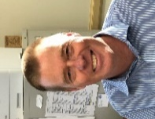 | Council administration  National issues  Area-based management  MSA reauthorization, legislation  Council history
Diana Evans,  Deputy Director | 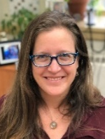 | Agendas, scheduling  Staff Tasking  Council process  Ecosystem issues
Maria Davis,  Communications/ IT Specialist  Lead for the administrative team | 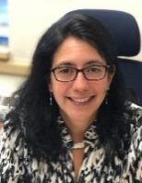 | Council broadcasting and logistics  Technical or communication issues  Website and eAgenda design  Graphics or brochures
Danielle Merculief,  Administration | 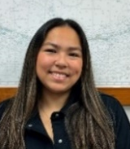 | Travel arrangements/ reservations  Council meeting planning/ logistics  Council & SSC secretary – motions, minutes
Serine Reeves,  Administration | 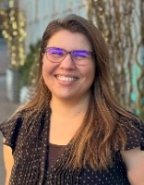 | Document formatting  Infographics  Agenda/Newsletter posting and distribution  Advisory Panel secretary – motions, minutes
Nicole Schmidt,  Finance Officer | 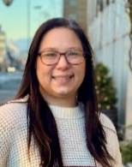 | Travel claims, reimbursements  Council finances  Technical and administrative support
Kaylah Hillary,  contractor |  | Technical and administrative meeting support
Mike Fey,  Data Analyst,  Pacific States Marine Fisheries Commission | 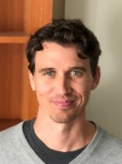 | Data – insights into data involved in the Council process: its use, interpretation and availability  Fleet, community profiles  Economic data collection  Allocation reviews

Diana Stram,  Senior Scientist | 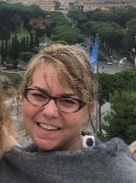 | BSAI Groundfish Plan Team  GOA Tanner crab protections  Cook Inlet Salmon  Plan Team coordination  Groundfish, crab biology  NS1 guidelines
Sara Cleaver,  Fishery Analyst | 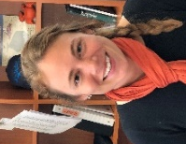 | GOA Groundfish Plan Team  Spatial apportionment  Observer/monitoring issues  Seabird, mammal interactions  Programmatic Evaluation  IFQ fisheries
Kate Haapala,  Rural Fisheries Community and Tribal Liaison/ Fishery Analyst | 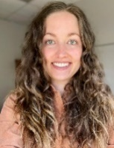 | Social science  Community/Alaska Native issues  LKTKS protocol  Bering Sea Salmon Bycatch
Anna Henry,  Fishery Analyst | 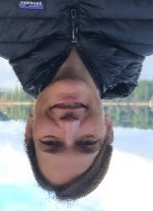 | IFQ issues  Halibut bycatch  Pot cod LAPP paper  Program reviews  Trawl electronic monitoring
Taylor Holman,  Economist | 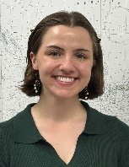 | MRA analysis  Crab C shares  Pelagic trawl gear definition  Enforcement
Anita Kroska,  Fishery Analyst | 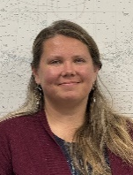 | BSAI Crab Plan Team  Scallop Plan Team  GOA Tanner crab protections  Pelagic trawl innovation  EFH, habitat issues
Katie Latanich,  Climate Project Manager | 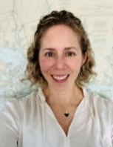 | Coordinate Council’s climate projects under IRA funding  Climate Workshops  Programmatic Evaluation
Sarah Marrinan,  Economist | 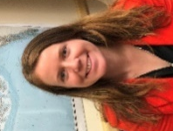 | BSAI crab allocation  Charter halibut  Chum salmon bycatch  CDQ, IFQ, halibut allocations  Economic data reports  Social Science Planning Team

