IPHC fishery-independent setline survey index through 2018
for the NPFMC ABM analysis

The IPHC fishery-independent setline survey index was updated with data collected in 2018. Using the space-time model, the entire time-series was updated to account for improved estimates of space-time correlations, new expansion data collected in IPHC Regulatory Areas 2B and 2C, and the addition of a WPUE index estimate for 2018. The setline survey time-series estimates for each IPHC Regulatory Area are available in Appendix A of IPHC document IPHC-2019-AM095-08. There are indices for O32 (over 32 inches) and “All Sizes” (all sizes of Pacific halibut caught in the setline survey, which is mainly O26). The indices for IPHC Regulatory Areas 4A, 4B, and 4CDE were combined in a single index for 4ABCDE by appropriately weighting by the bottom area in each of the IPHC Regulatory Areas.
Year | WPUE | Standardize to 2016
1998 | 18502 | 2.3642
1999 | 16201 | 2.0702
2000 | 16203 | 2.0704
2001 | 13780 | 1.7608
2002 | 12104 | 1.5467
2003 | 10866 | 1.3885
2004 | 9987 | 1.2762
2005 | 9550 | 1.2204
2006 | 9802 | 1.2524
2007 | 9673 | 1.236
2008 | 10264 | 1.3115
2009 | 9834 | 1.2566
2010 | 9146 | 1.1687
2011 | 8669 | 1.1077
2012 | 8403 | 1.0737
2013 | 7989 | 1.0208
2014 | 7995 | 1.0216
2015 | 8130 | 1.0388
2016 | 7826 | 1
2017 | 7250 | 0.9264
2018 | 7141 | 0.9125

Note that the entire time-series is updated because it is using a space-time model, and that the past estimates from the 2017 model are nearly identical to the 2018 when standardized (Figure 1).
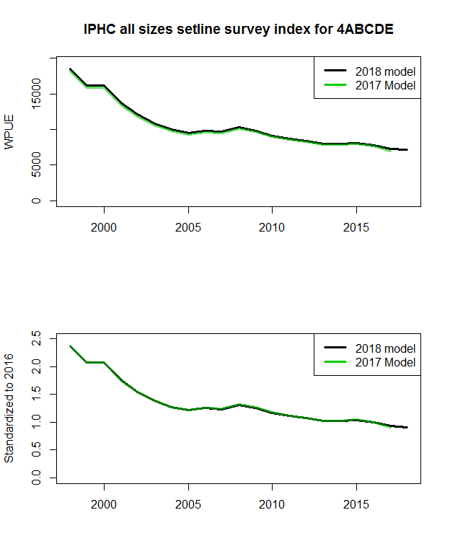
Figure 1: Estimated IPHC fishery-independent setline survey indices of WPUE (top) and WPUE standardized to 2016 (bottom) from the 2017 model and the 2018 model.

https://iphc.int/venues/details/95th-session-of-the-iphc-annual-meeting-am095

