
Bering Sea Fishery Ecosystem Plan:

Action Module to develop protocols for Local Knowledge, Traditional Knowledge, and Subsistence
  - DRAFT Action Module Workplan
Contents
Goal 1
Introduction/Background 1
Objectives 3
Action Module Results/Workproducts 3
Project ideas 3
How this action module work will be integrated into the Council process 4
Planning and Logistics 4
How will the action module integrate with ongoing work 4
Proposed Timeline 5
Membership 5
Meeting Logistics 7
Reporting 7
Public involvement 7
Appendix 1. Action Module Scoping Summary from Core BS FEP 8
Appendix 2. Action Module Project Ideas from Core BS FEP 9
Part A Operationalizing LK and TK in the Council Process 9
Part B Subsistence 13

Goal
The goal of this Action Module is to develop protocols for using LK and TK in management and understanding impacts of Council decisions on subsistence resources, users, and practices. More specifically, this Action Module aims to provide a roadmap for operationalizing LK and TK (potentially through processes like Co-Production of Knowledge) in the short- to long-term, as well as to formulate methods for assessing the likelihood a given Council action may affect subsistence resources, the ability of users to access those resources, or impact subsistence practices. Stakeholders have described this goal as an aim to develop structured ways the Council might consistently ensure solicitation and consideration of LK, TK, and subsistence concerns and information throughout Council processes. Outcomes are expected to inform where and how these types of knowledge and information should or could consistently enter into all Council processes.

Introduction/Background
This Action Module provides opportunity for the Council to operationalize plans for strengthening partnerships with bearers of LK and TK, subsistence users, and organizations that represent and work with these groups. This project will guide the use of subsistence data in analyses and is expected to help the Council be increasingly responsive to National Standards 2 and 8. This Action Module will potentially improve Council decision-making by giving the Council access to a more complete picture of the ecosystem and the potential impacts of their actions.

This Action Module is most responsive to BS FEP Research Objective 4, which links directly to Process Objective 6 (see Chapter 2 of the Core BS FEP document). This Action Module is meant to positively inform the overall Council process and decision-making structure. The completed work will aim to provide a framework and data for analysts to consider ways to make better use of non-economic social science data in the form of, and regarding, LK and TK along with outcomes from engagement actions, as well as whether fishery activities or changes in regulation are likely to impact subsistence resources or patterns of subsistence use.

This Action Module was drafted as having two parts (see Appendix 1, below). In Part A, methods for integrating/incorporating LK and TK into Council processes in the short- to long-term would be addressed. In Part B, a methodology would be developed for how the Council can consider potential impacts to subsistence species, habitats that support those species, subsistence practices, and access to subsistence resources.

Part A of this Action Module would include guidelines for evaluating and incorporating LK and TK into Council documents and processes on an ongoing basis. Part A would also include strengthening relationships with bearers of LK and TK (and their representatives) and better capturing LK and TK in Council analyses. Part B of this Action Module would develop a process for better understanding and considering how removals from commercially important fish stocks may affect subsistence resources important to Alaska Native communities or affect resource use patterns of those communities. Part B may result in a method to prescribe the way subsistence data are incorporated into Council analyses and describe circumstances in which measures may be necessary to mitigate potential impacts to subsistence resources, or the use of those resources by Alaska Natives.

Stakeholders have proposed separating this Action Module work into three parts:
- Processes for incorporating LK;
- Processes for incorporating TK; and,
- Processing for incorporating subsistence data and understanding impacts of Council actions on subsistence

Recognizing that methods for understanding and considering LK, TK, and subsistence issues are at varying levels of development within existing Council processes, this Action Module work will consider methods for the inclusion of LK, TK, and subsistence knowledge/information separately from each other.

Separating this Action Module into “parts” is not meant to detract from the linkages across each part. This separation reflects acknowledgement of differences in the current state of incorporating LK, TK, and subsistence information in the Council process, as well as the need for different methods to strengthen each one. The three subtopics are grouped under one Action Module to promote a holistic approach that allows for connectivity and leveraging of progress across the LK, TK, and subsistence work. Progress on each part is expected to occur at differing timescales, but through a single Taskforce group.

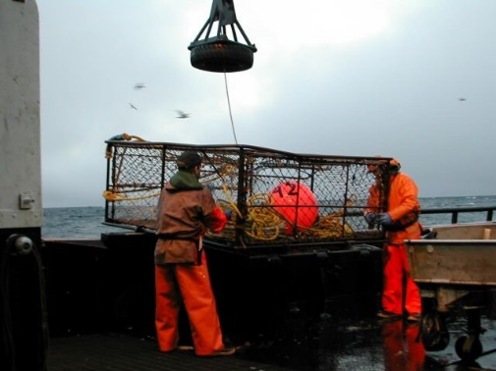
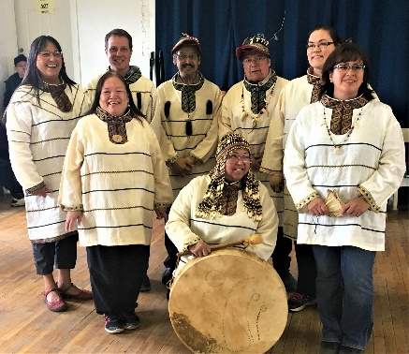
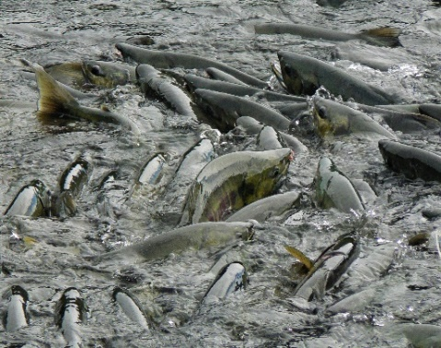
PHOTO CREDITS

Objectives

Regarding LK and TK, the overarching objective of this Action Module work is to create a clear set of directions for the Council regarding best practices for solicitation and consideration of these types of knowledge and information.

Regarding subsistence, the overarching objective of this Action Module work is to create clear direction(s) for the Council regarding how impacts to subsistence are understood and incorporated into analyses as well as how to mitigate potential impacts to subsistence resources or use of those resources by Alaska Natives. To date, this portion of the module has been bounded to focus on developing protocols for how to use subsistence data to inform Council analyses. The Taskforce for this Action Module may choose to develop expanded or different objectives for this portion of the Action Module, for review by the Council.

Once a Taskforce is convened, an important first task will be to discuss/recommend edits to the overarching objectives described above and agree on 3 to 5 key objectives that will help achieve the overarching objectives described above. This could form the background for what the Taskforce will attempt to achieve and how they will get there.

Upon determination of the key objectives, the Taskforce should then add 1-5 sentences of rationale to this section to bolster each succinct objective.

Action Module Results/Workproducts
As described above, this Action Module work is expected to result in multiple sets of directions, processes, or “best practices” guidance for the Council regarding LK, TK, and subsistence in Council analysis and processes.

A key accomplishment of BS FEP work related to LK, TK, and subsistence to date has been collaboration early and often with stakeholder individuals and groups in the BS FEP geographic area. The collaborative method used to date is a workproduct in and of itself. Often taking the form of both formal and informal conversations and comments, deep levels of communication have been achieved between Council staff and regional stakeholders with the goal of ensuring that LK, TK, and subsistence are approached in a regionally appropriate manner.

Consistent and meaningful communication between Council staff, the FEP Team, and regional stakeholders will be a critical method to carry forward through forming a Taskforce and completing this Action Module work. While it has been acknowledged that it is not always possible to get regular feedback from all stakeholders in the region—and to date there has not been fully representative feedback from all communities in the expansive BS FEP Area—taking the time to solicit and incorporate feedback and advice from regional stakeholders is critical for the success of this Action Module. This approach can be time consuming. Staff have described this as a “no steps back” approach. With a “no steps back” approach, progress may not always occur swiftly or in a large-scale way, but the goal is to ensure that trust and collaboration between staff and stakeholders grow stronger throughout this work.

Project ideas
An extensive list of potential bounded actions the Council might choose to take related to this Action Module was drafted and adopted by the Council in December 2018, as part of the Core BS FEP document (see Appendix 2, below). The list is composed primarily of requests and recommendations from stakeholders and is organized into actions that could be taken at varying timescales (short-, medium-, or long-term). Taskforce members of this Action Module may choose to focus projects on items in the existing list (see Appendix 2, below) or draft a new list of ideas within the scope of the Goals and Objectives described above, for review by the FEP Team (and, through the FEP Team, by the Council) as necessary.

Members of the FEP Team recommended that this Taskforce look to the Kawerak website and to the State of Alaska Salmon and People program for lessons learned about convening diverse stakeholder working groups similar to this.

How this action module work will be integrated into the Council process

This Action Module work will likely function across multiple timescales, with multiple bounded projects to be determined through Action Planning after members have been appointed to the Taskforce. Upon completion of work, the Taskforce will be expected to present ideas to the FEP Team. The FEP Team will develop recommendations for the Council based on ideas from the Taskforce. The Council will then hear recommendations from the FEP Team and take regulatory or non-regulatory action as necessary.

This Action Module is meant to positively inform the overall Council process and decision-making structure. The completed work will provide a framework and data for analysts to consider ways to make better use of non-economic social science data in the form of, and regarding, LK and TK along with outcomes from engagement actions, as well as whether fishery activities or changes in regulation are likely to impact subsistence resources or patterns of subsistence use. It is anticipated that incorporating subsistence data in to the Council process would involve adding a section to future analyses. If included in the discussion paper and preliminary draft stages of an action, it is expected that subsistence data would be considered during development of alternatives for specific actions. Impacts to subsistence resources or use will thus be considered throughout the Council process.

Planning and Logistics

How will the action module integrate with ongoing work

Work products from all Action Modules are meant to inform the Council process as well as leverage work of other Action Modules. It is expected that objectives for this Action Module will reflect ways LK, TK, and subsistence can inform and be considered in the Council process. Work done for this Action Module is expected to overlap with other Action Modules insofar as other Action Module work will benefit from increased incorporation of LK, TK, and subsistence information. For example, it is expected that the Taskforce created for working on this Action Module will work closely with the Taskforce for the Climate Change Action Module. The Taskforce for this Action Module might choose to define an objective (or objectives) that explicitly relate(s) to the Climate Change Action Module.
Outcomes from this Action Module are also expected to inform the Action Modules that come after it, as the other Action Modules will benefit from clear guidelines about how to solicit and incorporate LK, TK, and subsistence information appropriately.

Proposed Timeline
All Action Module Taskforces are meant to be temporary groups, with members who work to achieve the objectives of each Action Module within its scope as defined by the Council. As such, they are anticipated to have finite timelines.

This Action Module work will likely function across multiple timescales, with multiple bounded projects to be determined through Action Planning after members have been appointed to the Taskforce. Upon completion of work, the Taskforce will be expected to present ideas to the FEP Team. The FEP Team will develop recommendations for the Council based on ideas from the Taskforce. The Council will then hear recommendations from the FEP Team and take regulatory or non-regulatory action as necessary.

Taskforce members are expected to lead progress on the objectives of each Action Module within the defined scope. After formation of each Taskforce, members will be expected to maintain an ongoing timeline in their workplan, to be presented to the FEP Team (and by the FEP Team to the Council) as necessary. A preliminary timeline for Action Modules is outlined below.

Dec 2018 | Council adopts BS FEP Core Document and prioritizes two Action Modules.
Jan - May 2019 | Action Module Workplan drafting
May 2019 | FEP Team meeting, Seattle; FEP Team finalizes draft Action Module workplans to forward to the Council/advisory bodies
June 2019 | Council reviews workplans presented by the FEP Team, institutes a process for forming the Taskforces, and takes action as necessary
Fall 2019 | Formation of Taskforces for prioritized Action Modules
Fall/Winter 2019 | First meetings of Action Module Taskforces
2020 | Taskforces continue to meet, make recommendations to the FEP Team and Ecosystem Committee/SSC/Council; Council reviews work products, recommendations, and takes action as necessary
2021-2023 (T) | Action Module Taskforces complete work and achieve objectives within the scope of their workplans; Taskforces disband.

The Taskforce should be specific about prioritization for timing of work related to each of their objectives for Action Module 4. For example, some stakeholders have noted that some work related to the LK portion(s) of Action Module 4 may be readily accessible and therefore might be achieved on a shorter timeline than other portions. This should be discussed at the first meeting of the Taskforce for Action Module 4.

The Taskforce for this Action Module will likely need to schedule a secondary check-in with the Council during the winter of 2019 or the spring of 2020—before commencing a project—after a succinct list of key objectives has been agreed upon by Taskforce members.

Membership
Pending funding constraints, the Council will pay travel costs for non-Federal members of the project taskforce to noticed taskforce meetings.
Formal membership on this Taskforce should be limited to no more than 15 people, with a goal of creating a group of 7-10 individuals. Stakeholders have encouraged the Council to consider putting out an initial call for nominations for 7-10 individuals with a plan to allow the appointees to recommend whether further expertise (up to 15 people total) is warranted.

Stakeholders have recommended that at least two-thirds of the non-agency stakeholders appointed to this Taskforce be composed of experts related to items “2” and “3” in the above list (TK and subsistence knowledge, respectively), and have recommended one-third of the Taskforce members be LK experts/knowledge bearers.

Stakeholders have recommended the Council look outside its normal areas of inclusion (i.e., agencies and academia) to choose 7-10 nominees with a variety of expertise, including:
- TK holders
- LK holders
- Expert subsistence practitioners
- People in Alaska Native Organizations and Tribes who have experience working with fisheries TK
- Social scientists with TK expertise/Experts collecting and working with a wide variety of TK information/data
- Social scientists with LK expertise/Experts collecting and working with a wide variety of LK information/data
- Social scientists with subsistence expertise/Experts working with subsistence data
- Indigenous scholars with expertise related to the Action Module

The resulting Taskforce should be a diverse group of individuals that are geographically representative of the entire BS FEP Area. Stakeholders have recommended the Taskforce include local residents and be representative of multiple age groups. Stakeholders have further recommended that membership on the Taskforce avoid overlap with existing bodies (e.g., the SSPT, SSC, CEC, and Bering Sea FEP Team), while ensuring expertise in all key areas of the Action Module work (i.e., social science of LK, social science of TK, social science of subsistence, TK-bearers, expert users of resources, etc.). The Council could also direct the Taskforce to invite outside experts, including members of existing Council bodies, to attend or present at Taskforce meetings to expand expertise on a meeting-specific basis (e.g., invite staff from the ADFG Division of Subsistence to participate during meetings focused on subsistence issues).

It is anticipated that each Taskforce will benefit from having some appointed members be Council and agency staff, who can help answer questions and guide progress in alignment with Council processes. For this Taskforce, that might result in some overlap with existing bodies. This would potentially yield a Taskforce composed of 7-10 stakeholder experts and 1-5 non-stakeholder members.

If a call for nominations is put forth by the Council, Taskforce members might be solicited who have expertise in the desired fields described above, who can also demonstrate some familiarity with Council processes (e.g., have attended meetings, testified, etc.).

Given the unique funding opportunity to support meetings of the Taskforce, the Council may choose to extend a call for nominations to this Taskforce to a wider group than the Council newsletter, as practicable. Extending how a call for nominations is advertised could encourage engagement from candidates who typically are not as involved in the Council process due to funding constraints. This is not meant to penalize stakeholders currently participating in the Council process but, rather, to encourage nominations from people who may not typically put their name in. To further widen a call for nominations, the Council might also waive a requirement of nominees submitting formal CVs or resumes, and instead request letters of interest. If time allows, the Community Engagement Committee and highly engaged ANOs/regional stakeholder groups could be consulted regarding how to distribute a call for nominations.

Meeting Logistics
Stakeholders have requested that efforts be made to maximize all possibilities for access and examine the possibility of diversity in meeting site choices, where funding allows.

Staff have proposed consideration of a non-typical meeting format to allow for Taskforce meetings to take place in rural communities throughout the Bering Sea region. A non-typical format might involve a subgroup of Taskforce members flying/driving to a rural community in the BS FEP region to visit the community, meet with community members, and host a teleconference or video conference meeting for the full Taskforce. This structure might alleviate some timing and funding constraints of attempting to convene the full Taskforce in remote locations, while allowing a two-way communication and collaboration processes to reach a broader geographical area.

Stakeholders have recommended that most meetings take place in-person when possible, with an inaugural meeting in-person in Anchorage, AK.

At their first meeting, Taskforce members should agree on and draft more information for this section regarding where, when, how often, and in what format meetings of the Taskforce will take place. Staff anticipate that the goals and objectives of this Action Module might be completed in about 6 meetings of a Taskforce.

Reporting
As stated above, the Taskforce for this Action Module will likely need to schedule a check-in with the Council during the winter of 2019 or the spring of 2020—before commencing a project—after a succinct list of key objectives has been agreed upon by Taskforce members.

Public involvement
It is anticipated that LK, TK, and subsistence experts will need to be actively involved on the development team for this Action Module. Outreach to partner agencies and their constituents as well as ongoing collaboration with Tribes, Alaska Native Organizations, and communities throughout the Bering Sea region will be important in verifying the data, products, and methods to use in management.

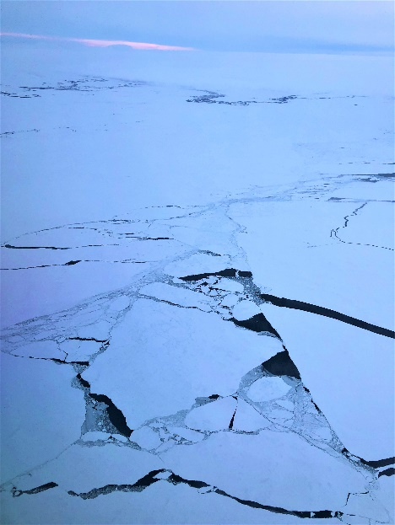
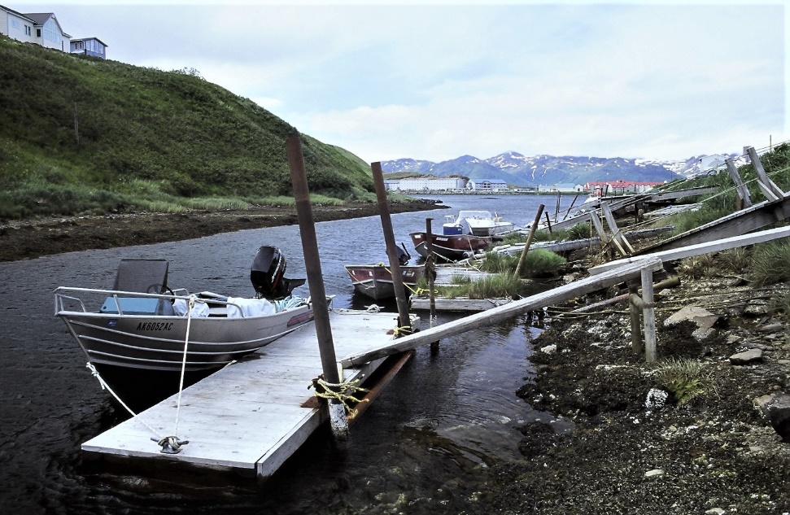

Appendix 1. Action Module Scoping Summary from Core BS FEP
1. Synopsis  including how it will be accomplished | This Action Module has two parts. In Part A, methods for integrating/incorporating LK and TK into Council processes in the short- to long-term will be addressed. In Part B, a methodology will be developed for how the Council can consider potential impacts to subsistence species, habitats that support those species, and access to subsistence resources. To develop this Action Module, the Council will strengthen and broaden ties with Alaska Native organizations, organizations that are familiar with subsistence data, non-economic social scientists, and agency scientists. Through collaboration with LK, TK, and subsistence experts, a protocol will be developed to ensure Council analysts know how to review and utilize LK, TK, and subsistence information successfully in analyses.
2. Purpose  relationship to the BS FEP’s strategic objectives | This Action Module is most responsive to BS FEP Research Objective 4, which links directly to Process Objective 6. As relates to Part A, the Council is interested in strengthening relationships with bearers of LK and TK and better capturing LK and TK in Council analyses. As relates to Part B, the Council is interested in developing a process for better understanding and considering how removals from commercially important fish stocks may affect subsistence resources important to Alaska Native communities or affect resource use patterns of those communities.
3. How it will inform the Council process | This Action Module will improve Council decision-making by giving the Council access to a more complete picture of the ecosystem and the potential impacts of their actions. This Action Module aims to provide a roadmap for operationalizing LK, TK and potentially processes like Co-Production of Knowledge (CPK) in the short- to long-term, as well as formulate a method for assessing the likelihood a given Council action may affect subsistence resources or the ability of users to access those resources. This project will guide the use of subsistence data in analyses and is expected to help the Council be increasingly responsive to National Standards 2 and 8.
4. How it will be integrated in the Council process | This Action Module is meant to positively inform the overall Council process and decision-making structure. The completed work will provide a framework and data for analysts to consider ways to make better use of non-economic social science data in the form of LK and TK along with outcomes from engagement actions (e.g., CPK processes), as well as whether fishery activities or changes in regulation are likely to impact subsistence resources or patterns of subsistence use. It is anticipated that incorporating subsistence data in to the Council process would involve adding a section to future analyses. If included in the discussion paper and preliminary draft stages, it is expected that subsistence data would be considered during development of alternatives for specific actions. Impacts to subsistence resources or use will thus be considered throughout the Council process.
5. Estimate of time and staff resources | This is expected to be an ongoing process to cultivate relationships, with short- to medium-term goals including gathering existing data about specific issues. Once protocols for reviewing and using LK, TK, and subsistence use information are in a format that can be accessed and used by analysts, there may be limited commitment of Council time or staff resources to incorporate that information into analyses. Regular staff time would be required to maintain ongoing relationships and update descriptions in the BS FEP.
6. Plan for public involvement | As described above, the Council is reliant on partnering with other organizations to create an environment conducive to processes like CPK, as well as identifying and using subsistence data in analyses. It is anticipated that LK, TK, and subsistence experts would need to be actively involved on the development team for this Action Module. Outreach to partner agencies and their constituents as well as ongoing collaboration with Tribes and communities throughout the Bering Sea region will be important in verifying the data, products, and methods to use in management.

Appendix 2. Action Module Project Ideas from Core BS FEP

Part A Operationalizing LK and TK in the Council Process
A BS FEP provides opportunity for the Council to operationalize plans for strengthening partnerships with bearers of LK and TK, as well as developing methodology for integrating LK and TK into management using multiple methods, including Co-Production of Knowledge (CPK). Part A of this Action Module will include guidelines for evaluating and incorporating LK and TK into Council documents and processes on an ongoing basis.

Recent work by Indigenous leaders and Western scientists in Alaska develops a conceptual framework for carrying out Co-Production of Knowledge (CPK; Behe, Daniel, and Raymond-Yakoubian, 2018). CPK is a process for bringing together knowledge-holders from different systems. The CPK conceptual framework is focused on bringing together TK knowledge systems with LK and Western science through an equitable process that strengthens partnerships between these different knowledge systems. Behe, Daniel, and Raymond-Yakoubian (2018) explain CPK is a process for sharing information, values, and ideas, and for conducting research and informing holistic and adaptive decision making and policy. Most examples of knowledge co-production in Alaska to date have been carried out in research. CPK is a potential method for carrying out BS FEP objectives focused on bringing together TK, LK, and Western science for evidence-based decision making and policy. CPK will be considered as a potential method for carrying out LK and TK objectives of this Action Module. The CPK process includes:

Characterized by:  - Decolonization  (a lot of top down and outside processes have been imposed on Indigenous communities; acknowledge those on an even playing field)  - Deliberate and intentional  (power dynamics should be acknowledged early in the process; issues of power and control need to be discussed clearly and completely at the beginning of any project)  - Trust and respect  - Capacity  (Tribes and Indigenous peoples should have means and ability to participate in the process from beginning to the end, even to data maintenance over time)  - Sovereignty  - Ethical  - Real relationships  - Empowerment |  | Leading to:  - Review results  - Access to and control over information  - Define a problem  - Identify questions  - Develop methods  - Gather information  - Conduct analysis and  - Communicate/share results  Resulting in:  - Shared knowledge systems

CPK is a process that extends beyond a single, distilled, deliverable research product. In a true CPK process, TK, LK, and Western science are all respected as different knowledge systems, with each holding unique methodologies, evaluation, and validation processes. With this understanding, the different knowledge systems are not translated into each other, but instead are trusted and respected in their uniqueness. Within a CPK process, participation of all knowledge holders is needed throughout the entire process, from inception through analysis and output.
Co-production requires an understanding that Western science and TK are different knowledge systems often articulated through a cross-cultural setting. The co-production of knowledge “requires the integration of different ways of knowledge to be salient, credible, and legitimate” and the inclusion of actors on both sides of the boundary of decision making for a productive output (Robards et al. 2018:23). TK is not based on the key assumptions of science. TK is based on interconnections between systems, whereas Western science is often based on a set of independent facts. Successful co-production of knowledge requires trust in the different knowledge systems, to bring together different questions and different methods for achieving results.

CPK is rooted in ideas of equity, and environmental and political justice. A primary goal of co-production of knowledge is to have Indigenous perspectives, LK, and TK taken seriously from the beginning and to build relationships throughout the process of any work or project. It is important to recognize self-determination and sovereignty and informed consent of TK bearers. Most examples of knowledge co-production in Alaska to date have been carried out in research.
Using a mixture of CPK and other methods, the Council could consider the following short-, medium-, and long-term actions in the process of developing best practices for LK and TK:

Short-term (require lower level of time/staff commitment)
- The Council may instruct the BS FEP Team to include Tribal/Native representation to provide input on an ongoing basis.
- The Council may discuss potential mitigation actions regarding lack of capacity for conducting LK and TK analyses (and non-economic social science more generally).
- Preliminary guidelines may be laid out regarding how to evaluate LK and TK information/data in Council analyses (and non-economic social science more generally).
- A compendium of information resources for LK and TK could be prepared and stored at the Council, for use by analysts. Some of these resources are listed in the Core BS FEP document.
- A question may be added to the analytical template used by Council staff, that reads, “Are there known sources of LK and TK relevant to this topic?”
- The Council may choose to request explicit incorporation of LK and TK into the ecosystem assessment process carried out through NOAA and at the Council.
- The Council may choose to establish explicit support of co-production of knowledge (CPK) work in the Bering Sea region. Understanding that CPK is a process, and not a product in and of itself, Council support for CPK would indicate a willingness to support collection and sharing of information and research that lies outside the Western scientific paradigm.

Medium-term (require medium level of time/staff commitment)
- The Council might encourage or voice support for compensated participation of Alaska Native Tribes and Indigenous peoples in monitoring, observation and research of Bering Sea ecosystem issues (outside the Council process).
- A plan may be developed to increase capacity at the Council for working on LK and TK (and non-economic social science more generally). If the Council would like to pursue this idea, the next step would be to determine what type(s) of capacity it would like to increase, before determining whether existing staff might fulfill the desired role(s).
- The Council may choose to develop mitigation measures in collaboration with Tribes and NMFS (in their Tribal Consultation role) for dealing with a lack of capacity for LK and TK (and non-economic social science more generally) in analyses. If the Council would like to pursue this idea, the next step would be to determine what type(s) of capacity it would like to increase, before determining whether existing staff might fulfill the desired role(s).
- The Council could appoint/hire an LK and TK liaison staffer, who would facilitate the inclusion of LK and TK at all levels of the Council process. Some other organizations have dedicated staff liaisons for this purpose (e.g., US Fish & Wildlife Service). If the Council would like to pursue this idea, the next step would be to define roles and responsibilities of such a position.
- The Council may consider formalizing a specific process for inputting LK (and non-economic social science more generally) into existing analyses and assessments.
- The Council may consider formalizing a specific process for inputting TK into existing analyses and assessments (see *NOTE below).
- The Council may task staff or another entity with compiling LK and TK resources (potentially through a CPK process) for use in an early warning model (conceptual or statistical) for ecosystem change, in partnership with Western science information (e.g., example of sea lions on St. Lawrence Island).
- A subcommittee for LK and TK could be formed within the recently formed Social Science Planning Team (SSPT) or the Community Engagement Committee (CEC), as a potential route for incorporating LK and TK into the Council process in a way that makes use of existing advisory structures. The SSPT or CEC could facilitate meaningful contributions of LK and TK to ongoing analyses, as well as thoughtful review of completed analyses. The SSPT or CEC could further facilitate longer-term goals for LK and TK to take part in evolving the Council management process to reflect EBFM. The SSPT or CEC might also invite a member from an agency (e.g., ADFG) or the public (e.g., active stakeholder group(s) from the region) with expertise in LK and TK work.
- The Council could consider forming an LK and TK Committee to allow for a dedicated space in the existing Council process for LK and TK to inform management.
- As with research priorities, policy priorities and objectives are rooted in a Western science paradigm. The Council may choose to task staff with developing a set of best practices for determining management priorities, alternatives, and tradeoffs through a CPK process, including answering questions such as:
  - What are local/regional community priorities for Federal fisheries policy?
  - What stories do local/regional community members want to share?
  - What kind of spatial data for subsistence uses are appropriate to use in public documents/discussions, and how?
  - What do local/regional community members feel are appropriate and ethical ways for non-Indigenous and non-locals to contribute in Federal fisheries policy and decision-making in the Bering Sea region? What are not appropriate or ethical ways?

Long-term (require significant level of time/staff commitment)
- The Council may consider composing protocols for long-term and specific data-use agreements with Tribes and communities providing LK and TK information, especially as relates to spatial mapping (see Part B of this Action Module; Note: Not all spatial information documented by Alaska Native organizations is currently available to the public, because specific data-use agreements need to be established for the sharing of much of that data. Additionally, current publicly-available spatial information may not be appropriate for further use without updated permissions and formal consent of the Tribe(s) or community(ies) that initially provided it.).
- The Council might consider formalizing a process for CPK in the Bering Sea region, as it relates to policy and decision-making. This might involve providing regular trainings for staff in LK, TK, and CPK methods, and to have a permanent space on staff for an expert in LK, TK, and/or CPK methods.
- The Council might consider how to shift towards an adaptive co-management approach (Berkes, 2009) that more fully incorporates LK and TK into the process at all stages. One example of this type of approach is the Arctic Borderlands Ecological Knowledge Co-Op.
- The Council might include Tribal membership on all Council committees and plan teams.
- The Council might encourage and facilitate increased TK representation through increased Indigenous/Tribal representation on the Council and Council bodies (e.g., Tribal seats on the Council are desired by Indigenous communities), understanding that a permanent Indigenous/Tribal seat (voting or non-voting) on the Council would require a change to the MSA.

*NOTE: The Council may consider formalizing a specific process for inputting TK into existing analyses and assessments. Examples of this exist around the world, including in Canada. Usher (2000) describes four categories of TEK for use in Environmental Assessment and management using a case study from Canada. If the Council is interested in formalizing a process for incorporating LK and TK into existing assessments, a similar approach might be considered for incorporation into the BS FEP (paraphrased):

Category 1: Factual/rational knowledge about the environment.
Category 2: Factual knowledge about past and current use of the environment.
Category 3: Values about the environment, including culturally based value statements about how things should be, and what is fitting and proper to do, including moral or ethical statements about how to behave with respect to animals and the environment, and about human health and well-being in a holistic sense.
Category 4: Culturally based cosmology; the knowledge system itself.

According to Usher (2000), each category of TEK has different potential uses within existing fisheries management structures and processes in Canada. This example from Usher (2000) may not be entirely appropriate for the Council’s uses (e.g., the Council may feel descriptions of which categories of TEK and how they should be used may be overly prescriptive or wholly inappropriate in our region) but this could serve as a jumping-off point for discussions about formalizing the use of LK and TK in our various impact analyses (e.g., SIA, RIR, EIS, EA, etc.).

Part B Subsistence
This portion of Action Module 4 is expected to prescribe the way subsistence data are incorporated into Council analyses and will describe circumstances in which measures may be necessary to mitigate potential impacts to subsistence resources, or the use of those resources by Alaska Natives. The BS FEP will not automatically require mitigation for circumstances where the potential for impacts exist, nor will the BS FEP limit the sorts of actions that the Council may take. Rather, the BS FEP will provide a roadmap for the Council to follow to assess the likelihood of impacts and develop mitigation measures should they be necessary. This part of the Action Module is responsive to BS FEP Strategic Objectives 1 and 2, to synthesize the current understanding of Bering Sea ecosystem processes and create a cohesive plan for EBFM.
In recent years, potential impacts of commercial fisheries on subsistence resources or use patterns have received increasing attention. A BS FEP provides opportunity for the Council to outline best practices for how subsistence use data may inform understandings of potential impacts of commercial fisheries on subsistence resources and use and, if appropriate, mitigate those potential impacts to ensure that subsistence use of marine resources continues unabated in the Bering Sea. The Council is interested in understanding ways that removals from commercially important fish stocks may affect the subsistence resources important to Alaska Native communities or affect resource use patterns of those communities. Where subsistence use data are already available, data may be incorporated into existing models that predict fishery behavior or responses to changes in conditions or regulations.
One hurdle to incorporating subsistence use data into management decisions has been collection of data and preparation of data products for use in current assessment models. Non-governmental and Tribal organizations (corporations, governments, etc.) have been working to describe and document subsistence use patterns of Alaska Native communities throughout the Bering Sea region. In addition to non-governmental and Tribal data sources, the State of Alaska Department of Fish and Game Subsistence Division has ongoing projects to document subsistence use patterns and would provide a wide range of subsistence use data. The State of Alaska Division of Subsistence reports, and the Northern Bering Sea Mapping Project and Bering Strait Marine Life and Subsistence Use Data Synthesis are some examples of products that have made subsistence use and subsistence species occurrence data available to fishery managers. Some subsistence use data are currently available in spatial mapping formats (e.g., in ArcGIS software programs) that allow managers to evaluate them (e.g., for potential conflicts with commercial fisheries). The Council will use subsistence data appropriately as they become available.
Collection and preparation of subsistence data are major undertakings. The Council will work with organizations that collect and prepare subsistence data in the short-term and may wish to prepare a long-term subsistence data use plan in the future. To carry out this part of the Action Module, it is likely the Council will need to develop collaborative relationships with Alaska Native organizations, organizations that are familiar with subsistence data, non-economic social scientists, and agency scientists to ensure data quality and to ensure products are in a form that is useful to fishery analysts as well as subsistence users. This would likely require an initial in-depth process to identify a working list of sources of subsistence use data, and a smaller ongoing commitment to maintain and update that list. Some regular staff time would be required to communicate with collaborating organizations on an ongoing basis (e.g., to update descriptions in the BS FEP).

Outcomes from this part of the Action Module are expected to provide a framework and data for analysts to consider whether fishery activities or changes in regulation over time are likely to impact subsistence resources or patterns of subsistence use. It is anticipated that incorporating subsistence data in to the Council process may involve adding a section to all future analyses. Some actions may require no additional section, for other actions the additional section might be much longer and more involved. If included in the discussion paper and preliminary draft stages, it is likely that subsistence data would be considered during the development of alternatives and impacts to subsistence resources or use would be considered throughout the Council process.

This part of the Action Module is expected to affect the Council’s decision-making by providing resources necessary for analysts to determine the likelihood that a Council action would affect subsistence resources or the ability of Alaska Natives to access those resources. This is also expected to provide ready access to subsistence data for use in analyses and provide guidelines for when mitigation may be necessary. Management measures may or may not be changed by consideration of subsistence data. Where management measures may be changed, the Council may, ultimately, be more responsive to National Standards 2 and 8, especially when fishing communities also rely on subsistence resources.

As described above, the Council is reliant on other organizations to collect and prepare subsistence data, and for this part of the Action Module, it is anticipated that subsistence experts would need to be actively involved on any Action Module development team(s). Outreach to agencies and their constituents would be important in verifying the data and products to use in management.

https://glosbe.com/en/fr/Arctic%20Borderlands%20Ecological%20Knowledge%20Co-op; https://www.arcticborderlands.org/about-us
E.g., Northern Bering Sea Mapping Project available at: http://www.akmarine.org/fisheries-conservation/protect-habitat/northern-bering-sea-initiative/ and Bering Strait Marine Life and Subsistence Use Data Synthesis available at: http://oceana.org/publications/reports/the-bering-strait-marine-life-and-subsistence-data-synthesis.

