Norton Sound Red King Crab Stock Assessment for the fishing year 2025

Toshihide Hamazaki¹
Alaska Department of Fish and Game Commercial Fisheries Division
¹333 Raspberry Rd., Anchorage, AK 99518-1565
Phone: 907-267-2158
Email: Toshihide.Hamazaki@alaska.gov

Executive Summary
- Stock: Red king crab, Paralithodes camtschaticus, in Norton Sound, Alaska.

- Catches: This stock supports three fisheries: summer commercial, winter commercial, and winter subsistence. Of those, the summer commercial fishery accounts for 85% of the total harvest. The summer commercial fishery started in 1977. Catch peaked in the late 1970s with retained catch of over 2.9 million pounds. Since 1994, the Norton Sound crab fishery has operated as super-exclusive. During the 2024 fishery season, commercial fisheries harvested 4,834 crab (13,675 lb) in winter and 140,379 crab (432,635 lb) in summer. The winter subsistence fishery caught a total of 5,500 male crab (15,565 lb) and 181 female crab, and retained 47,08 (13,324 lb) male and no female crab (permit returned 96 %). In total, harvest of 149,921 crab (459,635 lb) has been reported during the 2024 season. The assessment model (Model 21.0) derived discard mortality for winter and summer commercial fisheries was 14,375 lb. The total fishing mortality was 0.474 million lb that was below ABC of 0.513 million lb (0.233 kt). Overfishing did not occur during the 2024 season.

- Data sources:
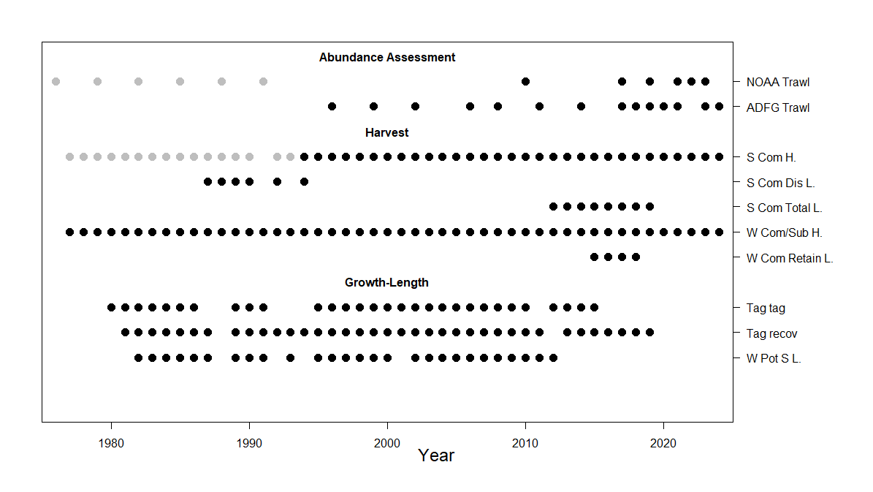
Time series of available data: Gray and black dots in NOAA Trawl indicate NMFS survey (gray) and NBS survey (black). Gray and black dots in S. Com H indicate fisheries by large vessels (gray) and small local vessels (black).

Data | Data Types
NOAA Trawl | Abundance
NOAA Trawl | Length, shell, sex
ADFG Trawl | Abundance
 | Length, shell, sex
Summer Commercial Fishery | Retained catch
(S. Com. H) | Length, shell, sex
 | Abundance
Summer Commercial Fishery Discards | Length, shell, sex
(S. Com. Dis L)
Summer Commercial Fishery total catch | Length, shell, sex
(S. Com. Total H)
Winter Commercial and Subsistence catch | Retained catch (Com, Sub)
(W com/Sub. H) | Total catch (Sub)
Winter Commercial Retained  (W Com Retain L) | Length, shell, sex
Tag release (Tag Tag) | Length, shell, sex
Tag recovery (Tag recov) | Length, shell, sex
Winter Pot survey (W Pots L) | Length , shell, sex

- Stock Biomass: Norton Sound red king crab is monitored not in biomass but in abundance. For the assessment model, biomass is calculated by multiplying the average weight of each length class. Abundance of the Norton Sound red king crab stock has been monitored by trawl surveys since 1976 by NMFS (1976-1991), NOAA NBS (2010-2022), and ADF&G (1996-2021). Historical survey abundance of Norton Sound red king crab of carapace length greater than and equal to 64 mm (CL ≥ 64 mm) ranged from 1.41 million to 5.90 million crab. In 2024 the abundance of crab estimated from the ADF&G trawl survey was 1.41 million crab with CV 0.28 (Table 3). The NOAA NBS survey was not conducted in 2024.

- Recruitment: Model (21.0) -estimated recruitment since the 1980s has averaged ~0.70 million, ranging from 0.20 to 1.60 million (Table 12).

- Management performance.

Status and catch specifications (million lb)
Shaded values are new estimates or projections based on the current assessment. Other table entries are based on historical assessments and are not updated except for total and retained catch.
Year | MSST | Biomass (MMB) | GHL | Retained  Catch | Total  Catch | OFL | ABC
2021/21 | 2.25 | 5.05 | 0.31 | 0.007 | 0.007 | 0.59 | 0.35
2022/22 | 2.08 | 5.33 | 0.34 | 0.34 | 0.36 | 0.67 | 0.40
2023/23 | 2.65 | 5.29 | 0.392 | 0.425 | 0.444 | 0.643 | 0.450
2024/24 | 2.2 | 5.52 | 0.483 | 0.460 | 0.474 | 0.733 | 0.513
2025/26 (21.0) | 2.17 | 4.34 |  |  |  | 0.577 | 0.404
2025/26 (24.0) | 2.36 | 4.72 |  |  |  | 0.628 | 0.440
Note
MSST was calculated as B_{MSY}/2
GHL: Summer commercial fishery retained only

Status and catch specifications (kt)
Year | MSST | Biomass  (MMB) | GHL | Retained  Catch | Total  Catch | OFL | ABC
2021/21 | 1.02 | 2.29 | 0.14 | 0.003 | 0.003 | 0.20 | 0.16
2022/22 | 0.95 | 2.42 | 0.15 | 0.15 | 0.16 | 0.30 | 0.18
2023/23 | 1.20 | 2.40 | 0.178 | 0.192 | 0.201 | 0.292 | 0.204
2024/24 | 1.00 | 2.50 | 0.219 | 0.209 | 0.215 | 0.332 | 0.233
2025/26 (21.0) | 0.98 | 1.97 |  |  |  | 0.263 | 0.163
2025/26 (24.0) | 1.08 | 2.15 |  |  |  | 0.284 | 0.199
Conversion to metric ton: 1 metric ton (t) = 2.2046×1000 lb

- Basis for the OFL (million lb)
Year | Tier | B_{MSY} | Current MMB | B/B_{MSY} (MMB) | F_{OFL} | Years to define  B_{MSY} | Natural Mortality
2021/21 | 4a | 4.53 | 5.05 | 1.1 | 0.18 | 1980-2021 | 0.18
2022/22 | 4a | 4.17 | 5.33 | 1.3 | 0.18 | 1980-2022 | 0.18
2023/23 | 4a | 4.37 | 5.29 | 1.2 | 0.18 | 1980-2023 | 0.18
2024/24 | 4a | 4.45 | 5.52 | 1.2 | 0.18 | 1980-2024 | 0.18
2025/26 (21.0) | 4a | 4.28 | 4.39 | 1.02 | 0.18 | 1980-2025 | 0.18
2025/26  (24.0) | 4a | 4.33 | 4.72 | 1.09 | 0.18 | 1980-2025 | 0.18

Basis for the OFL (kt)
Year | Tier | B_{MSY} | Current MMB | B/B_{MSY} (MMB) | F_{OFL} | Years to define  B_{MSY} | Natural Mortality
2021/21 | 4a | 2.05 | 2.29 | 1.1 | 0.18 | 1980-2021 | 0.18
2022/22 | 4a | 1.90 | 2.42 | 1.3 | 0.18 | 1980-2022 | 0.18
2023/23 | 4a | 1.98 | 2.40 | 1.2 | 0.18 | 1980-2023 | 0.18
2024/24 | 4a | 2.02 | 2.50 | 1.2 | 0.18 | 1980-2024 | 0.18
2025/26 (21.0) | 4a | 1.94 | 1.99 | 1.02 | 0.18 | 1980-2025 | 0.18
2025/26 (24.0) | 4a | 1.96 | 2.37 | 1.09 | 0.18 | 1980-2025 | 0.18

- Probability Density Function of the OFL
Model 21.0 only. Not available for Model 24.0

- The basis for the ABC recommendation.

For Tier 4 stocks, the default maximum ABC is based on P*=49%: essentially identical to the OFL. The annual ABC buffer is determined by accounting for uncertainties in assessment and model results, in which the CPT produces a risk table (SAFE introduction).
The buffer was 10% from 2011 to 2014, increased to 20% in 2015, to 30% in 2020, and to 40% in 2021. In 2023 CPT produced a risk table recommended to reduce the buffer to 30%.

Table Ex-9: Progression of ABC buffer.
Year | ABC Buffer
2011-2014 | 10%
2015-2019 | 20%
2020 | 30%
2021-2022 | 40%
2023-2024 | 30%

- Summary of the results of any rebuilding analysis

NA: NSRKC is not overfished.

Summary of Major Changes

- Changes to the management of the fishery.
None
- Changes to the input data.
Input data were updated through 2024:
Winter subsistence (Total, Retained)
Winter commercial (Retained)
Summer commercial (Retained, length-shell composition)
Trawl survey (Abundance, length-shell compositions)
Update: ADF&G abundance time series re-estimated under the new core/tier 1,2,3 area
Update: NMFS size-shell data (data clean up)
Standardized CPUE (updated with 2024 data: Appendix B)

- Changes to the assessment methodology.
GMACS (Model 24.0) is introduced in this iteration.

Response to SSC and CPT Comments

SSC (Feb 2024)
- Provide details on net mensuration data available for the ADF&G trawl net being used on different vessels with potentially different selectivity.

Author reply:
Provided (see Table T.1 in Data section)

- Consideration of time blocks for survey selectivity for 3 trawl surveys.

Author reply:
The author examined this previously, and selectivity of all the 3 trawl surveys were estimated to be 1.0 across all size classes.

- Consider developing an index of abundance based on the multiple survey data efforts by further identifying the core stations among the surveys within broader grid cells instead of only those directly overlapping.
Author reply:
Author does not consider developing the index. The model indicates that survey catchability differ among the three survey data sets. NBS survey grids differ from those of ADF&G.

4. The exploration of VAST, sdmTMB

Author reply (3,4):

Catlin Stern (ADF&G) will present initial sdmTMB results for the Jan 2025 Modeling workshop.

The author acknowledges the SSC’s requests. The survey coverage of the Norton Sound trawled stations (and thus abundance estimates) differed across years and agencies (See Data section), which could lead to inaccurate estimates of NSRKC abundance that warrants corrections using some methodologies (e.g., VAST, semTMB). While the author agrees with this possibility, the author would request the intent of the SSC regarding the requests.

The fundamental issue regarding NSRKC assessment is a lack of clearly defined spatial boundaries. The NSRKC management area is Area Q3 that extends from Norton Sound to the US-Russia border, including St. Lawrence Island (Figure 1) that has never been trawl surveyed until 2010. 1976-1991 NMFS trawl surveys were conducted within Norton Sound as exploratory without clear target survey coverage. Succeeding trawl survey by ADF&G since 1996 has standardized trawl target survey area that is smaller than NMFS (Figure ). The target survey area set in 2023 is the smallest with the full coverage area of 6068.4 nm² . The above issue is also reflected in the estimate of abundance (Tabe 7). Abundance of 1976-1991 NMFS trawl survey is standardized to 7600 nm², Table 7) (Jon Richer NOAA personal comm), whereas that of ADF&G survey is unexpanded, with coverage ranged from 4700 – 5200 nm² (by the author).

Within the spatial extents of the standardized ADF&G trawl survey area stations, trawl surveys have been covering the majority of the standardized stations. On average trawl survey covered 97% (35 stations out of 36 stations) of core stations, 88% (8.8 out of 10) of Tier 1, 55% (4.4 out of 8) of Tier 2 and 66% (4.6 out of 7) Tier 3 stations, which is 87 % (53 out of 61) of total coverage that trawl survey abundance is derived from (See Table T.2, Data section). Majority of the unsurveyed stations are in Tier 1, 2, 3. Those areas are designated as trawl as time allows because of historical low abundance (Table T3). CV of trawl survey is around 20-30% (Table 4).

The author recommends abundance of the 1971-91 NMFS and ADF&G trawl survey be standardized based on the 2023 ADF&G target survey stations. However, even if all the unsurveyed stations (~10 stations) had been estimated by the spatial modeling, the ‘revised’ abundance estimate would be within the CV range.

Regarding model fit to the trawl survey data, the assessment model shows poor fit to the trawl survey abundance (Figure 10). Thus far, none of historical model revisions including GMACS, have ever improved the model fit to the trawl survey abundance. It is unlikely that the spatial model estimated standardized abundance would improve the assessment model fit (and thus OFL/ABC).

The author acknowledges that the standardized ADF&G trawl survey area is a fraction of Norton Sound where NSRKC lives and can be subject to fisheries and that the assessment model using the “Total abundance” would be more appropriate. For this, the spatial model, such as VAST, sdmTMB can be useful for estimating historical “Total abundance” wherever the spatial extent of NSRKC would be.

For this, the author (request by SSC) has previously provided the VAST estimated abundance of the entire Norton Sound area and NSRKC management area (Area Q) as well as the assessment model MMB/OFL using the VAST model abundance (Sept 2020, SAFE 2021, NSRKC Appendix D). Not surprisingly, the VAST estimated abundance and the model estimated MMB/OFL were 30-75% higher than that using the trawl survey abundance. However, the CPT/SSC did not recommend using the VAST estimated time series data for the NSRKC assessment model (Sept 2020).

Other potential application of the spatial modeling would be examining changes in spatial distribution of NSRKC, which be used to build a spatial stock assessment model. However, thus far, none of other crab assessments that have far more data than NSRKC have not adopted this approach.

The author appreciates SSC’s clarification regarding the scope of the requests (e.g., spatial extents, expected outputs).

Introduction

Scientific name
Red king crab, Paralithodes camtschaticus, in Norton Sound, Alaska.

General Distribution:
Norton Sound red king crab (NSRKC) is one of the northernmost red king crab populations that can support a commercial fishery (Powell et al. 1983). The overall distribution and population boundary of NSRKC is unknown. Within the area ADF&G surveys have been conducted, it is more often found in areas less than 30 m, and summer bottom temperatures above 4º C. NOAA NBS survey (Fig C.2) showed intermittent connections between Bristol Bay red king crab on the southern end. Red king crab bycatch is also reported in the area around St. Lawrence island.

The Norton Sound red king crab management area consists of two units: Norton Sound Section (Q3) and Kotzebue Section (Q4) (Menard et al. 2011). The Norton Sound Section (Q3) consists of all waters in Registration Area Q north of the latitude of Cape Romanzof, east of the International Dateline, and south of 66°N latitude (Figure 1). By regulation, all red king crabs in the Q3 sections are considered Norton Sound red king crab.

Figure C.2, Distribution of NSRKC (from Markowitz et al. 2023. Northern Bering Sea groundfish and crab trawl survey highlights (https://www.fisheries.noaa.gov/s3//2023-10/Community-report-2023.pdf). Author added: Red line indicates Norton Sound red king crab management area (Area Q). Orange rectangular indicates a standardized ADF&G trawl survey area. _

Evidence of stock structure:
Based on variability at 15 SNP loci and in mtDNA sequences (COI, 665 bp), the NSRKC stock belongs to the Okhotsk Sea–Norton Sound–Aleutian Islands evolutionary lineage (SNPs, FCT = 0.054; mtDNA FCT = 0.222) (Grant and Chen 2012). However, this does not indicate that NSRKC is a single stock. The study indicates it was incapable of detecting possible evolutionary stock differences within the NSRKC stock. No studies have investigated possible stock separation within the Norton Sound management area.

Description of life history characteristics relevant to stock assessments
One of the unique life-history traits of NSRKC is that they spend their entire lives in shallow water since Norton Sound is generally less than 30 m in depth (as opposed to Bristol Bay red king crab of 60-130 m depth). Based on the 1976-2021 trawl surveys, NSRKC are found in areas with a mean depth range of 19 ± 6 (SD) m and bottom temperatures of 7.4º ± 2.5 (SD) C during summer. NSRKC are consistently abundant offshore of Nome. NSRKC migrate between deep (20-30m) offshore and shallow (5-10m) inshore waters within Norton Sound. The timing of the inshore mating migration is unknown but is assumed to be during late fall to winter (Powell et al. 1983). Offshore migration occurs in late May - July (Bell et al. 2016). Some older/larger crab (> 104mm CL) may stay offshore in the winter, as larger crab are not found nearshore during the spring offshore migration periods (Jenefer Bell, ADF&G, personal comm). Molting occurs from fall to winter. Double shelled crabs were often observed in late August commercial catch (Joyce Song ADF&G personal comm). Laboratory observation showed that male crab molted in August – November and female crab molted in Jan-March (Leah Zacher and Jennifer Gardner NOAA-AFSC personal comm). Functional maturity of NSRKC male crab is as small as 79.4 mm CL (Leah Zacher NOAA-AFSC personal comm). Small males may be more successful than large males for mating, as small males could also fertilize the eggs of ~ 4 females, whereas the largest crab (> 123 mm) was able to fertilize the eggs of ~ 2 females.

Brief summary of management history:
A complete summary of the management history is provided in the ADF&G Annual Management Report Norton Sound-Port Clarence Area and Arctic-Kotzebue Areas (http://www.adfg.alaska.gov/FedAidPDFs/FMR22-27.pdf )

NSRKC fisheries consist of commercial and subsistence fisheries. The commercial red king crab fisheries occur in summer (June – August) and winter (December – May), and subsistence is open year-round. The majority of NSRKC harvested occurs during the offshore summer commercial fishery, whereas the winter commercial and subsistence fisheries occur nearshore through ice and take a much smaller harvest.

A distinguishing characteristic of the NSRKC fisheries is that all fisheries, surveys, research, and management are primarily conducted by local residents of Norton Sound. Commercial fisheries are designated as super-exclusive: a vessel registered for the Norton Sound crab fishery may not be used to take king crabs in any other registration areas. The ADF&G and the NSRKC crab research and management biologists are residents of Nome and are acquainted with many local fishermen (commercial and subsistence) and staff of community organizations such as Norton Sound Economic Development Corporation (NSEDC) and Kawerak Inc, exchanging information and research ideas about crab biology and fisheries management.

Summer Commercial Fishery
A large-vessel summer commercial crab fishery started in 1977 in the Norton Sound Section (Table 1) and continued from 1977 through 1990. No summer commercial fishery occurred in 1991 because there were no ADF&G staff to manage the fishery. In March 1993, the Alaska Board of Fisheries (BOF) limited participation in the fishery to small boats. Then on June 27, 1994, a super-exclusive designation went into effect for the fishery. This designation states that a vessel registered for the Norton Sound crab fishery may not be used to take king crabs in any other registration areas during that registration year. A vessel moratorium was put into place before the 1996 season. This was intended to precede a license limitation program. In 1998, Community Development Quota (CDQ) groups were allocated a portion of the summer harvest; however, no CDQ harvest occurred until the 2000 season. On January 1, 2000, the North Pacific License Limitation Program (LLP) went into effect for the Norton Sound crab fishery. The program dictates that a vessel which exceeds 32 feet in length overall must hold a valid crab license issued under the LLP by the National Marine Fisheries Service. Changes in regulations resulted in the fishery being conducted solely by local residents with vessel sizes of under 40 feet and the fishery occurring eastward of Norton Sound.
In Norton Sound, a legal crab is defined as ≥ 4 3/4-inch carapace width (CW, Menard et al. 2011), which is approximately equivalent to ≥ 104 mm carapace length (CL). In 2005 and 2006, commercial buyers, specifically Norton Sound Economic Development Corporation (NSEDC), accepted only legal crab of ≥ 5 inch CW. This preference became permanent in 2008.
Some portions of Norton Sound are closed to commercial fishing for red king crab. Since the beginning of the commercial fisheries in 1977, waters approximately 5-10 miles offshore of southern Seward Peninsula from Port Clarence to St. Michael have been closed to protect nearshore subsistence fisheries and to function as a refuge for crab during the summer commercial crab fishery (Figure 2). The spatial extent of closed waters has varied historically, with the closure line being moved in to provide additional area to achieve harvest goals. In 2020 the BOF closed Norton Sound east of 167 degrees W. longitude for the commercial summer crab fishery. In 2020 and 2021 the NSEDC did not purchase NSRKC resulting in small or no harvest. In 2022, the NSEDC resumed purchasing summer commercial catch.

CDQ Fishery
The Norton Sound and Lower Yukon CDQ groups divide the NSRKC CDQ allocation. Only fishers designated by the Norton Sound and Lower Yukon CDQ groups are allowed to participate in this portion of the fishery. Fishers are required to have a CDQ fishing permit from the Commercial Fisheries Entry Commission (CFEC) and register their vessel with the Alaska Department of Fish and Game (ADF&G) before beginning fishing. Fishers operate under the authority of each CDQ group. CDQ harvest share is 7.5% of the guideline harvest level (GHL), and can be prosecuted in both summer and winter seasons.

Winter Commercial Fishery
The winter commercial crab fishery uses hand lines and pots through the nearshore ice. On average 10 permit holders harvested 2,500 crab during 1978-2009. From 2007 to 2015 the winter commercial catch increased from 3,000 crab to over 40,000 (Table 2). In 2015 the winter commercial catch reached 20% of the total crab catch. The BOF responded in May 2015 by amending regulations to allocate 8% of the total commercial GHL to the winter commercial fishery, which has been in effect since the 2017 season. The timing of the winter red king crab commercial fishing season has changed over time to address ice stability. It was originally from January 1 to April 30, amended in 1985 to from November 15 to May 15. In 2015 the period was changed to January 15 to April 30 after fisheries opened on November 15 in 2014, so that January 15 starting date was into effect in 2016. In 2021 it was further amended to February 1 to April 30. The NSEDC terminated purchasing winter fishery crab in 2019, and since then all the winter commercial catches are by catcher-seller permit holders.

Winter commercial NSRKC fishery opening periods.
Year | Opening period
1977-1984 | Jan 01 – Apr 30
1985- 2014 | Nov 15 – May 15
2015 | Nov 15 – Apr 30
2016-2020 | Jan 15 – Apr 30
2021 - present | Feb 01 – Apr 30

Subsistence Fishery
The winter subsistence fishery has a long history; however, harvest information is available only since the 1977/78 season. The majority of subsistence crab harvest occurs in winter using hand lines and pots through nearshore ice. The average annual winter subsistence harvest is 5,281 crabs (1977-2021). Subsistence harvesters need to obtain a permit before fishing and record daily effort and catch. There are no size or sex-specific harvest limits; however, the majority of retained catch is males of near legal size.
Summer subsistence crab fishery harvest has been monitored since 2004 with an average harvest of 1,145 crabs (2004-2020). The summer subsistence fishery was not included in the assessment model.
Harvest of both winter commercial and subsistence fisheries is influenced by the availability of stable ice conditions. Small harvests can occur due to poor ice conditions, regardless of crab abundance.

Brief description of the annual ADF&G harvest strategy
Since 1997 NSRKC has been managed based on a guideline harvest level (GHL). From 1999 to 2011 the GHL for the summer commercial fishery was determined using model estimated biomass: (1) 0% harvest rate of legal crab when estimated legal biomass < 1.5 million lb; (2) ≤ 5% of legal male biomass when the estimated legal biomass falls within the range 1.5-2.5 million lb; and (3) ≤ 10% of legal male biomass when estimated legal biomass >2.5 million lb. In 2012 the summer commercial fishery GHL was revised to (1) 0% harvest rate of legal crab when estimated legal biomass < 1.25 million lb; (2) ≤ 7% of legal male biomass when the estimated legal biomass falls within the range 1.25-2.0 million lb; (3) ≤ 13% of legal male biomass when the estimated legal biomass falls within the range 2.0-3.0 million lb; and (3) ≤ 15% of legal male biomass when estimated legal biomass >3.0 million lb.
In 2015 the BOF passed the following regulations regarding the winter commercial fisheries:
  - Revise GHL to include summer and winter commercial fisheries.
  - Set GHL for the winter commercial fishery (GHL_{w}) at 8% of the total GHL

Table C-7: ADF&G GHL determination table
Legal crab biomass  Million lb (kt) | Total GHL harvest rate (%) | Winter allocation (%) | CDQ  allocation (%)
< 1.25 (0.57) | 0 | 8 | 7.5
1.25-2.0 (0.57-0.91)_ | ≤ 7 | 8 | 7.5
2.0-3.0 (0.91-1.36) | ≤ 13 | 8 | 7.5
> 3.0 (1.36) | ≤ 15 | 8 | 7.5

GHL is determined in early February, not to exceed (e.g., 5-10% less) the retained portion of the total catch ABC.

Summary of the history of the basis and estimates B_{MSY.}
NSRKC is a Tier 4 crab stock. Direct estimation of the B_{MSY} is not possible. The B_{MSY} proxy is calculated as the mean model estimated mature male biomass (MMB) from 1980 to the present. The choice of this period was based on a hypothesized shift in stock productivity due to a climatic regime shift indexed by the Pacific Decadal Oscillation (PDO) in 1976-77.

Brief history of the target fishery
Table: Brief NSRK fishery management history
Year | Notable historical management changes
1976 | The abundance survey started
1977 | Large vessel commercial fisheries began. Legal size was set to ≥ 5 inch CW
1978 | Legal size was changed to ≥ 4.75 inch CW
1991 | Fishery closed due to staff constraints
1993 | Fishery is restricted to small boat. The end of large vessel commercial fishery operation.
1994 | Super exclusive designation went into effect.
1998 | Community Development Quota (CDQ) allocation went into effect
1999 | Guideline Harvest Level (GHL) went into effect
2000 | North Pacific License Limitation Program (LLP) went into effect.
2002 | Change in closed water boundaries (Figure 2)
2006 | The Statistical area Q3 section expanded (Figure 1)
2008 | Start date of the open access fishery changed from July 1 to after June 15 by emergency order.  Pot configuration requirement: at least 4 escape rings (> 4.5 inch diameter) per pot located within one mesh of the bottom of the pot, or at least ½ of the vertical surface of a square pot or sloping side-wall surface of a conical or pyramid pot with mesh size > 6.5 inches.
2008 | Market preferred size of ≥ 5 inch CW became a standard commercial retained size.
2012 | The BOF adopted a revised GHL for summer fishery.
2016 | Winter GHL for commercial fisheries was established and modified winter fishing season dates were implemented.
2019 | The NSEDC stopped purchasing the winter commercial crab.
2020  2021 | The BOF closed summer commercial fishery East of 167 longitude. Summer commercial fisheries opened but the NSEDC did not purchase the summer commercial crab.
2021 | Change winter fishery open date to February 1

Data

Summary of new information:
Input data were updated through 2024:

Winter subsistence (Total) (Not used for the model 24.0 GMACS)
Winter subsistence (Retained)
Winter commercial (Retained)
Summer commercial (Retained, length-shell composition)
Trawl survey (Abundance, length-shell compositions) ADF&G
Standardized CPUE

Data which should be presented as time series:
      - Retained catch Summer (Table 1),
Winter: commercial retained, subsistence: total and retained (Table 2)

      - Information on bycatch and discards

Bycatch

In Norton Sound, the directed Pacific cod pot fishery was issued in 2018 under the CDQ permit. In 2018 and 2019 fishery seasons, a total of 8 and 13 kg (mortality applied) of NSRKC were taken in the groundfish fisheries (CPT 2020). However, all bycatch occurred to the west of 168.0 longitude where NSRKC survey has not been conducted. Norton Sound Fishery Management Area (Q3) extends to St. Lawrence Island and US-Russia border (Figure 1). In the absence of survey abundance extended to that area, it is questionable whether those bycatch mortalities should be included in the NSRKC assessment.
 | Fishery | Data availability
Other crab fisheries | Does not exist | NA
Groundfish pot | Pacific cod | Y
Groundfish trawl | Does not exist | NA
Scallop fishery | Does not exist | NA

Discards

NSRKC discards have not been observed systematically. Length-shell composition from ad hoc surveys are available (Table 8, 9).

      - Catch-at-length
Summer commercial retained (Table 4)
Winter commercial retained (Table 5)
Summer commercial discards (Table 8)
Summer commercial total (Table 9)

      - Survey biomass estimates

Trawl survey (Table 3)

The trawl survey consists of 3 surveys: NMFS triennial survey: 1976-1992, ADF&G survey: 1996-2023, and NOAA NBS survey: 2010, 2017-2023. Since the initiation of the survey in 1976, Norton Sound trawl surveys have never had a standardized area. Survey coverage has changed based on availability of budget, survey schedule, and research interests at the time (Figure 3).

NMFS triennial survey:

A Norton Sound trawl survey was initiated by NMFS in 1976 to assess the stock status of crab and groundfish in Norton Sound and Kotzebue Sound. The survey established 10 nautical mile (nm) grid survey stations throughout the entire Norton Sound and 15 nm grids outside the Norton Sound area. The initial Norton Sound survey became the standard stations moving forward. The survey was conducted from mid-late August to September-October, except for 1979, which was in late July/early August. The survey used 83-112 Eastern Otter trawl gear, with a tow distance of 1.3 – 1.7 nm (30 minutes tow). The survey was terminated in 1992.

ADF&G survey:

After the termination of the NMFS trawl survey, ADF&G began trawl surveys in 1996 using the same survey stations, but using smaller boat and smaller survey coverage. The survey started as triennial, but it became an annual survey in 2017 and biennial in 2021. The survey usually occurs in late July – mid August, using 400 Eastern Otter trawl gear with a tow distance of 1.0 nm. The survey used to have a re-tow protocol: when the first tow caught more than 5 legal red king crab, the station was re-towed. This protocol was dropped in 2012 in favor of more coverage. The ADF&G trawl survey area consists of core (36 stations, 3568.4 nm²), tier 1 (10 stations, 1000 nm²), tier 2 (8 stations, 800 nm²), and tier 3 (7 stations, 700 nm²), in the order of survey priorities. During the survey periods, the core stations are trawled first, followed by tire 1, tier 2, and tire 3 as time allows.

NOAA NBS survey:

NOAA NBS trawl survey started in 2010, and biennially since 2017. The survey occurs in late July-mid August, similar to the ADF&G survey. The survey has 20 nm grid using 83-112 Eastern Otter trawl gear, with tow distance of 1.3 – 2.5 nm (30 min tow).

Table d.1 : Survey protocols of the NMFS, ADF&G, and NBS survey
Survey | Net | Net width | Tow Distance | Survey Grids | Survey  strategy
NMFS  (1976-1992) | 83-112 Eastern Otter | 50ft | 1.3 – 1.7 nm (30 min tow). | 10 nm
ADF&G  (1996- ) | 400 Eastern Otter | 40ft | 1.0 nm | 10 nm | As time allows
NOAA NBS  (2010- ) | 83-112 Eastern Otter | ~50ft (measured) | 1.3 – 2.5 nm (30 min tow). | 20 nm | Survey all stations

Table d.2 The number of stations trawled by survey area (Core, Tier 1, Tier 2, Tier 3). The numbers in parenthesis show the number of survey stations in each survey area.
Year | Agency | Core  (36) | Tier 1  (10) | Tier 2  (8) | Tier 3  (7)
1976 | NMFS | 33 | 8 | 8 | 5
1979 | NMFS | 32 | 8 | 4 | 6
1982 | NMFS | 33 | 6 | 4 | 6
1985 | NMFS | 34 | 10 | 4 | 6
1988 | NMFS | 34 | 10 | 4 | 6
1991 | NMFS | 29 | 10 | 4 | 1
1996 | ADF&G | 36 | 10 | 0 | 0
1999 | ADF&G | 36 | 5 | 0 | 6
2002 | ADF&G | 36 | 10 | 6 | 2
2006 | ADF&G | 36 | 10 | 8 | 7
2008 | ADF&G | 36 | 10 | 7 | 6
2011 | ADF&G | 36 | 10 | 7 | 7
2014 | ADF&G | 36 | 10 | 0 | 0
2017 | ADF&G | 36 | 10 | 7 | 6
2018 | ADF&G | 36 | 10 | 7 | 7
2019 | ADF&G | 36 | 10 | 3 | 3
2020 | ADF&G | 36 | 10 | 7 | 7
2021 | ADF&G | 36 | 0 | 0 | 3
2023 | ADF&G | 33 | 10 | 3 | 4
2024 | ADF&G | 30 | 10 | 0 | 0

Table d.3 The abundance by each area (Core, Tier 1, Tier 2, Tier 3).
Year | Agency | Core | Tier 1 | Tier 2 | Tier 3
1976 | NMFS | 2530371 | 332309 | 102800 | 312860
1979 | NMFS | 455480 | 265613 | 0 | 0
1982 | NMFS | 2162521 | 455096 | 7548 | 15886
1985 | NMFS | 2078585 | 151824 | 15286 | 15862
1988 | NMFS | 2120874 | 344561 | 0 | 15190
1991 | NMFS | 2422448 | 270102 |  | 0
1996 | ADF&G | 1071532 | 242225
1999 | ADF&G | 2213409 | 194844 |  | 222277
2002 | ADF&G | 1461382 | 234364 | 65101 | 0
2006 | ADF&G | 2730106 | 243044 | 151903 | 197474
2008 | ADF&G | 2476015 | 273425 | 121522 | 91142
2011 | ADF&G | 2204254 | 273425 | 701225 | 30381
2014 | ADF&G | 5600084 | 349376
2017 | ADF&G | 1321554 | 364567 | 60761 | 15190
2018 | ADF&G | 911912 | 91142 | 45571 | 60761
2019 | ADF&G | 1592366 | 3083625 | 0 | 0
2020 | ADF&G | 1270287 | 394947 | 15190 | 45571
2021 | ADF&G | 2400063 |  |  | 30381
2023 | ADF&G | 2925278 | 501279 | 15190 | 106332
2024 | ADF&G | 1103596 | 303805

Abundance estimation method

Methods of estimating red king crab abundance differed among the three surveys and throughout time periods. Abundance estimates have been revised many times.

Abundance and CV of the NMFS 1976-1991 surveys were provided by NOAA (Jon Richer NOAA personal communication). The abundance was estimated by averaging catch CPUE (#/nm²) of all surveyed stations and multiplied by the standard Norton Sound Area (7,600 nm²) (i.e., N = 7,600*mean CPUE). The ADF&G survey abundance was calculated at each station (i.e., n= CPUE*100 nm²) and summed across all surveyed stations (i.e., N = sum of 100*CPUEs) (Bell and Hamazaki 2019). Extent of the ADF&G survey coverage differed among years due to survey conditions, and survey abundance has not been standardized. NOAA NBS survey abundance is estimated by the author in similar manner as ADF&G survey with the data limited to the Norton Sound survey area that overlaps the ADF&G survey area (5841 nm²) (Figure d1).

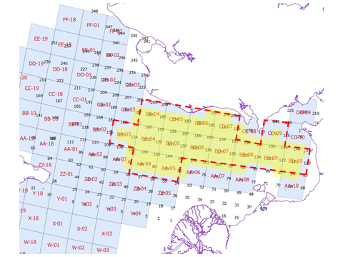

Figure d1. ADF&G trawl survey coverage (yellow shade) and NOAA NBS trawl survey coverage where abundance estimates were made (red hashed line),

Survey catchability appears to differ among ADF&G, NMFS, and NOAA NBS trawl surveys. ADF&G trawl survey abundance tended to be higher than NMFS and NOAA NBS trawl survey even though NMFS and NOAA NBS survey coverages were greater than ADF&G. The assessment model assumes (recommendation by CPT-SSC) that survey q of ADF&G trawl survey be 1.0, which resulted in q = 0.7-0.8 for NMFS and 0.7-0.96 for NOAA NBS survey.

Trawl survey catches were highly patchy. The majority of catches occurred at 1 to 4 stations that accounted for 20% to 80% of crabs caught during the entire survey (Figure d2). The most consistently abundant survey stations are near Nome (blue dots) outside of the summer commercial fishery area (red rectangular). Some offshore stations had high catches for a few years (orange dots: 1990s, yellow dots: 2020s) but they did not persist.

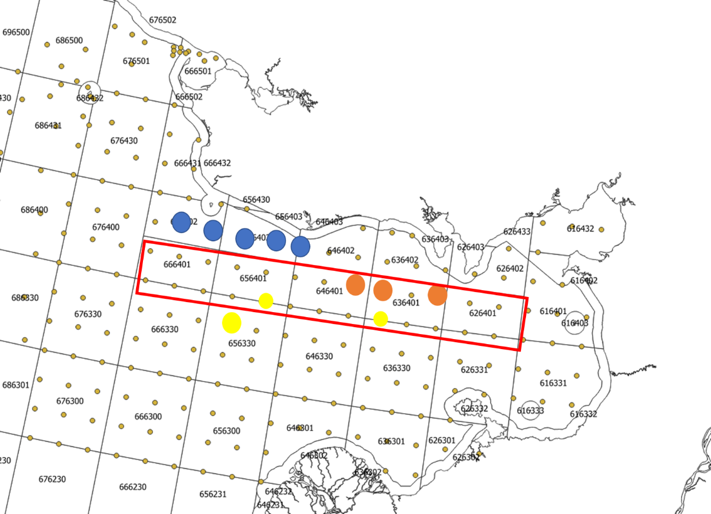

Figure B. Trawl survey stations where majority of catch occurred. Red rectangular indicates where the majority of summer commercial fishery occurs. Blue dots indicate the stations that had high catch consistently since 1976. Orange and yellow dots indicate high crab catch stations that occurred during the 1990s (orange) and 2020s (yellow).

      - Survey catch-at-length
Summer trawl survey (Table 6)
Winter pot survey (Table 7)

      - Catch-per-unite effort time-series

Standardized CPUE (Appendix B, Table 1).

Standardized summer commercial fishery CPUE is included in the NSRKC assessment model as an index of NSRKC abundance that could supplement the triennial trawl survey. In 2013, the CPUE standardization model was developed by Gretchen Bishop (ADF&G) (NPFMC 2013). Since then, the same model has been applied with updated data (Appendix B). Standardized CPUE for the years of 1991, 2020, and 2021 were not calculated because a commercial fishery was closed (1991) or no crab was harvested during the commercial fishery (2020, 2021).

The standardized CPUE consists of the 3 periods:
1977-1992: Large Scale commercial fishery (CL > 4.75 inches)
1993-2007: Small boat commercial fishery (CL > 4.75 inches)
2008-2024: Small boat commercial fishery with high grading (CL > 5.0 inches)

      - Other times series data

Norton Sound red king crab tagging was initially conducted in 1980 as a part of mark-recapture abundance survey (Brannian 1987). The study was conducted in 1980-1982 and 1985. From 1986 to 2012 crabs were tagged during the winter pot survey. The winter pot surveys tagged mostly sublegal crab crab; however, very few were recovered. Tagging resumed from 2012-2015 for a spring migration movement survey. In all the above studies, most of the tagged crabs were recovered by commercial fishermen, but subsistence fishermen also recovered a small number of tags.

Data which may be aggregated over time

      - Growth-per-molt
Estimated with the model, the tagging data (Table 10)

      - Weight-at length
Weight-at-length data were summarized as:

Length class | 1 | 2 | 3 | 4 | 5 | 6 | 7 | 8
lb | 0.52 | 0.82 | 1.20 | 1.70 | 2.32 | 3.00 | 3.69 | 4.37

Information on any data sources that were available, but were excluded from the assessment

- Trawl survey females data, surface-bottom temperature, salinity
- Tagging-recovery locations (2012-2019)
- Satellite tag migration tracking (NOAA 2016, ADF&G 2020-21)
- Spring offshore migration distance and direction (2012-2015)
- Monthly blood hormone level (indication of molting timing) (2014-2015)
- Functional maturity and mating success of captured crab (2021-22)

Other data available but not used for assessment
Data | Years | Data Types | Reason for not used
Summer pot survey | 80-82,85 | Abundance | Uncertainties on how estimates were made.
Summer pot survey | 80-82,85 | Length proportion | Uncertainties on how estimates were made.
Summer preseason survey | 95 | Length proportion | Just one year of data
Summer subsistence fishery | 2005-present | retained catch | Too few catches, ignored.
Winter Pot survey | 87, 89-91,93,95-00,02-12 | CPUE | CPUE data unreliable.
Preseason Spring pot survey | 2011-15 | CPUE,  Length proportion | Years of data too short
Postseason Fall pot survey | 2013-15 | CPUE,  Length proportion | Years of data too short

Analytic Approach

History of the modeling approach and issues:
The Norton Sound red king crab stock was assessed using a length-based synthesis model (Zheng et al. 1998). Since adoption of the model, the model had the following model mismatches:

  - Model projects higher abundance-proportions of large size class (> 123mm CL) of crab than observed.

  - Poor model fit to trawl survey abundance.

  - Some model parameters hit boundaries

The issues of 1 and 2 are attributed to natural mortality specification. Natural mortality M specification was originally specified to be 0.2 for BSAI red king crab stocks including NSRKC (NPFMC 1998) and was specified to 0.18 with Amendment 24 (NPFMC 2011). Natural mortality is assumed to be the same across all individual lengths (i.e., length-independent M).

Model projects higher abundance-proportions of large size class (> 123mm CL) of crab.

This issue has been solved by assuming (3-4 times) higher M for the large crab (i.e., M = 0.18 for length classes ≤ 123 mm, and higher M for > 123 mm) (NPFMC 2012, 2013, 2014, 2015, 2016, 2017, 2018). However, because this solution deviates from the length-indepenent M assumption applied to all the other crab assessment models, several alternative assumptions have been considered in the past.

              - Large crabs move out of the survey and fishing area

In modeling, this was dealt with by setting dome-shaped survey and commercial catch selectivity (i.e., lower catchability for large crabs). This modeling configuration resulted in estimating MMB two times higher than the default model, which indicates that true NSRKC abundance is two-times larger than the current trawl survey and commercial crab fishery indicate (NPFMC 2017). The NOAA NBS surveys (2010, 2017, 2019, 2021) did not find high numbers of red king crabs outside Norton Sound. The large crab could also be nearshore where the commercial fishery is closed, and a trawl survey is not conducted due to rocky bottom. However, spring tagging studies showed that most crabs migrated from near shore to offshore (fishing) area (Jenefer Bell, ADF&G personal comm.). There was little evidence that large crabs stay in nearshore waters during summer.

              - Molting and growth of NSRKC are slower. (i.e., model overestimating molting and growth probability: transition matrix)

The model originally estimated the transition outside of the model. In 2014 the model was configured to estimate the transition matrix inside of the assessment model (NPFMC 2014). The transition matrix estimated inside of the model was similar to that estimated outside of the model. When length-specific molting probability was estimated individually, the shape of the probability curve was also similar to the default inverse logistic molting function (NPFMC 2016). A time-varying molting function (random walk) process did not improve model fit. Laboratory studies showed that observed growth after molting was comparable to those from tag-recovery data, though sample size was limited and comparable tank-natural condition factors such as water temperature and food availability, were questionable (Leah Zacher of NOAA AFSC personal comm).

              - Higher natural mortality (M) than assumed M = 0.18

Profile analyses and estimating M across all length classes resulted in higher M (0.3-0.45) than default M=0.18 (NPFMC 2013, 2016, 2017). However, the model fit is worse than the default model.

              - Higher natural mortality (M > 0.18) for small crab and large crab having higher mortality than small crab (M > 0.18).

This model configuration had the best fit to data (NPFMC 2016, 2017).

              - Gradual size-dependent natural mortality.

The default assessment model assumes an abrupt M increase at size CL 124mm or greater. An alternative model suggested that M gradually increasing from size as low as 94 mm CL; however, the overall model fit did not greatly improve from the default model (NPFMC 2017). In 2022, CPT requested estimating M for each length class, which also suggested length-dependent natural mortality. However, this resulted in M = 0 for immature crabs (size classes 1, 2) (NPFMC 2022).

Poor model fit to trawl survey abundance, especially NMFS survey (1976-1992) data

The NSRKC assessment model suggests higher crab abundance than observed during the 1976-1990s period. The model deals with this issue by including survey q (q < 1), or the model assumes the NMFS trawl surveys underestimated NSRKC abundance. However, this assumption is arbitrary, which is also affected by other model configurations. For instance, when M = 0.18 is assumed for all length classes, the model suggests that survey q for NMFS is greater than 1.0 (NPFMC 2022). Alternatively, assuming the NMFS survey q = 1.0 resulted in ADF&G trawl survey q greater than 1.0 (i.e., trawl survey overestimates abundance), even though ADF&G trawl survey area is generally smaller than NMFS and NOAA NBS survey areas.

This model fitting issue was also influenced by input sample sizes for size-shell compositions. Increasing the input sample size resulted in the model estimating lower abundance. Reducing the input sample sizes improved model fit to the trawl survey data but caused lower fit to size-shell composition data (NPFMC 2012, 2013, 2015). Alternative model weighting methods (e.g., Francis 2012) have been tried, but those did not improve model fit.

Some model parameters hit boundaries.

There are two model parameters that hits boundaries: Trawl survey selectivity (log_φ_{st1}), and the proportion of recruits (r1, r2).

- Trawl Survey selectivity parameter

Trawl survey selectivity model is a one parameter logistic curve that reaches 1.0 at L_{max} (143.5 mm)

where α = exp(log_φ_{st1}), L_{max} = 143.5 mm L (63.5-143.5 mm)

Model estimated trawl survey selectivity is 1.0 across all size classes. This means that ≈ 0, α(L_{max}-L)+ln(1/0.999-1) = -∞, α ≈ 0, and log_ϕ_{st1} = -∞. Hence, the parameter will hit the boundary.

An alternative option is assuming S_{l} = 1.0 for all length classes; however, this also removes the model’s ability to estimate length dependent selectivity.

- The proportion of recruits

The proportion of recruits is a multinomial formula of n =3
Model estimated recruit proportions for length classes 1, 2, 3 (P₁, P₂, P₃) are 0.592, 0403, and 0.003. P₃ ≈ 0 makes it extremely difficult for the model to estimate P₁ and P₂, and thus model parameters r1 and r2 (Tables 11, 12). Increasing the upper bound of the r parameters would still make r1 hit the boundary and make estimates of P₁, P₂, P₃ to be closer to P₁ = 0.60, P₂ ₌ 0.40, and P₃=0. An alternative option is assuming P₃ = 0; however, this also removes the model’s ability to estimate P₃ when P₃ is far greater than 0.

Historical Model configuration progression:

2011 (NPFMC 2011)
1). M =0.18 : Implemented
2). M of the last length class = 0.288.
3). Include summer commercial discards mortality = 0.2 : Implemented
4). Weight of fishing effort = 20.
5). The maximum effective sample size for commercial catch and winter surveys = 100.

2012 (NPFMC 2012)
- M of the last length class = 3.6×M.
- The maximum effective sample size for commercial catch and winter surveys = 50. Implemented
- Weight of fishing effort = 50.

2013 (NPFMC 2013)
  - Standardize commercial catch CPUE and replace the likelihood of commercial catch efforts with standardized commercial catch CPUE with weight = 1.0. Implemented
  - Eliminate summer pot survey data from likelihood. Implemented
  - Estimate survey q of 1976-1991 NMFS survey with a maximum of 1.0. Implemented
  - The maximum effective sample size for commercial catch and winter surveys = 20. Implemented

2014 (NPFMC 2014)
- Modify the functional form of selectivity and molting probability to improve parameter estimates (2 parameter logistic to 1 parameter logistic). Implemented
- Include additional variance for the standardized CPUE. Implemented
- Include winter pot survey CPUE (was removed from the final model due to lack of fit).
- Estimate growth transition matrix from tag-recovery data. Implemented

2015 (NPFMC 2015)
- Winter pot survey selectivity is an inverse logistic, estimating selectivity of the smallest length group independently. Implemented
- Reduce weight of tag-recovery: W = 0.5. Implemented
- Model parsimony: one trawl survey selectivity and one commercial pot selectivity. : Implemented

2016 (NPFMC 2016)
- Length range extended from 74 mm – 124 mm above to 64 mm – 134 mm above. Implemented
- Estimate multiplier for the largest (> 123mm) length classes. Implemented

2017 (NPFMC 2017)
- Change molting probability function from 1 to 2 parameter logistic. Assume molting probability not reaching 1 for the smallest length class. Implemented

2018 (NPFMC 2017) CPT-SSC suggested no model alternatives

2019 (NPFMC 2019)
- Fit total catch length composition and estimate retention probability for summer and winter commercial fishery. Implemented
- Include winter commercial retained length data. Implemented

2020 (NPFMC 2020) The CPT and SSC suggested no model alternatives

2021 (NPFMC 2021) Include discards data at the request of CPT and SSC
- Models that bridge from the Model 19.0e to 21.0
- Model 21.0 with natural mortality estimated by model. Rejected for high M estimate
- Estimate size specific natural mortality. Rejected for unrealistic M estimate

2022 (NPFMC 2022): Adopted model: Model 21.0
- Examine shell-based retention probability. Rejected for model parsimony
- Estimate individual length class M. Exploratory

2023 (NPFMC 2023): Adopted model: Model 21.0

- Model with single M estimated. Exploratory

- (NPFMC 2024): Adopted model: Model 21.0
        - Transition to GMACS

Model Description
- Description of overall modeling approach:
The model is a male-only size structured model based on abundance that combines multiple sources of surveys, fishery catches and discards, and mark-recovery data using a maximum likelihood modeling framework to estimate population dynamics under fisheries. The model is an extension of the length-based model developed by Zheng et al. (1998) for NSRKC. A detailed description of the model is in Appendix A.
The model estimates abundances of male crab with CL ≥ 64 mm and with 10 mm length intervals (8 length classes, ≥ 134mm) because few crab measuring less than 64 mm CL were caught during surveys or fisheries.
The model assumes newshell crab as molted and oldshell crab as unmolted.
One critical characteristic of the model is that it does not estimate fishing mortality (F). Observed harvests were considered accurate and thus directly subtracted from the model estimated abundance.

The modeling scheme and data are described in the following figure.

Length proportion
Pot Survey
1980-2012:

Standardized
CPUE

Length proportion
Com retained & discards

Com Fishery
Jun – Sept
Assume: July 01

Molting, Growth

Tag recovery

Recruitment

Natural mortality
7 months

July 01
Pre-fishery Population

Feb 01: SAFE
Assessment
Abundance

Catch selectivity

Com & Sub Fishery
Nov – May
Assume: Feb 01

July 01
Post-fishery Population

Catch & Survey selectivity
Survey selectivity

Length proportion
Com retained:
2015 - 2019

Natural mortality
5 months

Feb 01
Post-fishery Population

Survey selectivity

Population
During fishery

Abundance & Length proportion
Trawl survey

Norton Sound Red King Crab Modeling Scheme
Com Fishery Discards (discontinued j2019)

Figure C. Norton Sound red king crab model and data scheme. Bold type indicate data that were fitted to the model. Boxes in dotted line indicate model estimated parameters and quantities.
Natural mortality, M was set to 0.18 except for CL greater than 123mm that was estimated in the model.

Timeline of calendar events and crab modeling events:
- Model year starts February 1st to January 31st of the following year.
- Initial Population Date: February 1st, 1976, consisting of only newshell crab.
- Instantaneous fishing mortality: winter (February 1st) and summer (July 1st) fisheries
- Instantaneous molting and recruitment occur on July 1^{st\}

- Reference software used
AD Model Builder 13.2 (Model 21.0)
GMACS: Version 2.20.14 Compiled with AD Model Builder 13.2

- Description of all likelihood components
Model 21.0 / Model 24.0 GMACS
TSA: Trawl Survey Abundance (lognormal)
St. CPUE: Summer commercial catch standardized CPUE (lognormal with additional var)
TLP: Trawl survey length-shell composition (multinomial)
WLP: Winter pot survey length-shell composition (multinomial)
CLP: Summer commercial retention catch length-shell composition (multinomial)
REC: Recruitment deviation (normal)
OBS: Summer commercial catch observer discards and total catch length-shell composition (multinomial)
TAG: Tagging recovery data composition (multinomial)
WCLP: Winter commercial length-shell composition (multinomial)
DIS: Summer commercial discards abundance (lognormal)

- Description of how the state of the population at the start of the first year of the assessment period is determined and the size-range that the model covers

The first year of the assessment period was set to 1976 when the first Norton Sound trawl survey was conducted. Size range of the model is 8 length classes starting CL 64mm. with 20 mm width.

- Parameter estimation framework
- List of the parameters outside of the assessment
Natural mortality 0.18 for length classes 1-6
Discards mortality 0.2

- List of the parameters estimated conditionally (Table 11)

- List of constraints imposed on parameters (Table 11)
Recruitment deviation 0.5

- The default for average recruitment.
Recruitment during the projected year is average of past 5 years to reflect the recent recruitment conditions.

- Definition of model outputs

- Biomass: mature male biomass: CL 94mm and above
- Recruitment: CL 64-93mm
- Fishing mortality (NA)

- Critical model assumptions and consequence of assumption failures

Followings describe critical model assumptions regarding NSRKC Biology, Survey, and Fisheries.

NSRKC Biology

- Instantaneous annual natural mortality (M) is 0.18 and increases at sizes greater than 123 mm CL. M is constant over time.

See History of the modeling approach and issues section for detailed discussion regarding this assumption

- Male crab size at maturity is 94mm CL.

Size at maturity of NSRKC is highly uncertain (NPFMC 2018, 2019, 2020, 2021). First, maturity has two categories (biological and functional). Biological maturity indicates that male red king crab can produce viable sperm, whereas functional maturity indicates that male red king crab are large enough to mate. The former can be determined using the presence/absence of spermatophores in the vas deferens, whereas the latter can be inferred by measuring mating pairs in situ or in lab experiments. The current NSRKC functional maturity size (>94 mm) was inferred from Bristol Bay red king crab by incorporating the fact that Norton Sound red king crab are smaller. Recent laboratory studies reported that NSRKC male crab as small as 79.4 mm CL can fertilize females (Leah Zacher NOAA Kodiak personal comm).

Although determining size at functional maturity is important biologically, there is limited utility of this information for Tier 4 crab stock assessment. In Tier 4 stock assessment, size at maturity is used only for calculation of mature male biomass (MMB) and B_{MSY} (average MMB). Harvest control (F_{OFL}) is based on the ratio of projected MMB and B_{MSY} (projected MMB/B_{MSY}). (See OFL calculation section)

The MMB/B_{MSY} ratio is affected very little by changes of maturity size unless the ratio is very close to 1.0 (Tier 4a vs Tier 4b borderline). To illustrate this, we present 2022 assessment model results with various minimum size at maturity cutoffs, as follows.

Maturity size | 74mm | 84mm | 94mm | 104mm | 114mm | 124mm | >134mm
 |  |  | (default)
B_{MSY} mil. lb | 5.21 | 4.92 | 4.88 | 3.76 | 2.71 | 1.33 | 0.39
MMB(2022) mil. lb | 5.91 | 5.61 | 5.21 | 4.42 | 2.86 | 1.03 | 0.27
MMB/B_{MSY} | 1.13 | 1.14 | 1.16 | 1.18 | 1.06 | 0.77 | 0.7
Tier 4 level | a | a | a | a | a | b | b
F_{OFL} | 0.18 | 0.18 | 0.18 | 0.18 | 0.18 | 0.13 | 0.12

- Molting occurs right after the summer fishery.

Molt timing of NSRKC was verified by field and laboratory survey. Double shelled crabs are often observed in September (Joyce Soong ADFG personal comm.), and crabs sent to Kodiak Lab molted in September-October (Leah Zacher NOAA personal comm).

- Recruitment occurs in fall at the same time as molting.

In NSRKC assessment modeling, recruitment is not a function of mature males, but estimated model parameters entering to the immature length classes 64 mm - 93 mm. In modeling, this adjustment is done after molting and growth.

- Molting probability is a descending logistic function of crab size. Molted crab become newshell and unmolted crab become oldshell crab.

Tag recovery data during the 2012-2014 study suggested lower molting probability for larger crabs. The table below shows the number of newshell crab tagged, released, and recaptured at 1 year of liberty. Crabs recaptured newshell were considered as molted and oldshell were considered as unmomolted.

Length Class | Newshell | Oldshell | % molted
1 (64-73mm) | 3 | 0 | 100
2 (74-83mm) | 30 | 0 | 100
3 (84-93mm) | 64 | 5 | 93
4 (94-103mm) | 113 | 9 | 93
5 (104-113mm) | 44 | 36 | 56
6 (114-123mm) | 22 | 21 | 51
7 (124-133mm) | 5 | 10 | 33
8 (>133mm) | 0 | 4 | 0

This assumes that shell condition observations are correct, which is difficult to verify objectively. For instance, in tag-recovery data (2012-2016) below, 125 crabs had no growth (+/- 3 mm) after one year of liberty. Of those, 100 crabs were released as newshell and 25 crabs were released as oldshell. If no growth is considered unmolted, all those crabs should be recaptured as oldshell. However, 29% of crabs released as newshell were recaptured as newshell crab and 48% of crabs released as oldshell were recaptured as newshell.

 | Recovered
Released | Newshell | Oldshell
Newshell | 29 | 73
Oldshell | 14 | 13

This could be caused by (1) inaccurate length measurement, (2) inaccurate shell condition assessment, or (3) no growth after molting.

- Growth increment is a function of length, constant over time. Molted crab does not shrink.

Tag recovery data showed that growth increment of large crab tend to be smaller than that of small crab (Figure D). The data also showed negative growth increment, at the largest length class.
Growth increment by tagged length class of molted (newshell recovered) crab with 1 year at liberty.

NSRKC Surveys

            - ADF&G trawl survey (1996-2024) abundance has the same scale as the population (i.e., catchability q = 1.0). Abundances by historical NMFS (1976-1991) and NOAA NBS (2010-2023) survey are biased low (i.e., q < 1.0) (though empirical catchability seems the same between ADF&G and NBS survey: Appendix C).

Survey q =1.0 for ADF&G trawl survey and lower survey q for NOAA survey was adopted in 2013 assessment (NPFMC 2013). However, it is possible that ADF&G surveys overestimate abundance. Model estimated survey q for ADF&G trawl survey was greater than 1.0 (NPFMC 2013, 2019).

            - Size selectivity is an asymptotic one parameter logistic function of 1.0 at the length class 134 mm CL and the same across years and survey agencies.

This logistic function form was adopted during the crab workshop in 2005 to reduce model parameters and increase parameter estimation stability.

Although the surveys differ among NMFS (1976-1991), ADF&G (1996-2021), and NOAA NBS (2010-present) in terms of survey vessel and trawl net structure, selectivity of all surveys were assumed to be identical. Model fits separating and combining the surveys were examined in 2015; however, selectivity was essentially identical (1.0 across all size classes) (NPFMC 2015). For model parsimony, the SSC recommended using only one selectivity.

            - Winter pot survey selectivity is a dome shaped function: a combination of a reverse logistic function starting from length class 84 mm CL and model estimate for CL < 84 mm length classes. The selectivity is constant over time.

This assumption is based on the low proportion of large crab that are caught in the nearshore area where winter surveys occur. This does not necessarily imply that the crab pots are less selective to large crabs. Alternatively, this may imply that fewer large crab migrate into nearshore waters in winter.

NSRKC Fisheries

            - Fisheries occur twice on Feb 01 and mid-point of summer commercial fishery period are
instantaneous.

            - Summer commercial fishery size selectivity is an asymptotic one parameter logistic function of length, with the selectivity in length class 134 mm CL set to 1. Selectivity is constant over time.

This logistic function form was adopted during the crab workshop in 2005 to reduce model parameters and parameter estimation stability. Although summer commercial fishery changed greatly between the periods (1977-1992, 1993-present) in terms of fishing vessel composition, and pot configuration, the selectivity of each period is assumed to be identical. Model fits of separating and combining the two periods were examined in 2015 and showed no difference between the two (NPFMC 2015). For model parsimony, the SSC recommended using only one selectivity.

3. Not all legal sized crabs are retained. Retention probability is an asymptotic logistic
function.

Legal size of NSRKC is defined as carapace width (CW) greater than 4.75 inches that was conventionally equated as greater than 104 mm CL. Since 1996 ADF&G has started noting legal size crab based on carapace width in trawl, commercial fishery observer, and other miscellaneous surveys to complement the carapace length measurement. Originally, the proportion was based solely from the trawl survey. As more data are collected from commercial observer surveys, recent proportions have been based on more observer data.

Proportion of legal (CW>4.75 inch) crab in Trawl survey

size class | 64 | 74 | 84 | 94 | 104 | 114 | 124 | 134
1996 | 0 | 0 | 0 | 0.18 | 0.93 | 1 | 1 | 1
1999 | 0 | 0 | 0 | 0.4 | 0.98 | 0.98 | 1 | 1
2002 | 0 | 0 | 0 | 0.28 | 0.97 | 1 | 1 | 1
2006 | 0 | 0 | 0 | 0.18 | 1 | 1 | 1 | 1
2008 | 0 | 0 | 0 | 0.19 | 0.96 | 1 | 1 | 1
2011 | 0 | 0 | 0 | 0.24 | 0.99 | 1 | 1 | 1
2014 | 0 | 0 | 0 | 0.21 | 0.98 | 1 | 1 | 1
2017 | 0 | 0 | 0 | 0 | 1 | 1 | 1 | 1
2018 | 0 | 0 | 0 | 0 | 1 | 1 | 1 | 1
2019 | 0 | 0 | 0 | 0.33 | 1 | 1 | 1 | 1
2020 | 0 | 0 | 0 | 0.22 | 1 | 1 | 1 | 1
Average | 0 | 0 | 0 | 0.25 | 0.98 | 1 | 1 | 1

Proportion of legal (CW>4.75 inch) crab in Observer survey

The proportion of legal crab used in the assessment model was an average proportion based on observer survey data. In the assessment model, this proportion was used to estimate the number of retained crab in winter and summer commercial fisheries prior to 2008. It was assumed all legal sized crab were retained prior to 2008. Since 2008 commercially retained crab size was CW > 5.0 inches and retention probability was estimated from the observer survey.

The table below shows the proportion of legal vs. retained crab during the 2012-2019 observer survey, in response to request from the public.
size class | 64 | 74 | 84 | 94 | 104 | 114 | 124 | 134
2012 | 0 | 0.01 | 0.02 | 0.22 | 0.9 | 1 | 1 | 1
2013 | 0 | 0 | 0 | 0.44 | 0.98 | 1 | 1 | 1
2014 | 0 | 0 | 0 | 0.22 | 0.91 | 1 | 1 | 1
2015 | 0 | 0 | 0 | 0.38 | 0.98 | 1 | 1 | 1
2016 | 0 | 0 | 0 | 0.46 | 1 | 1 | 1 | 1
2017 | 0 | 0 | 0 | 0.13 | 0.91 | 1 | 1 | 1
2018 | 0 | 0 | 0 | 0.16 | 0.95 | 0.99 | 1 | 1
2019 | 0 | 0 | 0 | 0.18 | 0.93 | 1 | 1 | 1
Average | 0 | 0 | 0 | 0.3 | 0.95 | 1 | 1 | 1

The proportion of legal sized crab retained from observer survey 2012-2019
Year | 64 | 74 | 84 | 94 | 104 | 114 | 124 | 134
2012 | 0 | 0 | 0 | 0.23 | 0.51 | 0.63 | 0.64 | 0.85
2013 | 0 | 0 | 0 | 0.31 | 0.88 | 0.99 | 1 | 1
2014 | 0 | 0 | 0 | 0.19 | 0.82 | 0.97 | 0.99 | 1
2015 | 0 | 0 | 0 | 0.28 | 0.76 | 0.91 | 0.94 | 0.89
2016 | 0 | 0 | 0 | 0.28 | 0.89 | 0.99 | 1 | 1
2017 | 0 | 0 | 0 | 0.14 | 0.82 | 0.99 | 1 | 1
2018 | 0 | 0 | 0 | 0.87 | 0.98 | 1 | 1 | 0.99
2019 | 0 | 0 | 0 | 0.86 | 1 | 1 | 1 | 1

The above data justifies using logistic function as selection criteria.

Fishery | Model retention | Data
Summer:1977-2007 | Logistic retention prob | Discard, retained size prop
Summer: 2008-2022 | Logistic retention prob | Total, retained size prop
Winter: 1977-2007 | Mean legal crab proportion | No data
Winter: 2008-2022 | Logistic retention prob | Retained size prop
Winter: Subsistence | All crab > 94mm retained | No data (No legal-size limit)

            - Winter commercial pot selectivity is the same as the selectivity of the winter pot survey.

This assumption is based on the survey pot being similar to the one used for subsistence, and that many commercial fishermen are also subsistence harvesters. However, by regulation winter commercial king crab pots can be any dimension (5AAC 34.925(d)) and recent popularity of winter commercial fishery may have deviated this assumption.

            - Winter subsistence fishery retains crab size greater than 94 mm CL.

This was based on the assumption that subsistence fishermen would keep crab smaller than legal crab size. By regulation, subsistence fishery had no size limit for retention. Size of crab caught by subsistence fishery has never been monitored.

            - Discards handling mortality rate for all fisheries is 20%.

Discards mortality rate was specified by CPT. No empirical estimates are available.

- Changes to any of the above since the previous assessment
None

- Method used to validate the model and code availability
Model 21.0 is validated by Dr. Andre Punt in the process of implementing the Model into GMACS. The model is available by contacting the author.

GMACS is validated by the team of CPT members and is available at https://github.com/GMACS-project

Model Selection and Evaluation

- Description of alternative model configurations.

For the 2025 draft assessment, the following alternative models are presented.

Model 21.0: Default 2021 model.
GMACS (Version 2.20.14, compiled with ADMB 13.2 07/18/2024): Data and model configurations closely matched the assessment model.

Table: Structural difference between Model 21.0 and Model 24.0 GMACS

 | Model 21.0 | Model 24.0 GMACS
Structure | Discrete | Continuous
Fishery | Instantaneous | Instantaneous (Winter)  Continuous (Summer)
Fishery Retain | Fixed (use data): Subtract from the modeled population | Estimate: Estimate F and fit observed retain data  (Winter subsistence total catch data ignored)
Fishery Discards | Fixed (use data): Winter Subsistence (Total-retain)  Estimate: Witner and Summer commercial | Estimate: all fisheries
Model Timing
Feb 01 | Winter fishery | Winter fishery
Mortality | Feb 01 to Mid-summer fishery | Feb 01 to First day of summer fishery
Summer fishery | Instantaneous | Continuous: First to last day of summer fishery
Molting and Growth | Mid-summer fishery (right after fishery) | The last day of summer fishery (right after fishery)
Mortality | Mid-summer fishery to Jan 31 | The last summer fishery date to Jan 31
Recruit | Jan 31 | Jan 31
Trawl survey Assessment
Survey period: | Mid survey period. | Mid survey period.
Case 1: Survey occurs AFTER fishery | Post-fishery population x mortality till the survey period | Mortality extended to the survey period
Case 2: Survey occurs DURING the fishery | Summer population – harvest till the survey period. | Mortality trimmed to the survey period

- Progression of results/Results

Understanding CPT-SSC’s desire to move NSRKC model from bespoke(21.0) to GMACS (24.0), the main question whether model 24.0 is as good as 21.0 in terms of model fit.

One crucial difference between the two model is the use of total winter subsistence catch data in model 24.0. In model 24.0 including the winter subsistence total catch data drastically changed the overall model fit and population dynamics, and hence the data were removed from the model (Andre Punt, personal comm).
Following model comparison are based on the model 24.0 not using the winter subsistende total catch data.

Parameters and bounds of the Model 21.0 and GMACS are provided in Table 11. However, because the two models differ in model structure, selectivity function parameterization, likelihood calculation, direct comparison between the two is not possible.

Overall, the two models are similar in terms of data fit and estimates of selectivity, natural mortality, and transition probability. Natural mortality, molting probability, selectivity, and transition probability are similar between the two models (Figure 4, 5). One notable difference is retention probability of the Winter commercial and Summer commercial (2008-2024). Both models showed similar estimates in size-shell compositions, except for 2022 and 2024 ADF&G trawl survey (Figures 12-17).

Post hoc RMSE and negative loglikelihood (length-shell composition) shows that both models are equivalent in terms of fit to observation.

 | Model 21.0 | GMACS
Trawl Survey (RMSE) | 0.350 | 0.371
CPUE (RMSE) | 0.411 | 0.404
Length-shell composition
Trawl | 179.0 | 174.9
Winter pot | 40.0 | 38.3
Summer Com | 50.0 | 51.2
Summer Com Dis | 26.9 | 24.5
Summer Com Total | 10.7 | 11.6
Winter com | 3.1 | 2.9
Tag | 110.6 | 114.6

As for population dynamics, model 24.0 had higher estimates of initial abundance, especially the sizes 64 and 124+ (Figure 7). Progression of the predicted abundance by size were also similar except for 2024 and 2025, where model 24.0 showed lower recruitment (Figure 8).

Results
a.
b. Effective sample sizes
See Addendum
c. Table showing differences in likelihood.
See Section 3
d. Tables of estimates
- All parameters: Table 11
- Abundance and biomass time series: Table 12
- Recruitment time series: Table 12
- Time series of catch divided by spawning biomass: Not presented

e. Graph of estimates
- Fishery and survey selectivities: Figure 4
- Estimated abundances: Figure 6, 7, 8
- Estimated full-selection F over time: Not presented
- Estimated fishing mortality vs. estimated spawning stock biomass: Not presented
- Fit of a stock-recruitment relationship: Not feasible.

f. Evaluation of the fit to the data
i. Graphs of the fits to observed catches: Not applicable
ii. Graphs of the fits to observed surveys:
Trawl Survey: Figure 10.
Standardized CPUE: Figure 11.

iii. Graphs of the model fits to catch proportions by length
Summer Commercial retained: Figure 12, 19, 20
Summer Commercial discards: Figure 15, 19, 20
Summer Commercial total: Figure 15, 19, 20
Winter Commercial retained: Figure 15, 19, 20

iv. Graphs of model fits to survey proportions by length
Trawl Survey: Figure 13, 19, F 20
Winter pot Survey: Figure 14, 19, 20

- Marginal distribution for the fits to the compositional and tagging data
Figure 17

- Plots of implied versus input effective sample sizes and time-series of implied effective samples sizes
Figure 18

- Tables of the RMSE
Figure 21 lists RMSE for trawl and standardized CPUE

- Quantile-quantile plots and residuals
Figure 21

g. Retrospective and historical analyses
i. Retrospective analysis: Figure 22
ii. Historical analysis Figure 23

h. Uncertainty and sensitivity analyses

None of the approaches listed in the recent guideline (https://www.npfmc.org/wp-content/PDFdocuments/meetings/CPT/SAFE_guidelines_revised.pdf ) were conducted.

i. Retrospective analyses : Figure 22
Mohn’s rho for the past 9 years was 0.083 for the model 21.0 and 0.201 for the model 24.0 (GMACS) . This suggests that model 21.0 had superior predictable performance than 24.0

j. jitter analysis: Table 14
Jitter analysis showed that likelihood of the both Model 21.0 and 24.0 reached similar values

Stock projections
A table of 5-year projections of stock abundance and fishery yield is not provided.

Calculation of the OFL
1. Specification of the Tier level and stock status.

NSRKC stock is placed in Tier 4. It is not possible to estimate the spawner-recruit relationship, but some abundance and harvest estimates are available to build a computer simulation model that captures the essential population dynamics. Tier 4 stocks are assumed to have reliable estimates of current survey biomass and instantaneous M; however, the estimates of M for NSRKC stock are uncertain.

At the Tier 4 level the OFL is determined by the F_{MSY} proxy, B_{MSY} proxy, and estimated legal male abundance and biomass:

Level | Criteria | F_{OFL}
A
B
C
where B is a mature male biomass (MMB), B_{MSY} proxy is average mature male biomass over a specified time period, M = 0.18, γ = 1, α = 0.1, and β = 0.25.

And F_{OFL} for calculation of the OFL is
for M is length invariant of 0.18 and for length-dependent M

- Calculation formula of NSRKC OFL.

OFL of NSRKC is total OFL (OFL_{T}) that is a sum of the retained and unretained OFL (OFL_{r}, OFL_{nr}).

where
and

retained_B is a biomass of crab subject to fisheries that is a sum of the products of crab abundance (N_{w,l} + O_{w,l}), fishery selectivity (S_{s,l}), retention probability (S_{r,l}), and average weight lb (wm_{l}) by length class (l).

uretained_B is a biomass of crab subject to fisheries and is a sum of the products of crab abundance (N_{w,l} + O_{w,l}), fishery selectivity (S_{s,l}), 1 minus retention probability (S_{r,l}), and average weight lb (wm_{l}) by length class (l).

hm is handling mortality, default 0.2

The NSRKC fishery consists of two distinct fisheries: winter and summer. The two fisheries are discontinuous with 5 months (0.42 year) between them during which natural mortality occurs. To estimate the OFL for the two fisheries, the CPT in 2016 recommended the following formula that the sum of winter and summer catch (Hw, Hs) equals total OFL (OFL = Hw+Hs) and that winter catch is a fraction (p) of total OFL: H_{w} = p∙OFL, where p is predetermined fraction of the winter fishery to total fishery. For this assessment p = 0.08 was used.
,
, and
where
B_{w} is the winter NSRKC biomass, B_{s} is the summer NSRKC biomass, and x is a fraction parameter,

Solving x of the above (see Appendix A for derivation), retained and unretained OFL is calculated as:

(1)
and
(2)

Because M of NSRKC is length-dependent, the proper calculation of NSRKC OFL should account for length-dependent M as:

(3)
and
(4)
where M_{l} is a size specific natural mortality,

GMACS based OFL

GMACS calculation of Tier 4 OFL is unclear. Following are GMACS code (line 8222-8283) of the gmacsbase.tpl.

// Tier 4 control rule
if (OFLTier==4)
{
// BMSY is the mean SSB over a set of years
Bmsy = mean(calc_ssb()(spr_syr,spr_nyr));
Fmsy = OFLgamma * M0(1);
for (int k=1;k<=nfleet;k++) log_fimpbar(k) = log(Fave(k));
for (int k=1;k<=nfleet;k++)
if (Ffixed(k) != 1) log_fimpbar(k) = log(Fmsy);
}

// Save FMSY
for (int k=1;k<=nfleet;k++) sd_fmsy(k) = mfexp(log_fimpbar(k));
if (OutRefPars==YES)
for (int k=1;k<=nfleet;k++) ParsOut(NRefPars+6+k) = sd_fmsy(k);

// Store reference points
Fmsy = 1;
spr_bmsy = Bmsy;

// Store the N from the last year
for ( int ig = 1; ig <= n_grp; ig++ ) d4_Npass(ig) = d4_N(ig)(nyrRetro+1)(1);

// Check if above Bmsy when F=FOFL
log_fimpbarOFL = log(sd_fmsy);
Bproj = project_biomass_OFL(nyrRetro, spr_grow_yr,spr_M_syr,spr_M_nyr,spr_Prop_syr,spr_Prop_nyr,spr_sel_syr,spr_sel_nyr, spr_rbar, iproj,d4_Npass);
if (ssb_pass > Bmsy)
{
spr_fofl = 1.0;
spr_depl = ssb_pass / Bmsy;
}
else
{
// It is not above Bmsy so check if F=0 leads to a stock above Beta*Bmsy
FF = 1.0e-10;
for (int k=1;k<=nfleet;k++) if (Ffixed(k) != 1) log_fimpbarOFL(k) = log(sd_fmsy(k)*FF);
Bproj = project_biomass_OFL(nyrRetro,spr_grow_yr,spr_M_syr,spr_M_nyr,spr_Prop_syr,spr_Prop_nyr,spr_sel_syr,spr_sel_nyr,spr_rbar,iproj,d4_Npass);

// Even under zero F the OFL is zero
if (ssb_pass < OFLbeta * Bmsy)
{
spr_fofl = FF/Fmsy;
spr_depl = ssb_pass / Bmsy;
}
else
{
// Adjust F if below target since it's a function biomass needs to be interated
for( int iloop = 1; iloop <= 10; iloop++)
{
Fmult2 = Fmsy * (ssb_pass / Bmsy - OFLalpha) / (1 - OFLalpha);
if (Fmult2 < 0.1*FF)
FF = 0.1*FF;
else
FF = Fmult2;
if (FF < 0.00001) FF = 0.00001;
for (int k=1;k<=nfleet;k++) if (Ffixed(k) != 1) log_fimpbarOFL(k) = log(sd_fmsy(k)*FF);
Bproj = project_biomass_OFL(nyrRetro,spr_grow_yr,spr_M_syr,spr_M_nyr,spr_Prop_syr,spr_Prop_nyr,spr_sel_syr,spr_sel_nyr,spr_rbar, iproj,d4_Npass);
}
spr_fofl = FF/Fmsy;
spr_depl = ssb_pass / Bmsy;
}
}

Determination of Total catch OFL

BMSY: Mean MMB (1980-2025)
Model 21.0 4.28 million lb
GMACS 4.34 million lb

Current MMB: (2025)
Model 21.0 4.39 million lb
GMACS 4.72 million lb

Current B/BMSY
Model 21.0 1.03
GMACS 1.09

5. FOFL:
Model 21.0 0.18
GMACS 0.18

6. OFL:

OFL (million lb) | Total | Retained | Unretained
Model 21.0 | 0.58 | 0.56 | 0.02
GMACS (formula) | 0.63 | 0.62 | 0.01
GMACS model output) | 1.15 | 1.12 | 0.03

Calculation of the ABC
1. Specification of the probability distribution of the OFL.

ABC is calculated as (1-ABC buffer)∙OFL

Rebuilding Analyses
Not applicable

Data Gaps and Research Priorities

In transitioning from model 21.0 and 24.0 (GMACS), it is imperative to 1) investigate the cause of the model failure by inclusion of winter subsistence total catch data, and 2) correct Tier 4 OFL calculation when fisheries occurring in multiple fleets and multiple timings.

The major data gap of NSRKC is an incomplete understanding of NSRKC biology, as well as limited long-term datasets. While series of short-term research provide some information about NSRKC life-history, long-term datasets are needed to discern population trends and assessment model. As for management, incorporation of local and traditional knowledge (LK/TK) and socio-economic impacts of NSRKC fisheries on the region, could bring further insights and guidance.

Ecosystem Considerations

Not included

Acknowledgments

I thank many ADF&G, CPT, SSC for review of the assessment model and suggestions for improvements and diagnoses. My appreciation extends to the ADF&G Nome office biologists and managers for their deep knowledge and insights about the biology of NSRKC and its fishery, which is far more helpful for model improvements and interpretation of the model results than reviewers. Finally, I thank Tyler Jackson (ADF&G) for GMACS transition.

Literature Cited.

Bell, J., J. M. Leon, T. Hamazaki, S. Kent, and W. W. Jones. 2016. Red king crab movement, growth, and size composition within eastern Norton Sound, Alaska, 2012-2014. Alaska Department of Fish and Game, Fishery Data Series No. 16-37, Anchorage.
Bell, J. and T. Hamazaki 2019. Summary of 2017 and 2018 Norton Sound red king crab bottom trawl survey. Fishery Data Series No. 19-33. Alaska Department of Fish and Game Anchorage
Fournier, D., and C.P. Archibald. 1982. A general theory for analyzing catch at age data. Can. J. Fish. Aquat. Sci. 39:1195-1207.
Fournier, D.A., H.J. Skaug, J. Ancheta, J. Ianelli, A. Magnusson, M.N. Maunder, A. Nielsen, and J. Sibert. 2012. AD Model Builder: using automatic differentiation for statistical inference of highly parameterized complex nonlinear models. Optim. Methods Softw. 27:233-249.
Grant, S.W. and W. Chen. 2012. Incorporating deep and shallow components of genetic structure into the management of Alaskan red king crab. Evolutionary Applications. 5:820-837.
Matsuura, S., and Takeshita, K. 1989. Longevity of red king crab, Paralithodes camtschatica, revealed by long-term rearing study. In Proceedings of the International Symposium on King and Tanner Crabs, Anchorage, Alaska, USA, pp. 181–188. University of Alaska
Menard, J., J. Soong, and S. Kent 2011. 2009 Annual Management Report Norton Sound, Port Clarence, and Kotzebue. Fishery Management Report No. 11-46. Alaska Department of Fish and Game Anchorage
Methot, R.D. 1989. Synthetic estimates of historical abundance and mortality for northern anchovy. Amer. Fish. Soc. Sym. 6:66-82.
Mohn, R. 1999. The retrospective problem in sequential population analysis: An investigation using cod fishery and simulated data. ICES Journal of Marine Science, 56:473-488.
NPFMC 1998. Stock assessment and fishery evaluation report for the King and Tanner crab
fisheries of the Bering Sea and Aleutian Islands regions. 1998 Crab SAFE. North Pacific Fishery Management Council, Anchorage, AK, USA.

NPFMC 2010. Stock assessment and fishery evaluation report for the King and Tanner crab
fisheries of the Bering Sea and Aleutian Islands regions. 2010 Crab SAFE. North Pacific Fishery Management Council, Anchorage, AK, USA.

NPFMC 2011. Stock assessment and fishery evaluation report for the King and Tanner crab
fisheries of the Bering Sea and Aleutian Islands regions. 2011 Crab SAFE. North Pacific Fishery Management Council, Anchorage, AK, USA.

NPFMC 2012. Stock assessment and fishery evaluation report for the King and Tanner crab
fisheries of the Bering Sea and Aleutian Islands regions. 2012 Crab SAFE. North Pacific Fishery Management Council, Anchorage, AK, USA.

NPFMC 2013. Stock assessment and fishery evaluation report for the King and Tanner crab
fisheries of the Bering Sea and Aleutian Islands regions. 2013 Crab SAFE. North Pacific Fishery Management Council, Anchorage, AK, USA.

NPFMC 2014. Stock assessment and fishery evaluation report for the King and Tanner crab
fisheries of the Bering Sea and Aleutian Islands regions. 2014 Crab SAFE. North Pacific Fishery Management Council, Anchorage, AK, USA.

NPFMC 2015. Stock assessment and fishery evaluation report for the King and Tanner crab
fisheries of the Bering Sea and Aleutian Islands regions. 2015 Crab SAFE. North Pacific Fishery Management Council, Anchorage, AK, USA.

NPFMC 2016. Stock assessment and fishery evaluation report for the King and Tanner crab
fisheries of the Bering Sea and Aleutian Islands regions. 2016 Crab SAFE. North Pacific Fishery Management Council, Anchorage, AK, USA.

NPFMC 2017. Stock assessment and fishery evaluation report for the King and Tanner crab
fisheries of the Bering Sea and Aleutian Islands regions. 2017 Crab SAFE. North Pacific Fishery Management Council, Anchorage, AK, USA.

NPFMC 2018. Stock assessment and fishery evaluation report for the King and Tanner crab
fisheries of the Bering Sea and Aleutian Islands regions. 2018 Crab SAFE. North Pacific Fishery Management Council, Anchorage, AK, USA.

NPFMC 2019. Stock assessment and fishery evaluation report for the King and Tanner crab
fisheries of the Bering Sea and Aleutian Islands regions. 2019 Crab SAFE. North Pacific Fishery Management Council, Anchorage, AK, USA.

NPFMC 2020. Stock assessment and fishery evaluation report for the King and Tanner crab
fisheries of the Bering Sea and Aleutian Islands regions. 2020 Crab SAFE. North Pacific Fishery Management Council, Anchorage, AK, USA.

Ott, R.S., R.A. MacIntosh, and P.A. Cummiskey. 1989. Fecundity and other reproductive
parameters of female red king crab (Paralithodes camtschatica) in Bristol Bay and Norton Sound, Alaska. In Proceedings of the International Symposium on King and Tanner Crab, Anchorage, Alaksa, USA, pp. 65–90. University of Alaska Sea Grant College Program, Report 90-04, Fairbanks, Alaska.

Powell, G.C., R. Peterson, and L. Schwarz. 1983. The red king crab, Paralithodes camtschatica (Tilesius), in Norton Sound, Alaska: History of biological research and resource utilization through 1982. Alaska Dept. Fish and Game, Inf. Leafl. 222. 103 pp.
Zheng, J., G.H. Kruse, and L. Fair. 1998. Use of multiple data sets to assess red king crab, Paralithodes camtschaticus, in Norton Sound, Alaska: A length-based stock synthesis approach. Pages 591-612 In Fishery Stock Assessment Models, edited by F. Funk, T.J. Quinn II, J. Heifetz, J.N. Ianelli, J.E. Powers, J.F. Schweigert, P.J. Sullivan, and C.-I. Zhang, Alaska Sea Grant College Program Report No. AK-SG-98-01, University of Alaska Fairbanks.

Addendum:

Model data weighting

Survey data | Input sample size
Summer commercial, winter pot,  and summer observer | minimum of 0.1 × actual sample size or 10
Summer trawl and pot survey | minimum of 0.5 × actual sample size or 20
Tag recovery | 0.5× actual sample size

“Implied” effective sample sizes were calculated as
Where and are observed and estimated length compositions in year y and length group l, respectively. Estimated implied effective sample sizes vary greatly over time.

Data-weighting for NSRKC model is aimed at achieving a balance between various data sets. The current model data weighting schemes, although arbitrary, were deemed appropriate by the CPT-SSC (NPFMC 2011, 2012, See Section E. 1. Historical Model configuration progression section). As illustrated in the figure below, increasing weight of size composition data (input sample size: from minimum) would lower model fit to the trawl survey abundance data.
Figure E. Model 21.0 default input sample size (20: trawl, 10: others) (black) vs. increased input sample size (200, 100) (blue dash line), and reduce input size (10, 5) (orange hash line).

Thus far, there is no objective criteria for determining the balance (i.e., how much a model should fit observed trawl abundance data vs. size composition data). The author has tried alternative weighting schemes (NPFMC 2019, 2020, 2021) and found current ones are most appropriate.

Table 1. Historical summer commercial red king crab fishery harvest and economic performance, Norton Sound Section, eastern Bering Sea. Bold type shows data that are used for the assessment model.
 | Guideline | Commercial |  |  |  |  |  |  |  |  |  |  |  |  |  | Mid-day from July 1
 | Harvest | Harvest (lb) ^{a, b} |  |  |  |  |  |  |  |  |  |  |  |  |  | Mid-day from July 1
 | Level | Open |  | Number | Total Number (Open Access)  CDQ) |  |  |  | Total Pots |  | ST CPUE |  | Season Length |  |  | Mid-day from July 1
Year | (lb) ^{b} | Access | CDQ | Harvest (lb) | Vessels | Permits | Landings |  | Registered | Pulls | CPUE | CV | Days | Dates |  | Mid-day from July 1
1977 | ^{c} | 517.787 |  | 195,877 | 7 | 7 | 13 |  |  | 5,457 | 2.82 | 0.35 | 60 | ^{c} |  | 0.049
1978 | 3,000.000 | 2,091.961 |  | 660,829 | 8 | 8 | 54 |  |  | 10,817 | 3.41 | 0.23 | 60 | 6/07-8/15 |  | 0.142
1979 | 3,000.000 | 2,931.672 |  | 970,962 | 34 | 34 | 76 |  |  | 34,773 | 1.55 | 0.22 | 16 | 7/15-7/31 |  | 0.088
1980 | 1,000.000 | 1,186.596 |  | 329,778 | 9 | 9 | 50 |  |  | 11,199 | 1.82 | 0.28 | 16 | 7/15-7/31 |  | 0.066
1981 | 2,500.000 | 1,379.014 |  | 376,313 | 36 | 36 | 108 |  |  | 33,745 | 0.62 | 0.20 | 38 | 7/15-8/22 |  | 0.096
1982 | 500.000 | 228.921 |  | 63,949 | 11 | 11 | 33 |  |  | 11,230 | 0.18 | 0.27 | 23 | 8/09-9/01 |  | 0.151
1983 | 300.000 | 368.032 |  | 132,205 | 23 | 23 | 26 |  | 3,583 | 11,195 | 0.72 | 0.22 | 3.8 | 8/01-8/05 |  | 0.096
1984 | 400.000 | 387.427 |  | 139,759 | 8 | 8 | 21 |  | 1,245 | 9,706 | 1.11 | 0.23 | 13.6 | 8/01-8/15 |  | 0.110
1985 | 450.000 | 427.011 |  | 146,669 | 6 | 6 | 72 |  | 1,116 | 13,209 | 0.67 | 0.24 | 21.7 | 8/01-8/23 |  | 0.118
1986 | 420.000 | 479.463 |  | 162,438 | 3 | 3 |  |  | 578 | 4,284 | 1.63 | 0.52 | 13 | 8/01-8/25 |  | 0.153
1987 | 400.000 | 327.121 |  | 103,338 | 9 | 9 |  |  | 1,430 | 10,258 | 0.64 | 0.35 | 11 | 8/01-8/12 |  | 0.107
1988 | 200.000 | 236.688 |  | 76,148 | 2 | 2 |  |  | 360 | 2,350 | 1.60 | 0.71 | 9.9 | 8/01-8/11 |  | 0.110
1989 | 200.000 | 246.487 |  | 79,116 | 10 | 10 |  |  | 2,555 | 5,149 | 1.35 | 0.33 | 3 | 8/01-8/04 |  | 0.096
1990 | 200.000 | 192.831 |  | 59,132 | 4 | 4 |  |  | 1,388 | 3,172 | 1.06 | 0.45 | 4 | 8/01-8/05 |  | 0.099
1991 | 340.000 |  |  | 0 | No Summer Fishery
1992 | 340.000 | 74.029 |  | 24,902 | 27 | 27 |  |  | 2,635 | 5,746 | 0.26 | 0.32 | 2 | 8/01-8/03 |  | 0.093
1993 | 340.000 | 335.790 |  | 115,913 | 14 | 20 | 208 |  | 560 | 7,063 | 1.02 | 0.09 | 52 | 7/01-8/28 |  | 0.093
1994 | 340.000 | 327.858 |  | 108,824 | 34 | 52 | 407 |  | 1,360 | 11,729 | 0.44 | 0.17 | 31 | 7/01-7/31 |  | 0.044
1995 | 340.000 | 322.676 |  | 105,967 | 48 | 81 | 665 |  | 1,900 | 18,782 | 1.09 | 0.13 | 67 | 7/01-9/05 |  | 0.093
1996 | 340.000 | 224.231 |  | 74,752 | 41 | 50 | 264 |  | 1,640 | 10,453 | 1.01 | 0.09 | 57 | 7/01-9/03 |  | 0.101
1997 | 80.000 | 92.988 |  | 32,606 | 13 | 15 | 100 |  | 520 | 2,982 | 1.14 | 0.09 | 44 | 7/01-8/13 |  | 0.074
1998 | 80.000 | 29.684 | 0.00 | 10,661 | 8 | 11 | 50 |  | 360 | 1,639 | 1.31 | 0.12 | 65 | 7/01-9/03 |  | 0.110
1999 | 80.000 | 23.553 | 0.00 | 8,734 | 10 | 9 | 53 |  | 360 | 1,630 | 0.97 | 0.10 | 66 | 7/01-9/04 |  | 0.104
2000 | 336.000 | 297.654 | 14.87 | 111,728 | 15 | 22 | 201 |  | 560 | 6,345 | 2.08 | 0.11 | 91 | 7/01- 9/29 |  | 0.126
2001 | 303.000 | 288.199 | 0 | 98,321 | 30 | 37 | 319 |  | 1,200 | 11,918 | 0.76 | 0.25 | 97 | 7/01- 9/09 |  | 0.104
2002 | 248.000 | 244.376 | 15.226 | 86,666 | 32 | 49 | 201 |  | 1,120 | 6,491 | 0.76 | 0.09 | 77 | 6/15-9/03 |  | 0.060
2003 | 253.000 | 253.284 | 13.923 | 93,638 | 25 | 43 | 236 |  | 960 | 8,494 | 1.65 | 0.08 | 68 | 6/15-8/24 |  | 0.058
2004 | 326.500 | 314.472 | 26.274 | 120,289 | 26 | 39 | 227 |  | 1,120 | 8,066 | 1.36 | 0.07 | 51 | 6/15-8/08 |  | 0.033
2005 | 370.000 | 370.744 | 30.06 | 138,926 | 31 | 42 | 255 |  | 1,320 | 8,867 | 0.64 | 0.12 | 73 | 6/15-8/27 |  | 0.058
2006 | 454.000 | 419.191 | 32.557 | 150,358 | 28 | 40 | 249 |  | 1,120 | 8,867 | 0.93 | 0.10 | 68 | 6/15-8/22 |  | 0.052
2007 | 315.000 | 289.264 | 23.611 | 110,344 | 38 | 30 | 251 |  | 1,200 | 9,118 | 0.88 | 0.22 | 52 | 6/15-8/17 |  | 0.036
2008 | 412.000 | 364.235 | 30.9 | 143,337 | 23 | 30 | 248 |  | 920 | 8,721 | 1.18 | 0.05 | 73 | 6/23-9/03 |  | 0.079
2009 | 375.000 | 369.462 | 28.125 | 143,485 | 22 | 27 | 359 |  | 920 | 11,934 | 0.81 | 0.04 | 98 | 6/15-9/20 |  | 0.090
2010 | 400.000 | 387.304 | 30 | 149,822 | 23 | 32 | 286 |  | 1,040 | 9,698 | 1.19 | 0.05 | 58 | 6/28-8/24 |  | 0.074
2011 | 358.000 | 373.990 | 26.851 | 141,626 | 24 | 25 | 173 |  | 1,040 | 6,808 | 1.36 | 0.05 | 33 | 6/28-7/30 |  | 0.038
2012 | 465.450 | 441.080 | 34.91 | 161,113 | 40 | 29 | 312 |  | 1,200 | 10,041 | 1.20 | 0.04 | 72 | 6/29-9/08 |  | 0.093
2013 | 495.600 | 373.278 | 18.585 | 130,603 | 37 | 33 | 460 |  | 1,420 | 15,058 | 0.62 | 0.04 | 74 | 7/3-9/14 |  | 0.110
2014 | 382.800 | 360.860 | 28.148 | 129,657 | 52 | 33 | 309 |  | 1,560 | 10,127 | 0.94 | 0.04 | 52 | 6/25-8/15 |  | 0.052
2015 | 394.600 | 371.520 | 29.595 | 144,255 | 42 | 36 | 251 |  | 1,480 | 8,356 | 1.17 | 0.05 | 26 | 6/29-7/24 |  | 0.033
2016 | 517.200 | 416.576 | 3.583 | 138,997 | 36 | 37 | 220 |  | 1,520 | 8,009 | 1.03 | 0.05 | 25 | 6/27-7/21 |  | 0.025
2017 | 496.800 | 411.736 | 0 | 135,322 | 36 | 36 | 270 |  | 1,640 | 9,401 | 0.88 | 0.05 | 30 | 6/26-7/25 |  | 0.027
2018 | 319.400 | 298.396 | 0 | 89,613 | 34 | 34 | 256 |  | 1,400 | 8,797 | 0.51 | 0.05 | 35 | 6/24-7/29 |  | 0.030
2019 | 150,600 | 73.784 | 1.239 | 24,506 | 24 | 26 | 146 |  | 1,096 | 5,438 | 0.24 | 0.06 | 62 | 6/25-9/03 |  | 0.068
2020 | 170.000 | 0 | 0 | 0 | 0 | 0 | 0 |  | 0 | 0 |  |  |  | 6/25-9/03 |  | NA
2021 | 290.000 | 0 | 0 | 0 | 0 | 0 | 0 |  | 0 | 0 |  |  |  | 6/15-9/03 |  | NA
2022 | 341.600 | 291.553 | 25.620 | 121,323 | 27 | 27 | 138 |  | 1,240 | 5,154 | 1.31 | 0.07 | 40 | 6/15-7/24 |  | 0.014
2023 | 392.500 | 389.176 | 29.438 | 148,062 | 25 | 30 | 154 |  | 1,240 | 5,125 | 2.00 | 0.07 | 29 | 6/21-7/19 |  | 0.014
2024 | 483,000 | 396.412 | 36.224 | 140,379 | 31 |  | 105 |  |  | 5,262 | 2.63 | 0.14 |  | 6/15-7/13 |  | 0.014
ª Deadloss included in total. ^{b} Thousand pounds. ^{c} Information not available.

Table 2. Historical winter commercial and subsistence red king crab fisheries, Norton Sound Section, eastern Bering Sea. Bold typed data are used for the assessment model.
 |  |  | Commercial |  | Subsistence
Model Year | Yearª | # of  Fishers |  | # of Crab Harvested |  | Winter^{b} | Permits |  |  | Total Crab
 |  |  |  |  |  |  | Issued | Returned | Fished | Caught^{c} | Retained^{d}
1978 | 1978 | 37 |  | 9,625 |  | 1977/78 | 290 | 206 | 149 | NA | 12,506
1979 | 1979 | 1^{f} |  | 221^{f} |  | 1978/79 | 48 | 43 | 38 | NA | 224
1980 | 1980 | 1^{f} |  | 22^{f} |  | 1979/80 | 22 | 14 | 9 | NA | 213
1981 | 1981 | 0 |  | 0 |  | 1980/81 | 51 | 39 | 23 | NA | 360
1982 | 1982 | 1^{f} |  | 17^{f} |  | 1981/82 | 101 | 76 | 54 | NA | 1,288
1983 | 1983 | 5 |  | 549 |  | 1982/83 | 172 | 106 | 85 | NA | 10,432
1984 | 1984 | 8 |  | 856 |  | 1983/84 | 222 | 183 | 143 | 15,923 | 11,220
1985 | 1985 | 9 |  | 1,168 |  | 1984/85 | 203 | 166 | 132 | 10,757 | 8,377
1986 | 1985/86 | 5 |  | 2,168 |  | 1985/86 | 136 | 133 | 107 | 10,751 | 7,052
1987 | 1986/87 | 7 |  | 1,040 |  | 1986/87 | 138 | 134 | 98 | 7,406 | 5,772
1988 | 1987/88 | 10 |  | 425 |  | 1987/88 | 71 | 58 | 40 | 3,573 | 2,724
1989 | 1988/89 | 5 |  | 403 |  | 1988/89 | 139 | 115 | 94 | 7,945 | 6,126
1990 | 1989/90 | 13 |  | 3,626 |  | 1989/90 | 136 | 118 | 107 | 16,635 | 12,152
1991 | 1990/91 | 11 |  | 3,800 |  | 1990/91 | 119 | 104 | 79 | 9,295 | 7,366
1992 | 1991/92 | 13 |  | 7,478 |  | 1991/92 | 158 | 105 | 105 | 15,051 | 11,736
1993 | 1992/93 | 8 |  | 1,788 |  | 1992/93 | 88 | 79 | 37 | 1,193 | 1,097
1994 | 1993/94 | 25 |  | 5,753 |  | 1993/94 | 118 | 95 | 71 | 4,894 | 4,113
1995 | 1994/95 | 42 |  | 7,538 |  | 1994/95 | 166 | 131 | 97 | 7,777 | 5,426
1996 | 1995/96 | 9 |  | 1,778 |  | 1995/96 | 84 | 44 | 35 | 2,936 | 1,679
1997 | 1996/97 | 2^{f} |  | 83^{f} |  | 1996/97 | 38 | 22 | 13 | 1,617 | 745
1998 | 1997/98 | 5 |  | 984 |  | 1997/98 | 94 | 73 | 64 | 20,327 | 8,622
1999 | 1998/99 | 5 |  | 2,714 |  | 1998/99 | 95 | 80 | 71 | 10,651 | 7,533
2000 | 1999/00 | 10 |  | 3,045 |  | 1999/00 | 98 | 64 | 52 | 9,816 | 5,723
2001 | 2000/01 | 3 |  | 1,098 |  | 2000/01 | 50 | 27 | 12 | 366 | 256
2002 | 2001/02 | 11 |  | 2,591 |  | 2001/02 | 114 | 61 | 45 | 5,119 | 2,177
2003 | 2002/03 | 13 |  | 6,853 |  | 2002/03 | 107 | 70 | 61 | 9,052 | 4,140
2004 | 2003/04 | 2^{f} |  | 522 ^{f} |  | 2003/04^{g} | 96 | 77 | 41 | 1,775 | 1,181
2005 | 2004/05 | 4 |  | 2,091 |  | 2004/05 | 170 | 98 | 58 | 6,484 | 3,973
2006 | 2005/06 | 1^{f} |  | Conf |  | 2005/06 | 98 | 97 | 67 | 2,083 | 1,239
2007 | 2006/07 | 8 |  | 3,313 |  | 2006/07 | 129 | 127 | 116 | 21,444 | 10,690
2008 | 2007/08 | 9 |  | 5,796 |  | 2007/08 | 139 | 137 | 108 | 18,621 | 9,485
2009 | 2008/09 | 7 |  | 4,951 |  | 2008/09 | 105 | 105 | 70 | 6,971 | 4,752
2010 | 2009/10 | 10 |  | 4,834 |  | 2009/10 | 125 | 123 | 85 | 9,004 | 7,044
2011 | 2010/11 | 5 |  | 3,365 |  | 2010/11 | 148 | 148 | 95 | 9,183 | 6,640
2012 | 2011/12 | 35 |  | 9,157 |  | 2011/12 | 204 | 204 | 138 | 11,341 | 7,311
2013 | 2012/13 | 26 |  | 22,639 |  | 2012/13 | 149 | 148 | 104 | 21,524 | 7,622
2014 | 2013/14 | 21 |  | 14,986 |  | 2013/14 | 103 | 103 | 75 | 5,421 | 3,252
2015 | 2014/15 | 44 |  | 41,062 |  | 2014/15 | 155 | 153 | 107 | 9,840 | 7,651
2016 | 2015/16 | 25 |  | 29,792 |  | 2015/16 | 139 | 97 | 64 | 6,468 | 5,340
2017 | 2017 | 43 |  | 26,008 |  | 2017 | 163 | 163 | 109 | 7,185 | 6,039
2018 | 2018 | 28 |  | 9,180 |  | 2018 | 123 | 120 | 82 | 5,767 | 4,424
2019 | 2019 | 6 |  | 1,050 |  | 2019 | 101 | 101 | 60 | 2,080 | 1,545
2020 | 2020 | 1 |  | Conf |  | 2020 | 79 | 79 | 50 | 813 | 548
2021 | 2021 | 5 |  | 320 |  | 2021 | 103 | 103 | 76 | 4,655 | 2,892
2022 | 2022 | 8 |  | 2,424 |  | 2022 | 113 | 63 | 42 | 10,686 | 7,630
2023 | 2023 | 7 |  | 3,580 |  | 2023 | 113 | 110 | 66 | 6,613 | 5,407
2024 | 2024 | 9 |  | 4,834 |  | 2024 | 109 | 105 | 74 | 5,879 | 4,751
a Prior to 1985 the winter commercial fishery occurred from January 1 - April 30. since March 1985, fishing may occur from November 15 - May 15., since 2017 fishery occurs from February 1 to April 30.
b The winter subsistence fishery occurs during months of two calendar years (as early as December, through May).
c The number of crab actually caught, including females (2023: permit return rate 43%)
d The number of crab retained is the number of crab caught and kept, including females (2023: permit return rate 43%)
f Confidentiality was waived by the fishers.
h Prior to 2005, permits were only given out of the Nome ADF&G office. Starting with the 2004-5 season, permits were given out in Elim, Golovin, Shaktoolik, and White Mountain

Table 3. Summary of Norton Sound red king crab trawl survey abundance estimates (x 1000) (CL ≥ 64 mm). NMFS and ADF&G trawl survey abundance estimate is based on 10×10 nm² grids, and NBS trawl survey is based on 20×20 nm² grids. Bold typed data are used for the assessment model.
 |  |  |  | Abundance  ≥64 mm |  | Female
Year | Dates | Survey  Agency | Survey  Method |  | CV | N | % barren | % clutch full | % clutch full 95% CI
1976 | 9/02 – 9/25 | NMFS | Trawl | 4301.8 | 0.31 | 181 | 2.6 | 66.7 | 62.4-71.0
1979 | 7/26 - 8/05 | NMFS | Trawl | 1457.4 | 0.22 | 42 | 25.0 | 79.9 | 64.8-94.8
1980 | 7/04 - 7/14 | ADF&G | Pots | 2092.3 | N/A
1981 | 6/28 - 7/14 | ADF&G | Pots | 2153.4 | N/A
1982 | 7/06 - 7/20 | ADF&G | Pots | 1140.5 | N/A
1982 | 9/05 - 9/11 | NMFS | Trawl | 3548.9 | 0.25 | 269 | 0 | 84.3 | 81.5-87.2
1985 | 7/01 - 7/14 | ADF&G | Pots | 2320.4 | 0.083
1985 | 9/16 -10/01 | NMFS | Trawl | 2424.9 | 0.26 | 151 | 0 | 87.5 | NA
1988 | 8/16 - 8/30 | NMFS | Trawl | 2702.3 | 0.29 | 219 | 1.0 | 80.7 | 77.3-84.2
1991 | 8/22- 8/30 | NMFS | Trawl | 3132.5 | 0.43 | 105 | 0 | 69.3 | 57.7-80.8
1996 | 8/07 - 8/18 | ADF&G | Trawl | 1313.8 | 0.26 | 168 | 30.8 | 71.9 | 65.9-77.9
1999 | 7/28 - 8/07 | ADF&G | Trawl | 2630.5 | 0.24 | 81 | 4.7 | 80.4 | 76.0-84.7
2002 | 7/27 - 8/06 | ADF&G | Trawl | 1760.8 | 0.41 | 168 | 4.7 | 76.8 | 73.4-80.2
2006 | 7/25 - 8/08 | ADF&G | Trawl | 3322.5 | 0.39 | 194 | 3.6 | 67.3 | 63.2-71.5
2008 | 7/24 - 8/11 | ADF&G | Trawl | 2962.1 | 0.30 | 116 | 3.3 | 56.1 | 48.5-61.7
2010 | 7/27 - 8/09 | NBS | Trawl | 1980.1 | 0.44 | 28 | 0 | 70.2 | 63.8-78.5
2011 | 7/18 - 8/15 | ADF&G | Trawl | 3209.3 | 0.29 | 135 | 9.8 | 67.2 | 61.7-72.6
2014 | 7/18 - 7/30 | ADF&G | Trawl | 5949.5 | 0.47 | 60 | 0 | 60.4 | 54.3-66.6
2017 | 7/28 - 8/08 | ADF&G | Trawl | 1762.1 | 0.22 | 43 | 21.4 | 71.6 | 60.0-82.7
2017 | 8/18 - 8/29 | NBS | Trawl | 864.5 | 0.47 | 58 | 0 | 80.0 | 72.5-87.5
2018 | 7/22 - 7/29 | ADF&G | Trawl | 1109.4 | 0.25 | 424 | 15.8 | 76.3 | 59.7-83.5
2019 | 7/17-7/29 | ADF&G | Trawl | 4676.0 | 0.60 | 386 | 47.8 | 50.6 | 43.1-56.4
2019 | 8/04-8/07 | NBS | Trawl | 2071.9 | 0.35 | 94 | 17.6 | 47.9 | 36.8-58.9
2020 | 7/31-8/14 | ADF&G | Trawl | 1726.0 | 0.29 | 186 | 4.5 | 66.2 | 61.6-70.8
2021 | 7/19-8/03 | ADF&G | Trawl | 2430.4 | 0.61 | 90 | 3.4 | 59.8 | 54.9-64.6
2021 | 7/29-8/07 | NBS | Trawl | 2338.0 | 0.44 | 139 | 2.6 | 61.1 | 58.8-63.4
2022 | 8/03-8/12 | NBS | Trawl | 2103.0 | 0.37 | 3877 | 3.5 | 66.5 | 64.2-68.7
2023 | 7/21-7/30 | ADF&G | Trawl | 3548.08 | 0.32 | 47 | 0 | 80.0 | 74.1-85.8
2023 | 7/29-8/11 | NBS | Trawl | 1686.3 | 0.39 | 38 | 0 | 62.9 | 56.2-69.6
2024 | 7/20-8/2 | ADF&G | Trawl | 1407.4 | 0.28 | 25 | 13.3 | 45.0 | 30.1-59.9
Abundance of NMFS survey was estimated by NMFS, by multiplying the mean CPUE (# NRKC/nm²) across all hauls (including re-tows) to a standard survey area (7600nm²). Abundance of ADF&G and NBS survey was estimated by ADF&G by multiplying CPUE (# NRKC/nm²) of each station to the grid represented by the station and summing across all surveyed stations (ADF&G: 4700 – 5200 nm². NBS 5841 nm²).
N crab: the number of male crab ≥ 64 mm CL, N st: the number of stations used for abundance estimate
%barren is calculated by dividing the number of mature females with no eggs by total number of mature females.
Mean and 95% CI of % clutch full is calculated among non-barren mature females. Clutch fullness of each non-barren female was assigned by fullness index that was converted to percentage in the table below.
NMFS and NBS  Code | NMFS and NBS  Fullness | Assigned  % | ADF&G  code | ADF&G  Fullness | Assigned  %
1 | barren | 0 | 1 | barren
2 | 0-1/8 | 6.25 | 2 | 0 (post-release)
3 | 1/8-1/4 | 18.75 | 3 | 1-29% | 15
4 | 1/4 – 1/2 | 27.5 | 4 | 30-59% | 45
5 | 1/2 – 3/4 | 62.5 | 5 | 60-89% | 75
6 | 3/4 – 1 | 87.5 | 6 | 90-100% | 95
7 | >1 | 100
Table 4. Summer commercial retained catch length-shell compositions.
 |  |  |  | New Shell |  |  |  |  |  |  |  | Old Shell
Year | Sample | 64-73 | 74-83 | 84-93 | 94-103 | 104-113 | 114-123 | 124-133 | 134+ | 64-73 | 74-83 | 84-93 | 94-103 | 104-113 | 114-123 | 124-133 | 134+
1977 | 1549 | 0 | 0 | 0 | 0.00 | 0.42 | 0.34 | 0.08 | 0.05 | 0 | 0 | 0 | 0.00 | 0.06 | 0.04 | 0.01 | 0.00
1978 | 389 | 0 | 0 | 0 | 0.01 | 0.19 | 0.47 | 0.26 | 0.04 | 0 | 0 | 0 | 0.00 | 0.01 | 0.01 | 0.01 | 0.00
1979 | 1660 | 0 | 0 | 0 | 0.03 | 0.23 | 0.38 | 0.26 | 0.07 | 0 | 0 | 0 | 0.00 | 0.03 | 0.00 | 0.00 | 0.01
1980 | 1068 | 0 | 0 | 0 | 0.00 | 0.10 | 0.31 | 0.37 | 0.18 | 0 | 0 | 0 | 0.00 | 0.00 | 0.01 | 0.02 | 0.01
1981 | 1784 | 0 | 0 | 0 | 0.00 | 0.07 | 0.15 | 0.28 | 0.23 | 0 | 0 | 0 | 0.00 | 0.00 | 0.05 | 0.12 | 0.09
1982 | 1093 | 0 | 0 | 0 | 0.04 | 0.19 | 0.16 | 0.22 | 0.29 | 0 | 0 | 0 | 0.00 | 0.01 | 0.02 | 0.03 | 0.03
1983 | 802 | 0 | 0 | 0 | 0.04 | 0.41 | 0.36 | 0.06 | 0.03 | 0 | 0 | 0 | 0.00 | 0.04 | 0.01 | 0.02 | 0.02
1984 | 963 | 0 | 0 | 0 | 0.10 | 0.42 | 0.28 | 0.06 | 0.01 | 0 | 0 | 0 | 0.01 | 0.07 | 0.05 | 0.01 | 0.00
1985 | 2691 | 0 | 0 | 0.00 | 0.06 | 0.31 | 0.37 | 0.15 | 0.02 | 0 | 0 | 0 | 0.00 | 0.03 | 0.03 | 0.01 | 0.00
1986 | 1138 | 0 | 0 | 0 | 0.03 | 0.36 | 0.39 | 0.12 | 0.02 | 0 | 0 | 0 | 0.00 | 0.02 | 0.04 | 0.02 | 0.00
1987 | 1985 | 0 | 0 | 0 | 0.02 | 0.18 | 0.29 | 0.27 | 0.11 | 0 | 0 | 0 | 0.00 | 0.03 | 0.06 | 0.03 | 0.01
1988 | 1522 | 0 | 0.00 | 0 | 0.02 | 0.20 | 0.30 | 0.18 | 0.04 | 0 | 0 | 0 | 0.01 | 0.06 | 0.10 | 0.07 | 0.02
1989 | 2595 | 0 | 0 | 0 | 0.01 | 0.16 | 0.32 | 0.17 | 0.05 | 0 | 0 | 0 | 0.00 | 0.06 | 0.12 | 0.09 | 0.02
1990 | 1289 | 0 | 0 | 0 | 0.01 | 0.14 | 0.35 | 0.26 | 0.07 | 0 | 0 | 0 | 0.00 | 0.04 | 0.07 | 0.05 | 0.01
1991
1992 | 2566 | 0 | 0 | 0 | 0.02 | 0.20 | 0.27 | 0.14 | 0.09 | 0 | 0 | 0 | 0.00 | 0.08 | 0.13 | 0.06 | 0.02
1993 | 17804 | 0 | 0 | 0 | 0.01 | 0.23 | 0.39 | 0.23 | 0.03 | 0 | 0 | 0 | 0.00 | 0.02 | 0.04 | 0.03 | 0.01
1994 | 404 | 0 | 0 | 0 | 0.02 | 0.09 | 0.08 | 0.07 | 0.02 | 0 | 0 | 0 | 0.02 | 0.19 | 0.25 | 0.20 | 0.05
1995 | 1167 | 0 | 0 | 0 | 0.04 | 0.26 | 0.29 | 0.15 | 0.05 | 0 | 0 | 0 | 0.01 | 0.05 | 0.07 | 0.06 | 0.01
1996 | 787 | 0 | 0 | 0 | 0.03 | 0.22 | 0.24 | 0.09 | 0.05 | 0 | 0 | 0 | 0.01 | 0.12 | 0.14 | 0.08 | 0.02
1997 | 1198 | 0 | 0 | 0 | 0.03 | 0.37 | 0.34 | 0.10 | 0.03 | 0 | 0 | 0 | 0.00 | 0.06 | 0.04 | 0.03 | 0.01
1998 | 1055 | 0 | 0 | 0 | 0.03 | 0.23 | 0.24 | 0.08 | 0.03 | 0 | 0 | 0 | 0.02 | 0.11 | 0.14 | 0.08 | 0.03
1999 | 562 | 0 | 0 | 0 | 0.06 | 0.29 | 0.24 | 0.18 | 0.09 | 0 | 0 | 0 | 0.00 | 0.02 | 0.05 | 0.04 | 0.00
2000 | 17213 | 0 | 0 | 0 | 0.02 | 0.30 | 0.39 | 0.11 | 0.02 | 0 | 0 | 0 | 0.00 | 0.05 | 0.07 | 0.04 | 0.01
2001 | 20030 | 0 | 0 | 0 | 0.02 | 0.22 | 0.37 | 0.21 | 0.07 | 0 | 0 | 0 | 0.00 | 0.02 | 0.05 | 0.02 | 0.01
2002 | 5219 | 0 | 0 | 0 | 0.04 | 0.23 | 0.28 | 0.25 | 0.07 | 0 | 0 | 0 | 0.00 | 0.03 | 0.04 | 0.03 | 0.01
2003 | 5226 | 0 | 0 | 0 | 0.02 | 0.37 | 0.32 | 0.12 | 0.03 | 0 | 0 | 0 | 0.00 | 0.02 | 0.05 | 0.05 | 0.01
2004 | 9606 | 0 | 0 | 0 | 0.01 | 0.38 | 0.39 | 0.11 | 0.03 | 0 | 0 | 0 | 0.00 | 0.03 | 0.03 | 0.01 | 0.01
2005 | 5360 | 0 | 0 | 0 | 0.00 | 0.25 | 0.47 | 0.16 | 0.02 | 0 | 0 | 0 | 0.00 | 0.02 | 0.05 | 0.02 | 0.01
2006 | 6707 | 0 | 0 | 0 | 0.00 | 0.18 | 0.35 | 0.17 | 0.02 | 0 | 0 | 0 | 0.00 | 0.05 | 0.14 | 0.07 | 0.01
2007 | 6125 | 0 | 0 | 0 | 0.01 | 0.36 | 0.34 | 0.14 | 0.03 | 0 | 0 | 0 | 0.00 | 0.02 | 0.06 | 0.03 | 0.01
2008 | 5766 | 0 | 0 | 0 | 0.00 | 0.35 | 0.35 | 0.06 | 0.01 | 0 | 0 | 0 | 0.00 | 0.09 | 0.09 | 0.04 | 0.01
2009 | 6026 | 0 | 0 | 0 | 0.01 | 0.34 | 0.33 | 0.11 | 0.02 | 0 | 0 | 0 | 0.00 | 0.08 | 0.08 | 0.02 | 0.01
2010 | 5902 | 0 | 0 | 0 | 0.01 | 0.39 | 0.36 | 0.10 | 0.01 | 0 | 0 | 0 | 0.00 | 0.05 | 0.05 | 0.02 | 0.00
2011 | 2552 | 0 | 0 | 0 | 0.00 | 0.32 | 0.40 | 0.12 | 0.02 | 0 | 0 | 0 | 0.00 | 0.06 | 0.06 | 0.02 | 0.00
2012 | 5056 | 0 | 0 | 0 | 0.00 | 0.24 | 0.46 | 0.18 | 0.02 | 0 | 0 | 0 | 0.00 | 0.03 | 0.04 | 0.02 | 0.00
2013 | 6072 | 0 | 0 | 0 | 0.00 | 0.24 | 0.37 | 0.24 | 0.06 | 0 | 0 | 0 | 0.00 | 0.01 | 0.04 | 0.02 | 0.00
2014 | 4682 | 0 | 0 | 0 | 0.01 | 0.28 | 0.24 | 0.18 | 0.07 | 0 | 0 | 0 | 0.00 | 0.04 | 0.09 | 0.07 | 0.02
2015 | 4173 | 0 | 0 | 0 | 0.01 | 0.48 | 0.28 | 0.10 | 0.03 | 0 | 0 | 0 | 0.00 | 0.02 | 0.03 | 0.03 | 0.01
2016 | 1543 | 0 | 0 | 0 | 0.00 | 0.25 | 0.47 | 0.16 | 0.03 | 0 | 0 | 0 | 0.00 | 0.02 | 0.02 | 0.03 | 0.01
2017 | 3412 | 0 | 0 | 0 | 0.00 | 0.18 | 0.39 | 0.21 | 0.03 | 0 | 0 | 0 | 0.01 | 0.03 | 0.12 | 0.05 | 0.01
2018 | 2609 | 0 | 0 | 0 | 0.00 | 0.11 | 0.32 | 0.32 | 0.08 | 0 | 0 | 0 | 0 | 0.01 | 0.08 | 0.08 | 0.02
2019 | 1136 | 0 | 0 | 0 | 0.01 | 0.32 | 0.23 | 0.13 | 0.03 | 0 | 0 | 0 | 0 | 0.02 | 0.10 | 0.14 | 0.03
2020
2021
2022 | 2981 | 0 | 0 | 0 | 0.02 | 0.46 | 0.30 | 0.03 | 0.00 | 0 | 0 | 0 | 0.00 | 0.12 | 0.05 | 0.01 | 0.00
2023 | 2458 | 0 | 0 | 0 | 0.00 | 0.26 | 0.42 | 0.13 | 0.01 | 0 | 0 | 0 | 0.00 | 0.07 | 0.09 | 0.01 | 0.02
2024 | 2476 | 0 | 0 | 0 | 0.00 | 0.12 | 0.38 | 0.31 | 0.07 | 0 | 0 | 0 | 0 | 0.02 | 0.06 | 0.03 | 0.00

Table 5. Winter commercial catch length-shell compositions.
 |  |  |  | New Shell |  |  |  |  |  |  |  | Old Shell
Year | Sample | 64-73 | 74-83 | 84-93 | 94-103 | 104-113 | 114-123 | 124-133 | 134+ | 64-73 | 74-83 | 84-93 | 94-103 | 104-113 | 114-123 | 124-133 | 134+
2015 | 576 | 0 | 0 | 0 | 0.07 | 0.50 | 024 | 0.06 | 0.01 | 0 | 0 | 0 | 0.01 | 0.04 | 0.03 | 0.03 | 0.01
2016 | 1016 | 0 | 0 | 0 | 0.03 | 0.45 | 0.31 | 0.03 | 0.00 | 0 | 0 | 0 | 0.01 | 0.09 | 0.04 | 0.02 | 0.01
2017 | 540 | 0 | 0 | 0 | 0.00 | 0.20 | 0.30 | 0.13 | 0.02 | 0 | 0 | 0 | 0.00 | 0.08 | 0.19 | 0.06 | 0.02
2018 | 401 | 0 | 0 | 0 | 0.00 | 0.11 | 0.25 | 0.27 | 0.05 | 0 | 0 | 0 | 0 | 0.04 | 0.16 | 0.10 | 0.02

Table 6. Summer Trawl Survey length-shell compositions.

 |  |  | New Shell |  |  |  |  |  |  |  | Old Shell
Year | Survey | Sample | 64-73 | 74-83 | 84-93 | 94-103 | 104-113 | 114-123 | 124-133 | 134+ | 64-73 | 74-83 | 84-93 | 94-103 | 104-113 | 114-123 | 124-133 | 134+
1976 | NMFS | 502 | 0.02 | 0.03 | 0.16 | 0.15 | 0.17 | 0.12 | 0.03 | 0.01 | 0.00 | 0.01 | 0.03 | 0.07 | 0.08 | 0.10 | 0.02 | 0.01
1979 | NMFS | 220 | 0.01 | 0.01 | 0.00 | 0.02 | 0.05 | 0.05 | 0.03 | 0.01 | 0.01 | 0.00 | 0.01 | 0.04 | 0.14 | 0.40 | 0.19 | 0.03
1982 | NMFS | 327 | 0.22 | 0.07 | 0.16 | 0.23 | 0.17 | 0.03 | 0.00 | 0.00 | 0.00 | 0.00 | 0.01 | 0.02 | 0.03 | 0.02 | 0.02 | 0.03
1985 | NMFS | 350 | 0.11 | 0.11 | 0.19 | 0.17 | 0.16 | 0.06 | 0.01 | 0.00 | 0.00 | 0.00 | 0.00 | 0.02 | 0.05 | 0.08 | 0.05 | 0.01
1988 | NMFS | 366 | 0.16 | 0.19 | 0.12 | 0.13 | 0.11 | 0.06 | 0.03 | 0.00 | 0.00 | 0.00 | 0.01 | 0.01 | 0.03 | 0.07 | 0.05 | 0.03
1991 | NMFS | 340 | 0.18 | 0.08 | 0.02 | 0.03 | 0.06 | 0.03 | 0.01 | 0.01 | 0.03 | 0.06 | 0.02 | 0.08 | 0.16 | 0.14 | 0.09 | 0.02
1996 | ADF&G | 269 | 0.29 | 0.21 | 0.13 | 0.09 | 0.05 | 0.00 | 0.00 | 0.01 | 0.00 | 0.00 | 0.03 | 0.03 | 0.04 | 0.04 | 0.04 | 0.03
1999 | ADF&G | 283 | 0.03 | 0.01 | 0.10 | 0.29 | 0.26 | 0.13 | 0.03 | 0.01 | 0.00 | 0.00 | 0.00 | 0.03 | 0.05 | 0.04 | 0.02 | 0.00
2002 | ADF&G | 244 | 0.09 | 0.12 | 0.14 | 0.11 | 0.02 | 0.03 | 0.02 | 0.01 | 0.01 | 0.03 | 0.07 | 0.10 | 0.09 | 0.09 | 0.05 | 0.02
2006 | ADF&G | 373 | 0.18 | 0.26 | 0.21 | 0.11 | 0.06 | 0.04 | 0.02 | 0.00 | 0.00 | 0.00 | 0.00 | 0.02 | 0.04 | 0.04 | 0.01 | 0.00
2008 | ADF&G | 275 | 0.12 | 0.15 | 0.21 | 0.11 | 0.10 | 0.03 | 0.02 | 0.01 | 0.00 | 0.01 | 0.04 | 0.06 | 0.08 | 0.01 | 0.04 | 0.00
2010 | NOAA | 69 | 0.01 | 0.04 | 0.06 | 0.17 | 0.06 | 0.03 | 0.00 | 0.00 | 0.00 | 0.03 | 0.09 | 0.20 | 0.19 | 0.07 | 0.03 | 0.01
2011 | ADF&G | 315 | 0.13 | 0.11 | 0.09 | 0.11 | 0.18 | 0.14 | 0.03 | 0.01 | 0.00 | 0.00 | 0.01 | 0.02 | 0.09 | 0.04 | 0.03 | 0.00
2014 | ADF&G | 387 | 0.08 | 0.15 | 0.24 | 0.18 | 0.09 | 0.02 | 0.01 | 0.01 | 0.00 | 0.00 | 0.03 | 0.10 | 0.05 | 0.04 | 0.01 | 0.00
2017 | ADF&G | 116 | 0.14 | 0.12 | 0.05 | 0.09 | 0.10 | 0.04 | 0.00 | 0.00 | 0.01 | 0.02 | 0.02 | 0.02 | 0.07 | 0.18 | 0.04 | 0.00
2017 | NOAA | 58 | 0.09 | 0.10 | 0.14 | 0.05 | 0.05 | 0.05 | 0.05 | 0.03 | 0.03 | 0.00 | 0.03 | 0.05 | 0.03 | 0.19 | 0.05 | 0.03
2018 | ADF&G | 73 | 0.37 | 0.10 | 0.11 | 0.03 | 0.01 | 0.03 | 0.04 | 0.01 | 0 | 0.07 | 0.01 | 0.04 | 0.03 | 0.03 | 0.10 | 0.03
2019 | ADF&G | 307 | 0.55 | 0.30 | 0.03 | 0 | 0.00 | 0.00 | 0.00 | 0 | 0.00 | 0.00 | 0.01 | 0.02 | 0.01 | 0.02 | 0.03 | 0.01
2019 | NOAA | 135 | 0.36 | 0.30 | 0.08 | 0.04 | 0.01 | 0 | 0.01 | 0.01 | 0.04 | 0.01 | 0.04 | 0.02 | 0.01 | 0.01 | 0.04 | 0.01
2020 | ADF&G | 111 | 0.13 | 0.22 | 0.30 | 0.06 | 0.05 | 0.01 | 0 | 0 | 0.03 | 0.08 | 0.05 | 0.02 | 0.02 | 0.02 | 0 | 0.01
2021 | ADF&G | 158 | 0.06 | 0.17 | 0.22 | 0.22 | 0.22 | 0.04 | 0.01 | 0.01 | 0 | 0 | 0.01 | 0 | 0.02 | 0.01 | 0.01 | 0.01
2021 | NOAA | 82 | 0.05 | 0.16 | 0.21 | 0.16 | 0.10 | 0.02 | 0 | 0 | 0.01 | 0.05 | 0.11 | 0.06 | 0.06 | 0.01 | 0 | 0
2022 | NOAA | 378 | 0.16 | 0.17 | 0.11 | 0.10 | 0.07 | 0.03 | 0.01 | 0.01 | 0.02 | 0.02 | 0.07 | 0.08 | 0.087 | 0.05 | 0.02 | 0.01
2023 | ADF&G | 240 | 0 | 0.00 | 0.03 | 0.09 | 0.20 | 0.21 | 0.07 | 0.00 | 0 | 0 | 0.01 | 0.03 | 0.17 | 0.16 | 0.03 | 0
2023 | NOAA | 77 | 0.01 | 0.04 | 0.06 | 0.08 | 0.16 | 0.10 | 0.05 | 0.01 | 0 | 0 | 0.01 | 0.08 | 0.18 | 0.17 | 0.04 | 0
2024 | ADF&G | 93 | 0.03 | 0.03 | 0.02 | 0.08 | 0.08 | 0.22 | 0.25 | 0.02 | 0 | 0 | 0 | 0 | 0.05 | 0.17 | 0.03 | 0.02

Table 7. Winter pot survey length-shell compositions.

 |  |  | New Shell |  |  |  |  |  |  |  |  | Old Shell
Year | CPUE | Sample | 64-73 | 74-83 | 84-93 | 94-103 | 104-113 |  | 114-123 | 124-133 | 134+ | 64-73 | 74-83 | 84-93 | 94-103 | 104-113 | 114-123 | 124-133 | 134+
1981/82 | NA | 719 | 0.00 | 0.10 | 0.23 | 0.21 | 0.07 |  | 0.02 | 0.02 | 0.00 | 0.00 | 0.05 | 0.11 | 0.11 | 0.04 | 0.02 | 0.02 | 0.00
1982/83 | 24.2 | 2583 | 0.03 | 0.08 | 0.28 | 0.28 | 0.21 |  | 0.07 | 0.01 | 0.00 | 0.00 | 0.00 | 0.00 | 0.00 | 0.02 | 0.01 | 0.01 | 0.01
1983/84 | 24.0 | 1677 | 0.01 | 0.16 | 0.26 | 0.23 | 0.15 |  | 0.06 | 0.01 | 0.00 | 0.00 | 0.00 | 0.00 | 0.02 | 0.06 | 0.03 | 0.01 | 0.01
1984/85 | 24.5 | 789 | 0.02 | 0.09 | 0.25 | 0.35 | 0.16 |  | 0.06 | 0.01 | 0.00 | 0.00 | 0.00 | 0.00 | 0.01 | 0.03 | 0.02 | 0.00 | 0.00
1985/86 | 19.2 | 594 | 0.04 | 0.12 | 0.17 | 0.24 | 0.19 |  | 0.08 | 0.01 | 0.00 | 0.00 | 0.00 | 0.00 | 0.01 | 0.06 | 0.04 | 0.01 | 0.00
1986/87 | 5.8 | 144 | 0.00 | 0.06 | 0.15 | 0.19 | 0.07 |  | 0.04 | 0.00 | 0.00 | 0.00 | 0.00 | 0.01 | 0.04 | 0.30 | 0.11 | 0.03 | 0.00
1987/88
1988/89 | 13.0 | 500 | 0.02 | 0.13 | 0.15 | 0.13 | 0.19 |  | 0.17 | 0.03 | 0.00 | 0.00 | 0.00 | 0.00 | 0.00 | 0.05 | 0.08 | 0.03 | 0.00
1989/90 | 21.0 | 2076 | 0.00 | 0.05 | 0.21 | 0.26 | 0.18 |  | 0.12 | 0.06 | 0.01 | 0.00 | 0.00 | 0.00 | 0.00 | 0.03 | 0.06 | 0.02 | 0.00
1990/91 | 22.9 | 1283 | 0.00 | 0.01 | 0.09 | 0.29 | 0.27 |  | 0.10 | 0.01 | 0.00 | 0.00 | 0.00 | 0.00 | 0.00 | 0.03 | 0.12 | 0.07 | 0.02
1992/93 | 5.5 | 181 | 0.00 | 0.01 | 0.03 | 0.06 | 0.13 |  | 0.12 | 0.03 | 0.00 | 0.00 | 0.00 | 0.00 | 0.02 | 0.19 | 0.27 | 0.10 | 0.05
1993/94
1994/95 | 6.2 | 858 | 0.01 | 0.06 | 0.08 | 0.10 | 0.26 |  | 0.23 | 0.07 | 0.01 | 0.00 | 0.00 | 0.00 | 0.00 | 0.03 | 0.07 | 0.06 | 0.02
1995/96 | 9.9 | 1580 | 0.06 | 0.14 | 0.20 | 0.19 | 0.11 |  | 0.07 | 0.03 | 0.00 | 0.00 | 0.00 | 0.00 | 0.01 | 0.06 | 0.07 | 0.03 | 0.01
1996/97 | 2.9 | 398 | 0.07 | 0.21 | 0.22 | 0.11 | 0.15 |  | 0.11 | 0.05 | 0.01 | 0.00 | 0.00 | 0.00 | 0.00 | 0.02 | 0.03 | 0.01 | 0.01
1997/98 | 10.9 | 881 | 0.00 | 0.14 | 0.41 | 0.27 | 0.05 |  | 0.02 | 0.00 | 0.00 | 0.00 | 0.00 | 0.01 | 0.02 | 0.03 | 0.02 | 0.02 | 0.01
1998/99 | 10.7 | 1307 | 0.00 | 0.02 | 0.12 | 0.36 | 0.36 |  | 0.08 | 0.01 | 0.00 | 0.00 | 0.00 | 0.00 | 0.01 | 0.02 | 0.01 | 0.01 | 0.00
1999/00 | 6.2 | 575 | 0.02 | 0.09 | 0.10 | 0.16 | 0.33 |  | 0.18 | 0.03 | 0.00 | 0.00 | 0.00 | 0.00 | 0.00 | 0.05 | 0.02 | 0.01 | 0.00
2000/01 | 3.1 | 44
2001/02 | 13.0 | 828 | 0.05 | 0.29 | 0.26 | 0.17 | 0.06 |  | 0.06 | 0.04 | 0.01 | 0.01 | 0.00 | 0.01 | 0.01 | 0.00 | 0.01 | 0.00 | 0.00
2002/03 | 9.6 | 824 | 0.02 | 0.10 | 0.22 | 0.28 | 0.18 |  | 0.06 | 0.02 | 0.00 | 0.00 | 0.01 | 0.01 | 0.02 | 0.02 | 0.03 | 0.02 | 0.01
2003/04 | 3.7 | 296 | 0.00 | 0.02 | 0.16 | 0.26 | 0.32 |  | 0.14 | 0.01 | 0.00 | 0.00 | 0.00 | 0.01 | 0.02 | 0.02 | 0.01 | 0.02 | 0.01
2004/05 | 4.4 | 405 | 0.00 | 0.07 | 0.14 | 0.18 | 0.22 |  | 0.19 | 0.07 | 0.00 | 0.00 | 0.00 | 0.00 | 0.00 | 0.04 | 0.06 | 0.01 | 0.00
2005/06 | 6.0 | 512 | 0.00 | 0.14 | 0.23 | 0.21 | 0.16 |  | 0.05 | 0.02 | 0.00 | 0.00 | 0.01 | 0.01 | 0.02 | 0.04 | 0.07 | 0.03 | 0.01
2006/07 | 7.3 | 159 | 0.07 | 0.14 | 0.19 | 0.35 | 0.13 |  | 0.04 | 0.00 | 0.00 | 0.00 | 0.00 | 0.01 | 0.01 | 0.02 | 0.04 | 0.00 | 0.00
2007/08 | 25.0 | 3552 | 0.01 | 0.14 | 0.25 | 0.17 | 0.14 |  | 0.07 | 0.01 | 0.00 | 0.01 | 0.04 | 0.07 | 0.03 | 0.03 | 0.01 | 0.01 | 0.00
2008/09 | 21.9 | 525 | 0.00 | 0.07 | 0.13 | 0.35 | 0.20 |  | 0.08 | 0.01 | 0.00 | 0.00 | 0.00 | 0.00 | 0.00 | 0.04 | 0.10 | 0.00 | 0.00
2009/10 | 25.3 | 578 | 0.01 | 0.05 | 0.13 | 0.21 | 0.24 |  | 0.11 | 0.02 | 0.00 | 0.00 | 0.00 | 0.01 | 0.06 | 0.10 | 0.05 | 0.01 | 0.00
2010/11 | 22.1 | 596 | 0.02 | 0.08 | 0.13 | 0.20 | 0.17 |  | 0.13 | 0.05 | 0.00 | 0.00 | 0.00 | 0.01 | 0.03 | 0.11 | 0.05 | 0.01 | 0.00
2011/12 | 29.4 | 675 | 0.03 | 0.11 | 0.23 | 0.19 | 0.12 |  | 0.13 | 0.04 | 0.00 | 0.00 | 0.00 | 0.00 | 0.01 | 0.05 | 0.05 | 0.03 | 0.00

Table 8. Summer commercial 1987-1994 observer discards length-shell compositions.

 |  | New Shell |  |  |  |  |  |  |  | Old Shell
Year | Sample | 64-73 | 74-83 | 84-93 | 94-103 | 104-113 | 114-123 | 124-133 | 134+ | 64-73 | 74-83 | 84-93 | 94-103 | 104-113 | 114-123 | 124-133 | 134+
1987 | 1146 | 0.06 | 0.19 | 0.32 | 0.33 | 0.03 | 0.00 | 0.00 | 0.00 | 0.00 | 0.00 | 0.02 | 0.04 | 0.00 | 0.00 | 0.00 | 0.00
1988 | 722 | 0.01 | 0.04 | 0.15 | 0.48 | 0.14 | 0.00 | 0.00 | 0.00 | 0.00 | 0.01 | 0.03 | 0.10 | 0.04 | 0.00 | 0.00 | 0.00
1989 | 1000 | 0.07 | 0.19 | 0.24 | 0.22 | 0.03 | 0.00 | 0.00 | 0.00 | 0.02 | 0.03 | 0.07 | 0.11 | 0.03 | 0.00 | 0.00 | 0.00
1990 | 507 | 0.08 | 0.23 | 0.27 | 0.27 | 0.04 | 0.00 | 0.00 | 0.00 | 0.02 | 0.02 | 0.02 | 0.05 | 0.01 | 0.00 | 0.00 | 0.00
1992 | 580 | 0.11 | 0.17 | 0.30 | 0.29 | 0.03 | 0.00 | 0.00 | 0.00 | 0.01 | 0.02 | 0.02 | 0.04 | 0.01 | 0.00 | 0.00 | 0.00
1994 | 850 | 0.07 | 0.06 | 0.11 | 0.15 | 0.02 | 0.00 | 0.00 | 0.00 | 0.07 | 0.07 | 0.15 | 0.24 | 0.05 | 0.00 | 0.00 | 0.00

Table 9. Summer commercial observer total catch length-shell compositions.

 |  | New Shell |  |  |  |  |  |  |  | Old Shell
Year | Sample | 64-73 | 74-83 | 84-93 | 94-103 | 104-113 | 114-123 | 124-133 | 134+ | 64-73 | 74-83 | 84-93 | 94-103 | 104-113 | 114-123 | 124-133 | 134+
2012 | 3055 | 0.10 | 0.05 | 0.08 | 0.15 | 0.15 | 0.17 | 0.06 | 0.01 | 0.00 | 0.00 | 0.00 | 0.03 | 0.08 | 0.09 | 0.03 | 0.00
2013 | 4762 | 0.19 | 0.16 | 0.09 | 0.10 | 0.16 | 0.16 | 0.09 | 0.01 | 0.00 | 0.00 | 0.00 | 0.00 | 0.01 | 0.02 | 0.01 | 0.00
2014 | 3506 | 0.02 | 0.05 | 0.13 | 0.22 | 0.22 | 0.12 | 0.08 | 0.03 | 0.00 | 0.00 | 0.00 | 0.02 | 0.03 | 0.03 | 0.02 | 0.01
2015 | 1671 | 0.01 | 0.04 | 0.09 | 0.23 | 0.37 | 0.14 | 0.05 | 0.01 | 0.00 | 0.00 | 0.00 | 0.01 | 0.02 | 0.02 | 0.01 | 0.00
2016 | 2114 | 0.01 | 0.01 | 0.03 | 0.12 | 0.29 | 0.36 | 0.08 | 0.02 | 0.00 | 0.00 | 0.00 | 0.01 | 0.03 | 0.03 | 0.02 | 0.00
2017 | 2748 | 0.02 | 0.03 | 0.03 | 0.06 | 0.19 | 0.33 | 0.18 | 0.02 | 0.00 | 0.00 | 0.00 | 0.00 | 0.02 | 0.07 | 0.03 | 0.01
2018 | 1628 | 0.03 | 0.06 | 0.12 | 0.11 | 0.09 | 0.17 | 0.18 | 0.04 | 0.00 | 0.00 | 0.01 | 0.01 | 0.15 | 0.07 | 0.08 | 0.02
2019 | 236 | 0.13 | 0.06 | 0.06 | 0.13 | 0.08 | 0.05 | 0.01 | 0.01 | 0 | 0 | 0.00 | 0.04 | 0.11 | 0.14 | 0.14 | 0.05

Table 10. The observed number of tagged crab by each size class released and recovered after 1 -3 year of liberty 1980-2019 periods.
Year at liberty 1
 | 64-73 | 74-83 | 84-93 | 94-103 | 104-113 | 114-123 | 124-33 | > 134
64-73 |  | 1 | 4
74-83 |  |  | 21 | 22 | 4
84-93 |  |  |  | 47 | 91 | 7 | 1
94-103 |  |  |  | 10 | 196 | 108 | 2 | 1
104-113 |  |  |  |  | 75 | 143 | 22
114-123 |  |  |  |  |  | 88 | 98 | 24
124-133 |  |  |  |  |  |  | 56 | 25
>134 |  |  |  |  |  |  |  | 26

Year at liberty 2
 | 64-73 | 74-83 | 84-93 | 94-103 | 104-113 | 114-123 | 124-33 | > 134
64-73 |  |  | 1 | 6 | 4
74-83 |  |  |  | 12 | 96 | 5
84-93 |  |  |  | 6 | 36 | 70 | 3
94-103 |  |  |  | 2 | 34 | 39 | 19
104-113 |  |  |  |  | 7 | 77 | 24
114-123 |  |  |  |  |  | 11 | 47 | 7
124-133 |  |  |  |  |  |  | 9 | 16
>134 |  |  |  |  |  |  |  | 8

Year at liberty 3
 | 64-73 | 74-83 | 84-93 | 94-103 | 104-113 | 114-123 | 124-33 | > 134
64-73 |  |  |  |  | 11 | 11
74-83 |  |  |  |  | 19 | 48 | 6
84-93 |  |  |  | 2 | 14 | 28 | 9
94-103 |  |  |  |  | 3 | 35 | 14
104-113 |  |  |  |  |  | 9 | 21 | 4
114-123 |  |  |  |  |  |  | 11 | 3
124-133 |  |  |  |  |  |  | 1 | 9
>134 |  |  |  |  |  |  |  | 1

Table 11. Summary of bounds and model estimated parameters for a length-based population model of Norton Sound red king crab. Parameters with “log_” indicate log scaled parameters

Parameter | Parameter description | Lower | Upper
log_q₁ | Commercial fishery catchability (1977-93) | -20.5 | 20
log_q2 | Commercial fishery catchability (1994-2007) | -20.5 | 20
log_q3 | Commercial fishery catchability (2008-2019) | -20.5 | 20
log_N₇₆ | Initial abundance | 2.0 | 15.0
R₀ | Mean Recruit | 2.0 | 12.0
log_σ_{R}² | Recruit standard deviation | -40.0 | 40.0
a₁₋₇ | Intimal length proportion | 0 | 10.0
r_{1,2} | Proportion of length class 1 for recruit | 0 | 5.0
log_α | Inverse logistic molting parameter | -5.0 | -1.0
log_β | Inverse logistic molting parameter | 1.0 | 5.5
log_φ_{st1} | Logistic trawl selectivity parameter | -5.0 | 1.0
log_φ_{wa} | Inverse logistic winter pot selectivity parameter | -5.0 | 1.0
log_φ_{wb} | Inverse logistic winter pot selectivity parameter | 0.0 | 6.0
Sw_{1,2} | Winter pot selectivity of length class 1,2 | 0.1 | 1.0
log_φ₁ | Logistic commercial catch selectivity parameter | -5.0 | 1.0
log_φra | Logistic summer commercial retention selectivity Newshell (1976-2007, 2008-2022) | -5.0 | 1.0
log_φrb | Logistic summer commercial retention selectivity  Newshell (1976-2007, 2008-2022) | 0.0 | 6.0
log_φwra | Logistic winter commercial retention selectivity p | -5.0 | 1.0
log_φwrb | Logistic winter commercial retention selectivity | 0.0 | 6.0
w²_{t} | Additional variance for standard CPUE | 0.0 | 6.0
m1-8 | Natural mortality multipliers | 0 | 5.0
q.1 | Survey q for NMFS trawl 1976-91 | 0.1 | 1.0
q.2 | Survey q for NMFS NBS trawl 2010,17,19 | 0.1 | 1.0
σ | Growth transition sigma | 0.0 | 30.0
β₁ | Growth transition mean | 0.0 | 20.0
β₂ | Growth transition increment | 0.0 | 20.0
*: Parameter was unestimable because model estimated trawl survey selectivity was 1.0 across all size classes.

 | 21.0
Name | Estimate | std.dev
log_q₁ | -7.301 | 0.194
log_q₂ | -6.717 | 0.165
log_q₃ | -6.862 | 0.150
log_N₇₆ | 9.119 | 0.136
R₀ | 6.441 | 0.079
a₁ | -0.091 | 0.300
a₂ | -0.760 | 0.360
a₃ | 1.021 | 4.451
a₄ | 1.753 | 4.181
a₅ | 3.495 | 3.922
a₆ | 3.980 | 3.900
a₇ | 4.242 | 3.891
r1 | 5.000 | 0.002
r2 | 4.645 | 0.161
log_a | -2.737 | 0.087
log_b | 4.829 | 0.015
log_φ_{st1} | -5.000 | 0.038
log_φ_{wa} | -2.402 | 0.425
log_φ_{wb} | 4.772 | 0.069
Sw1 | 0.061 | 0.034
Sw2 | 0.422 | 0.147
Sw3 | 0.733 | 0.238
log_φ₁ | -2.052 | 0.043
log_φra1 | -0.854 | 0.143
log_φrb1 | 4.641 | 0.008
log_φra2 | -0.507 | 0.266
log_φrb2 | 4.654 | 0.013
log_φwra | -0.951 | 0.558
log_φwrb | 4.654 | 0.038
w²_{t} | 0.143 | 0.039
q.1 | 0.726 | 0.129
q.2 | 0.777 | 0.141
σ | 3.778 | 0.208
β₁ | 11.838 | 0.692
β₂ | 7.811 | 0.170
M
m1
m2
m3
m4
m5
m6
m7
m8 | 3.405 | 0.260

parameter | estimate | lower | upper | penalty | se
Log(Rinitial): | 9.16 | -15 | 20 | 3.56 | 0.12
Log(Rbar): | 6.30 | -15 | 20 | 3.56 | 0.15
Recruitment_ra-males: | 72.93 | 65 | 130 | 2.90 | 1.93
Recruitment_rb-males: | 0.07 | 1.00E-08 | 1.6 | 0.47 | 0.49
Scaled_logN_for_male_mature_mature_newshell_class_2: | -0.19 | -15 | 5 | 3.00 | 0.41
Scaled_logN_for_male_mature_mature_newshell_class_3: | 0.68 | -15 | 5 | 3.00 | 0.37
Scaled_logN_for_male_mature_mature_newshell_class_4: | 0.91 | -15 | 5 | 3.00 | 0.36
Scaled_logN_for_male_mature_mature_newshell_class_5: | 0.87 | -15 | 5 | 3.00 | 0.34
Scaled_logN_for_male_mature_mature_newshell_class_6: | 0.34 | -15 | 5 | 3.00 | 0.36
Scaled_logN_for_male_mature_mature_newshell_class_7: | -0.35 | -15 | 5 | 3.00 | 0.42
Scaled_logN_for_male_mature_mature_newshell_class_8: | -0.67 | -15 | 5 | 3.00 | 0.45
Alpha_base_male: | 35.36 | 0 | 200 | 5.30 | 1.13
Beta_base_male: | 0.23 | -0.2 | 20 | 3.01 | 0.01
Gscale_base_male: | 3.89 | 2 | 10 | 2.08 | 0.14
Molt_probability_mu_base_male_period_1: | 125.54 | 50 | 200 | 5.01 | 1.31
Molt_probability_CV_base_male_period_1: | 0.13 | 0 | 1 | 0.00 | 0.01
Sel_Winter_Com_male_base_Dec_Logistic_cv: | 0.58 | 0.05 | 1 | 2.26 | 0.03
Sel_Winter_Com_male_base_Dec_Logistic_cv: | 4.76 | 3.69 | 5.30 | 5.08 | 0.06
Sel_Winter_Com_male_base_Dec_Logistic_extra_par1: | -2.50 | -4.61 | 3.00 | 3.00 | 0.30
Sel_Winter_Com_male_base_Dec_Logistic_extra_par2: | -2.82 | -11.51 | 0.00 | 0.00 | 0.39
Sel_Winter_Com_male_base_Dec_Logistic_extra_par3: | -0.88 | -11.51 | 0.00 | 0.00 | 0.27
Sel_Summer_Com_male_base_Dec_Logistic_mean: | -0.36 | -11.51 | 0.00 | 0.00 | 0.26
Sel_NMFS_Trawl_male_base_Dec_Logistic_mean: | -2.09 | -11.51 | 3.00 | 3.00 | 0.03
Ret_Winter_Com_male_base_Logistic_mean: | -11.51 | -11.51 | 3.00 | 3.00 | 10.15
Ret_Winter_Com_male_Logistic_cv_block_group_2_block_1: | 4.66 | 3.91 | 6.55 | 6.48 | 0.02
Ret_Subsistence_male_base_class_1: | 1.05 | 0 | 3.00 | 2.94 | 0.30
Ret_Summer_Com_male_base_Logistic_cv: | 4.64 | 3.91 | 6.55 | 6.48 | 0.01
Ret_Summer_Com_male_Logistic_mean_block_group_1_block_1: | 0.85 | 0 | 3.00 | 2.94 | 0.10
Ret_Summer_Com_male_Logistic_cv_block_group_1_block_1: | 4.67 | 3.91 | 6.55 | 6.48 | 0.01
Log_vn_aggregated_size_comp1: | 0.87 | 0 | 3.00 | 2.94 | 0.12
Log_fbar_Winter_Com: | -5.77 | -1000 | 1000 | 0 | 0.76
Log_fbar_Subsistence: | -5.53 | -1000 | 1000 | 0 | 2.25
Log_fbar_Summer_Com: | -2.19 | -1000 | 1000 | 0 | 0.71
Log_fdev_Winter_Com_year_1978_season_1: | 0.23 | -1000 | 1000 | 0 | 0.71
Log_fdev_Winter_Com_year_1979_season_1: | -3.09 | -1000 | 1000 | 0 | 0.71
Log_fdev_Winter_Com_year_1980_season_1: | -4.70 | -1000 | 1000 | 0 | 0.72
Log_fdev_Winter_Com_year_1982_season_1: | -4.57 | -1000 | 1000 | 0 | 0.73
Log_fdev_Winter_Com_year_1983_season_1: | -1.44 | -1000 | 1000 | 0 | 0.73
Log_fdev_Winter_Com_year_1984_season_1: | -1.16 | -1000 | 1000 | 0 | 0.72
Log_fdev_Winter_Com_year_1985_season_1: | -0.95 | -1000 | 1000 | 0 | 0.72
Log_fdev_Winter_Com_year_1986_season_1: | -0.38 | -1000 | 1000 | 0 | 0.72
Log_fdev_Winter_Com_year_1987_season_1: | -1.04 | -1000 | 1000 | 0 | 0.72
Log_fdev_Winter_Com_year_1988_season_1: | -1.90 | -1000 | 1000 | 0 | 0.72
Log_fdev_Winter_Com_year_1989_season_1: | -1.86 | -1000 | 1000 | 0 | 0.72
Log_fdev_Winter_Com_year_1990_season_1: | 0.42 | -1000 | 1000 | 0 | 0.72
Log_fdev_Winter_Com_year_1991_season_1: | 0.54 | -1000 | 1000 | 0 | 0.72
Log_fdev_Winter_Com_year_1992_season_1: | 1.31 | -1000 | 1000 | 0 | 0.72
Log_fdev_Winter_Com_year_1993_season_1: | -0.01 | -1000 | 1000 | 0 | 0.72
Log_fdev_Winter_Com_year_1994_season_1: | 1.35 | -1000 | 1000 | 0 | 0.72
Log_fdev_Winter_Com_year_1995_season_1: | 1.84 | -1000 | 1000 | 0 | 0.72
Log_fdev_Winter_Com_year_1996_season_1: | 0.55 | -1000 | 1000 | 0 | 0.72
Log_fdev_Winter_Com_year_1997_season_1: | -2.58 | -1000 | 1000 | 0 | 0.72
Log_fdev_Winter_Com_year_1998_season_1: | -0.41 | -1000 | 1000 | 0 | 0.72
Log_fdev_Winter_Com_year_1999_season_1: | 0.27 | -1000 | 1000 | 0 | 0.72
Log_fdev_Winter_Com_year_2000_season_1: | 0.38 | -1000 | 1000 | 0 | 0.72
Log_fdev_Winter_Com_year_2001_season_1: | -0.41 | -1000 | 1000 | 0 | 0.72
Log_fdev_Winter_Com_year_2002_season_1: | 0.52 | -1000 | 1000 | 0 | 0.72
Log_fdev_Winter_Com_year_2003_season_1: | 1.37 | -1000 | 1000 | 0 | 0.72
Log_fdev_Winter_Com_year_2004_season_1: | -1.26 | -1000 | 1000 | 0 | 0.72
Log_fdev_Winter_Com_year_2005_season_1: | 0.25 | -1000 | 1000 | 0 | 0.72
Log_fdev_Winter_Com_year_2006_season_1: | -2.98 | -1000 | 1000 | 0 | 0.72
Log_fdev_Winter_Com_year_2007_season_1: | 0.67 | -1000 | 1000 | 0 | 0.72
Log_fdev_Winter_Com_year_2008_season_1: | 1.36 | -1000 | 1000 | 0 | 0.72
Log_fdev_Winter_Com_year_2009_season_1: | 1.02 | -1000 | 1000 | 0 | 0.72
Log_fdev_Winter_Com_year_2010_season_1: | 0.89 | -1000 | 1000 | 0 | 0.72
Log_fdev_Winter_Com_year_2011_season_1: | 0.60 | -1000 | 1000 | 0 | 0.72
Log_fdev_Winter_Com_year_2012_season_1: | 1.79 | -1000 | 1000 | 0 | 0.72
Log_fdev_Winter_Com_year_2013_season_1: | 2.85 | -1000 | 1000 | 0 | 0.72
Log_fdev_Winter_Com_year_2014_season_1: | 2.39 | -1000 | 1000 | 0 | 0.72
Log_fdev_Winter_Com_year_2015_season_1: | 3.14 | -1000 | 1000 | 0 | 0.72
Log_fdev_Winter_Com_year_2016_season_1: | 2.88 | -1000 | 1000 | 0 | 0.72
Log_fdev_Winter_Com_year_2017_season_1: | 3.03 | -1000 | 1000 | 0 | 0.72
Log_fdev_Winter_Com_year_2018_season_1: | 2.34 | -1000 | 1000 | 0 | 0.72
Log_fdev_Winter_Com_year_2019_season_1: | 0.32 | -1000 | 1000 | 0 | 0.72
Log_fdev_Winter_Com_year_2020_season_1: | -2.50 | -1000 | 1000 | 0 | 0.73
Log_fdev_Winter_Com_year_2021_season_1: | -1.86 | -1000 | 1000 | 0 | 0.73
Log_fdev_Winter_Com_year_2022_season_1: | -0.09 | -1000 | 1000 | 0 | 0.72
Log_fdev_Winter_Com_year_2023_season_1: | 0.20 | -1000 | 1000 | 0 | 0.72
Log_fdev_Winter_Com_year_2024_season_1: | 0.70 | -1000 | 1000 | 0 | 0.72
Log_fdev_Subsistence_year_1978_season_1: | 0.11 | -1000 | 1000 | 0 | 2.24
Log_fdev_Subsistence_year_1979_season_1: | -3.41 | -1000 | 1000 | 0 | 2.24
Log_fdev_Subsistence_year_1980_season_1: | -2.78 | -1000 | 1000 | 0 | 2.24
Log_fdev_Subsistence_year_1981_season_1: | -2.04 | -1000 | 1000 | 0 | 2.24
Log_fdev_Subsistence_year_1982_season_1: | -0.94 | -1000 | 1000 | 0 | 2.24
Log_fdev_Subsistence_year_1983_season_1: | 0.87 | -1000 | 1000 | 0 | 2.24
Log_fdev_Subsistence_year_1984_season_1: | 0.82 | -1000 | 1000 | 0 | 2.24
Log_fdev_Subsistence_year_1985_season_1: | 0.44 | -1000 | 1000 | 0 | 2.24
Log_fdev_Subsistence_year_1986_season_1: | 0.28 | -1000 | 1000 | 0 | 2.24
Log_fdev_Subsistence_year_1987_season_1: | 0.16 | -1000 | 1000 | 0 | 2.24
Log_fdev_Subsistence_year_1988_season_1: | -0.53 | -1000 | 1000 | 0 | 2.24
Log_fdev_Subsistence_year_1989_season_1: | 0.38 | -1000 | 1000 | 0 | 2.24
Log_fdev_Subsistence_year_1990_season_1: | 1.13 | -1000 | 1000 | 0 | 2.24
Log_fdev_Subsistence_year_1991_season_1: | 0.72 | -1000 | 1000 | 0 | 2.24
Log_fdev_Subsistence_year_1992_season_1: | 1.29 | -1000 | 1000 | 0 | 2.24
Log_fdev_Subsistence_year_1993_season_1: | -0.97 | -1000 | 1000 | 0 | 2.24
Log_fdev_Subsistence_year_1994_season_1: | 0.56 | -1000 | 1000 | 0 | 2.24
Log_fdev_Subsistence_year_1995_season_1: | 1.04 | -1000 | 1000 | 0 | 2.24
Log_fdev_Subsistence_year_1996_season_1: | -0.05 | -1000 | 1000 | 0 | 2.24
Log_fdev_Subsistence_year_1997_season_1: | -1.00 | -1000 | 1000 | 0 | 2.24
Log_fdev_Subsistence_year_1998_season_1: | 1.07 | -1000 | 1000 | 0 | 2.24
Log_fdev_Subsistence_year_1999_season_1: | 0.71 | -1000 | 1000 | 0 | 2.24
Log_fdev_Subsistence_year_2000_season_1: | 0.56 | -1000 | 1000 | 0 | 2.24
Log_fdev_Subsistence_year_2001_season_1: | -2.33 | -1000 | 1000 | 0 | 2.24
Log_fdev_Subsistence_year_2002_season_1: | -0.23 | -1000 | 1000 | 0 | 2.24
Log_fdev_Subsistence_year_2003_season_1: | 0.28 | -1000 | 1000 | 0 | 2.24
Log_fdev_Subsistence_year_2004_season_1: | -0.97 | -1000 | 1000 | 0 | 2.24
Log_fdev_Subsistence_year_2005_season_1: | 0.40 | -1000 | 1000 | 0 | 2.24
Log_fdev_Subsistence_year_2006_season_1: | -0.76 | -1000 | 1000 | 0 | 2.24
Log_fdev_Subsistence_year_2007_season_1: | 1.20 | -1000 | 1000 | 0 | 2.24
Log_fdev_Subsistence_year_2008_season_1: | 0.87 | -1000 | 1000 | 0 | 2.24
Log_fdev_Subsistence_year_2009_season_1: | 0.05 | -1000 | 1000 | 0 | 2.24
Log_fdev_Subsistence_year_2010_season_1: | 0.46 | -1000 | 1000 | 0 | 2.24
Log_fdev_Subsistence_year_2011_season_1: | 0.59 | -1000 | 1000 | 0 | 2.24
Log_fdev_Subsistence_year_2012_season_1: | 0.86 | -1000 | 1000 | 0 | 2.24
Log_fdev_Subsistence_year_2013_season_1: | 0.93 | -1000 | 1000 | 0 | 2.24
Log_fdev_Subsistence_year_2014_season_1: | -0.17 | -1000 | 1000 | 0 | 2.24
Log_fdev_Subsistence_year_2015_season_1: | 0.58 | -1000 | 1000 | 0 | 2.24
Log_fdev_Subsistence_year_2016_season_1: | 0.50 | -1000 | 1000 | 0 | 2.24
Log_fdev_Subsistence_year_2017_season_1: | 0.99 | -1000 | 1000 | 0 | 2.24
Log_fdev_Subsistence_year_2018_season_1: | 0.94 | -1000 | 1000 | 0 | 2.24
Log_fdev_Subsistence_year_2019_season_1: | -0.16 | -1000 | 1000 | 0 | 2.24
Log_fdev_Subsistence_year_2020_season_1: | -1.87 | -1000 | 1000 | 0 | 2.24
Log_fdev_Subsistence_year_2021_season_1: | -0.76 | -1000 | 1000 | 0 | 2.24
Log_fdev_Subsistence_year_2022_season_1: | 0.11 | -1000 | 1000 | 0 | 2.24
Log_fdev_Subsistence_year_2023_season_1: | -0.05 | -1000 | 1000 | 0 | 2.24
Log_fdev_Subsistence_year_2024_season_1: | 0.15 | -1000 | 1000 | 0 | 2.24
Log_fdev_Summer_Com_year_1977_season_3: | -0.92 | -1000 | 1000 | 0 | 0.72
Log_fdev_Summer_Com_year_1978_season_3: | 0.41 | -1000 | 1000 | 0 | 0.71
Log_fdev_Summer_Com_year_1979_season_3: | 1.25 | -1000 | 1000 | 0 | 0.71
Log_fdev_Summer_Com_year_1980_season_3: | 0.74 | -1000 | 1000 | 0 | 0.72
Log_fdev_Summer_Com_year_1981_season_3: | 1.47 | -1000 | 1000 | 0 | 0.73
Log_fdev_Summer_Com_year_1982_season_3: | -0.19 | -1000 | 1000 | 0 | 0.73
Log_fdev_Summer_Com_year_1983_season_3: | 0.24 | -1000 | 1000 | 0 | 0.72
Log_fdev_Summer_Com_year_1984_season_3: | 0.10 | -1000 | 1000 | 0 | 0.72
Log_fdev_Summer_Com_year_1985_season_3: | 0.01 | -1000 | 1000 | 0 | 0.72
Log_fdev_Summer_Com_year_1986_season_3: | 0.03 | -1000 | 1000 | 0 | 0.72
Log_fdev_Summer_Com_year_1987_season_3: | -0.42 | -1000 | 1000 | 0 | 0.72
Log_fdev_Summer_Com_year_1988_season_3: | -0.72 | -1000 | 1000 | 0 | 0.72
Log_fdev_Summer_Com_year_1989_season_3: | -0.62 | -1000 | 1000 | 0 | 0.72
Log_fdev_Summer_Com_year_1990_season_3: | -0.83 | -1000 | 1000 | 0 | 0.72
Log_fdev_Summer_Com_year_1992_season_3: | -1.58 | -1000 | 1000 | 0 | 0.71
Log_fdev_Summer_Com_year_1993_season_3: | 0.10 | -1000 | 1000 | 0 | 0.71
Log_fdev_Summer_Com_year_1994_season_3: | 0.22 | -1000 | 1000 | 0 | 0.71
Log_fdev_Summer_Com_year_1995_season_3: | 0.44 | -1000 | 1000 | 0 | 0.72
Log_fdev_Summer_Com_year_1996_season_3: | 0.28 | -1000 | 1000 | 0 | 0.72
Log_fdev_Summer_Com_year_1997_season_3: | -0.56 | -1000 | 1000 | 0 | 0.72
Log_fdev_Summer_Com_year_1998_season_3: | -1.88 | -1000 | 1000 | 0 | 0.72
Log_fdev_Summer_Com_year_1999_season_3: | -2.45 | -1000 | 1000 | 0 | 0.72
Log_fdev_Summer_Com_year_2000_season_3: | 0.02 | -1000 | 1000 | 0 | 0.72
Log_fdev_Summer_Com_year_2001_season_3: | 0.04 | -1000 | 1000 | 0 | 0.72
Log_fdev_Summer_Com_year_2002_season_3: | 0.04 | -1000 | 1000 | 0 | 0.72
Log_fdev_Summer_Com_year_2003_season_3: | 0.07 | -1000 | 1000 | 0 | 0.72
Log_fdev_Summer_Com_year_2004_season_3: | 0.25 | -1000 | 1000 | 0 | 0.72
Log_fdev_Summer_Com_year_2005_season_3: | 0.48 | -1000 | 1000 | 0 | 0.72
Log_fdev_Summer_Com_year_2006_season_3: | 0.71 | -1000 | 1000 | 0 | 0.72
Log_fdev_Summer_Com_year_2007_season_3: | 0.34 | -1000 | 1000 | 0 | 0.72
Log_fdev_Summer_Com_year_2008_season_3: | 0.54 | -1000 | 1000 | 0 | 0.72
Log_fdev_Summer_Com_year_2009_season_3: | 0.35 | -1000 | 1000 | 0 | 0.72
Log_fdev_Summer_Com_year_2010_season_3: | 0.25 | -1000 | 1000 | 0 | 0.72
Log_fdev_Summer_Com_year_2011_season_3: | 0.20 | -1000 | 1000 | 0 | 0.72
Log_fdev_Summer_Com_year_2012_season_3: | 0.52 | -1000 | 1000 | 0 | 0.72
Log_fdev_Summer_Com_year_2013_season_3: | 0.49 | -1000 | 1000 | 0 | 0.72
Log_fdev_Summer_Com_year_2014_season_3: | 0.47 | -1000 | 1000 | 0 | 0.72
Log_fdev_Summer_Com_year_2015_season_3: | 0.36 | -1000 | 1000 | 0 | 0.72
Log_fdev_Summer_Com_year_2016_season_3: | 0.31 | -1000 | 1000 | 0 | 0.72
Log_fdev_Summer_Com_year_2017_season_3: | 0.52 | -1000 | 1000 | 0 | 0.72
Log_fdev_Summer_Com_year_2018_season_3: | 0.41 | -1000 | 1000 | 0 | 0.72
Log_fdev_Summer_Com_year_2019_season_3: | -0.76 | -1000 | 1000 | 0 | 0.72
Log_fdev_Summer_Com_year_2022_season_3: | -0.34 | -1000 | 1000 | 0 | 0.72
Log_fdev_Summer_Com_year_2023_season_3: | -0.23 | -1000 | 1000 | 0 | 0.72
Log_fdev_Summer_Com_year_2024_season_3: | -0.15 | -1000 | 1000 | 0 | 0.72
Rec_dev_est_1976: | -0.62 | -8 | 8 | 0 | 0.54
Rec_dev_est_1977: | -0.86 | -8 | 8 | 0 | 0.42
Rec_dev_est_1978: | -0.84 | -8 | 8 | 0 | 0.38
Rec_dev_est_1979: | 0.51 | -8 | 8 | 0 | 0.29
Rec_dev_est_1980: | 0.77 | -8 | 8 | 0 | 0.26
Rec_dev_est_1981: | 0.68 | -8 | 8 | 0 | 0.25
Rec_dev_est_1982: | 0.73 | -8 | 8 | 0 | 0.28
Rec_dev_est_1983: | 0.78 | -8 | 8 | 0 | 0.26
Rec_dev_est_1984: | 0.32 | -8 | 8 | 0 | 0.27
Rec_dev_est_1985: | 0.53 | -8 | 8 | 0 | 0.26
Rec_dev_est_1986: | 0.13 | -8 | 8 | 0 | 0.27
Rec_dev_est_1987: | 0.18 | -8 | 8 | 0 | 0.24
Rec_dev_est_1988: | 0.19 | -8 | 8 | 0 | 0.25
Rec_dev_est_1989: | -0.19 | -8 | 8 | 0 | 0.27
Rec_dev_est_1990: | -0.14 | -8 | 8 | 0 | 0.25
Rec_dev_est_1991: | -0.38 | -8 | 8 | 0 | 0.29
Rec_dev_est_1992: | -0.65 | -8 | 8 | 0 | 0.32
Rec_dev_est_1993: | -0.64 | -8 | 8 | 0 | 0.30
Rec_dev_est_1994: | -0.28 | -8 | 8 | 0 | 0.26
Rec_dev_est_1995: | 0.07 | -8 | 8 | 0 | 0.23
Rec_dev_est_1996: | 0.73 | -8 | 8 | 0 | 0.22
Rec_dev_est_1997: | -0.05 | -8 | 8 | 0 | 0.29
Rec_dev_est_1998: | -0.88 | -8 | 8 | 0 | 0.33
Rec_dev_est_1999: | -0.17 | -8 | 8 | 0 | 0.30
Rec_dev_est_2000: | 0.33 | -8 | 8 | 0 | 0.24
Rec_dev_est_2001: | 0.27 | -8 | 8 | 0 | 0.23
Rec_dev_est_2002: | -0.24 | -8 | 8 | 0 | 0.30
Rec_dev_est_2003: | -0.46 | -8 | 8 | 0 | 0.32
Rec_dev_est_2004: | 0.40 | -8 | 8 | 0 | 0.23
Rec_dev_est_2005: | 0.56 | -8 | 8 | 0 | 0.22
Rec_dev_est_2006: | 0.70 | -8 | 8 | 0 | 0.23
Rec_dev_est_2007: | 0.61 | -8 | 8 | 0 | 0.23
Rec_dev_est_2008: | 0.11 | -8 | 8 | 0 | 0.27
Rec_dev_est_2009: | -0.39 | -8 | 8 | 0 | 0.28
Rec_dev_est_2010: | 0.04 | -8 | 8 | 0 | 0.23
Rec_dev_est_2011: | 0.33 | -8 | 8 | 0 | 0.22
Rec_dev_est_2012: | 0.98 | -8 | 8 | 0 | 0.18
Rec_dev_est_2013: | -0.22 | -8 | 8 | 0 | 0.25
Rec_dev_est_2014: | -0.93 | -8 | 8 | 0 | 0.29
Rec_dev_est_2015: | -1.02 | -8 | 8 | 0 | 0.25
Rec_dev_est_2016: | -0.43 | -8 | 8 | 0 | 0.21
Rec_dev_est_2017: | -0.09 | -8 | 8 | 0 | 0.22
Rec_dev_est_2018: | 1.33 | -8 | 8 | 0 | 0.19
Rec_dev_est_2019: | 1.06 | -8 | 8 | 0 | 0.21
Rec_dev_est_2020: | 0.45 | -8 | 8 | 0 | 0.25
Rec_dev_est_2021: | -0.15 | -8 | 8 | 0 | 0.28
Rec_dev_est_2022: | -1.44 | -8 | 8 | 0 | 0.38
Rec_dev_est_2023: | -1.19 | -8 | 8 | 0 | 0.41
Rec_dev_est_2024: | -0.53 | -8 | 8 | 0 | 0.70
Survey_q_survey_1: | 0.74 | 0.1 | 2 | 0.64 | 0.13
Survey_q_survey_3: | 0.70 | 0.1 | 2 | 0.64 | 0.13
Survey_q_survey_4: | 0.00 | 0 | 2 | 0.69 | 0.00
Survey_q_survey_5: | 0.00 | 0 | 2 | 0.69 | 0.00
Survey_q_survey_6: | 0.00 | 0 | 2 | 0.69 | 0.00
Log_add_cvt_survey_4: | -1.06 | -18.42 | 0.69 | 0.69 | 0.15

Table 12. Annual abundance estimates mature male biomass (Feb 01) (MMB, million lb) and Recruit (abundance x 1000) for Norton Sound red king crab estimated by a length-based analysis.

MMB
Year | Model  21.0 | St.dev | Model  24.0 | St.dev |  | Recruit  21.0 | Recruit  24.0
1976 | 14.17 | 0.21 | 15.92 | 0.17 |  | 2.57 | 3.21
1977 | 17.02 | 0.13 | 17.68 | 0.13 |  | 0.83 | 1.23
1978 | 15.29 | 0.11 | 16.30 | 0.12 |  | 0.60 | 0.49
1979 | 11.03 | 0.12 | 11.85 | 0.12 |  | 0.47 | 0.39
1980 | 5.96 | 0.15 | 6.57 | 0.16 |  | 0.87 | 1.05
1981 | 4.02 | 0.16 | 4.49 | 0.17 |  | 1.46 | 1.69
1982 | 3.04 | 0.20 | 3.53 | 0.21 |  | 1.54 | 1.77
1983 | 3.84 | 0.17 | 4.41 | 0.19 |  | 1.56 | 1.80
1984 | 4.42 | 0.17 | 5.10 | 0.19 |  | 1.77 | 1.88
1985 | 5.04 | 0.16 | 5.77 | 0.19 |  | 1.34 | 1.47
1986 | 5.45 | 0.17 | 6.13 | 0.18 |  | 1.33 | 1.41
1987 | 5.39 | 0.17 | 6.03 | 0.19 |  | 1.16 | 1.17
1988 | 5.40 | 0.16 | 5.93 | 0.18 |  | 1.02 | 1.05
1989 | 5.23 | 0.16 | 5.64 | 0.17 |  | 1.06 | 1.06
1990 | 4.98 | 0.16 | 5.29 | 0.17 |  | 0.91 | 0.86
1991 | 4.74 | 0.15 | 4.93 | 0.16 |  | 0.85 | 0.76
1992 | 4.59 | 0.14 | 4.63 | 0.15 |  | 0.77 | 0.66
1993 | 4.31 | 0.13 | 4.20 | 0.14 |  | 0.66 | 0.52
1994 | 3.73 | 0.14 | 3.49 | 0.14 |  | 0.62 | 0.47
1995 | 3.21 | 0.14 | 2.83 | 0.14 |  | 0.70 | 0.59
1996 | 2.84 | 0.15 | 2.37 | 0.15 |  | 0.90 | 0.83
1997 | 2.83 | 0.15 | 2.34 | 0.15 |  | 1.51 | 1.47
1998 | 3.43 | 0.13 | 2.95 | 0.14 |  | 1.25 | 1.17
1999 | 4.27 | 0.13 | 3.84 | 0.13 |  | 0.70 | 0.58
2000 | 4.50 | 0.13 | 4.08 | 0.12 |  | 0.72 | 0.62
2001 | 4.06 | 0.13 | 3.64 | 0.13 |  | 1.06 | 1.03
2002 | 3.85 | 0.13 | 3.46 | 0.13 |  | 1.15 | 1.16
2003 | 3.92 | 0.13 | 3.60 | 0.13 |  | 0.91 | 0.87
2004 | 3.92 | 0.13 | 3.66 | 0.12 |  | 0.72 | 0.63
2005 | 3.65 | 0.13 | 3.39 | 0.12 |  | 1.07 | 1.03
2006 | 3.43 | 0.13 | 3.16 | 0.12 |  | 1.39 | 1.42
2007 | 3.61 | 0.13 | 3.37 | 0.12 |  | 1.53 | 1.66
2008 | 4.13 | 0.12 | 4.00 | 0.11 |  | 1.54 | 1.66
2009 | 4.59 | 0.12 | 4.62 | 0.11 |  | 1.17 | 1.23
2010 | 4.82 | 0.11 | 4.96 | 0.11 |  | 0.79 | 0.77
2011 | 4.53 | 0.12 | 4.68 | 0.11 |  | 0.91 | 0.81
2012 | 4.09 | 0.12 | 4.15 | 0.11 |  | 1.22 | 1.09
2013 | 3.85 | 0.12 | 3.76 | 0.11 |  | 1.95 | 1.90
2014 | 4.25 | 0.11 | 4.03 | 0.10 |  | 1.34 | 1.28
2015 | 4.84 | 0.10 | 4.56 | 0.10 |  | 0.60 | 0.55
2016 | 4.45 | 0.10 | 4.12 | 0.10 |  | 0.37 | 0.35
2017 | 3.64 | 0.11 | 3.34 | 0.11 |  | 0.47 | 0.48
2018 | 2.80 | 0.12 | 2.56 | 0.12 |  | 0.64 | 0.70
2019 | 2.41 | 0.12 | 2.27 | 0.12 |  | 2.14 | 2.35
2020 | 3.20 | 0.11 | 3.23 | 0.11 |  | 2.39 | 2.73
2021 | 5.14 | 0.10 | 5.47 | 0.11 |  | 1.55 | 1.84
2022 | 6.45 | 0.10 | 7.12 | 0.10 |  | 0.97 | 1.05
2023 | 6.37 | 0.10 | 7.15 | 0.11 |  | 0.56 | 0.45
2024 | 5.52 | 0.11 | 6.17 | 0.12 |  | 0.49 | 0.27
2025 | 4.39 | 0.12 | 4.73 | 0.13

Table 14: Jitter Analysis

Model 21.0 |  | Model 24.0
Lieklihoood | Gradient | Likelihood | Gradident
394.8241 | 0.005176425 | 30165.56587 | 0
395.1411 | 6.57158E-05 | 4186.245808 | 0.00069264
622.9008 | 10989.69605 | 4188.031781 | 0.00254841
395.3215 | 5.67444E-07 | 4188.031781 | 0.00023338
394.0045 | 2.29718E-05 | 4188.031781 | 0.00087856
NA | 2213.993331 | 4188.031781 | 0.00010644
394.6613 | 1.32823E-05 | 4186.245808 | 0.00040913
396.5703 | 1.7631E-05 | 4186.245808 | 0.00022987
394.9872 | 2.10771E-08 | 4188.031781 | 0.00047869
395.0936 | 2.21092E-06 | 4188.031781 | 0.00363899
NA | 387.3598441 | 4188.031781 | 0.00150789
394.2497 | 1.68711E-06 | 4188.031781 | 0.00114039
394.3511 | 2.33069E-08 | 4188.031781 | 0.00122578
394.1834 | 1.47871E-06 | 4188.031781 | 0.00459552
396.2529 | 9.26231E-06 | 4188.031781 | 0.00137376
393.7636 | 3.9152E-08 | 4188.031781 | 0.00376213
469.3956 | 7369.64598 | 4188.031781 | 0.0001719
395.3303 | 2.72221E-05 | 4186.245808 | 0.00492726
395.4729 | 3.37282E-05 | 4188.031781 | 0.0007002
394.296 | 5.30059E-08 | 4188.031781 | 0.00041302
394.9049 | 5.64841E-05 | 4186.245808 | 0.00389902
395.2852 | 3.64474E-05 | 4188.031781 | 0.00222071
394.897 | 5.99725E-07 | 4186.245808 | 0.00002951
394.5968 | 8.45135E-06 | 4186.245808 | 0.00000913
396.1633 | 2.25397E-06 | 4188.031781 | 0.00046097
395.1529 | 1.12862E-07 | 4188.031781 | 0.00565501
395.0073 | 5.9597E-07 | 4268.964405 | 0
NA | 472.5776322 | 4188.031781 | 0.01226343
395.7003 | 2.56594E-07 | 4188.031781 | 0.00081627
394.3348 | 1.29699E-05 | 4188.031781 | 0.01856372
NA | 559.7138781 | 4188.031781 | 0.0026885
395.0242 | 1.85167E-07 | 4188.031781 | 0.00285293
395.4612 | 2.69042E-05 | 4188.031781 | 0.0004917
395.1206 | 8.75524E-07 | 4188.039323 | 29.77532657
395.2198 | 2.09301E-08 | 4188.031781 | 0.00222044
NA | 623.2881677 | 4206.979363 | 0
394.9764 | 2.58227E-08 | 4188.031781 | 0.00139383
395.3063 | 7.07157E-07 | 4188.031781 | 0.00421346
395.0689 | 1.78254E-06 | 4305.863616 | 0
394.3378 | 2.20449E-07 | 4186.245808 | 0.00069203
395.5023 | 2.1361E-07 | 405138.7212 | 0
396.4265 | 5.55951E-06 | 4188.031781 | 0.00349735
394.6416 | 1.45235E-05 | 4257.849576 | 0.00408461
395.5792 | 2.47049E-07 | 4188.031781 | 0.00237121
394.7738 | 9.60273E-07 | 4188.031781 | 0.00005286
393.8724 | 6.88384E-08 | 4188.031781 | 0.00006133
NA | 480.0640801 | 4188.727027 | 606804.0987
393.6737 | 2.63301E-07 | 4188.031781 | 0.00082872
395.6827 | 1.96178E-07 | 4188.031781 | 0.00033533
394.8974 | 3.59613E-06 | 4188.031781 | 0.00047699
396.46 | 5.63446E-06 | 4188.031781 | 0.00035145
394.9793 | 9.90093E-07 | 4207.774008 | 0.00059308
394.1672 | 7.52451E-08 | 4186.245808 | 0.00018327
394.4833 | 4.07365E-05 | 4188.031781 | 0.00017298
394.4798 | 2.10061E-05 | 4186.245808 | 0.00028406
394.7382 | 2.1138E-05 | 4188.031781 | 0.00022081
394.9894 | 3.79693E-06 | 4188.031781 | 0.00033974
395.1877 | 2.94807E-08 | 4188.031781 | 0.00086528
394.6688 | 5.68642E-07 | 4188.031781 | 0.0000922
NA | 688.8059281 | 4188.031781 | 0.00055291
395.1559 | 5.67747E-08 | 4188.031781 | 0.00049952
394.1186 | 1.03554E-05 | 4188.031781 | 0.00081062
11713.46 | 78629.35684 | 4188.031781 | 0.00762291
394.5428 | 2.30225E-08 | 4188.031781 | 0.00056513
394.9353 | 7.24823E-07 | 4308.04169 | 0
394.8294 | 7.62359E-07 | 4186.245808 | 0.00017693
395.5371 | 7.81047E-06 | 4188.031781 | 0.00028502
393.8688 | 5.58187E-08 | 4188.031781 | 0.00118955
394.4151 | 1.82703E-05 | 4188.031781 | 0.01303734
394.3071 | 1.62309E-06 | 4188.031781 | 0.00026842
393.8071 | 2.83646E-08 | 4188.031781 | 0.00007166
NA | 911.4410607 | 4188.031781 | 0.00027945
394.4521 | 7.99857E-07 | 4188.031781 | 0.00005326
394.6548 | 5.97909E-07 | 4188.031781 | 0.00057351
395.7011 | 1.86016E-07 | 4188.031781 | 0.00101606
394.9722 | 3.43949E-05 | 4188.031781 | 0.00121377
394.8808 | 8.34255E-08 | 4188.031781 | 0.00148744
395.0573 | 1.00902E-05 | 4188.031781 | 0.00266938
NA | 15100.8938 | 4188.031781 | 0.00081921
394.9535 | 6.07263E-07 | 4188.031781 | 0.00006506
394.9001 | 1.60619E-05 | 4274.857448 | 0
964691.9 | 1090043.014 | 4188.031781 | 0.00450391
396.292 | 3.10095E-07 | 4188.031781 | 0.0111442
394.6861 | 8.78447E-07 | 4188.031781 | 0.01398682
394.5669 | 9.30371E-06 | 4188.031781 | 0.00504112
NA | 474.6683286 | 4186.245808 | 0.00029638
394.5998 | 1.08962E-05 | 4188.031781 | 0.0014976
394.7271 | 1.68152E-05 | 4188.031781 | 0.00017195
393.958 | 3.38516E-06 | 4188.031781 | 0.0000131
394.7454 | 6.2981E-06 | 4186.245808 | 0.00007107
395.2364 | 1.79284E-05 | 4188.031781 | 0.00284786
394.8327 | 0.012013917 | 4188.031781 | 0.0000263
396.4826 | 1.55769E-07 | 4188.031781 | 0.00208147
396.7206 | 3.3537E-06 | 4263.329633 | 0
394.618 | 2.043E-07 | 4188.031781 | 0.29273402
395.3484 | 2.01948E-08 | 4188.031781 | 0.00041211
395.0859 | 2.1896E-08 | 4188.031781 | 0.00180119
NA | 149.0421702 | 4188.031781 | 0.00085066
395.6115 | 7.16873E-05 | 14204.38188 | 0
393.9637 | 3.31561E-06 | 4188.031781 | 0.00075913

Figure 1. King crab fishing districts and sections of Statistical Area Q.
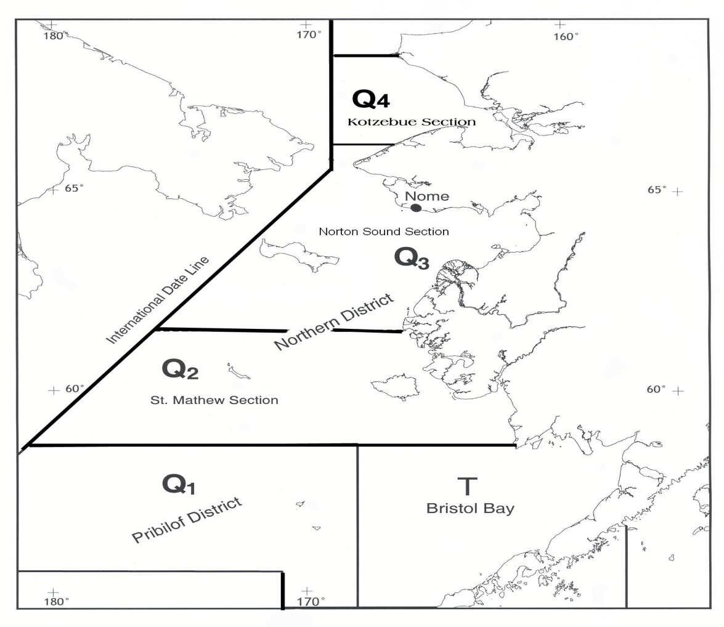

Figure 2. Closed water regulations in effect for the Norton Sound commercial crab fishery. Line around the coastline delineates the 3-mil state waters zone.

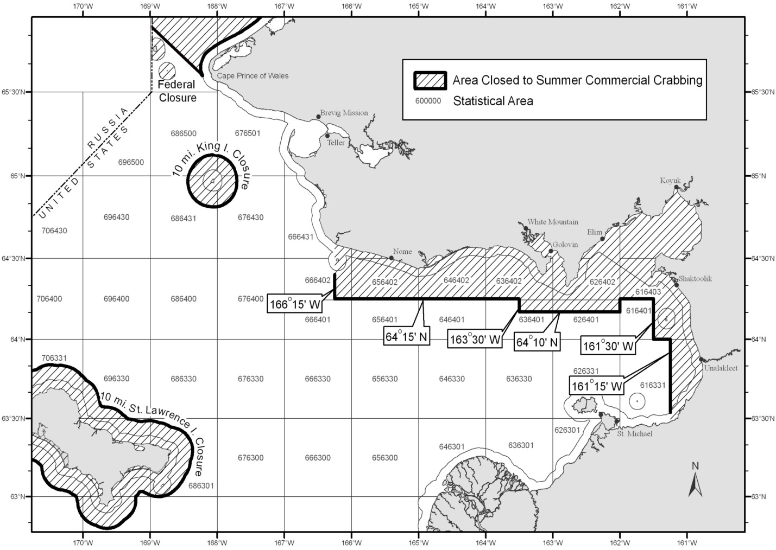

Figure 3: ADF&G trawl survey boundaries established in 2023. Bold numbers indicate successfully trawled in 2023. Bule solid line indicate the standard stations established in 2002.
Dashed line indicates the 2002 Tier 2 area. Red circles indicate NOAA NBS trawl survey stations. Stations within the 2023 boundaries are used for NBS abundance estimation by the author.

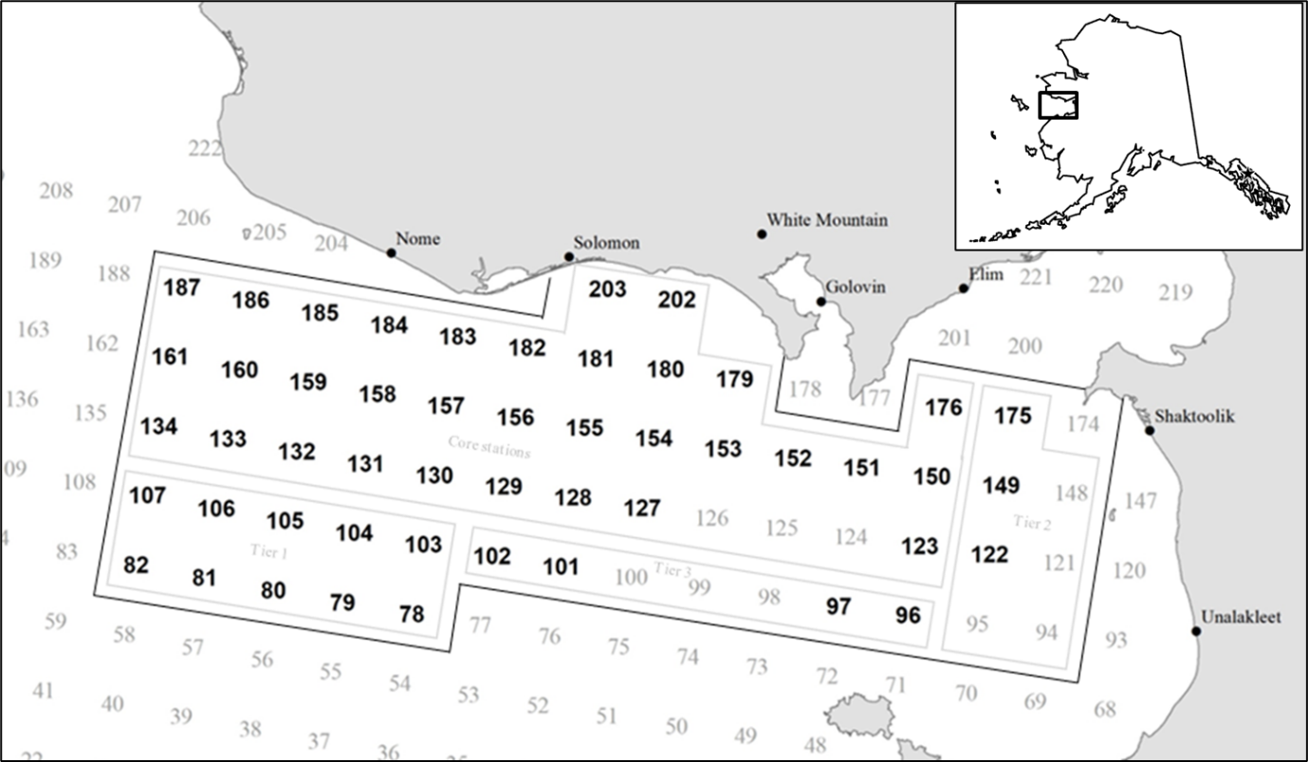

Figure 4. Model estimated natural mortality, annual molting probability, selectivity for trawl survey, winter pot survey, and summer commercial fishery, and retention probability for winter commercial and summer commercia. X-axis is carapace length (mm).

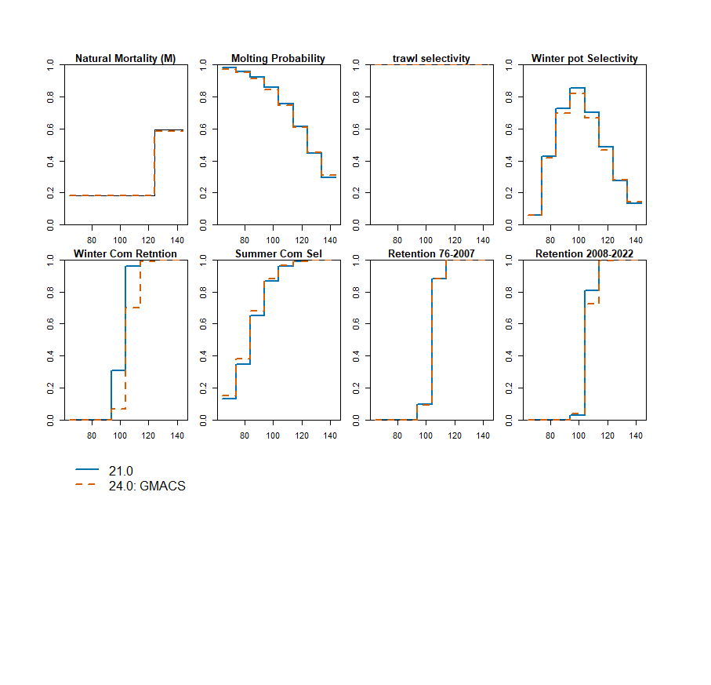

Figure 5. Model estimated transition probability for each size class.
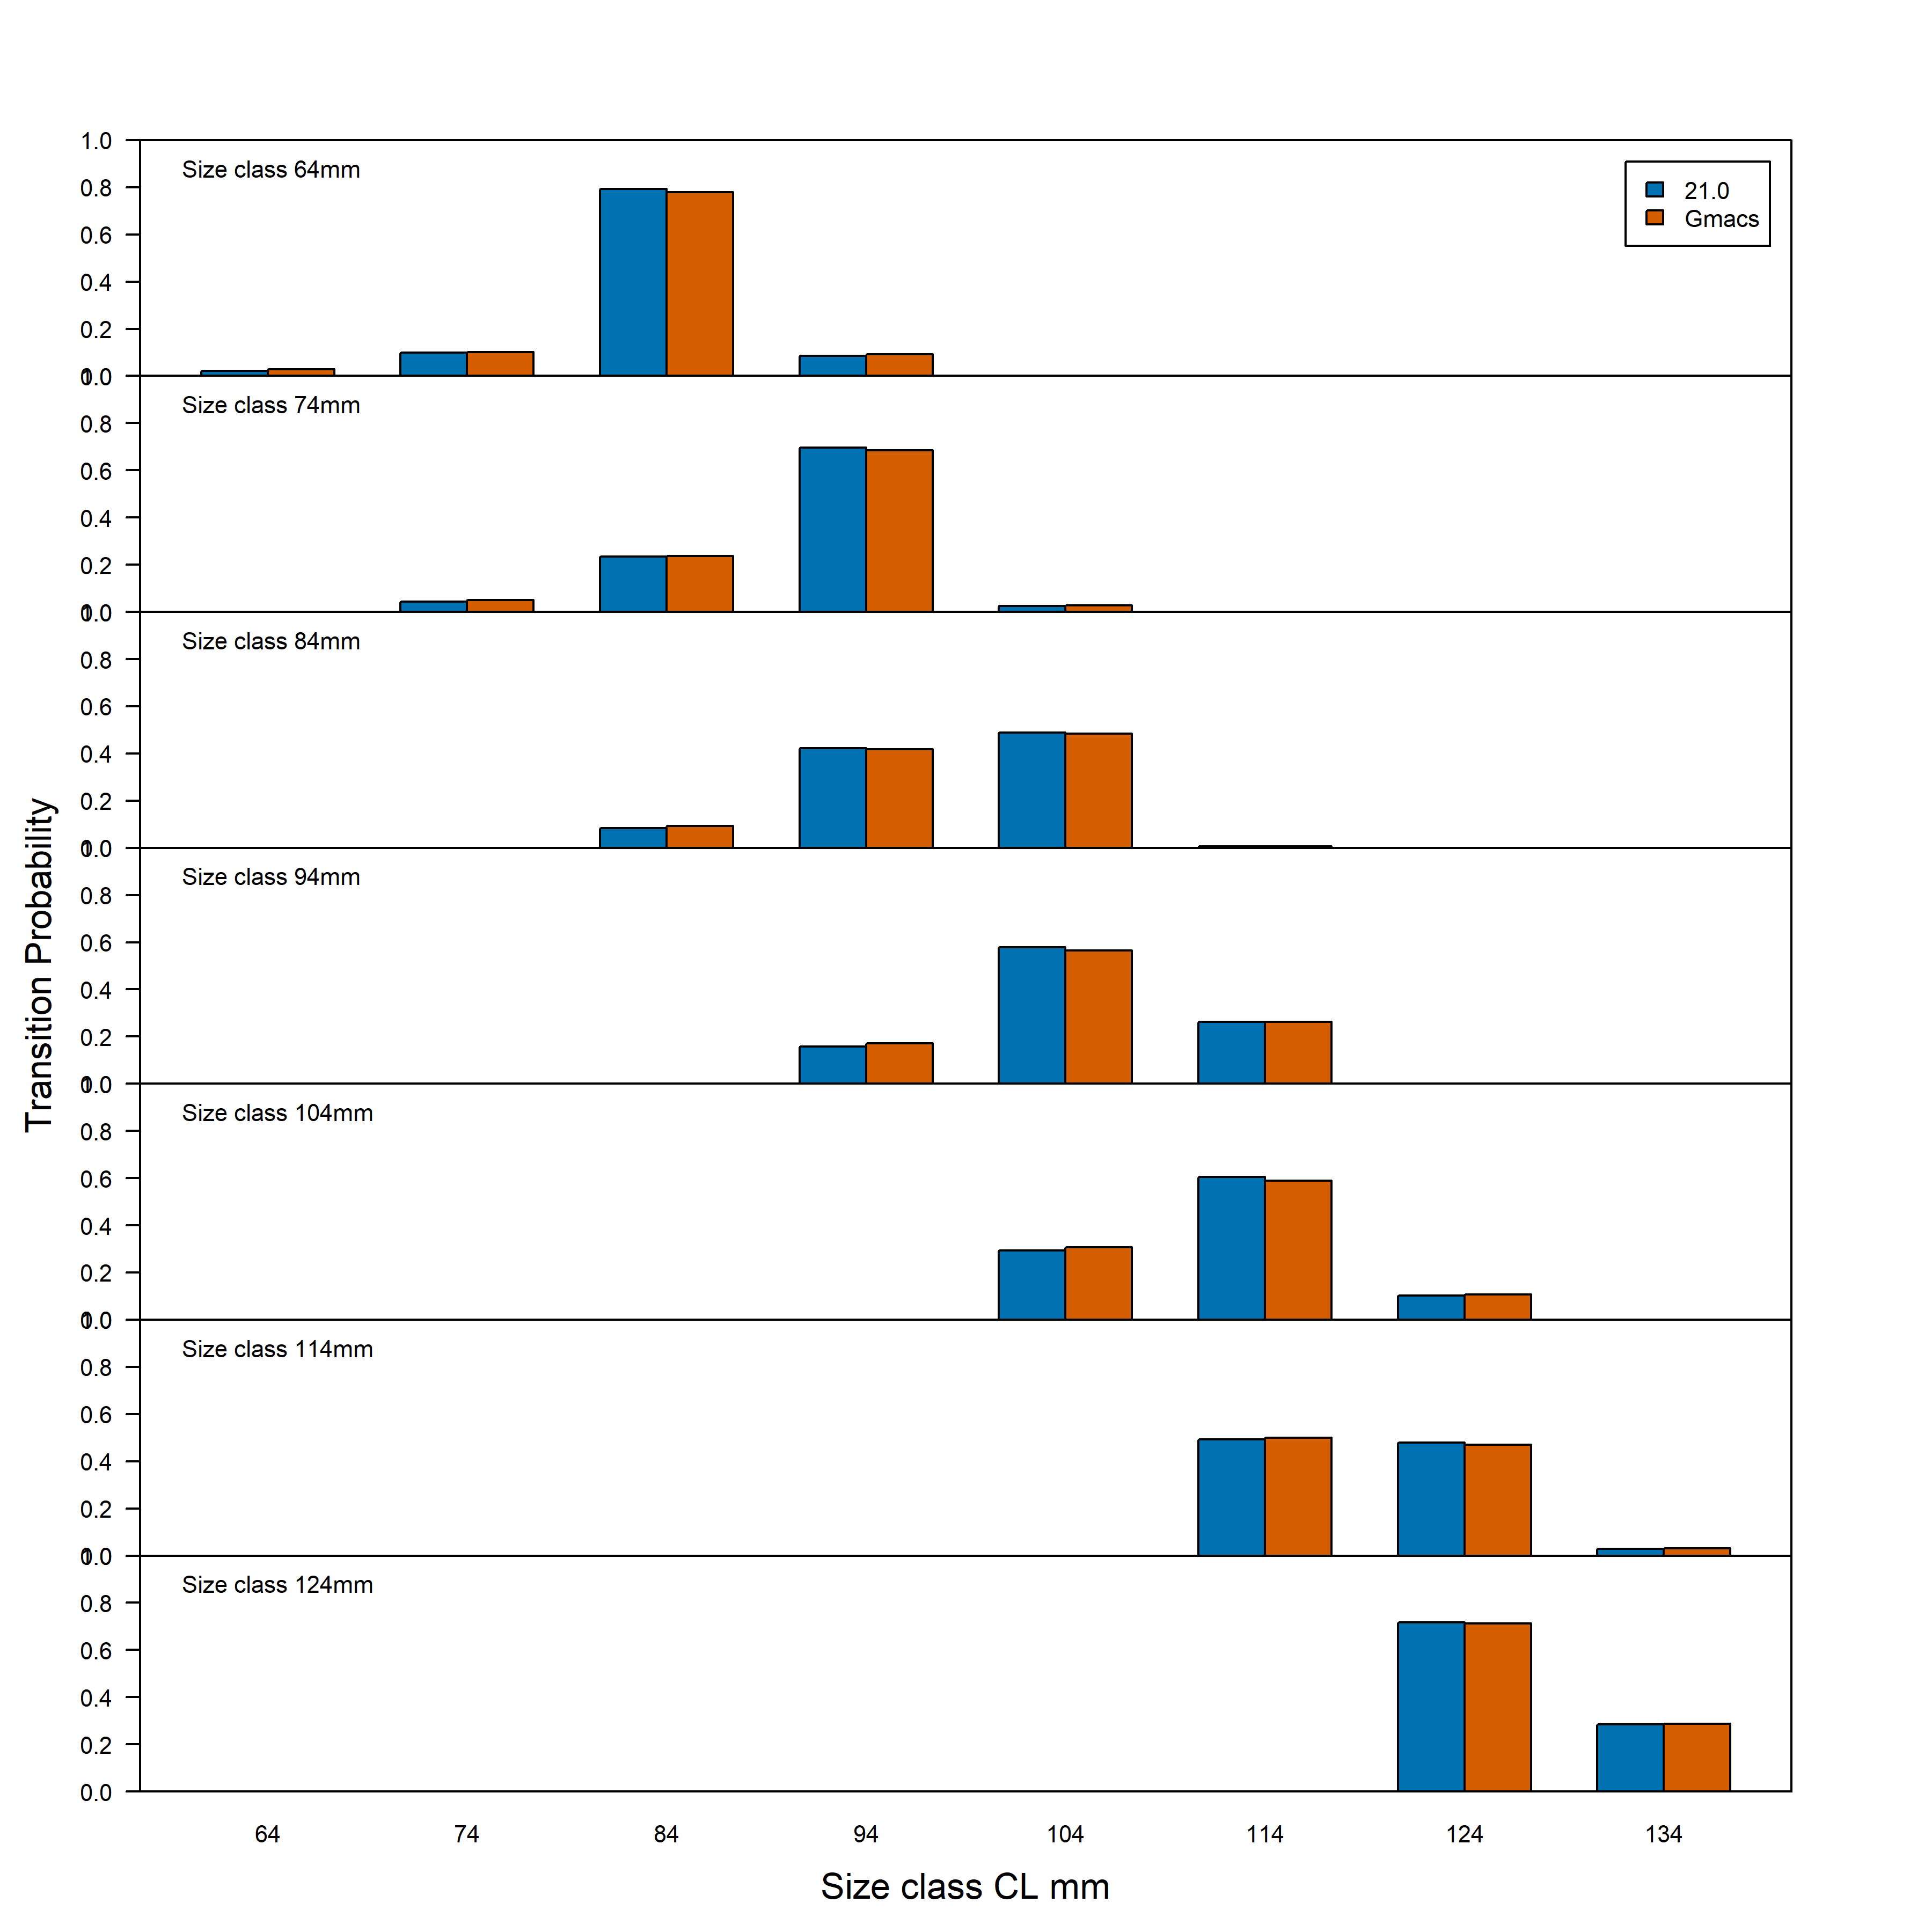

Figure 6. Model estimated abundances of total, legal (CL>104 mm) and recruit (CL 64-94 mm) male.
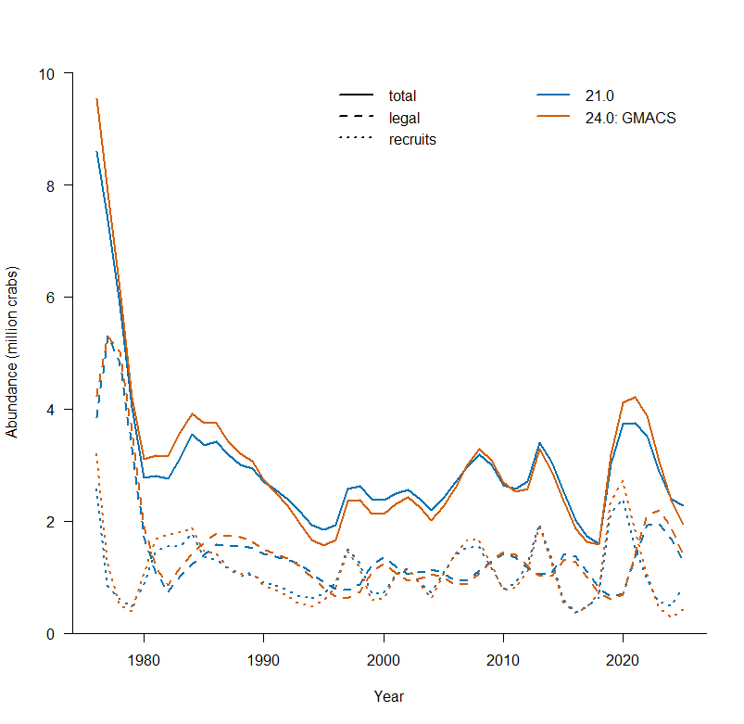

Figure 7,. Model estimated abundances by each length class1976-2025.
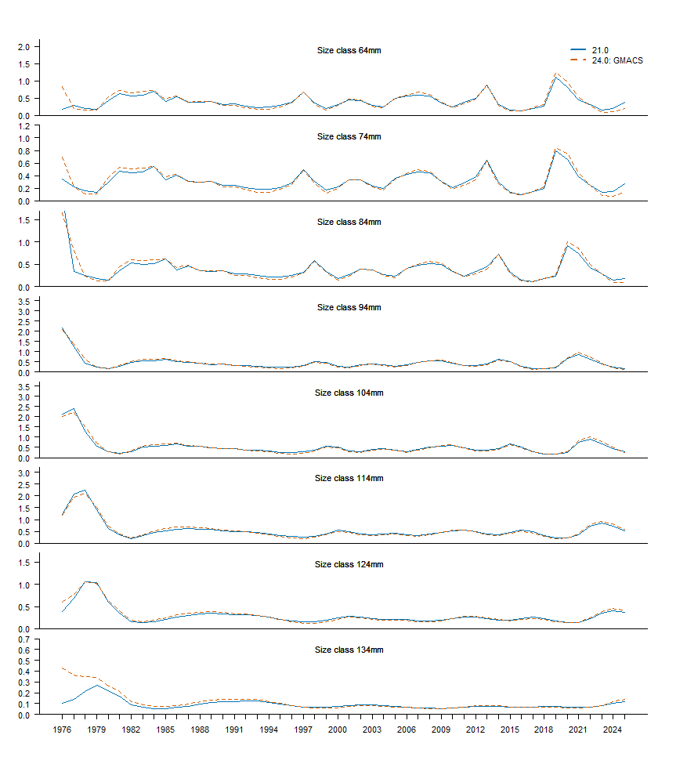

Figure 8. Model estimated abundances by length and shell class1976-2025. Left: new shell, right old shell. Blue solid line model 21.0, Red dashed line: model 24.0 GMACS.
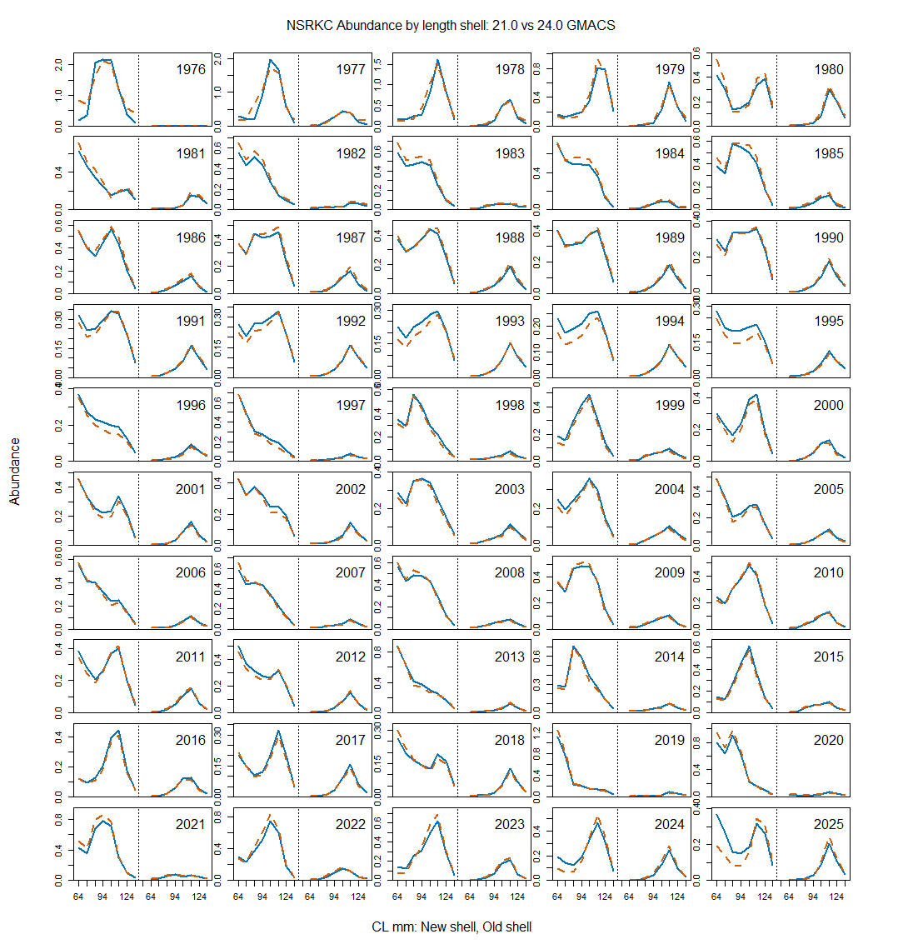

Figure 9. Estimated mean and 95% CI range of MMB 1976-2025. Horizontal line Bmsy (Average MMB of 1980-2025).

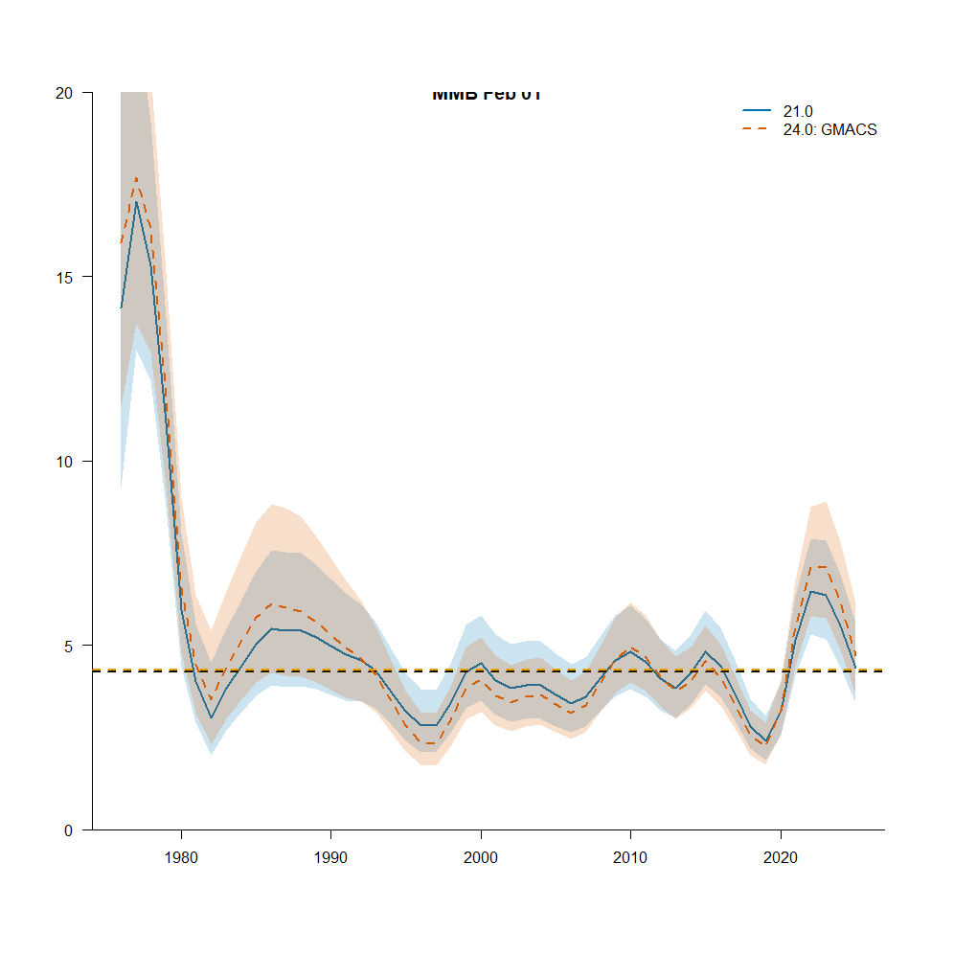

Figure 10. Observed (open circle) and model trawl survey male abundances with 95% lognormal Confidence Intervals (crab ≥ 64 mm CL).
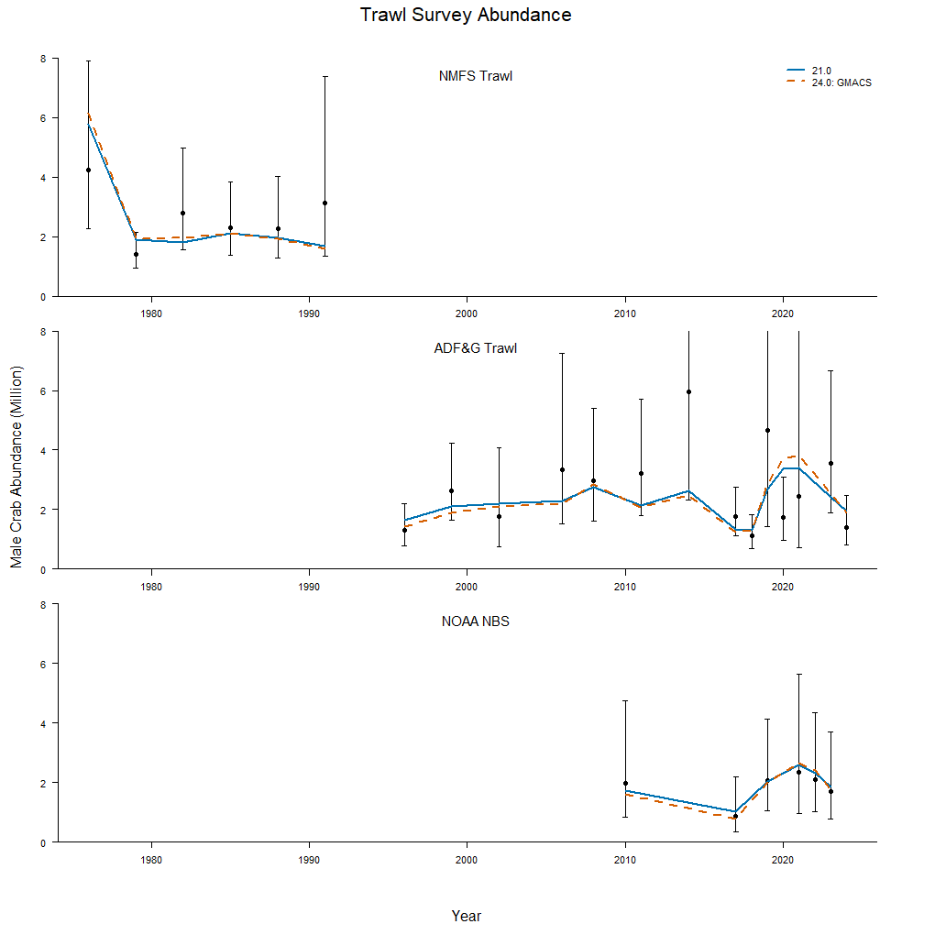

Figure 11. Observed (open circle) with 95% lognormal confidence intervals with additional variance (red), and model estimated standardized CPUE.

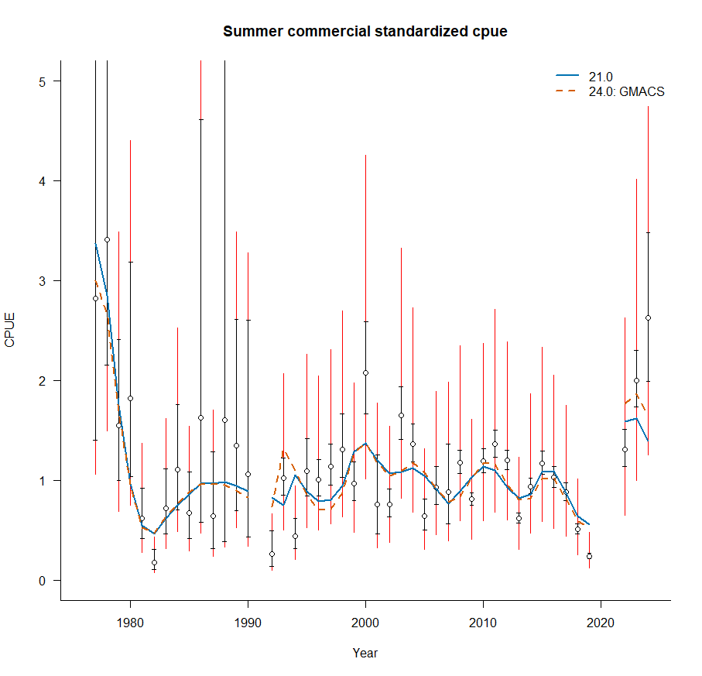

Figure 12. Predicted (line) vs. observed (bar New Shell: blue, Old Shell: green) length class proportions for the summer commercial harvest.

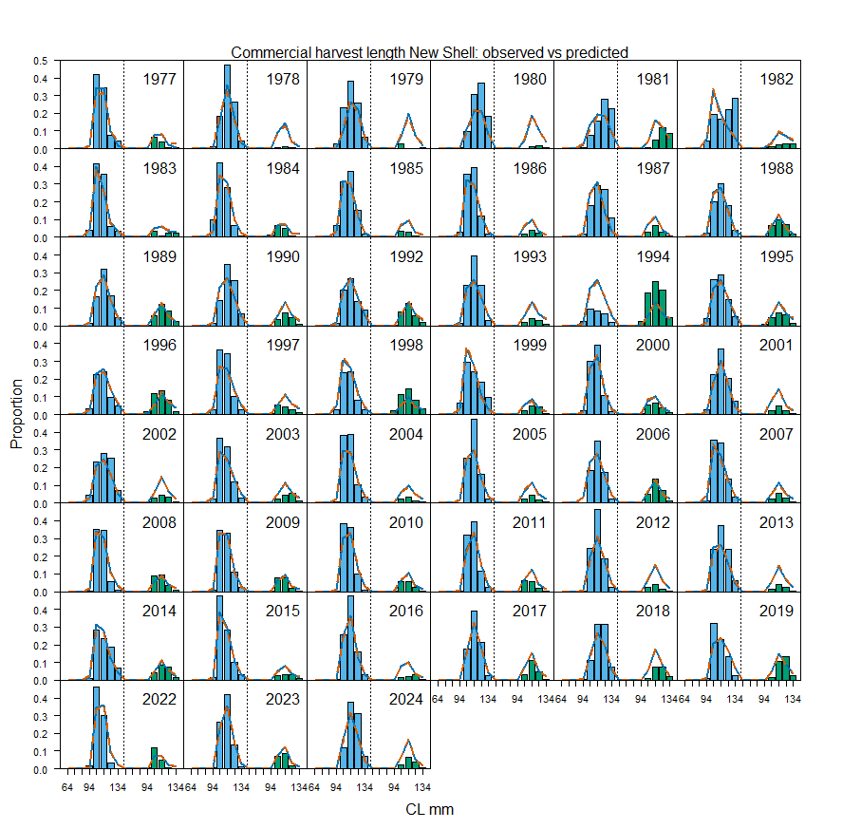

Figure 13. Predicted (line) vs. observed (bar New Shell: blue, Old Shell: green) length class proportions for trawl survey.

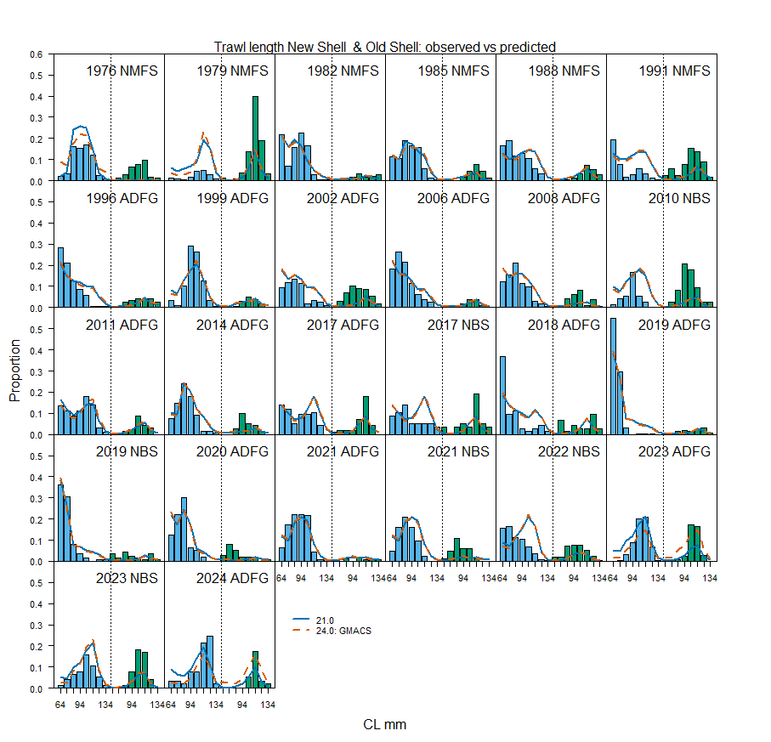

Figure 14. Predicted (line) vs. observed (bar New Shell: blue, Old Shell: green) length class proportions for winter pot survey.
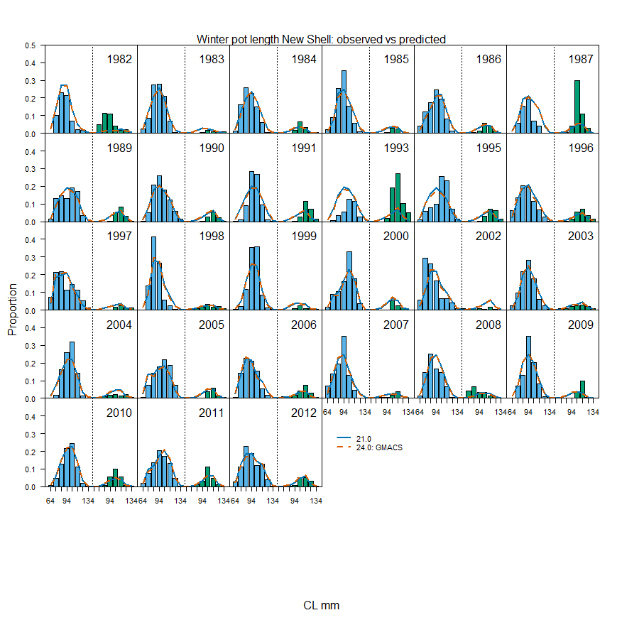

Figure 15. Predicted (line) vs. observed (bar New Shell: left blue, Old Shell: right green) length class proportions for summer commercial total and discards (1987-1994, 2012-2019) and winter commercial retained fishery 2015-2018.

Figure 16. Summary comparison of observed vs predicted size class.
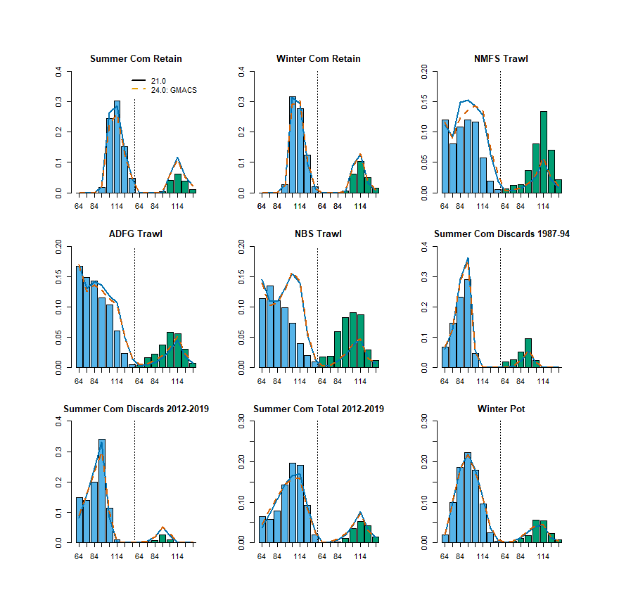

Figure 17. Predicted (line) vs. observed (bar) length class proportions for tag recovery data.

Figure 18. Input vs. model implied effective sample size. Figures in the first column show implied effective sample size (x-axis) vs. frequency (y-axis). Vertical solid line is the harmonic mean of implied sample size. Figures in the second column show input sample sizes (x-axis) vs. implied effective sample sizes (y-axis). Dashed line indicates the linear regression slope, and solid line is 1:1 line. Figures in the third column show years (x-axis) vs. implied effective sample sizes (y-axis). Horizontal solid line is the harmonic mean of implied sample size.

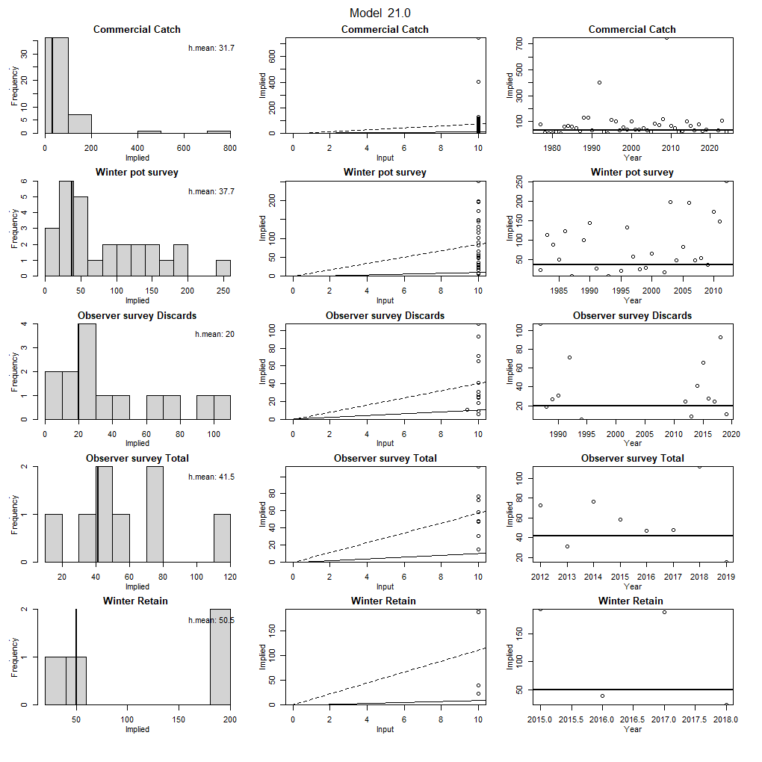
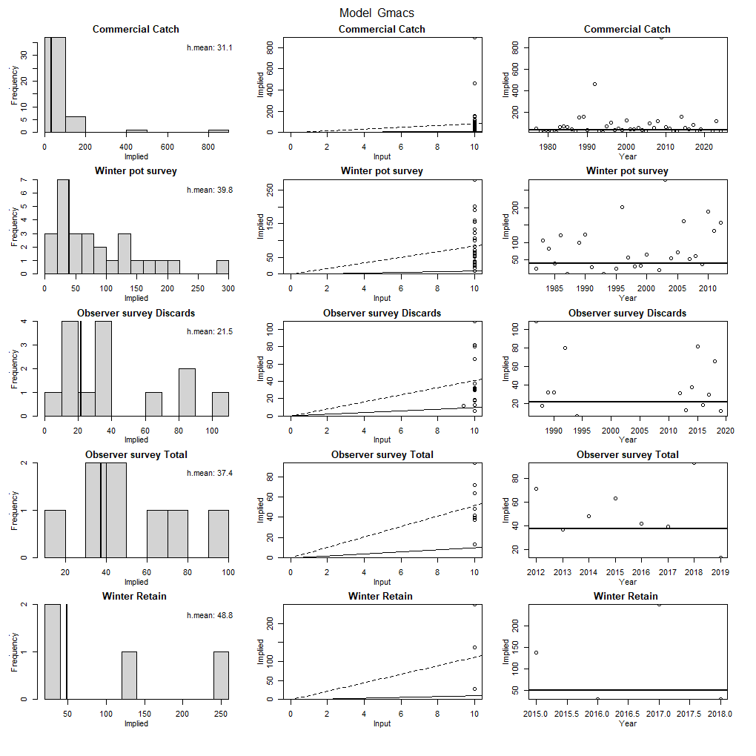

Figure 19. Bubble plots of predicted and observed length proportions.
Black circles indicate model underestimates compared to observed, and white circles indicate model overestimates compared to observed. Size of circle indicates degree of deviance (larger circle = larger deviance). In ideal model fit case, distribution of sizes and colors of circles should be random (i.e., no systematic model misfits).

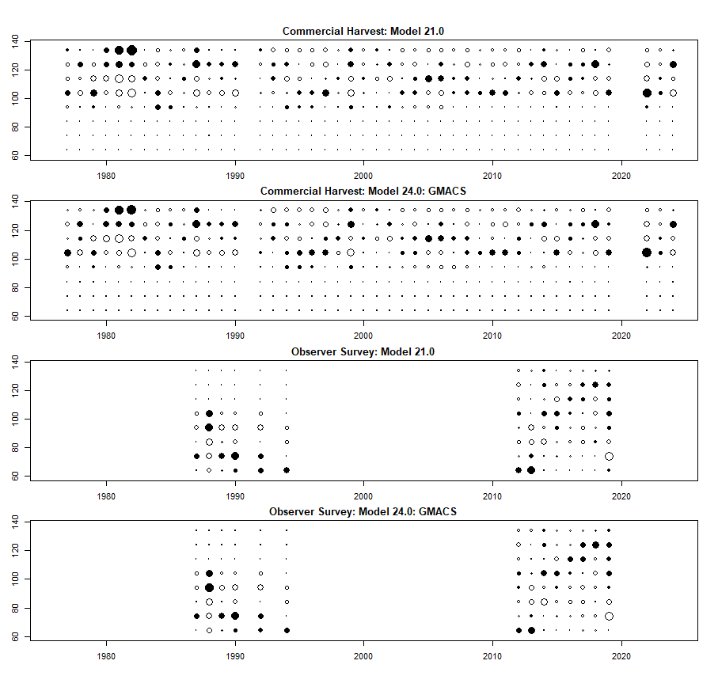

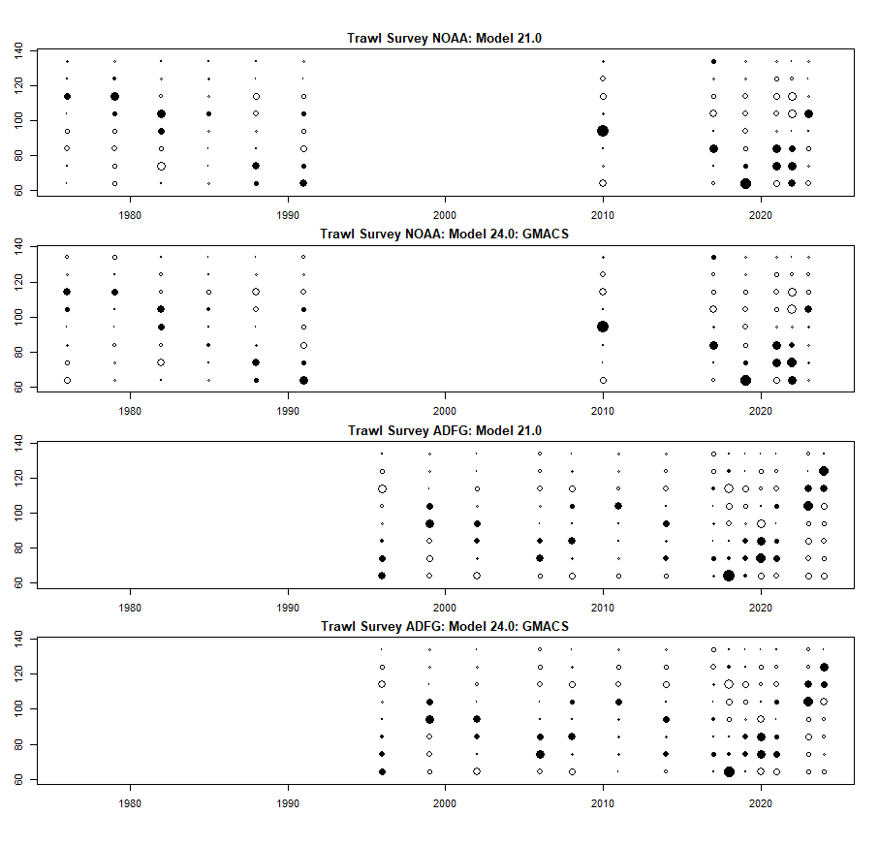

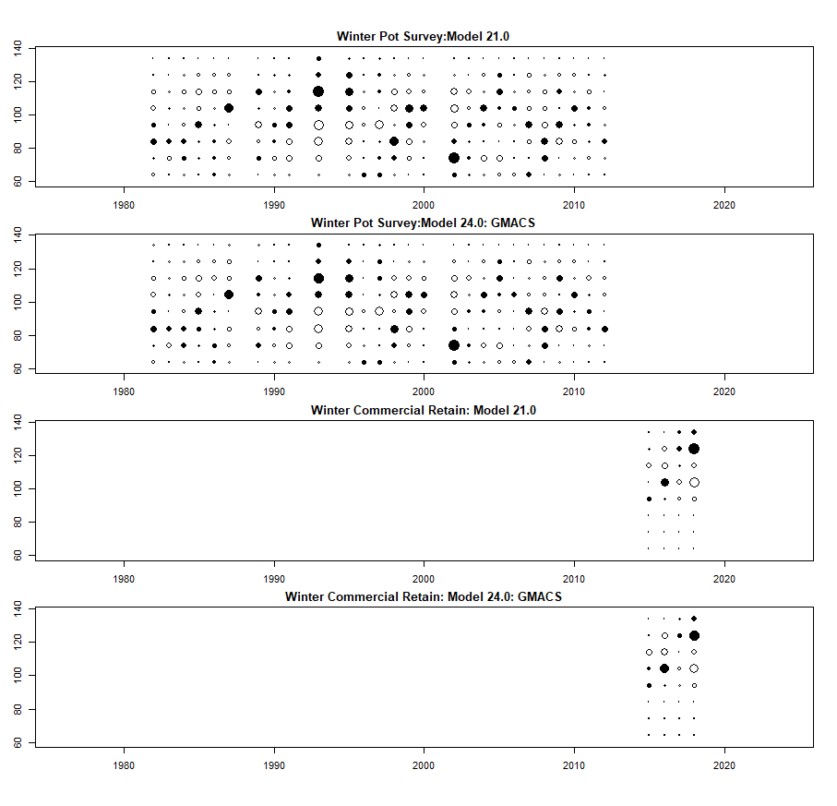

Figure 20. Standardized Pearson residual plots for trawl survey, summer commercial retained catch, winter pot survey, and observer for length size classes 1-8.

Trawl Survey
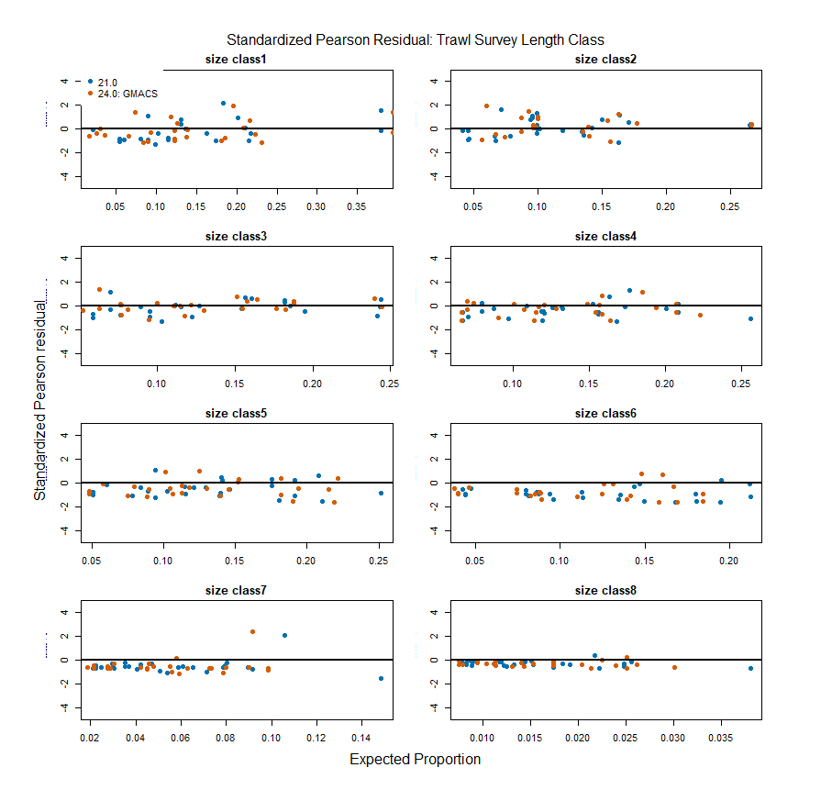
Summer Commercial retained
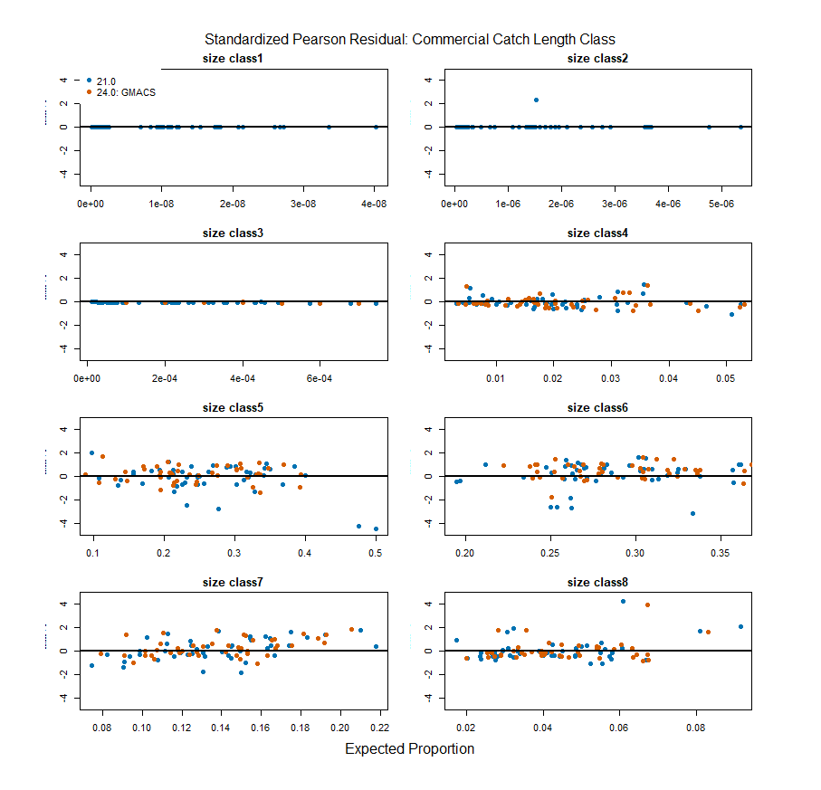

Winter Pot
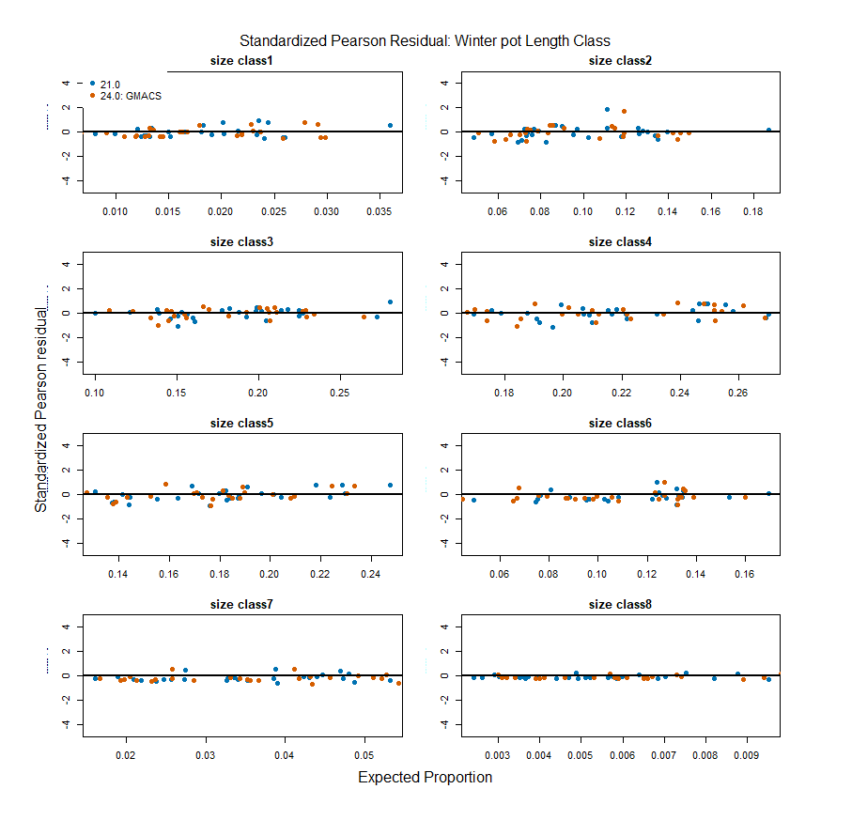
Summer Commercial Discards
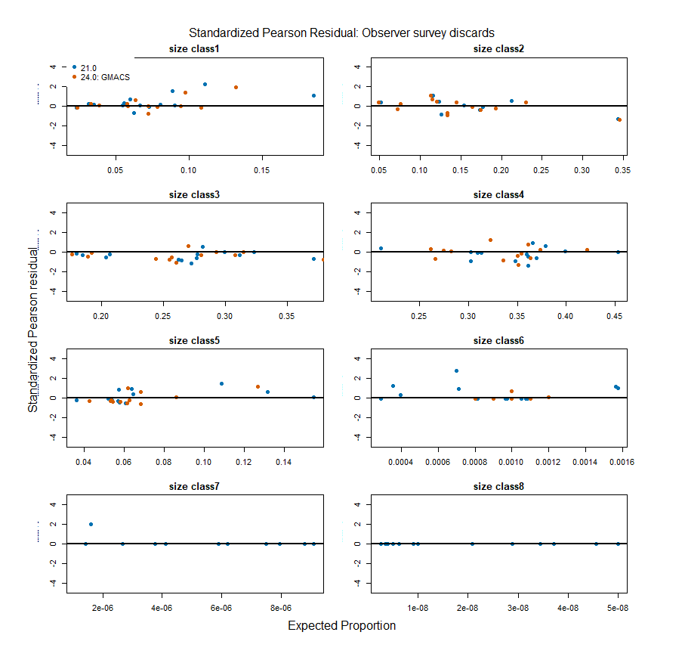
Summer Commercial Total
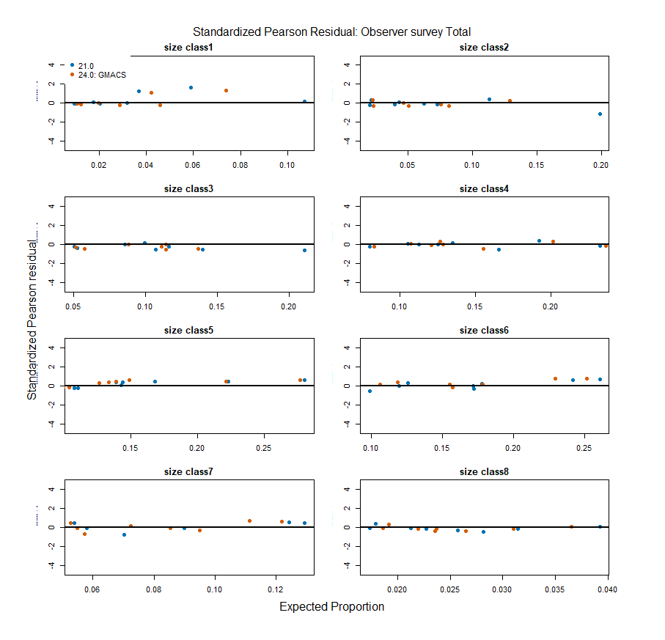

Winter Commercial retained
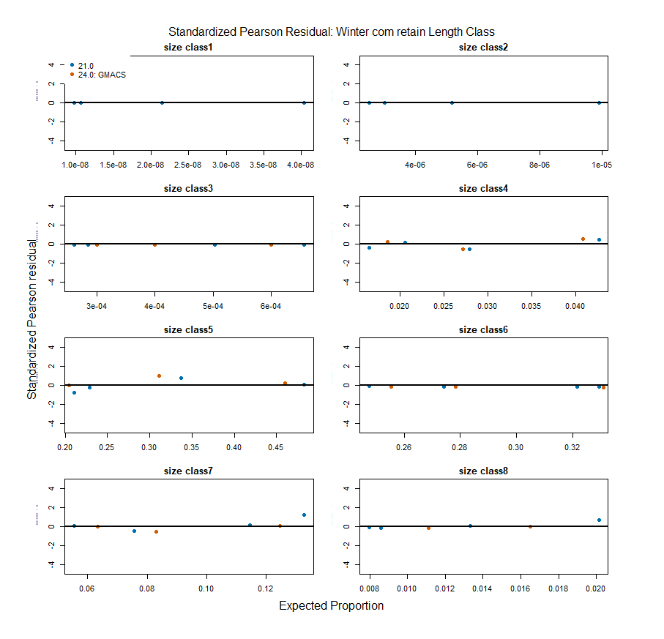

Figure 21. QQ Plot of Trawl survey and Commercial CPUE

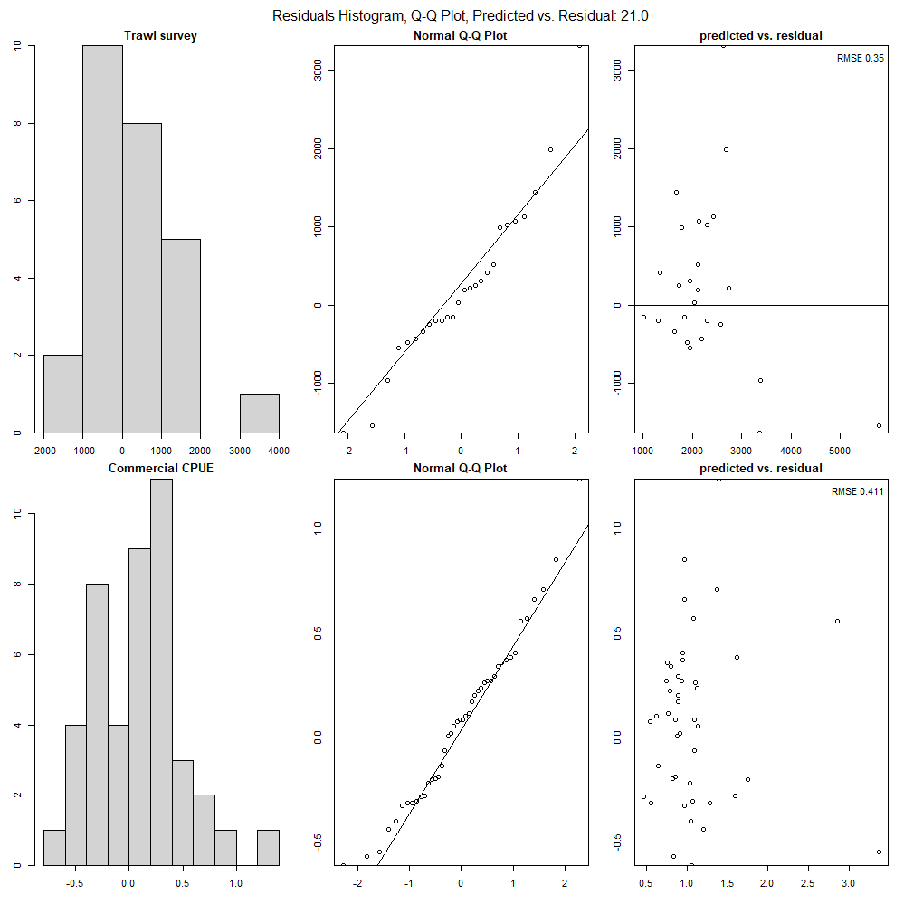

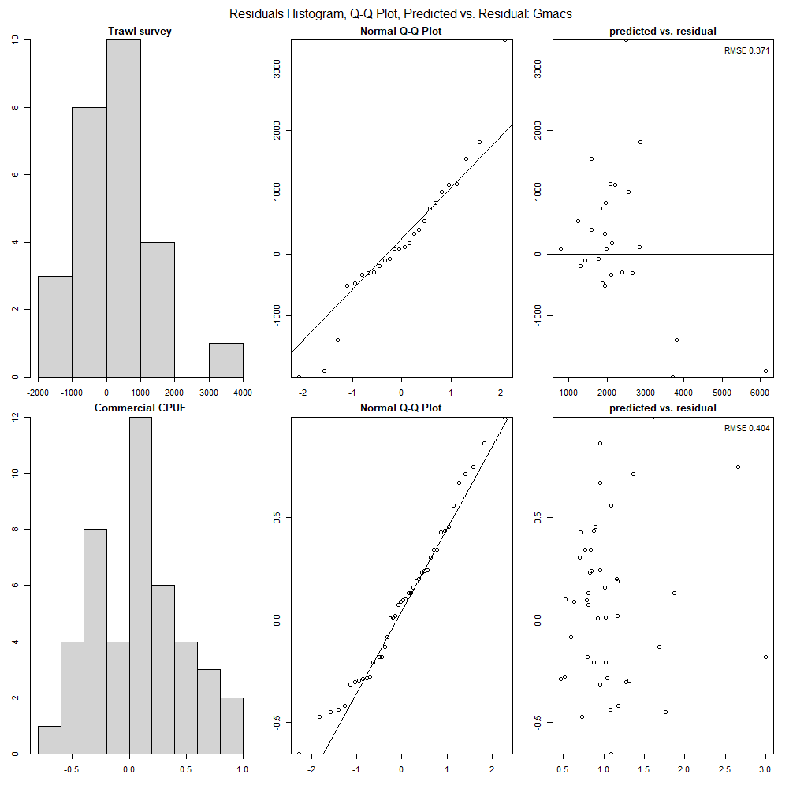

Figure 22. Retrospective Analyses of Norton Sound Red King Crab MMB from 2015 to 2025.
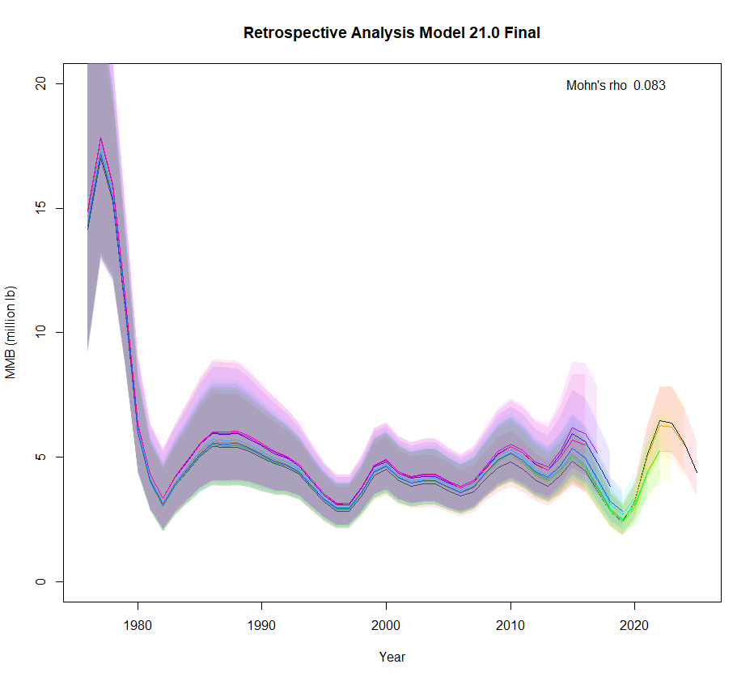
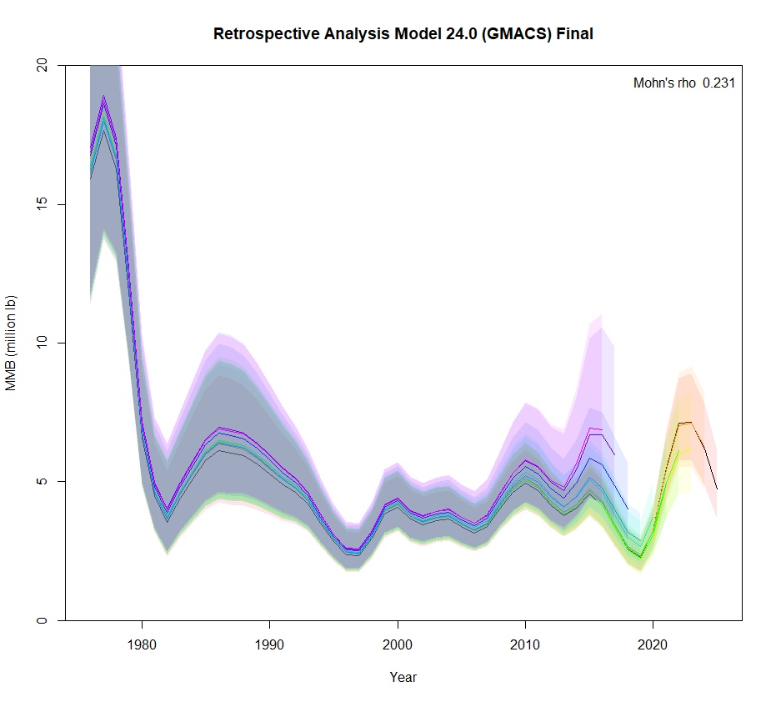

Figure 22. Historical Analyses of Norton Sound Red King Crab MMB from 2008 to 2025 assessment year. MMB shows the SAFE adopted model MMB in each year’s SAFE report.
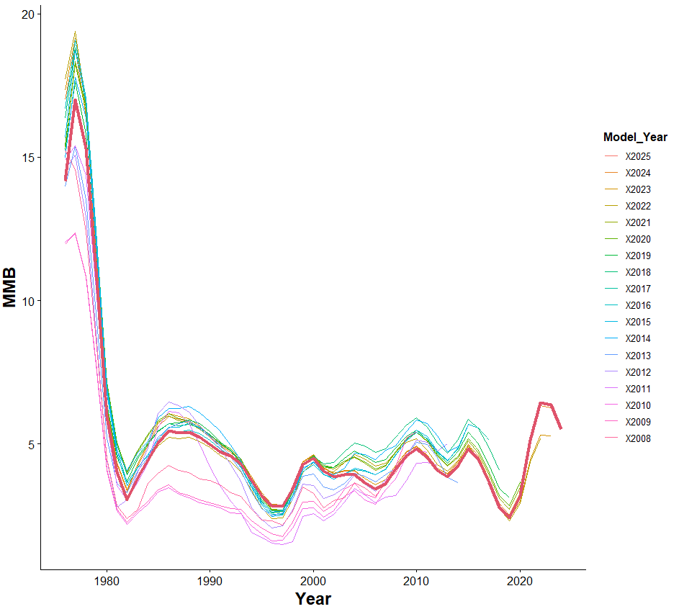
Appendix A. DescriptioTabn of the Norton Sound Red King Crab Model

a. Model description.
The model is an extension of the length-based model developed by Zheng et al. (1998) for Norton Sound red king crab. The model has 8 male length classes with model parameters estimated by the maximum likelihood method. The model estimates abundances of crab with CL ≥64 mm and with 10-mm length intervals (8 length classes, ≥134 mm) because few crab measuring less than 64 mm CL were caught during surveys or fisheries and there were relatively small sample sizes for trawl and winter pot surveys. The model treats newshell and oldshell male crab separately but assumes they have the same molting probability and natural mortality.

Length proportion
Pot Survey
1980-2012:

Standardized
CPUE

Length proportion
Com retained & discards

Com Fishery & discard mortality
Jun – Sept
Assume: July 01

Molting, Growth

Tag recovery

Recruitment

Natural mortality
7 months

July 01
Pre-fishery Population

Feb 01: SAFE
Assessment
Abundance

Catch selectivity

Com & Sub Fishery
Nov – May
Assume: Feb 01

July 01
Post-fishery Population

Catch & Survey selectivity
Survey selectivity

Length proportion
Com retained:
2015 -

Natural mortality
5 months

Feb 01
Post-fishery Population

Survey selectivity

Population
During fishery

Abundance & Length proportion
Trawl survey

Norton Sound Red King Crab Modeling Scheme

Timeline of calendar events and crab modeling events:

- Model year starts February 1st to January 31st of the following year.
- Initial Population Date: February 1st 1976, consisting of only newshell crab.
- All winter fishery catch occurs on February 1st
- All summer fishery catch occurs on July 1st
- During 1976-2004, all legal crab caught in Commercial are retained.
- During 2004-2005, only commercially marketable legal crab caught in Commercial crabs are retained (i.e., high grading of crab ≥ 5 in CW).
- Winter Subsistence fishery retains all mature crab.
- Molting and recruitment occur on July 1st

Initial pre-fishery summer crab abundance on February 1st 1976:
Abundance of the initial pre-fishery population was assumed to consist of newshell crab to reduce the number of parameters, and estimated as
(1)

where length proportion of the first year (p_{l}) was calculated as

(2)

for model estimated parameters a_{l}.

Crab abundance on July 1st :

Summer (01 July) crab abundance of newshell and oldshell are of survivors of Winter (Feb 01) population from winter commercial and subsistence crab fisheries, and natural mortality from 01Feb to 01July.
(3)

where
N_{s,l,y} , O_{s,l,y} : summer abundances of newshell and oldshell crab in length class l in year y ,
N_{w,l,y}, O_{w,l,y} : winter abundances of newshell and oldshell crab in length class l in year y,
C_{w,t,y}, C_{p,t} : total winter commercial and subsistence catches in year t,
P_{w,n,l,y}, P_{w,o,l,y} : Proportion of newshell and oldshell length class l crab in year y, harvested by winter commercial fishery,
P_{p,n,l,y} , P_{p,o,l,y} : Proportion of newshell and oldshell length class l crab in year y, harvested by winter subsistence fishery,
D_{w,n,l,y}, D_{w,o,l,y}: Discard mortality of newshell and oldshell length class l crab in winter commercial fishery in year y,
D_{p,n,l,y}, D_{p,o,l,y} : Discard mortality of newshell and oldshell length class l crab in winter subsistence fishery in year y,
M_{l} : instantaneous natural mortality in length class l,
0.42 : proportion of the year from Feb 1 to July 1 is 5 months.

Length proportion compositions of winter commercial retained catch (P_{w,n,l,y}, P_{w,o,l,y}) in year t were estimated as:
1976-2007  2008-present | (4)
where
P_{lg,l} : the proportion of legal males in length class l ,
S_{w,l} : Selectivity of winter fishery pot.
S_{wr,l} : Retention probability of winter fishery

In the above, we assumed that all legal crabs were retained during 1976-2007 periods, and high grading has occurred since 2008 season.

The subsistence fisheries do not have a size limit; however, immature crab (< 94 mm) are generally not retained. Thus, we assumed proportion of length composition l = 1 and 2 as 0, and estimated length compositions (l ≥ 3) as follows

(5)

Crab abundance on Feb 1st :
The assessment model assumes that molting and growth occur immediately after summer fishery harvests, and that recruitment would occur between July 01 and Feb 01 of the next year. That is, the following events occur: (1) summery fishery, (2) summer fishery discards mortality, (3) molting and recruitment, and (4) natural mortality between July 01 and Feb 01. Those are formulated as follows:
Newshell Crab- Abundance of newshell crab of year t and length-class l (N_{w,l,y} ) year-y consist of: (1) new and oldshell crab that survived the summer commercial fishery and molted, and (2) recruitment (R_{l,y}):
(6)

Oldshell Crab- Abundance of oldshell crabs of year y and length-class l (O_{w,l,y} ) consists of the non-molting portion of survivors from the summer fishery:
(7)

where
G_{l’, l} : a growth matrix representing the expected proportion of crabs growing from length class l’ to length class l
C_{s,y}: total summer catch in year y
P_{s,n,l,y} , P_{s,o,l,y} : proportion of summer catch for newshell and oldshell crab of length class l in year y,
D_{l,y} : summer discard mortality of length class l in year y,
m_{l} : molting probability of length class l,
y_{c} : the time in year from July 1 to the mid-point of the summer fishery,
0.58: Proportion of the year from July 1st to Feb 1st : 7 months = 0.58 year,
R_{l,y}: recruitment into length class l in year y.

Discards

Discards are crabs that were caught in summer and winter commercial and winter subsistence fisheries but were not retained.

Summer and winter commercial discards
In summer (D_{l,t}) and winter (D_{w,n,l,t} , D_{w,o,l,t}) commercial fisheries, sublegal males (<4.75 inch CW and <5.0 inch CW since 2008) are discarded. Those discarded crabs are subject to handling mortality. The number of discards was not directly observed, and thus was estimated from the model as: Observed Catch x (estimated abundance of crab that are not caught by commercial pot)/(estimated abundance of crab that are caught by commercial pot)

Model discard mortality in length-class l in year y from the summer and winter commercial pot fisheries is given by
 | (8)
1977 – 2007 2008 – present | (9)
1977 – 2007 2008 – 2022 | (10)
where

hm_{s}: summer commercial handling mortality rate assumed to be 0.2,
hm_{w}: winter commercial handling mortality rate assumed to be 0.2,
S_{s,l} : Selectivity of the summer commercial fishery,
S_{w,l} : Selectivity of the winter commercial fishery,
S_{r,l} : Retention selectivity of the summer commercial fishery,
S_{wr,l} : Retention selectivity of the winter commercial fishery,

Winter subsistence discards
Discards (unretained) from the winter subsistence fishery are reported in a permit survey (C_{d,y}), though its size composition is unknown. We assumed that subsistence fishers discard all crabs of length classes 1 -2.

(11)
(12)
where

C_{d,y}: Winter subsistence discards

Recruitment

Recruitment of year y, R_{y}, is a stochastic process around the geometric mean, R₀:
(13)
R_{t} of the last year was assumed to be an average of previous 5 years: R_{y} = (R_{y-1} + R_{y-2} + R_{y-3} + R_{y-4} + R_{y-5} )/5.

R_{t} was assumed to be newshell crab of immature (< 94 mm) length classes 1 to r:

(14)

where p_{r} takes multinomial distribution, same as equation (2)

Molting Probability

Molting probability for length class l, m_{l}, was estimated as an inverse logistic function of length-class mid carapace length (L) and parameters (α, β) where β corresponds to L₅₀.

(15)

Trawl net and summer commercial pot selectivity

Trawl and summer commercial pot selectivity was assumed to be a logistic function of mid-length-class, constrained to be 0.999 at the largest length-class (L_{max}):
(16)

Winter pot selectivity,

Winter pot selectivity was assumed to be a dome-shaped with logistic function of length-class mid carapace length (L) and parameters (α, β) where β corresponds to L₅₀.
(17)

Selectivity of the first 3 length classes S_{w,s} (S= l₁, l₂, l₃) were individually estimated.

Retention probability: Winter commercial, summer commercial
Winter and summer commercial retention probability was assumed to be a logistic function of length-class mid carapace length (L) and parameters (α, β) where β corresponds to L₅₀.
(17)

Growth transition matrix
The growth matrix G_{l’, l} (the expected proportion of crab molting from length class l’ to length class l ) was assumed to be normally distributed:

(18)

where

Observation model

Summer trawl survey abundance

Modeled trawl survey abundance of year y (B_{st,y}) is July 1st abundance subtracted by summer commercial fishery harvest occurring from July 1st to the mid-point of summer trawl survey, multiplied by natural mortality occurring between the mid-point of commercial fishery date and trawl survey date, and multiplied by trawl survey selectivity. For the first year (1976) trawl survey, the commercial fishery did not occur.

(19)

where
y_{st}: the time in year from July 1 to the mid-point of the summer trawl survey,
y_{c}: the time in year from July 1 to the mid-point for the catch before the survey, (y_{st} > y_{c}: Trawl survey starts after opening of commercial fisheries),
P_{c,y} : the proportion of summer commercial crab harvested before the mid-point of trawl survey date.
S_{st,l} : Selectivity of the trawl survey.

Winter pot survey CPUE (depleted)
Winter pot survey cpue (f_{wy}) was calculated with catchability coefficient q and exploitable abundance:
(20)

Summer commercial CPUE

Summer commercial fishing CPUE (f_{y}) was calculated as a product of catchability coefficient q and mean exploitable abundance, A_{t} minus one half of summer catch, C_{t}:
(21)
Because the fishing fleet and pot limit configuration changed in 1993, q₁ is for fishing efforts before 1993, q₂ is from 1994 to present.

Where A_{y} is exploitable legal abundance in year t, estimated as
(22)

Summer pot survey abundance (depleted)

Abundance of y-th year pot survey was estimated as

(23)

Where

y_{p}: the time in year from July 1 to the mid-point of the summer pot survey.

Length composition

Summer commercial retained catch

Length compositions of the summer commercial catch for new and old shell crabs P_{s,n,l,y} and P_{s,o,l,y}, were modeled based on the summer population, selectivity, and retention probability

(24)
Retention probability is separated into two periods: 1977–2007 and 2008–2020 indicating before and after the start of high grading.

Summer commercial fishery discards (1977-1993)

Prior to 1993, Observer survey data contained length-shell composition of only discards.
Length/shell compositions of observer discards were modeled as
(25)

Summer commercial fishery total catch (212-2019)
The 2012–2019 Observer survey had total as well as retained and discard length-shell composition, and total catch length-shell composition was fitted.

Length/shell compositions of observer total catch was modeled as
(26)

Summer trawl survey

Proportions of newshell and oldshell crab, P_{st,n,l,y} and P_{st,o,l,y} were given by

(27)

Winter pot survey

Winter pot survey length compositions for newshell and oldshell crab, P_{sw,n,l,t} and P_{sw,o,l,t} (l ≥ 1) were calculated as

(28)

Winter commercial retained

Winter commercial retained length compositions for newshell and oldshell crab, P_{cw,n,l,t} and P_{cw,o,l,t} (l ≥ 1) were calculated as

(29)

Spring Pot survey 2012-2015 (depleted)

Spring pot survey length compositions for newshell and oldshell crab, P_{sw,n,l,t} and P_{sw,o,l,t} (l ≥ 1) were assumed to be similar to crab population caught by winter pot survey

(30)

Estimates of tag recovery
The proportion of released tagged length class l’ crab recovered after t-th year with length class of l by a fishery of s-th selectivity (S_{l}) was assumed to be proportional to the growth matrix, catch selectivity, and molting probability (m_{l}) as

(31)

where X is a molting probability adjusted growth matrix with each component consisting of

(32)
c. Likelihood components.
Under assumptions that measurement errors of annual total survey abundances and summer commercial fishing efforts follow lognormal distributions, and each type of length composition has a multinomial error structure (Fournier and Archibald 1982; Methot 1989), the log-likelihood function is

(32)
where
i: length/shell compositions of:
1 triennial summer trawl survey,
2 annual winter pot survey,
3 summer commercial fishery retained,
4 summer commercial observer discards or total catch,
5 winter commercial fishery retained.
K_{i,y}: the effective sample size of length/shell compositions for data set i in year y,
P_{i,l,y} : observed and estimated length compositions for data set i, length class l, and year y.
κ : a constant equal to 0.0001,
CV: coefficient of variation for the survey abundance,
B_{j,y}: observed and estimated annual total abundances for data set i and year y,
F_{y}: observed and estimated summer fishery CPUE,
w²_{t}: extra variance factor,
SDR: Standard deviation of recruitment = 0.5,
K_{l’,y}: sample size of length class l’ released and recovered after y-th in year,
P_{l’,l,y,s}: observed and estimated proportion of tagged crab released at length l’ and recaptured at
length l, after y-th year by commercial fishery pot selectivity s,
W: weighting for the tagging survey likelihood = 0.5

b. Software used: AD Model Builder (Fournier et al. 2012).

d. Out of model parameter estimation framework:
- Parameters Estimated Independently
M: Natural mortality
Natural mortality (M = 0.18) was based on an assumed maximum age, t_{max}, and the 1% rule (Zheng 2005):
,
where p is the proportion of animals that reach the maximum age and is assumed to be 0.01 for the 1% rule (Shepherd and Breen 1992, Clarke et al. 2003). The maximum age of 25, which was used to estimate M for U.S. federal overfishing limits for red king crab stocks results in an estimated M of 0.18.

e. Definition of model outputs.

- Mature male biomass (MMB) is on February 1st and is consisting of the biomass of male crab in length classes 4 to 8
wm_{l}: mean weight of each length class.

- Recruitment: the number of males in length classes 1, 2, and 3.

f. OFL
The Norton Sound red king crab fishery consists of two distinct fisheries: winter and summer. The two fisheries are discontinuous with 5 months between the two fisheries during which natural mortalities occur. To incorporate this, the CPT in 2016 recommended the following formula:

OFL = winter harvest biomass (Hw) + summer harvest biomass (Hs) | (1)
And
(2)
Where p is a specific proportion of winter crab harvest to total (winter + summer) harvest
At given fishery mortality (F_{OFL}), Winter harvest is a fishing mortality

(3)

(4)
where B_{s} is a summer crab biomass after winter fishery and x (0 ≤ x ≤1) is a fraction that satisfies the equation (2).
Since B_{s} is a summer crab biomass after winter fishery and 5 months of natural morality, ()
(5)
Substituting m for 0.42M, summer harvest is
(6)
Thus, OFL is
(7)
Combining equations (2) and (7),
(8)
Solving equation (8) for x
(9)
Combining equations (7) and (9), and substituting back m and
revised retained OFL is
(10)

Calculation of empirical F

From the equation (3) and (4) empirical F is derived as:

(11)

(12)
Combining (11) and (12)
(13)

Where Bs and Bw were derived from the model. Hs and Hw are biomass of retained catch + the model derived discards mortality.

Appendix B

Norton Sound Red King Crab CPUE Standardization
Note: This is an update of model by G. Bishop (NPFMC 2013). Please see SAFE 2013 for more detailed descriptions.

Methods

Model

Let $U_{ijk}$ denote the observed CPUE, U₀ the reference CPUE, P_{ij} a factor i at level j, and let X_{ij} take a value of 1 when the j^{th} level of the factor P_{ij} is present and 0 when it is not. The lognormal distribution of $U_{ijk}$ (Quinn and Deriso 1999), can be denoted as:

$U_{ijk}=U_{0}\prod_{i}{\prod_{j}{P_{ij}^{X_{ij}}}}e^{ε_{ijk}}$ (1)

or

$ln{(U}_{ijk})=\ln\left(U_{0}\right)+\sum_{i=1}^{p}{\sum_{j=1}^{n_{j}-1}{X_{ij}}\ln\left(P_{ij}\right)+ε_{ijk}}$ .

where ε_{ijk}, ~ N(0, σ²) observation error

Substituting $\ln\left(U_{0}\right)$ to β₀ and ln(P_{ij} ) to β_{ij}, we then obtain an additive GLM lognormal error distribution of $U_{ijk}$:

$ln{(U}_{ijk})=β_{0}+\sum_{i=1}^{p}{\sum_{j=1}^{n_{j}-1}{X_{ij}}β_{ij}+ε_{ijk}}$ . (2)

Standardized CPUE was calculated as follows:

- Divide the coefficients $β_{ij}$ by their geometric mean $\overline{β}$to obtain canonical coefficients:

${β_{i}}^{'}=\frac{β_{i}}{\overline{β}}$ . (3)

- Exponentiate the result to obtain the arithmetic scale canonical coefficients:

$b^{'}=e^{β_{i}-\overline{β}}$. (4)

- Subtract the year coefficient reference level to obtain standardized CPUE U_{j} for each year level j as:

$U_{Yj}=e^{{β'}_{Yj}-{β'}_{Y0}}$ . (5)

- Base year CPUE index is calculated by eliminating all factors but Year in the GLM and following Equations (2) and (3), (4), and (5) above.

SE of the standardized CPUE is calculated as:

Standard errors of CPUE are standard errors of the Year coefficients, ${\hat{β}}_{yr}$. These are obtained from the square root of the diagonal elements of the estimated covariance matrix, cov ($\hat{β})$, i.e., $\sqrt{C'∅C}$ .

where C = $X{(X^{T}X)}^{-1}$ , C’ is transpose of C; and $∅$ = $σ^{2}I_{n}$
where X is the matrix of predictor variables, $I_{n}$ is the identity matrix, and $σ$ is the standard error of the GLM fit.

Data Source & Cleaning

Commercial fishery harvest data were obtained from ADF&G fish ticket database, which included: Landing Date, Fish Ticket Number, Vessel Number, Permit Fishery ID, Statistical Area(s) fished, Effort, and Number and Pounds of Crab harvested (Table B2-1,2,3, Figure B2-1). The fish ticket database may have multiple entries of identical Fish Ticket Number, Vessel Number, Permit Fishery ID, and Statistical Area.

The following data cleaning and combining methods were conducted:

- Sum crab number and efforts by Fish Ticket Number, Vessel Number, Permit Fishery ID, and Statistical Area.
- Remove data with missing or zero values in Effort, Number of Crab, or Pounds of Crab; (these are considered true missing data).
- Calculate CPUE as Number of Crab/Effort.

Data cleaning and censoring.

Norton Sound commercial red king crab fishery can be largely divided into three periods: large vessel operation (1977-1992), small vessel superexclusive (1993-2007), and small vessel superexclusive and high grading since 2008. The pre-superexclusive fishery consisted of a few large boats, fishing west of 167 longitude, and few deliveries, and the post-superexclusive fishery consists of many small boats operated by local fishermen, fishing east of 167 longitude and near shore, and delivering frequently (Figure B1). The post-superexclusive period can further be divided into pre and post high grading periods of 2008. The majority of commercially caught red king crab are sold to the Norton Sound Economic Development Corporation (NSEDC). Legal crab in Norton Sound is defined as male with carapace width (CW) greater than 4.75 inch. Since 20008 the NSEDC purchased only crab of CW 5 inch or greater.

Censoring data

During 1977-92 period, vessels of 1 year of operation and/or 1 delivery per year harvested 20-90% of crab (Table B2-5, Figure B2-2). For instance, all vessels made only 1 delivery in 1989, and in 1988 64% of crab were harvested by 1 vessel that made only 1 delivery. On the other hand, during the 1993-2022 period of post-superexclusive fishery status, the majority of commercial crab fishery and harvest was done by vessels with more than 5 years of operations and more than 5 deliveries per year. For 1977 – 1993, censoring was made for vessels of more than 2 years of operations. Increasing deliveries to more than one would result in no estimates for some years. For 1994 – 2022, the data were censored to vessels that fished more than 5 years and delivered crab more than 5 times per year.

Analyses

A GLM was constructed as

Where YR: Year, VSL: Vessel, MSA: Statistical Area, WOY: Week of Year, and PF: Permit vs open fishery (Table 1). All variables were treated as categorical. Inclusion of interaction terms was not considered because they were absent (SAFE 2013).

The fishery strata (PD) consisted of the 3 periods based on changes in fishery operations, and the model was run for each fishery period.

1977-1992: Large Vessel fishery
1993-2007: Small boat fishery
2008-2022: Small boat and high-grading fishery

For selection of the best model, forward and backward stepwise selection was conducted. (R step function)
fit <- glm(L.CPUE.NO ~ factor(YR) + factor(VSL) + factor(WOY) + factor(MSA) + factor(PF),data=NSdata.C)
step <- step(fit, direction='both', trace = 10)
best.glm<-glm(formula(step), data=NSdata.C)

Table B-1. List of variables in the fish ticket database. Variables in bold face were used for generalized linear modeling.
Variable | Description
YR |  | Year of commercial fishery
VSL |  | Unique vessel identification number
Fish Ticket Number |  | Unique delivery to a processor by a vessel
PF |  | Unique Permit Fishery categories
PD |  | Fishery period: 1977-1992, 1993-2004,2005-2018
Statistical Area |  | Unique fishery area.
MOA |  | Modified statistical area, combining each statistical area into 4 larger areas: Inner, Mid, Outer, Outer North
Fishing Beginning Date |  | Date of pots set
Landing Date |  | Date of crab landed to processor
WOY |  | Week of Landing Date (calculated)
Effort |  | The number of pot lift
Crab Numbers |  | Total number of crabs harvested from pots
Crab Pounds |  | Total pounds of crab harvested from pots
ln(CPUE) |  | ln(Crab Numbers/Effort) (calculated)

Table B-2. Permit fisheries, descriptions, and years with deliveries for Norton Sound summer commercial red king crab harvest data.
Permit fishery | Type | Description | Years
K09Q | Open access | KING CRAB , POT GEAR VESSEL UNDER 60', BERING SEA | 1994–2002
K09Z | Open access | KING CRAB , POT GEAR VESSEL UNDER 60', NORTON SOUND | 1992–2022
K09ZE | CDQ | KING CRAB , POT GEAR VESSEL UNDER 60', NORTON SOUND CDQ, NSEDC | 2000–2022
K09ZF | CDQ | KING CRAB , POT GEAR VESSEL UNDER 60', NORTON SOUND CDQ, YDFDA | 2002–2004
K91Q | Open access | KING CRAB , POT GEAR VESSEL 60' OR OVER, BERING SEA | 1978–1989
K91Z | Open access | KING CRAB , POT GEAR VESSEL 60' OR OVER, NORTON SOUND | 1982–1994

Table B-3. Modified statistical area definitions used for analysis of Norton Sound summer commercial red king crab harvest data.
Modified statistical area | Statistical areas included
Inner | 616331, 616401, 626331, 626401, 626402
Mid | 636330, 636401, 636402, 646301, 646330, 646401, 646402
Outer | 656300, 656330, 656401, 656402, 666230, 666300, 666330, 666401
Outer North | 666402, 666431, 676300, 676330 ,676400, 676430, 676501, 686330
Table B-4. Final generalized linear model formulae and AIC selected for Norton Sound summer commercial red king crab fishery. The dependent variable is ln(CPUE) in numbers.
Periods: 1977-1992
 | Df | Deviance | Resid. Df | Resid. Dev | F | Pr(>F)
NULL |  |  | 643 | 909.33
YR | 14 | 403.94 | 629 | 505.39 | 47.2949 | < 2.2e-16
VSL | 119 | 175.99 | 510 | 329.4 | 2.4242 | 1.20E-11
MSA | 3 | 11.36 | 507 | 318.04 | 6.2084 | 0.000381
MOY | 2 | 6.45 | 505 | 311.58 | 5.289 | 0.005336
WOY | 9 | 8.99 | 496 | 302.59 | 1.6378 | 0.101682

Periods: 1993-2007
 | Df | Deviance | Resid. Df | Resid. Dev | F | Pr(>F)
NULL |  |  | 2468 | 1924
VSL | 44 | 454.37 | 2424 | 1469.7 | 21.646 | < 2.2e-16
YR | 14 | 232.07 | 2410 | 1237.6 | 34.747 | < 2.2e-16
WOY | 15 | 72.29 | 2395 | 1165.3 | 10.102 | < 2.2e-16
MSA | 3 | 24.21 | 2392 | 1141.1 | 16.918 | 7.13E-11

Periods: 2008-2024
 | Df | Deviance | Resid. Df | Resid. Dev | F | Pr(>F)
NULL |  |  | 3544 | 2735.9
YR | 14 | 603.5 | 3530 | 2132.4 | 87.6336 | < 2.2e-16
VSL | 44 | 331.74 | 3486 | 1800.7 | 15.3273 | < 2.2e-16
WOY | 13 | 65.9 | 3473 | 1734.8 | 10.3053 | < 2.2e-16
MSA | 3 | 26.29 | 3470 | 1708.5 | 17.8138 | 1.80E-11
MOY | 3 | 3.05 | 3467 | 1705.4 | 2.0697 | 0.1021
NULL |  |  | 3544 | 2735.9

Table B-5. Standardized (censored/full data), and scaled arithmetic observed CPUE indices.
Year | St. CPUE |  | Arithmetic
Year | CPUE | CV | CPUE
1977 | 2.82 | 0.36 | 0.22
1978 | 3.41 | 0.23 | 0.05
1979 | 1.55 | 0.23 | 0.04
1980 | 1.82 | 0.29 | 0.05
1981 | 0.62 | 0.20 | 0.05
1982 | 0.18 | 0.27 | 0.04
1983 | 0.72 | 0.22 | 0.04
1984 | 1.11 | 0.24 | 0.04
1985 | 0.67 | 0.24 | 0.05
1986 | 1.63 | 0.55 | 0.05
1987 | 0.64 | 0.36 | 0.05
1988 | 1.60 | 0.81 | 0.05
1989 | 1.35 | 0.34 | 0.06
1990 | 1.06 | 0.48 | 0.22
1991
1992 | 0.26 | 0.33 | 0.24
1993 | 1.02 | 0.09 | 1.22
1994 | 0.44 | 0.17 | 0.79
1995 | 1.09 | 0.13 | 0.49
1996 | 1.01 | 0.09 | 0.64
1997 | 1.14 | 0.09 | 1.03
1998 | 1.31 | 0.13 | 0.74
1999 | 0.97 | 0.10 | 0.63
2000 | 2.08 | 0.11 | 1.56
2001 | 0.76 | 0.25 | 0.79
2002 | 0.76 | 0.09 | 1.23
2003 | 1.65 | 0.08 | 1.02
2004 | 1.36 | 0.07 | 1.59
2005 | 0.64 | 0.12 | 1.48
2006 | 0.93 | 0.10 | 1.60
2007 | 0.88 | 0.09 | 1.19
2008 | 0.88 | 0.22 | 1.05
2009 | 1.18 | 0.05 | 0.77
2010 | 0.81 | 0.04 | 0.98
2011 | 1.19 | 0.05 | 1.26
2012 | 1.36 | 0.05 | 1.16
2013 | 1.20 | 0.04 | 0.62
2014 | 0.62 | 0.04 | 0.91
2015 | 0.94 | 0.04 | 1.11
2016 | 1.17 | 0.05 | 1.11
2017 | 1.03 | 0.05 | 0.93
2018 | 0.88 | 0.05 | 0.62
2019 | 0.51 | 0.05 | 0.28
2020
2021
2022 | 1.31 | 0.07 | 1.50
2023 | 2.00 | 0.07 | 1.79
2024 | 1.31 | 0.14 | 2.88

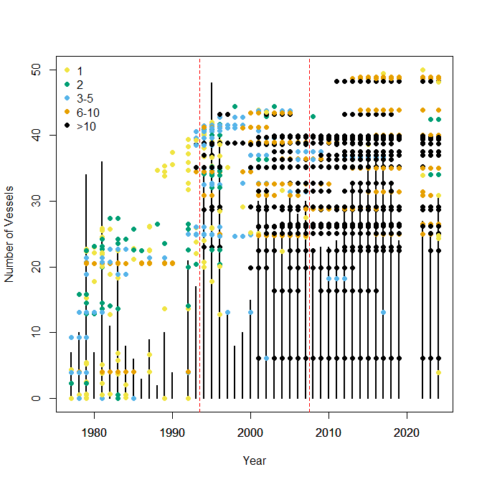
Figure B1. Number of fishing vessel (Vertical line) and distribution of unique vessel (dots) operated by year. Dot colors indicate the number of deliveries for each year by each vessel. Dashed red vertical line indicates a break between pre- (1977-1992), post- (1994-2007) superexclusive, and high-grade (2008-2024) fishery. No fishery occurred in 1993, and no fishery harvest occurred in 2020 and 2021.

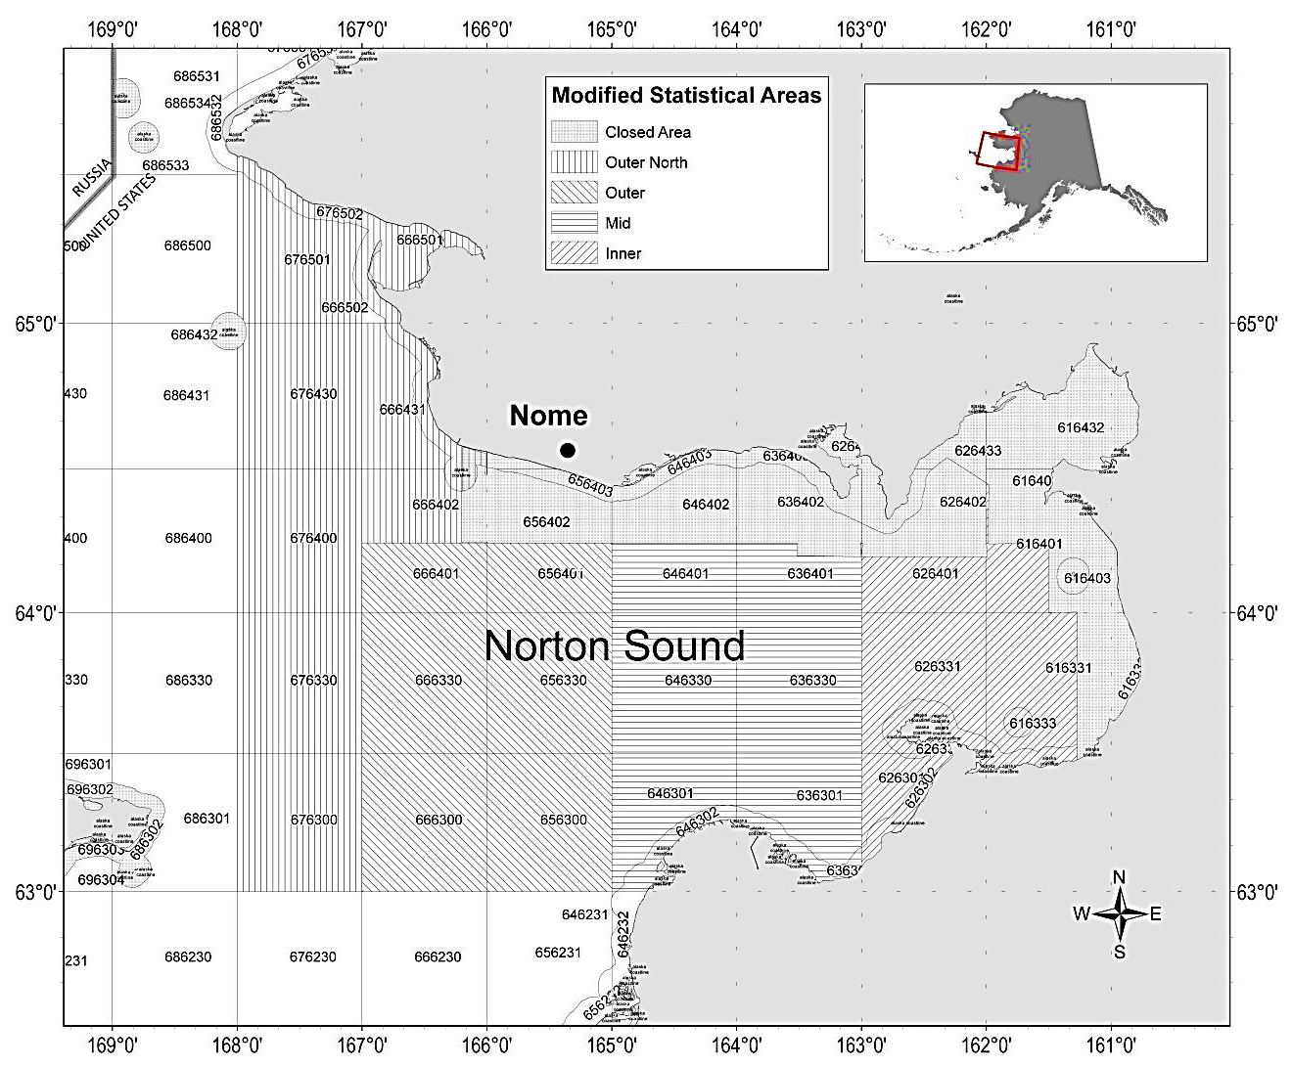
Figure B2. Closed area and statistical area boundaries used for reporting commercial harvest information for red king crab in Registration Area Q, Northern District, Norton Sound Section and boundaries of the new Modified Statistical Areas used in this analysis.

Appendix C

Norton Sound Trawl Survey quasi comparison
ADF&G and NOAA NBS surveys

Methods

Both ADF&G and NOAA NBS trawl survey occurred on Norton Sound in 2017, 2019, 2021, and 2023. Over the 4 years, a total of 51 stations were trawled by both surveys. Of those, 8 stations were trawled within 7 days (Table 1). For those catch weight CPUE (kg/km²) was calculated for each species. For each species, paired Wilcoxon test was conducted to determine statistical difference between the two surveys.

Results
A total of 124 species (Species Code) were identified by the two surveys (Table 2). Of those, 27 species were identified solely in ADF&G trawl and 54 species were identified solely in NBS surveys. Of the 124 species identified, 11 species had significant difference in CPUE (Table 2). Although CPUE of ADF&G survey ws

Table C1. List of trawled dates of ADF&G and NBS surveys and difference of days between the two surveys. The bold typed were selected for comparison
Year | ADFG_Station | ADF&G | NBS | Days
2017 | 79 | 30-Jul | 19-Aug | 20
2017 | 81 | 29-Jul | 24-Aug | 26
2017 | 121 | 6-Aug | 21-Aug | 15
2017 | 123 | 7-Aug | 20-Aug | 13
2017 | 125 | 3-Aug | 20-Aug | 17
2017 | 127 | 2-Aug | 22-Aug | 20
2017 | 129 | 2-Aug | 22-Aug | 20
2017 | 131 | 2-Aug | 24-Aug | 22
2017 | 133 | 30-Jul | 24-Aug | 25
2017 | 135 | 29-Jul | 25-Aug | 27
2017 | 176 | 6-Aug | 21-Aug | 15
2017 | 180 | 5-Aug | 22-Aug | 17
2017 | 182 | 5-Aug | 22-Aug | 17
2017 | 184 | 28-Jul | 24-Aug | 27
2017 | 186 | 28-Jul | 23-Aug | 26
2019 | 79 | 23-Jul | 7-Aug | 15
2019 | 81 | 24-Jul | 11-Aug | 18
2019 | 123 | 22-Jul | 6-Aug | 15
2019 | 125 | 22-Jul | 5-Aug | 14
2019 | 127 | 23-Jul | 5-Aug | 13
2019 | 129 | 23-Jul | 4-Aug | 12
2019 | 131 | 18-Jul | 4-Aug | 17
2019 | 133 | 17-Jul | 11-Aug | 25
2019 | 176 | 20-Jul | 6-Aug | 17
2019 | 180 | 19-Jul | 5-Aug | 17
2019 | 182 | 19-Jul | 5-Aug | 17
2019 | 184 | 18-Jul | 4-Aug | 17
2019 | 186 | 17-Jul | 4-Aug | 18
2021 | 123 | 24-Jul | 8-Aug | 15
2021 | 125 | 25-Jul | 7-Aug | 13
2021 | 127 | 25-Jul | 7-Aug | 13
2021 | 129 | 22-Jul | 7-Aug | 16
2021 | 131 | 1-Aug | 6-Aug | 5
2021 | 133 | 20-Jul | 2-Aug | 13
2021 | 176 | 24-Jul | 8-Aug | 15
2021 | 180 | 3-Aug | 7-Aug | 4
2021 | 182 | 21-Jul | 6-Aug | 16
2021 | 184 | 19-Jul | 6-Aug | 18
2021 | 186 | 19-Jul | 2-Aug | 14
2023 | 79 | 24-Jul | 2-Aug | 9
2023 | 81 | 22-Jul | 3-Aug | 12
2023 | 123 | 27-Jul | 31-Jul | 4
2023 | 127 | 29-Jul | 31-Jul | 2
2023 | 129 | 30-Jul | 1-Aug | 2
2023 | 131 | 24-Jul | 1-Aug | 8
2023 | 133 | 23-Jul | 3-Aug | 11
2023 | 176 | 26-Jul | 30-Jul | 4
2023 | 180 | 25-Jul | 29-Jul | 4
2023 | 182 | 25-Jul | 29-Jul | 4
2023 | 184 | 21-Jul | 29-Jul | 8
2023 | 186 | 21-Jul | 3-Aug | 13

Table C2: Mean CPUE and p-value of paired Wilcoxon test by species. Bold type indicate significance difference between the two.

Spcode | Species Name | Taxon.  Confidence | ADFG | NBS | p.value
10 | Petromyzontidae |  | 0.00 | 0.25 | 1.00
10120 | Hippoglossus stenolepis | High | 60.32 | 71.20 | 1.00
10140 | Hippoglossoides robustus | Moderate | 0.00 | 0.19 | 1.00
10155 | Liopsetta glacialis (=Pleuronectes glacialis) | Low | 0.00 | 0.81 | 1.00
10210 | Limanda aspera | High | 229.23 | 549.86 | 0.02
10211 | Limanda proboscidea (=Pleuronectes proboscidea) | High | 6.47 | 133.95 | 1.00
10220 | Platichthys stellatus | High | 613.93 | 608.29 | 0.25
10260 | Lepidopsetta sp. (= Pleuronectes in part) |  | 24.09 | 0.00 | 1.00
10285 | Pleuronectes quadrituberculatus | High | 87.27 | 112.93 | 0.46
20001 | Pallasi barbata | High | 0.00 | 0.07 | 0.50
20041 | Podothecus veternus | High | 1.02 | 0.66 | 1.00
20061 | Occella dodecaedron | High | 3.59 | 3.77 | 0.88
20322 | Arhichas orientalis | High | 0.00 | 33.96 | 1.00
21110 | Clupea pallasi (=Clupea harengus pallasi) | High | 10.86 | 5.54 | 0.75
21300 | Cottidae | High | 4.61 | 0.00 | 1.00
21313 | Gymnocanthus sp. | Moderate | 23.17 | 0.65 | 0.06
21314 | Gymnocanthus pistilliger | Moderate | 0.00 | 17.85 | 0.25
21315 | Gymnocanthus tricuspis | Moderate | 0.00 | 10.72 | 1.00
21370 | Myoxocephalus polyacanthocephalus | High | 0.00 | 6.70 | 1.00
21371 | Myoxocephalus jaok | High | 0.00 | 75.43 | 0.01
21375 | Myoxocephalus sp. | High | 44.24 | 0.00 | 0.02
21376 | Megalocottus platycephalus | Low | 0.00 | 2.22 | 1.00
21388 | Enophrys diceraus (=Enophrys claviger) | High | 1.84 | 7.01 | 0.13
21405 | utichthys pribilovius | High | 0.00 | 0.27 | 0.50
21423 | Eurymen gyrinus | High | 0.00 | 1.87 | 0.50
21720 | Gadus macrocephalus | High | 1.86 | 0.00 | 1.00
21725 | Boreogadus saida | Moderate | 0.00 | 0.90 | 0.13
21735 | Eleginus gracilis | High | 130.65 | 477.67 | 0.01
21740 | Theragra chalcogramma | High | 68.31 | 23.21 | 0.63
21753 | Pungitius pungitius | High | 0.00 | 0.05 | 1.00
21932 | Hexagrammos stelleri | High | 1.45 | 2.34 | 0.75
22201 | Liparis sp. | High | 0.00 | 0.23 | 1.00
22205 | Liparis gibbus (=Liparis cyclostigma) | High | 0.00 | 1.31 | 1.00
22208 | Liparis pulchellus |  | 0.00 | 0.64 | 1.00
22254 | Liparis bathyarcticus |  | 0.00 | 6.05 | 1.00
23041 | Mallotus villosus | High | 0.35 | 0.11 | 1.00
23055 | Osmerus mordax | High | 0.00 | 14.51 | 0.13
23801 | Lumpenus sp. |  | 32.66 | 0.00 | 0.03
23804 | Stichaeus punctatus | Moderate | 2.31 | 1.77 | 1.00
23807 | Lumpenus fabricii | Moderate | 0.00 | 112.77 | 0.03
23808 | Lumpenus sagitta | Moderate | 0.00 | 5.07 | 0.50
23809 | Acantholumpenus mackayi | Moderate | 0.00 | 44.82 | 0.03
23843 | Chirolophis snyderi | Low | 0.00 | 0.34 | 1.00
24180 | Lycodes sp. | High | 6.19 | 0.00 | 1.00
24185 | Lycodes palearis | High | 0.00 | 6.88 | 0.13
24186 | Lycodes mucosus | Low | 0.00 | 1.38 | 1.00
24189 | Lycodes turneri | Low | 0.00 | 5.17 | 0.13
40049 | Sertulariidae |  | 0.00 | 14.98 | 1.00
40500 | Scyphozoa (class) | High | 19.55 | 4.68 | 0.16
40504 | Chrysaora melaster | High | 0.00 | 0.90 | 1.00
40519 | Staurostoma mertensii |  | 0.00 | 0.18 | 1.00
40561 | Cyanea capillata | High | 0.00 | 8.69 | 0.25
41201 | Gersemia sp. (=Eunephthya sp.) | High | 109.23 | 180.58 | 0.81
43000 | Actiniaria (order) | High | 52.18 | 48.53 | 0.30
43010 | Metridium sp. | High | 0.00 | 199.52 | 0.03
43040 | Tealia sp. | Low | 0.00 | 28.52 | 1.00
43042 | Urtici crassicornis | Low | 0.00 | 52.98 | 1.00
43082 | Cribrinopsis ferldi | Low | 0.00 | 76.78 | 1.00
45000 | Ctenophora (phylum) |  | 0.00 | 0.05 | 1.00
50301 | Arctonoe vittata |  | 0.13 | 0.00 | 0.50
54030 | Cheilonereis cyclurus |  | 0.04 | 0.00 | 1.00
56300 | Polynoidae |  | 0.11 | 0.00 | 0.50
56311 | Eunoe nodosa | Moderate | 0.58 | 1.60 | 0.85
56312 | Eunoe depressa | Moderate | 0.02 | 0.67 | 1.00
60100 | Amphipoda | High | 0.07 | 1.06 | 1.00
62000 | Isopoda (order) | High | 0.04 | 0.00 | 1.00
63000 | Cumacea |  | 0.00 | 3.19 | 1.00
63500 | Euphausiacea (order) |  | 0.04 | 0.00 | 1.00
65100 | Thoracica (order) | High | 11.00 | 41.61 | 0.63
65203 | Balanus evermanni | Low | 5.76 | 0.00 | 1.00
66045 | Pandalus goniurus | Moderate | 28.04 | 6.63 | 0.09
66050 | Pandalus hypsinotus | Moderate | 0.35 | 0.00 | 1.00
66502 | Crangon sp. | Moderate | 9.37 | 66.44 | 0.11
66530 | Crangon dalli |  | 8.03 | 0.00 | 0.06
66548 | Crangon septemspinosa | Moderate | 30.25 | 0.00 | 0.06
66570 | Argis sp. | Moderate | 15.50 | 24.29 | 0.15
66601 | Sclerocrangon boreas | Low | 11.17 | 22.33 | 0.50
68580 | Chionoecetes opilio | High | 0.00 | 1.25 | 1.00
68781 | Telmessus cheiragonus | High | 110.62 | 148.12 | 0.55
69061 | Labidochirus splendescens (=Pagurus splendescens) | High | 4.42 | 41.13 | 0.02
69086 | Pagurus trigonocheirus | High | 21.99 | 172.50 | 0.50
69090 | Pagurus ochotensis | High | 27.28 | 61.13 | 0.19
69120 | Pagurus capillatus | High | 190.06 | 149.19 | 0.94
69316 | Hapalogaster grebnitzkii | High | 0.00 | 7.71 | 1.00
69322 | Paralithodes camtschaticus | High | 94.36 | 37.64 | 0.56
71001 | Gastropod sp. Eggs | High | 15.67 | 7.47 | 0.84
71010 | Nudibranchia | High | 0.39 | 0.00 | 1.00
71250 | Nudibranchia | Low | 62.70 | 0.00 | 1.00
71500 | Gastropod unident. | High | 0.39 | 0.00 | 1.00
71511 | ticidae egg | High | 3.70 | 0.00 | 0.25
71583 | Lamellariidae |  | 0.00 | 43.45 | 1.00
71634 | Tachyrhynchus erosus |  | 0.00 | 3.19 | 1.00
71639 | Calyptraeidae |  | 0.09 | 0.00 | 1.00
71753 | Pyrulofusus deformis | High | 51.80 | 0.00 | 0.50
71772 | Beringius beringii | Low | 26.70 | 7.23 | 0.50
71882 | Neptunea ventricosa | Low | 84.37 | 11.31 | 0.50
71884 | Neptunea heros | Low | 391.77 | 404.35 | 1.00
74080 | Mytilus edulis |  | 38.98 | 0.00 | 1.00
74311 | Hiatella arctica | Low | 0.79 | 0.00 | 0.03
74980 | Clinocardium sp. | Low | 0.00 | 3.19 | 1.00
75284 | Serripes sp. | High | 69.76 | 0.00 | 0.50
75287 | Serripes notabilis | Moderate | 0.00 | 211.14 | 1.00
80020 | Evasterias echinosoma | Moderate | 184.25 | 261.61 | 0.46
80200 | Lethasterias nimensis | High | 107.51 | 82.69 | 0.46
80540 | Henricia sp. | High | 0.00 | 3.33 | 0.50
80590 | Leptasterias polaris | High | 0.00 | 0.53 | 1.00
80595 | Leptasterias sp. | High | 3.65 | 1.53 | 0.63
81095 | Crossaster papposus | High | 0.00 | 2.51 | 1.00
81742 | Asterias amurensis | High | 2671.30 | 3439.21 | 0.15
82510 | Strongylocentrotus droebachiensis | Low | 165.95 | 539.51 | 0.22
82511 | Strongylocentrotus | Moderate | 0.00 | 433.86 | 1.00
83000 | Ophiuroid unident. | High | 192.59 | 0.00 | 1.00
83020 | Gorgonocephalus caryi | High | 0.00 | 3.24 | 0.50
83320 | Ophiura sarsi | Low | 0.00 | 707.02 | 1.00
91000 | Porifera | High | 7.79 | 8.32 | 1.00
95000 | Bryozoa (phylum) | Moderate | 0.00 | 64.37 | 1.00
95020 | Eucratea loricata | Low | 7.96 | 0.00 | 0.03
95030 | Flustra serrulata | Low | 0.09 | 0.00 | 1.00
95039 | Alcyonidium disciforme |  | 0.00 | 62.89 | 0.25
98082 | Styela rustica | High | 4.17 | 0.00 | 0.25
98105 | Boltenia ovifera | High | 1.95 | 0.00 | 1.00
98300 | Ascidiacea |  | 0.00 | 500.27 | 1.00
98310 | Aplidium sp. | High | 145.04 | 0.00 | 0.06
98312 | Aplidium sp. |  | 0.00 | 114.08 | 1.00

Table C3 Red King Crab CPUE
Year | ADFG_Station | ADFG | NBS
2021 | 131 | 19.58 | 25.62
2021 | 180 | 14.70 | 42.85
2023 | 123 | 0 | 63.22
2023 | 127 | 185.12 | 10.18
2023 | 129 | 256.0 | 50.62
2023 | 180 | 90.79 | 33.34

Appendix D GMACS data files
NSRKC.dat
#======================================================================================
# Gmacs Main Data File NSRKC 2024
# GEAR_INDEX DESCRIPTION
# 1 : Winter Commercial Fishery Retained catch
# 2 : Winter Subsistence Fishery Retained catch
# 3 : Winter Subsistence Fishery Total catch
# 4 : Summer Commercial Fishery Retained catch
# 5 : Summer Commercial Fishery Total catch
# 6 : ADF&G Survey
# 7 : NMFS Survey
# 8 : Pot CPUE

# Fisheries: 1 Winter Pot Fishery, 2 Winter Subsistace, 3 Summer Pot Fishery
# Surveys: 4 NMFS Trawl Survey, 5 ADFG Trawl Survey, 6 NBS Trawl Survey, 7 Winter Pot survey
#======================================================================================

1976 # Start year
2024 # End year
#2025 # Projection year
6 # Number of seasons
7 # Number of distinct data groups (fleet, among fishing fleets and surveys)
1 # Number of sexes
2 # Number of shell condition types
1 # Number of maturity types
8 # Number of size-classes in the model
6 # Season recruitment occurs
3 # Season molting and growth occurs
1 # Season to calculate SSB
1 # Season for N output
# maximum size-class (males then females)
8
# size_breaks (a vector giving the break points between size intervals with dimension nclass+1)
63.5 73.5 83.5 93.5 103.5 113.5 123.5 133.5 143.5
# Natural mortality per season input type (1 = vector by season, 2 = matrix by season/year)
2
# Proportion of the total natural mortality to be applied each season (each row must add to 1)
# 1. Winter Fishery (Feb01)
# 2. Mortality between winter and summer fishery
# 3. Summer fishery
# 4. Time between summer fishery and Nov 1 (Molt and recruit)
# 5. Time to Feb 01
# 6. Feb 01 recruit

0 0.3452055 0.1863014 0.1351932 0.3333 0 # 1976
0 0.3452055 0.1863014 0.1351932 0.3333 0 # 1977
0 0.3452055 0.1863014 0.1351932 0.3333 0 # 1978
0 0.4493151 0.04109589 0.176289 0.3333 0 # 1979
0 0.4493151 0.04109589 0.176289 0.3333 0 # 1980
0 0.4493151 0.1013699 0.1160151 0.3333 0 # 1981
0 0.5150685 0.06027397 0.09135753 0.3333 0 # 1982
0 0.4931507 0.0109589 0.1625904 0.3333 0 # 1983
0 0.4931507 0.03835616 0.1351932 0.3333 0 # 1984
0 0.4931507 0.06027397 0.1132753 0.3333 0 # 1985
0 0.4931507 0.06575342 0.1077959 0.3333 0 # 1986
0 0.4931507 0.03013699 0.1434123 0.3333 0 # 1987
0 0.4931507 0.02739726 0.1461521 0.3333 0 # 1988
0 0.4931507 0.008219178 0.1653301 0.3333 0 # 1989
0 0.4931507 0.0109589 0.1625904 0.3333 0 # 1990
0 0.4931507 0.0109589 0.1625904 0.3333 0 # 1991
0 0.4931507 0.005479452 0.1680699 0.3333 0 # 1992
0 0.4109589 0.1561644 0.09957671 0.3333 0 # 1993
0 0.4109589 0.07945205 0.176289 0.3333 0 # 1994
0 0.4109589 0.1643836 0.09135753 0.3333 0 # 1995
0 0.4109589 0.169863 0.08587808 0.3333 0 # 1996
0 0.4109589 0.1150685 0.1406726 0.3333 0 # 1997
0 0.4109589 0.169863 0.08587808 0.3333 0 # 1998
0 0.4109589 0.1726027 0.08313836 0.3333 0 # 1999
0 0.4109589 0.2410959 0.01464521 0.3333 0 # 2000
0 0.4109589 0.1863014 0.06943973 0.3333 0 # 2001
0 0.3671233 0.2136986 0.08587808 0.3333 0 # 2002
0 0.3671233 0.1890411 0.1105356 0.3333 0 # 2003
0 0.3671233 0.1452055 0.1543712 0.3333 0 # 2004
0 0.3671233 0.1972603 0.1023164 0.3333 0 # 2005
0 0.3671233 0.1835616 0.1160151 0.3333 0 # 2006
0 0.3671233 0.169863 0.1297137 0.3333 0 # 2007
0 0.3890411 0.1917808 0.08587808 0.3333 0 # 2008
0 0.3671233 0.260274 0.03930274 0.3333 0 # 2009
0 0.4027397 0.1534247 0.1105356 0.3333 0 # 2010
0 0.4027397 0.08767123 0.176289 0.3333 0 # 2011
0 0.4054795 0.1890411 0.07217945 0.3333 0 # 2012
0 0.4164384 0.1945205 0.0557411 0.3333 0 # 2013
0 0.3945205 0.1369863 0.1351932 0.3333 0 # 2014
0 0.4054795 0.06849315 0.1927274 0.3333 0 # 2015
0 0.4000000 0.06575342 0.2009466 0.3333 0 # 2016
0 0.3972603 0.07945205 0.1899877 0.3333 0 # 2017
0 0.3917808 0.09589041 0.1790288 0.3333 0 # 2018
0 0.3945205 0.1643836 0.1077959 0.3333 0 # 2019
0 0.3945205 0.1643836 0.1077959 0.3333 0 # 2020
0 0.3945205 0.1643836 0.1077959 0.3333 0 # 2021
0 0.3671233 0.109589 0.189987 0.3333 0 # 2022
0 0.3835616 0.07671233 0.206426 0.3333 0 # 2023
0 0.3643836 0.07945205 0.2228644 0.3333 0 # 2024

# Fishing fleet names (delimited with : no spaces in names)
Winter_Com Subsistence Summer_Com
# Survey names (delimited with : no spaces in names)
NMFS_Trawl ADFG_Trawl NBS_Trawl Winter_Pot
# Are the seasons instantaneous (0) or continuous (1)
1 1 1 1 1 1
# Use Old format (0)
0
# Number of catch data frames
4
# Number of rows in each data frame
46 47 41 45
## CATCH DATA
## Type of catch: 1 = retained, 2 = discard
## Units of catch: 1 = biomass, 2 = numbers

## Winter commercial
# year seas fleet sex obs cv type units mult effort discard_mortality
1978 1 1 1 9.625 0.03 1 2 1 0 0.2
1979 1 1 1 0.221 0.03 1 2 1 0 0.2
1980 1 1 1 0.022 0.03 1 2 1 0 0.2
#1981 1 1 1 0 0.03 1 2 1 0 0.2
1982 1 1 1 0.017 0.03 1 2 1 0 0.2
1983 1 1 1 0.549 0.03 1 2 1 0 0.2
1984 1 1 1 0.856 0.03 1 2 1 0 0.2
1985 1 1 1 1.168 0.03 1 2 1 0 0.2
1986 1 1 1 2.168 0.03 1 2 1 0 0.2
1987 1 1 1 1.04 0.03 1 2 1 0 0.2
1988 1 1 1 0.425 0.03 1 2 1 0 0.2
1989 1 1 1 0.403 0.03 1 2 1 0 0.2
1990 1 1 1 3.626 0.03 1 2 1 0 0.2
1991 1 1 1 3.8 0.03 1 2 1 0 0.2
1992 1 1 1 7.478 0.03 1 2 1 0 0.2
1993 1 1 1 1.788 0.03 1 2 1 0 0.2
1994 1 1 1 5.753 0.03 1 2 1 0 0.2
1995 1 1 1 7.538 0.03 1 2 1 0 0.2
1996 1 1 1 1.778 0.03 1 2 1 0 0.2
1997 1 1 1 0.083 0.03 1 2 1 0 0.2
1998 1 1 1 0.984 0.03 1 2 1 0 0.2
1999 1 1 1 2.714 0.03 1 2 1 0 0.2
2000 1 1 1 3.045 0.03 1 2 1 0 0.2
2001 1 1 1 1.098 0.03 1 2 1 0 0.2
2002 1 1 1 2.591 0.03 1 2 1 0 0.2
2003 1 1 1 6.853 0.03 1 2 1 0 0.2
2004 1 1 1 0.522 0.03 1 2 1 0 0.2
2005 1 1 1 2.121 0.03 1 2 1 0 0.2
2006 1 1 1 0.075 0.03 1 2 1 0 0.2
2007 1 1 1 3.313 0.03 1 2 1 0 0.2
2008 1 1 1 5.796 0.03 1 2 1 0 0.2
2009 1 1 1 4.951 0.03 1 2 1 0 0.2
2010 1 1 1 4.834 0.03 1 2 1 0 0.2
2011 1 1 1 3.365 0.03 1 2 1 0 0.2
2012 1 1 1 9.157 0.03 1 2 1 0 0.2
2013 1 1 1 22.639 0.03 1 2 1 0 0.2
2014 1 1 1 14.986 0.03 1 2 1 0 0.2
2015 1 1 1 41.046 0.03 1 2 1 0 0.2
2016 1 1 1 29.792 0.03 1 2 1 0 0.2
2017 1 1 1 26.008 0.03 1 2 1 0 0.2
2018 1 1 1 9.18 0.03 1 2 1 0 0.2
2019 1 1 1 1.05 0.03 1 2 1 0 0.2
2020 1 1 1 0.08 0.03 1 2 1 0 0.2
2021 1 1 1 0.32 0.03 1 2 1 0 0.2
2022 1 1 1 2.708 0.03 1 2 1 0 0.2
2023 1 1 1 3.580 0.03 1 2 1 0 0.2
2024 1 1 1 4.830 0.03 1 2 1 0 0.2

# Subsistence retained
1978 1 2 1 12.506 0.03 1 2 1 0 0.2
1979 1 2 1 0.224 0.03 1 2 1 0 0.2
1980 1 2 1 0.213 0.03 1 2 1 0 0.2
1981 1 2 1 0.36 0.03 1 2 1 0 0.2
1982 1 2 1 1.288 0.03 1 2 1 0 0.2
1983 1 2 1 10.432 0.03 1 2 1 0 0.2
1984 1 2 1 11.22 0.03 1 2 1 0 0.2
1985 1 2 1 8.377 0.03 1 2 1 0 0.2
1986 1 2 1 7.052 0.03 1 2 1 0 0.2
1987 1 2 1 5.772 0.03 1 2 1 0 0.2
1988 1 2 1 2.724 0.03 1 2 1 0 0.2
1989 1 2 1 6.126 0.03 1 2 1 0 0.2
1990 1 2 1 12.152 0.03 1 2 1 0 0.2
1991 1 2 1 7.366 0.03 1 2 1 0 0.2
1992 1 2 1 11.736 0.03 1 2 1 0 0.2
1993 1 2 1 1.097 0.03 1 2 1 0 0.2
1994 1 2 1 4.113 0.03 1 2 1 0 0.2
1995 1 2 1 5.426 0.03 1 2 1 0 0.2
1996 1 2 1 1.679 0.03 1 2 1 0 0.2
1997 1 2 1 0.745 0.03 1 2 1 0 0.2
1998 1 2 1 8.622 0.03 1 2 1 0 0.2
1999 1 2 1 7.533 0.03 1 2 1 0 0.2
2000 1 2 1 5.723 0.03 1 2 1 0 0.2
2001 1 2 1 0.256 0.03 1 2 1 0 0.2
2002 1 2 1 2.177 0.03 1 2 1 0 0.2
2003 1 2 1 4.14 0.03 1 2 1 0 0.2
2004 1 2 1 1.181 0.03 1 2 1 0 0.2
2005 1 2 1 3.973 0.03 1 2 1 0 0.2
2006 1 2 1 1.239 0.03 1 2 1 0 0.2
2007 1 2 1 10.69 0.03 1 2 1 0 0.2
2008 1 2 1 9.485 0.03 1 2 1 0 0.2
2009 1 2 1 4.752 0.03 1 2 1 0 0.2
2010 1 2 1 7.044 0.03 1 2 1 0 0.2
2011 1 2 1 6.64 0.03 1 2 1 0 0.2
2012 1 2 1 7.311 0.03 1 2 1 0 0.2
2013 1 2 1 7.622 0.03 1 2 1 0 0.2
2014 1 2 1 3.252 0.03 1 2 1 0 0.2
2015 1 2 1 7.651 0.03 1 2 1 0 0.2
2016 1 2 1 5.34 0.03 1 2 1 0 0.2
2017 1 2 1 6.039 0.03 1 2 1 0 0.2
2018 1 2 1 4.424 0.03 1 2 1 0 0.2
2019 1 2 1 1.54 0.03 1 2 1 0 0.2
2020 1 2 1 0.55 0.03 1 2 1 0 0.2
2021 1 2 1 2.892 0.03 1 2 1 0 0.2
2022 1 2 1 7.630 0.03 1 2 1 0 0.2
2023 1 2 1 5.407 0.03 1 2 1 0 0.2
2024 1 2 1 4.751 0.03 1 2 1 0 0.2

# Subistence total
#1978 1 2 1 0 0.03 0 2 1 0 0.2
#1979 1 2 1 0 0.03 0 2 1 0 0.2
#1980 1 2 1 0 0.03 0 2 1 0 0.2
#1981 1 2 1 0 0.03 0 2 1 0 0.2
#1982 1 2 1 0 0.03 0 2 1 0 0.2
#1983 1 2 1 0 0.03 0 2 1 0 0.2
1984 1 2 1 15.923 0.03 0 2 1 0 0.2
1985 1 2 1 10.757 0.03 0 2 1 0 0.2
1986 1 2 1 10.751 0.03 0 2 1 0 0.2
1987 1 2 1 7.406 0.03 0 2 1 0 0.2
1988 1 2 1 3.573 0.03 0 2 1 0 0.2
1989 1 2 1 7.945 0.03 0 2 1 0 0.2
1990 1 2 1 16.635 0.03 0 2 1 0 0.2
1991 1 2 1 9.295 0.03 0 2 1 0 0.2
1992 1 2 1 15.051 0.03 0 2 1 0 0.2
1993 1 2 1 1.193 0.03 0 2 1 0 0.2
1994 1 2 1 4.894 0.03 0 2 1 0 0.2
1995 1 2 1 7.777 0.03 0 2 1 0 0.2
1996 1 2 1 2.936 0.03 0 2 1 0 0.2
1997 1 2 1 1.617 0.03 0 2 1 0 0.2
1998 1 2 1 20.327 0.03 0 2 1 0 0.2
1999 1 2 1 10.651 0.03 0 2 1 0 0.2
2000 1 2 1 9.816 0.03 0 2 1 0 0.2
2001 1 2 1 0.366 0.03 0 2 1 0 0.2
2002 1 2 1 5.119 0.03 0 2 1 0 0.2
2003 1 2 1 9.052 0.03 0 2 1 0 0.2
2004 1 2 1 1.775 0.03 0 2 1 0 0.2
2005 1 2 1 6.484 0.03 0 2 1 0 0.2
2006 1 2 1 2.083 0.03 0 2 1 0 0.2
2007 1 2 1 21.444 0.03 0 2 1 0 0.2
2008 1 2 1 18.621 0.03 0 2 1 0 0.2
2009 1 2 1 6.971 0.03 0 2 1 0 0.2
2010 1 2 1 9.004 0.03 0 2 1 0 0.2
2011 1 2 1 9.183 0.03 0 2 1 0 0.2
2012 1 2 1 11.341 0.03 0 2 1 0 0.2
2013 1 2 1 21.524 0.03 0 2 1 0 0.2
2014 1 2 1 5.421 0.03 0 2 1 0 0.2
2015 1 2 1 9.84 0.03 0 2 1 0 0.2
2016 1 2 1 6.468 0.03 0 2 1 0 0.2
2017 1 2 1 7.185 0.03 0 2 1 0 0.2
2018 1 2 1 5.767 0.03 0 2 1 0 0.2
2019 1 2 1 2.079 0.03 0 2 1 0 0.2
2020 1 2 1 0.815 0.03 0 2 1 0 0.2
2021 1 2 1 3.999 0.03 0 2 1 0 0.2
2022 1 2 1 10.041 0.03 0 2 1 0 0.2
2023 1 2 1 6.613 0.03 0 2 1 0 0.2
2024 1 2 1 5.9879 0.03 0 2 1 0 0.2

# Summer Commercial Retain
1977 3 3 1 195.877 0.03 1 2 1 0 0.2
1978 3 3 1 660.829 0.03 1 2 1 0 0.2
1979 3 3 1 970.962 0.03 1 2 1 0 0.2
1980 3 3 1 329.778 0.03 1 2 1 0 0.2
1981 3 3 1 376.313 0.03 1 2 1 0 0.2
1982 3 3 1 63.949 0.03 1 2 1 0 0.2
1983 3 3 1 132.205 0.03 1 2 1 0 0.2
1984 3 3 1 139.759 0.03 1 2 1 0 0.2
1985 3 3 1 146.669 0.03 1 2 1 0 0.2
1986 3 3 1 162.438 0.03 1 2 1 0 0.2
1987 3 3 1 103.338 0.03 1 2 1 0 0.2
1988 3 3 1 76.148 0.03 1 2 1 0 0.2
1989 3 3 1 79.116 0.03 1 2 1 0 0.2
1990 3 3 1 59.132 0.03 1 2 1 0 0.2
#1991 3 3 1 0 0.03 1 2 1 0 0.2
1992 3 3 1 24.902 0.03 1 2 1 0 0.2
1993 3 3 1 115.913 0.03 1 2 1 0 0.2
1994 3 3 1 108.824 0.03 1 2 1 0 0.2
1995 3 3 1 105.967 0.03 1 2 1 0 0.2
1996 3 3 1 74.752 0.03 1 2 1 0 0.2
1997 3 3 1 32.606 0.03 1 2 1 0 0.2
1998 3 3 1 10.661 0.03 1 2 1 0 0.2
1999 3 3 1 8.734 0.03 1 2 1 0 0.2
2000 3 3 1 111.728 0.03 1 2 1 0 0.2
2001 3 3 1 98.321 0.03 1 2 1 0 0.2
2002 3 3 1 86.666 0.03 1 2 1 0 0.2
2003 3 3 1 93.638 0.03 1 2 1 0 0.2
2004 3 3 1 120.289 0.03 1 2 1 0 0.2
2005 3 3 1 138.926 0.03 1 2 1 0 0.2
2006 3 3 1 150.358 0.03 1 2 1 0 0.2
2007 3 3 1 110.344 0.03 1 2 1 0 0.2
2008 3 3 1 143.337 0.03 1 2 1 0 0.2
2009 3 3 1 143.485 0.03 1 2 1 0 0.2
2010 3 3 1 149.822 0.03 1 2 1 0 0.2
2011 3 3 1 141.626 0.03 1 2 1 0 0.2
2012 3 3 1 161.113 0.03 1 2 1 0 0.2
2013 3 3 1 130.603 0.03 1 2 1 0 0.2
2014 3 3 1 129.656 0.03 1 2 1 0 0.2
2015 3 3 1 144.225 0.03 1 2 1 0 0.2
2016 3 3 1 138.997 0.03 1 2 1 0 0.2
2017 3 3 1 135.322 0.03 1 2 1 0 0.2
2018 3 3 1 89.613 0.03 1 2 1 0 0.2
2019 3 3 1 23.964 0.03 1 2 1 0 0.2
#2020 3 3 1 0 0.03 1 2 1 0 0.2
#2021 3 3 1 0 0.03 1 2 1 0 0.2
2022 3 3 1 125.042 0.03 1 2 1 0 0.2
2023 3 3 1 148.062 0.03 1 2 1 0 0.2
2024 3 3 1 140.379 0.03 1 2 1 0 0.2

## RELATIVE ABUNDANCE DATA
## Units of abundance: 1 = biomass, 2 = numbers
## Use old format (0)
0
## Number of relative abundance indicies
6
# Type of 'survey' catchability (1=Selectivity; 2=Selectivity+Retention), by data frame
1 1 1 2 2 2
## Number of rows in index
71
# ADFG/NOAA Trawl survey
#Index Year Season Fleet Sex Maturity Value CV Type Time
1 1976 3 4 1 0 4247.462 0.311 2 1.411765
1 1979 3 4 1 0 1417.215 0.204 2 1
1 1982 3 4 1 0 2791.733 0.289 2 1.318182
1 1985 3 4 1 0 2306.321 0.254 2 2.363636
1 1988 3 4 1 0 2263.353 0.288 2 2.2
1 1991 3 4 1 0 3132.508 0.428 2 6.25

# ADFG Trawl sruvey
2 1996 3 5 1 0 1313.757 0.259 2 0.6612903
2 1999 3 5 1 0 2630.53 0.236 2 0.4920635
2 2002 3 5 1 0 1769.85 0.418 2 0.5897436
2 2006 3 5 1 0 3322.53 0.391 2 0.6865672
2 2008 3 5 1 0 2962.1 0.30 2 0.5571429
2 2011 3 5 1 0 3209.285 0.289 2 1.03125
2 2014 3 5 1 0 5949.46 0.473 2 0.58
2 2017 3 5 1 0 1762.072 0.223 2 1.241379
2 2018 3 5 1 0 1109.39 0.249 2 0.8857143
2 2019 3 5 1 0 4675.99 0.598 2 0.4666667
2 2020 3 5 1 0 1725.99 0.298 2 0.7
2 2021 3 5 1 0 2430.44 0.608 2 0.5166667
2 2023 3 5 1 0 3548.08 0.315 2 1.214286
2 2024 3 5 1 0 1407.401 0.281 2 1.413793

# NOAA NBS survey
3 2010 3 6 1 0 1980.079 0.436 2 0.6071429
3 2017 3 6 1 0 864.497 0.467 2 1.965517
3 2019 3 6 1 0 2071.94 0.346 2 0.5882353
3 2021 3 6 1 0 2338.06 0.441 2 0.6666667
3 2022 3 6 1 0 2103.02 0.363 2 0.6166667
3 2023 3 6 1 0 1686.34 0.391 2 1.3

# ST CPUE
4 1977 3 3 1 0 2.82 0.35 2 0.5
4 1978 3 3 1 0 3.41 0.23 2 0.5
4 1979 3 3 1 0 1.55 0.22 2 0.5
4 1980 3 3 1 0 1.82 0.28 2 0.5
4 1981 3 3 1 0 0.62 0.20 2 0.5
4 1982 3 3 1 0 0.18 0.27 2 0.5
4 1983 3 3 1 0 0.72 0.22 2 0.5
4 1984 3 3 1 0 1.11 0.23 2 0.5
4 1985 3 3 1 0 0.67 0.24 2 0.5
4 1986 3 3 1 0 1.63 0.52 2 0.5
4 1987 3 3 1 0 0.64 0.35 2 0.5
4 1988 3 3 1 0 1.60 0.71 2 0.5
4 1989 3 3 1 0 1.35 0.33 2 0.5
4 1990 3 3 1 0 1.06 0.45 2 0.5
4 1992 3 3 1 0 0.26 0.32 2 0.5
5 1993 3 3 1 0 1.02 0.09 2 0.5
5 1994 3 3 1 0 0.44 0.17 2 0.5
5 1995 3 3 1 0 1.09 0.13 2 0.5
5 1996 3 3 1 0 1.01 0.09 2 0.5
5 1997 3 3 1 0 1.14 0.09 2 0.5
5 1998 3 3 1 0 1.31 0.12 2 0.5
5 1999 3 3 1 0 0.97 0.10 2 0.5
5 2000 3 3 1 0 2.08 0.11 2 0.5
5 2001 3 3 1 0 0.76 0.25 2 0.5
5 2002 3 3 1 0 0.76 0.09 2 0.5
5 2003 3 3 1 0 1.65 0.08 2 0.5
5 2004 3 3 1 0 1.36 0.07 2 0.5
5 2005 3 3 1 0 0.64 0.12 2 0.5
5 2006 3 3 1 0 0.93 0.10 2 0.5
6 2007 3 3 1 0 0.88 0.22 2 0.5
6 2008 3 3 1 0 1.18 0.05 2 0.5
6 2009 3 3 1 0 0.81 0.04 2 0.5
6 2010 3 3 1 0 1.19 0.05 2 0.5
6 2011 3 3 1 0 1.36 0.05 2 0.5
6 2012 3 3 1 0 1.20 0.04 2 0.5
6 2013 3 3 1 0 0.62 0.04 2 0.5
6 2014 3 3 1 0 0.94 0.04 2 0.5
6 2015 3 3 1 0 1.17 0.05 2 0.5
6 2016 3 3 1 0 1.03 0.05 2 0.5
6 2017 3 3 1 0 0.88 0.05 2 0.5
6 2018 3 3 1 0 0.51 0.05 2 0.5
6 2019 3 3 1 0 0.24 0.06 2 0.5
6 2022 3 3 1 0 1.31 0.07 2 0.5
6 2023 3 3 1 0 2.00 0.07 2 0.5
6 2024 3 3 1 0 2.63 0.14 2 0.5

## Use old format (0)
0
## Number of length frequency matrices
16
## Number of rows in each matrix
4 4 45 45 14 14 8 8 6 6 14 14 6 6 27 27
## Number of bins in each matrix (columns of size data)
8 8 8 8 8 8 8 8 8 8 8 8 8 8 8 8
## SIZE COMPOSITION DATA FOR ALL FLEETS
## SIZE COMP LEGEND
## Sex: 1 = male, 2 = female, 0 = both sexes combined
## Type of composition: 1 = retained, 2 = discard, 0 = total composition
## Maturity state: 1 = immature, 2 = mature, 0 = both states combined
## Shell condition: 1 = new shell, 2 = old shell, 0 = both shell types combined

##Winter Com Retain newshell
##Year, Seas, Fleet, Sex, Type, Shell, Maturity, Nsamp, DataVec
2015 1 1 1 1 1 0 10 0 0 0 43 287 138 35 3
2016 1 1 1 1 1 0 10 0 0 0 29 462 318 35 5
2017 1 1 1 1 1 0 10 0 0 0 1 110 162 71 9
2018 1 1 1 1 1 0 10 0 0 0 0 43 102 107 21

##Winter Com Retain oldshell
##Year, Seas, Fleet, Sex, Type, Shell, Maturity, Nsamp, DataVec
2015 1 1 1 1 2 0 10 0 0 0 6 23 17 17 7
2016 1 1 1 1 2 0 10 0 0 0 8 93 42 16 8
2017 1 1 1 1 2 0 10 0 0 0 1 42 101 32 11
2018 1 1 1 1 2 0 10 0 0 0 0 15 64 39 10

##Summer Com Retain newwhell
##Year, Seas, Fleet, Sex, Type, Shell, Maturity, Nsamp, DataVec
1977 3 3 1 1 1 0 10 0 0 0 5 650 530 119 70
1978 3 3 1 1 1 0 10 0 0 0 4 72 184 103 16
1979 3 3 1 1 1 0 10 0 0 0 42 386 636 425 109
1980 3 3 1 1 1 0 10 0 0 0 4 105 327 396 196
1981 3 3 1 1 1 0 10 0 0 0 7 131 275 502 406
1982 3 3 1 1 1 0 10 0 0 0 46 210 180 239 313
1983 3 3 1 1 1 0 10 0 0 0 31 331 287 51 27
1984 3 3 1 1 1 0 10 0 0 0 93 404 270 62 7
1985 3 3 1 1 1 0 10 0 0 1 173 840 1000 417 53
1986 3 3 1 1 1 0 10 0 0 0 33 405 448 134 20
1987 3 3 1 1 1 0 10 0 0 0 33 355 578 539 215
1988 3 3 1 1 1 0 10 0 1 0 36 305 457 274 58
1989 3 3 1 1 1 0 10 0 0 0 33 426 826 442 117
1990 3 3 1 1 1 0 10 0 0 0 19 185 447 331 88
#1991 3 3 1 1 1 0 10 0 0 0 0 0 0 0 0
1992 3 3 1 1 1 0 10 0 0 0 44 515 682 350 229
1993 3 3 1 1 1 0 10 0 0 0 253 4116 7013 4095 589
1994 3 3 1 1 1 0 10 0 0 0 10 38 33 28 8
1995 3 3 1 1 1 0 10 0 0 0 46 307 335 176 60
1996 3 3 1 1 1 0 10 0 0 0 25 176 188 74 37
1997 3 3 1 1 1 0 10 0 0 0 35 438 409 119 30
1998 3 3 1 1 1 0 10 0 0 0 30 246 256 85 28
1999 3 3 1 1 1 0 10 0 0 0 36 165 137 103 53
2000 3 3 1 1 1 0 10 0 0 0 334 5149 6743 1884 266
2001 3 3 1 1 1 0 10 0 0 0 487 4472 7394 4116 1455
2002 3 3 1 1 1 0 10 0 0 0 231 1222 1469 1316 382
2003 3 3 1 1 1 0 10 0 0 0 121 1923 1671 634 162
2004 3 3 1 1 1 0 10 0 0 0 84 3660 3727 1016 324
2005 3 3 1 1 1 0 10 0 0 0 12 1361 2524 860 117
2006 3 3 1 1 1 0 10 0 0 0 14 1222 2337 1168 167
2007 3 3 1 1 1 0 10 0 0 0 68 2189 2087 842 208
2008 3 3 1 1 1 0 10 0 0 0 27 2025 2004 322 63
2009 3 3 1 1 1 0 10 0 0 0 63 2076 1985 675 132
2010 3 3 1 1 1 0 10 0 0 0 31 2275 2135 586 60
2011 3 3 1 1 1 0 10 0 0 0 11 809 1013 294 60
2012 3 3 1 1 1 0 10 0 0 0 13 1224 2336 932 113
2013 3 3 1 1 1 0 10 0 0 0 27 1450 2253 1465 369
2014 3 3 1 1 1 0 10 0 0 0 40 1324 1105 866 335
2015 3 3 1 1 1 0 10 0 0 0 58 1987 1177 418 122
2016 3 3 1 1 1 0 10 0 0 0 5 392 731 247 48
2017 3 3 1 1 1 0 10 0 0 0 4 602 1341 728 86
2018 3 3 1 1 1 0 10 0 0 0 9 300 842 845 197
2019 3 3 1 1 1 0 10 0 0 0 10 364 260 151 29
#2020 3 3 1 1 1 0 10 0 0 0 0 0 0 0 0
#2021 3 3 1 1 1 0 10 0 0 0 0 0 0 0 0
2022 3 3 1 1 1 0 10 0 0 0 56 1375 892 96 5
2023 3 3 1 1 1 0 10 0 0 0 10 645 1027 331 25
2024 3 3 1 1 1 0 10 0 0 0 4 295 951 777 174

##Summer Com Retain oldwhell
##Year, Seas, Fleet, Sex, Type, Shell, Maturity, Nsamp, DataVec
1977 3 3 1 1 2 0 10 0 0 0 0 97 62 10 6
1978 3 3 1 1 2 0 10 0 0 0 0 2 4 3 1
1979 3 3 1 1 2 0 10 0 0 0 0 42 1 5 14
1980 3 3 1 1 2 0 10 0 0 0 0 3 12 17 8
1981 3 3 1 1 2 0 10 0 0 0 0 8 90 207 158
1982 3 3 1 1 2 0 10 0 0 0 4 14 24 33 30
1983 3 3 1 1 2 0 10 0 0 0 3 29 8 17 18
1984 3 3 1 1 2 0 10 0 0 0 10 63 47 6 1
1985 3 3 1 1 2 0 10 0 0 0 7 90 84 23 3
1986 3 3 1 1 2 0 10 0 0 0 2 23 43 27 3
1987 3 3 1 1 2 0 10 0 0 0 5 53 129 60 18
1988 3 3 1 1 2 0 10 0 0 0 9 98 148 107 29
1989 3 3 1 1 2 0 10 0 0 0 11 144 315 221 60
1990 3 3 1 1 2 0 10 0 0 0 1 48 95 61 14
#1991 3 3 1 1 2 0 10 0 0 0 0 0 0 0 0
1992 3 3 1 1 2 0 10 0 0 0 7 203 331 153 52
1993 3 3 1 1 2 0 10 0 0 0 7 308 778 512 133
1994 3 3 1 1 2 0 10 0 0 0 10 76 101 81 19
1995 3 3 1 1 2 0 10 0 0 0 9 57 87 75 15
1996 3 3 1 1 2 0 10 0 0 0 11 94 107 62 13
1997 3 3 1 1 2 0 10 0 0 0 4 67 50 32 14
1998 3 3 1 1 2 0 10 0 0 0 23 118 151 86 32
1999 3 3 1 1 2 0 10 0 0 0 1 13 27 25 2
2000 3 3 1 1 2 0 10 0 0 0 48 914 1125 609 141
2001 3 3 1 1 2 0 10 0 0 0 17 483 996 476 134
2002 3 3 1 1 2 0 10 0 0 0 24 147 219 165 44
2003 3 3 1 1 2 0 10 0 0 0 6 114 243 276 76
2004 3 3 1 1 2 0 10 0 0 0 4 245 333 143 70
2005 3 3 1 1 2 0 10 0 0 0 0 110 242 102 32
2006 3 3 1 1 2 0 10 0 0 0 2 334 922 464 77
2007 3 3 1 1 2 0 10 0 0 0 5 151 351 186 38
2008 3 3 1 1 2 0 10 0 0 0 8 516 535 204 62
2009 3 3 1 1 2 0 10 0 0 0 7 463 479 114 32
2010 3 3 1 1 2 0 10 0 0 0 11 322 322 136 24
2011 3 3 1 1 2 0 10 0 0 0 5 156 150 42 12
2012 3 3 1 1 2 0 10 0 0 0 1 131 214 79 13
2013 3 3 1 1 2 0 10 0 0 0 2 85 256 137 28
2014 3 3 1 1 2 0 10 0 0 0 1 193 405 336 77
2015 3 3 1 1 2 0 10 0 0 0 3 99 137 137 35
2016 3 3 1 1 2 0 10 0 0 0 2 27 36 45 10
2017 3 3 1 1 2 0 10 0 0 0 3 100 384 164 22
2018 3 3 1 1 2 0 10 0 0 0 0 23 197 196 50
2019 3 3 1 1 2 0 10 0 0 0 0 18 119 154 31
#2020 3 3 1 1 2 0 10 0 0 0 0 0 0 0 0
#2021 3 3 1 1 2 0 10 0 0 0 0 0 0 0 0
2022 3 3 1 1 2 0 10 0 0 0 20 359 149 24 5
2023 3 3 1 1 2 0 10 0 0 0 1 169 209 36 5
2024 3 3 1 1 2 0 10 0 0 0 0 51 141 75 8

##Summer Com Discards newshell
##Year, Seas, Fleet, Sex, Type, Shell, Maturity, Nsamp, DataVec
1987 3 3 1 2 1 0 10 69 216 367 379 37 0 0 0
1988 3 3 1 2 1 0 10 9 29 108 344 99 0 0 0
1989 3 3 1 2 1 0 10 71 193 242 216 25 0 0 0
1990 3 3 1 2 1 0 10 40 115 137 139 19 0 0 0
1992 3 3 1 2 1 0 10 65 99 173 171 19 0 0 0
1994 3 3 1 2 1 0 10 63 50 92 126 19 0 0 0
2012 3 3 1 2 1 0 10 242 137 195 313 97 9 0 0
2013 3 3 1 2 1 0 10 845 722 390 416 113 6 2 0
2014 3 3 1 2 1 0 10 79 175 460 724 207 14 4 0
2015 3 3 1 2 1 0 10 26 120 278 709 303 37 11 1
2016 3 3 1 2 1 0 10 19 22 71 215 71 7 0 0
2017 3 3 1 2 1 0 10 53 88 73 166 137 8 0 0
2018 3 3 1 2 1 0 10 52 91 189 160 12 0 0 0
2019 3 3 1 2 1 0 10 30 13 14 25 2 0 0 0

##Summer Com Discards oldshell
##Year, Seas, Fleet, Sex, Type, Shell, Maturity, Nsamp, DataVec
1987 3 3 1 2 2 0 10 0 2 23 47 5 0 0 0
1988 3 3 1 2 2 0 10 2 8 23 69 31 0 0 0
1989 3 3 1 2 2 0 10 18 34 67 109 25 0 0 0
1990 3 3 1 2 2 0 10 8 9 10 27 3 0 0 0
1992 3 3 1 2 2 0 10 3 13 11 23 5 0 0 0
1994 3 3 1 2 2 0 10 61 63 128 205 43 0 0 0
2012 3 3 1 2 2 0 10 2 2 2 22 22 0 1 0
2013 3 3 1 2 2 0 10 2 1 1 7 2 2 0 0
2014 3 3 1 2 2 0 10 0 4 15 50 19 3 1 0
2015 3 3 1 2 2 0 10 0 0 2 24 17 6 1 4
2016 3 3 1 2 2 0 10 0 0 1 12 6 2 0 0
2017 3 3 1 2 2 0 10 2 2 3 2 7 0 0 0
2018 3 3 1 2 2 0 10 0 6 12 7 1 0 0 1
2019 3 3 1 2 2 0 10 0 0 1 8 1 0 0 0

##Summer Com total newshell
##Year, Seas, Fleet, Sex, Type, Shell, Maturity, Nsamp, DataVec
2012 3 3 1 0 1 0 10 242 137 195 339 385 437 150 19
2013 3 3 1 0 1 0 10 845 722 390 481 722 747 397 68
2014 3 3 1 0 1 0 10 79 175 460 754 782 419 296 115
2015 3 3 1 0 1 0 10 26 120 278 794 1177 440 162 48
2016 3 3 1 0 1 0 10 19 22 71 247 607 755 173 35
2017 3 3 1 0 1 0 10 53 88 73 168 514 894 496 63
2018 3 3 1 0 1 0 10 52 91 189 181 144 277 294 69
2019 3 3 1 0 1 0 10 30 13 14 30 20 11 2 1

##Summer Com total oldshell
##Year, Seas, Fleet, Sex, Type, Shell, Maturity, Nsamp, DataVec
2012 3 3 1 0 2 0 10 2 2 2 25 91 92 34 4
2013 3 3 1 0 2 0 10 2 1 1 8 55 103 43 12
2014 3 3 1 0 2 0 10 0 4 15 54 97 119 87 50
2015 3 3 1 0 2 0 10 0 0 2 27 54 42 32 13
2016 3 3 1 0 2 0 10 0 0 1 14 64 67 34 5
2017 3 3 1 0 2 0 10 2 2 3 3 64 186 86 20
2018 3 3 1 0 2 0 10 0 6 12 10 25 109 127 40
2019 3 3 1 0 2 0 10 0 0 1 9 25 34 34 12

##NMFS Trawl newshell
##Year, Seas, Fleet, Sex, Type, Shell, Maturity, Nsamp, DataVec
1976 3 4 1 0 1 0 20 10 17 81 77 85 60 13 4
1979 3 4 1 0 1 0 20 3 2 1 4 10 11 6 2
1982 3 4 1 0 1 0 20 71 20 42 60 47 9 0 1
1985 3 4 1 0 1 0 20 29 20 28 18 29 9 5 1
1988 3 4 1 0 1 0 20 60 66 40 33 29 19 8 0
1991 3 4 1 0 1 0 20 66 26 6 10 20 11 4 2

##NMFS Trawl oldshell
##Year, Seas, Fleet, Sex, Type, Shell, Maturity, Nsamp, DataVec
1976 3 4 1 0 2 0 20 0 6 15 33 39 40 8 6
1979 3 4 1 0 2 0 20 3 1 2 8 30 88 42 7
1982 3 4 1 0 2 0 20 0 0 4 5 11 6 7 9
1985 3 4 1 0 2 0 20 0 0 0 6 16 27 16 4
1988 3 4 1 0 2 0 20 0 0 2 4 12 27 20 10
1991 3 4 1 0 2 0 20 9 19 8 26 53 47 31 6

# ADFG Trawl Newshell
1996 3 5 1 0 1 0 20 78 58 35 24 16 1 1 2
1999 3 5 1 0 1 0 20 9 3 29 82 74 36 9 2
2002 3 5 1 0 1 0 20 23 29 33 28 4 8 6 2
2006 3 5 1 0 1 0 20 69 98 80 42 23 14 9 0
2008 3 5 1 0 1 0 20 34 42 58 31 27 8 5 2
2011 3 5 1 0 1 0 20 42 35 27 35 56 44 10 3
2014 3 5 1 0 1 0 20 30 57 91 69 36 6 5 3
2017 3 5 1 0 1 0 20 16 14 6 11 11 12 5 0
2018 3 5 1 0 1 0 14.6 27 7 8 2 1 2 3 1
2019 3 5 1 0 1 0 20 169 91 10 0 1 1 1 0
2020 3 5 1 0 1 0 20 14 24 33 7 6 2 0 0
2021 3 5 1 0 1 0 20 10 27 35 35 34 7 1 1
2023 3 5 1 0 1 0 20 0 1 8 21 48 50 16 1
2024 3 5 1 0 1 0 20 3 3 2 7 7 20 23 2

## ADFG Trawl Oldshell
##Year, Seas, Fleet, Sex, Type, Shell, Maturity, Nsamp, DataVec
1996 3 5 1 0 2 0 20 1 1 7 9 12 12 11 7
1999 3 5 1 0 2 0 20 0 0 1 8 14 11 5 0
2002 3 5 1 0 2 0 20 2 7 17 25 22 21 13 4
2006 3 5 1 0 2 0 20 0 0 0 6 14 14 3 1
2008 3 5 1 0 2 0 20 0 2 12 17 23 3 10 1
2011 3 5 1 0 2 0 20 0 1 4 7 27 14 10 0
2014 3 5 1 0 2 0 20 0 0 10 38 20 17 5 0
2017 3 5 1 0 2 0 20 1 2 2 2 8 21 5 0
2018 3 5 1 0 2 0 20 0 5 1 3 2 2 7 2
2019 3 5 1 0 2 0 20 1 1 4 6 4 7 9 2
2020 3 5 1 0 2 0 20 3 9 6 2 2 2 0 1
2021 3 5 1 0 2 0 20 0 0 2 0 3 1 1 1
2023 3 5 1 0 1 0 20 0 0 2 6 41 39 7 0
2024 3 5 1 0 1 0 20 0 0 0 0 5 16 3 2

##NOAA NBS Trawl newshell
##Year, Seas, Fleet, Sex, Type, Shell, Maturity, Nsamp, DataVec
2010 3 6 1 0 1 0 20 1 3 4 12 4 2 0 0
2017 3 6 1 0 1 0 20 5 6 8 3 3 3 3 2
2019 3 6 1 0 1 0 20 49 41 11 5 2 0 1 1
2021 3 6 1 0 1 0 20 4 13 17 13 8 2 0 0
2022 3 6 1 0 1 0 20 60 63 42 38 26 13 3 2
2023 3 6 1 0 1 0 20 1 3 5 6 12 9 4 1

##NOAA NBS Trawl oldshell
##Year, Seas, Fleet, Sex, Type, Shell, Maturity, Nsamp, DataVec
2010 3 6 1 0 2 0 20 0 2 6 15 13 7 2 2
2017 3 6 1 0 2 0 20 2 0 2 3 2 11 3 2
2019 3 6 1 0 2 0 20 5 2 6 3 2 1 5 1
2021 3 6 1 0 2 0 20 1 4 9 5 5 1 0 0
2022 3 6 1 0 2 0 20 8 8 27 29 29 19 9 2
2023 3 6 1 0 2 0 20 0 0 1 6 14 13 3 0

##Winter Pot Survey newshell
##Year, Seas, Fleet, Sex, Type, Shell, Maturity, Nsamp, DataVec
1982 1 7 1 0 1 0 10 0 72 164 154 50 14 12 0
1983 1 7 1 0 1 0 10 68 215.5 711.5 719 543 178 18 3.5
1984 1 7 1 0 1 0 10 23 271 433.5 379 248.5 99.5 9 0.5
1985 1 7 1 0 1 0 10 16 72 199 279.5 122.5 44 7 0.5
1986 1 7 1 0 1 0 10 25.5 72.5 102 145 115 49 7 0.5
1987 1 7 1 0 1 0 10 0 8 22 28 10 6 0 0
1989 1 7 1 0 1 0 10 8 66 74.5 66.5 95.5 86.5 17 0
1990 1 7 1 0 1 0 10 7 102.5 430 542 372 253 118 29.5
1991 1 7 1 0 1 0 10 2 16 118 366 343 123 13 1
1993 1 7 1 0 1 0 10 0 1 6 10 23 21 5 0
1995 1 7 1 0 1 0 10 8 49 68 84 219 199 61 11
1996 1 7 1 0 1 0 10 102 215 320 307 181 106 40 7
1997 1 7 1 0 1 0 10 28 85 87 44 58 45 21 4
1998 1 7 1 0 1 0 10 1 122 364 234 48 21 3 0
1999 1 7 1 0 1 0 10 6 25 152 464 469 109 17 3
2000 1 7 1 0 1 0 10 10 50 60 93 189 101 20 1
2002 1 7 1 0 1 0 10 45 244 215 137 53 52 32 7
2003 1 7 1 0 1 0 10 20 80 180 233 145 49 20 4
2004 1 7 1 0 1 0 10 0 5 48 77 94 42 4 0
2005 1 7 1 0 1 0 10 2 30 57 72 88 75 30 1
2006 1 7 1 0 1 0 10 2 72 116 107 80 28 10 1
2007 1 7 1 0 1 0 10 11 22 31 56 21 7 0 0
2008 1 7 1 0 1 0 10 50 514 884 596 513 234 24 4
2009 1 7 1 0 1 0 10 1 37 69 184 106 44 5 2
2010 1 7 1 0 1 0 10 4 27 74 124 141 65 10 1
2011 1 7 1 0 1 0 10 11 46 80 122 102 78 29 1
2012 1 7 1 0 1 0 10 17 76 154 128 82 85 27 3

##Winter Pot Survey oldshell
##Year, Seas, Fleet, Sex, Type, Shell, Maturity, Nsamp, DataVec
1982 1 7 1 0 2 0 10 0 36 82 79 29 11 14 2
1983 1 7 1 0 2 0 10 0 0 0 10 49 24.5 21.5 21
1984 1 7 1 0 2 0 10 0 0 1 29.5 107.5 54.5 11 9.5
1985 1 7 1 0 2 0 10 0 0 1 5 22.5 18.5 1 0
1986 1 7 1 0 2 0 10 0 0 2 8.5 34.5 25 7 0
1987 1 7 1 0 2 0 10 0 0 1 6 43 16 4 0
1989 1 7 1 0 2 0 10 0 0 0 1 26 42 16 1
1990 1 7 1 0 2 0 10 0 0 0 2 54.5 116 44 5.5
1991 1 7 1 0 2 0 10 0 0 0 5 34 149 92 21
1993 1 7 1 0 2 0 10 0 0 0 3 35 49 19 9
1995 1 7 1 0 2 0 10 0 1 0 3 28 61 53 13
1996 1 7 1 0 2 0 10 0 0 5 20 87 114 55 21
1997 1 7 1 0 2 0 10 0 0 0 0 7 10 5 4
1998 1 7 1 0 2 0 10 0 1 6 14 28 15 16 8
1999 1 7 1 0 2 0 10 0 0 0 13 29 9 8 3
2000 1 7 1 0 2 0 10 0 0 0 1 29 13 7 1
2002 1 7 1 0 2 0 10 5 4 7 6 4 12 4 1
2003 1 7 1 0 2 0 10 1 5 5 18 20 22 17 5
2004 1 7 1 0 2 0 10 0 0 3 5 6 4 6 2
2005 1 7 1 0 2 0 10 0 1 1 1 16 24 5 2
2006 1 7 1 0 2 0 10 0 4 5 9 22 38 15 3
2007 1 7 1 0 2 0 10 0 0 1 1 3 6 0 0
2008 1 7 1 0 2 0 10 22 148 239 120 118 53 28 5
2009 1 7 1 0 2 0 10 0 0 1 1 20 52 2 1
2010 1 7 1 0 2 0 10 0 0 4 33 58 31 5 1
2011 1 7 1 0 2 0 10 1 0 7 19 66 27 7 0
2012 1 7 1 0 2 0 10 0 2 2 6 35 35 21 2

## Growth data (increment)
# Type of growth increment (0=no growth data;1=size-at-release; 2= size-class-at-release)
3
# nobs_growth
66
# Class-at-release; Sex; Class-at-recapture; Years-at-liberty; number transition matrix; sample size
1 1 2 1 1 3 1993 1
1 1 3 1 1 3 1993 4
1 1 3 2 1 3 1993 1
1 1 4 2 1 3 1993 6
1 1 5 2 1 3 1993 4
1 1 5 3 1 3 1993 11
1 1 6 3 1 3 1993 11
2 1 3 1 1 3 1993 21
2 1 4 1 1 3 1993 22
2 1 4 2 1 3 1993 12
2 1 5 1 1 3 1993 4
2 1 5 2 1 3 1993 96
2 1 5 3 1 3 1993 19
2 1 6 2 1 3 1993 5
2 1 6 3 1 3 1993 48
2 1 7 3 1 3 1993 6
3 1 4 1 1 3 1993 47
3 1 4 2 1 3 1993 5
3 1 4 3 1 3 1993 2
3 1 5 1 1 3 1993 91
3 1 5 2 1 3 1993 36
3 1 5 3 1 3 1993 14
3 1 6 1 1 3 1993 7
3 1 6 2 1 3 1993 70
3 1 6 3 1 3 1993 28
3 1 7 1 1 3 1993 1
3 1 7 2 1 3 1993 3
3 1 7 3 1 3 1993 9
4 1 4 1 1 3 1993 10
4 1 4 2 1 3 1993 2
4 1 5 1 1 3 1993 196
4 1 5 2 1 3 1993 34
4 1 5 3 1 3 1993 3
4 1 6 1 1 3 1993 108
4 1 6 2 1 3 1993 39
4 1 6 3 1 3 1993 35
4 1 7 1 1 3 1993 2
4 1 7 2 1 3 1993 19
4 1 7 3 1 3 1993 14
4 1 8 1 1 3 1993 1
5 1 5 1 1 3 1993 75
5 1 5 2 1 3 1993 7
5 1 6 1 1 3 1993 143
5 1 6 2 1 3 1993 77
5 1 6 3 1 3 1993 9
5 1 7 1 1 3 1993 22
5 1 7 2 1 3 1993 24
5 1 7 3 1 3 1993 21
5 1 8 3 1 3 1993 4
6 1 6 1 1 3 1993 88
6 1 6 2 1 3 1993 11
6 1 7 1 1 3 1993 98
6 1 7 2 1 3 1993 47
6 1 7 3 1 3 1993 11
6 1 8 1 1 3 1993 24
6 1 8 2 1 3 1993 7
6 1 8 3 1 3 1993 3
7 1 7 1 1 3 1993 56
7 1 7 2 1 3 1993 9
7 1 7 3 1 3 1993 1
7 1 8 1 1 3 1993 25
7 1 8 2 1 3 1993 16
7 1 8 3 1 3 1993 9
8 1 8 1 1 3 1993 26
8 1 8 2 1 3 1993 8
8 1 8 3 1 3 1993 1

# Environmental data
## Use old format (0)
0
# Number of series
0
# Year ranges
# Indices
# Index Year Value

## eof
9999
NSRKC.ctl
## GMACS Version 2.11.05; ** AEP **; Compiled 2024-03-13

# Block structure
# Number of blocks
2
# Block structure
1 1
# The blocks
2008 2025
2008 2025

## ————————————————————————————————————————————————————————————————————————————————— ##
## GENERAL CONTROLS
## ————————————————————————————————————————————————————————————————————————————————— ##
#
1976 # First year of recruitment estimation,rec_dev.
2024 # last year of recruitment estimation, rec_dev
0 # Terminal molting (0 = off, 1 = on). If on, the calc_stock_recruitment_relationship() isn't called in the procedure
2 # phase for recruitment estimation,earlier -1. rec_dev estimation phase, BBRKC uses 2
-2 # phase for recruitment sex-ratio estimation
0.5 # Initial value for Expected sex-ratio
3 # Initial conditions (0 = Unfished, 1 = Steady-state fished, 2 = Free parameters, 3 = Free parameters (revised))
1 # Reference size-class for initial conditons = 3
1 # Lambda (proportion of mature male biomass for SPR reference points).
0 # Stock-Recruit-Relationship (0 = none, 1 = Beverton-Holt)
1 # Use years specified to computed average sex ratio in the calculation of average recruitment for reference points (0 = off -i.e. Rec based on End year, 1 = on)
200 ### Year to compute equilibria
5 # Devpar phase (!!)
0 # First year of bias-correction
0 # First full bias-correction
0 # Last full bias-correction
0 # Last year of bias-correction

# Expecting 23 theta parameters
# Core parameters
## Initial: Initial value for the parameter (must lie between lower and upper)
## Lower & Upper: Range for the parameter
## Phase: Set equal to a negative number not to estimate
## Prior type:
## 0: Uniform - parameters are the range of the uniform prior
## 1: Normal - parameters are the mean and sd
## 2: Lognormal - parameters are the mean and sd of the log
## 3: Beta - parameters are the two beta parameters [see dbeta]
## 4: Gamma - parameters are the two gamma parameters [see dgamma]
# Initial_value Lower_bound Upper_bound Phase Prior_type Prior_1 Prior_2
7.00000000 -15.00000000 20.00000000 -1 0 -10.00000000 20.00000000
10.11100000 -15.00000000 20.00000000 1 0 -10.00000000 20.00000000
8.00000000 -15.00000000 20.00000000 1 0 -10.00000000 20.00000000
72.50000000 65.00000000 130.00000000 3 1 72.50000000 7.25000000
0.75000000 0.00000001 1.60000000 3 0 0.10000000 5.00000000
-0.10000000 -15.00000000 0.75000000 -2 0 -10.00000000 0.75000000
0.75000000 0.20000000 1.00000000 -4 3 3.00000000 2.00000000
0.00100000 0.00000000 1.00000000 -3 3 1.01000000 1.01000000
0.64670000 -15.00000000 5.00000000 2 0 10.00000000 20.00000000
1.00340000 -15.00000000 5.00000000 2 0 10.00000000 20.00000000
1.36040000 -15.00000000 5.00000000 2 0 10.00000000 20.00000000
1.40420000 -15.00000000 5.00000000 2 0 10.00000000 20.00000000
1.45990000 -15.00000000 5.00000000 2 0 10.00000000 20.00000000
1.26570000 -15.00000000 5.00000000 2 0 10.00000000 20.00000000
0.72280000 -15.00000000 5.00000000 2 0 10.00000000 20.00000000
-100.00000000 -101.00000000 5.00000000 -2 0 10.00000000 20.00000000
-100.00000000 -101.00000000 5.00000000 -2 0 10.00000000 20.00000000
-100.00000000 -101.00000000 5.00000000 -2 0 10.00000000 20.00000000
-100.00000000 -101.00000000 5.00000000 -2 0 10.00000000 20.00000000
-100.00000000 -101.00000000 5.00000000 -2 0 10.00000000 20.00000000
-100.00000000 -101.00000000 5.00000000 -2 0 10.00000000 20.00000000
-100.00000000 -101.00000000 5.00000000 -2 0 10.00000000 20.00000000
-100.00000000 -101.00000000 5.00000000 -2 0 10.00000000 20.00000000
# lw_type
2
0.52420370 0.82067430 1.19824500 1.70175900 2.32125400 2.99365100 3.68849500 4.37139500
# Proportion mature by sex and size
0.00000000 0.00000000 0.00000000 1.00000000 1.00000000 1.00000000 1.00000000 1.00000000
# Proportion legal by sex and size
0.00000000 0.00000000 0.00000000 0.00000000 1.00000000 1.00000000 1.00000000 1.00000000

## ================================================================================== ##
## GROWTH PARAMETER CONTROLS ##
## ================================================================================== ##
##
# Maximum number of size-classes to which recruitment must occur
3
# Use functional maturity for terminally molting animals (0=no; 1=Yes)?
0
# Growth transition
##Type_1: Options for the growth matrix
# 1: Pre-specified growth transition matrix (requires molt probability)
# 2: Pre-specified size transition matrix (molt probability is ignored)
# 3: Growth increment is gamma distributed (requires molt probability)
# 4: Post-molt size is gamma distributed (requires molt probability)
# 5: Von Bert.: kappa varies among individuals (requires molt probability)
# 6: Von Bert.: Linf varies among individuals (requires molt probability)
# 7: Von Bert.: kappa and Linf varies among individuals (requires molt probability)
# 8: Growth increment is normally distributed (requires molt probability)
## Type_2: Options for the growth increment model matrix
# 1: Linear
# 2: Individual
# 3: Individual (Same as 2)
# Block: Block number for time-varying growth
## Type_1 Type_2 Block
8 1 0
# Molt probability
# Type: Options for the molt probability function
# 0: Pre-specified
# 1: Constant at 1
# 2: Logistic
# 3: Individual
# Block: Block number for time-varying growth
## Type Block
2 0
## General parameter specificiations
## Initial: Initial value for the parameter (must lie between lower and upper)
## Lower & Upper: Range for the parameter
## Prior type:
## 0: Uniform - parameters are the range of the uniform prior
## 1: Normal - parameters are the mean and sd
## 2: Lognormal - parameters are the mean and sd of the log
## 3: Beta - parameters are the two beta parameters [see dbeta]
## 4: Gamma - parameters are the two gamma parameters [see dgamma]
## Phase: Set equal to a negative number not to estimate
## Relative: 0: absolute; 1 relative
## Block: Block number for time-varying selectivity
## Block_fn: 0:absolute values; 1:exponential
## Env_L: Environmental link - options are 0:none; 1:additive; 2:multiplicative; 3:exponential
## EnvL_var: Environmental variable
## RW: 0 for no random walk changes; 1 otherwise
## RW_blk: Block number for random walks
## Sigma_RW: Sigma used for the random walk

# Inputs for sex * type 1
# MAIN PARS: Initial Lower_bound Upper_bound Prior_type Prior_1 Prior_2 Phase Block Blk_fn Env_L Env_vr RW RW_Blk RW_Sigma
36.998620 0.000000 200.000000 0 0.000000 20.000000 2 0 0 0 0 0 0 0.3000 # Alpha_male_period_1
0.243015 -0.200000 20.000000 0 0.000000 10.000000 2 0 0 0 0 0 0 0.3000 # Beta_male_period_1
3.773156 2.000000 10.000000 0 0.000000 3.000000 5 0 0 0 0 0 0 0.3000 # Gscale_male_period_1
# EXTRA PARS: Initial Lower_bound Upper_bound Prior_type Prior_1 Prior_2 Phase Reltve
# Inputs for sex * type 2
# MAIN PARS: Initial Lower_bound Upper_bound Prior_type Prior_1 Prior_2 Phase Block Blk_fn Env_L Env_vr RW RW_Blk RW_Sigma
122.965900 50.000000 200.000000 0 0.000000 170.000000 2 0 0 0 0 0 0 0.3000 # Molt_probability_mu_male_period_1
0.127616 0.000000 1.000000 0 0.000000 3.000000 2 0 0 0 0 0 0 0.3000 # Molt_probability_CV_male_period_1
# EXTRA PARS: Initial Lower_bound Upper_bound Prior_type Prior_1 Prior_2 Phase Reltve

## ================================================================================== ##
## NATURAL MORTALITIY PARAMETER CONTROLS ##
## ================================================================================== ##
##
# Relative: 0 - absolute values; 1+ - based on another M-at-size vector (indexed by ig)
# Type: 0 for standard; 1: Spline
# For spline: set extra to the number of knots, the parameters are the knots (phase -1) and the log-differences from base M
# Extra: control the number of knots for splines
# Brkpts: number of changes in M by size
# Mirror: Mirror M-at-size over to that for another partition (indexed by ig)
# Block: Block number for time-varying M-at-size
# Block_fn: 0:absolute values; 1:exponential
# Env_L: Environmental link - options are 0: none; 1:additive; 2:multiplicative; 3:exponential
# EnvL_var: Environmental variable
# RW: 0 for no random walk changes; 1 otherwise
# RW_blk: Block number for random walks
# Sigma_RW: Sigma for the random walk parameters
# Mirror_RW: Should time-varying aspects be mirrored (Indexed by ig)
## Relative? Type Extra Brkpts Mirror Block Blk_fn Env_L EnvL_Vr RW RW_blk Sigma_RW Mirr_RW
0 0 0 1 0 0 1 0 0 0 0 0.3000 0
# MaxMbreaks
7 # sex*maturity state: male & 1

# Initial Lower_bound Upper_bound Prior_type Prior_1 Prior_2 Phase
0.18000000 0.00000000 0.20000000 0 0.00000000 0.20000000 -1
0.50000000 0.05000000 1.00000000 1 0.00000000 0.25000000 3

## ================================================================================== ##
## SELECTIVITY PARAMETERS CONTROLS ##
## ================================================================================== ##
##
# ## Selectivity parameter controls
# ## Selectivity (and retention) types
# ## <0: Mirror selectivity
# ## 0: Nonparametric selectivity (one parameter per class)
# ## 1: Nonparametric selectivity (one parameter per class, constant from last specified class)
# ## 2: Logistic selectivity (inflection point and slope)
# ## 3: Logistic selectivity (50% and 95% selection)
# ## 4: Double normal selectivity (3 parameters)
# ## 5: Flat equal to zero (1 parameter; phase must be negative)
# ## 6: Flat equal to one (1 parameter; phase must be negative)
# ## 7: Flat-topped double normal selectivity (4 parameters)
# ## 8: Declining logistic selectivity with initial values (50% and 95% selection plus extra)
# ## 9: Cubic-spline (specified with knots and values at knots)
# ## Inputs: knots (in length units); values at knots (0-1) - at least one should have phase -1
# ## 10: One parameter logistic selectivity (inflection point and slope)
## Selectivity specifications --
# ## Extra (type 1): number of selectivity parameters to estimated
# # Winter_Com Subsistence Summer_Com NMFS_Trawl ADFG_Trawl NBS_Trawl Winter_Pot
0 0 0 0 0 0 0 # is selectivity sex=specific? (1=Yes; 0=No)
8 -1 10 10 -4 -4 -1 # male selectivity type
0 0 0 0 0 0 0 # selectivity within another gear
3 0 0 0 0 0 0 # male extra parameters for each pattern
0 0 1 1 1 1 1 # male: is maximum selectivity at size forced to equal 1 (1) or not (0)
0 0 0 0 0 0 0 # size-class at which selectivity is forced to equal 1 (ignored if the previous input is 1)
## Retention specifications --
0 0 0 0 0 0 0 # is retention sex=specific? (1=Yes; 0=No)
2 0 2 6 6 6 6 # male retention type
1 1 1 0 0 0 0 # male retention flag (0 = no, 1 = yes)
0 0 0 0 0 0 0 # male extra parameters for each pattern
0 0 0 0 0 0 0 # male - should maximum retention be estimated for males (1=Yes; 0=No)

## General parameter specificiations
## Initial: Initial value for the parameter (must lie between lower and upper)
## Lower & Upper: Range for the parameter
## Prior type:
## 0: Uniform - parameters are the range of the uniform prior
## 1: Normal - parameters are the mean and sd
## 2: Lognormal - parameters are the mean and sd of the log
## 3: Beta - parameters are the two beta parameters [see dbeta]
## 4: Gamma - parameters are the two gamma parameters [see dgamma]
## Phase: Set equal to a negative number not to estimate
## Relative: 0: absolute; 1 relative
## Block: Block number for time-varying selectivity
## Block_fn: 0:absolute values; 1:exponential
## Env_L: Environmental link - options are 0:none; 1:additive; 2:multiplicative; 3:exponential
## EnvL_var: Environmental variable
## RW: 0 for no random walk changes; 1 otherwise
## RW_blk: Block number for random walks
## Sigma_RW: Sigma used for the random walk

# Inputs for type*sex*fleet: selectivity male Winter_Com
# MAIN PARS: Initial Lower_bound Upper_bound Prior_type Prior_1 Prior_2 Phase Block Blk_fn Env_L Env_vr RW RW_Blk RW_Sigma
128.894800 40.000000 200.000000 0 10.000000 200.000000 2 0 0 0 0 0 0 0.3000 # Sel_Winter_Com_male_period_1_par_1
0.154697 0.010000 20.000000 0 0.100000 100.000000 2 0 0 0 0 0 0 0.3000 # Sel_Winter_Com_male_period_1_par_2
0.045586 0.000010 0.999990 0 0.100000 100.000000 2 0 0 0 0 0 0 0.3000 # Sel_Winter_Com_male_period_1_par_3
0.375288 0.000010 0.999990 0 0.100000 100.000000 2 0 0 0 0 0 0 0.3000 # Sel_Winter_Com_male_period_1_par_4
0.733787 0.000010 0.999990 0 0.100000 100.000000 2 0 0 0 0 0 0 0.3000 # Sel_Winter_Com_male_period_1_par_5

# Inputs for type*sex*fleet: selectivity male Summer_Com
# MAIN PARS: Initial Lower_bound Upper_bound Prior_type Prior_1 Prior_2 Phase Block Blk_fn Env_L Env_vr RW RW_Blk RW_Sigma
0.143640 0.000010 20.000000 0 0.100000 100.000000 2 0 0 0 0 0 0 0.3000 # Sel_Summer_Com_male_period_1_par_1

# Inputs for type*sex*fleet: selectivity male NMFS_Trawl
# MAIN PARS: Initial Lower_bound Upper_bound Prior_type Prior_1 Prior_2 Phase Block Blk_fn Env_L Env_vr RW RW_Blk RW_Sigma
0.092094 0.000010 20.000000 0 0.100000 100.000000 2 0 0 0 0 0 0 0.3000 # Sel_NMFS_Trawl_male_period_1_par_1

# Inputs for type*sex*fleet: selectivity male ADFG_Trawl
# MAIN PARS: Initial Lower_bound Upper_bound Prior_type Prior_1 Prior_2 Phase Block Blk_fn Env_L Env_vr RW RW_Blk RW_Sigma
# 0.092094 0.000010 20.000000 0 0.100000 100.000000 2 0 0 0 0 0 0 0.3000 # Sel_NMFS_Trawl_male_period_1_par_1

# Inputs for type*sex*fleet: selectivity male NBS_Trawl
# MAIN PARS: Initial Lower_bound Upper_bound Prior_type Prior_1 Prior_2 Phase Block Blk_fn Env_L Env_vr RW RW_Blk RW_Sigma
# 0.092094 0.000010 20.000000 0 0.100000 100.000000 2 0 0 0 0 0 0 0.3000 # Sel_NMFS_Trawl_male_period_1_par_1

# Inputs for type*sex*fleet: retention male Winter_Com
# MAIN PARS: Initial Lower_bound Upper_bound Prior_type Prior_1 Prior_2 Phase Block Blk_fn Env_L Env_vr RW RW_Blk RW_Sigma
100.49375 50.000000 200.000000 0 1.000000 900.000000 -2 2 0 0 0 0 0 0.3000 # Ret_Winter_Com_male_period_1_par_1
2.48336 0.001000 20.000000 0 1.000000 900.000000 -2 2 0 0 0 0 0 0.3000 # Ret_Winter_Com_male_period_1_par_2
# EXTRA PARS: Initial Lower_bound Upper_bound Prior_type Prior_1 Prior_2 Phase Reltve
100.49375 50.000000 700.000000 0 0.100000 100.000000 2 0 # Ret_Summer_Com_male_period_2_par_1
2.4833 1.000000 20.000000 0 0.100000 100.000000 2 0 # Ret_Summer_Com_male_period_2_par_2

# Inputs for type*sex*fleet: retention male Subsistence
# MAIN PARS: Initial Lower_bound Upper_bound Prior_type Prior_1 Prior_2 Phase Block Blk_fn Env_L Env_vr RW RW_Blk RW_Sigma
0.000001 0.000000 0.000002 0 1.000000 900.000000 -2 0 0 0 0 0 0 0.3000 # Ret_Subsistence_male_period_1_par_1
0.000001 0.000000 0.000002 0 1.000000 900.000000 -2 0 0 0 0 0 0 0.3000 # Ret_Subsistence_male_period_1_par_2
0.000001 0.000000 0.000002 0 1.000000 900.000000 -2 0 0 0 0 0 0 0.3000 # Ret_Subsistence_male_period_1_par_3
0.999999 0.000000 1.000000 0 1.000000 900.000000 -2 0 0 0 0 0 0 0.3000 # Ret_Subsistence_male_period_1_par_4
0.999999 0.000000 1.000000 0 1.000000 900.000000 -2 0 0 0 0 0 0 0.3000 # Ret_Subsistence_male_period_1_par_5
0.999999 0.000000 1.000000 0 1.000000 900.000000 -2 0 0 0 0 0 0 0.3000 # Ret_Subsistence_male_period_1_par_6
0.999999 0.000000 1.000000 0 1.000000 900.000000 -2 0 0 0 0 0 0 0.3000 # Ret_Subsistence_male_period_1_par_7
0.999999 0.000000 1.000000 0 1.000000 900.000000 -2 0 0 0 0 0 0 0.3000 # Ret_Subsistence_male_period_1_par_8

# Inputs for type*sex*fleet: retention male Summer_Com
# MAIN PARS: Initial Lower_bound Upper_bound Prior_type Prior_1 Prior_2 Phase Block Blk_fn Env_L Env_vr RW RW_Blk RW_Sigma
104.310600 50.000000 700.000000 0 1.000000 900.000000 2 1 0 0 0 0 0 0.3000 # Ret_Summer_Com_male_period_1_par_1
2.421736 1.000000 20.000000 0 1.000000 900.000000 2 1 0 0 0 0 0 0.3000 # Ret_Summer_Com_male_period_1_par_2
# EXTRA PARS: Initial Lower_bound Upper_bound Prior_type Prior_1 Prior_2 Phase Reltve
105.150900 50.000000 700.000000 0 0.100000 100.000000 2 0 # Ret_Summer_Com_male_period_2_par_1
1.648215 1.000000 20.000000 0 0.100000 100.000000 2 0 # Ret_Summer_Com_male_period_2_par_2

## ================================================================================= ##
## CATCHABILITY PARAMETER CONTROLS ##
## ================================================================================== ##
##
# Catchability (specifications)
# Analytic: should q be estimated analytically (1) or not (0)
# Lambda: the weight lambda
# Emphasis: the weighting emphasis
# Block: Block number for time-varying M-at-size
# Block_fn: 0:absolute values; 1:exponential
# Env_L: Environmental link - options are 0: none; 1:additive; 2:multiplicative; 3:exponential
# EnvL_var: Environmental variable
# RW: 0 for no random walk changes; 1 otherwise
# RW_blk: Block number for random walks
# Sigma_RW: Sigma for the random walk parameters
## Analytic Lambda Emphass Mirror Block Env_L EnvL_Vr RW RW_blk Sigma_RW
0 1 1 0 0 0 0 0 0 0.3000
0 1 1 0 0 0 0 0 0 0.3000
0 1 1 0 0 0 0 0 0 0.3000
0 1 1 0 0 0 0 0 0 0.3000
0 1 1 0 0 0 0 0 0 0.3000
0 1 1 0 0 0 0 0 0 0.3000
# Catchability (parameters)
# Initial Lower_bound Upper_bound Prior_type Prior_1 Prior_2 Phase
0.77700000 0.10000000 2.00000000 0 0.10000000 1.00000000 2
1.00000000 0.10000000 2.00000000 0 0.10000000 1.00000000 -2
0.77700000 0.10000000 2.00000000 0 0.10000000 1.00000000 2
0.00150000 0.00000000 2.00000000 0 0.00000000 1.00000000 1
0.00150000 0.00000000 2.00000000 0 0.00000000 1.00000000 1
0.00150000 0.00000000 2.00000000 0 0.00000000 1.00000000 1

## ================================================================================= ##
## ADDITIONAL CV PARAMETER CONTROLS ##
## ================================================================================ ##
##
# Catchability (specifications)
# Mirror: should additional variance be mirrored (value > 1) or not (0)?
# Block: Block number for time-varying M-at-size
# Block_fn: 0:absolute values; 1:exponential
# Env_L: Environmental link - options are 0: none; 1:additive; 2:multiplicative; 3:exponential
# EnvL_var: Environmental variable
# RW: 0 for no random walk changes; 1 otherwise
# RW_blk: Block number for random walks
# Sigma_RW: Sigma for the random walk parameters
## Mirror Block Env_L EnvL_Vr RW RW_blk Sigma_RW
0 0 0 0 0 0 0.3000
0 0 0 0 0 0 0.3000
0 0 0 0 0 0 0.3000
0 0 0 0 0 0 0.3000
4 0 0 0 0 0 0.3000
4 0 0 0 0 0 0.3000
## Mirror Block Env_L EnvL_Var RW RW_blk Sigma_RW
# Additional variance (parameters)
# Initial Lower_bound Upper_bound Prior_type Prior_1 Prior_2 Phase
0.00010000 0.00000001 2.00000000 0 1.00000000 100.00000000 -4
0.00010000 0.00000001 2.00000000 0 1.00000000 100.00000000 -4
0.00010000 0.00000001 2.00000000 0 1.00000000 100.00000000 -4
0.10000000 0.00000001 2.00000000 0 1.00000000 100.00000000 4
# 0.00010000 0.00000001 2.00000000 0 1.00000000 100.00000000 -4
# 0.00010000 0.00000001 2.00000000 0 1.00000000 100.00000000 -4

## ==================================================================================== ##
## CONTROLS ON F ##
## ==================================================================================== ##
##
# Controls on F
# Initial_male_F Initial_fema_F Pen_SD (early) Pen_SD (later) Phz_mean_F_mal Phz_mean_F_fem Lower_mean_F Upper_mean_F Low_ann_male_F Up_ann_male_F Low_ann_f_F Up_ann_f_F
0.020000 0.000000 0.500000 45.500000 1.000000 -1.000000 -15.000000 4.000000 -10.000000 10.000000 -10.000000 10.000000 # Winter_Com
0.020000 0.000000 0.500000 45.500000 1.000000 -1.000000 -15.000000 4.000000 -10.000000 10.000000 -10.000000 10.000000 # Subsistence
0.120000 0.000000 0.500000 45.500000 1.000000 -1.000000 -15.000000 4.000000 -10.000000 10.000000 -10.000000 10.000000 # Summer_Com
0.000000 0.000000 2.000000 20.000000 -1.000000 -1.000000 -15.000000 4.000000 -10.000000 10.000000 -10.000000 10.000000 # NMFS_Trawl
0.000000 0.000000 2.000000 20.000000 -1.000000 -1.000000 -15.000000 4.000000 -10.000000 10.000000 -10.000000 10.000000 # ADFG_Trawl
0.000000 0.000000 2.000000 20.000000 -1.000000 -1.000000 -15.000000 4.000000 -10.000000 10.000000 -10.000000 10.000000 # NBS_Trawl
0.000000 0.000000 2.000000 20.000000 -1.000000 -1.000000 -15.000000 4.000000 -10.000000 10.000000 -10.000000 10.000000 # Winter_Pot

## ==================================================================================== ##
## SIZE COMPOSITIONS OPTIONS ##
## ==================================================================================== ##
##
# Options when fitting size-composition data
## Likelihood types:
## 1:Multinomial with estimated/fixed sample size
## 2:Robust approximation to multinomial
## 3:logistic normal
## 4:multivariate-t
## 5:Dirichlet

# Winter_Com Winter_Com Summer_Com Summer_Com Summer_Com Summer_Com Summer_Com Summer_Com NMFS_Trawl NMFS_Trawl ADFG_Trawl ADFG_Trawl NBS_Trawl NBS_Trawl Winter_Pot Winter_Pot
# male male male male male male male male male male male male male male male male
# retained retained retained retained discard discard total total total total total total total total total total
# newshell oldshell newshell oldshell newshell oldshell newshell oldshell newshell oldshell newshell oldshell newshell oldshell newshell oldshell
# immature+mature immature+mature immature+mature immature+mature immature+mature immature+mature immature+mature immature+mature immature+mature immature+mature immature+mature immature+mature immature+mature immature+mature immature+mature immature+mature
1 1 1 1 1 1 1 1 1 1 1 1 1 1 1 1 # Type of likelihood
0 0 0 0 0 0 0 0 0 0 0 0 0 0 0 0 # Auto tail compression (pmin)
# 1.0000 1.0000 1.0000 1.0000 1.0000 1.0000 1.0000 1.0000 1.0000 1.0000 1.0000 1.0000 1.0000 1.0000 1.0000 1.0000 # Initial value for effective sample size multiplier
# -4 -4 -4 -4 -4 -4 -4 -4 -4 -4 -4 -4 -4 -4 -4 -4 # Phz for estimating effective sample size (if appl.)
1 1 2 2 3 3 4 4 5 5 6 6 7 7 8 8 # Composition aggregator codes
1 1 1 1 1 1 1 1 2 2 2 2 2 2 2 2 # Set to 1 for catch-based predictions; 2 for survey or total catch predictions
1.0000 1.0000 1.0000 1.0000 1.0000 1.0000 1.0000 1.0000 1.0000 1.0000 1.0000 1.0000 1.0000 1.0000 1.0000 1.0000 # Lambda for effective sample size
1.0000 1.0000 1.0000 1.0000 1.0000 1.0000 1.0000 1.0000 1.0000 1.0000 1.0000 1.0000 1.0000 1.0000 1.0000 1.0000 # Lambda for overall likelihood

# Effective sample size parameters (number matches max(Composition Aggregator code))
# Initial Lower_bound Upper_bound Prior_type Prior_1 Prior_2 Phase
1.00000000 0.10000000 10.00000000 0 0 999 -1 # Overdispersion_parameter_for_size_comp_1(possibly extended)
1.00000000 0.10000000 10.00000000 0 0 999 -1 # Overdispersion_parameter_for_size_comp_2(possibly extended)
1.00000000 0.10000000 10.00000000 0 0 999 -1 # Overdispersion_parameter_for_size_comp_3(possibly extended)
1.00000000 0.10000000 10.00000000 0 0 999 -1 # Overdispersion_parameter_for_size_comp_4(possibly extended)
1.00000000 0.10000000 10.00000000 0 0 999 -1 # Overdispersion_parameter_for_size_comp_5(possibly extended)
1.00000000 0.10000000 10.00000000 0 0 999 -1 # Overdispersion_parameter_for_size_comp_6(possibly extended)
1.00000000 0.10000000 10.00000000 0 0 999 -1 # Overdispersion_parameter_for_size_comp_7(possibly extended)
1.00000000 0.10000000 10.00000000 0 0 999 -1 # Overdispersion_parameter_for_size_comp_8(possibly extended)

## ================================================================================= ##
## EMPHASIS FACTORS ##
## ================================================================================= ##
1.0000 # Emphasis on tagging data

1.0000 1.0000 0.0000 1.0000 # Emphasis on Catch: (by catch dataframes)

#AEP AEP AEP AEP
1.0000 0.0000 0.0000 0.0000 # Winter_Com
0.1000 0.0000 0.0000 0.0000 # Subsistence
1.0000 0.0000 0.0000 0.0000 # Summer_Com
0.0000 0.0000 0.0000 0.0000 # NMFS_Trawl
0.0000 0.0000 0.0000 0.0000 # ADFG_Trawl
0.0000 0.0000 0.0000 0.0000 # NBS_Trawl
0.0000 0.0000 0.0000 0.0000 # Winter_Pot
#
## Emphasis Factors (Priors/Penalties: 13 values) ##
1.0000 #--Log_fdevs
0.0000 #--MeanF
0.0000 #--Mdevs
1.0000 #--Rec_devs
15.0000 #--Initial_devs
1.0000 #--Fst_dif_dev
3.0000 #--Mean_sex_ratio
60.0000 #--Molt_prob
0.1000 #--free selectivity
1.0000 #--Init_n_at_len
0.0000 #--Fvecs
0.0000 #--Fdovss
1.0000 #--Random walk in selectivity

# eof_ctl
9999

NSRKC.prj
# references
0 # compute MSY (1=Yes)
0 0 0 1 1 1 1 # Set to 0 if F35% applied to this fleet; 1 if F is to be fixed
1980 2024 # First and last year for average recruitment/MMB for Bspr calculation (Tier 3 or Tier 4)
1976 2024 # First and last year for average sex ratio for computing reference points UPDATED
1980 2024 # First and last year for average F for discards (computing reference points and projections)
2023 2024 # First and last years for M (0 = last year)
2023 2024 # First and last years for proportion of the season
2024 # Year for specifying growth (0 = last year)
2024 2024 # first and last years for average selex and discard (0 = last year)

# OFL specifications
0.35 # Target SPR ratio for Bmsy proxy.
4 # Tier
0.10 # Alpha (cut-off)
0.25 # Beta (limit)
1.00 # Gamma
0.75 # ABC-OFL buffer
0 # Produce a yield curve (1=yes; 2=no)

# Projection material
2035 # Last year of projection
1 # Projection type (1=Constant F; 2=proportion of current F)
2 # Number of strategies (0 for no projections)
0 0.18 # Range of F values
1 # 0 for no mortality for non-directed fleets (see input #1 above); 1=Yes
#2 # Projection type (1=Constant F; 2=proportion of current F)
#3 # Number of strategies (0 for no projections)
#0.00001 0.5 1.0 # Range of F values
1 # Mcmc replicates per draw
-3423.8 # Fixed BMSY (negative number for replicate-specific)
0 2018 # for Rbar calc, First and last year for average recruitment
2000 2018 # First and last years for average sex ratio
2018 2018 # First and last years for average F for discards
0 0 # First and last years for M (0=last year)
0 0 # First and last years for proportion of the season
0 # Year for specifying growth for projections (0=last year)
0 0 # First and last years for average selex and discard (0=last year)

1 # Stock-recruitment option (1=Mean Rec;2=Ricker;3=Beverton-Holt;4=Mean recruitment)
6 # Time to recruitment
1984 2017 # First and last years for generating future recruitment (only used if Stock_recruitment option = 1)
10000 # mean recruitment
0.6 # SigmaR (only used if Stock_recruitment option = 2) [0.6]
0.2 # Prow
-999 # Initial eps
# State strategy
0 # 1 # Apply strategies [OFL, ABC] (1=apply HCR;0= constant F)
1 # Apply the state startegy (1=Yes; 0=No)
2 # Number of state parameters
0.001729630 # Mean weight to use (mature)
0.001930932 # Mean weight to use (legal)
# Stop after XX mcdraws
10000
# Full diagnostics (1=Yes)
0
## eof
9999

