

Bering Sea Fishery Ecosystem Plan

Climate Change Action Module:

Supporting climate-resilient fisheries through understanding climate change impacts and adaptation responses

December 2020
DRAFT Action Module Workplan

Diana Stram, Kirstin Holsman

Lauren Divine, Scott Goodman, Joe Krieger, Mike LeVine, Steve Martell, Brenden Raymond-Yakoubian, Jeremy Sterling

Contents
Overview[Diana, Kirstin] 3
Introduction [ Scott, Jeremy, Kir, Diana ] 4
Figure 1. Projected end of century changes in sea surface temperature (SST) anomalies relative to historical SST under global carbon mitigation (left) and unmitigated (right) future scenarios. Based on Coupled Model Intercomparison Project (CMIP) 5 ensemble scenarios. 5
Module Goal [Mike, Kir, Diana] 6
The goal of the Climate Change Module is to facilitate the Council’s work toward climate-ready fisheries management that helps ensure both short- and long-term resilience for the coupled social-ecological system of the Bering Sea. 6
Adaptation and Resilience 7
Figure 2. Climate adaptation pathways. From Wise et al. 2014. 8
Adaptation [Brenden, Lauren, Kir, Diana] 8
Resilience [Lauren, Brenden, Kir, Diana] 9
Action Module Objectives [Joe, Steve, Kir. Diana] 9
Figure 3. Iterative climate-resilient fisheries management approach. Modified from Holsman et al. 2019. 10
Approach [ Kirstin, Diana, and all] 10
Objectives and Associated Activities [Joe, Steve, Lauren, Mike, Brenden (deliverables) Kir, Diana] 11
Objective 1: Operationalize the delivery of climate change information to the Council. 11
CCTF Activity 1.1. Synthesize diverse sources of current knowledge regarding climate change effects on the Bering Sea ecosystem, including longer-term projections and forecasting. 11
CCTF Activity 1.2. Coordinate researchers and knowledge holders to synthesize and communicate policy relevant information resulting from a diversity of ongoing and completed climate change projects, partnerships, experiences, knowledge, and research (Fig. x) 11
CCTF Activity 1.3. Evaluate the scope of impacts on focal species and communities identified in step (2) with participation from Indigenous, Traditional and Local Knowledge holders, researchers, and other regional and topical experts. 12
CCTF Activity 1.4. Aid decision-making that may range from simple conceptual models to complex tools that integrate the most recent Intergovernmental Panel on Climate Change projections of carbon mitigation scenarios that … 12
Objective 2: Risk assessment and adaptation assessment 12
CCTF Activity 2.1 Identify the key hazards, impacts and risks for the ecosystem. 12
CCTF Activity 2.2. Identify the potential list of climate planning and mitigation tools for adaptation and assess and synthesize the relative efficacy across a range of potential climate scenarios. 13
Objective 3: Summarize and communicate potential actions 13
CCTF Activity 3.1. Recommend pathways for inclusion of Climate Change Task Force Synthesis into Council and agency decision-making processes. 13
CCTF Activity 3.2. Provide recommendations for short-, medium-, and long-term actions that could be considered and initiated through the Council process. 13
Figure 4. Climate change impacts on marine systems. From Alisson and Bassett 2015. 14
How Action Module will interface with existing work [Scott, Jeremy, Kir, Diana ] 14
Figure 5. Climate Change Task Force process for synthesis and delivery of information to the Council to support climate-informed management in the Bering Sea. 15
Deliverables and Progress Tracking [ Brenden, Joe, Steve, Diana, Kir, ] 16
Milestones[ Diana, Kir] 17
Requests for Council feedback 18
References 19
Appendix 1. Action Module Scoping Summary from Core BS FEP 22
Appendix 2: Membership of Climate Change Taskforce 24
Appendix 3: Case study criteria [ all; Wed to discuss] 24

Overview[Diana, Kirstin]

The North Pacific Fishery Management Council (Council; NPFMC) initiated an Action Module for Climate Change within the Bering Sea Fishery Ecosystem Plan (BSFEP). This draft workplan reflects the proposed scope of work based on the efforts of the NPFMC’s BSFEP Climate Change Taskforce (CCTF). The goal of this Climate Change Module is to facilitate the Council’s work toward climate-ready fisheries management that helps ensure both short-term and long-term resilience for the coupled social-ecological system of the Bering Sea.
The work plan provides three overarching objectives:
- Operationalize the delivery of climate change information to the Council;
- Identify and analyze the risks and probabilities of success for potential climate-resilient management actions and policies under future scenarios of change
- Provide recommendations for short-, medium-, and long-term actions that could be considered and initiated by the Council
Activities associated with each objective are detailed in the workplan. Additionally we propose an annual cycle to summarize and deliver actionable climate information and advice relevant to fisheries management in the Eastern Bering Sea (EBS). The CCTF will conduct Adaptation and Climate Testimonial Workshops, centered around Climate Briefings, which will aid in this endeavor. These Briefings will include Indigenous, Traditional, and Local Knowledge (IK, TK, and LK) inputs regarding climate change from communities in Alaska, as well as academic and agency research inputs regarding climate change and fisheries. The Taskforce will coordinate a draft synthesis of anticipated short- to long-term climate change impacts on the Bering Sea ecosystem, including fish, protected species, fisheries and coastal communities, and an evaluation of and recommendations for management actions. The Taskforce will assemble information from recent ongoing and completed efforts, present synthesized results to the Council and other stakeholders for feedback, and work with the Council and stakeholders to develop a suite of potential climate resilient management tools and policies, and a plan for their consideration, implementation and evaluation.
In summary, over the 5-year timeframe of this Task Force effort, this module will seek to provide the Council with recommendations for pathways to identify and implement management measures that provide for fisheries adaptation to future climate conditions and to ensure that diverse perspectives and knowledge sources are considered when developing these recommendations and when assessing risks, impacts and tradeoffs.

Introduction [ Scott, Jeremy, Kir, Diana ]
Climate change is posing ongoing and new challenges to fisheries management in Alaska that require fisheries managers to be able to adapt and respond appropriately. In particular, the Bering Sea ecosystem supports a broad array of fisheries that are collectively considered well managed and sustainable, but continued sustainability will likely depend to some extent on building further consideration of climate-related impacts into fisheries management. The Bering Sea is characterized by a strong connection between the marine system, coastal communities and regional fisheries that support the region’s cultures, food security and well-being. Subsistence and commercial capture fisheries in the Bering Sea support economic vitality, social prosperity and food security both within and outside of Alaska and will be an essential contributor to sustainable and affordable nutrition for the future global population of 9 billion people (2050 UN estimate;Dumas, 1984; Fall et al., 2013; Haynie and Huntington, 2016; Raymond-Yakoubian et al., 2017; Meredith et al., 2019). Coastal communities in the Bering Sea are inextricably connected to the marine ecosystem, and subsistence fisheries and harvests have been critical for the collective well-being and stability of Alaskan communities since time immemorial. For decades, Bering Sea fisheries have sustainably supported the largest and most valuable US fisheries, and are important for national and global nutrition and food security. One out of every two fish captured annually in the US comes from Alaska, and regional fisheries support a >$5 billion USD fishing industry (2018), nearly half of which is Bering Sea groundfish harvest. Groundfish fisheries in the Bering Sea have a 30+ year history of proactive, science-based adaptive management that has been able to adjust to highly-productive yet variable ecosystem dynamics.
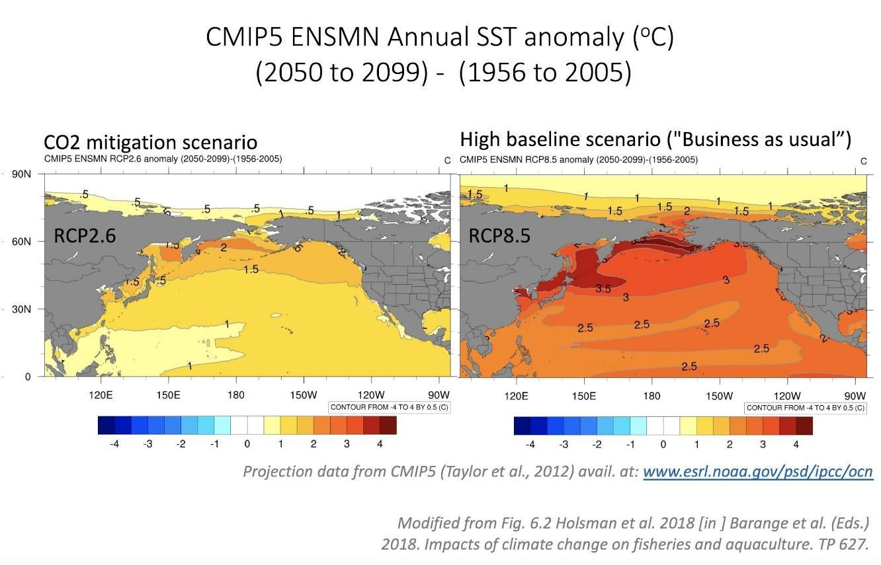

Figure 1. Projected end of century changes in sea surface temperature (SST) anomalies relative to historical SST under global carbon mitigation (left) and unmitigated (right) future scenarios. Based on Coupled Model Intercomparison Project (CMIP) 5 ensemble scenarios.
However, Bering Sea marine systems are driven by ecological processes and climate conditions that are increasingly extreme and difficult to anticipate (e.g., 2016 and 2018 marine heatwaves and associated negative impacts to seabirds, marine mammals, coastal communities and commercially important groundfish fisheries). The frequency and intensity of marine heatwaves and extreme events in the Bering Sea are projected to increase in coming decades, and conditions are expected to shift markedly over the next 20-50 years (Figure 2; Frölicher et al. 2018, Cheung and Frölicher 2020, Laufkötter et al. 2020, Oliver et al. 2018). Specifically, marine heatwaves may become more commonplace and severe, winter and summer water temperatures are anticipated to increase, and the duration and frequency of productive “cold” multi-year stanzas are projected to decline (Oliver et al., 2019, Laufkötter et al. 2020).
Climate change is very likely to continue to cause changes in fish distribution, survival, growth, timing, behavior, catchability and strength of species interactions (Polozinsca et al. 2013, Meredith 2019, Smale et al. 2019). Some of these changes may occur gradually, whereas other species may exhibit sudden threshold-like changes in response to changing climate conditions (i.e., as conditions cross ecological “tipping-points”; Lenton et al. 2019). Recent examples include the rapid redistribution northward from the EBS to the NBS of most of the Pacific cod stock (Stevenson et al. 2019, Spies et al. 2020), multitrophic shifts (i.e., phytoplankton through forage fish) in response to low sea ice in 2016-2017 (Duffy-Anderson et al. 2019), size structure and distribution range contraction of northern Bering Sea snow crab (Fedewa et al. 2020), and synchronous mortality events of seabirds, whales, and sea ice seals across the Northern Bering sea from 2016-2018 (Piatt et al. 2020).
.
Productive future Bering Sea fisheries and harvests will require efficient and sustainable approaches and implementation of cutting edge, “climate-ready” fisheries management tools and policies. Some of these tools exist in the context of Indigenous management and stewardship practices as well as ecosystem-based management tools and should be maintained and evaluated going forward (Gadamus and Raymond-Yakoubian 2015, Raymond-Yakoubian and Daniel 2018, Holsman et al., 2019,; Karp et al., 2019). In addition, long-term and fixed Ecosystem-based fisheries management (EBFM) measures, like the 2 MT cap on groundfish harvest and the minimal biomass threshold for Steller sea lions, may be particularly important as climate change affects the Bering Sea system; recent studies indicate such measures can stabilize fisheries and forestall climate driven collapse (Holsman et al. 2020). Similarly, other EBFM measures like protected areas, minimal biomass thresholds, by-catch limits, are by design intended to provide stability and remain stationary even when conditions are variable and may be vital as conditions become increasingly anomalous (Holsman et al. 2019). Periodic evaluation of such measures may be needed to ensure they continue to support ecosystem productivity as species distributions and phenology shifts give rise to new interactions, altered habitats, and novel management challenges (Holsman et al. 2019, Karp et al. 2019). To improve and ready fisheries management in the face of climate change and uncertainty, a robust portfolio management approach should be developed. CCTF activities are intended to provide clarity and efficiently build available and new information through the Council process into management through the development of climate-related options.

Module Goal [Mike, Kir, Diana]
The BSFEP summarizes the purpose for this “climate project” as “evaluat[ing] the vulnerability of key species and fisheries to climate change, to strengthen resilience in regional fisheries management” (NPFMC 2019, p.45). It states further that the module “is specifically responsive to Process Objective 13, to establish a process for addressing change under novel or intensified stressors, as well as the implementation strategy of the Council’s ecosystem policy vision statement,” and that it is intended to help the Council meet its objectives related to synthesis of and incorporation of climate change information and evaluation and development of climate-resilient management tools.
To help guide its work and ensure that it is meeting the objectives set by the Council, the Task Force crafted the following goal statement based on the direction in the BSFEP:

The goal of the Climate Change Module is to facilitate the Council’s work toward climate-ready fisheries management that helps ensure both short- and long-term resilience for the coupled social-ecological system of the Bering Sea.

The Climate Change Module will provide information, tools, and recommendations that can help the Council further its ecosystem vision statement through equitable climate change adaptation pathways, transparent communication, utilization of diverse knowledge sources, and broad engagement. This module will support the North Pacific Fishery Management Council’s capacity to:
- more effectively incorporate climate change information from diverse knowledge holders into the fishery management process through transparent, effective and dynamic communication and engagement with communities, fishers, managers, scientists and other Council stakeholders with the Council and Council staff; and
- evaluate and implement management measures that can: help preserve livelihoods, economies, health and well-being across fisheries and dependent coastal communities; support near- and long-term adaptation to climate change; and ensure the continued productivity and sustainability of the coupled social-ecological Bering Sea system.
This module addresses the need to incorporate climate change knowledge, science and information about the Bering Sea system (see geographic description in the FEP) throughout the Council process. Current information is focused on annual advice and near-term forecasts while a wealth of information is available to inform longer-term strategic planning for the Bering Sea.

Adaptation and Resilience
The CCTF seeks to provide information recommendations to help the Council advance adaptive management that helps ensure resilient ecosystems, fisheries, and communities.The IPCC definitions for “adaptation” and “resilience” and the CCTF preliminary definitions of each are provided below and included here as starting points for discussion. The CCTF intends to use a co-production of knowledge approach to periodically update and revise the working definitions of adaptation and resilience that underlie this workplan and Action Module work products. The CCTF will maintain evolving documents describing Adaptation and Resilience.
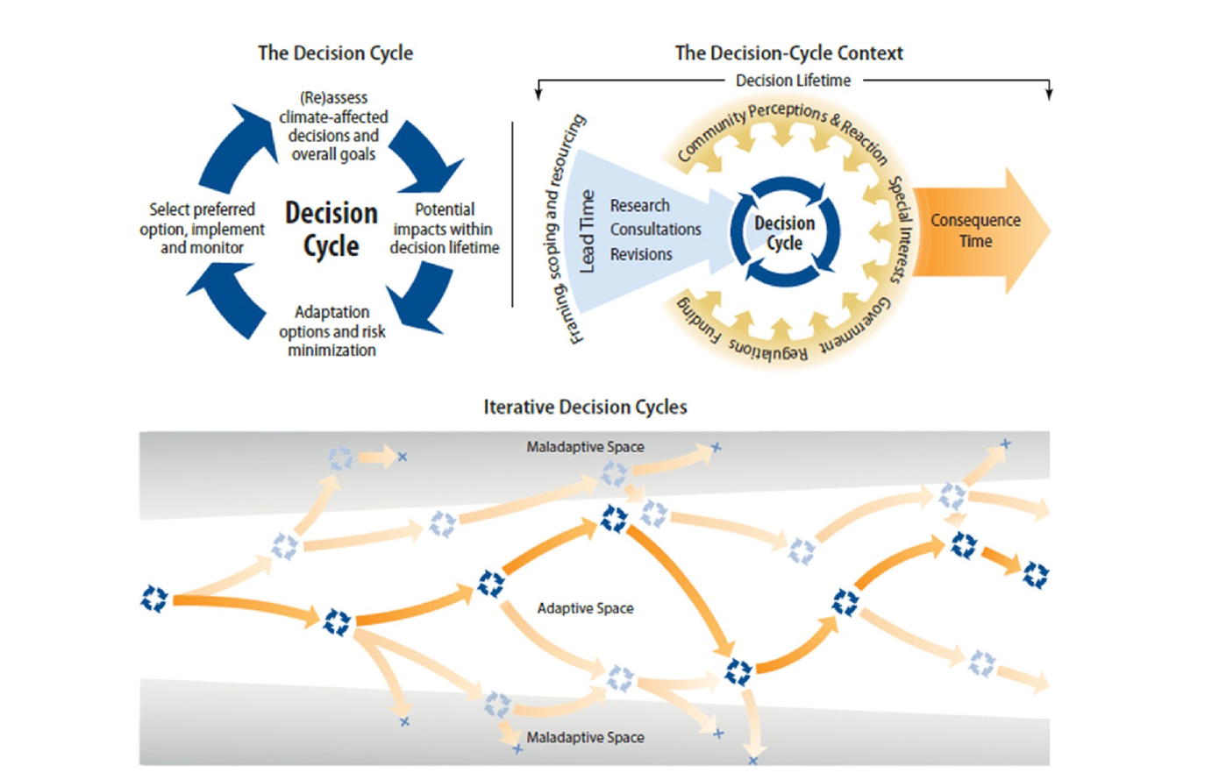

Figure 2. Climate adaptation pathways. From Wise et al. 2014.

Adaptation [Brenden, Lauren, Kir, Diana]
The IPCC defines adaptation as “the process of adjustment to actual or expected climate change and its effects” (IPCC 2014, p. 5). In the context of Bering Sea fisheries, adaptation to support climate resilient social-ecological systems includes ecosystem-based management policies that embrace uncertainty, adjust at a rate that is consistent with observed changes (e.g., allows communities and fisheries to adapt in a proactive rather than a solely reactive manner), are inclusive of diverse knowledge sources and information that may change and evolve over time, and consider both direct and indirect impacts and interactions with other species, sectors, and stakeholders and the environment. Adaptation can include reactive responses as well as proactive, anticipatory planning and prevention. Adaptation is separate from, but can be synergistic with (i.e., have co-benefits for), “carbon mitigation” measures, which are actions at global or regional scales that aim to reduce or recapture atmospheric CO₂. Climate adaptation is a multi-step and iterative process that includes evaluation of key risks and needs, assessment of available potential tools and approaches, understanding of institutional capacity and feasibility for adaptation planning and implementation (and evolving limits and constraints to adaptation), and interactive inclusive discussions regarding realized costs, trade offs, and benefits of adaptation measures (Meredith et al. 2019).
This module will seek to provide the Council with recommendations for pathways to identify and implement management measures that provide for fisheries adaptation to future climate conditions and to ensure that diverse perspectives and knowledge sources are considered when developing these recommendations and when assessing risks, impacts and tradeoffs. The latter relies on understanding and considering biological trajectories of change as well as the social, cultural and economic implications and scope of adaptation in the intricately coupled social-ecological Bering Sea ecosystem. Co-production of knowledge is essential for understanding changes as well as identifying, understanding and promoting pathways of adaptation in both fisheries and fishing communities. Some social and ecological changes could help promote adaptation, but others might intensify negative impacts of climate-driven change. Thus, climate-related advice to managers must include coupled climate-biological-social-economic evaluations in order to inform management actions that effectively address climate-driven impacts, utilize novel opportunities, and identify and promote equitable adaptive pathways. Of particular interest to the Council might be the future performance of existing management approaches and ecosystem-based management measures, such as area-based conservation measures, alternative time-space closures, catch share programs, bycatch reduction incentives, sector/gear specific fishing areas, minimum biomass thresholds that address target and non-target species and upper/lower trophic levels, and aggregate total harvest limits.

Resilience [Lauren, Brenden, Kir, Diana]
As with ‘adaptation’, the CCTF will work collaboratively with stakeholders to develop a working definition of ‘resilience,’ as it is interlinked to adaptation. Climate resilience likely entails understanding resilience in terms of human communities, biological resilience, and coupled social-ecological systems. Human and community resilience has numerous interconnected aspects, including the epistemic (e.g. access to information, rich involvement in scientific-management-policy activities, etc.), the individual (e.g. mental and physical health), and the sociocultural (e.g. social cohesion, self-determination, integration of community with natural resources, thriving intergenerational relationships, community sustainability and vibrancy, food security, economic diversity, adaptability to change, etc.). The biological resilience of marine resources likewise spans a wide array of considerations including genetic diversity, healthy habitats and resources, sustained recruitment, and a balanced trophic structure. Finally, resilience must be considered at the nexus of these two domains, i.e. coupled social-ecological systems. This includes, for example: sustained strong connections between harvest species and humans and communities that rely on them; management that is both capable of being adaptive while generating stability; supportiveness for fishery flexibility; drawing strength from co-management, community engagement, and co-production of knowledge; matching knowledge, management, and policy to challenges of variability and unpredictability; and strong information-based decision making that includes diverse knowledge sources and perspectives.

Action Module Objectives [Joe, Steve, Kir. Diana]
The climate module will provide information, pathways, and tools that can be used by the Council to ensure equitable climate resilience in the region’s fishery management. Specifically, the module will leverage ongoing, proposed, and completed projects at State and Federal government entities (e.g., AFSC, PMEL), academic institutions, non-governmental organizations, Alaska Native Tribes and Organizations, industry, communities and other stakeholders to develop a synthesis report and framework for recommended short-, medium-, and long-term actions, processes and evaluations that could be implemented by the Council. Specifically this module will be used to:
[Joe, Steve, Kir. Diana]
- Operationalize the delivery of climate change information to the Council;
- Perform risk assessment and adaptation assessment;
- Summarize and communicate potential actions

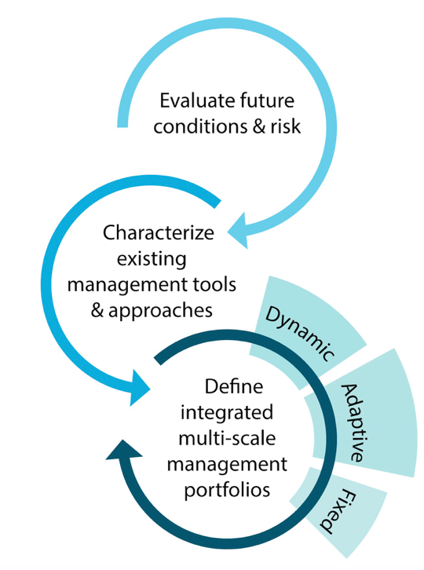

Figure 3. Iterative climate-resilient fisheries management approach. Modified from Holsman et al. 2019.

Approach [ Kirstin, Diana, and all]
Initially, the Task Force will coordinate a draft synthesis of anticipated short to long-term climate change impacts on the Bering Sea ecosystem, including fish, protected species, fisheries, and coastal communities, and an evaluation of and recommendations for management actions. Initial studies suggest that the outcome of potential climate change impacts on fish and fisheries in the Bering Sea largely depends on harvest strategies in the region (Seung et al. 2018, Hollowed et al. 2020, Reum et al. 2020, Holsman et al. 2020, Punt et al. 2016). Climate change creates additional sources of uncertainty in the system that need to be accounted for in trade-off analyses and future policies. Fortunately, completed and ongoing studies continue to advance regional understanding of potential climate change impacts to fish and fisheries.
The taskforce will assemble information from recent ongoing and completed efforts, present synthesized results to the Council and other stakeholders for feedback, and work with the Council and stakeholders to develop a suite of potential climate resilient management tools and policies and a plan for their consideration, implementation, and evaluation. This report and framework will evolve iteratively over (and, ideally, beyond) the course of the Task Force's lifespan to include information and perspectives gathered during and from other Task Force activities and products.
The synthesis prepared by the task force will specify short-(1-3 years), medium-(5-10 years), and long-term (10+ years) management actions that the Council could consider to build climate resilience in regional fisheries and fisheries-dependent communities. It will also identify knowledge gaps, information requirements, and technological needs that should be addressed in order to promote resilience and adaptation to climate-induced changes (Figure 3). Strategic advice could be provided as needed between management cycles and would aim to use long-term management scenario analyses to inform short-term climate-specific decisions during relevant management cycles (e.g., annual groundfish assessment cycle, updates to essential fish habitat designations, updates to marine mammal assessments and species biological opinions). Particular emphasis would be focused on emergent approaches for the purposes of testing and exploring alternative policy options including: in-season management tools, adaptive management experiments (e.g., temperature-dependent shifts in spatial distribution), and fixed management measures (e.g., long-term ecosystem biomass caps, closure areas, and/or minimal biomass threshold reference points).
In this way, the results of this module will help the Council track climate impacts on the Bering Sea ecosystem and ensure that fisheries managers in the region have the right tools to adapt to rapid shifts in species distributions or abundances under future conditions. If implemented, these new tools and pathways should help ensure that fisheries management best complies with the Magnuson-Stevens Act, including the National Standards, Fishery Management Plan objectives, and other statutory obligations, and that the Council has a more complete understanding of impacts to communities as conditions change.
Short-term “climate-ready” management actions can be developed and implemented relatively quickly (e.g. 1-3 year time frame), thus management strategy evaluations would be focused on testing their performance under a wide range of potential future climate conditions. In contrast, modification of medium- and long-term management measures require more specific characterizations of risks and uncertainty around future trajectories (i.e., long-term change as well as the frequency, intensity and recovery from extreme events) mandating thorough interdisciplinary scientific evaluation as well as consistent and regular stakeholder and Council review and feedback. Thus, evaluations should be initiated early, should use a co-production approach to the extent possible,on and should continue as performance under various policies options are fully evaluated

Objectives and Associated Activities [Joe, Steve, Lauren, Mike, Brenden (deliverables) Kir, Diana]

Objective 1: Operationalize the delivery of climate change information to the Council.

CCTF Activity 1.1. Synthesize diverse sources of current knowledge regarding climate change effects on the Bering Sea ecosystem, including longer-term projections and forecasting.
In addition to scientific literature, the CCTF will also elicit input from a diverse group of Bering Sea resource users. The CCTF will host two Adaptation and Climate Testimonial Workshops and encourage interested participants to submit a Climate Briefing in which they will be asked to highlight crucial information and perspectives that the NPFMC should know regarding climate change, the marine environment, and implications for fisheries management. This synthesis derived from Activity 1.1 will be designed to support adaptation through ecosystem-based fisheries management, including evaluations of risks and tradeoffs among alternative policies.

CCTF Activity 1.2. Coordinate researchers and knowledge holders to synthesize and communicate policy relevant information resulting from a diversity of ongoing and completed climate change projects, partnerships, experiences, knowledge, and research (Fig. x)

CCTF Activity 1.3. Evaluate the scope of impacts on focal species and communities identified in step (2) with participation from Indigenous, Traditional and Local Knowledge holders, researchers, and other regional and topical experts.

CCTF Activity 1.4. Aid decision-making that may range from simple conceptual models to complex tools that integrate the most recent Intergovernmental Panel on Climate Change projections of carbon mitigation scenarios that …

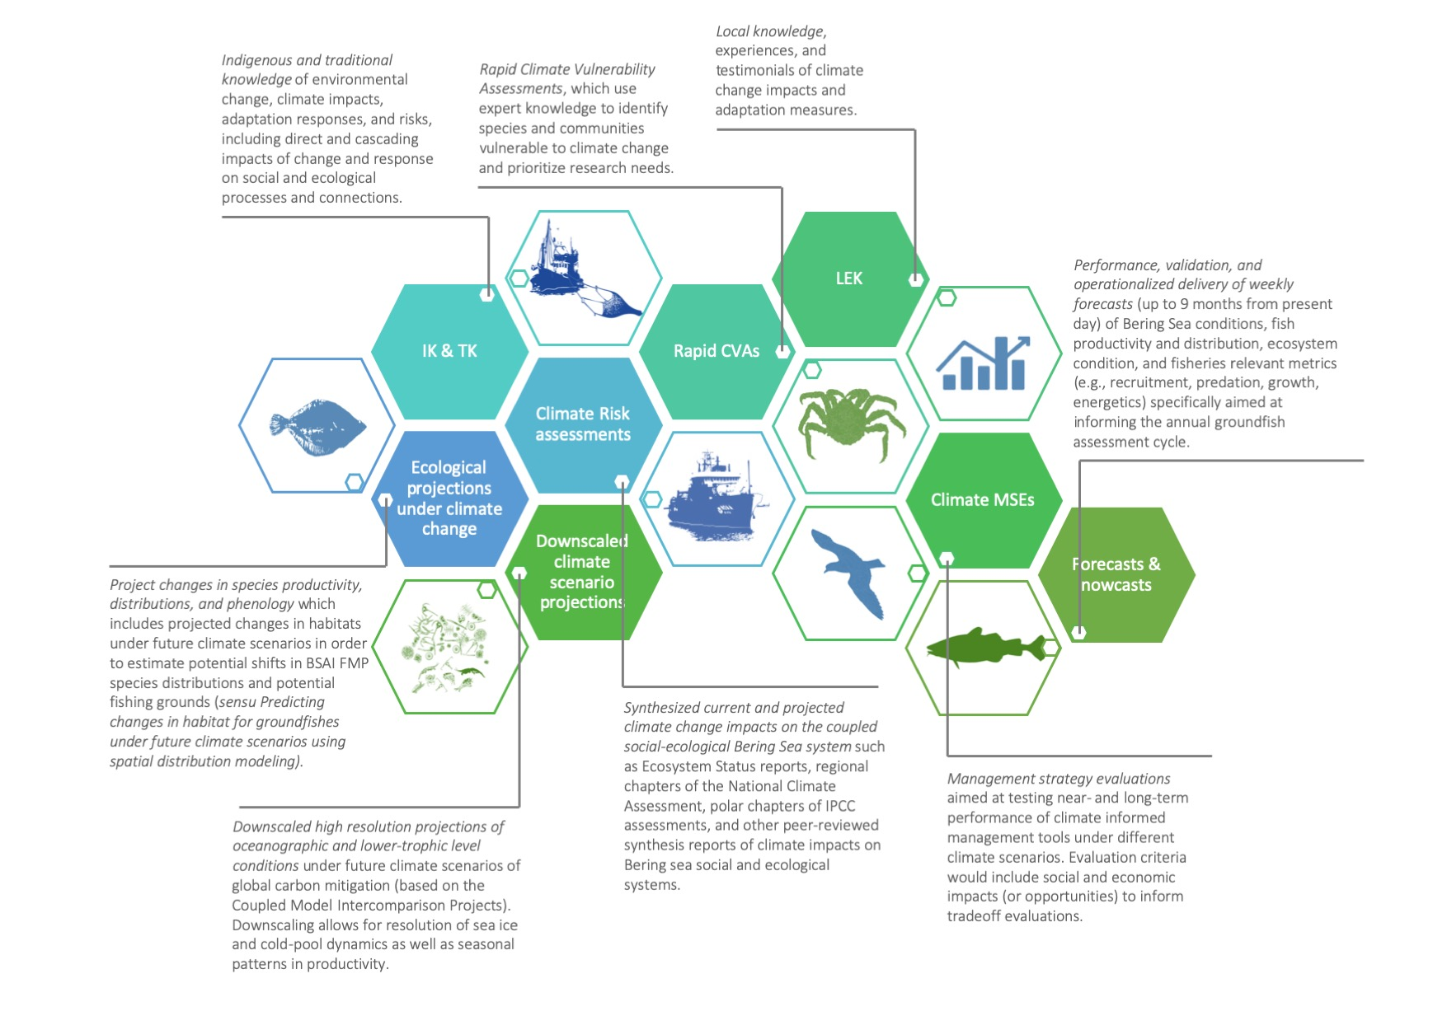
Figure X. Example of potential sources of information to be synthesized by the CCTF.
[Delete: LINK to Fig]

Objective 2: Risk assessment and adaptation assessment

CCTF Activity 2.1 Identify the key hazards, impacts and risks for the ecosystem.
In doing so, the CCTF can help summarize impacts, gaps in understanding or response, and identify barriers to adaptation.

CCTF Activity 2.2. Identify the potential list of climate planning and mitigation tools for adaptation and assess and synthesize the relative efficacy across a range of potential climate scenarios.
This may be done through synthesis of information, targeted workshops in coordination with the Ecosystem committee, and regular climate impacts and adaptation summary Council reports.

Objective 3: Summarize and communicate potential actions

CCTF Activity 3.1. Recommend pathways for inclusion of Climate Change Task Force Synthesis into Council and agency decision-making processes.

CCTF Activity 3.2. Provide recommendations for short-, medium-, and long-term actions that could be considered and initiated through the Council process.
The CCTF will work with the, FEP Team (and/or Council committees, Plan Teams, working groups, and other module task forces) to iteratively (annual basis) identify potential short-term, medium and long-term management actions for climate adaptation (i.e., derive alternative strategies for MSEs). Based on information from Activities 1 and 2, provide a summary of recommended short-, medium-, and long-term actions for the Council to consider. Examples are provided in Table 1.
CCTF Activity 3.3. [Help identify tradeoff considerations for discussion
CCTF Activity 3.4. ID management scenarios and research priorities for future research/ analyses]
Table 1. Potential adaptation and responses toolbox [ Link to doc with text] [Joe, Steve, Diana, Kir]
WORKING TABLE AVAILABLE HERE: TABLE1 LINK

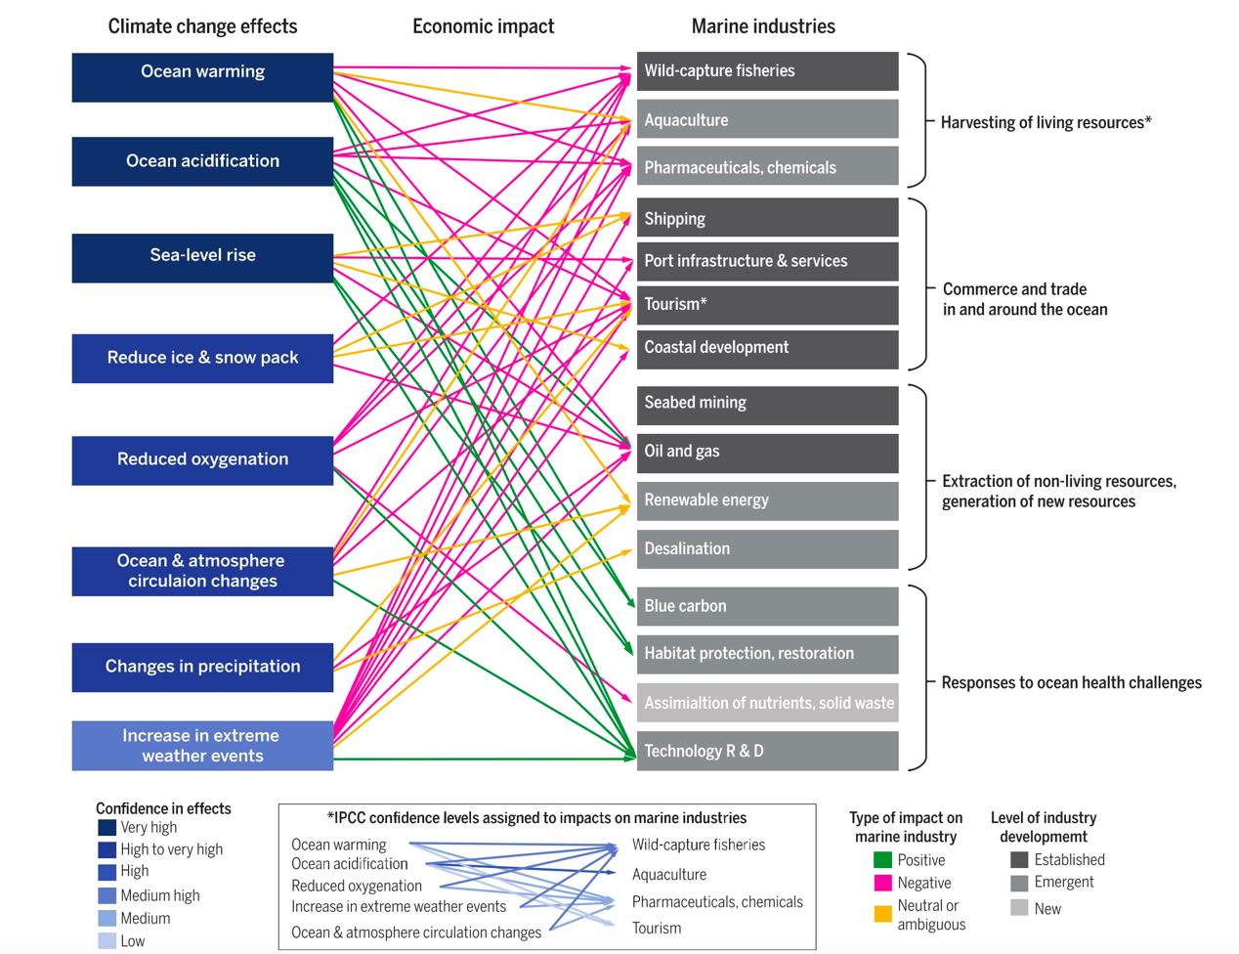

Figure 4. Climate change impacts on marine systems. From Alisson and Bassett 2015.

How Action Module will interface with existing work [Scott, Jeremy, Kir, Diana ]
We aim to complement existing delivery of ecosystem-based management to the Council process by organizing and synthesizing the breadth of climate information, a subset of which is currently communicated through various channels to the Council (Fig. 5). This module will also standardize the method of communicating actionable climate information to the Council. This includes 1) systematic review of new and emergent climate change information, both immediate and long-term in scope (most long-term information is currently not included in ESRs and other reports), 2) synthesis and evaluation of key issues, emergent trends, and potential red flags relevant to the Council, 3) coordination and iterative review with the LK TK Subsistence Taskforce and FEP Team to support the diversity plurality of perspectives and knowledge sources needed for evaluations of risk, and tradeoffs, and the variety of sources of climate information, and 4) identification of climate-resilient management actions to enable adaptation to climate-driven change (this particular point would be in the form of recommendations that can be considered by the Council through the Council process). A proposed approach is outlined in Figure 5 below. As much as possible we will work with existing teams and products (such as the Ecosystem Status Report teams) to minimize the amount of reporting and review and avoid duplication of existing efforts.

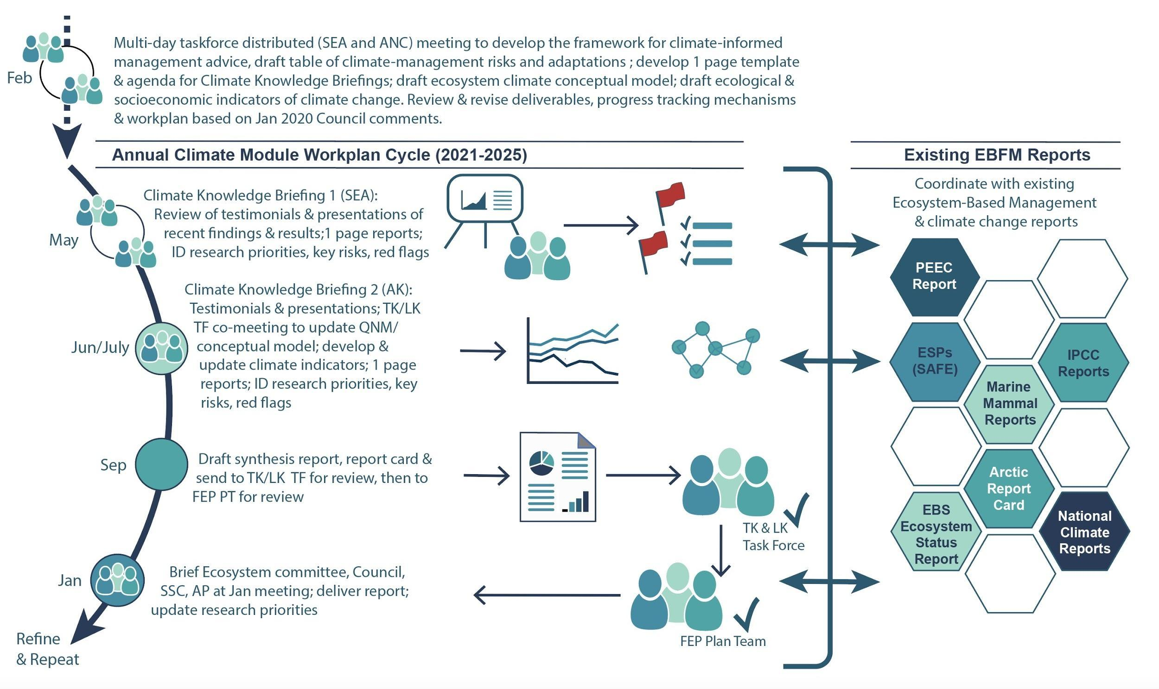

Figure 5. Climate Change Task Force process for synthesis and delivery of information to the Council to support climate-informed management in the Bering Sea.
We propose the following annual cycle to summarize and deliver actionable climate-information and advice relevant to fisheries management in the EBS. First, there will be two “Climate Knowledge Briefings”, that will include Indigenous, Traditional, and Local Knowledge regarding climate change from communities in Alaska as well as academic and agency research findings regarding climate change and fisheries. Speakers will be asked to provide information according to a template (link to appendix with form) in order to standardize information for the EBS Climate Change and Fisheries Report. This will aid in synthesis and summary of findings, which will be included as a short report card and executive summary (similar in structure to the Ecosystem Status Report but with a strategic rather than tactical goal to differentiate from the purpose of the ESR in informing the specifications process). In addition, and with input and coordination with the LK/TK/Subsistence Taskforce, the CCTF will consider best practices related to analyzing LK, TK, and subsistence information; emergent issues; red flags; research priorities and knowledge gaps; and key risks. If warranted, the CCTF may also make recommendations for management or action that could be considered by the Council through the Council process. The Alaska Integrated Ecosystem Assessment program, the Bering Sea Regional Action Plan teams, and multiple ongoing projects at AFSC and various academic and independent research efforts are already providing the logistical and analytical support to meet objectives 1 and 2 of the module, as well as providing the modeling platforms for objective 3. Under the Regional Action Plan, climate assessment teams from the IEA (Integrated Ecosystem Assessments), the ACLIM( Alaska Climate Integrated Modeling project), and the related habitat projection project (third bullet above) are working closely together with each other and with Pacific Marine Environment Lab researchers to expand the suite of downscaled climate projections coupled to climate-enhanced bioeconomic assessment, ecosystem and fish habitat models, as well as MSE sub-modules for some of the ecosystem and assessment models. Thus the expert teams, analytical capacity, and climate scenarios are already available for some priority species. The rapid climate assessment conducted during 2016 provides a framework for quickly and efficiently identifying additional species that may be impacted (cite). Similarly, the other projects maintain the operational readiness of AFSC to evaluate climate impacts on Bering Sea species and additional ecosystem models or species additions to existing models could be readily implemented for future evaluations.
Interdisciplinary teams like those already assembled for ongoing projects will be needed to conduct the full 3-5 year MSE evaluations, but personnel needs will depend greatly on the number and complexity of MSE scenarios and the number of new species evaluations.

Deliverables and Progress Tracking [ Brenden, Joe, Steve, Diana, Kir, ]
Taskforce deliverables are listed below and discussed in relationship to the Objectives and/or Activities from which they will be developed. Progress towards meeting the Taskforce’s goals is also noted.
Climate change task force annual process:
- On ramp 1: red flags for ESP indicators →CE stock assessments
- On ramp 2: ESR summary (annual) → strategic context
- On ramp 3: Synthesis report (bi-annual, part of the FEP) “State of the climate” report

CCTF deliverables:
- Adaptation Briefing Note (collaboratively and iteratively developed with stakeholders)
- Resilience Briefing Note (collaboratively and iteratively developed with stakeholders)
- Climate Briefing Form and Process (used for Adaptation and Climate Testimonial workshops)
- Table of climate change drivers, impacts, potential policy/management responses, targets, and gaps/needs
- Adaptation and Climate Testimonial workshop summaries

The CCTF will produce the following deliverables:

- Synthesis Report and Framework
  - This Synthesis product will contain the following information:
    - Model for operationalizing climate information in Council processes (including synthesis of diverse knowledge about climate change effects, evaluation of the scope of impacts from such change, suggestions about tools to aid in decision-making, and on-ramps for climate information into the Council process) (Objective 1 and associated Activities)
    - Risk and Adaptation Assessments (Objective 2 and associated Activities)
    - Recommendations for short-, medium-, and long-term actions that could be considered and initiated through the Council process (Objective 3 and associated Activities)
  - Embedded within this, a multi-faceted Framework will be developed which:
    - Describes ways in which climate information can be on-ramped and operationalized within the Council process (especially in association with Objective 1 and its associated Activities, as well as through coordination with LK/TK/Subsistence Taskforce)
    - Examines a range of Bering Sea management actions and identify risks and potential for success across a range of climate scenarios (e.g. periodic review of existing and alternative management strategies/policies)
    - Inclusive of the above-noted items, also provides an annual process to:
      - Review climate change tactical and strategic considerations for the coming year. Any tactical considerations should be provided to the Ecosystem Status Report team while strategic considerations will be summarized in the Bering Sea Ecosystem Health and Climate report (in conjunction with the BS FEP team)
      - Table of potential short-, medium-, and long-term adaptive measures and new climate tools
      - Table of climate risks/unknowns, data and information needs
      - Conceptual model of climate-social-ecological linkages (including direct and indirect connections)
      - Recommendations for potential management action(s) to be considered in the Council process
- Associated Products. These key products will be included by reference or appended to the above-noted Synthesis Report and Framework, and will be developed iteratively throughout the CCTF’s work:
  - Adaptation Briefing Note (collaboratively and iteratively developed with stakeholders)
  - Resilience Briefing Note (collaboratively and iteratively developed with stakeholders)
  - Climate Briefing Form and Process (used for Adaptation and Climate Testimonial workshops)
  - Table of climate change drivers, impacts, potential policy/management responses, targets, and gaps/needs
  - Adaptation and Climate Testimonial workshop summaries
- Coordination with LK/TK/Subsistence Taskforce and the BS FEP Core Team to communicate issues/topics of joint relevance, minimize duplicative efforts/products, and coordinate related to pertinent Activities noted above to follow best practices (e.g. regarding use of LK/TK/Subsistence information).
- Periodic updates with SSC, Plan Teams, and Ecosystem Committee to provide interim synthetic climate information of value to ongoing work by those bodies e.g. assisting in the period update of recommendations for the Council’s climate-specific research priorities.

Milestones[ Diana, Kir]
Completed tasks in italics
May 2019 FEP Plan Team meets to discuss draft workplan
June 2019 Council approves draft workplan
June-August 2019 Formation of Climate Change Action Module Taskforce (CCTF)
January 2020 CCTF initial Webex meeting, draft workplan revisions; Report progress to Ecosystem Committee/SSC/Council
Feb 26-28, 2020 (tent) ~3 day meeting ANC/SEA dual locations/web coordinated: Taskforce meeting to develop framework, begin to draft list of short-, medium-, and long-term projects and scenarios to explore; draft table of climate- management risks and adaptations by species or focal components; develop one-page template and tasking for climate knowledge briefing reports; agenda for proposed Climate Knowledge Briefing 1 meeting in May and Climate Knowledge Briefing 2 workshop with LK TK Subsistence Taskforce; draft ecosystem climate conceptual model; draft ecological and socioeconomic indicators of climate change;review and revise deliverables and progress tracking mechanisms; revise workplan based on Jan 2020 Council comments
March 2020 Report progress to FEP Plan Team ( meets Mar 3-5, 2020) team including performance metrics
March/April 2020 Report progress to Ecosystem Committee/SSC/Council
________________________
May 18 & 19, 2021 (tent) Climate Knowledge Briefing 1: meeting in SEA (possible dual locations web coordinated TBD) in coordination with PEEC meeting (May 19-20). Highlight red flags, upcoming issues, new tools and products, emergent management actions/ recommendations; outline report and assign writing tasks and deadlines for contributions to the Climate Synthesis report [potentially add Climate section to PEEC report].
Summer 2021 TBD Climate Knowledge Briefing 2: workshop with LK TK Subsistence Taskforce (ideally in a Bering Sea community). Derive communication and engagement plan in conjunction with LK TK Subs. TF; Additional issues TBD
June-September 2021 Continued development and update of climate indicators; draft Climate Synthesis report and climate report card
June 2022 Continue drafting Climate Synthesis report; 2 hr telecon check-in June [date TBD]
June- July 2022 LK TK Subs. TF and FEP Plan Team review of draft Climate Synthesis report
September 2022 Present Final Climate Synthesis report to FEP Plan Team
December 2021 Report progress to Ecosystem Committee/SSC/Council potentially in conjunction with ESR
April 2022 Case study/red flags presentations to Council; progress report on updated tools and adaptation measures
2022-2026 Repeat and refine May 2021 - April 2022 work products

Requests for Council feedback
- What is the best method for delivery of a Climate Synthesis report? Part of ESR, along with ESR but separate?
- Endorse or amend the CCTF direction; are we on the right track?
- “Research priorities” and “Management recommendations” language and intent?

References
Allison, E and HR Bassett. (2015). Climate change in the oceans: Human impacts and responses, Science 350 (6262), 778-782.
Cheung, W. W. L., and T. L. Frölicher. 2020. Marine heatwaves exacerbate climate change impacts for fisheries in the northeast Pacific. Scientific Reports 10:1–10.
Duffy‐Anderson, J. T., P. Stabeno, A. G. Andrews, K. Cieciel, A. Deary, E. Farley, C. Fugate, C. Harpold, R. Heintz, D. Kimmel, K. Kuletz, J. Lamb, M. Paquin, S. Porter, L. Rogers, A. Spear, and E. Yasumiishi. 2019. Responses of the Northern Bering Sea and Southeastern Bering Sea Pelagic Ecosystems Following Record‐Breaking Low Winter Sea Ice. Geophysical Research Letters 46:9833–9842.
Dumas, 1984. Prehistory of the Bering Sea Region. In: Damas (Editor), Handbook of North American Indians. Smithsonian Institute, Washington DC, pp. 94-105.
Fall et al. 2013. Continuity and change in subsistence harvests in five Bering Sea communities: Akutan, Emmonak, Savoonga, St. Paul and Togiak. Deep-Sea Research Part II, 94: 274-291.
Frölicher, T. L., E. M. Fischer, and N. Gruber. 2018. Marine heatwaves under global warming. Nature 560:360–364.
Gadamus, L. and J. Raymond-Yakoubian. 2015. A Bering Strait Indigenous Framework for Resource Management: Respectful Seal and Walrus Hunting. In Arctic Anthropology 52(2): 87-101.
Haynie and Huntington 2016. Strong connections, loose coupling: the influence of the Bering Sea ecosystem on commercial fisheries and subsistence harvests in Alaska. Ecology and Society, 21(4).
Holsman, K. K., A. C. Haynie, A. B. Hollowed, J. C. P. Reum, K. Aydin, A. J. Hermann, W. Cheng, A. Faig, J. N. Ianelli, K. A. Kearney, and A. E. Punt. 2020. Ecosystem-based fisheries management forestalls climate-driven collapse. Nature Communications 11.
Holsman, K. K., E. L. Hazen, A. Haynie, S. Gourguet, A. Hollowed, S. J. Bograd, J. F. Samhouri, and K. Aydin. 2019. Towards climate resiliency in fisheries management. ICES Journal of Marine Science.
Karp, M. A., J. O. Peterson, P. D. Lynch, R. B. Griffis, C. F. Adams, W. S. Arnold, L. A. K. Barnett, Y. DeReynier, J. DiCosimo, K. H. Fenske, S. K. Gaichas, A. Hollowed, K. Holsman, M. Karnauskas, D. Kobayashi, A. Leising, J. P. Manderson, M. McClure, W. E. Morrison, E. Schnettler, A. Thompson, J. T. Thorson, J. F. Walter, A. J. Yau, R. D. Methot, and J. S. Link. 2019. Accounting for shifting distributions and changing productivity in the development of scientific advice for fishery management. ICES Journal of Marine Science 76:1305–1315. https://doi.org/10.1093/icesjms/fsz048
Laufkötter, C., J. Zscheischler, and T. L. Frölicher. 2020. High-impact marine heatwaves attributable to human-induced global warming. Science (New York, N.Y.) 369:1621–1625.
Lenton, T. M., J. Rockström, O. Gaffney, S. Rahmstorf, K. Richardson, W. Steffen, and H. J. Schellnhuber. 2019. Climate tipping points — too risky to bet against. Nature 575:592–595.
Meredith et al. 2019. Polar Regions. In: Portner, Roberts, Masson-Delmotte, Zhai, Tignor, Poloczanska, Mintenbeck, Nicolai, Okem, Petzold, Rama and Weyer (Editors), IPCC Special Report on the Ocean and Cryosphere in a Changing Climate.
North Pacific Fishery Management Council (NPFMC), 2019. Bering Sea Fishery Ecosystem Plan.
Oliver, E. C. J., M. G. Donat, M. T. Burrows, P. J. Moore, D. A. Smale, L. V. Alexander, J. A. Benthuysen, M. Feng, A. Sen Gupta, A. J. Hobday, N. J. Holbrook, S. E. Perkins-Kirkpatrick, H. A. Scannell, S. C. Straub, and T. Wernberg. 2018. Longer and more frequent marine heatwaves over the past century. Nature Communications 9:1–12.
Piatt, J. F., J. K. Parrish, H. M. Renner, S. K. Schoen, T. T. Jones, M. L. Arimitsu, K. J. Kuletz, B. Bodenstein, M. García-Reyes, R. S. Duerr, R. M. Corcoran, R. S. A. Kaler, G. J. McChesney, R. T. Golightly, H. A. Coletti, R. M. Suryan, H. K. Burgess, J. Lindsey, K. Lindquist, P. M. Warzybok, J. Jahncke, J. Roletto, and W. J. Sydeman. 2020. Extreme mortality and reproductive failure of common murres resulting from the northeast Pacific marine heatwave of 2014-2016. PLOS ONE 15:doi: 10.1371/journal.pone.0226087.
Poloczanska, E. S., C. J. Brown, W. J. Sydeman, W. Kiessling, D. S. Schoeman, P. J. Moore, K. Brander, J. F. Bruno, L. B. Buckley, M. T. Burrows, C. M. Duarte, B. S. Halpern, J. Holding, C. V Kappel, M. I. O’Connor, J. M. Pandolfi, C. Parmesan, F. Schwing, S. A. Thompson, and A. J. Richardson. 2013. Global imprint of climate change on marine life. Nature Climate Change 3:919–925.
Raymond-Yakoubian, et al. 2017. The incorporation of traditional knowledge into Alaska federal fisheries management. Marine Policy, 78: 132-142.
Raymond-Yakoubian, J. and R. Daniel. 2018. An Indigenous approach to ocean planning and policy in the Bering Strait region of Alaska. In Marine Policy 97: 101-108. https://doi.org/10.1016/j.marpol.2018.08.028
Sigler, M, Hollowed, A, Holsman, KK,+9 (2016). Alaska Regional Action Plan for Southeastern Bering Sea Climate Science. NOAA Technical Memo NMFS-AFSC-336 doi:10.7289/V5/TM-AFSC-336.
Smale, D. A., T. Wernberg, E. C. J. Oliver, M. Thomsen, B. P. Harvey, S. C. Straub, M. T. Burrows, L. V. Alexander, J. A. Benthuysen, M. G. Donat, M. Feng, A. J. Hobday, N. J. Holbrook, S. E. Perkins-Kirkpatrick, H. A. Scannell, A. Sen Gupta, B. L. Payne, and P. J. Moore. 2019. Marine heatwaves threaten global biodiversity and the provision of ecosystem services. Nature Climate Change 9:306–312.
Spies, I., K. M. Gruenthal, D. P. Drinan, A. B. Hollowed, D. E. Stevenson, C. M. Tarpey, and L. Hauser. 2020. Genetic evidence of a northward range expansion in the eastern Bering Sea stock of Pacific cod. Evolutionary Applications 13:362–375.
Stevenson, D. E., and R. R. Lauth. 2019. Bottom trawl surveys in the northern Bering Sea indicate recent shifts in the distribution of marine species. Polar Biology 42:407–421.
Wise et al. 2014. Reconceptualising adaptation to climate change as part of pathways of change and response. Global Environmental Change 28: 325–336.

Appendix 1. Action Module Scoping Summary from Core BS FEP
1. Synopsis  including how it will be accomplished | The goal of this climate project is to evaluate the vulnerability of key species, fisheries and communities to climate change and to strengthen resilience in regional fisheries management. Methods will leverage ongoing projects at AFSC and partner organizations. The Action Module will address the following objectives: (1) coordinate to synthesize results of various ongoing and completed climate change research projects; (2) evaluate the scope of impacts on priority species identified in initial studies; and (3) strategically reevaluate management strategies every ~5 years; (4) include synthesis to evaluate climate-resilient management tools. The climate change Action Module taskforce will work with the Council to iteratively identify and assess the performance of potential short-term, medium and long-term management actions for climate adaptation (i.e., derive alternative strategies for MSEs).
2. Purpose  relationship to the BS FEP’s strategic objectives | This Action Module is specifically responsive to Process Objective 13, to establish a process for addressing change under novel or intensified stressors, as well as the implementation strategy of the Council’s ecosystem policy vision statement. While the Action Module leverages ongoing AFSC research projects on climate change, including it in the BS FEP provides a direct link for the Council to be involved in prioritizing Action Module research that addresses questions most relevant to Council fishery management. This is in keeping with the BS FEP’s purpose to facilitate dialogue between managers, co-managers, scientists, and diverse stakeholders. This Action Module will provide a five to seven-year climate context within which to interpret and respond to annual signals and will establish a more formal process for considering those variables. This is responsive to the BS FEP purpose to build resiliency into the Council’s management strategies, and to enhance the capacity for adaptive EBFM approaches in the context of shifting climate conditions.
3. How it will inform the Council process | Climate-ready fisheries management will help continue the legacy of sustainable fisheries management in the region, including management to promote a productive marine ecosystem and healthy vibrant marine fisheries. Results will inform short, medium, and long-term “climate ready” tactical and strategic management measures.
4. How it will be integrated in the Council process | Short-term “climate-ready” management actions can be developed and implemented relatively quickly, thus climate change management strategy evaluations would be focused on testing their performance under the full scope of potential future conditions. In contrast, modification of medium- and long-term management measures require more specific characterization of risk and uncertainty around future trajectories, with thorough scientific evaluation as well as stakeholder and Council review and feedback. This information can provide a frame of reference for setting harvest recommendations and implementing other management actions. Alternatively, climate-specific biomass reference limits (e.g., temperature-specific F_{ABC}) are derived using projections of environmentally enhanced single- or multi-species assessment models and can be used to set harvest rates that account for future climate variability. If management strategy evaluations as part of objective (3) determine the performance of these reference points is acceptable or preferable, they could be used to set harvest recommendations (or alternatively, could be presented along with status-quo assessment values) and to inform conservation measures.
5. Estimate of time and staff resources | Multiple ongoing projects at AFSC are already providing the logistical and analytical support to meet the first two parts of the Action Module, as well as provide the modeling platforms for part 3. Interdisciplinary teams like those already assembled for ongoing projects will be needed to conduct the full 5- to 7-year MSE evaluations, but personnel needs will depend greatly on the number and complexity of MSE scenarios and the number of new species evaluations.
6. Plan for public involvement | For this Action Module, the Council may solicit public input, to identify priorities for MSE evaluations. The climate change module taskforce would ideally include broad expertise across diverse knowledge holders (e.g., traditional knowledge holders). Stakeholders will also be involved through the Council process and iterative dialogue with module taskforce members.

Appendix 2: Membership of Climate Change Taskforce
Lauren Divine (Aleut Community of Saint Paul Island)
Scott Goodman (Natural Resources Consultants/Bering Sea Fisheries Research Foundation) Kirstin Holsman co-Chair (AFSC-Seattle)
Joe Krieger (NMFS-Regional Office)
Mike LeVine (Ocean Conservancy)
Steve Martell (SeaState)
Brenden Raymond-Yakoubian (Sandhill.Culture.Craft)
Jeremy Sterling (AFSC Marine Mammal Lab)
Diana Stram co-Chair (NPFMC)

Appendix 3: Case study criteria [ all; Wed to discuss]
- Case studies to test the process / give a starting point with a specific issue and management implications
- Criteria
  - Something near-term and tangible
    - but also don’t avoid complex ones too [ scott] maybe have a mix
  - Can be tested with the process in next 1-3 years
  - High priority/meaningful
  - Tangible examples that demonstrate how our process promotes resilience and adaptation
  - Can be historical, hypothetical or emergent
  - Could be scenario planning oriented around contrasting projections (Steve’s suggestion)
- E.g.,
  - Future scenario planning (sensu CMIP6 projections for the EBS) - Steve’s
    - How could have scenario planning helped with:
      - Norton Sound red king crab
      - Pacific cod/NBS
      - Dynamic management / now casts to reduce bycatch risk using temp & cooperative data collection
      - Incidental catch and bycatch issues: Herring squid
      - Pandemic impacts as a case study for climate change
      - Sablefish

diana.stram@noaa.gov, North Pacific Fishery Management Council, Anchorage, AK, USA
kirstin.holsman@noaa.gov, Alaska Fisheries Science Center, National Oceanic and Atmospheric Administration, Seattle, WA, USA
Aleut Community of Saint Paul Island
Natural Resources Consultants/Bering Sea Fisheries Research Foundation
NMFS-Regional Office
Ocean Conservancy
SeaState
Sandhill.Culture.Craft
AFSC Marine Mammal Lab

