Research Priorities – Reference Material and Plan Team Reports
Summary Report
Reference material describing the research priorities process, description of categories, public input, and the most recent research priority recommendations is linked below:

- Research Priorities webpage
- Flowchart illustrating 2023-2024 process
- July-Oct 2023 input from public eAgenda
- Comprehensive list of new submissions
- Description of categories and definitions
- 2021 Research Priorities
- NPFMC Research Priorities Database (note this has not been updated since 2021)

From 1-November through 17-January, the Plan Teams and the SSC Subgroup met to discuss new and existing research priorities and to receive public testimony on prioritization of those priorities. Three lists were compiled for each group: the top 5, a supplementary list of no more than 10, and critical ongoing monitoring research priorities. Additional details, descriptions, and rationale from each Plan Team can be found in the Plan Team reports on the SSC’s February 2024 eAgenda, or through the links provided below:
- Joint Groundfish Plan Team report, eAgenda
- BSAI Crab Plan Team report, eAgenda
- Scallop Plan Team report, eAgenda
- Bering Sea Fishery Ecosystem Plan Team report, eAgenda
- Social Science Planning Team report, eAgenda
- SSC Subgroup report, eAgenda
An alpha-numeric identification system was utilized for new and Plan Team member submissions to allow easy reference to the origin of a new research priority: New public submissions are N followed by numerals (ex. N001) and Plan Team member submissions are identified by the Plan Team acronym + numerals (ex. CPT001, ScPT001, GPT001). Identification numbers for existing priorities are only in numerical format (unchanged from the database).

Plan Team Top 5 Research Priorities
Below is a collated list of all Plan Team’s Research Priorities. These are ordered by rank assigned by each Plan Team. Please note that the Bering Sea FEP (BSFEP) team indicated each of their top 5 research priorities to have equal weight and have been assigned a rank of “NA” for this collated list.
Research ID | Title | Rank | Plan Team
148 | Spatial distribution, habitat requirements, and movement of crabs relative to life history events and fishing. | 1 | CPT
171 | Acquire basic life history information (e.g., natural mortality, growth, size at maturity) for data-poor stocks | 1 | ScPT
230 | Examine social and economic interactions between coastal communities and commercial and recreational fisheries. | 1 | SSPT
733 | Climate change: Develop predictive tools to inform management options related to resilience and adaptation. | 1 | SSCSub
N037d | Traditional Knowledge: There are numerous ways Traditional Knowledge will strengthen all Research Priorities, including offering new frameworks for analysis; fostering relationships between Indigenous and Western scientific researchers and communities; and filling gaps in existing ecological and social scientific research. | 1 | SSPT
GPT015 | Develop stock-specific indicators and evaluate incorporation of nonstationarity and climate change impacts for informing the stock assessment process. | 1 | GPT
166 | Estimate scallop stock abundance | 2 | ScPT
CPT004 | Evaluate fishing gear impacts on crab, benthic communities, and essential fish habitat. | 2 | CPT
GPT002 | Maturity studies | 2 | GPT
SSCSub001 | Further research on monitoring, understanding, and reducing western Alaska salmon bycatch in Bering Sea groundfish fisheries. (Combines N024, N029, N031, N034, N035c) | 2 | SSCSub
SSPT003 | Document and assess Tribal citizen and Tribal Nation reliance on, participation in, and impacts of federally managed fisheries (historically and throughout time) | 2 | SSPT
165 | Suggested title change to: 'Conduct routine surveys of subsistence uses of resources in communities across the Bering Sea, northern Bering Sea and Arctic Ocean' | 3 | SSPT
553 | Population structure of scallops | 3 | ScPT
731 | Norton Sound Red King Crab case study | 3 | SSPT
CPT003 | Improved maturity estimation and reproductive potential characterization for crab. Combines CPT002, N008, 592. | 3 | CPT
GPT016 | Develop Operating models to evaluate management strategies under varying climate, ecological, and economic conditions and evaluate impacts to managed resources and coastal communities. | 3 | GPT
SSCSub002 | Quantifying the magnitude of benthic habitat disturbance due to contact with fishing gear and their associated impacts on benthic species in Bering Sea (Combines N025, N028, N030, N033, N039d) | 3 | SSCSub
146 | Improve surveys in untrawlable habitat, particularly for rockfish, Atka mackerel, and sculpins | 4 | GPT
203 | Improve discard mortality rate estimates for scallops | 4 | ScPT
715 | Physiological responses of crab to climate stressors. | 4 | CPT
N035a | Emphasize the ongoing urgency of priority #189 from the 2021 review: “Develop stock-specific ecosystem indicators and incorporate into stock assessments.” This work should include precautionary responses to climate change factors. | 4 | SSCSub
N027 | Retrospective and meta- analysis regarding whether, how, when and why objectives and goals of fishery management plans are or are not achieved over time. In light of the PEIS discussion, a fruitful first focus would be the existing BSAI groundfish FMP. | 5 | SSCSub
CPT001 | Early life history population bottlenecks. | 5 | CPT
GPT008 | Incorporate economics into decisions | 5 | GPT
ScPT002 | Develop population dynamic models for scallop assessment | 5 | ScPT
BSFEP006 | Biological and fisheries research on commercially important crab stocks | NA | BSFEP
BSFEP007 | Characterize expected changes in benthic production due to climate change, including collecting time-series data and understanding the impact of fisheries. | NA | BSFEP
BSFEP008 | Develop projection models and predictive tools to evaluate down-scaled climate variability scenarios and inform management options related to resilience and adaptation, and their effects on managed resources and coastal communities. | NA | BSFEP
BSFEP009 | Evaluate the role of fisheries in the Bering Sea in providing economic opportunities and food security in coastal communities. | NA | BSFEP
BSFEP010 | Research into actionable ecosystem indicators relevant to management strategy evaluations, stock assessments, and ecosystem assessments. | NA | BSFEP

Critical Ongoing Monitoring
Research Priorities that were identified by more than one Plan Team as Critical Ongoing Monitoring are indicated in bold typeface. Critical Ongoing Monitoring priorities are unranked. No critical ongoing monitoring research priorities were provided from the Social Science Planning Team.
Research ID | Title | Plan Team
145 | Continuation of State and Federal annual and biennial surveys. | CPT  GPT
150 | Maintain the core biological and oceanographic data (e.g., biophysical moorings, diet data, zooplankton, age 0 surveys, benthic production) necessary to support integrated ecosystem assessment. | BSFEP
155 | Evaluation of salmon PSC mitigation measures | GPT
163 | Conduct routine fish, crab, and oceanographic surveys in the Arctic Ocean | GPT
173 | Expand studies to identify stock and management boundaries | ScPT
189 | Develop stock-specific ecosystem indicators and incorporate into stock assessments. | CPT
192 | Collect, analyze, and monitor diet information in seasons in addition to summer. | BSFEP
208 | Explore factors that contribute to year class strength for managed resources | GPT
226 | Monitor the economic effects from fishery policy changes on coastal communities. | CPT
246 | Cooperative research efforts to supplement existing at-sea surveys that provide seasonal, species-specific information on upper trophic levels | SSCSub
367 | Continue to improve crab stock assessment methodology with respect to uncertainty. | CPT
533 | Explore optimal sampling strategies and geospatial approaches for time series of survey data | GPT
556 | Re-evaluate the location and temporal structure of Herring Savings Areas | GPT
611 | Collection of socio-economic information. | CPT  ScPT
612 | Maintain observer program. | CPT  GPT  ScPT
735 | Fishery monitoring and catch accounting. | CPT
ScPT003 | Continuation of State and Federal annual and biennial surveys | ScPT

Supplementary Research Priorities
Research ID | Title | Plan Team
144 | District-wide survey for demersal shelf rockfish in Southeast Alaska | GPT
167 | Alternative approaches to acquire fishery-independent abundance data for unsurveyed crab stocks. | CPT
174 | Develop spatially explicit stock assessment models | GPT
175 | Develop age-structured models for scallop assessment | ScPT
178 | Develop a framework and collect economic information. | SSPT
179 | Conduct pre- and post-implementation studies of the benefits and costs, and their distribution, associated with dedicated access privileges. | SSPT
226 | (Suggested title change) Monitor the economic, social, and cultural effects from fishery policy changes on coastal communities. | SSPT
235 | Investigate gear modifications and changes in fishing practices to reduce bycatch and PSC | GPT
363 | Area-specific variability in scallop population processes | ScPT
365 | Retrospective analysis of the impact of Chinook PSC avoidance measures on communities of western Alaska. | SSPT
366 | Continue to investigate time variation and the shape of fishery and survey selectivity models | GPT
431 | Develop tools for analyzing coastal community vulnerability to fisheries management changes. | SSPT
532 | Natural mortality estimation for crab stocks. | CPT
556 | Re-evaluate the location and temporal structure of Herring Savings Areas | BSFEP
571 | Age validation for scallop shells | ScPT
611 | Collection of socio-economic information | SSPT
614 | Expansion of catch in areas database to include BSAI and GOA crab and scallop fishing. | ScPT
714 | (Suggested title change) Evaluate impacts on Northern Bering Sea communities, commercial fishermen, and shore-based processing facilities from climate impacts, for example Pacific cod and pollock shifts northward | SSPT
731 | Norton Sound Red King Crab case study. | CPT
BSFEP 002 | Coordination/synthesis of Aleutians Islands research/fishery issues | BSFEP
CPT005 | Annual monitoring survey in the NBS. | CPT
CPT006 | Develop and evaluate global climate models (GCMs) or other projection models to assess climate change impacts on biology (recruitment, growth, spatial distributions, and benthic productivity), and to evaluate management strategies under different climate, ecological, and economic conditions. Combines 223 and 225. | CPT
GPT001 | New: Modernization of fisheries-independent groundfish monitoring methods. | GPT
GPT011 | Marine mammals & ABCs | GPT
GPT013 | Alternative models for data or resource limited stocks | GPT
GPT014 | B_{msy} proxy evaluation | GPT
GPT017 | Analyses on loss of biological samples due to implementation of EM | GPT
GPT019 | Pacific cod, pollock FT-NIRS, and age validation. | GPT
N020 | Identify pathways and other opportunities for fishermen and communities to diversify and adapt in the face of climate-driven changes to fisheries (e.g., Bering Sea crab crashes). | SSPT
N032 | Retrospective analysis of whether and how social science is or is not used regarding predictions of changed fishing behavior in light of proposed changes to management structures. | SSPT
ScPT001 | Map scallop habitat-related distribution and abundance and assess fishery interactions | ScPT
SSCSub006 | Quantifying the magnitude of unobserved fishing mortality due to contact with fishing gear in the Bering Sea (Combines N025, N028, N030, N033, N039d) | SSCSub
SSCSub007 | Evaluate direct marine mammal-fishery interactions (including feeding on discards and bycatch spatial and temporal trends) and potential mitigation measures for marine mammal conservation | SSCSub
SSCSub008 | Improved documentation and understanding of indirect marine mammal / fishery interactions and bi-directional competition for fish resources. | SSCSub
SSPT001 | Assessing equity in the distribution of fishery management benefits. | SSPT
SSPT002 | Regional Economic Impact Modelling | SSPT

Process for the 2024 Research Priorities Review
The process utilized for the 2024 Research Priorities review is detailed in Figure 1. Generally, the process began with new submissions from the public being accepted from 01-Jul-2023 through 31-Oct-2023. The submissions were categorized and distributed to Plan Teams based on the Teams expertise.
Plan Team members were asked to complete a Google Form to indicate which of the new and existing submissions were their top five, unranked priorities. Team members were able to provide new submissions both on the Google Form and during their Team meeting. Responses to the Team Google Form were compiled into a “Shortlist” to guide the Plan Team Research Priority meeting discussion. The comprehensive lists of new and existing submissions were available to Team members at this time for reference.
During each Plan Team meeting, members discussed the shortlist of research priorities, had the opportunity to bring forth new priorities, edit new and existing priorities, and received public testimony on the prioritization of the research priorities. During the discussions, a voting list of no more than 15 priorities and an unranked critical ongoing monitoring list were compiled.
Rank choice voting occurred over the voting list in which members were asked to rank their top 5 from the list provided. Final ranking was reviewed and discussed by the Plan Team. Research priorities that were on the voting list but did not rank in the top 5 were categorized as the “Supplementary List” for that Plan team, indicating they were deemed important but did not rank within the top 5. Written reports were compiled by each Plan Team and are provided on the February 2024 SSC eAgenda.

Next Steps
At this meeting, the SSC will complete its initial review of research priorities and receive public testimony on the prioritization of the proposed research priorities. The SSC Subgroup for research priorities will then meet between February and April 2024 to further review input of the Plan Teams and the SSC to develop a candidate list of >10 research priorities from which to create the top 10 research priority list (Figure 2).
The research priorities final review will take place at the April 2024 Council meeting. At that time, the SSC Subgroup co-chairs will present the candidate list of research priorities, receive public testimony on prioritization, and the SSC will finalize the top 10 research priority list and the proposed new research priorities to be added to the Research Priority Database. The SSC will report to the Council with the finalized list of the top 10 research priorities (Figure 2).
Additional Background
The Magnuson-Stevens Fishery Conservation and Management Act (MSA) requires that regional fishery management councils develop “multi-year research priorities for fisheries, fisheries interactions, habitats, and other areas of research that are necessary for management purposes” (16 U.S.C. 1852(h)(7)). This includes research to support fishery management plans and associated regulations for fisheries requiring conservation and management to prevent overfishing, rebuild depleted fish stocks, and ensure sustainable fishing practices. The Council reviews its research priorities every three years.
The MSA identifies the intended audience for Council research priorities as the Secretary of Commerce and, the Alaska Fisheries Science Center (AFSC), “for their consideration in developing research priorities and budgets” for Alaska. This information is also provided to research and funding entities including universities, research boards, and other management agencies in the region. In the past, new research priorities were developed and reviewed by the Council’s four stock assessment plan teams, the Scientific and Statistical Committee (SSC), and the Council, with public input provided at plan team, SSC, and Council meetings. This review included public input early in the process with the opportunity to suggest new research priorities from July 1 – October 31, 2023. From November 2023 through January 2024, the Plan Teams reviewed new and existing submissions, received public testimony on prioritization, and recommended their top 5 research priorities, a supplementary list and critical ongoing monitoring.

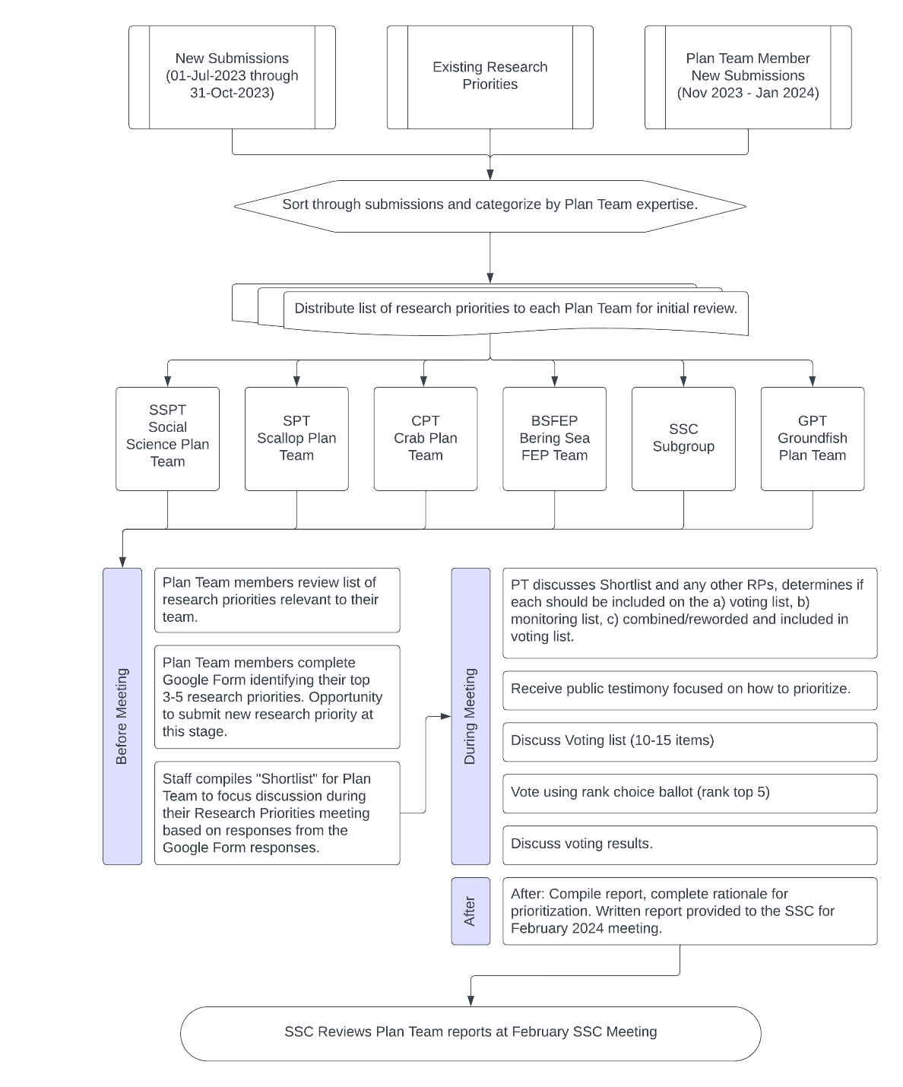
Figure 1: Process for 2024 Research Priority review from new submissions starting on 1-Jul-2024 through the February 2024 SSC Initial Review.

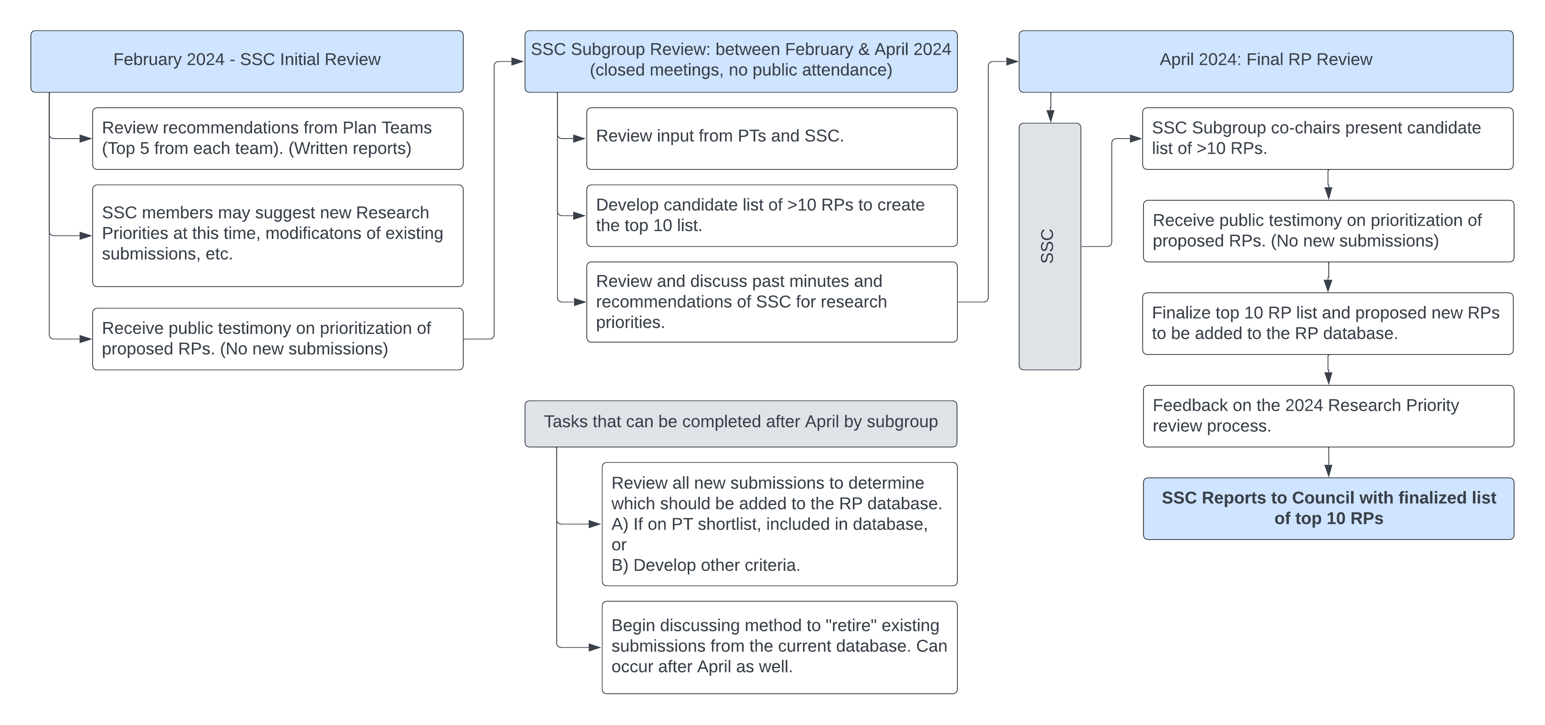
Figure 2: Next steps in the 2024 Research Priorities review process, including the February 2024 SSC Initial Review.

